Chess Engine

# Contents list

**Contents list 2**

**Analysis 3**

Problem identification 3

Stakeholders 5

Computational methods 12

Research 21

Essential features 49

Limitations 52

Requirements 55

Success criteria 57

**Design 59**

Breaking the problem down 59

Usability features 67

Algorithms 78

Variables and data structures 121

Iterative development 199

Post development 206

Final stages of development 221

**Development 223**

First Prototype 223

Second Prototype 282

Third Prototype 310

Fourth prototype 366

**Evaluation 416**

Testing for the evaluation 416

Evaluation of success criteria 449

Evaluation of usability features 456

Limitations and maintenance 470

**Code Listings 474**

**Bibliography 539**

# Analysis

## Problem identification

People keep beating me at chess and I want to either get better than them at chess through the use of my software or implement a chess AI into my chess engine that plays accurate enough moves to beat them for me. To achieve this, I would like to make a chess engine with a chess AI that the player can play against. I would also like there to be two different modes. One for playing against the AI and another for playing against another player. I would also like the AI to have multiple difficulties; for example, an easy, medium or hard difficulty. I would also like to provide a login system for the users and store information about the user such as their username and password and their number of wins, draws and losses.

So, I aim to develop a software application that requires user registration or user login for access. The core functionality of the application will revolve around playing chess matches, offering users the option to engage in chess matches against either another player or an AI opponent integrated within the software. Furthermore, users will have the flexibility to select from varying difficulty levels (easy, medium or hard) when playing against the AI opponent.

In addition to facilitating gameplay, the software will incorporate a feature for tracking our user’s statistics. This tracking mechanism will record essential information such as our user’s number of wins, draws and losses, providing our user with insights into their performance over time.

To accomplish this, I have broken my project down into 6 solvable steps:

1. Chessboard Interface:

I need to design and implement a graphical user interface (GUI) for a chess board. To do this, I will use a 2D array data structure to represent a chessboard. It will have eight rows and eight columns, creating 64 squares on the board just like a real chessboard. I will also need to represent chess pieces on this chess board. In the 2D array, a piece will be represented by a string. The first character of the string will represent the piece’s colour and the second character will represent what type of piece it is (whether it’s a pawn, knight, bishop, rook, queen or king). A blank square will be represented by the string: “--”. Finally, my chessboard will need to implement some user interaction requirements, such as clicking on squares to select and move pieces. To do this, I will use the GUI functionality of a popular Python library called PyGame.

1. Chess Logic:

I will need to develop a chess engine that handles any and all calculations to do with chess game rules and logic. To do this, I will need to generate every move available on the board and then validate those moves to see if they should actually be played or not. For example, a pawn may have a possible move generated in front of it but if it is pinned by a bishop then it shouldn’t be allowed to play that move. Also, I will need to implement turn based mechanics so that, for example, white can not make two moves in a row. Finally, I will also need the chess engine to calculate when it is checkmate or stalemate.

1. Player vs. Player Mode:

This will be when the chess engine application will enable our users to engage in local multiplayer chess matches, allowing them to play against another human player on the same device.

1. Player vs. AI Mode:

This will be when the chess engine application will allow our users to play against a computer player. The goal will be to have three levels of difficulty that a player can play against: an easy, medium and hard difficulty. Each level of difficulty will use its own AI algorithm to generate moves to play on the board.

1. User Statistics:

This will be when the chess engine calculates statistics about the user’s performance, for example, wins, draws and losses. At the end of each game played, statistics will be updated and stored locally on a database file.

1. User Login System:

Users will be able to create new accounts, enter usernames and passwords to log in and have their statistics stored and linked to their account. All of this data will be stored locally on the device running the software on a database file.

## Stakeholders

Potential stakeholders for my chess engine may include:

* Users:
  + These are the individuals who will want to play chess using my chess engine application. This could include all types of users such as casual chess players, chess enthusiasts, and people of all ages and skill levels. This makes all these different types of people stakeholders for my project.
* Developer:
  + I am also a stakeholder in my project not only because I am developing the project but also because I am planning to use it to learn how to play chess better myself.
* Chess Federations and Organisations:
  + If I would like my chess engine to be able to be linked to official chess events, I will need my software to abide by official chess governing bodies. Thereby, these too will be stakeholders for my project.
* Chess community:
  + Chess enthusiasts, clubs, tournaments and online platforms within the broader chess community may have an interest in my chess engine software because it would offer them convenient access to practise chess from their devices. This makes them stakeholders in my project too.
* Educational institutions:
  + My school has a chess club and the students attending this club may wish to use my chess engine software to play chess. This makes the students stakeholders for my project. My software could also be used to teach students chess, making my school, as a whole, a stakeholder too.

I will return to my stakeholders for input by conducting surveys and allowing beta testing throughout the development of my project. I will conduct a survey pre-development, during development and after development for feedback from my users.

I have conducted a pre-development survey for users, members of educational institutions and members of the broader chess community. I have collected responses from a sample of 25 stakeholders. This survey has asked our stakeholders questions that will give me an idea of what kind of chess player will be using my chess engine software and what kind of features they will be expecting my chess engine software to incorporate:

* Question one:

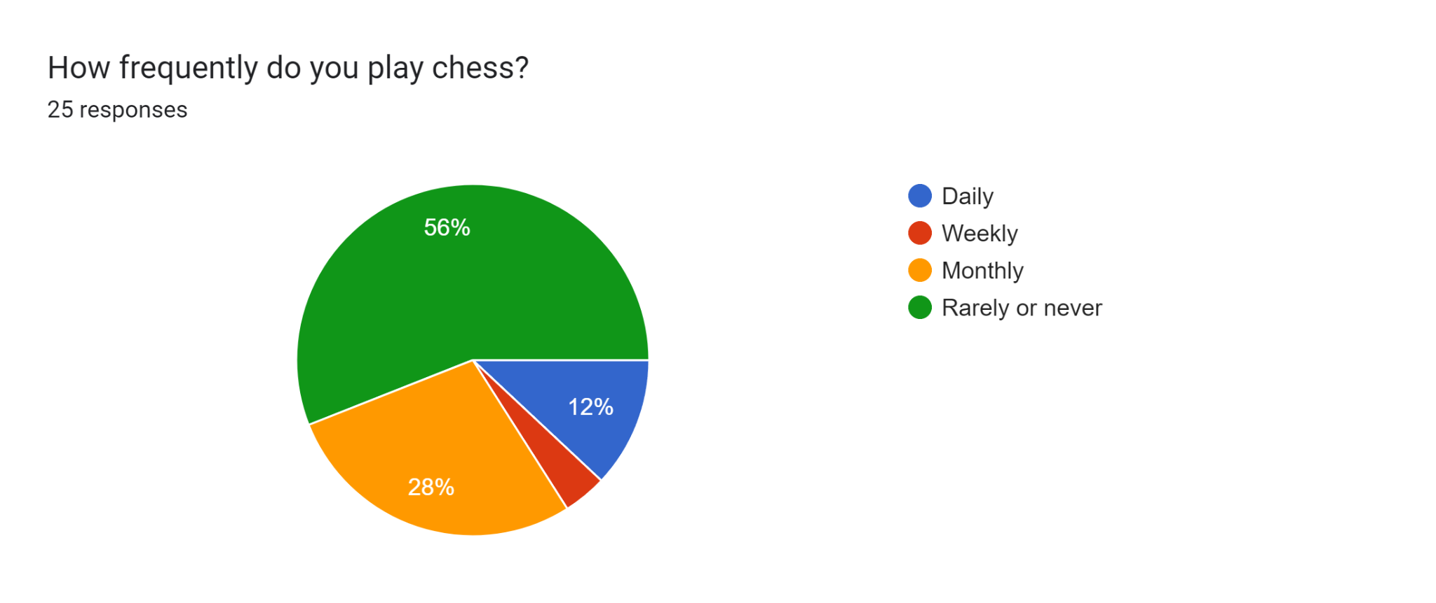

This tells me that most of the users of our chess engine software will be new to chess or they don’t play often and that I should be aiming my features towards them. This will also mean that I will require a simple and intuitive design for my chess engine application.

* Question two:

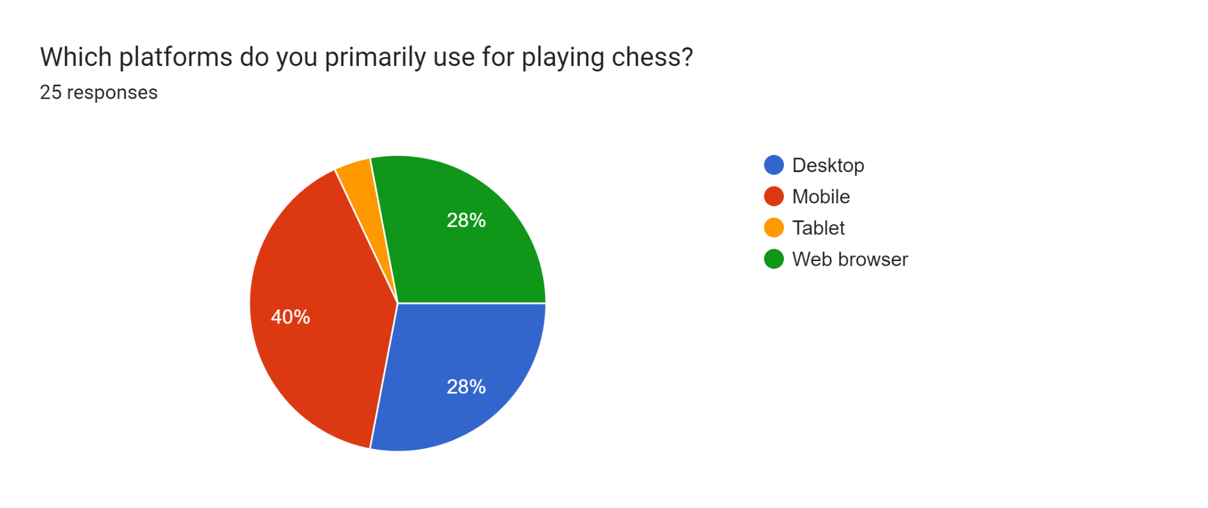

This tells me that most of the users of our chess engine software will want to use our application on their desktop device more than on their mobile device. This is because 40% of our stakeholders picked mobile devices and 4% of our stakeholders picked tablet devices, however, 28% of our stakeholders picked a web browser and another 28% of our stakeholders picked desktop devices which makes desktop devices the winner by majority decision from our stakeholders since 28% + 28% = 56% and 56% is greater than 44%. This means that my chess engine software will be developed for a desktop application.

* Question three:

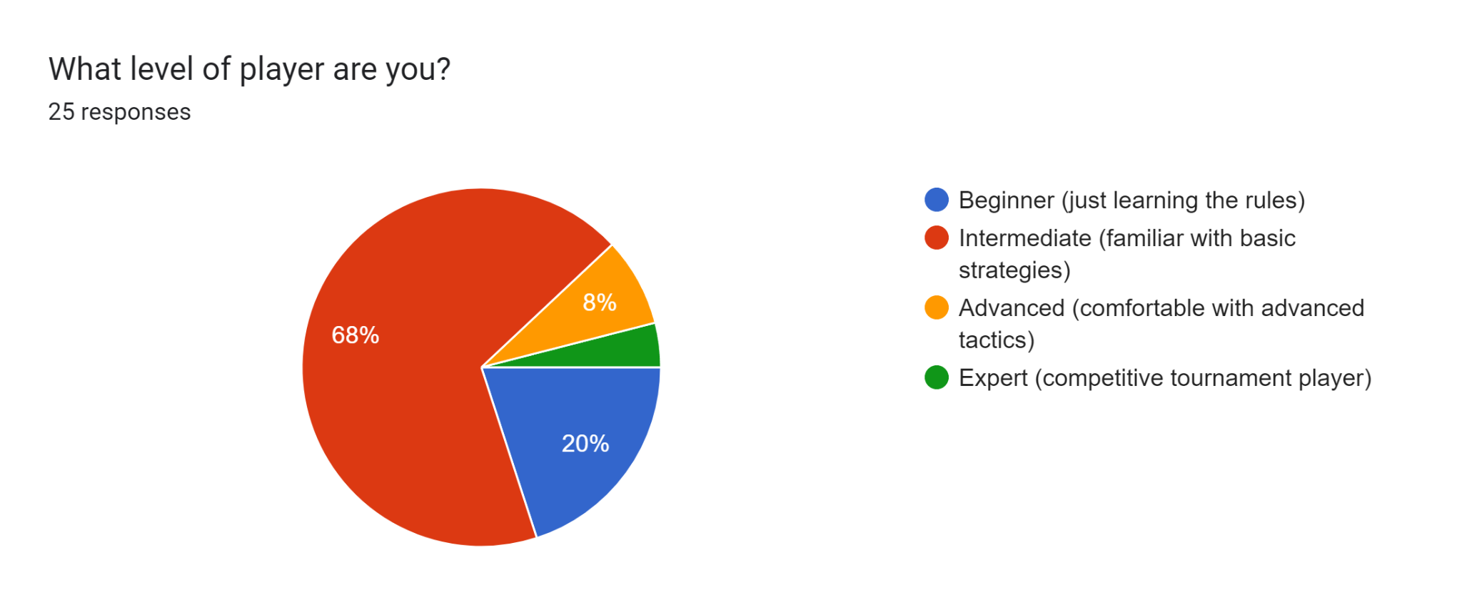

This tells me that most of the users of our chess engine software consider themselves intermediate chess players and will already be familiar with basic strategies in chess. This means that I should be aiming some of my features towards these types of players.

* Question four:

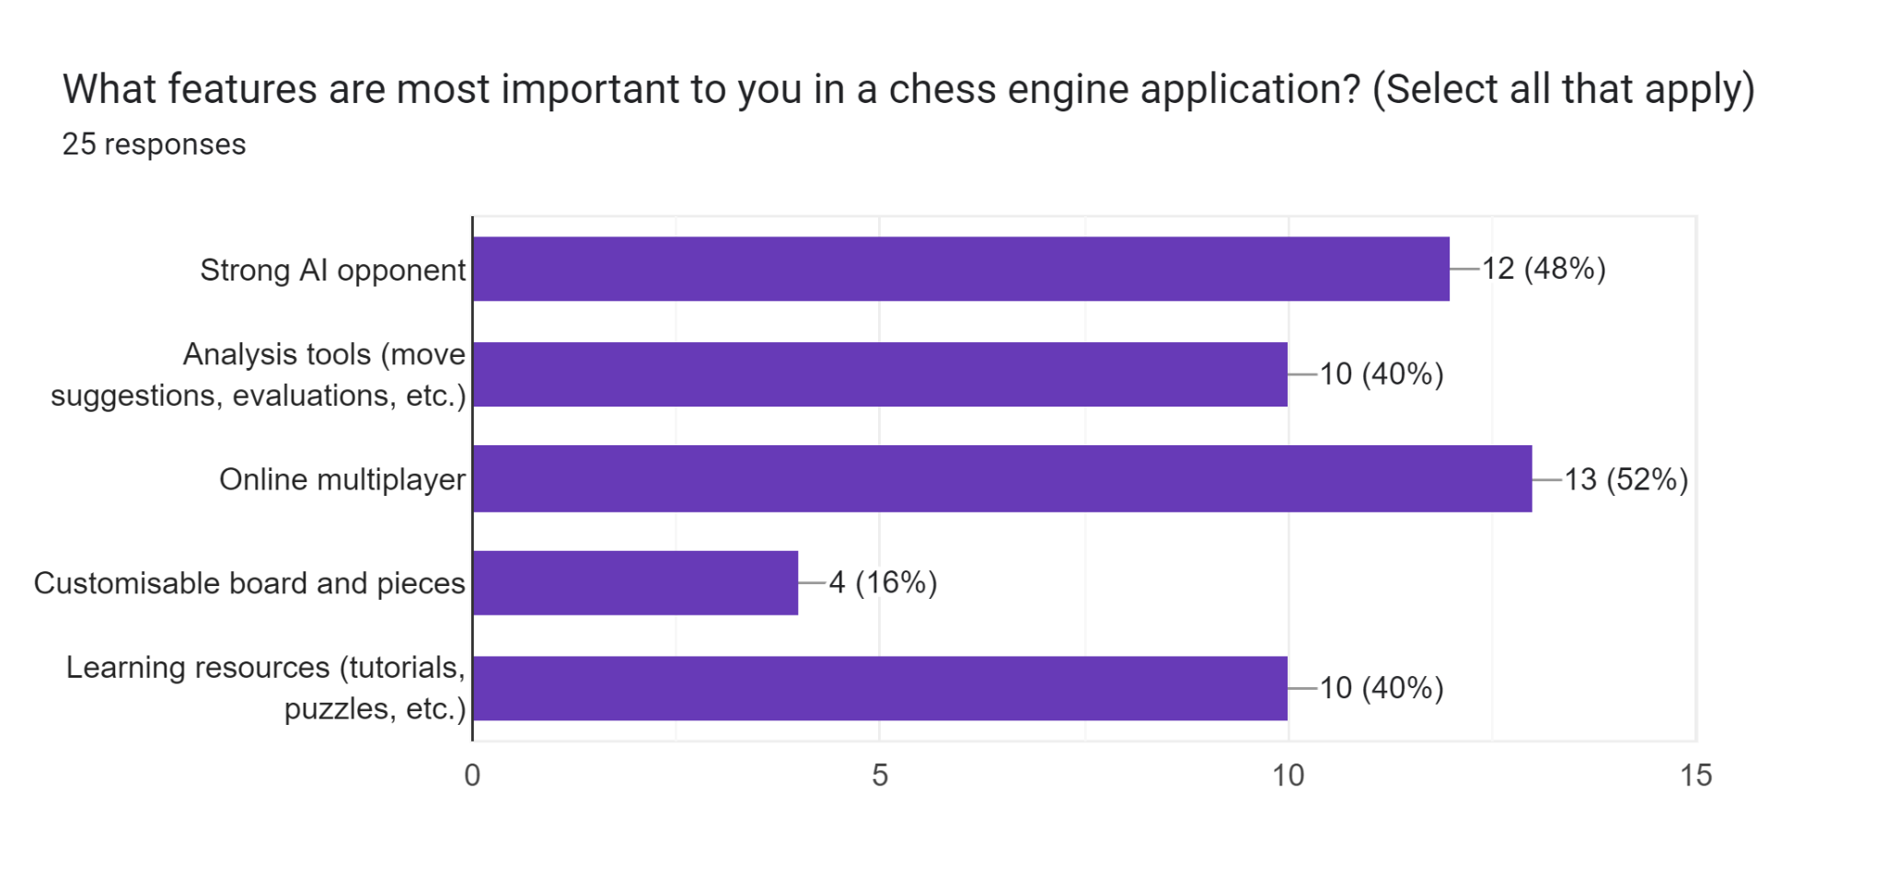

This tells me that most of the users of our chess engine software would like an online multiplayer feature, however, I am not sure how realistic this is for our development given the timeframe that I am allowed. It also tells me that they will want a strong AI opponent to play against. This is something that I will want to try and include in our chess engine software. Additionally, many users also want access to analysis tools such as move suggestions and match evaluations, however, again I am not sure how realistic this is. Many users will also want access to learning resources such as tutorials and puzzles, however, this also seems unrealistic to me given the short timeframe that I am allowed to develop this software. Finally, only a small percentage of users want a customisable board and pieces feature. Therefore, I will not be including this in our chess engine software.

* Question five:

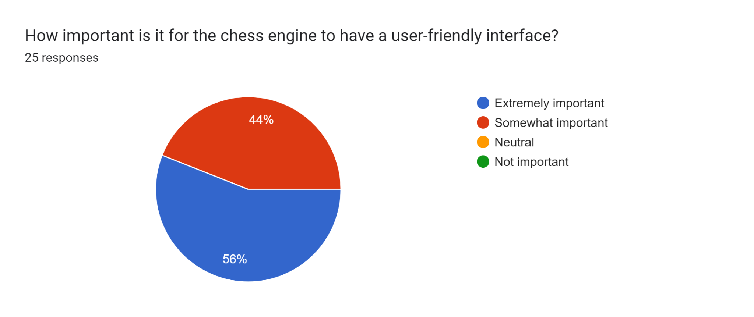

This tells me that all of the users of our chess engine software agree that it is important for our software to have a user-friendly interface. This means that I should aim to provide a simple and intuitive design for the user interface of our chess engine software.

* Question six:

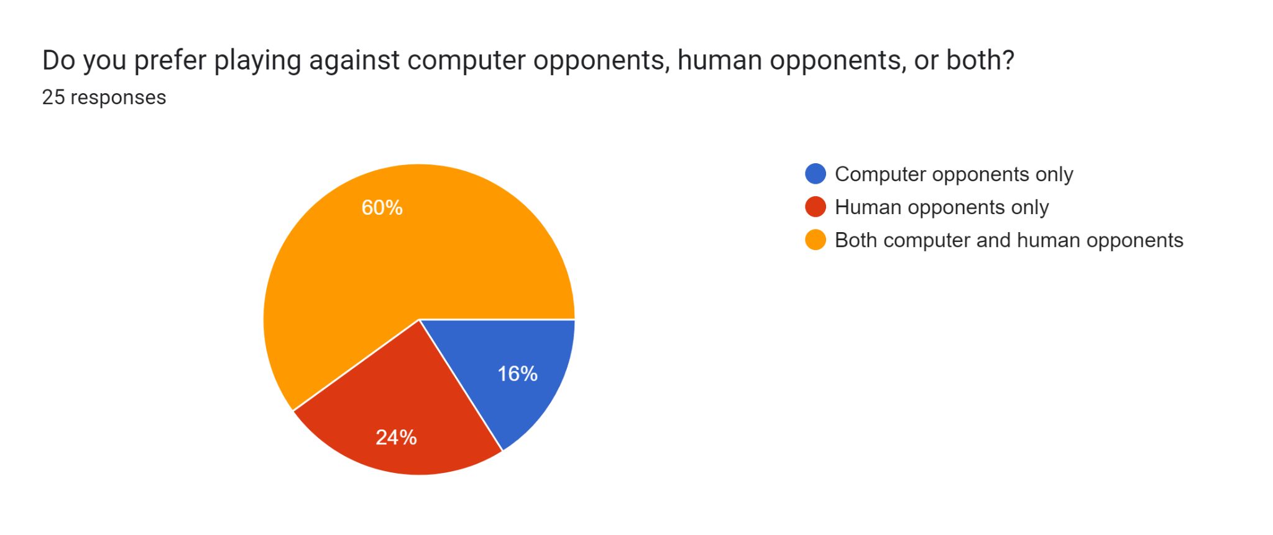

This tells me that most of the users of our chess engine software want to be able to play against both computer and human opponents. This means that I should aim to include an option for our user to play against human opponents and another option for our user to play against computer opponents in our chess engine software.

* Question seven:

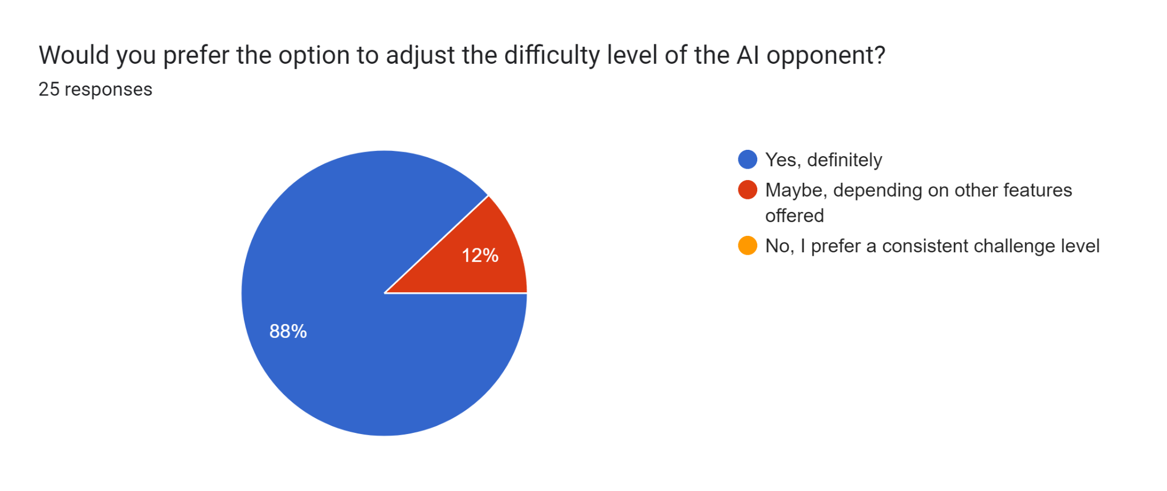

This tells me that most of the users of our chess engine software want to be able to adjust the difficulty of the computer opponent. This means that I should aim to include different levels of difficulty for our computer opponent such as an easy, medium or hard difficulty in our chess engine software.

* Question eight:

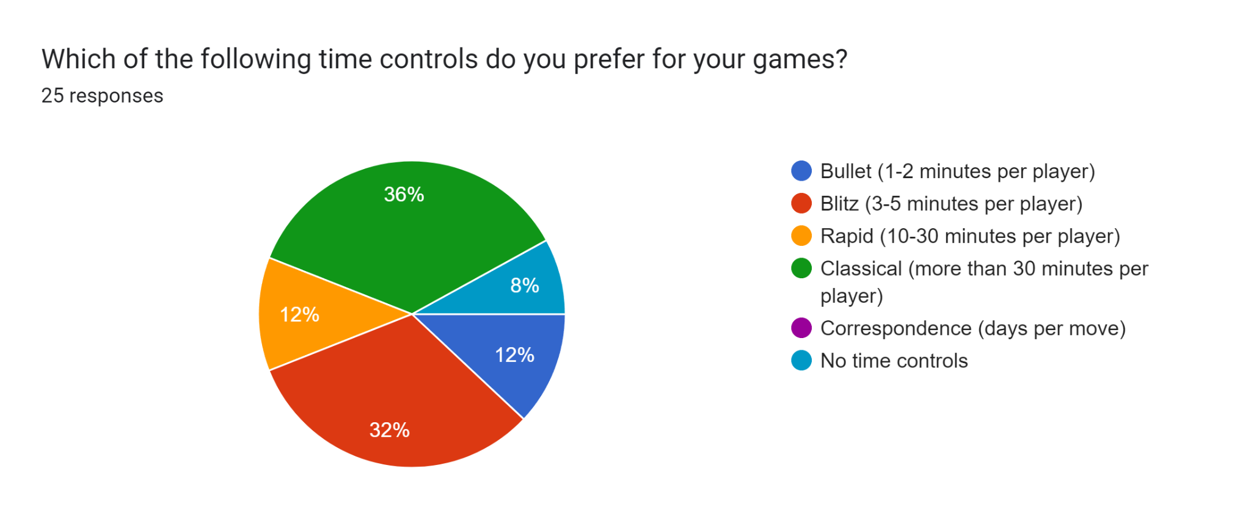

This tells me that most of the users of our chess engine software prefer classical time controls (more than 30 minutes per player) or blitz time controls (3-5 minutes per player) for their chess matches. This means that I should aim to include these time controls in our chess engine software.

* Question nine:

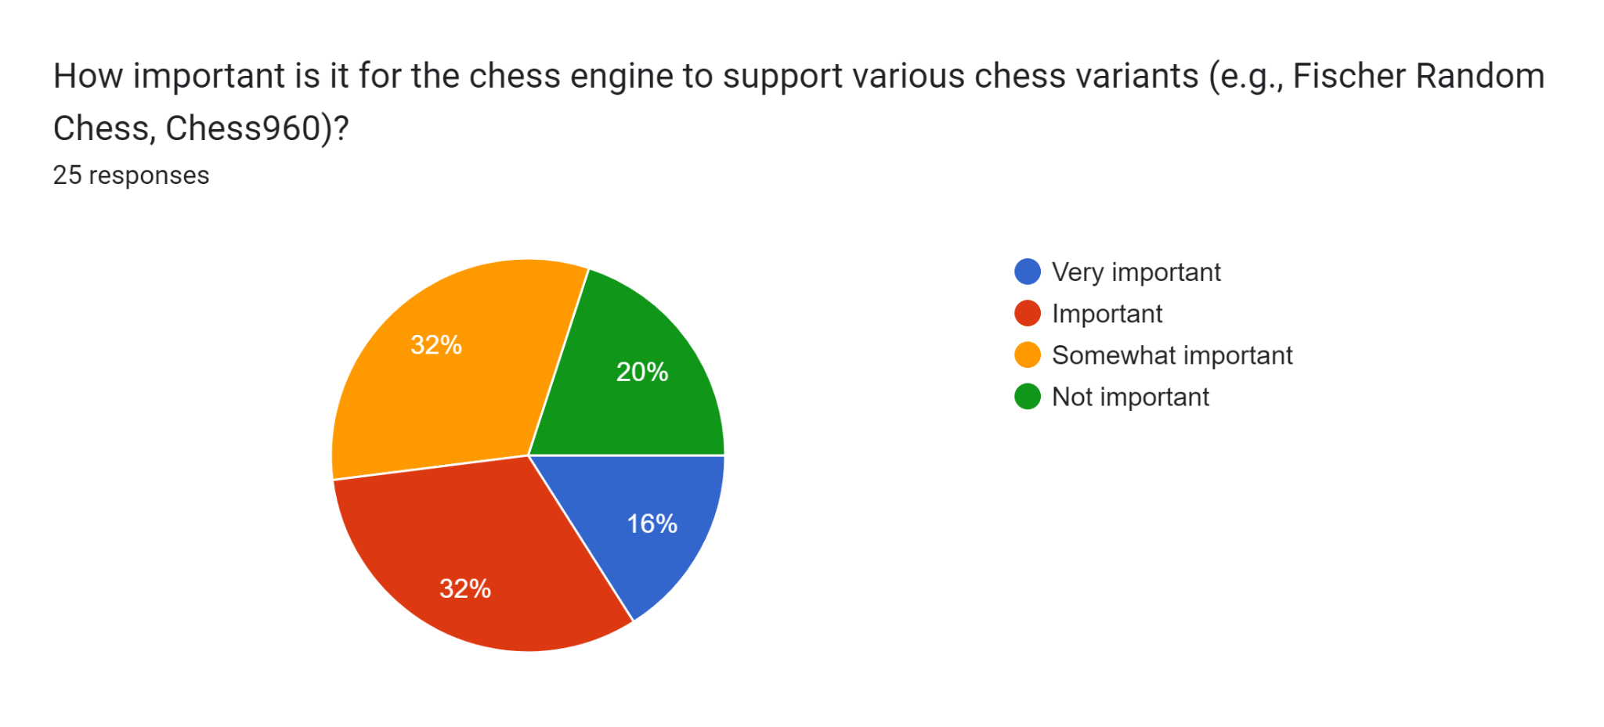

This tells me that most of the users of our chess engine software find it important for our chess engine to be able to support various chess variants such as Fischer Random Chess and Chess960. This means that I should aim to include this feature in our chess engine software.

* Question ten:

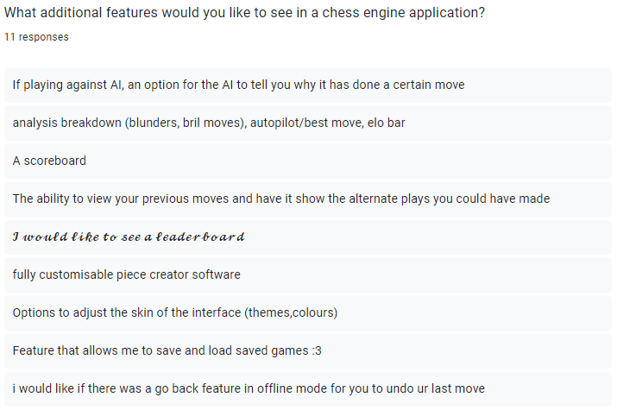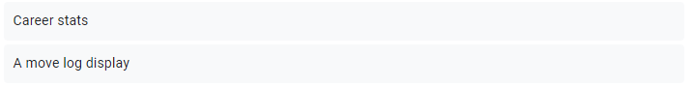

This tells me that some of the users of our chess engine software would like additional features such as an analysis breakdown, elo bar, and a scoreboard. However, I am not sure that all of these additional features are realistic for our development given the timeframe that I am allowed. That said, the last three suggested additional features stand out to me in particular. I will try to include these features that will allow our user to be able to undo moves, view their career statistics (wins, draws and losses) and view a move log display during their chess match in our chess engine software.

## Computational methods

Why our chess engine software is suitable for a computational solution:

* Algorithmic Nature:
  + Chess is a game of well-defined rules and limited possibilities. Each move by a player leads to a finite number of potential responses. This makes it suitable for algorithmic analysis, which computers excel at.
* Computational Power:
  + Chess engines can evaluate millions of positions per second, a feat impossible for a human player. This computational power allows them to explore deep into the game tree, considering numerous possibilities and potential outcomes.
* Efficient Search Algorithms:
  + Chess engines utilise sophisticated search algorithms, such as minimax with alpha-beta pruning, which efficiently explore the game tree by discarding unpromising lines of play. These algorithms are well-suited to implementation in computer programs.
* Evaluation Functions:
  + Chess engines employ evaluation functions to assess the strength of a position. These functions assign numerical values to various factors like piece activity, pawn structure, king safety, etc. Computers can quickly evaluate positions based on these criteria, allowing them to make informed decisions.
* Database Access:
  + Chess engines can access vast databases of opening theory, endgame knowledge, and historical games. This wealth of information helps them make better decisions during gameplay.
* Constant Improvement:
  + Unlike humans, chess engines can continually improve through iteration and analysis. Developers can refine the algorithms, optimise performance and update the software with new strategies and techniques.
* Consistency and Lack of Bias:
  + Chess engines are consistent and unbiased in their analysis. They don’t suffer from human emotions, fatigue or biases, which can affect a human player’s decision-making ability.
* Machine Learning and AI Techniques:
  + Modern chess engines often incorporate machine learning and artificial intelligence techniques to improve their playing strength. Computers are ideal platforms for implementing and training these techniques, allowing the engine to learn and adapt from vast amounts of game data and self-play.
* User Interface:
  + Chess engine programs typically include user interfaces that allow players to interact with the engine, input moves and visualise the game. Computers provide a versatile platform for creating rich and user-friendly interfaces, enhancing the overall experience for players.
* Performance Optimisation:
  + Chess engines can benefit from performance optimisation techniques tailored to the specific hardware and software environment of a computer. This includes utilising multi-threading, parallel processing and hardware acceleration to improve computational efficiency and speed up analysis.

Features of our chess engine software that are amenable to a computational solution:

* Thinking abstractly:
  + Abstract thinking involves conceptualising ideas or solutions without being constrained by specific instances or details, focusing instead on underlying patterns and principles.
  + Here are some ways that we could utilise abstract thinking:
    - *Algorithm Design:* Abstract thinking can help in designing efficient algorithms for various aspects of the chess engine, such as move generation, board evaluation, and search techniques. By abstracting the problem into its essential components, we can devise algorithms that are not only correct but also optimised for speed and scalability.
    - *Pattern Recognition:* Abstract thinking helps in recognising and exploiting patterns in the chessboard, such as tactical themes (such as pins, forks and skewers), piece coordination and typical pawn structures. By abstracting these patterns into general principles, our chess engine software can make more informed decisions during gameplay.
    - *Generalisation:* Abstract thinking allows us to generalise solutions to specific problems, making our chess engine more adaptable and capable of handling a wide range of positions and playing styles. Instead of relying on hardcoded rules for certain situations, we can abstract the underlying principles and apply them more flexibly.
    - *Data Structures:* Abstract thinking enables us to choose appropriate data structures for representing the chessboard, gamestate and other relevant information. For example, we might use bitboards to efficiently represent the state of the board or hash tables for transposition tables in search algorithms.
    - *Evaluation Functions:* Abstracting the evaluation function allows us to create a flexible framework that can adapt to different types of positions, instead of hardcoded values for specific features. For example, an abstract evaluation function could accurately assess the value of a given position based on features, such as piece activity, pawn structure, king safety and material balance.
    - *Search Techniques:* Abstract thinking plays a crucial role in designing search algorithms such as minimax with alpha-beta pruning or more advanced techniques like Monte Carlo Tree Search (MCTS). By abstracting the search space and considering different pruning strategies or exploration policies, we can improve the efficiency and effectiveness of the search.
    - *Machine Learning:* Abstract thinking can guide the integration of machine learning techniques, such as neural networks, into our chess engine software. By abstracting the features and patterns to be learned, we can design neural network architectures that effectively capture the complexities of the game and improve the engine’s performance through training.
    - *Abstraction Layers:* We can divide the chess engine software into layers of abstraction, with each layer responsible for a specific aspect of the game (e.g., board representation, move generation, evaluation). This modular approach allows for easier maintenance and extensibility of the software.
* Thinking ahead:
  + Thinking ahead involves considering potential future outcomes, consequences, or scenarios and making decisions or plans based on these anticipated possibilities to achieve desired goals or mitigate risks.
  + Here are some ways that we could utilise forward thinking:
    - *Move Generation:* We can develop efficient algorithms for generating legal moves for each piece on the board. Thinking ahead here involves considering not only the immediate moves available but also anticipating potential future moves and their consequences.
    - *Search Algorithms:* We can implement search algorithms like minimax with alpha-beta pruning or more advanced techniques such as iterative deepening search. Thinking ahead in this context involves exploring deeper into the game tree to evaluate potential future positions and choose the best move accordingly.
    - *Evaluation Function:* We can design an evaluation function that accurately assesses the strength of a given board position. Thinking ahead in evaluation involves considering the long-term implications of certain positional features, such as pawn structure, piece activity, king safety and material balance.
    - *Quiescence Search:* We can implement a quiescence search to handle positions where the board is likely to undergo significant changes due to captures or checks. Thinking ahead in quiescence search involves looking beyond the horizon and evaluating the consequences of potential captures or forcing moves.
    - *Transposition Tables:* We can use transposition tables to store previously evaluated positions and their associated scores. Thinking ahead with transposition tables involves recognising and exploiting opportunities for position repetition or transposition to improve search efficiency.
    - *Pruning Techniques:* We can apply pruning techniques such as null move pruning, late move reductions, and history heuristics to reduce the search space and focus on the most promising lines. Thinking ahead with pruning involves predicting which branches of the search tree are less likely to lead to favourable outcomes and pruning them early.
    - *Endgame Databases:* We can integrate endgame databases or tablebases to accurately evaluate endgame positions with a small number of pieces remaining on the board. Thinking ahead with endgame databases involves anticipating the outcome of the game based on the current position and the contents of the database.
    - *Parallelisation:* We can utilise parallelisation techniques to search multiple branches of the game tree simultaneously. Thinking ahead with parallelisation involves distributing the computational workload effectively to explore as many potential moves as possible within a limited time frame.
* Thinking procedurally:
  + Thinking procedurally involves breaking down tasks or problems into a sequence of ordered steps or procedures, considering how each step contributes to achieving the desired outcome, and understanding the logical flow of execution to effectively solve problems or accomplish goals.
  + Here are some ways that we could utilise procedural thinking:
    - *Modular Design:* We can divide our chess engine software into modular components, each responsible for a specific aspect of the game such as move generation, evaluation, search algorithms and user interface. Procedural thinking here involves designing clear interfaces between modules and defining the procedures each module should perform.
    - *Step-by-Step Algorithms:* We can develop algorithms for various tasks in the chess engine, such as move generation, board evaluation and search. Procedural thinking involves outlining the steps needed to accomplish each task and implementing them in a systematic manner.
    - *Iterative Development:* We can adopt an iterative development process where we continuously refine and improve our chess engine based on feedback and testing. Procedural thinking involves breaking down the development process into iterative cycles, each consisting of planning, implementation, testing and refinement.
    - *Move Generation:* We can develop procedures to generate legal moves for each piece type on the board. This involves systematically checking each square to determine if it’s a valid destination for the piece, considering factors such as piece mobility and blocking.
    - *Search Algorithms:* We can implement procedural algorithms for searching the game tree to find the best move. This could include procedures for recursively exploring possible moves, evaluating positions and backtracking when necessary.
    - *Evaluation Function:* We can develop procedures to evaluate the strength of a given position. This could involve calculating scores based on factors such as piece value, piece activity, pawn structure, king safety and material balance.
    - *Board Representation:* We can design procedures to represent the chessboard and gamestate efficiently. This could involve using data structures such as arrays or bitboards to store piece positions and other relevant information, as well as procedures for updating the board after each move.
    - *User Interface:* We can develop procedures for interacting with the user interface, allowing players to input moves, view the board and receive feedback from the engine. This could include procedures for parsing algebraic notation, validating moves and updating the graphical representation of the board.
* Thinking logically:
  + Thinking logically involves systematically analysing information, identifying patterns and making deductions or inferences based on established principles of reasoning, such as the laws of logic, to arrive at valid conclusions or solutions.
  + Here are some ways that we could utilise logical thinking:
    - *Rule-based Systems:* We can develop a set of logical rules to govern the behaviour of the chess engine. For example, establish rules for piece movement, capturing and check/checkmate conditions. These rules form the foundation of the engine’s decision-making process.
    - *Move Validation:* We can implement logical rules to validate the legality of moves generated by the engine. This involves checking if a move conforms to the rules of chess, such as whether the destination square is within the bounds of the board, whether the move adheres to the movement rules of the piece and whether the move exposes the king to check.
    - *Board Representation:* We can use logical data structures and representations to model the chessboard and gamestate accurately. This could involve organising pieces and squares in a logical grid-like structure, using bitboards to efficiently represent piece positions and gamestate information, and maintaining consistency in the board representation throughout the program.
    - *Search Algorithms:* We can apply logical algorithms for searching the game tree to find the best move. This includes implementing logical decision-making processes such as minimax with alpha-beta pruning, which involves systematically exploring possible moves and evaluating their consequences to make optimal decisions.
    - *Evaluation Function:* We can design a logically sound evaluation function to assess the strength of a given position. This involves identifying logical criteria for evaluating positional features such as piece activity, pawn structure, king safety and material balance, and assigning logical scores to quantify their importance.
    - *Pruning Techniques:* We can utilise logical pruning techniques to reduce the search space and improve search efficiency. This includes applying logical conditions to determine which branches of the search tree can be safely pruned based on alpha-beta bounds, null move conditions or other heuristic criteria.
    - *Pattern Recognition:* We can apply logical reasoning to recognise and exploit patterns in the gamestate. For example, we can identify tactical motifs such as forks, pins and skewers, and use logical reasoning to determine the best response to these threats.
    - *Endgame Logic:* We can implement logical reasoning specific to endgame positions to guide the engine’s decision-making process. For example, use logical rules to determine whether a particular endgame position is winning, losing or drawn based on known endgame principles.
* Thinking concurrently:
  + Thinking concurrently involves the ability to process multiple tasks, ideas or information simultaneously, considering their interrelations and interactions in real-time to effectively manage and solve complex problems or tasks.
  + Here are some ways that we could utilise concurrent thinking:
    - *Parallel Search:* We can implement parallel search algorithms to explore different branches of the game tree simultaneously. By dividing the search space among multiple threads or processes, we can speed up the search process and potentially find better moves within the same amount of time.
    - *Asynchronous Move Generation:* We can design procedures for asynchronously generating legal moves for different pieces on the board. This allows the engine to continue searching while moves are being generated, maximising the utilisation of computational resources.
    - *Parallel Evaluation Function:* We can develop a parallel evaluation function that can evaluate different aspects of a position concurrently. For example, we could assign different threads or processes to evaluate pawn structure, piece activity, king safety and other positional features simultaneously, then combine the results to produce an overall evaluation score.
    - *Transposition Table Access:* We can implement concurrent access to the transposition table, allowing multiple threads or processes to read and write to the table simultaneously. This can improve search efficiency by reducing contention for access to the table and ensuring that the most up-to-date information is available to all threads.
    - *Multi-Threading:* We can utilise multi-threading techniques to perform various tasks concurrently, such as move generation, position evaluation and search tree traversal. By assigning each thread to a specific task, we can leverage the capabilities of multi-core processors to improve overall performance.
    - *Pipeline Processing:* We can design a pipeline architecture for processing different stages of the engine’s decision-making pipeline concurrently. For instance, move generation, evaluation and search can each be implemented as separate stages in the pipeline, with data flowing sequentially from one stage to the next. By overlapping the execution of these stages, we can maximise throughput and reduce latency.
    - *Lock-Free Algorithms:* We can implement lock-free or wait-free algorithms to minimise contention and synchronisation overhead in highly concurrent scenarios. This involves designing data structures and algorithms that do not rely on traditional locking mechanisms, allowing multiple threads to operate independently without blocking or waiting for each other.
    - *Concurrency Control:* We can employ concurrency control mechanisms such as thread pools, semaphores and barriers to manage and regulate concurrent execution. This involves coordinating the scheduling and synchronisation of concurrent tasks to prevent resource contention, deadlocks and other concurrency-related issues.

Why the output from our chess engine software is valuable to our stakeholders:

* Users:
  + *Training and Practice:* Our chess engine software enables users to engage in practice matches. Users can set up custom scenarios, simulate specific game situations and challenge the engine at various difficulty levels. This allows players to hone their skills, test new strategies and experiment with different approaches in a controlled environment. The instant feedback provided by the engine helps users track their progress, identify areas for improvement and adapt their gameplay accordingly.
  + *Competition and Entertainment:* For casual players and chess enthusiasts, our software offers an immersive and enjoyable gaming experience. Users can play against the engine in single-player mode or compete against friends in local multiplayer games. The engine’s strong playing strength and diverse gameplay options ensure challenging and dynamic encounters, keeping users engaged and entertained for hours on end.
* Developer:
  + *Algorithmic Research and Development:* The output provides me as a developer with valuable insights for conducting algorithmic research and development. By studying the engine’s decision-making process and evaluating its performance across various game scenarios, as a developer, I can identify areas for improvement and innovation. This may involve exploring new algorithms, experimenting with different evaluation functions or incorporating advanced techniques from the field of artificial intelligence and machine learning.
  + *Debugging and Testing:* The output generated by our chess engine software serves as a crucial debugging and testing resource for me as a developer. By scrutinising the engine’s output, I can detect errors, identify inconsistencies and diagnose issues in the codebase. This allows for efficient debugging and troubleshooting, enabling me as a developer to rectify defects, improve stability and ensure the reliability of the software.
* Chess Federations and Organisations:
  + *Training and Practice:* Chess federations and organisations play a crucial role in nurturing and developing chess talent at various levels, from grassroots to elite. The output from our chess engine software can be utilised in talent identification, training programs and coaching initiatives. Federations can analyse players’ games, assess their strengths and weaknesses and provide targeted feedback and guidance for improvement. This contributes to the growth and competitiveness of the chess community, fostering a pipeline of skilled players and enhancing the federation’s reputation.
  + *Tournament Organisation:* Chess federations and organisers utilise chess engine software in the organisation of tournaments and competitions. They can use the software to have players play against each other in tournaments, providing a platform for them to showcase their talent, skill and achievement on a competitive stage. Players compete for prizes, titles and recognition, with successful players garnering respect and admiration from their peers. This inspires others to strive for excellence and contribute to the vibrancy of the chess community.
* Chess community:
  + *Training and Practice:* The output from our chess engine software serves as a valuable training tool for players at all skill levels. Beginners can learn fundamental concepts and principles. Additionally, intermediate and advanced players can use the software to refine their tactical awareness, strategic planning and endgame techniques. The software’s capabilities help players identify weaknesses, explore new ideas and develop their skills in an effective manner.
  + *Competitive Play and Entertainment:* Competitive chess players and enthusiasts derive enjoyment and inspiration from the output generated by our chess engine software. The software enables players to engage in competitive play against the engine and play against other players in a local single-player mode. The engine’s strong playing strength and diverse gameplay options ensure challenging and dynamic encounters, keeping members of the chess community engaged and entertained for hours on end.
* Educational institutions:
  + *Chess Education and Curriculum Enhancement:* Educational institutions, ranging from primary schools to universities, often incorporate chess into their curriculum as a means of promoting critical thinking, problem-solving and strategic reasoning skills among students. The output from our chess engine software provides valuable resources for chess education which teachers can utilise to enhance their chess instruction, engage students in meaningful learning activities and facilitate skill development in a stimulating and engaging manner.
  + *STEM Education Integration:* Chess offers a rich interdisciplinary context for integrating science, technology, engineering and mathematics (STEM) education into the curriculum. Our chess engine software serves as a powerful tool for exploring mathematical concepts, computational thinking and algorithmic problem-solving within the context of the game. Students can analyse chess positions, study patterns and algorithms used by the software and explore the underlying principles of artificial intelligence and machine learning. This integration of chess and STEM education fosters interdisciplinary learning, encourages creativity and innovation and prepares students for future academic and career opportunities in STEM fields.

## Research

To gain a deeper comprehension of my project and its development, I will delve into existing chess applications, explore chess engines, and study AI algorithms. This research will serve as a foundation for shaping the direction of my chess engine software.

Chess Applications:

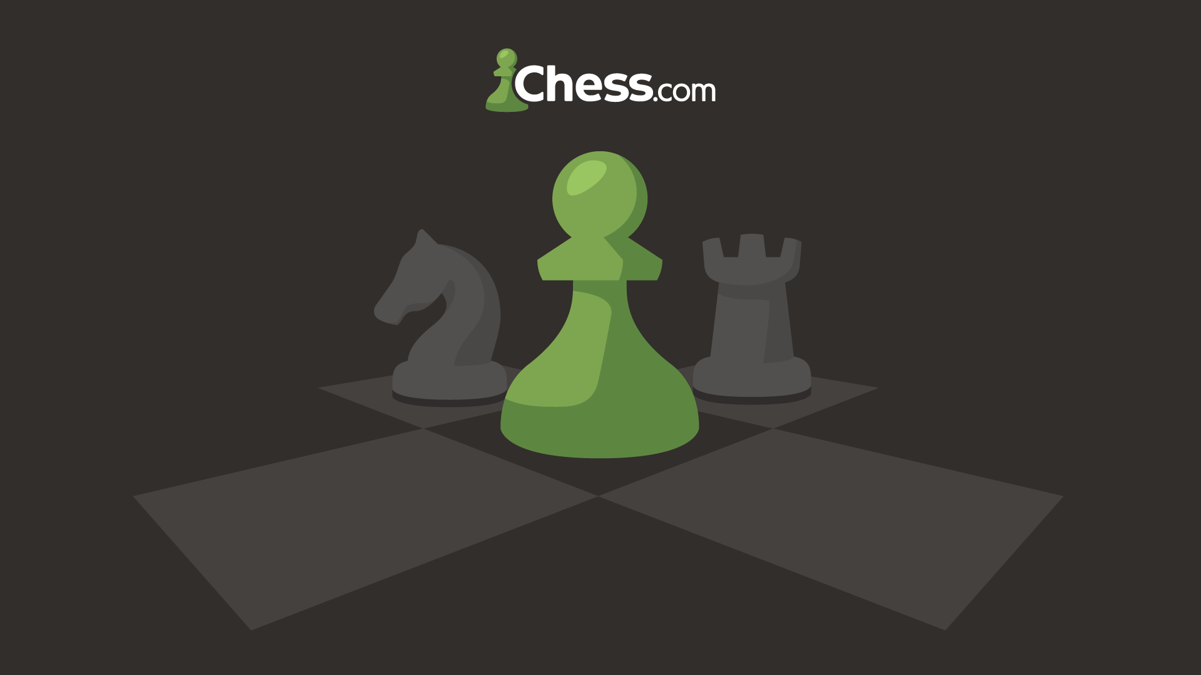

Overview:

Chess.com is a website and mobile application that provides a wide range of chess-related resources and features, catering to chess players of all skill levels, from total beginners to grandmasters. It was founded in 2007 and has since become a thriving online chess community.

Key Features:

* Play Chess:
  + Chess.com offers a platform where users can play chess games online in real-time against opponents from around the world. You can play standard, blitz, bullet, and correspondence chess games.
* Tournaments and Events:
  + Chess.com hosts a variety of tournaments and events, from casual online club tournaments to high-stakes championships. Users can participate in these events, earn prizes, and compete against other players at their own skill level.
* Computer Analysis:
  + The platform provides computer analysis of games, which is beneficial for players looking to learn from their games and identify mistakes. The analysis highlights key positions and suggests better moves.
* Puzzles and Training:
  + Chess.com offers an extensive library of chess puzzles and lessons. These help players improve their tactical, strategic, and endgame skills. The interactive lessons are suitable for all skill levels.
* Chess Learning:
  + Chess.com offers structured lessons and videos for those looking to improve their chess skills. Lessons are organised by level, and you can track your progress as you complete them.
* Chess Openings Explorer:
  + This feature allows users to explore various chess openings and see statistics on how often each move is played. It’s useful for studying and developing your opening repertoire.
* Live and Online Chess Broadcasts:
  + Chess.com frequently hosts live broadcasts of major chess events, with expert commentary. Users can follow and watch these events in real-time.
* Community and Clubs:
  + Chess.com has a strong and active online chess community. Users can join or create chess clubs, participate in forums, and engage with fellow chess enthusiasts.
* Mobile Application:
  + Chess.com also provides a mobile application for both iOS and Android platforms, allowing users to play chess, access lessons, and engage with the community on the go.
* Player Statistics and Ratings:
  + Users can track their progress and view detailed statistics about their games and performance, including ratings, wins, losses, and more.
* Chess Analysis Board:
  + The analysis board allows users to set up positions, explore different variations, and analyse games with friends or fellow chess players.
* Premium Membership:
  + Chess.com offers premium membership plans with additional features, such as unlimited access to lessons and puzzles, enhanced game analysis, and more.

Features I will include:

* Play Chess:
  + Users will be able to play chess using our chess engine, enjoying an intuitive interface and the ability to challenge opponents locally or play against strong AI opponents.
* Tournaments and Events:
  + Users will be able to use our chess engine software to participate in organised tournaments or events, as it will adhere to official chess rules, ensuring fair play and compatibility with established competitive standards.
* Community and Clubs:
  + Users will be able to use our chess engine software to play chess in chess clubs and other chess community events, as it will adhere to official chess rules, ensuring fair play and compatibility with established competitive standards.
* Player Statistics and Ratings:
  + Users will be able to see their statistics using our chess engine software such as their wins, draws and losses. This will allow them to be able to track their progress and improve their gameplay skills.

Features I will not include:

* Computer Analysis:
  + Chess analysis requires very complicated computational algorithms and extensive processing power to provide meaningful insights into game positions, potential moves and strategic evaluations. Therefore, I will not be including this feature in our chess engine software because I do not think it is realistic to implement in the short timeframe that I am allowed for this project.
* Puzzles and Training:
  + Puzzles and training require very extensive content curation to offer meaningful challenges and learning opportunities for users. Therefore, I will not be including this feature in our chess engine software because I do not think it is realistic to implement in the short timeframe that I am allowed for this project.
* Chess Learning:
  + Chess learning requires sophisticated instructional design, comprehensive content creation and adaptive learning algorithms to effectively educate users on various aspects of the game, from basic principles to advanced strategies. Therefore, I will not be including this feature in our chess engine software because I do not think it is realistic to implement in the short timeframe that I am allowed for this project.
* Chess Openings Explorer:
  + A chess openings explorer requires extensive database integration, sophisticated search algorithms and comprehensive analysis capabilities to provide users with valuable insights into various opening lines and their nuances. Therefore, I will not be including this feature in our chess engine software because I do not think it is realistic to implement in the short timeframe that I am allowed for this project.
* Live and Online Chess Broadcasts:
  + Live and online chess broadcasts require sophisticated streaming infrastructure, real-time data synchronisation and interactive viewer engagement features to deliver an immersive viewing experience. Therefore, I will not be including this feature in our chess engine software because I do not think it is realistic to implement in the short timeframe that I am allowed for this project.
* Mobile Application:
  + As shown in the pre-development stakeholder survey, the majority of our stakeholders would prefer a desktop application over a mobile application. Therefore, I will not be including this feature in our chess engine software.
* Chess Analysis Board:
  + A chess analysis board would require sophisticated graphical user interface (GUI) development, integration with chess engines for real-time analysis and interactive features for exploring variations and evaluating positions. Therefore, I will not be including this feature in our chess engine software because I do not think it is realistic to implement in the short timeframe that I am allowed for this project.
* Premium Membership:
  + A premium membership feature would require the development of secure user authentication systems, subscription management functionalities and exclusive content or benefits to incentivise users to upgrade. Therefore, I will not be including this feature in our chess engine software because I do not think it is realistic to implement in the short timeframe that I am allowed for this project.

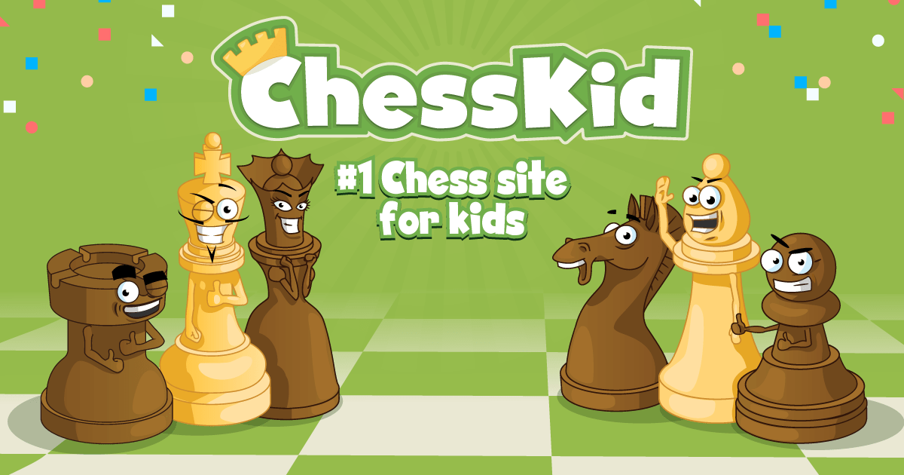

Overview:

ChessKid was created as a kid-friendly offshoot of Chess.com, which is designed for chess players of all ages and skill levels. ChessKid focuses on making chess accessible and enjoyable for children, providing educational content and a safe platform for learning and playing chess. It offers a playful and interactive way for kids to explore the world of chess.

Key Features:

* Child-Friendly Interface:
  + ChessKid has a colourful and user-friendly interface tailored to kids. It’s designed to be visually appealing and easy for children to navigate.
* Lessons and Puzzles:
  + The app offers a wide range of lessons, videos, and interactive puzzles. These resources are designed to teach kids the rules and strategies of chess progressively. Lessons are organised by skill level.
* Play Against the Computer:
  + Kids can play chess against a computer opponent at different difficulty levels. This allows them to practise and learn without the pressure of playing against other children or adults.
* Play Against Friends or Siblings:
  + ChessKid allows kids to play against their friends or siblings in a safe and controlled online environment. Parents can manage these connections.
* Live Chess Tournaments:
  + The app hosts live chess tournaments specifically for kids. This offers a competitive but supportive environment where they can test their skills against other young players.
* Chess Coach:
  + ChessKid offers a virtual chess coach, which provides tips and advice during games, helping kids make better moves and learn from their mistakes.
* Progress Tracking:
  + ChessKid provides tools for parents and teachers to track a child’s progress in chess. This feature allows adults to see how their child is advancing through the lessons and games.
* Chess Puzzle Rush:
  + A fun and educational feature, Puzzle Rush challenges kids to solve as many chess puzzles as they can within a set time. This helps develop their tactical skills.
* Achievements and Awards:
  + The app rewards kids with badges and trophies for their accomplishments, such as completing lessons, winning games, and achieving various milestones.
* Safe Environment:
  + ChessKid is designed to be a safe and secure platform for kids to learn and play chess. There are strong measures in place to protect children while they interact with others online.
* Parent and Teacher Tools:
  + ChessKid offers features that allow parents and teachers to monitor a child’s progress and ensure a safe online experience. It provides resources for educators to incorporate chess into the classroom.
* Mobile Apps:
  + ChessKid is available as a mobile application for both iOS and Android devices, making it accessible for on-the-go learning and play.

Features I will include:

* Child-Friendly Interface:
  + Users will be provided with a child-friendly interface when using our chess engine software in order to cultivate a welcoming and accessible environment for young players, facilitating their engagement with the game while promoting learning and skill development.
* Play Against the Computer:
  + Users can play against the computer when using our chess engine, experiencing challenging gameplay tailored to their skill level through adjustable difficulty settings and sophisticated AI algorithms.
* Play Against Friends or Siblings:
  + Users can play against friends or siblings when using our chess engine, fostering friendly competition and social interaction through local multiplayer functionality.
* Live Chess Tournaments:
  + Users will be able to use our chess engine software to participate in organised tournaments or events, as it will adhere to official chess rules, ensuring fair play and compatibility with established competitive standards.
* Progress Tracking:
  + Users will be able to track their progress using our chess engine software as it will track their statistics such as their wins, draws and losses.
* Achievements and Awards:
  + Users will be able to receive achievements and awards through the statistics stored about them on our chess engine software as whenever they win, their wins statistic will increase.
* Safe Environment:
  + Users will be provided with a safe and child-friendly environment when using our chess engine software as it will not provide any online functionality. Our chess engine software will provide local functionality only.

Features I will not include:

* Lessons and Puzzles:
  + Lessons and puzzles would require extensive content creation, curriculum development and algorithmic design to ensure educational effectiveness and engagement. Therefore, I will not be including this feature in our chess engine software because I do not think it is realistic to implement in the short timeframe that I am allowed for this project.
* Chess Coach:
  + A chess coach feature would require sophisticated artificial intelligence algorithms, personalised learning models and extensive content development to offer tailored coaching sessions and constructive feedback to users. Therefore, I will not be including this feature in our chess engine software because I do not think it is realistic to implement in the short timeframe that I am allowed for this project.
* Chess Puzzle Rush:
  + A chess puzzle rush feature would require the development of a vast database of diverse and challenging puzzles or real-time puzzle generation algorithms. Therefore, I will not be including this feature in our chess engine software because I do not think it is realistic to implement in the short timeframe that I am allowed for this project.
* Parent and Teacher Tools:
  + Parent and teacher tools would require online functionality, tools for parental oversight and customisable learning modules tailored educational purposes. Therefore, I will not be including this feature in our chess engine software because I do not think it is realistic to implement in the short timeframe that I am allowed for this project.
* Mobile Apps:
  + As shown in the pre-development stakeholder survey, the majority of our stakeholders would prefer a desktop application over a mobile application. Therefore, I will not be including this feature in our chess engine software.

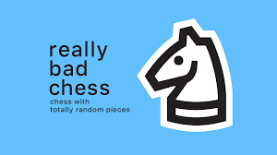

Overview:

Really Bad Chess is a chess variant that deliberately breaks the conventions of traditional chess. In this game, the rules of chess are still followed, but the initial placement of the pieces is randomised, leading to wildly unbalanced and often unpredictable games. This approach makes chess accessible and fun for players of all skill levels, as it levels the playing field and provides a fresh and enjoyable experience.

Key Features:

* Randomised Piece Placement:
  + The key feature of Really Bad Chess is the randomisation of the starting position of the pieces. This means that each game begins with a unique and unexpected arrangement of chess pieces. It might include multiple queens, bishops in front of pawns, or other unconventional setups.
* Adjustable Difficulty Levels:
  + The game offers a range of difficulty levels, from “Really Bad” (where you, the player, have the advantage with stronger pieces) to “Grandmaster” (where your opponent has the advantage). This allows players of all skill levels to enjoy the game, from beginners to experienced chess players.
* Daily Challenges:
  + Really Bad Chess provides daily challenges, which are unique and predetermined puzzle-like positions with specific goals. These challenges encourage players to think creatively and find the best moves within these unusual setups.
* Achievements and Leaderboards:
  + Players can earn achievements for completing specific challenges and achieving certain milestones. The game also features leaderboards where players can compare their performance with others.
* Customisation:
  + The game offers various customisation options, allowing players to choose different piece styles and themes for the chessboard to suit their preferences.
* No Pay-to-Win Model:
  + Really Bad Chess doesn’t have a pay-to-win model, making it a fair and accessible game for everyone. There are no in-app purchases that give players an unfair advantage.
* Minimalistic Design:
  + The game features a clean and minimalistic design, focusing on gameplay and fun rather than complex graphics.
* Cross-Platform Play:
  + Really Bad Chess is available on both iOS and Android platforms, allowing players on different devices to compete with each other.
* Educational Value:
  + The game encourages players to think creatively, adapt to unexpected situations, and learn to strategise in unconventional chess scenarios. It can be a great tool for learning different aspects of chess tactics.
* Positive Reception:
  + Really Bad Chess received positive reviews from players and critics, particularly for its innovative and entertaining take on traditional chess.

Features I will include:

* Adjustable Difficulty Levels:
  + Users will be able to adjust the level of difficulty of our chess engine’s computer opponents by being allowed to select an easy, medium or hard difficulty to play against. Each difficulty setting will use a different AI algorithm to generate what moves to play.
* No Pay-to-Win Model:
  + Our chess engine software will not have a pay-to-win model, making it fair and accessible for everyone. There will be no in-app purchases that give players an unfair advantage.
* Minimalistic Design:
  + Our chess engine software will have a minimalistic design, prioritising simplicity, ease of use and intuitive navigation to ensure a streamlined and enjoyable user experience.
* Educational Value:
  + Our chess engine software will provide educational value as it will allow educational institutions to be able to use it to teach their students how to play chess and learn about the underlying principles of artificial intelligence and machine learning by studying the AI algorithms behind the software.

Features I will not include:

* Randomised Piece Placement:
  + Our chess engine software will not include randomised piece placement as a feature. Instead, I aim for our software to uphold a more traditional approach, distinguishing it from the unconventional style seen in Really Bad Chess.
* Daily Challenges:
  + Daily challenges would require the development of a diverse range of unique and engaging chess puzzles and integration of a scheduling system for daily distribution. Therefore, I will not be including this feature in our chess engine software because I do not think it is realistic to implement in the short timeframe that I am allowed for this project.
* Achievements and Leaderboards:
  + Achievements and leaderboards would require the development of a comprehensive system for tracking player milestones, designing a variety of meaningful achievements and implementing leaderboard functionality to showcase player rankings and progress. Therefore, I will not be including this feature in our chess engine software because I do not think it is realistic to implement in the short timeframe that I am allowed for this project.
* Customisation:
  + Customisation features would require backend implementation for storing and retrieving user preferences, and development of customisable options such as piece sets, board themes, and game modes. Therefore, I will not be including this feature in our chess engine software because I do not think it is realistic to implement in the short timeframe that I am allowed for this project.
* Cross-Platform Play:
  + Cross-platform play would require online functionality and ongoing maintenance to ensure consistent performance and user experience across all supported devices. Therefore, I will not be including this feature in our chess engine software because I do not think it is realistic to implement in the short timeframe that I am allowed for this project.

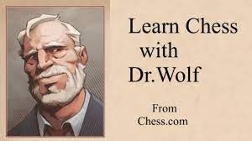

Overview:

Learn Chess with Dr. Wolf is a versatile chess learning game designed to cater to players of all skill levels, ranging from complete novices to seasoned grandmasters. Offering tailored in-game coaching, this application equips users with invaluable chess insights. It encompasses a rich array of features, including illuminating hints, thorough explanations, and targeted training exercises suitable for every proficiency level. In this engaging experience, players interact with four distinct chess coaches, each possessing their unique personalities. Notably, Dr. Wolf stands out as the friendly, patient, and witty guide, ready to accompany learners on their chess journey.

Key Features:

* Play chess:
  + Learn Chess with Dr. Wolf offers an intuitive platform that caters to players of all skill levels, offering a space for both learning and gameplay.
* User-Friendly Design:
  + Learn Chess with Dr. Wolf provides a user-friendly graphical interface, ensuring ease of use and accessibility for chess enthusiasts of all skill levels.
* Personalised Lessons:
  + Learn Chess with Dr. Wolf further enhances the learning experience of the user by offering personalised lessons designed to benefit players of any skill level.
* Unique Coaches:
  + Learn Chess with Dr. Wolf introduces four unique coaches, each brimming with their own unique personality. Take Dr. Wolf, for instance,a coach characterised by his friendliness, patience and wit. These personalities collectively create an engaging environment that appeals to users across all skill levels.
* User Feedback:
  + Learn Chess with Dr. Wolf provides valuable and insightful guidance aimed at assisting players in their journey to learn and enhance their chess prowess.
* Progress Tracking:
  + Learn Chess with Dr. Wolf offers users a valuable progress-tracking feature. Lessons are thoughtfully categorised by difficulty, spanning from beginner to grandmaster difficulties, ensuring that learners can keep track of their development with useful insights.
* Educational Value:
  + Learn Chess with Dr. Wolf could also be used as a valuable educational tool for institutions interested in integrating chess into their curriculum. Its proficient coaches and comprehensive user feedback make it an invaluable resource for educational initiatives.
* Mobile Application:
  + Learn Chess with Dr. Wolf is a versatile mobile application compatible with iOS and Android devices, ensuring accessibility and convenience for chess enthusiasts seeking on-the-go learning and play.
* Positive Reception:
  + Learn Chess with Dr. Wolf garnered overwhelmingly positive feedback from both users and critics, who praised the mobile application for its user-friendly design and the invaluable, constructive feedback it provides.

Features I will include:

* Play Chess:
  + Users will be able to play chess using our chess engine, enjoying an intuitive interface and the ability to challenge opponents locally or play against strong AI opponents.
* User-Friendly Design:
  + Our chess engine software will provide a user-friendly design, featuring intuitive navigation, clear visual elements and streamlined functionality to ensure ease of use for players of all skill levels.
* Progress Tracking:
  + Users will be able to track their progress using our chess engine software as it will track their statistics such as their wins, draws and losses.
* Educational Value:
  + Our chess engine software will provide educational value as it will allow educational institutions to be able to use it to teach their students how to play chess and learn about the underlying principles of artificial intelligence and machine learning by studying the AI algorithms behind the software.

Features I will not include:

* Personalised Lessons:
  + Personalised lessons would require the development of sophisticated machine learning algorithms, extensive content creation and adaptive learning models tailored to individual user profiles and skill levels. Therefore, I will not be including this feature in our chess engine software because I do not think it is realistic to implement in the short timeframe that I am allowed for this project.
* Unique Coaches:
  + Unique coaches would require the development of diverse coaching personalities and extensive dialogue trees to offer personalised guidance and feedback to users. Therefore, I will not be including this feature in our chess engine software because I do not think it is realistic to implement in the short timeframe that I am allowed for this project.
* User Feedback:
  + User feedback would require very complicated computational algorithms and extensive processing power to provide meaningful insights into game positions, potential moves and strategic evaluations. Therefore, I will not be including this feature in our chess engine software because I do not think it is realistic to implement in the short timeframe that I am allowed for this project.
* Mobile Application:
  + As shown in the pre-development stakeholder survey, the majority of our stakeholders would prefer a desktop application over a mobile application. Therefore, I will not be including this feature in our chess engine software.

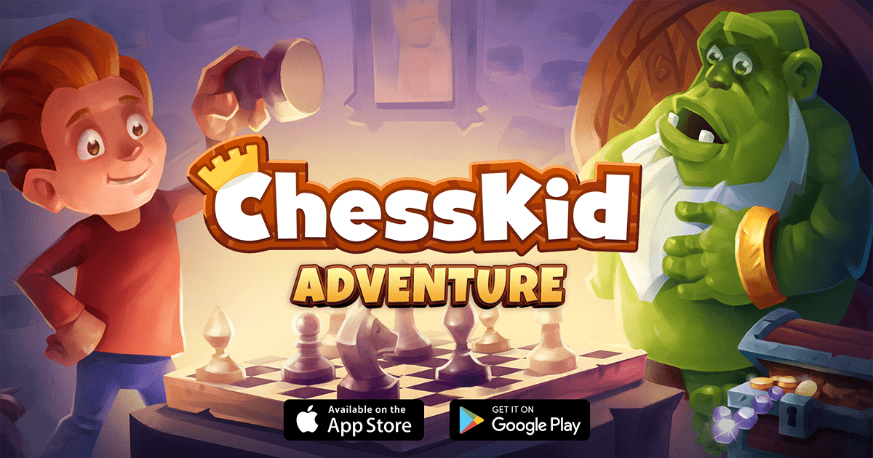

Overview:

ChessKid Adventure is an app that combines the world of chess with an interactive and imaginative storyline. It is aimed at teaching chess to children in a way that is both entertaining and educational. The app encourages kids to learn and improve their chess skills through a series of challenges and adventures.

Key Features:

* Engaging Storyline:
  + ChessKid Adventure introduces children to a captivating storyline, often involving characters and plots that unfold as they progress through the game. This keeps kids engaged and motivated to explore further.
* Progressive Learning:
  + The app offers chess lessons, puzzles, and challenges that increase in complexity as the child advances. This progressive structure helps kids build a solid foundation of chess knowledge.
* Interactive Puzzles:
  + Chess puzzles are presented in an interactive way, allowing kids to solve them by moving pieces on the board. These puzzles are designed to enhance their understanding of tactics and strategies.
* Mini-Games and Quests:
  + Kids can play mini-games and embark on quests that are both entertaining and educational. These activities often involve solving puzzles or achieving specific chess-related goals.
* Characters and Avatars:
  + The app may include characters or avatars that guide children through their chess adventure. These characters provide guidance, encouragement, and add a fun element to the learning process.
* Rewards and Achievements:
  + To motivate and engage children, ChessKid Adventure includes a system of rewards and achievements. Completing lessons, solving puzzles, or winning games can earn kids badges, trophies, and other incentives.
* Safe Environment:
  + The application is designed with children’s safety in mind, offering a secure and controlled online environment for learning and playing chess.
* Accessibility and User-Friendly Design:
  + The user interface is tailored to children, featuring vibrant graphics, intuitive navigation, and a design that appeals to younger users.
* Parental Controls:
  + The app may provide features for parents to monitor their child’s progress, set limitations, and ensure a safe online experience.
* Progress Tracking:
  + Parents and children can track progress and improvements in chess skills, making it easy to see how their knowledge and skills have developed.
* Mobile Application:
  + ChessKid Adventure is available as a mobile application, allowing kids to learn and play chess on various devices, including smartphones and tablets.

Features I will include:

* Rewards and Achievements:
  + Users will be able to receive rewards and achievements through the statistics stored about them on our chess engine software as whenever they win, their wins statistic will increase.
* Safe Environment:
  + Users will be provided with a safe and child-friendly environment when using our chess engine software as it will not provide any online functionality. Our chess engine software will provide local functionality only.
* Accessibility and User-Friendly Design:
  + Our chess engine software will provide accessibility and a user-friendly design, featuring intuitive navigation, clear visual elements and streamlined functionality to ensure ease of use for players of all skill levels.
* Progress Tracking:
  + Users will be able to track their progress using our chess engine software as it will track their statistics such as their wins, draws and losses.

Features I will not include:

* Engaging Storyline:
  + An engaging storyline would require the development of intricate narrative arcs and integration with gameplay mechanics to create a cohesive and immersive experience. Therefore, I will not be including this feature in our chess engine software because I do not think it is realistic to implement in the short timeframe that I am allowed for this project.
* Progressive Learning:
  + Progressive learning would require the development of a structured curriculum, adaptive learning algorithms and personalised feedback mechanisms to tailor the learning experience to each user's proficiency level. Therefore, I will not be including this feature in our chess engine software because I do not think it is realistic to implement in the short timeframe that I am allowed for this project.
* Interactive Puzzles:
  + Interactive puzzles would require the development of an extensive library of diverse and engaging puzzles and feedback systems to provide users with guidance and assistance as they navigate through each puzzle. Therefore, I will not be including this feature in our chess engine software because I do not think it is realistic to implement in the short timeframe that I am allowed for this project.
* Mini-Games and Quests:
  + Mini-games and quests would require the development of diverse gameplay mechanics and level design to create engaging and immersive experiences within the chess engine software. Therefore, I will not be including this feature in our chess engine software because I do not think it is realistic to implement in the short timeframe that I am allowed for this project.
* Characters and Avatars:
  + Characters and avatars would require the development of diverse character designs, animation sequences and customisation options to offer users a range of unique personalities and visual representations within the chess engine software. Therefore, I will not be including this feature in our chess engine software because I do not think it is realistic to implement in the short timeframe that I am allowed for this project.
* Parental Controls:
  + Parental controls would require online functionality and tools for parental oversight. Therefore, I will not be including this feature in our chess engine software because I do not think it is realistic to implement in the short timeframe that I am allowed for this project.
* Mobile Application:
  + As shown in the pre-development stakeholder survey, the majority of our stakeholders would prefer a desktop application over a mobile application. Therefore, I will not be including this feature in our chess engine software.

Chess Engines:



Overview:

AlphaZero is an AI system that was introduced by Google DeepMind in 2017. It represents a significant advancement in the field of AI and machine learning. It was designed to excel at chess, as well as other board games and problems. What sets AlphaZero apart is its ability to teach itself to play at a superhuman level, learning and improving from scratch with no human-provided strategies or prior knowledge. This AI system became renowned for its extraordinary performance in chess and board games, surpassing the abilities of all human players and previously developed chess engines.

Key Features:

* Reinforcement Learning:
  + AlphaZero employs a reinforcement learning approach to master games like chess. It learns through self-play, receiving a reward (or punishment) based on the outcomes of its games. Over time, it refines its strategies to optimise its performance.
* Monte Carlo Tree Search (MCTS):
  + AlphaZero combines deep neural networks with the Monte Carlo Tree Search algorithm. This combination allows the AI to explore possible moves efficiently and select the most promising moves, even in complex games.
* Generalisation to Other Games:
  + While initially designed for chess, AlphaZero demonstrated its adaptability by excelling in other games such as shogi and Go. This versatility showcases its potential to tackle a wide range of strategic games and problems.
* Zero Human Knowledge:
  + AlphaZero doesn’t rely on databases of previous human games or strategies. It learns solely from the rules of the game, making it a “tabula rasa” learner, starting from scratch in each game it plays.
* Superhuman Performance:
  + AlphaZero has achieved superhuman levels of play, surpassing all known chess engines and achieving a Grandmaster-level performance in a short period. It defeated the world champion computer chess engine, Stockfish, in a series of games.
* Self-Improvement and Efficiency:
  + AlphaZero demonstrates the ability to continuously self-improve. It can quickly evaluate the strengths and weaknesses of different strategies, making it highly efficient in learning and adapting.
* Real-World Applications:
  + Beyond board games, the underlying AI techniques used in AlphaZero have real-world applications, including optimisation problems, robotics, and autonomous systems.
* Implications for AI Research:
  + AlphaZero has had a significant impact on AI research, highlighting the potential of reinforcement learning, neural networks, and self-improvement techniques in solving complex problems.

The features of this chess engine are far too complex and surpass the scope of my project. Therefore, I do not believe that it is realistic to implement these features in the short timeframe that I am allowed for this project. However, this research remains invaluable as it shows the depth and intricacies involved in developing a top-tier chess engine.



Overview:

Stockfish is a free and open-source chess engine developed by a group of dedicated programmers and chess enthusiasts. It’s written in C++ and is compatible with various chess interfaces, making it a popular choice for serious chess players, analysts, and developers. Stockfish’s strength lies in its ability to evaluate chess positions and calculate deep variations with remarkable accuracy. It has been a leading engine in computer chess competitions and is widely used for game analysis, opening preparation, and chess research.

Key Features:

* Open-Source:
  + Stockfish is released under the GNU General Public License (GPL), which means that it’s freely available for anyone to use, modify, and distribute. This open-source nature has contributed to its popularity and widespread use.
* Exceptional Playing Strength:
  + Stockfish is one of the strongest chess engines in the world. It consistently ranks among the top engines in various computer chess rating lists, making it an invaluable tool for players seeking to improve their game.
* Multiplatform:
  + Stockfish is available for various operating systems, including Windows, MacOS, and Linux. It can be integrated into many popular chess graphical user interfaces, allowing users to play against the engine, analyse games, and prepare openings.
* Multi-Core Support:
  + Stockfish can efficiently utilise multiple processor cores, which significantly enhances its analysis speed and strength when running on modern multi-core machines.
* Infinite Analysis Mode:
  + Stockfish can be used in an “infinite analysis” mode, where it continuously evaluates positions and displays the best moves and evaluations. This is a valuable tool for analysing games, studying openings, and identifying improvements in a player’s gameplay.
* Position Analysis:
  + Stockfish provides detailed positional evaluations, suggesting moves based on the current position’s strengths and weaknesses. It can help players understand the dynamics of a position better.
* Endgame Tablebases:
  + Stockfish can access endgame tablebases, providing perfect knowledge of endgames with a small number of pieces. This is especially valuable for analysing complex endgame positions.
* Variation Trees:
  + Users can explore and navigate through extensive variation trees to analyse lines of play and understand the consequences of different moves.
* Syzygy Endgame Tablebase Support:
  + Stockfish can utilise the Syzygy tablebase format, providing endgame analysis and optimal moves for positions with five or fewer pieces. This is a valuable resource for precise endgame play.
* UCI and Xboard Support:
  + Stockfish is compatible with the Universal Chess Interface (UCI) and XBoard protocols, making it easy to integrate into various chess interfaces and applications.
* Continual Development:
  + Stockfish is actively developed by a dedicated community of programmers, which ensures that it stays competitive and incorporates the latest advances in chess engine technology.

The features of this chess engine are far too complex and surpass the scope of my project. Therefore, I do not believe that it is realistic to implement these features in the short timeframe that I am allowed for this project. However, this research remains invaluable as it shows the depth and intricacies involved in developing a top-tier chess engine.

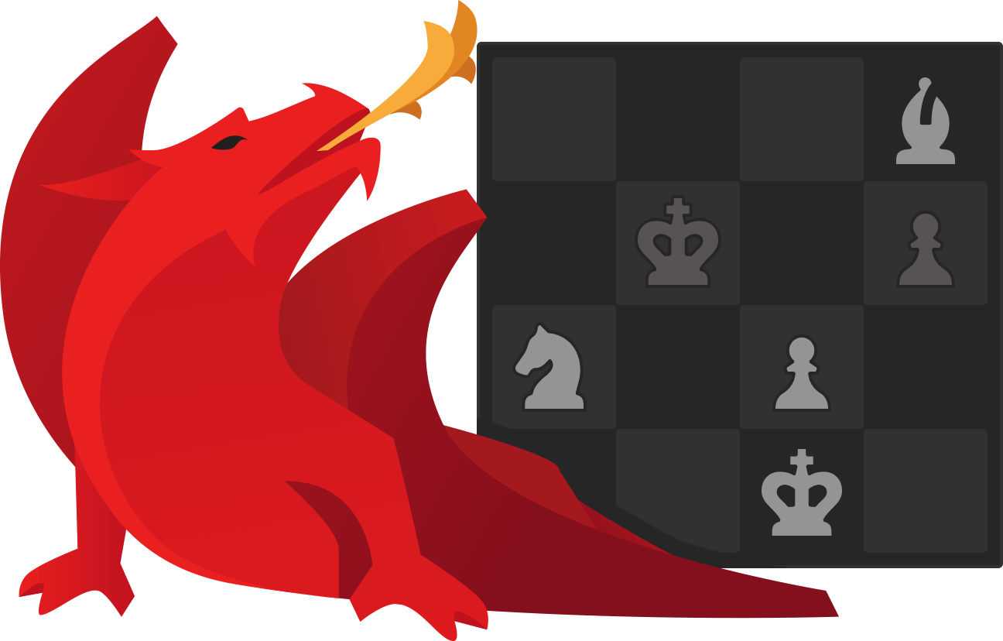

Overview:

Komodo Chess is a commercial chess engine developed by chess programmers Don Dailey and Mark Lefler. It’s widely recognised for its exceptional playing strength, frequently competing at the highest levels of computer chess tournaments. Komodo’s name, which means “dragon” in Japanese, reflects its fierce and competitive nature. It has a reputation for its deep positional understanding and efficient calculation of variations.

Key Features:

* High Playing Strength:
  + Komodo is one of the strongest chess engines globally, consistently ranking among the top engines in various computer chess rating lists. Its strength makes it an ideal opponent for both professional and amateur players.
* Multi-Platform Compatibility:
  + Komodo Chess is compatible with various operating systems, including Windows, MacOS, and Linux, ensuring accessibility for users with different computer setups.
* Multi-Core Support:
  + The engine efficiently utilises multiple processor cores, providing substantial performance improvements when running on modern multi-core machines. This allows for faster and deeper analysis.
* Innovative Evaluation:
  + Komodo is known for its innovative positional evaluation and understanding of chess positions. It excels in assessing the imbalances, weaknesses, and potential of a given position, contributing to stronger and more strategic gameplay.
* Dynamic Contempt:
  + Komodo includes a “dynamic contempt” feature that allows users to fine-tune the engine’s evaluation of drawn positions and its willingness to simplify or complicate the game. This customisation enhances its adaptability.
* Endgame Tablebases:
  + Komodo can access endgame tablebases, which are crucial for analysing endgame positions with a small number of pieces accurately. This is particularly valuable for studying complex endgames.
* UCI Support:
  + Komodo Chess adheres to the Universal Chess Interface (UCI), a standard protocol for chess engines. This makes it compatible with a wide range of chess interfaces, enabling users to play against the engine, analyse games, and study openings.
* Customisable Strength:
  + Users can adjust the engine’s strength by changing its playing style, time controls, and search settings. This feature allows players of all skill levels to find an appropriate level of challenge.
* Variation Trees:
  + Komodo offers comprehensive variation trees, which enable users to explore and analyse lines of play thoroughly. This is especially valuable for post-game analysis and opening preparation.
* Regular Updates:
  + The Komodo team provides regular updates to improve the engine’s performance, address bugs, and keep it competitive in the ever-evolving world of computer chess.

The features of this chess engine are far too complex and surpass the scope of my project. Therefore, I do not believe that it is realistic to implement these features in the short timeframe that I am allowed for this project. However, this research remains invaluable as it shows the depth and intricacies involved in developing a top-tier chess engine.



Overview:

Shredder Chess is a chess engine that has been in the industry for many years. Developed by Stefan Meyer-Kahlen, it has established a reputation for its strong chess-playing abilities and a range of features designed to assist and challenge players. Shredder Chess is available for various platforms, including Windows, MacOS, iOS, and Android, making it accessible to a broad user base.

Key Features:

* High Playing Strength:
  + Shredder Chess is well-regarded for its strong and competitive play. It has consistently ranked among the top chess engines in various computer chess rating lists, making it a formidable opponent for players of all skill levels.
* Multi-Platform Compatibility:
  + Shredder Chess is available for different operating systems, ensuring accessibility for users with various computing environments.
* Multi-Core Support:
  + The engine is optimised to utilise multiple processor cores efficiently, leading to improved performance and faster analysis when running on modern multi-core machines.
* User-Friendly Interface:
  + Shredder Chess provides a user-friendly and visually appealing graphical interface, making it accessible and enjoyable for players of all skill levels. This interface is a significant advantage for those who prefer a well-designed, interactive chess experience.
* Positional Understanding:
  + Shredder Chess is known for its strong positional evaluation, and it excels in understanding the strategic aspects of a chess position. This is particularly valuable for players looking to improve their chess strategy.
* Large Opening Book:
  + The engine comes with a substantial opening book, which is essential for opening preparation and learning. This opening book provides a wide range of well-known and respected openings.
* Endgame Tablebases:
  + Shredder Chess can access endgame tablebases, enabling accurate analysis of endgame positions with a limited number of pieces. This is particularly beneficial for understanding and improving endgame play.
* Customisable Strength:
  + Users can adjust the engine’s playing strength by configuring the difficulty level, time controls, and other settings. This allows players to find an appropriate challenge level or use Shredder Chess for learning and analysis.
* Analysis Mode:
  + Shredder Chess offers an analysis mode where it continuously evaluates positions and suggests moves, making it a valuable tool for post-game analysis and opening research.
* UCI and XBoard Support:
  + The engine supports the Universal Chess Interface (UCI) and XBoard protocols, enabling compatibility with a wide range of chess graphical user interfaces and applications.
* Regular Updates:
  + The Shredder Chess team provides regular updates to enhance performance, address issues, and maintain the engine’s competitiveness.

The features of this chess engine are far too complex and surpass the scope of my project. Therefore, I do not believe that it is realistic to implement these features in the short timeframe that I am allowed for this project. However, this research remains invaluable as it shows the depth and intricacies involved in developing a top-tier chess engine.



Overview:

Fritz, developed by ChessBase, is a versatile and popular chess engine that combines a powerful chess-playing program with a user-friendly graphical interface. It’s designed to cater to chess enthusiasts, whether they are beginners looking to learn or advanced players seeking a strong opponent for analysis and practice. Fritz has a history of strong tournament play and a reputation for its user-friendly features.

Key Features:

* High Playing Strength:
  + Fritz is known for its strong chess play and competitive strength. It is consistently among the top chess engines in various computer chess rating lists, making it a valuable opponent for players of all skill levels.
* User-Friendly Interface:
  + Fritz offers an intuitive and visually appealing graphical interface, making it accessible and enjoyable for players of all skill levels. The user interface provides features for analysing games, studying openings, and learning chess strategies.
* Multi-Platform Compatibility:
  + Fritz is available for various operating systems, including Windows and MacOS. This ensures accessibility for users with different computing environments.
* Multi-Core Support:
  + The engine is optimised to utilise multiple processor cores efficiently, leading to faster and deeper analysis, especially on modern multi-core machines.
* Positional Understanding:
  + Fritz is celebrated for its strong positional evaluation and understanding of the strategic aspects of chess positions. It provides valuable insights and guidance for players looking to improve their strategic thinking.
* Large Opening Book:
  + The engine is equipped with a substantial and well-curated opening book, offering a broad array of well-known openings for study and practice.
* Customisable Strength:
  + Users can adjust the engine’s playing strength by configuring the difficulty level, time controls, and other settings. This feature is useful for finding an appropriate challenge or for use in training and analysis.
* Endgame Tablebases:
  + Fritz can access endgame tablebases, which provide precise information on endgames with a limited number of pieces. This is invaluable for improving endgame play.
* Variation Trees:
  + The engine provides comprehensive variation trees, allowing users to navigate and analyse lines of play in-depth. This is especially useful for post-game analysis and opening research.
* Analysis Mode:
  + Fritz includes an analysis mode that continuously evaluates positions, offering suggestions for moves and improvements. This is a valuable tool for post-game analysis and study.
* Regular Updates:
  + ChessBase provides regular updates to Fritz, enhancing performance, addressing issues, and keeping the engine competitive in the ever-evolving world of computer chess.
* UCI and XBoard Support:
  + Fritz supports the Universal Chess Interface (UCI) and XBoard protocols, ensuring compatibility with various chess graphical user interfaces and applications.

The features of this chess engine are far too complex and surpass the scope of my project. Therefore, I do not believe that it is realistic to implement these features in the short timeframe that I am allowed for this project. However, this research remains invaluable as it shows the depth and intricacies involved in developing a top-tier chess engine.

AI Algorithms:

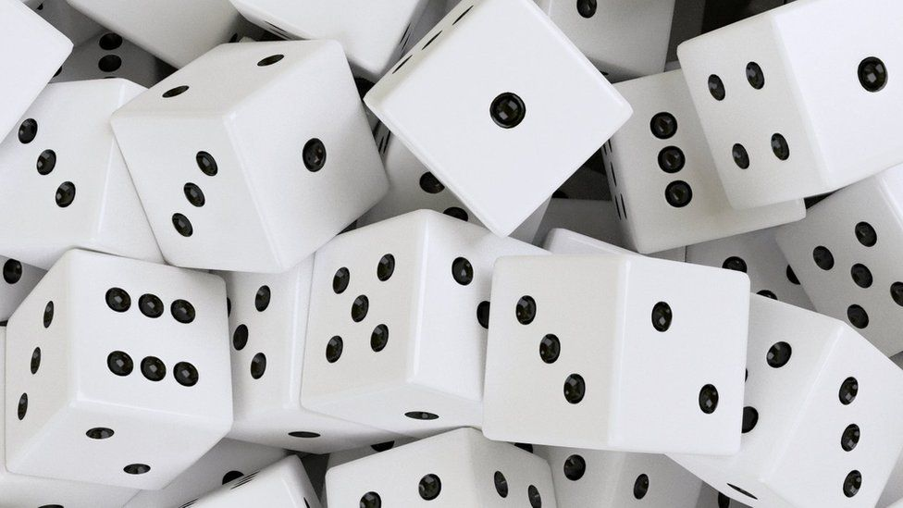

Overview:

The Random Move Algorithm is a simple method for selecting chess moves. It does not involve any evaluation of the position or consideration of long-term strategies. Instead, it randomly selects a move from the legal moves available to a player at a particular position. This approach is often used for educational purposes, as a basis for more sophisticated AI development, and to introduce randomness and unpredictability in chess analysis.

Key Features:

* Random Move Selection:
  + The primary feature of the Random Move Algorithm is its randomness. It selects a move without any regard for the position’s strategic or tactical considerations. This randomness is often used to introduce unpredictability and variability in chess analysis and AI behaviour.
* No Evaluation:
  + The Random Move Algorithm does not evaluate the current position, calculate tactics, or consider the long-term consequences of a move. It lacks the ability to make informed decisions based on positional factors.
* Educational Tool:
  + In educational settings, the Random Move Algorithm can be used to demonstrate the importance of strategy and tactical calculation in chess. It shows the stark contrast between random moves and moves made with purpose and understanding.
* Baseline for Testing:
  + Chess programmers and AI developers often use the Random Move Algorithm as a baseline to test and compare the performance of more sophisticated chess engines. It provides a reference point for evaluating the strength of other algorithms.
* Diversifying Analysis:
  + In chess analysis, introducing random moves into the analysis can help diversify the lines of play considered. This can be useful in exploring a broader range of possibilities and identifying unexpected tactics.
* Limited Practical Application:
  + While the Random Move Algorithm has value in educational and testing contexts, it has limited practical application in serious chess play. Random moves do not contribute to strategic or tactical success in chess games.
* Unpredictability:
  + Random moves can add an element of unpredictability to games or analysis, making it a fun addition to casual chess variants and puzzles.
* Simple to Implement:
  + The algorithm is straightforward to implement, making it a quick and easy method for generating random moves.
* No Long-Term Planning:
  + The Random Move Algorithm does not engage in long-term planning, and it doesn’t have the ability to consider a series of moves that lead to a particular strategic goal.
* Not Competitive:
  + In competitive chess, random moves are unlikely to result in a successful game. Strong chess play relies on evaluating positions, formulating strategies, and calculating tactics.

Given this AI algorithm’s simplicity and limited playing strength, I will integrate it into our chess engine software as the designated algorithm for the easy difficulty setting.



Overview:

The Greedy Algorithm is a fundamental algorithm used in chess to make decisions that appear to be the best at the current moment without considering the global, long-term consequences of each move. It often involves assigning values to pieces and squares and making moves that seem to maximise immediate gains, such as capturing an opponent’s piece or controlling an important square. However, the Greedy Algorithm may overlook more strategic or defensive considerations.

Key Features:

* Piece Valuation:
  + In a chess context, the Greedy Algorithm assigns values to chess pieces based on a simple evaluation system. For example, a queen might be assigned a higher value than a pawn, reflecting their relative importance. These values guide piece exchanges and capture decisions.
* Material Advantage:
  + The Greedy Algorithm often focuses on gaining material advantage. It prefers moves that capture an opponent’s piece without immediate tactical drawbacks, such as losing the capturing piece in the next move. This approach aims to accumulate a material lead.
* Controlling Key Squares:
  + The Greedy Algorithm may prioritise moves that control important squares on the chessboard, such as the center. By exerting control over key areas, it can influence the position’s dynamics.
* Fast Development:
  + In the opening phase of the game, the Greedy Algorithm may prioritise the rapid development of pieces, such as knights and bishops, even if it means temporarily neglecting pawn structure or safety considerations.
* Pawn Promotion:
  + In the endgame, the Greedy Algorithm often seeks to promote pawns to queens whenever possible, as queens are considered more valuable and powerful pieces.
* No Long-Term Planning:
  + A key characteristic of the Greedy Algorithm is its lack of long-term planning. It doesn’t consider future moves or the potential consequences of its decisions beyond the immediate tactical benefits.
* Vulnerability to Traps:
  + While the Greedy Algorithm is straightforward and can lead to quick tactical gains, it can also make a player vulnerable to traps, tactical blunders, and strategic weaknesses.
* Risks and Imbalances:
  + The Greedy Algorithm can lead to imbalanced positions, as it may prioritise material gains over maintaining a balanced position. This can result in open lines for the opponent and increased vulnerability.
* Simplistic and Fast:
  + The simplicity of the Greedy Algorithm makes it computationally efficient and easy to implement. It is often used for quick evaluations and in tactical puzzles.
* Teaching Tool:
  + In chess education, the Greedy Algorithm can serve as a teaching tool to help beginners understand the importance of piece value and tactics.

Given this AI algorithm’s slightly more intricate design and improved playing strength, I will integrate it into our chess engine software as the designated algorithm for the medium difficulty setting.

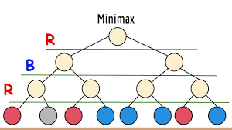

Overview:

The MinMax Algorithm is a decision-making algorithm that is particularly well-suited for two-player, zero-sum games like chess. It aims to determine the best move for a player by considering the potential consequences of each move, assuming the opponent makes optimal decisions to minimise the player’s gain (hence the name “MinMax”). In chess, this algorithm is used to evaluate different moves and select the move that leads to the most advantageous position for the player.

Key Features:

* Two-Player, Zero-Sum Game:
  + Chess is a two-player, zero-sum game, meaning one player’s gain is the other player’s loss. The MinMax Algorithm is designed for such games where the players have conflicting goals.
* Recursive Evaluation:
  + MinMax employs a recursive approach to evaluate chess positions. It generates a tree of possible moves and countermoves, evaluating each move’s consequence by recursively applying the algorithm. This process continues until a certain depth or terminal state is reached.
* Utility Function:
  + Chess positions are evaluated using a utility function that assigns a numerical value to a position. This function is based on factors like material balance, piece activity, king safety, and pawn structure. The utility function is key to assessing the desirability of positions.
* Alpha-Beta Pruning:
  + To improve the efficiency of the MinMax Algorithm, chess engines often use alpha-beta pruning. This technique cuts off branches of the move tree that are guaranteed to be worse than the best move found so far, significantly reducing the number of evaluations.
* Transposition Tables:
  + Chess engines use transposition tables to store and retrieve previously evaluated positions, reducing the need to re-evaluate identical positions in the move tree.
* Heuristic Evaluation:
  + Chess engines may use heuristics to estimate a position’s value without fully exploring all possible moves. These heuristics provide quick evaluations of positions, particularly useful when searching at greater depths.
* Quiescence Search:
  + Chess engines often incorporate a quiescence search to deal with sharp tactical positions. It extends the search when the position is highly dynamic and contains tactical threats.
* Selecting the Best Move:
  + The MinMax Algorithm selects the move with the highest evaluated utility value for the player when playing to maximise and the lowest utility value for the opponent when playing to minimise.
* Depth-Limited Search:
  + Due to the vast number of possible moves in chess, the MinMax Algorithm is typically applied to a limited depth in the move tree, beyond which positions are evaluated using the utility function. The depth can be adjusted based on available computational resources.
* Strength and Performance:
  + The strength of a chess engine using MinMax is determined by the depth to which it can search and the quality of its utility function. More advanced engines use additional techniques, such as deep neural networks, to enhance evaluation.
* Game Tree Complexity:
  + Chess has a high branching factor and is a complex game, making the MinMax Algorithm, while a fundamental concept, challenging to implement at high depths.

Given this AI algorithm’s much more complex design and much better playing strength, I may integrate it into our chess engine software as the designated algorithm for the hard difficulty setting.

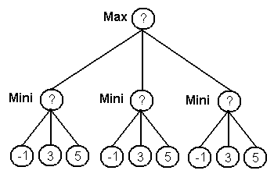

Overview:

The NegaMax Algorithm is designed to determine the best move for a player in a two-player, zero-sum game like chess. It simplifies the implementation of the MinMax Algorithm by unifying the roles of both players into a single function. The name “NegaMax” comes from the negation of the maximum value, as it aims to find the move with the maximum negated value. This negation effectively turns the maximising and minimising roles into a single operation, making the code more concise and easier to understand.

Key Features:

* Simplification of MinMax:
  + The primary feature of the NegaMax Algorithm is its simplification of the MinMax Algorithm. In the MinMax Algorithm, you typically have two functions: one for the maximising player (Max) and one for the minimising player (Min). NegaMax combines these two functions into a single function, reducing redundancy in the code.
* Negation:
  + NegaMax uses negation to switch between maximising and minimising players. When evaluating a move for the opponent, the algorithm negates the score, effectively transforming it into a score for the current player.
* Recursive Evaluation:
  + Like the MinMax Algorithm, NegaMax employs a recursive approach to evaluate chess positions. It generates a tree of possible moves and countermoves, evaluating each move’s consequence by recursively applying the algorithm. This process continues until a certain depth or terminal state is reached.
* Utility Function:
  + Chess positions are evaluated using a utility function that assigns a numerical value to a position. This function considers factors such as material balance, piece activity, king safety, and pawn structure.
* Alpha-Beta Pruning:
  + NegaMax can incorporate alpha-beta pruning, a technique that cuts off branches of the move tree that are guaranteed to be worse than the best move found so far, significantly reducing the number of evaluations.
* Transposition Tables:
  + Chess engines often use transposition tables with NegaMax to estimate a position’s value without fully exploring all possible moves. These heuristics provide quick evaluations of positions, especially when searching at greater depths.
* Heuristic Evaluation:
  + Chess engines may use heuristics with NegaMax to estimate a position’s value without fully exploring all possible moves. These heuristics provide quick evaluations of positions, especially when searching at greater depths.
* Selecting the Best Move:
  + The NegaMax Algorithm selects the move with the highest evaluated utility value for the current player when playing to maximise. The negation process during evaluation ensures that the best move corresponds to maximising the player’s score.
* Depth-Limited Search:
  + NegaMax, like the MinMax Algorithm, is applied to a limited depth in the move tree due to the vast number of possible moves in chess. The depth can be adjusted based on available computer resources.
* Strength and Performance:
  + The strength of a chess engine using NegaMax depends on the depth to which it can search and the quality of its utility function. More advanced engines use additional techniques, such as deep neural networks, to enhance evaluation.

This AI algorithm is similar in design to the last one (hence the namesake). The difference is, while both NegaMax and MinMax are used for game tree search and share similar principles, NegaMax simplifies the implementation by combining the maximising and minimising steps into a single function, making it easier to implement and understand. Therefore, this algorithm may also be integrated into our chess engine software as the designated algorithm for the hard difficulty setting. I will have to decide which one I want to use in the final product after testing.

## Essential features

List of essential features of my project based on research and stakeholder survey:

* Menu-Driven Interface:
  + Users will be able to navigate through a series of menus to interact with our chess engine software. These menus will allow our user to be able to sign up a new account or log into an already existing one. Upon logging in, they will be able to navigate through a main menu screen where they will be able to select to see the statistics menu screen or the difficulty menu screen. On the statistics menu screen, users will be able to see their number of wins, number of draws and number of losses. On the difficulty menu screen, users will be able to select between an easy difficulty setting, a medium difficulty setting, a hard difficulty setting or a local multiplayer setting for their chess game. Once a user has selected a difficulty setting, they will be taken to the game screen where they will be able to play a chess game. Once the game has finished, their statistics will update and they will be taken back to the main menu screen.
  + This feature is essential because it provides users with intuitive navigation and control over various features and settings. Through menus, users can effortlessly access functionalities like account management, game settings and their user statistics, enhancing their overall experience.
* User Account Management:
  + Users will be able to sign up a new account or log into an already existing one using our chess engine software. Each user account will store information about the user such as their username, password, number of wins, number of draws and number of losses. User account details will be securely stored in a database.
  + This feature is essential because it offers a personalised experience and fosters user engagement. By allowing users to create accounts and securely store their information, such as game statistics, the software enhances their sense of ownership and progression.
* Play Chess:
  + Users will be able to play chess using our chess engine software, engaging in challenging matches against computer opponents at various difficulty levels or enjoying multiplayer games with friends locally.
  + This feature is essential because it ensures that our chess engine software fulfils its primary function of delivering an immersive and enjoyable chess-playing experience for users.
* Local Multiplayer Mode:
  + Users will be able to use our chess engine software to play against friends and family through its local multiplayer mode feature, fostering lively face-to-face interactions and friendly competition in the comfort of their own homes.
  + This feature is essential because it enhances the social aspect of the software, bringing people together for interactive and engaging experiences. This feature not only promotes meaningful face-to-face interactions but also adds a dynamic and competitive element to the gameplay, making the chess experience more enjoyable and memorable for all involved.
* Single-Player Mode:
  + Users will be able to use our chess engine software to play against computer opponents through its single-player mode feature, offering a diverse range of difficulty levels to cater to players of varying abilities and preferences.
  + This feature is essential because it provides users with the opportunity to enjoy the game at their own pace and skill level, even when playing alone. Not everyone has access to human opponents at all times and a robust single-player mode ensures that users can always find a challenging and fulfilling chess experience.
* Difficulty Settings:
  + Users will be able to use our chess engine software to select various difficulty settings to play against our chess engine software’s computer opponents in its single-player mode feature, allowing users to tailor the level of challenge to their skill level and preferences, thereby ensuring a stimulating and rewarding experience for players of all abilities.
  + *Easy Difficulty:* This difficulty setting will use a random move algorithm to generate its moves. A random move algorithm is where the computer player selects its moves randomly from the set of all legal moves available in a given position. This algorithm does not consider any strategic or tactical considerations and does not aim to improve the position or search for optimal moves.
  + *Medium Difficulty:* This difficulty setting will use a greedy move algorithm to generate its moves. A greedy move algorithm is where the computer player prioritises immediate gains, such as capturing an opponent’s piece, without considering long-term consequences. This could potentially mean that it will overlook better moves that could result in a stronger overall position.
  + *Hard Difficulty:* This difficulty setting will use a NegaMax AI algorithm to generate its moves. A NegaMax algorithm is a recursive search algorithm used in artificial intelligence to find the best move for the computer player. It evaluates positions by assuming optimal play from both sides, alternating between maximising and minimising evaluation scores. It explores moves to a certain depth, selecting the move that maximises the computer player's advantage.
  + This feature is essential because it allows users to tailor their experience to their skill level and preferences, thereby ensuring an enjoyable and engaging gameplay experience for players of all abilities. By offering a range of difficulty levels, from easy to hard, users can gradually challenge themselves and improve their skills over time, while also providing options for more casual or more competitive gameplay.
* User Statistics:
  + Users will be able to use our chess engine software to see their user statistics, providing valuable insights into their performance and progression over time. This feature will display key metrics such as the user’s number of wins, draws, and losses, allowing users to track their success rate and evaluate their gameplay strategies.
  + This feature is essential because it allows users to monitor and analyse their gameplay performance, fostering a deeper understanding of their strengths and areas for improvement. By providing insights into key metrics such as wins, draws, and losses, users can track their progress over time and adapt their strategies accordingly.

## Limitations

List of limitations of my project based on research and stakeholder survey:

* Online Functionality:
  + Online functionality would require implementing network communication protocols, server infrastructure for matchmaking and game hosting and potentially anti-cheating measures. Therefore, I will not be including this feature in our chess engine software because I do not think it is realistic to implement in the short timeframe that I am allowed for this project.
  + This feature is a limitation because it restricts users from engaging in multiplayer matches. This means that users are limited to playing against computer opponents or against human opponents locally, thereby missing out on the dynamic and interactive experience of online gameplay.
* Computer Analysis:
  + Computer analysis would require implementing algorithms for post-game analysis, visualisation tools for displaying analysis results and potentially integration with third-party chess databases for reference. Therefore, I will not be including this feature in our chess engine software because I do not think it is realistic to implement in the short timeframe that I am allowed for this project.
  + This feature is a limitation because it deprives users of valuable insights and feedback on their gameplay. This means that users are unable to delve deeper into the strategic nuances of their moves or understand where they went wrong in their games.
* Chess Puzzles:
  + Chess puzzles would require generating a diverse set of puzzle positions, implementing a solution verification system and potentially integrating a scoring system to track user progress. Therefore, I will not be including this feature in our chess engine software because I do not think it is realistic to implement in the short timeframe that I am allowed for this project.
  + This feature is a limitation because it diminishes opportunities for users to engage in focused and interactive learning experiences. This means that users miss out on the chance to hone their skills in specific aspects of the game, such as mating patterns, tactics and endgame techniques.
* Daily Challenges:
  + Daily challenges would require designing a system for generating unique daily puzzles or scenarios, implementing a scheduling mechanism to deliver new challenges to users each day and potentially integrating a tracking system to record user progress over time. Therefore, I will not be including this feature in our chess engine software because I do not think it is realistic to implement in the short timeframe that I am allowed for this project.
  + This feature is a limitation because it deprives users of a dynamic and engaging way to enhance their chess skills and stay motivated. This means that users are unable to engage with fresh and varied puzzle scenarios on a regular basis which encourage consistent practice and skill development.
* Chess Learning:
  + Chess learning would require implementing a sophisticated algorithm for analysing user games and providing personalised feedback, integrating a user-friendly interface for presenting learning materials such as tutorials and annotated games and potentially incorporating machine learning techniques for adaptive learning. Therefore, I will not be including this feature in our chess engine software because I do not think it is realistic to implement in the short timeframe that I am allowed for this project.
  + This feature is a limitation because it hinders users’ opportunities for structured skill improvement and strategic understanding of the game. This means that users are unable to receive tailored guidance on their strengths and weaknesses or access instructional content to deepen their understanding of chess strategies.
* Customisation:
  + Customisation would require implementing features such as customisable piece sets, board themes and user preferences, as well as developing a flexible user interface for configuring these options. Therefore, I will not be including this feature in our chess engine software because I do not think it is realistic to implement in the short timeframe that I am allowed for this project.
  + This feature is a limitation because it restricts users from personalising their gaming experience to suit their preferences. This means that users are limited to a standard interface and aesthetic, potentially diminishing their overall satisfaction and engagement with the software.
* Self-Learning AI:
  + Self-learning AI would require the implementation of advanced machine learning algorithms such as reinforcement learning or deep learning, extensive training data collection and significant computational resources for training and fine-tuning the model. Additionally, it would involve developing mechanisms for the AI to learn from its own gameplay experiences and improve its decision making over time. Therefore, I will not be including this feature in our chess engine software because I do not think it is realistic to implement in the short timeframe that I am allowed for this project.
  + This feature is a limitation because it restricts the software's ability to adapt and improve over time based on gameplay experiences. This means that the software may struggle to keep pace with evolving gameplay trends and user strategies, potentially leading to stagnant gameplay experiences and diminishing user engagement.
* Mobile Application:
  + As shown in the pre-development stakeholder survey, the majority of our stakeholders would prefer a desktop application over a mobile application. Therefore, I will not be including this feature in our chess engine software.
  + This feature is a limitation because it restricts accessibility and convenience for users who prefer to play chess on mobile devices. This means that the software may fail to cater to the preferences of stakeholders who favour mobile platforms.

## Requirements

Device requirements:

* **Monitor:** A monitor is required to display the graphical user interface (GUI) of the chess engine software. The monitor provides the interface through which users interact with the chess engine, view the gamestate and make moves.
* **Mouse:** A mouse is required for navigating the graphical interface of the chess engine software. The mouse allows users to click on pieces to select and move them, making the gameplay intuitive and efficient.
* **Keyboard:** A keyboard is required for interacting with the login menu sequences of the chess engine software. The keyboard allows users to input their username and password so that they may sign up a new account or log into an already existing one.

Microsoft hardware requirements:

* **Operating System:** Windows 11 or latest release
* **Processor:** Intel Core i3 - Provides the minimum requirements for a processor to run the chess engine software.
* **Memory:** 4 GB - Provides the minimum requirements for memory to run the chess engine software.
* **Graphics Card:** Intel HD Graphics - Provides the minimum requirements for a graphics card to run the chess engine software.

MacOS hardware requirements:

* **Operating System:** MacOS 14 or latest release
* **Processor:** Intel Core i3 - Provides the minimum requirements for a processor to run the chess engine software.
* **Memory:** 4 GB - Provides the minimum requirements for memory to run the chess engine software.
* **Graphics Card:** Intel HD Graphics - Provides the minimum requirements for a graphics card to run the chess engine software.

Linux hardware requirements:

* **Operating System:** Ubuntu 23 or latest release
* **Processor:** Intel Core i3 - Provides the minimum requirements for a processor to run the chess engine software.
* **Memory:** 4 GB - Provides the minimum requirements for memory to run the chess engine software.
* **Graphics Card:** Intel HD Graphics - Provides the minimum requirements for a graphics card to run the chess engine software.

Software requirements:

* In order to run my project you will need to install the latest version of Python. This is because Python is the programming language used to develop the chess engine software.
* In order to run my project you will need to install the latest version of Visual Studio Code. This is because Visual Studio Code is the integrated development environment (IDE) used to develop the chess engine software.
* In order to run my project you will need to install the latest version of the PyGame library. This is because PyGame is the library used to develop the chess engine software and it is not included in the installation of the programming language Python.

## Success criteria

Success criteria for my project:

* Sign Up Feature:
  + Users will be able to sign up for a new account with our chess engine software.
  + This can be used as a success criteria because it allows us to be able track if our chess engine software facilitates the ability to create accounts for users.
* Login Feature:
  + Users will be able to log into an already existing account with our chess engine software.
  + This can be used as a success criteria because it allows us to be able track if our chess engine software facilitates the ability to log into already existing accounts.
* Main Menu Screen:
  + Users will be able to access a main menu screen where they can select to see their statistics or play a new chess game.
  + This can be used as a success criteria because it allows us to be able to track if users are able to engage with the core functionalities of the software such as being able to check their statistics or play a new chess game.
* Statistics Menu Screen:
  + Users will be able to access a statistics menu screen where they will be able to see their current number of wins, draws and losses.
  + This can be used as a success criteria because it allows us to be able to track if our chess engine software facilitates the ability for users to be able to view their current statistics.
* Difficulty Menu Screen:
  + Users will be able to select to play against a computer opponent (single-player mode) or against friends and family locally (local multiplayer mode).
  + This can be used as a success criteria because it allows us to be able to track if our chess engine software facilitates the ability for users to be able to pick what mode they want to play in and what difficulty setting they want to play in.
* Local Multiplayer Mode:
  + Users will be able to play against friends and family locally on the same device.
  + This can be used as a success criteria because it allows us to be able to track if our chess engine software facilitates the ability for users to be able to play a game of chess locally on the same device with a human opponent.
* Single-Player Mode:
  + Users will be able to play against computer opponents. These computer opponents will have three difficulty settings: an easy difficulty, a medium difficulty and a hard difficulty.
  + This can be used as a success criteria because it allows us to be able to track if our chess engine software facilitates the ability for users to be able to play a game of chess with a computer opponent at their preferred difficulty setting.
* Difficulty Settings:
  + Easy Difficulty: This difficulty setting will use a random move algorithm to generate its moves.
  + This can be used as a success criteria because it allows us to be able to track if our chess engine software facilitates the ability for users to be able to play a game of chess with a computer opponent at the easy difficulty setting against a random move algorithm.
  + Medium Difficulty: This difficulty setting will use a greedy move algorithm to generate its moves.
  + This can be used as a success criteria because it allows us to be able to track if our chess engine software facilitates the ability for users to be able to play a game of chess with a computer opponent at the medium difficulty setting against a greedy move algorithm.
  + Hard Difficulty: This difficulty setting will use a NegaMax AI algorithm to generate its moves.
  + This can be used as a success criteria because it allows us to be able to track if our chess engine software facilitates the ability for users to be able to play a game of chess with a computer opponent at the hard difficulty setting against a NegaMax AI algorithm.
* Game Screen:
  + Users will be able to access a game screen where they will be able to play a full game of chess that adheres to official chess rules.
  + This can be used as a success criteria because it allows us to be able to track if our chess engine software facilitates the ability for users to be able to play a game of chess.
* User Statistics:
  + Users will be able to track their progress by the chess engine software’s capability to update and save user statistics such as their number of wins, draws and losses.
  + This can be used as a success criteria because it allows us to be able to track if our chess engine software facilitates the ability for our user statistics to be updated after a game of chess has been played.

# Design

## Breaking the problem down

Overview:

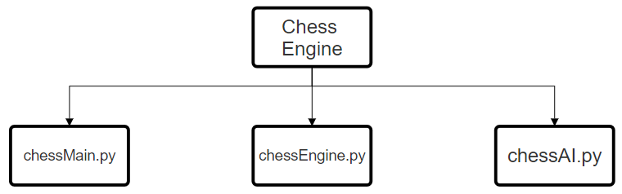

Initially, I’ve decomposed the overall problem into three distinct Python files, each dedicated to managing their own specific modules with unique purposes and responsibilities, crucial for the smooth operation of the chess engine application. While consolidating everything into a single file could be possible, I have chosen to adopt a more structured method here. I made this decision because I believe that a unified file could result in a disorderly and unorganised solution, which could potentially cause complications during debugging. By organising the code in this manner, I gain the advantage of being able to pinpoint the source of any errors that may arise, making it more efficient and easier to resolve these issues in future development cycles.

Our chessMain.py file will be in charge of handling user input, displaying our chess engine’s graphics as well as handling our menu system and login system.

Our chessEngine.py file will be in charge of running our chess engine. It will store the board (game state) and generate all possible moves on the board then filter these moves into just the valid set of moves. It will also allow the user to be able to undo moves.

Our chessAI.py file will be in charge of the chess engine’s AI move-finding algorithms. My chess engine will make use of a random move algorithm, a greedy move algorithm and a negamax move algorithm. I will use the random move algorithm for an easy mode, the greedy move algorithm for a medium mode and the negamax move algorithm for a hard mode.

That said, let’s break down our chessMain.py file:

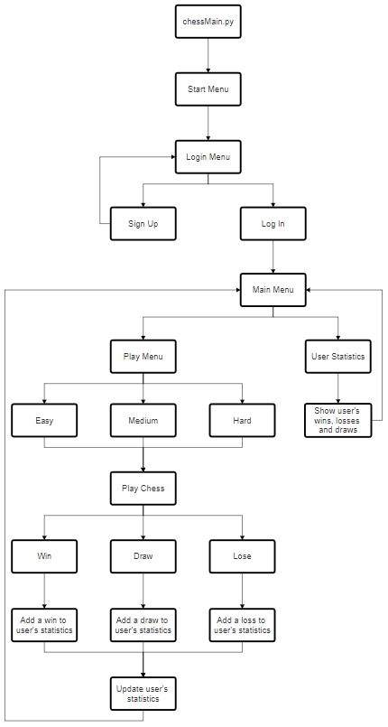

Our chessMain.py file will be where all the main user input handling will occur. In the final product, our user will first be introduced to the start menu screen. Here, they will be greeted with the game title, a start button and a quit button:

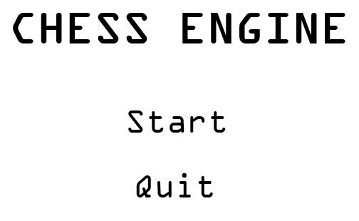

Upon clicking on the quit button, the user will quit the application. When they click the start button, the user will be taken to the login menu screen. Here, the user will be given the option to log in or sign up:

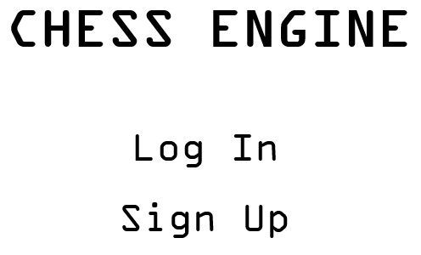

When they click the “Sign Up” button, the user will be taken to the sign up screen:

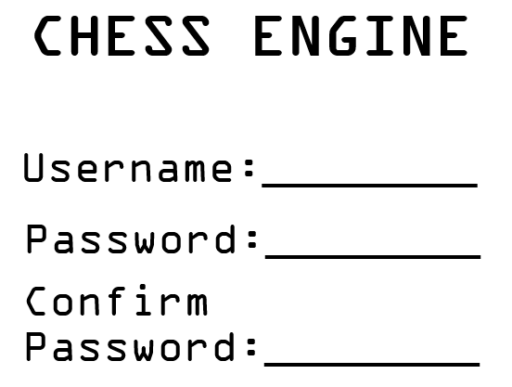

Upon clicking the “Log In” button, the user will be taken to the log in screen:

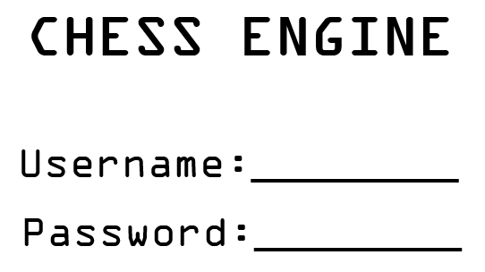

The user’s login and data will be stored on an SQLITE database and kept secure by using a hashing algorithm to store the password.

Once the user has signed up they will be taken to the log in screen.

Once the user has logged in they will be taken to the main menu screen where they will have a play button and a stats button:

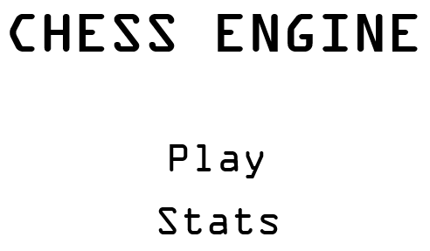

Upon clicking the stats button, they will be taken to a page where their statistics, such as their wins, losses and draws, will be displayed. They will also have a back button available which takes them back to the main menu screen:

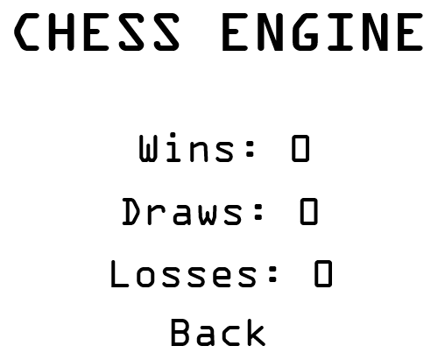

When they click the play button, the user will then be prompted to pick a difficulty:

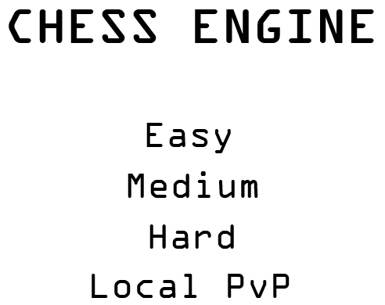

Finally, once the user has selected a difficulty they will then be able to play a game of chess at that difficulty to completion:

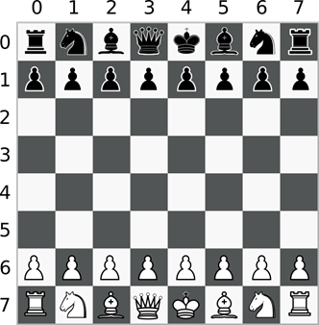

The user will be able to click on a piece to move it and the computer or another player will make a move back until the game reaches a checkmate or stalemate.

In any case of a user’s win, loss or draw, their statistics will be updated to the local SQLITE database and stored accordingly.

The user will then be taken back to the main menu screen.

Next, let’s break down our chessEngine.py file:

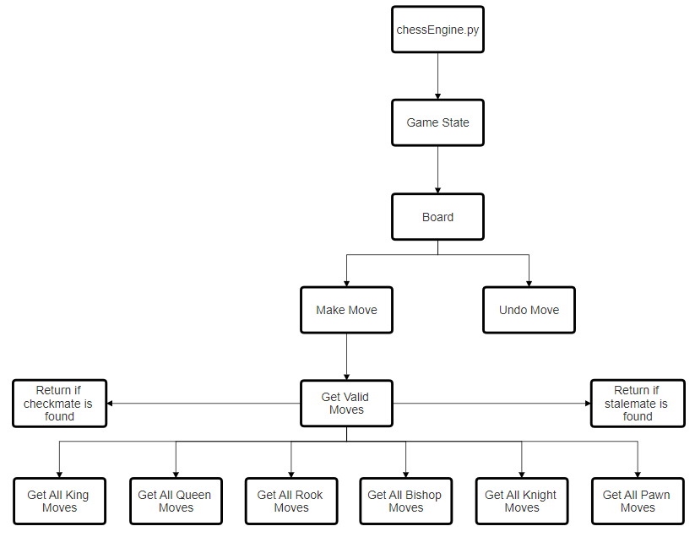

Our chessEngine.py file will be where most of the application’s backend processing will occur. The chess game in play will be stored in a class called gameState. I will be using a class because object-oriented programming makes organising the chess engine’s code much easier and modular. An attribute of this class will be the chessboard which will be represented using a 2D array. The 2D array will have 8 rows and 8 columns, just like a real chessboard and the pieces and empty spaces on the board will be represented using strings inside the 2D array corresponding to their position on the board. The gameState class will also have many methods, including a makeMove method and an undoMove method. A move will be represented using a separate class which takes the following arguments: a start square, an end square and the current board state. The makeMove method and undoMove method will take an object of this class as an argument and respectively either make the move or undo the move. For us to be able to make a move, we first need to generate a list of all possible moves on the board at a given time. To do this, we’re going to have methods in the game state class for getting all the king, queen, rook, bishop, knight and pawn moves possible. We then generate a list of all valid moves by taking these moves and passing them through another method which will filter out any invalid moves and return a list of only the valid moves available on the board. If the size of this list is 0 then we know that it is either checkmate or stalemate. We can then find out if it is a checkmate if either of the kings are in check. If not, then it must be a stalemate. We’ll know which player has won by checking who’s turn it is when the game ends.

Finally, let’s break down our chessAI.py file:

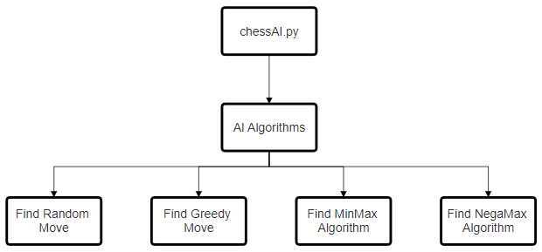

Our chess engine will make use of 3 different AI algorithms corresponding to three different difficulty levels (easy, medium and hard). However, for the purpose of testing I will be experimenting with four different algorithms instead. I will be talking about these algorithms in much more detail in the algorithms section but I will quickly introduce them now. The “Random Move” algorithm will take a list and return a totally random move from a list of valid moves available and play it. This will be the easiest difficulty to play against. The “Greedy Move” algorithm will take a list of valid moves and the current game state in order to assess and determine which move will result in the most amount of gain for the AI at that time. If it cannot find a best move then it will return a random one. This is the second easiest difficulty to play against. The “MinMax'' algorithm will return the best move available to the AI given a gamestate and a list of valid moves. It will also look a set amount of moves ahead, determined by the depth we give this algorithm. It will then analyse this information and determine the best possible move available given the outcomes it has analysed for the AI. The “NegaMax” algorithm is a variant form of the “MinMax” algorithm, the difference being that “NegaMax” is essentially just a more simplified version of “MinMax”. This explanation will make more sense once I cover the algorithms in more detail in the upcoming algorithm section.

## Usability features

Usability features refer to aspects of our software design that enhance the user’s experience and make it more intuitive, efficient and enjoyable for our users to interact with our chess engine application.

Our chess engine application will adopt a sleek and minimalistic black and white colour scheme, reminiscent of a traditional real life chessboard’s colour scheme. This is because I believe that this will make our chess engine more intuitive and enjoyable for our users to interact with.

Firstly, we’ll go through our start menu screen:



Here, our screen will display our start menu screen’s title text at the top of the screen. This title text will display the words “CHESS ENGINE” in bold which will be the name of our chess engine application. This is because I believe that this eye-catching text makes it very clear what the purpose of our application is to the user from the start. Below our title text, our start menu screen’s start button will be displayed. This button will display the word “Start”. This is because I believe that it makes it very clear that the purpose of this button is to start our chess engine application and send our user to the next screen, the login menu screen, when it is left clicked on by our user. Below our start button, our start menu screen’s quit button will be displayed. This button will display the word “Quit”. This is because I believe that it makes it very clear that the purpose of this button is to close our chess engine application when it is left clicked on by our user. If the user clicks on anything that is not a button, nothing will happen. The start menu screen should display until either button is left clicked on.

Next, we’ll go through our login menu screen:



Here, our screen will display our login menu screen’s title text at the top of the screen. This title text will display the words “CHESS ENGINE” in bold which will be the name of our chess engine application. This is because I believe that this eye-catching text makes it very clear what the purpose of our application is to the user from the start. Below our title text, our login menu screen’s log in button will be displayed. This button will display the words “Log In”. This is because I believe that it makes it very clear that the purpose of this button is to send our user to the log in screen when it is left clicked on by our user. Below our log in button, our login menu screen’s sign up button will be displayed. This button will display the words “Sign Up”. This is because I believe that it makes it very clear that the purpose of this button is to send our user to the sign up screen when it is left clicked on by our user. If the user clicks on anything that is not a button, nothing will happen. The login menu screen should display until either button is left clicked on.

Next, we’ll go through our sign up screen:



Here, our screen will display our sign up screen’s title text at the top of the screen. This title text will display the words “CHESS ENGINE” in bold which will be the name of our chess engine application. This is because I believe that this eye-catching text makes it very clear what the purpose of our application is to the user from the start. Below our title text, our sign up screen’s username input will be displayed. This input will display the word “Username” with an input field next to it. This is because I believe that it makes it very clear that the purpose of this input is to receive our user’s username that they want to use to sign up to our chess engine application. If the user clicks on the input field it will select it and allow them to be able to enter their username. Below our username input, our sign up screen’s password input will be displayed. This input will display the word “Password” with an input field next to it. This is because I believe that it makes it very clear that the purpose of this input is to receive our user’s password that they want to use to sign up to our chess engine application. If the user clicks on the input field it will select it and allow them to be able to enter their password. Below our password input, our sign up screen’s password confirmation input will be displayed. This input will display the words “Confirm Password” with an input field next to it. This is because I believe that it makes it very clear that the purpose of this input is to receive our user’s password confirmation that they want to use to sign up to our chess engine application. If the user clicks on the input field it will select it and allow them to be able to enter their password confirmation. If the user presses the enter key on their keyboard their entered username, password and password confirmation will be used to sign them up to our chess engine application. If this process is successful, then our user will be sent to our log in screen. If the user clicks on anything that is not an input field, nothing will happen. The sign up screen should display until our user has been successfully signed up.

Next, we’ll go through our log in screen:



Here, our screen will display our log in screen’s title text at the top of the screen. This title text will display the words “CHESS ENGINE” in bold which will be the name of our chess engine application. This is because I believe that this eye-catching text makes it very clear what the purpose of our application is to the user from the start. Below our title text, our log in screen’s username input will be displayed. This input will display the word “Username” with an input field next to it. This is because I believe that it makes it very clear that the purpose of this input is to receive our user’s username that they want to use to log in to our chess engine application. If the user clicks on the input field it will select it and allow them to be able to enter their username. Below our username input, our log in screen’s password input will be displayed. This input will display the word “Password” with an input field next to it. This is because I believe that it makes it very clear that the purpose of this input is to receive our user’s password that they want to use to log in to our chess engine application. If the user clicks on the input field it will select it and allow them to be able to enter their password. If the user presses the enter key on their keyboard their entered username and password will be used to log them in to our chess engine application. If this process is successful, then our user will be sent to our main menu screen. If the user clicks on anything that is not an input field, nothing will happen. The log in screen should display until our user has been successfully logged in.

Next, we’ll go through our main menu screen:



Here, our screen will display our main menu screen’s title text at the top of the screen. This title text will display the words “CHESS ENGINE” in bold which will be the name of our chess engine application. This is because I believe that this eye-catching text makes it very clear what the purpose of our application is to the user from the start. Below our title text, our main menu screen’s play button will be displayed. This button will display the word “Play”. This is because I believe that it makes it very clear that the purpose of this button is to send our user to the difficulty menu screen to choose a difficulty to play a chess game when it is left clicked on by our user. Below our play button, our main menu screen’s stats button will be displayed. This button will display the word “Stats”. This is because I believe that it makes it very clear that the purpose of this button is to send our user to the statistics menu screen to look at their saved wins, draws and losses when it is left clicked on by our user. If the user clicks on anything that is not a button, nothing will happen. The main menu screen should display until either button is left clicked on.

Next, we’ll go through our statistics menu screen:



Here, our screen will display our statistics menu screen’s title text at the top of the screen. This title text will display the words “CHESS ENGINE” in bold which will be the name of our chess engine application. This is because I believe that this eye-catching text makes it very clear what the purpose of our application is to the user from the start. Below our title text, our statistics menu screen’s wins text will be displayed. This text will display the word “Wins” followed by our user’s number of wins. This is because I believe that this text makes it very clear how many wins our user has. Below our wins text, our statistics menu screen’s draws text will be displayed. This text will display the word “Draws” followed by our user’s number of draws. This is because I believe that this text makes it very clear how many draws our user has. Below our draws text, our statistics menu screen’s losses text will be displayed. This text will display the word “Losses” followed by our user’s number of losses. This is because I believe that this text makes it very clear how many losses our user has. Below our losses text, our statistics menu screen’s back button will be displayed. This button will display the word “Back”. This is because I believe that it makes it very clear that the purpose of this button is to send our user back to the main menu screen when it is left clicked on by our user. If the user clicks on anything that is not the back button, nothing will happen. The statistics menu screen should display until the back button is left clicked on.

Next, we’ll go through our difficulty menu screen:



Here, our screen will display our difficulty menu screen’s title text at the top of the screen. This title text will display the words “CHESS ENGINE” in bold which will be the name of our chess engine application. This is because I believe that this eye-catching text makes it very clear what the purpose of our application is to the user from the start. Below our title text, our difficulty menu’s easy button will be displayed. This button will display the word “Easy”. This is because I believe that it makes it very clear that the purpose of this button is to send our user to the main procedure screen on easy settings when it is left clicked on by our user. Below our easy button, our difficulty menu’s medium button will be displayed. This button will display the word “Medium”. This is because I believe that it makes it very clear that the purpose of this button is to send our user to the main procedure screen on medium settings when it is left clicked on by our user. Below our medium button, our difficulty menu’s hard button will be displayed. This button will display the word “Hard”. This is because I believe that it makes it very clear that the purpose of this button is to send our user to the main procedure screen on hard settings when it is left clicked on by our user. Below our hard button, our difficulty menu’s local button will be displayed. This button will display the words “Local PvP”. This is because I believe that it makes it very clear that the purpose of this button is to send our user to the main procedure screen on local PvP settings when it is left clicked on by our user. If the user clicks on anything that is not a button, nothing will happen. The difficulty menu screen should display until any of the buttons have been left clicked on.

Next, we’ll go through our main procedure screen:



Here, our screen will display our chessboard on the screen. It will display as a chequered pattern of black and white squares with our chess pieces on top of them. This is because I believe that a black and white colour scheme would be reminiscent of a traditional chessboard’s colour scheme, allowing our chess engine application to be more intuitive and enjoyable for our user to interact with. At the start of the game, the chessboard will be set up with our white pieces at the bottom of the screen and our black pieces at the top of the screen. This is because I believe that this makes it very clear to the user that they will be playing white and are meant to make the first move. The pieces will be set up just as the pieces on a traditional chessboard would be with rook pieces on either end of the board, after that our knight pieces on either end, after that our bishop pieces on either end, after that our queen piece on the left hand side, after that our king piece on the right hand side and, finally, after that a row of pawns in front. This is because I want our chess engine application to be able to mimic real life games of chess in order to make it as intuitive and enjoyable to use as possible for our user.

A pawn piece will be able to move forward one square but will be able to optionally move two squares forward on its first move. It will also only be able to capture pieces diagonally. A rook piece will be able to move horizontally or vertically any number of squares. A knight piece will be able to move in an L shape, two squares in one direction followed by one square perpendicular to that direction. It will also be able to jump over other pieces. A bishop piece will be able to move diagonally any number of squares. A queen piece will be able to move horizontally, vertically or diagonally any number of squares. A king piece will be able to move one square in any direction as long as it will not move into check (a check is when the king is under immediate threat of capture by an opponent's piece). This is because this is just as a traditional game of chess is played, allowing our chess engine application to be as intuitive and easy to use as possible for our user.

To make the first move, our user will be able to left click on one of their white pieces to select them. They will then be allowed to make a second click which will either make the move if it is a valid move or it will deselect the piece if it is not a valid move. If our user wants to select a different piece to move, they can click on the new piece that they want to move. This is because I believe that this system of handling how our moves are made by our user is the most intuitive and easy to use approach for our user. After white has played the first move, black will be allowed to make a move. If the user has chosen to play on easy settings in the difficulty menu screen then a random move will be made by our chess engine. If the user has chosen to play on medium settings in the difficulty menu screen then the greediest move possible will be made by our chess engine. If the user has chosen to play on hard settings in the difficulty menu screen then the best move possible will be made by our chess engine. If the user has chosen to play on local PvP settings then black will be able to make clicks on the screen, in the same way white was able to, in order to make a move. This is because I believe that this system of handling how our moves are made by our user’s opponent is the most intuitive and easy to use approach for our user. Additionally, either player will be able to press the z key on their keyboard to undo the last move that was made on the chessboard. This is because I believe that this will make our chess engine application as intuitive and easy to use as possible for our user.

This process of turn taking will then continue until our chess engine has calculated that either a checkmate or a stalemate has occurred. If a stalemate has occurred, then our user has drawn the game and our draw text will appear on the screen as well as our end game button:

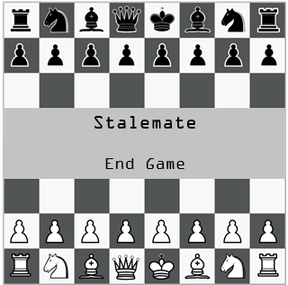

Here, our screen will display our draw text which will display the word “Stalemate”. This is because I believe that this text makes it very clear that our user has drawn the game. Below our draw text, our screen will display our end game button. This button will display the words “End Game”. This is because I believe that it makes it very clear that the purpose of this button is to update our user’s statistics according to the outcome of the chess game and send our user to the main menu screen when it is left clicked on by our user. If the user clicks on anything that is not a button, nothing will happen. This screen should display until the end game button is left clicked on or our user undoes the last move that was made on the chessboard by pressing the z key on their keyboard.

If a checkmate has occurred and it is currently white’s turn to move, then our user has lost the game and our loss text will appear on the screen as well as our end game button:

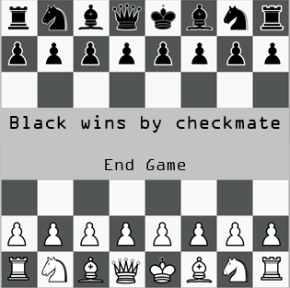

Here, our screen will display our loss text which will display the words “Black wins by checkmate”. This is because I believe that this text makes it very clear that our user has lost the game. Below our loss text, our screen will display our end game button. This button will display the words “End Game”. This is because I believe that it makes it very clear that the purpose of this button is to update our user’s statistics according to the outcome of the chess game and send our user to the main menu screen when it is left clicked on by our user. If the user clicks on anything that is not a button, nothing will happen. This screen should display until the end game button is left clicked on or our user undoes the last move that was made on the chessboard by pressing the z key on their keyboard.

If a checkmate has occurred and it is currently black’s turn to move, then our user has won the game and our win text will appear on the screen as well as our end game button:

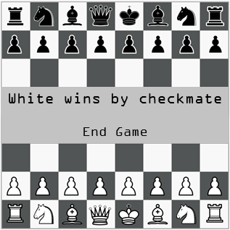

Here, our screen will display our win text which will display the words “White wins by checkmate”. This is because I believe that this text makes it very clear that our user has won the game. Below our win text, our screen will display our end game button. This button will display the words “End Game”. This is because I believe that it makes it very clear that the purpose of this button is to update our user’s statistics according to the outcome of the chess game and send our user to the main menu screen when it is left clicked on by our user. If the user clicks on anything that is not a button, nothing will happen. This screen should display until the end game button is left clicked on or our user undoes the last move that was made on the chessboard by pressing the z key on their keyboard.

## Algorithms

First, we’ll start with the algorithms we’ll be using in chessMain.py.

Start menu screen algorithm:

|  |
| --- |
| //start menu procedure  PROCEDURE startMenu():  startMenu = True //flag variable for while loop  screen.changeColour("White") //makes the screen white  WHILE startMenu: //start while loop  MENU_MOUSE_POS = playerMouse.getPos() //grabs the user's current mouse position  TITLE_TEXT = screen.Text(position=(375, 100), textInput="Chess Engine", fontStyle=("Calibri", 100), textColour="Black") //display main title text at the top  START_BUTTON = screen.Button(position=(375, 250), textInput="Start", fontStyle=("Calibri", 75), textColour="Black") //display start button below main title text  QUIT_BUTTON = screen.Button(position=(375, 350), textInput="Quit", fontStyle=("Calibri", 75), textColour="Black) //display quit button below below start button    FOR event IN screen.Event.Get(): //loop through events  IF event == Key.LEFTMOUSEBUTTONDOWN: //if a user has clicked their left mouse button  IF START_BUTTON.checkForInput(MENU_MOUSE_POS): //check if they clicked on the start button  startMenu = False //turn flag variable off  loginMenu() //send user to login menu  ENDIF  IF QUIT_BUTTON.checkForInput(MENU_MOUSE_POS): //check if they clicked on the start button  startMenu = False //turn flag variable off  system.exit() //close the application  ENDIF  ENDIF  NEXT event  ENDWHILE  ENDPROCEDURE |

This procedure will be the procedure that will be called when the chess engine application is run. Line 3 creates a flag variable called startMenu which controls our while loop. A flag variable is a variable which holds a boolean value and is used to control the flow of a function. In order for our while loop to run, we must initially set this variable to True. Line 4 makes the user’s screen turn white. This gives the illusion of a new blank screen appearing. Line 6 marks the start of our while loop. Line 7 grabs the user’s current mouse position and stores it in a variable called MENU_MOUSE_POS. This line runs at the start of every iteration of our while loop. This will be how we check where our user is clicking when they click. Line 9 creates a Text object that is placed on the screen at the (x, y) positions of (375, 100), displaying the text “Chess Engine”, with a font style of Calibri, font size of 100 and text colour of black. Line 11 creates a Button object that is placed on the screen at the (x, y) positions of (375, 250), displaying the text “Start”, with a font style of Calibri, font size of 75 and text colour of black. Line 12 creates a Button object that is placed on the screen at the (x, y) positions of (375, 350), displaying the text “Quit”, with a font style of Calibri, font size of 75 and text colour of black. Line 14 marks the start of our event handler for loop. This for loop will go through any user event that it catches and then run the code that is inside it. A user event can include any user input meaning any type of click or movement from a mouse or keyboard button press. Once it catches an event, line 15 checks if the type of event is a left button mouse click. If it isn’t then our code will skip to the next iteration of the for loop. If it is then it will run lines 16-23. Line 16 checks if the START_BUTTON has been clicked by the user by running the checkForInput() method of the button and passing the MENU_MOUSE_POS of the user as an argument. This method takes a mouse position and decides if it is colliding with the button or not. If it has been clicked, then the startMenu flag variable will be turned off (line 17) and the user will be sent to the login menu (line 18). Line 20 checks if the QUIT_BUTTON has been clicked by the user by running the checkForInput() method of the button and passing the MENU_MOUSE_POS of the user as an argument. If it has been clicked, then the startMenu flag variable will be turned off (line 21) and the user will have their application closed down (line 22). If neither of these buttons have been clicked then nothing will happen. After this, the next event in the list of events that have been caught will be processed until they have all been processed. After they have all been processed, the while loop will start again from the beginning.

Login menu screen algorithm:

|  |
| --- |
| //login menu procedure  PROCEDURE loginMenu():  loginMenu = True //flag variable for while loop  screen.changeColour("White") //makes the screen white  WHILE loginMenu: //start while loop  MENU_MOUSE_POS = playerMouse.getPos() //grabs the user's current mouse position  TITLE_TEXT = screen.Text(position=(375, 100), textInput="Chess Engine", fontStyle=("Calibri", 100), textColour="Black") //display main title text at the top  LOGIN_BUTTON = screen.Button(position=(375, 250), textInput="Log In", fontStyle=("Calibri", 75), textColour="Black") //display log in button below main title text  SIGNUP_BUTTON = screen.Button(position=(375, 350), textInput="Sign Up", fontStyle=("Calibri", 75), textColour="Black") //display sign up button below log in button  FOR event IN screen.Event.Get(): //loop through events  IF event == Key.LEFTMOUSEBUTTONDOWN: //if a user has clicked their left mouse button  IF LOGIN_BUTTON.checkForInput(MENU_MOUSE_POS): //check if they clicked on the log in button  loginMenu = False //turn flag variable off  logIn() //send user to log in  ENDIF  IF SIGNUP_BUTTON.checkForInput(MENU_MOUSE_POS): //check if they clicked on the sign up button  loginMenu = False //turn flag variable off  signUp() //send user to sign up  ENDIF  ENDIF  NEXT event  ENDWHILE  ENDPROCEDURE |

This procedure will be the procedure that will be called when the user clicks on the START_BUTTON in our start menu procedure. Line 3 creates a flag variable called loginMenu which controls our while loop. A flag variable is a variable which holds a boolean value and is used to control the flow of a function. In order for our while loop to run, we must initially set this variable to True. Line 4 makes the user’s screen turn white. This gives the illusion of a new blank screen appearing. Line 6 marks the start of our while loop. Line 7 grabs the user’s current mouse position and stores it in a variable called MENU_MOUSE_POS. This line runs at the start of every iteration of our while loop. This will be how we check where our user is clicking when they click. Line 9 creates a Text object that is placed on the screen at the (x, y) positions of (375, 100), displaying the text “Chess Engine”, with a font style of Calibri, font size of 100 and text colour of black. Line 11 creates a Button object that is placed on the screen at the (x, y) positions of (375, 250), displaying the text “Log In”, with a font style of Calibri, font size of 75 and text colour of black. Line 12 creates a Button object that is placed on the screen at the (x, y) positions of (375, 350), displaying the text “Sign Up”, with a font style of Calibri, font size of 75 and text colour of black. Line 14 marks the start of our event handler for loop. This for loop will go through any user event that it catches and then run the code that is inside it. A user event can include any user input meaning any type of click or movement from a mouse or keyboard button press. Once it catches an event, line 15 checks if the type of event is a left button mouse click. If it isn’t then our code will skip to the next iteration of the for loop. If it is then it will run lines 16-23. Line 16 checks if the LOGIN_BUTTON has been clicked by the user by running the checkForInput() method of the button and passing the MENU_MOUSE_POS of the user as an argument. This method takes a mouse position and decides if it is colliding with the button or not. If it has been clicked, then the loginMenu flag variable will be turned off (line 17) and the user will be sent to the log in screen (line 18). Line 20 checks if the SIGNUP_BUTTON has been clicked by the user by running the checkForInput() method of the button and passing the MENU_MOUSE_POS of the user as an argument. If it has been clicked, then the loginMenu flag variable will be turned off (line 21) and the user will be sent to the sign up screen (line 22). If neither of these buttons have been clicked then nothing will happen. After this, the next event in the list of events that have been caught will be processed until they have all been processed. After they have all been processed, the while loop will start again from the beginning.

Sign up screen algorithm:

|  |
| --- |
| //sign up screen procedure  PROCEDURE signUp():  signUp = True //flag variable for while loop  screen.changeColour("White") //makes the screen white  WHILE signUp: //start while loop  MENU_MOUSE_POS = playerMouse.getPos() //grabs the user's current mouse position  TITLE_TEXT = screen.Text(position=(375, 100), textInput="Chess Engine", fontStyle=("Calibri", 100), textColour="Black") //display main title text at the top  USERNAME_TEXT = screen.Text(position=(175, 250), textInput="Username", fontStyle=("Calibri", 75), textColour="Black") //display username text next to username input box  USERNAME_INPUT = screen.Input(position=(350, 250), size=(395, 75), fontStyle=("Calibri", 75), textColour="Black") //display username input box next to username text    PASSWORD_TEXT = screen.Text(position=(175, 350), textInput="Password", fontStyle=("Calibri", 75), textColour="Black") //display password text next to password input box  PASSWORD_INPUT = screen.Input(position=(350, 350), size=(395, 75), fontStyle=("Calibri", 75), textColour="Black") //display password input box next to password text  CONFIRM_PASSWORD_TEXT = screen.Text(position=(175, 450), textInput="Confirm Password", fontStyle=("Calibri", 75), textColour="Black") //display confirm password text next to confirm password input box  CONFIRM_PASSWORD_INPUT = screen.Input(position=(350, 450), size=(395, 75), fontStyle=("Calibri", 75), textColour="Black") //display confirm password input box next to confirm password text  FOR event IN screen.Event.Get(): //loop through events  IF event == Key.LEFTMOUSEBUTTONDOWN: //if a user has clicked their left mouse button  IF USERNAME_INPUT.checkForInput(MENU_MOUSE_POS): //check if they clicked on the username input box  USERNAME_INPUT.Select() //unselects all other input boxes and selects the username input box  ENDIF  IF PASSWORD_INPUT.checkForInput(MENU_MOUSE_POS): //check if they clicked on the password input box  PASSWORD_INPUT.Select() //unselects all other input boxes and selects the password input box  ENDIF  IF CONFIRM_PASSWORD_INPUT.checkForInput(MENU_MOUSE_POS): //check if they clicked on the confirm password input box  CONFIRM_PASSWORD_INPUT.Select() //unselects all other input boxes and selects the confirm password input box  ENDIF  ENDIF  IF event == Key.K_ENTER: //if a user has pressed enter on their keyboard  response = database.signUserUp(USERNAME_INPUT.getInput(), PASSWORD_INPUT.getInput(), CONFIRM_PASSWORD_INPUT.getInput()) //try to sign user up, returns true if a user has been signed up  ENDIF  NEXT event  IF response == True: //if a user has been successfully signed up  signUp = False //turn flag variable off  logIn() //send user to log in  ENDIF  ENDWHILE  ENDPROCEDURE |

This procedure will be the procedure that will be called when the user clicks on the SIGNUP_BUTTON in our login menu procedure. Line 3 creates a flag variable called signUp which controls our while loop. A flag variable is a variable which holds a boolean value and is used to control the flow of a function. In order for our while loop to run, we must initially set this variable to True. Line 4 makes the user’s screen turn white. This gives the illusion of a new blank screen appearing. Line 6 marks the start of our while loop. Line 7 grabs the user’s current mouse position and stores it in a variable called MENU_MOUSE_POS. This line runs at the start of every iteration of our while loop. This will be how we check where our user is clicking when they click. Line 9 creates a Text object that is placed on the screen at the (x, y) positions of (375, 100), displaying the text “Chess Engine”, with a font style of Calibri, font size of 100 and text colour of black. Line 11 creates a Text object that is placed on the screen at the (x, y) positions of (175, 250), displaying the text “Username”, with a font style of Calibri, font size of 75 and text colour of black. Line 12 creates an Input object that is placed on the screen at the (x, y) positions of (350, 250), with a (width, height) size of (395, 75), font style of Calibri, font size of 75 and text colour of black. This input object will be where the user’s username will be typed. Line 14 creates a Text object that is placed on the screen at the (x, y) positions of (175, 350), displaying the text “Password”, with a font style of Calibri, font size of 75 and text colour of black. Line 15 creates an Input object that is placed on the screen at the (x, y) positions of (350, 350), with a (width, height) size of (395, 75), font style of Calibri, font size of 75 and text colour of black. This input object will be where the user’s password will be typed. Line 17 creates a Text object that is placed on the screen at the (x, y) positions of (175, 450), displaying the text “Confirm Password”, with a font style of Calibri, font size of 75 and text colour of black. Line 18 creates an Input object that is placed on the screen at the (x, y) positions of (350, 450), with a (width, height) size of (395, 75), font style of Calibri, font size of 75 and text colour of black. This input object will be where the user’s password confirmation will be typed. Line 20 marks the start of our event handler for loop. This for loop will go through any user event that it catches and then run the code that is inside it. A user event can include any user input meaning any type of click or movement from a mouse or keyboard button press. Once it catches an event, line 21 checks if the type of event is a left button mouse click. If it is then it will run lines 22-30. Line 22 checks if the USERNAME_INPUT has been clicked by the user by running the checkForInput() method of the input and passing the MENU_MOUSE_POS of the user as an argument. This method takes a mouse position and decides if it is colliding with the input or not. If it has been clicked, then the USERNAME_INPUT will be selected for the user to type in (line 23). Afterwards, line 25 checks if the PASSWORD_INPUT has been clicked by the user by running the checkForInput() method of the input and passing the MENU_MOUSE_POS of the user as an argument. If it has been clicked, then the PASSWORD_INPUT will be selected for the user to type in (line 26). Afterwards, line 28 checks if the CONFIRM_PASSWORD_INPUT has been clicked by the user by running the checkForInput() method of the input and passing the MENU_MOUSE_POS of the user as an argument. If it has been clicked, then the CONFIRM_PASSWORD_INPUT will be selected for the user to type in (line 29). Line 32 checks if the type of event is an enter key keyboard button press. If it is then it will run line 33 which generates a response from the database by calling its signUserUp() method and passing USERNAME_INPUT.getInput(), PASSWORD_INPUT.getInput() and CONFIRM_PASSWORD_INPUT.getInput() as arguments. The method will return either True or False depending on whether or not the user has been successfully signed up to the database. This response will then be stored in a variable called response. If an event is neither a left button mouse click or an enter key keyboard button press then nothing will happen. After this, the next event in the list of events that have been caught will be processed until they have all been processed. After they have all been processed, line 37 checks if the response from the database was True. If it was, then the signUp flag variable will be turned off (line 38) and the user will be sent to the log in screen (line 39). If the response was not True then the while loop will start again from the beginning.

Log in screen algorithm:

|  |
| --- |
| //log in screen procedure  PROCEDURE logIn():  logIn = True //flag variable for while loop  screen.changeColour("White") //makes the screen white  WHILE logIn: //start while loop  MENU_MOUSE_POS = playerMouse.getPos() //grabs the user's current mouse position  TITLE_TEXT = screen.Text(position=(375, 100), textInput="Chess Engine", fontStyle=("Calibri", 100), textColour="Black") //display main title text at the top  USERNAME_TEXT = screen.Text(position=(175, 250), textInput="Username", fontStyle=("Calibri", 75), textColour="Black") //display username text next to username input box  USERNAME_INPUT = screen.Input(position=(350, 250), size=(395, 75), fontStyle=("Calibri", 75), textColour="Black") //display username input box next to username text    PASSWORD_TEXT = screen.Text(position=(175, 350), textInput="Password", fontStyle=("Calibri", 75), textColour="Black") //display password text next to password input box  PASSWORD_INPUT = screen.Input(position=(350, 350), size=(395, 75), fontStyle=("Calibri", 75), textColour="Black") //display password input box next to password text  FOR event IN screen.Event.Get(): //loop through events  IF event == Key.LEFTMOUSEBUTTONDOWN: //if a user has clicked their left mouse button  IF USERNAME_INPUT.checkForInput(MENU_MOUSE_POS): //check if they clicked on the username input box  USERNAME_INPUT.Select() //unselects all other input boxes and selects the username input box  ENDIF  IF PASSWORD_INPUT.checkForInput(MENU_MOUSE_POS): //check if they clicked on the password input box  PASSWORD_INPUT.Select() //unselects all other input boxes and selects the password input box  ENDIF  ENDIF  IF event == Key.K_ENTER: //if a user has pressed enter on their keyboard  response = database.logUserIn(USERNAME_INPUT.getInput(), PASSWORD_INPUT.getInput()) //try to log user in, returns true if a user has been logged in  ENDIF  NEXT event  IF response == True: //if a user has been successfully logged in  logIn = False //turn flag variable off  mainMenu(USERNAME_INPUT.getInput(), PASSWORD_INPUT.getInput()) //send user to main menu  ENDIF  ENDWHILE  ENDPROCEDURE |

This procedure will be the procedure that will be called when the user clicks on the LOGIN_BUTTON in our login menu procedure or after a user has been signed up. Line 3 creates a flag variable called logIn which controls our while loop. A flag variable is a variable which holds a boolean value and is used to control the flow of a function. In order for our while loop to run, we must initially set this variable to True. Line 4 makes the user’s screen turn white. This gives the illusion of a new blank screen appearing. Line 6 marks the start of our while loop. Line 7 grabs the user’s current mouse position and stores it in a variable called MENU_MOUSE_POS. This line runs at the start of every iteration of our while loop. This will be how we check where our user is clicking when they click. Line 9 creates a Text object that is placed on the screen at the (x, y) positions of (375, 100), displaying the text “Chess Engine”, with a font style of Calibri, font size of 100 and text colour of black. Line 11 creates a Text object that is placed on the screen at the (x, y) positions of (175, 250), displaying the text “Username”, with a font style of Calibri, font size of 75 and text colour of black. Line 12 creates an Input object that is placed on the screen at the (x, y) positions of (350, 250), with a (width, height) size of (395, 75), font style of Calibri, font size of 75 and text colour of black. This input object will be where the user’s username will be typed. Line 14 creates a Text object that is placed on the screen at the (x, y) positions of (175, 350), displaying the text “Password”, with a font style of Calibri, font size of 75 and text colour of black. Line 15 creates an Input object that is placed on the screen at the (x, y) positions of (350, 350), with a (width, height) size of (395, 75), font style of Calibri, font size of 75 and text colour of black. This input object will be where the user’s password will be typed. Line 17 marks the start of our event handler for loop. This for loop will go through any user event that it catches and then run the code that is inside it. A user event can include any user input meaning any type of click or movement from a mouse or keyboard button press. Once it catches an event, line 18 checks if the type of event is a left button mouse click. If it is then it will run lines 19-24. Line 19 checks if the USERNAME_INPUT has been clicked by the user by running the checkForInput() method of the input and passing the MENU_MOUSE_POS of the user as an argument. This method takes a mouse position and decides if it is colliding with the input or not. If it has been clicked, then the USERNAME_INPUT will be selected for the user to type in (line 20). Afterwards, line 22 checks if the PASSWORD_INPUT has been clicked by the user by running the checkForInput() method of the input and passing the MENU_MOUSE_POS of the user as an argument. If it has been clicked, then the PASSWORD_INPUT will be selected for the user to type in (line 23). Line 26 checks if the type of event is an enter key keyboard button press. If it is then it will run line 27 which generates a response from the database by calling its logUserIn() method and passing USERNAME_INPUT.getInput() and PASSWORD_INPUT.getInput() as arguments. The method will return either True or False depending on whether or not the user has been successfully logged in. This response will then be stored in a variable called response. If an event is neither a left button mouse click or an enter key keyboard button press then nothing will happen. After this, the next event in the list of events that have been caught will be processed until they have all been processed. After they have all been processed, line 31 checks if the response from the database was True. If it was, then the logIn flag variable will be turned off (line 32) and the user will be sent to the main menu screen along with their USERNAME_INPUT.getInput() and PASSWORD_INPUT.getInput() sent as arguments (line 33). If the response was not True then the while loop will start again from the beginning.

Main menu screen algorithm:

|  |
| --- |
| //main menu procedure  PROCEDURE mainMenu(username, password):  mainMenu = True //flag variable for while loop  screen.changeColour("White") //makes the screen white  WHILE mainMenu: //start while loop  MENU_MOUSE_POS = playerMouse.getPos() //grabs the user's current mouse position  TITLE_TEXT = screen.Text(position=(375, 100), textInput="Chess Engine", fontStyle=("Calibri", 100), textColour="Black") //display main title text at the top    PLAY_BUTTON = screen.Button(position=(375, 250), textInput="Play", fontStyle=("Calibri", 75), textColour="Black") //display play button below main title text  STATS_BUTTON = screen.Button(position=(375, 350), textInput="Stats", fontStyle=("Calibri", 75), textColour="Black") //display stats button below play button  FOR event IN screen.Event.Get(): //loop through events  IF event == Key.LEFTMOUSEBUTTONDOWN: //if a user has clicked their left mouse button  IF PLAY_BUTTON.checkForInput(MENU_MOUSE_POS): //check if they clicked on the play button  mainMenu = False //turn flag variable off  difficultyMenu(username, password) //send user to difficulty menu  ENDIF  IF STATS_BUTTON.checkForInput(MENU_MOUSE_POS): //check if they clicked on the stats button  mainMenu = False //turn flag variable off  statisticsMenu(username, password) //send user to statistics menu  ENDIF  ENDIF  NEXT event  ENDWHILE  ENDPROCEDURE |

This procedure will be the procedure that will be called when the user has successfully logged in and a game has ended. It will take the user’s username and password as parameters when called. Line 3 creates a flag variable called mainMenu which controls our while loop. A flag variable is a variable which holds a boolean value and is used to control the flow of a function. In order for our while loop to run, we must initially set this variable to True. Line 4 makes the user’s screen turn white. This gives the illusion of a new blank screen appearing. Line 6 marks the start of our while loop. Line 7 grabs the user’s current mouse position and stores it in a variable called MENU_MOUSE_POS. This line runs at the start of every iteration of our while loop. This will be how we check where our user is clicking when they click. Line 9 creates a Text object that is placed on the screen at the (x, y) positions of (375, 100), displaying the text “Chess Engine”, with a font style of Calibri, font size of 100 and text colour of black. Line 11 creates a Button object that is placed on the screen at the (x, y) positions of (375, 250), displaying the text “Play”, with a font style of Calibri, font size of 75 and text colour of black. Line 12 creates a Button object that is placed on the screen at the (x, y) positions of (375, 350), displaying the text “Stats”, with a font style of Calibri, font size of 75 and text colour of black. Line 14 marks the start of our event handler for loop. This for loop will go through any user event that it catches and then run the code that is inside it. A user event can include any user input meaning any type of click or movement from a mouse or keyboard button press. Once it catches an event, line 15 checks if the type of event is a left button mouse click. If it isn’t then our code will skip to the next iteration of the for loop. If it is then it will run lines 16-23. Line 16 checks if the PLAY_BUTTON has been clicked by the user by running the checkForInput() method of the button and passing the MENU_MOUSE_POS of the user as an argument. This method takes a mouse position and decides if it is colliding with the button or not. If it has been clicked, then the mainMenu flag variable will be turned off (line 17) and the user will be sent to the difficulty menu screen with the user’s username and password passed as arguments (line 18). Line 20 checks if the STATS_BUTTON has been clicked by the user by running the checkForInput() method of the button and passing the MENU_MOUSE_POS of the user as an argument. If it has been clicked, then the mainMenu flag variable will be turned off (line 21) and the user will be sent to the user statistics screen with the user’s username and password passed as arguments (line 22). If neither of these buttons have been clicked then nothing will happen. After this, the next event in the list of events that have been caught will be processed until they have all been processed. After they have all been processed, the while loop will start again from the beginning.

User statistics screen algorithm:

|  |
| --- |
| //statistics menu procedure  PROCEDURE statisticsMenu(username, password):  statisticsMenu = True //flag variable for while loop  screen.changeColour("White") //makes the screen white    userStatistics = database.fetchAll(username, password) //fetches a user's statistics from the database, given their username and password  userWins = userStatistics[0] //get the user's wins  userDraws = userStatistics[1] //get the user's draws  userLosses = userStatistics[2] //get the user's losses  WHILE statisticsMenu: //start while loop  MENU_MOUSE_POS = playerMouse.getPos() //grabs the user's current mouse position  TITLE_TEXT = screen.Text(position=(375, 100), textInput="Chess Engine", fontStyle=("Calibri", 100), textColour="Black") //display main title text at the top  WINS_TEXT = screen.Text(position=(375, 200), textInput="Wins: " + str(userWins), fontStyle=("Calibri", 75), textColour="Black") //display user's wins  DRAWS_TEXT = screen.Text(position=(375, 275), textInput="Draws: " + str(userDraws), fontStyle=("Calibri", 75), textColour="Black") //display user's draws  LOSSES_TEXT = screen.Text(position=(375, 350), textInput="Losses: " + str(userLosses), fontStyle=("Calibri", 75), textColour="Black") //display user's losses  BACK_BUTTON = screen.Button(position=(375, 450), textInput="Back", fontStyle=("Calibri", 75), textColour="Black") //display back button  FOR event IN screen.Event.Get(): //loop through events  IF event == Key.LEFTMOUSEBUTTONDOWN: //if a user has clicked their left mouse button  IF BACK_BUTTON.checkForInput(MENU_MOUSE_POS): //check if they clicked on the back button  statisticsMenu = False //turn flag variable off  mainMenu(username, password) //send user to main menu  ENDIF  ENDIF  NEXT event  ENDWHILE  ENDPROCEDURE |

This procedure will be the procedure that will be called when the user clicks on the STATS_BUTTON in our main menu procedure. It will take the user’s username and password as parameters when called. Line 3 creates a flag variable called statisticsMenu which controls our while loop. A flag variable is a variable which holds a boolean value and is used to control the flow of a function. In order for our while loop to run, we must initially set this variable to True. Line 4 makes the user’s screen turn white. This gives the illusion of a new blank screen appearing. Line 6 fetches the user’s wins, draws and losses in an array by calling the database’s fetchAll method and passing the user’s username and password as arguments. This data is stored in a variable called userStatistics. Line 7 takes the first value in userStatistics (the user’s wins) and stores them in a variable called userWins. Line 8 takes the second value in userStatistics (the user’s draws) and stores them in a variable called userDraws. Line 9 takes the third value in userStatistics (the user’s losses) and stores them in a variable called userLosses. Line 11 marks the start of our while loop. Line 12 grabs the user’s current mouse position and stores it in a variable called MENU_MOUSE_POS. This line runs at the start of every iteration of our while loop. This will be how we check where our user is clicking when they click. Line 14 creates a Text object that is placed on the screen at the (x, y) positions of (375, 100), displaying the text “Chess Engine”, with a font style of Calibri, font size of 100 and text colour of black. Line 16 creates a Text object that is placed on the screen at the (x, y) positions of (375, 200), displaying the text “Wins: “ + str(userWins) (e.g. “Wins: 0”), with a font style of Calibri, font size of 75 and text colour of black. Line 17 creates a Text object that is placed on the screen at the (x, y) positions of (375, 275), displaying the text “Draws: “ + str(userDraws) (e.g. “Draws: 0”), with a font style of Calibri, font size of 75 and text colour of black. Line 18 creates a Text object that is placed on the screen at the (x, y) positions of (375, 350), displaying the text “Losses: “ + str(userLosses) (e.g. “Losses: 0”), with a font style of Calibri, font size of 75 and text colour of black. Line 20 creates a Button object that is placed on the screen at the (x, y) positions of (375, 450), displaying the text “Back”, with a font style of Calibri, font size of 75 and text colour of black. Line 22 marks the start of our event handler for loop. This for loop will go through any user event that it catches and then run the code that is inside it. A user event can include any user input meaning any type of click or movement from a mouse or keyboard button press. Once it catches an event, line 23 checks if the type of event is a left button mouse click. If it isn’t then our code will skip to the next iteration of the for loop. If it is then it will run lines 24-27. Line 24 checks if the BACK_BUTTON has been clicked by the user by running the checkForInput() method of the button and passing the MENU_MOUSE_POS of the user as an argument. This method takes a mouse position and decides if it is colliding with the button or not. If it has been clicked, then the statisticsMenu flag variable will be turned off (line 25) and the user will be sent back to the main menu screen with their username and password passed as arguments (line 26). If the button has not been clicked then nothing will happen. After this, the next event in the list of events that have been caught will be processed until they have all been processed. After they have all been processed, the while loop will start again from the beginning.

Difficulty selection screen algorithm:

|  |
| --- |
| //difficulty menu procedure  PROCEDURE difficultyMenu(username, password):  difficultyMenu = True //flag variable for while loop  screen.changeColour("White") //makes the screen white  WHILE difficultyMenu: //start while loop  MENU_MOUSE_POS = playerMouse.getPos() //grabs the user's current mouse position  TITLE_TEXT = screen.Text(position=(375, 100), textInput="Chess Engine", fontStyle=("Calibri", 100), textColour="Black") //display main title text at the top  EASY_BUTTON = screen.Button(position=(375, 200), textInput="Easy", fontStyle=("Calibri", 75), textColour="Black") //display easy button  MEDIUM_BUTTON = screen.Button(position=(375, 275), textInput="Medium", fontStyle=("Calibri", 75), textColour="Black") //display medium button  HARD_BUTTON = screen.Button(position=(375, 350), textInput="Hard", fontStyle=("Calibri", 75), textColour="Black") //display hard button  LOCAL_BUTTON = screen.Button(position=(375, 425), textInput="Local PvP", fontStyle=("Calibri", 75), textColour="Black") //display local button  FOR event IN screen.Event.Get(): //loop through events  IF event == Key.LEFTMOUSEBUTTONDOWN: //if a user has clicked their left mouse button  IF EASY_BUTTON.checkForInput(MENU_MOUSE_POS): //check if they clicked on the easy button  difficultyMenu = False //turn flag variable off  main(username, password, False, "easy") //send user to main procedure on easy settings  ENDIF  IF MEDIUM_BUTTON.checkForInput(MENU_MOUSE_POS): //check if they clicked on the medium button  difficultyMenu = False //turn flag variable off  main(username, password, False, "medium") //send user to main procedure on medium settings  ENDIF  IF HARD_BUTTON.checkForInput(MENU_MOUSE_POS): //check if they clicked on the hard button  difficultyMenu = False //turn flag variable off  main(username, password, False, "hard") //send user to main procedure on hard settings  ENDIF  IF LOCAL_BUTTON.checkForInput(MENU_MOUSE_POS): //check if they clicked on the local button  difficultyMenu = False //turn flag variable off  main(username, password, True, "local") //send user to main procedure on local settings  ENDIF  ENDIF  NEXT event  ENDWHILE  ENDPROCEDURE |

This procedure will be the procedure that will be called when the user clicks on the PLAY_BUTTON in our main menu procedure. It will take the user’s username and password as parameters when called. Line 3 creates a flag variable called difficultyMenu which controls our while loop. A flag variable is a variable which holds a boolean value and is used to control the flow of a function. In order for our while loop to run, we must initially set this variable to True. Line 4 makes the user’s screen turn white. This gives the illusion of a new blank screen appearing. Line 6 marks the start of our while loop. Line 7 grabs the user’s current mouse position and stores it in a variable called MENU_MOUSE_POS. This line runs at the start of every iteration of our while loop. This will be how we check where our user is clicking when they click. Line 9 creates a Text object that is placed on the screen at the (x, y) positions of (375, 100), displaying the text “Chess Engine”, with a font style of Calibri, font size of 100 and text colour of black. Line 11 creates a Button object that is placed on the screen at the (x, y) positions of (375, 200), displaying the text “Easy”, with a font style of Calibri, font size of 75 and text colour of black. Line 12 creates a Button object that is placed on the screen at the (x, y) positions of (375, 275), displaying the text “Medium”, with a font style of Calibri, font size of 75 and text colour of black. Line 13 creates a Button object that is placed on the screen at the (x, y) positions of (375, 350), displaying the text “Hard”, with a font style of Calibri, font size of 75 and text colour of black. Line 14 creates a Button object that is placed on the screen at the (x, y) positions of (375, 425), displaying the text “Local PvP”, with a font style of Calibri, font size of 75 and text colour of black. Line 16 marks the start of our event handler for loop. This for loop will go through any user event that it catches and then run the code that is inside it. A user event can include any user input meaning any type of click or movement from a mouse or keyboard button press. Once it catches an event, line 17 checks if the type of event is a left button mouse click. If it isn’t then our code will skip to the next iteration of the for loop. If it is then it will run lines 18-33. Line 18 checks if the EASY_BUTTON has been clicked by the user by running the checkForInput() method of the button and passing the MENU_MOUSE_POS of the user as an argument. This method takes a mouse position and decides if it is colliding with the button or not. If it has been clicked, then the difficultyMenu flag variable will be turned off (line 19) and the user will be sent to the main procedure with their username, password, humanPlaying = False setting and difficulty = “easy” setting passed as arguments (line 20). Line 22 checks if the MEDIUM_BUTTON has been clicked by the user by running the checkForInput() method of the button and passing the MENU_MOUSE_POS of the user as an argument. If it has been clicked, then the difficultyMenu flag variable will be turned off (line 23) and the user will be sent to the main procedure with their username, password, humanPlaying = False setting and difficulty = “medium” setting passed as arguments (line 24). Line 26 checks if the HARD_BUTTON has been clicked by the user by running the checkForInput() method of the button and passing the MENU_MOUSE_POS of the user as an argument. If it has been clicked, then the difficultyMenu flag variable will be turned off (line 27) and the user will be sent to the main procedure with their username, password, humanPlaying = False setting and difficulty = “hard” setting passed as arguments (line 28). Line 30 checks if the LOCAL_BUTTON has been clicked by the user by running the checkForInput() method of the button and passing the MENU_MOUSE_POS of the user as an argument. If it has been clicked, then the difficultyMenu flag variable will be turned off (line 31) and the user will be sent to the main procedure with their username, password, humanPlaying = False setting and difficulty = “local” setting passed as arguments (line 32). If none of these buttons have been clicked then nothing will happen. After this, the next event in the list of events that have been caught will be processed until they have all been processed. After they have all been processed, the while loop will start again from the beginning.

Game screen algorithm:

|  |
| --- |
| //main procedure  PROCEDURE main(username, password, humanPlaying, difficulty):  running = True //flag variable for while loop  screen.changeColour("White") //makes the screen white  gameState = chessEngine.gameState() //creates a gameState object  validMoves = gameState.getValidMoves() //returns all the valid moves on the board  moveMade = False //flag variable for when a move has been made  moveUndone = False //flag variable for when a move has been undone  sqSelected = () //keeps track of the last click a user has made  playerClicks = [] //keeps track of where a user has clicked  gameOver = False //flag variable for when a game is over  playerOne = True //flag variable for when a human is playing white  playerTwo = humanPlaying //same as above but for black  WHILE running: //start while loop  humanTurn = (gameState.whiteToMove AND playerOne) OR (NOT gameState.whiteToMove AND playerTwo) //returns if a human is playing this turn or not  FOR event IN screen.Event.Get(): //loop through events  IF event == Key.LEFTMOUSEBUTTONDOWN: //if a user has clicked their left mouse button  IF gameOver: //if the game is over  IF END_BUTTON.checkForInput(MENU_MOUSE_POS): //check if the end button has been clicked  userStatistics = database.fetchAll(username, password) //fetches a user's statistics from the database, given their username and password  userWins = userStatistics[0] //get the user's wins  userDraws = userStatistics[1] //get the user's draws  userLosses = userStatistics[2] //get the user's losses  //update stats accordingly  IF gameState.stalemate: //stalemate  userDraws += 1 //increment amount of draws  database.saveAll(username, password, userDraws) //saves new user statistics  ELSE:  IF gameState.whiteToMove: //user lost  userLosses += 1 //increment amount of losses  database.saveAll(username, password, userLosses) //saves new user statistics  ELSE: //user won  userWins += 1 //increment amount of wins  database.saveAll(username, password, userWins) //saves new user statistics  ENDIF  ENDIF  running = False //turn flag variable off  mainMenu(username, password) //send user to main menu  ENDIF  ENDIF  IF NOT gameOver: //if the game is not over  location = playerMouse.getPos() //returns (x, y) location of mouse  col = location[0] DIV (screen.Height DIV 8) //returns the corresponding column the mouse is on  row = location[1] DIV (screen.Height DIV 8) //returns the corresponding row the mouse is on  IF sqSelected == (row, col): //the user has clicked the same square twice  sqSelected = () //deselect  playerClicks = [] //clear playerClicks  ELSE:  sqSelected = (row, col) //select  playerClicks.append(sqSelected) //append for both first and second clicks  ENDIF  IF len(playerClicks) == 2 AND humanTurn:  move = chessEngine.Move(playerClicks[0], playerClicks[1], gameState.board) //creates a move object using the Move class  FOR i IN range(len(validMoves)): //loop through list of valid moves  IF move == validMoves[i]: //is the move valid?  gameState.makeMove(validMoves[i]) //makes the move  moveMade = True //flags the moveMade as True  sqSelected = () //reset  playerClicks = [] //reset  ENDIF  NEXT i  IF NOT moveMade: //if a move has not been made yet  playerClicks = [sqSelected] //selects a different piece to move  ENDIF  ENDIF  ENDIF  ENDIF  IF event == Key.K_z: //if a user has pressed z on their keyboard  gameState.undoMove() //undoes the last move in the chess engine's move log  gameOver = False //flags the gameOver as False  moveMade = True //flags the moveMade as True  moveUndone = True //flags the moveUndone as True  ENDIF  NEXT event  IF NOT gameOver AND NOT humanTurn AND NOT moveUndone: //if game isn't over and a human isn't playing this turn and a move has not been undone  //set AI difficulty  IF difficulty == "easy":  gameState.makeMove(chessAI.findRandomMove(validMoves)) //makes a random valid move  moveMade = True //flags the moveMade as True  ELIF difficulty == "medium":  gameState.makeMove(chessAI.findGreedyMove(gameState, validMoves)) //makes the greediest move on the board  moveMade = True //flags the moveMade as True  ELIF difficulty == "hard":  gameState.makeMove(chessAI.findNegaMaxMove(gameState, validMoves)) //makes a move using the NegaMax algorithm to calculate it  moveMade = True //flags the moveMade as True  ENDIF  ENDIF  IF moveMade: //if a move was made  validMoves = gameState.getValidMoves() //generate a new list of valid moves  moveMade = False //reset  moveUndone = False //reset  ENDIF    //draw the board  colours = ["White", "Black"] //the colours of our squares  FOR row IN range(8): //for every row...  FOR col IN range(8): //for every column...  colour = colours[((row + col) MOD 2)] //returns either white or black, alternating each iteration  screen.Rectangle(position=(col * (screen.Height DIV 8), row * (screen.Height DIV 8)), size=(screen.Height DIV 8, screen.Height DIV 8), rectangleColour=colour) //display square on screen  NEXT col  NEXT row  //draw the pieces  FOR row IN range(8): //for every row...  FOR col IN range(8): //for every column...  piece = gameState.board[row][col] //returns the piece stored at this (row, col) location on the board  IF piece != "--": //not an empty square  screen.Image(position=(col * (screen.Height DIV 8), row * (screen.Height DIV 8)), size=(screen.Height DIV 8, screen.Height DIV 8), imageLink=piece + ".png")  ENDIF  NEXT col  NEXT row  IF gameState.checkmate or gameState.stalemate: //if the chess engine has calculated a checkmate or a stalemate  gameOver = True //flag the gameOver as True  IF gameState.stalemate: //if chess engine calculates stalemate  DRAW_TEXT = screen.Text(position=(375, 250), textInput="Stalemate", fontStyle=("Calibri", 75), textColour="Black") //display draw text  ELSE:  IF gameState.whiteToMove: //if user has lost by checkmate  LOSS_TEXT = screen.Text(position=(375, 250), textInput="Black wins by checkmate", fontStyle=("Calibri", 75), textColour="Black") //display loss text  ELSE: //if user has won by checkmate  WIN_TEXT = screen.Text(position=(375, 250), textInput="White wins by checkmate", fontStyle=("Calibri", 75), textColour="Black") //display win text  ENDIF  ENDIF  MENU_MOUSE_POS = playerMouse.getPos() //grabs the user's current mouse position  END_BUTTON = screen.Button(position=(375, 350), textInput="End Game", fontStyle=("Calibri", 75), textColour="Black") //display end button  ENDIF  ENDWHILE  ENDPROCEDURE |

This procedure will be the procedure that will be called when the user has selected a difficulty from the difficulty menu screen. It will take the user’s username, password, humanPlaying setting and difficulty setting as parameters when called. Line 3 creates a flag variable called running which controls our while loop. A flag variable is a variable which holds a boolean value and is used to control the flow of a function. In order for our while loop to run, we must initially set this variable to True. Line 4 makes the user’s screen turn white. This gives the illusion of a new blank screen appearing. Line 5 creates a gameState object from the gameState class in our chessEngine.py file and stores it in a variable called gameState. Line 6 calls our getValidMoves method from our gameState object. This will return our first array of valid moves available on the board and store it in a variable called validMoves. Line 7 creates a flag variable called moveMade which will be used to tell us when a move has been made during an iteration of the while loop. Line 8 creates a flag variable called moveUndone which will be used to tell us when a move has been undone during an iteration of the while loop. Line 9 creates an empty tuple which is stored in a variable called sqSelected. This will be used to store the (row, col) coordinates of the square a user has clicked on. Line 10 creates an empty array which is stored in a variable called playerClicks. This will be used to store multiple sqSelected tuples in order to keep track of the squares a player has clicked on. Line 11 creates a flag variable called gameOver which will be used to tell us when a chess game has reached a conclusion (checkmate or stalemate). Line 12 creates a flag variable called playerOne which will be used to tell us when a human is playing white. For now, it will always be set to True. Line 13 creates a flag variable called playerTwo which will be used to tell us when a human is playing black. It will be set to our humanPlaying setting which was passed as a parameter to the procedure. Line 15 marks the start of our while loop. Line 16 returns True or False depending on whether or not it is a human’s turn. It does this by evaluating if it is white’s turn to move and playerOne is set to True or if it is black’s turn to move and playerTwo is set to True. Line 17 marks the start of our event handler for loop. This for loop will go through any user event that it catches and then run the code that is inside it. A user event can include any user input meaning any type of click or movement from a mouse or keyboard button press. Once it catches an event, line 18 checks if the type of event is a left button mouse click. If it is, then line 19 checks if the gameOver variable is set to True. If it is, then line 20 checks if the END_BUTTON has been clicked by the user by running the checkForInput() method of the button and passing the MENU_MOUSE_POS of the user as an argument. This method takes a mouse position and decides if it is colliding with the button or not. If it has been clicked, then line 21 fetches the user’s wins, draws and losses in an array by calling the database’s fetchAll method and passing the user’s username and password as arguments. This data is stored in a variable called userStatistics. Line 22 takes the first value in userStatistics (the user’s wins) and stores them in a variable called userWins. Line 23 takes the second value in userStatistics (the user’s draws) and stores them in a variable called userDraws. Line 24 takes the third value in userStatistics (the user’s losses) and stores them in a variable called userLosses. Line 26 checks if the chess game has reached a stalemate. If it has then userDraws is incremented (line 27) and the user’s new draws are updated to the database by calling the database’s saveAll method and passing the user’s username, password and userDraws as arguments (line 28). If the game has not reached a stalemate then it must have reached a checkmate. Line 30 checks if the game has ended on white’s turn to move. If it has then the user has lost and userLosses is incremented (line 31) and the user’s new losses are updated to the database by calling the database’s saveAll method and passing the user’s username, password and userLosses as arguments (line 32). Otherwise, the game must have ended on black’s turn to move. If it has then the user has won and userWins is incremented (line 34) and the user’s new wins are updated to the database by calling the database’s saveAll method and passing the user’s username, password and userWins as arguments (line 35). Afterwards, line 38 turns the running flag variable off and line 39 sends the user back to the main menu screen, passing the user’s username and password as arguments. Line 42 checks if the gameOver variable is set to False. If it is, then line 43 will grab the (x, y) location of the user’s mouse and store it in a variable called location. Afterwards, line 44 finds the column of the board the user clicked on and stores it in a variable called col. It does this by taking the first value (x value) of location and dividing it by the screen’s height divided by 8. We divide the screen’s height by 8 because we have 8 columns. We must use the DIV operator here because we want an integer value in our col variable. Afterwards, line 45 finds the row of the board the user clicked on and stores it in a variable called row. It does this by taking the second value (y value) of location and dividing it by the screen’s height divided by 8. We divide the screen’s height by 8 because we have 8 rows. We must use the DIV operator here because we want an integer value in our row variable. Afterwards, line 46 checks if the user has clicked on the same square twice by evaluating if sqSelected is equal to our (row, col) values. If the user has clicked on the same square twice, our sqSelected variable is set to an empty tuple (line 47) and our playerClicks are set to an empty array (line 48). If the user has not clicked on the same square twice, line 50 sets our sqSelected to our (row, col) values. Afterwards, line 51 appends our sqSelected tuple to our playerClicks array. Afterwards, line 53 checks if our playerClicks array has two elements in it and if humanTurn is True. If these are both True then lines 54-65 will run. Line 54 creates a move object using the Move class from our chessEngine.py file, passing the first value of the playerClicks array, the second value of the playerClicks array and the board attribute from our gameState object as arguments. This move object is then stored in a variable called move. Line 55 marks the start of a for loop which will be used to iterate through our list of validMoves (lines 56-61). Line 56 checks if the move we created is within our list of validMoves. If it is, then the move will be made (line 57) and the moveMade flag variable will be set to True (line 58). Afterwards, sqSelected is set back to an empty tuple (line 59) and playerClicks is set back to an empty array (line 60). This process is repeated until every validMove has been checked. Afterwards, line 63 checks if a move has not been made yet. If a move has not been made yet, then we set our playerClicks to our current sqSelected tuple (line 64). This allows the user to select a different piece to move. Next, line 69 checks if our event handler for loop has caught a z key keyboard button press. If it has, then the last move in our chess engine’s move log will be undone by calling the undoMove() method of our gameState object (line 70), then the gameOver flag variable will be set to False (line 71) and then the moveMade (line 72) and moveUndone (line 73) flag variables will be set to True. After this, our event handler for loop will repeat until all events that have been caught have been processed. Afterwards, Line 77 checks if gameOver is set to False and if humanTurn is set to False and if moveUndone is set to False. If these are all false, then lines 78-88 will set our required AI difficulty. Line 79 checks if our difficulty setting, which was passed as a parameter, is set to the string “easy”. If it is, then a random valid move will be made (line 80) and the moveMade variable will be set to True (line 81). Otherwise, line 82 checks if our difficulty setting is set to the string “medium”. If it is, then the greediest move on the board will be made (line 83) and the moveMade variable will be set to True (line 84). Otherwise, line 85 checks if our difficulty setting is set to the string “hard”. If it is, then the chess engine will make a move using the NegaMax AI algorithm to calculate it (line 86) and the moveMade variable will be set to True (line 87). Line 91 checks if moveMade is set to True. If it is, then a new array of validMoves is generated and stored in our validMoves variable (line 92) and the moveMade (line 93) and moveUndone (line 94) flag variables are set back to False. Afterwards, line 98 creates an array of two strings, “White” and “Black”, and stores this array in a variable called colours. Afterwards, line 99 uses a for loop to go through every row on our chessboard then line 100 uses an embedded for loop to go through every column on our chessboard. After this, the index for the colour we want our square that we are drawing to be is calculated by the equation ((row + col) MOD 2). This index is passed into our colours array and the corresponding value will be stored in a variable called colour (line 101). The idea is that the equation will iterate between 0 and 1 every time the for loop is run until it has drawn the entire chessboard. Afterwards, line 102 will draw this square by placing a Rectangle object on the screen with a (x, y) position of (col * (screen.Height DIV 8), row * (screen.Height DIV 8)), a (width, height) size of (screen.Height DIV 8, screen.Height DIV 8) and a rectangleColour value of colour. This process will be repeated for every column in every row of the chessboard until the entire chessboard has been drawn to the screen. Afterwards, line 107 uses a for loop to go through every row on our chessboard then line 108 uses an embedded for loop to go through every column on our chessboard. Line 109 then returns the piece stored at this (row, col) location on the board and stores it in a variable called piece. Line 110 checks if this piece variable is not set to “--” (if it is not empty). If it is not empty then line 111 will draw the piece onto the chessboard by placing an Image object onto the screen with a (x, y) position of (col * (screen.Height DIV 8), row * (screen.Height DIV 8)), a (width, height) size of (screen.Height DIV 8, screen.Height DIV 8) and an imageLink value of piece + ".png". This process will be repeated for every column in every row of the chessboard until all the pieces on the chessboard have been drawn to the screen. Line 116 checks if our gameState object has calculated either checkmate or stalemate. If it has then line 117 sets our gameOver flag variable to True. Line 118 checks if it has calculated a stalemate. If it has then it will draw a Text object to the screen with a (x, y) position of (375, 250), a textInput of “Stalemate”, a font style of Calibri, a font size of 75 and a text colour of black (line 119). Otherwise, it must have calculated a checkmate. In which case, line 121 will check if it is currently white’s turn to move. If it is then it will draw a Text object to the screen with a (x, y) position of (375, 250), a textInput of “Black wins by checkmate”, a font style of Calibri, a font size of 75 and a text colour of black (line 122). Otherwise, it must be black’s turn to move. If it is then it will draw a Text object to the screen with a (x, y) position of (375, 250), a textInput of “White wins by checkmate”, a font style of Calibri, a font size of 75 and a text colour of black (line 124). Line 127 grabs the user’s current mouse position and stores it in a variable called MENU_MOUSE_POS. Afterwards, line 128 creates a Button object that is placed on the screen at the (x, y) positions of (375, 250), displaying the text “End Game”, with a font style of Calibri, font size of 75 and text colour of black. After this, the while loop will start again from the beginning until the user has clicked on the END_BUTTON.

Next, we’ll go over the algorithms we’ll be using in chessEngine.py.

gameState class algorithm:

|  |
| --- |
| //gameState class algorithm  CLASS gameState():  PROCEDURE new(self):  //board is an 8x8 2D array  //each element of the array contains 2 characters  //the first character represents the colour of the piece (either "b" or "w")  //the second character represents the type of piece it is (either "K", "Q", "R", "B", "N" or "P")  //"--" represents an empty space on the board with no piece  self.board = [  ["bR", "bN", "bB", "bQ", "bK", "bB", "bN", "bR"],  ["bP", "bP", "bP", "bP", "bP", "bP", "bP", "bP"],  ["--", "--", "--", "--", "--", "--", "--", "--"],  ["--", "--", "--", "--", "--", "--", "--", "--"],  ["--", "--", "--", "--", "--", "--", "--", "--"],  ["--", "--", "--", "--", "--", "--", "--", "--"],  ["wP", "wP", "wP", "wP", "wP", "wP", "wP", "wP"],  ["wR", "wN", "wB", "wQ", "wK", "wB", "wN", "wR"]  ]    self.moveFunctions = {"P": self.getPawnMoves, "R": self.getRookMoves, "N": self.getKnightMoves, "B": self.getBishopMoves, "Q": self.getQueenMoves, "K": self.getKingMoves} //dictionary of all our move methods  self.whiteToMove = True  self.moveLog = []  self.whiteKingLocation = (7, 4)  self.blackKingLocation = (0, 4)  self.checkmate = False  self.stalemate = False  ENDPROCEDURE  PROCEDURE makeMove(self, move):  //algorithm found below  ENDPROCEDURE  PROCEDURE undoMove(self):  //algorithm found below  ENDPROCEDURE    FUNCTION getAllPossibleMoves(self):  //algorithm found below  ENDFUNCTION  FUNCTION squareUnderAttack(self):  //algorithm found below  ENDFUNCTION  FUNCTION inCheck(self):  //algorithm found below  ENDFUNCTION  FUNCTION getValidMoves(self):  //algorithm found below  ENDFUNCTION  PROCEDURE getPawnMoves(self, row, col, moves):  //algorithm found below  ENDPROCEDURE  PROCEDURE getRookMoves(self, row, col, moves):  //algorithm found below  ENDPROCEDURE  PROCEDURE getKnightMoves(self, row, col, moves):  //algorithm found below  ENDPROCEDURE  PROCEDURE getBishopMoves(self, row, col, moves):  //algorithm found below  ENDPROCEDURE  PROCEDURE getQueenMoves(self, row, col, moves):  //algorithm found below  ENDPROCEDURE  PROCEDURE getKingMoves(self, row, col, moves):  //algorithm found below  ENDPROCEDURE  ENDCLASS |

This class will be responsible for storing all the information about the current state of a chess game. It will also be responsible for determining the valid moves at the current state. Line 3 defines our constructor procedure which will take no parameters. Lines 9-18 define an attribute called board. This attribute represents our chess game’s chessboard as an 8 by 8 2D array. Each element inside of the array contains a string which holds 2 characters. The first character represents the colour of the piece on the board (either “b” for black or “w” for white). The second character represents the type of piece it is (either “K” for king, “Q” for queen, “R” for rook, “B” for bishop, “N” for knight or “P” for pawn). If an element stores the string value of “--” then this space on the board is an empty space with no piece. Line 20 defines an attribute called moveFunctions. This attribute is a dictionary which stores our piece type characters (e.g., “P” for pawn, “R” for rook, “N” for knight, etc.) as keys for their respective move methods which are stored as values. Line 21 defines an attribute called whiteToMove. This attribute is a flag variable which will return True if it is white’s turn to move and will return False if it is black’s turn to move. Line 22 defines an attribute called moveLog. This attribute is an empty array which will be used to store moves made by our users. This is going to be useful for when we are undoing moves later on. Line 23 defines an attribute called whiteKingLocation. This attribute is a tuple which contains our white king’s row, 7, and column, 4, on the board. This is going to be useful for when we are validating moves later on. Line 24 defines an attribute called blackKingLocation. This attribute is a tuple which contains our black king’s row, 0, and column, 4, on the board. This is going to be useful for when we are validating moves later on. Line 25 defines an attribute called checkmate. This attribute is a flag variable which will return True if our chess engine has calculated a checkmate and will return False if our chess engine has not calculated a checkmate. Line 26 defines an attribute called stalemate. This attribute is a flag variable which will return True if our chess engine has calculated a stalemate and will return False if our chess engine has not calculated a stalemate. This class will also contain many methods: a makeMove method, a undoMove method, a getAllPossibleMoves method, a squareUnderAttack method, a inCheck method, a getValidMoves method, a getPawnMoves method, a getRookMoves method, a getKnightMoves method, a getBishopMoves method, a getQueenMoves method and a getKingMoves method. All of these methods will help our chess engine generate moves for our pieces, validate them and then allow our users to make these valid moves and undo them.

move class algorithm:

|  |
| --- |
| //move class algorithm  CLASS Move():  PROCEDURE new(self, startSquare, endSquare, board):  self.startRow = startSquare[0]  self.startCol = startSquare[1]  self.endRow = endSquare[0]  self.endCol = endSquare[1]  self.pieceMoved = board[self.startRow][self.startCol]  self.pieceCaptured = board[self.endRow][self.endCol]  ENDPROCEDURE  ENDCLASS |

This class will hold all the information about a chess move that could be played or has been played. Line 3 defines our constructor procedure which will take 3 parameters: a startSquare tuple, an endSquare tuple and our board 2D array. Line 4 defines an attribute called startRow which will store the first element of our startSquare tuple. Line 5 defines an attribute called startCol which will store the second element of our startSquare tuple. Line 6 defines an attribute called endRow which will store the first element of our endSquare tuple. Line 7 defines an attribute called endCol which will store the second element of our endSquare tuple. Line 8 defines an attribute called pieceMoved which will store the element stored on our board at our startRow and startCol coordinates. Line 9 defines an attribute called pieceCaptured which will store the element stored on our board at our endRow and endCol coordinates.

makeMove method algorithm:

|  |
| --- |
| //makeMove method  PROCEDURE makeMove(self, move):  self.board[move.startRow][move.startCol] = "--" //make the start square empty  self.board[move.endRow][move.endCol] = move.pieceMoved //make the end square the piece moved  self.moveLog.append(move) //log the move  self.whiteToMove = NOT self.whiteToMove //switch turns  IF move.pieceMoved == "wK": //if white king was moved  self.whiteKingLocation = (move.endRow, move.endCol) //update white king location  ENDIF  IF move.pieceMoved == "bK": //if black king was moved  self.blackKingLocation = (move.endRow, move.endCol) //update black king location  ENDIF  ENDPROCEDURE |

This method will make our player’s move on our chessboard. It will take one parameter: the move we want to make. Line 3 makes the start square an empty square by setting the element stored on our board at our startRow and startCol coordinates to the “--” string value. Line 4 makes the end square the piece we moved by setting the element stored on our board at our endRow and endCol coordinates to our move’s pieceMoved attribute. Line 5 will log the move we made by running our moveLog’s append method and passing our move as an argument. Line 6 will switch whose turn it is by reversing our whiteToMove flag variable. Line 8 checks if our white king was moved by evaluating if our move’s pieceMoved attribute stores the “wK” string value. If it does, then line 9 will update our whiteKingLocation tuple by setting our whiteKingLocation tuple to a tuple containing our move’s endRow and endCol attributes. Line 12 checks if our black king was moved by evaluating if our move’s pieceMoved attribute stores the “bK” string value. If it does, then line 13 will update our blackKingLocation tuple by setting our blackKingLocation tuple to a tuple containing our move’s endRow and endCol attributes.

undoMove method algorithm:

|  |
| --- |
| //undoMove method  PROCEDURE undoMove(self):  IF len(self.moveLog) != 0: //make sure that there is a move to undo  move = self.moveLog.pop() //take the last move out of the moveLog  self.board[move.startRow][move.startCol] = move.pieceMoved //puts the moved piece where it originally was  self.board[move.endRow][move.endCol] = move.pieceCaptured //puts the captured piece back  self.whiteToMove = NOT self.whiteToMove //switch turns  IF move.pieceMoved == "wK": //if white king was moved  self.whiteKingLocation = (move.startRow, move.startCol) //update white king location  ENDIF  IF move.pieceMoved == "bK": //if black king was moved  self.blackKingLocation = (move.startRow, move.startCol) //update black king location  ENDIF  self.stalemate = False //when we undo a move we can't be in stalemate  self.checkmate = False //when we undo a move we can't be in checkmate  ENDIF  ENDPROCEDURE |

This method will undo our player’s last move on our chessboard. It will take no parameters. Line 3 makes sure that there is a move for us to undo by evaluating if our moveLog attribute does not have 0 elements in it. If this is the case, then line 4 will define a variable called move which will take the last move out of our move log and store it by storing the product of running our moveLog attribute’s pop method. Line 5 will then put the moved piece where it originally was by setting the element stored on our board at our startRow and startCol coordinates to our move’s pieceMoved attribute. Line 6 will then put the captured piece where it originally was by setting the element stored on our board at our endRow and endCol coordinates to our move’s pieceCaptured attribute. Line 7 will then switch whose turn it is by reversing our whiteToMove flag variable. Line 9 checks if our white king was moved by evaluating if our move’s pieceMoved attribute stores the “wK” string value. If it does, then line 10 will update our whiteKingLocation tuple by setting our whiteKingLocation tuple to a tuple containing our move’s startRow and startCol attributes. Line 13 checks if our black king was moved by evaluating if our move’s pieceMoved attribute stores the “bK” string value. If it does, then line 14 will update our blackKingLocation tuple by setting our blackKingLocation tuple to a tuple containing our move’s startRow and startCol attributes. Line 17 will set our stalemate attribute to False because when we undo a move we cannot be in stalemate anymore. Line 18 will set our checkmate attribute to False because when we undo a move we cannot be in checkmate anymore.

getAllPossibleMoves method algorithm:

|  |
| --- |
| //getAllPossibleMoves method  FUNCTION getAllPossibleMoves(self):  moves = [] //empty list  FOR row IN range(len(self.board)): //loops through rows in board  FOR col IN range(len(self.board[row])): //loops through cols in given row  turn = self.board[row][col][0] //stores either "b" or "w"  IF (turn == "w" AND self.whiteToMove) OR (turn == "b" AND NOT self.whiteToMove): //checks if it is the piece's turn to move  piece = self.board[row][col][1] //stores either "K", "Q", "R", "B", "N" or "P"  self.moveFunctions[piece](row, col, moves) //calls the appropriate move function  ENDIF  NEXT col  NEXT row  RETURN moves  ENDFUNCTION |

This method will generate all of the moves that we have available on our board at a current gamestate. It will take no parameters. Line 3 defines a variable called moves which will be initialised to an empty array. This variable will hold all of our possible moves on the board. Line 4 defines a for loop which will iterate through every row on our board. Line 5 defines an embedded for loop which will iterate through every column in our row. Line 6 defines a variable called turn which will store the first character of the element stored on our board at our row and col coordinates. Line 7 checks if it is this piece’s turn to move by evaluating if our turn variable stores “w” and our whiteToMove attribute is set to True or our turn variable stores “b” and our whiteToMove attribute is set to False. If this is the case, then line 8 will define a variable called piece which will store the second character of the element stored on our board at our row and col coordinates. Line 9 will then call the appropriate move method for our piece by running the value stored in our moveFunctions attribute when our piece variable is used as a key and passing our row variable, our col variable and our moves variable as arguments. Afterwards, this process will repeat for the next column in our row. Then this process will repeat for the next row on our board until every square has been checked. Line 14 will then return our final moves variable.

squareUnderAttack method algorithm:

|  |
| --- |
| //squareUnderAttack method  FUNCTION squareUnderAttack(self, row, col):  self.whiteToMove = NOT self.whiteToMove //switch to opponent's turn  oppMoves = self.getAllPossibleMoves() //generate opponent's moves  self.whiteToMove = NOT self.whiteToMove //switch turns back  FOR move IN oppMoves: //iterate through opponent's moves  IF move.endRow == row AND move.endCol == col: //if square is under attack  RETURN True //returns that the square is under attack  ENDIF  NEXT move  RETURN False //returns that the square is not under attack  ENDFUNCTION |

This method will check if a given square is currently under attack by an enemy piece. It will take two parameters: the row the piece we are checking is on and the column the piece we are checking is on. Line 3 will switch to our opponent’s turn by reversing our whiteToMove flag variable. Line 4 will define a variable called oppMoves which will store our opponent’s moves by storing the product of running our getAllPossibleMoves method. Line 5 will then switch our turns back by reversing our whiteToMove flag variable. Line 6 defines a for loop which will iterate through all the moves in our oppMoves array. Line 7 will check if our square is under attack by evaluating if our move’s endRow attribute stores the same value as our row variable and our move’s endCol attribute stores the same value as our col variable. If this is the case, then line 8 will return True. This process will then repeat until every move in our oppMoves array has been checked. If after every move has been checked, the outcome is that the square is not under attack then line 11 will return False.

inCheck method algorithm:

|  |
| --- |
| //inCheck method  FUNCTION inCheck(self):  IF self.whiteToMove: //white's turn  RETURN self.squareUnderAttack(self.whiteKingLocation[0], self.whiteKingLocation[1]) //returns if white king is in check  ELSE: //black's turn  RETURN self.squareUnderAttack(self.blackKingLocation[0], self.blackKingLocation[1]) //returns if black king is in check  ENDIF  ENDFUNCTION |

This method will return if our king, whose turn it currently is, is in check or not. It will take no parameters. Line 3 will check if it is white’s turn to move by evaluating if our whiteToMove flag variable is set to True. If this is the case, then line 4 will return the product of running our squareUnderAttack method, passing the first element of our whiteKingLocation tuple and the second element of our whiteKingLocation tuple as arguments. Line 5 is an else statement which will run if it is black’s turn to move. If this is the case, then line 6 will return the product of running our squareUnderAttack method, passing the first element of our blackKingLocation tuple and the second element of our blackKingLocation tuple as arguments.

getValidMoves method algorithm:

|  |
| --- |
| //getValidMoves method  FUNCTION getValidMoves(self):  moves = self.getAllPossibleMoves() //generates all possible moves  FOR i IN range(len(moves)-1, -1, -1): //iterates through moves backwards  self.makeMove(moves[i]) //for each move, make the move - switches turns  self.whiteToMove = NOT self.whiteToMove //switch turns back  IF self.inCheck(): //if it is not a valid move  moves.remove(moves[i]) //remove the move from the list of moves  ENDIF  self.undoMove() //undo the made move - switches turns  self.whiteToMove = NOT self.whiteToMove //switch turns back  NEXT i  IF len(moves) == 0: //either checkmate or stalemate  IF self.inCheck():  self.checkmate = True //if there are no valid moves left and the king is in check, checkmate  ELSE:  self.stalemate = True //if there are no valid moves left and the king is not in check, stalemate  ENDIF  ELSE: //otherwise  self.checkmate = False //make sure checkmate remains as False  self.stalemate = False //make sure stalemate remains as False  ENDIF  RETURN moves  ENDFUNCTION |

This method will return an array consisting of only our valid moves available on the board and calculate if a checkmate move or a stalemate move has been played. It will take no parameters. Line 3 defines a variable called moves which will store all of our possible moves on the board by storing the product of running our getAllPossibleMoves method. Line 5 defines a for loop which will iterate through our moves array backwards. We want to iterate through it backwards in order to avoid errors when we are removing moves from our moves array. Line 6 will make our current move by running our makeMove method and passing the element stored in our moves array at the index i as an argument. This process will switch to our opponent’s turn. Line 7 will then switch turns back by reversing our whiteToMove flag variable. Line 9 will then check if our king is in check by running our inCheck method and evaluating if it returns True. If this is the case, then this move is not valid and line 10 will remove this move from our list of moves by running our moves variable’s remove method and passing the element stored in our moves array at the index i as an argument. Line 13 will then undo the move we made by running our undoMove method. This process will switch to our opponent’s turn. Line 14 will then switch turns back by reversing our whiteToMove flag variable. This process will then repeat for the next move in our moves array until all our moves have been validated. Line 17 will check if either a checkmate move or a stalemate move has been played by evaluating if our moves array has 0 elements. If this is the case, then line 18 will check if our king is in check by evaluating if our inCheck method returns True. If this is the case, then line 19 will set our checkmate attribute to True. Line 20 is an else statement which will run if our king is not in check. If this is the case, then line 21 will set our stalemate attribute to True. Line 23 is an else statement which will run if our moves array has more than 0 elements. If this is the case, then line 24 will set our checkmate attribute to False and line 25 will set our stalemate attribute to False. Line 28 will then return our final moves variable.

getPawnMoves method algorithm:

|  |
| --- |
| //getPawnMoves method  PROCEDURE getPawnMoves(self, row, col, moves):  IF self.whiteToMove: //white pawn moves  IF self.board[row-1][col] == "--": //1 square pawn advance  moves.append(Move((row, col), (row-1, col), self.board)) //add move to list  IF row == 6 AND self.board[row-2][col] == "--": //2 square pawn advance  moves.append(Move((row, col), (row-2, col), self.board)) //add move to list  ENDIF  ENDIF  IF col-1 >= 0: //captures on the left side of the board  IF self.board[row-1][col-1][0] == "b": //checks there is an enemy piece to capture  moves.append(Move((row, col), (row-1, col-1), self.board)) //add move to list  ENDIF  ENDIF  IF col+1 <= 7: //captures on the right side of the board  IF self.board[row-1][col+1][0] == "b": //checks there is an enemy piece to capture  moves.append(Move((row, col), (row-1, col+1), self.board)) //add move to list  ENDIF  ENDIF  ELSE: //black pawn moves  IF self.board[row+1][col] == "--": //1 square pawn advance  moves.append(Move((row, col), (row+1, col), self.board)) //add move to list  IF row == 1 AND self.board[row+2][col] == "--": //2 square pawn advance  moves.append(Move((row, col), (row+2, col), self.board)) //add move to list  ENDIF  ENDIF  IF col-1 >= 0: //captures on the left side of the board  IF self.board[row+1][col-1][0] == "w": //checks there is an enemy piece to capture  moves.append(Move((row, col), (row+1, col-1), self.board)) //add move to list  ENDIF  ENDIF  IF col+1 <= 7: //captures on the right side of the board  IF self.board[row+1][col+1][0] == "w": //checks there is an enemy piece to capture  moves.append(Move((row, col), (row+1, col+1), self.board)) //add move to list  ENDIF  ENDIF  ENDIF  ENDPROCEDURE |

This method will append all our possible pawn moves on this turn to our moves array. It will take 3 parameters: the row of our pawn piece, the column of our pawn piece and our current moves array. Line 3 checks if it is white’s turn to move by evaluating if our whiteToMove flag variable is set to True. If it is, then line 4 will check if the square in front of our pawn is empty by evaluating if the element stored on our board at our row-1 and col coordinates stores the “--” string value. If this is the case, then line 5 will append our 1 square white pawn advance move to our moves array by running the append method of our moves array and creating a Move object (with a startSquare of (row, col), an endSquare of (row-1, col) and a board of our current board attribute) to give as an argument. Line 6 will then check if our pawn is on its starting row and the square two spaces in front of our pawn is empty by evaluating if our row stores the 6 integer value and the element stored on our board at our row-2 and col coordinates stores the “--” string value. If this is the case, then line 7 will append our 2 square white pawn advance move to our moves array by running the append method of our moves array and creating a Move object (with a startSquare of (row, col), an endSquare of (row-2, col) and a board of our current board attribute) to give as an argument. Line 11 will check if our white pawn can capture on the left side of the board by evaluating if col-1 is greater than or equal to 0. If this is the case, then line 12 will check if there is an enemy piece to capture by evaluating if the first character of the element stored on our board at our row-1 and col-1 coordinates stores the “b” character value. If this is the case, then line 13 will append our left side white pawn capture move to our moves array by running the append method of our moves array and creating a Move object (with a startSquare of (row, col), an endSquare of (row-1, col-1) and a board of our current board attribute) to give as an argument. Line 17 will check if our white pawn can capture on the right side of the board by evaluating if col+1 is less than or equal to 7. If this is the case, then line 18 will check if there is an enemy piece to capture by evaluating if the first character of the element stored on our board at our row-1 and col+1 coordinates stores the “b” character value. If this is the case, then line 19 will append our right side white pawn capture move to our moves array by running the append method of our moves array and creating a Move object (with a startSquare of (row, col), an endSquare of (row-1, col+1) and a board of our current board attribute) to give as an argument. Line 22 is an else statement which will run if it is black’s turn to move. Line 23 will check if the square in front of our pawn is empty by evaluating if the element stored on our board at our row+1 and col coordinates stores the “--” string value. If this is the case, then line 24 will append our 1 square black pawn advance move to our moves array by running the append method of our moves array and creating a Move object (with a startSquare of (row, col), an endSquare of (row+1, col) and a board of our current board attribute) to give as an argument. Line 25 will then check if our pawn is on its starting row and the square two spaces in front of our pawn is empty by evaluating if our row stores the 1 integer value and the element stored on our board at our row+2 and col coordinates stores the “--” string value. If this is the case, then line 26 will append our 2 square black pawn advance move to our moves array by running the append method of our moves array and creating a Move object (with a startSquare of (row, col), an endSquare of (row+2, col) and a board of our current board attribute) to give as an argument. Line 30 will check if our black pawn can capture on the left side of the board by evaluating if col-1 is greater than or equal to 0. If this is the case, then line 31 will check if there is an enemy piece to capture by evaluating if the first character of the element stored on our board at our row+1 and col-1 coordinates stores the “w” character value. If this is the case, then line 32 will append our left side black pawn capture move to our moves array by running the append method of our moves array and creating a Move object (with a startSquare of (row, col), an endSquare of (row+1, col-1) and a board of our current board attribute) to give as an argument. Line 36 will check if our black pawn can capture on the right side of the board by evaluating if col+1 is less than or equal to 7. If this is the case, then line 37 will check if there is an enemy piece to capture by evaluating if the first character of the element stored on our board at our row+1 and col+1 coordinates stores the “w” character value. If this is the case, then line 38 will append our right side black pawn capture move to our moves array by running the append method of our moves array and creating a Move object (with a startSquare of (row, col), an endSquare of (row+1, col+1) and a board of our current board attribute) to give as an argument.

getRookMoves method algorithm:

|  |
| --- |
| //getRookMoves method  PROCEDURE getRookMoves(self, row, col, moves):  directions = ((-1, 0), (0, -1), (1, 0), (0, 1)) //what directions the rook can move in  enemyColour = "b" IF self.whiteToMove ELSE "w" //returns the enemy colour  FOR direction IN directions: //loops through all four directions  FOR i IN range(1, 8): //each iteration of i goes up a space on the board in the direction we are checking  endRow = row + direction[0] * i  endCol = col + direction[1] * i  IF (0 <= endRow < 8) AND (0 <= endCol < 8): //checks if the space is on the board  endPiece = self.board[endRow][endCol] //returns the space on the board we are checking  IF endPiece == "--": //checks if it is an empty space  moves.append(Move((row, col), (endRow, endCol), self.board)) //add move to list  ELIF endPiece[0] == enemyColour: //checks if it is an enemy piece  moves.append(Move((row, col), (endRow, endCol), self.board)) //add move to list  break //makes sure we don't go any further up the board  ELSE: //otherwise it must be a friendly piece  break //makes sure we don't go any further up the board  ENDIF  ELSE: //otherwise must be off the board  break //makes sure we don't go off the board  ENDIF  NEXT i  NEXT direction  ENDPROCEDURE |

This method will append all our possible rook moves on this turn to our moves array. It will take 3 parameters: the row of our rook piece, the column of our rook piece and our current moves array. Line 3 defines a variable called directions which stores a 2D tuple containing the directions our rook can move in. Line 4 defines a variable called enemyColour which will store the character value “b” if our whiteToMove flag variable is set to True, otherwise it will store the character value “w”. Line 6 defines a for loop which will iterate through all of our directions in our directions 2D tuple. Line 7 defines an embedded for loop which will iterate 8 times, once for each possible square on our board in a given direction. Line 8 defines a variable called endRow which will store the row of the square we are looking at by taking our row variable and adding the first element of our direction tuple multiplied by i. Line 9 defines a variable called endCol which will store the column of the square we are looking at by taking our col variable and adding the second element of our direction tuple multiplied by i. Line 10 will then check if the space we are looking at is on the board by evaluating if our endRow variable is between 0 and 8 and if our endCol variable is between 0 and 8. If this is the case, then line 11 will define an endPiece variable which stores the element stored on our board at our endRow and endCol coordinates. Line 12 checks if the square we are looking at is an empty space by evaluating if our endPiece variable stores the “--” string value. If this is the case, then line 13 will append our rook move to our moves array by running the append method of our moves array and creating a Move object (with a startSquare of (row, col), an endSquare of (endRow, endCol) and a board of our current board attribute) to give as an argument. Line 14 checks if the square we are looking at is an enemy piece by evaluating if the first character of our endPiece variable stores the same value as our enemyColour variable. If this is the case, then line 15 will append our rook capture move to our moves array by running the append method of our moves array and creating a Move object (with a startSquare of (row, col), an endSquare of (endRow, endCol) and a board of our current board attribute) to give as an argument. Line 16 will then run a break command which will make sure our rook doesn’t go any further up the board. Line 17 is an else statement which will run if the square we are looking at is a friendly piece. If this is the case, then line 18 will run a break command which will make sure our rook doesn’t go any further up the board. Line 20 is an else statement which will run if the square we are looking at is off the board. If this is the case, then line 21 will run a break command which will make sure we don’t go off the board. This process will then repeat for the next iteration of i. Afterwards, this process will repeat for the next direction in our directions 2D tuple.

getKnightMoves method algorithm:

|  |
| --- |
| //getKnightMoves method  PROCEDURE getKnightMoves(self, row, col, moves):  directions = ((-2, -1), (-2, 1), (-1, -2), (-1, 2), (1, -2), (1, 2), (2, -1), (2, 1)) //what directions the knight can move in  allyColour = "w" IF self.whiteToMove ELSE "b" //returns the allied colour  FOR direction IN directions: //loops through all directions  endRow = row + direction[0] //finds the endRow of this move  endCol = col + direction[1] //finds the endCol of this move  IF (0 <= endRow < 8) AND (0 <= endCol < 8): //checks if the space is on the board  endPiece = self.board[endRow][endCol] //returns this space on the board  IF endPiece[0] != allyColour: //if the space is not allied (it is empty or enemy)  moves.append(Move((row, col), (endRow, endCol), self.board)) //add move to list  ENDIF  ENDIF  NEXT direction  ENDPROCEDURE |

This method will append all our possible knight moves on this turn to our moves array. It will take 3 parameters: the row of our knight piece, the column of our knight piece and our current moves array. Line 3 defines a variable called directions which stores a 2D tuple containing the directions our knight can move in. Line 4 defines a variable called allyColour which will store the character value “w” if our whiteToMove flag variable is set to True, otherwise it will store the character value “b”. Line 6 defines a for loop which will iterate through all of our directions in our directions 2D tuple. Line 7 defines a variable called endRow which will store the row of the square we are looking at by taking our row variable and adding the first element of our direction tuple. Line 8 defines a variable called endCol which will store the column of the square we are looking at by taking our col variable and adding the second element of our direction tuple. Line 9 will then check if the space we are looking at is on the board by evaluating if our endRow variable is between 0 and 8 and if our endCol variable is between 0 and 8. If this is the case, then line 10 will define an endPiece variable which stores the element stored on our board at our endRow and endCol coordinates. Line 11 will then check if the space we are looking at is not an allied piece by evaluating if the first character of our endPiece variable does not store the same value as our allyColour variable. If this is the case, then line 12 will append our knight move to our moves array by running the append method of our moves array and creating a Move object (with a startSquare of (row, col), an endSquare of (endRow, endCol) and a board of our current board attribute) to give as an argument. This process will then repeat for the next direction in our directions 2D tuple.

getBishopMoves method algorithm:

|  |
| --- |
| //getBishopMoves method  PROCEDURE getBishopMoves(self, row, col, moves):  directions = ((-1, -1), (-1, 1), (1, -1), (1, 1)) //what directions the bishop can move in  enemyColour = "b" IF self.whiteToMove ELSE "w" //returns the enemy colour  FOR direction IN directions: //loops through all four directions  FOR i IN range(1, 8): //each iteration of i goes up a space on the board in the direction we are checking  endRow = row + direction[0] * i  endCol = col + direction[1] * i  IF (0 <= endRow < 8) AND (0 <= endCol < 8): //checks if the space is on the board  endPiece = self.board[endRow][endCol] //returns this space on the board  IF endPiece == "--": //checks if it is an empty space  moves.append(Move((row, col), (endRow, endCol), self.board)) //add move to list  ELIF endPiece[0] == enemyColour: //checks if it is an enemy piece  moves.append(Move((row, col), (endRow, endCol), self.board)) //add move to list  break //makes sure we don't go any further up the board  ELSE: //otherwise it must be a friendly piece  break //makes sure we don't go any further up the board  ENDIF  ELSE: //otherwise must be off the board  break //makes sure we don't go off the board  ENDIF  NEXT i  NEXT direction  ENDPROCEDURE |

This method will append all our possible bishop moves on this turn to our moves array. It will take 3 parameters: the row of our bishop piece, the column of our bishop piece and our current moves array. Line 3 defines a variable called directions which stores a 2D tuple containing the directions our bishop can move in. Line 4 defines a variable called enemyColour which will store the character value “b” if our whiteToMove flag variable is set to True, otherwise it will store the character value “w”. Line 6 defines a for loop which will iterate through all of our directions in our directions 2D tuple. Line 7 defines an embedded for loop which will iterate 8 times, once for each possible square on our board in a given direction. Line 8 defines a variable called endRow which will store the row of the square we are looking at by taking our row variable and adding the first element of our direction tuple multiplied by i. Line 9 defines a variable called endCol which will store the column of the square we are looking at by taking our col variable and adding the second element of our direction tuple multiplied by i. Line 10 will then check if the space we are looking at is on the board by evaluating if our endRow variable is between 0 and 8 and if our endCol variable is between 0 and 8. If this is the case, then line 11 will define an endPiece variable which stores the element stored on our board at our endRow and endCol coordinates. Line 12 checks if the square we are looking at is an empty space by evaluating if our endPiece variable stores the “--” string value. If this is the case, then line 13 will append our bishop move to our moves array by running the append method of our moves array and creating a Move object (with a startSquare of (row, col), an endSquare of (endRow, endCol) and a board of our current board attribute) to give as an argument. Line 14 checks if the square we are looking at is an enemy piece by evaluating if the first character of our endPiece variable stores the same value as our enemyColour variable. If this is the case, then line 15 will append our bishop capture move to our moves array by running the append method of our moves array and creating a Move object (with a startSquare of (row, col), an endSquare of (endRow, endCol) and a board of our current board attribute) to give as an argument. Line 16 will then run a break command which will make sure our bishop doesn’t go any further up the board. Line 17 is an else statement which will run if the square we are looking at is a friendly piece. If this is the case, then line 18 will run a break command which will make sure our bishop doesn’t go any further up the board. Line 20 is an else statement which will run if the square we are looking at is off the board. If this is the case, then line 21 will run a break command which will make sure we don’t go off the board. This process will then repeat for the next iteration of i. Afterwards, this process will repeat for the next direction in our directions 2D tuple.

getQueenMoves method algorithm:

|  |
| --- |
| //getQueenMoves method  PROCEDURE getQueenMoves(self, row, col, moves):  self.getRookMoves(row, col, moves)  self.getBishopMoves(row, col, moves)  ENDPROCEDURE |

This method will append all our possible queen moves on this turn to our moves array. It will take 3 parameters: the row of our queen piece, the column of our queen piece and our current moves array. The queen piece in chess moves like a rook and a bishop at the same time so generating the moves for it is very simple. Line 3 will call our getRookMoves method, passing our row variable, our col variable and our current moves array as arguments. Line 4 will then call our getBishopMoves method, passing our row variable, our col variable and our current moves array as arguments.

getKingMoves method algorithm:

|  |
| --- |
| //getKingMoves method  PROCEDURE getKingMoves(self, row, col, moves):  rowMoves = (-1, -1, -1, 0, 0, 1, 1, 1) //list of row moves for the king  colMoves = (-1, 0, 1, -1, 1, -1, 0, 1) //list of column moves for the king  allyColour = "w" IF self.whiteToMove ELSE "b" //finds allied colour  FOR i IN range(8):  endRow = row + rowMoves[i] //loop through row directions  endCol = col + colMoves[i] //loop through col directions  IF (0 <= endRow < 8) AND (0 <= endCol < 8): //is it on the board  endPiece = self.board[endRow][endCol]  IF endPiece[0] != allyColour: //not an ally piece (empty or enemy piece)  //place king on the end square and check for checks  IF allyColour == "w": //white's turn  self.whiteKingLocation = (endRow, endCol)  ELSE: //black's turn  self.blackKingLocation = (endRow, endCol)  ENDIF  IF NOT self.inCheck(): //if king is not in check  moves.append(Move((row, col), (endRow, endCol), self.board)) //add move to list  ENDIF  //place king back on original location  IF allyColour == "w": //white's turn  self.whiteKingLocation = (row, col)  ELSE: //black's turn  self.blackKingLocation = (row, col)  ENDIF  ENDIF  NEXT i  ENDPROCEDURE |

This method will append all our possible king moves on this turn to our moves array. It will take 3 parameters: the row of our king piece, the column of our king piece and our current moves array. Line 3 defines a variable called rowMoves which stores a tuple. Each element inside this tuple represents a row direction that our king piece could move towards. Line 4 defines a variable called colMoves which stores a tuple. Each element inside this tuple represents a column direction that our king piece could move towards. Line 5 defines a variable called allyColour which will store the character value “w” if our whiteToMove flag variable is set to True, otherwise it will store the character value “b”. Line 7 defines a for loop which will run 8 times, once for each square around the king. Line 8 defines a variable called endRow which will store the row of the square we are looking at by taking our row variable and adding the element stored in our rowMoves tuple at the index i. Line 9 defines a variable called endCol which will store the column of the square we are looking at by taking our col variable and adding the element stored in our colMoves tuple at the index i. Line 10 will then check if the space we are looking at is on the board by evaluating if our endRow variable is between 0 and 8 and if our endCol variable is between 0 and 8. If this is the case, then line 11 will define an endPiece variable which stores the element stored on our board at our endRow and endCol coordinates. Line 12 will then check if the space we are looking at is not an allied piece by evaluating if the first character of our endPiece variable does not store the same value as our allyColour variable. If this is the case, then line 14 checks if it is white’s turn to move by evaluating if our allyColour variable stores the character value “w”. If this is the case, then line 15 will set our whiteKingLocation attribute to a tuple containing our endRow and endCol variables. Line 16 is an else statement which will run if it is black’s turn to move. If this is the case, then line 17 will set our blackKingLocation attribute to a tuple containing our endRow and endCol variables. Line 20 will check if the king is not in check by running our inCheck method and evaluating if it returns False. If this is the case, then line 21 will append our king move to our moves array by running the append method of our moves array and creating a Move object (with a startSquare of (row, col), an endSquare of (endRow, endCol) and a board of our current board attribute) to give as an argument. Line 25 checks if it is white’s turn to move by evaluating if our allyColour variable stores the character value “w”. If this is the case, then line 26 will set our whiteKingLocation attribute to a tuple containing our row and col variables. Line 27 is an else statement which will run if it is black’s turn to move. If this is the case, then line 28 will set our blackKingLocation attribute to a tuple containing our row and col variables. This process will then repeat for the next iteration of i.

Finally, we’ll go over the algorithms we’ll be using in chessAI.py.

Random move AI algorithm:

|  |
| --- |
| //findRandomMove function  FUNCTION findRandomMove(validMoves):  RETURN random.choice(validMoves) //returns a random move from validMoves  ENDFUNCTION |

This function will return a random move from our current validMoves array when it is called. It will take one parameter: our current validMoves array. Line 3 returns a random move from our current validMoves array by running our random module’s choice method and passing our current validMoves array as an argument.

scoreMaterial function algorithm:

|  |
| --- |
| //scoreMaterial function  FUNCTION scoreMaterial(board):  pieceScores = {"K": 0, "Q": 9, "R": 5, "B": 3, "N": 3, "P": 1} //dictionary of our pieces and their respective material values  score = 0 //initialise score  FOR row IN board: //loop through every row  FOR square IN row: //loop through every square in that row  IF square[0] == "w": //if piece is white  score += pieceScores[square[1]] //add to total score  ELIF square[0] == "b": //if piece is black  score -= pieceScores[square[1]] //subtract from total score  ENDIF  NEXT square  NEXT row  RETURN score  ENDFUNCTION |

This function will score all the pieces on the board by their respective material values and return this score. It will take one parameter: our current board 2D array. Line 3 defines a variable called pieceScores which stores a dictionary of our pieces, as keys, and their respective material values, as values. Line 4 defines a variable called score which will be initialised to the integer 0. This variable will keep track of our total score on the board. Line 6 defines a for loop which will iterate through all of the rows on our board. Line 7 defines an embedded for loop which will iterate through all of the squares on our current row. Line 8 will check if the piece we are looking at is white by evaluating if the first character of our square variable stores the “w” character value. If this is the case, then line 9 will add to our score variable our piece’s respective material value by adding to our score variable the value passed from our pieceScores dictionary when we use the second character of our square variable as a key. Line 10 will check if the piece we are looking at is black by evaluating if the first character of our square variable stores the “b” character value. If this is the case, then line 11 will subtract from our score variable our piece’s respective material value by subtracting from our score variable the value passed from our pieceScores dictionary when we use the second character of our square variable as a key. This process will then repeat for the next square on our current row. Afterwards, this process will then repeat for the next row on our board. Line 16 will then return our final score variable.

Greedy move AI algorithm:

|  |
| --- |
| //findGreedyMove function  FUNCTION findGreedyMove(gameState, validMoves):  turnMultiplier = 1 IF gameState.whiteToMove ELSE -1 //returns turn multiplier based on who's turn it is  maxScore = -1000 //worst possible score  greedyMove = None //empty best move  random.shuffle(validMoves) //shuffles validMoves  FOR playerMove IN validMoves: //for every valid move  gameState.makeMove(playerMove) //make the move    IF gameState.checkmate:  score = 1000 //set highest possible score if checkmate is found  ELIF gameState.stalemate:  score = 0 //set score to 0 if stalemate is found  ELSE:  score = turnMultiplier * scoreMaterial(gameState.board) //score the move (only by material value)  ENDIF  IF score > maxScore: //if score is better  maxScore = score //new max score  greedyMove = playerMove //new best move  ENDIF  gameState.undoMove() //undo the move  NEXT playerMove  RETURN greedyMove  ENDFUNCTION |

This function will return the greediest move from our current validMoves array when it is called. It will take two parameters: our current gameState object and our current validMoves array. Line 3 defines a variable called turnMultiplier which will store 1 if our gameState’s whiteToMove attribute is set to True, otherwise it will store -1. Line 4 defines a variable called maxScore which will be initialised to -1000 because we want to start with the worst score possible on our board. Line 5 defines a variable called greedyMove which will be initialised to a None object. This variable will store the greediest move from our current validMoves array. Line 6 shuffles our validMoves array by calling the random module’s shuffle method and passing our validMoves array as an argument. This line is necessary because without it our algorithm will pick the same first move every time. Line 8 defines a for loop which will iterate through all of our moves in our validMoves array. Line 9 will make our current move on the board by running our gameState object’s makeMove method and passing our playerMove variable as an argument. Line 11 checks if the move we made was a checkmate move by evaluating if our gameState object’s checkmate attribute is set to True. If this is the case, then line 12 will define a variable called score and initialise it to 1000 because we want it to be set to the highest score possible on our board. Line 13 checks if the move we made was a stalemate move by evaluating if our gameState object’s stalemate attribute is set to True. If this is the case, then line 14 will define a variable called score and initialise it to 0 because we want it to be a score that is neither good nor bad for either player. Line 15 is an else statement which will run if the move we made was neither a checkmate move nor a stalemate move. If this is the case, then line 16 will define a variable called score and initialise it to our turnMultiplier multiplied by the product of running our scoreMaterial function when we pass our gameState object’s board attribute as an argument. Line 19 checks if our score variable is greater than our maxScore variable. If this is the case, then line 20 will set our maxScore variable to our score variable and line 21 will set our greedyMove variable to our playerMove variable. Line 24 will then undo the move we just made by running our gameState object’s undoMove method. This process will then repeat for the next move in our validMoves array. Line 27 will then return our final greedyMove variable.

scoreBoard function algorithm:

|  |
| --- |
| //scoreBoard function  FUNCTION scoreBoard(gameState):  pieceScores = {"K": 0, "Q": 9, "R": 5, "B": 3, "N": 3, "P": 1} //dictionary of our pieces and their respective material values  piecePositionScores = {"N": knightScores, "Q": queenScores, "B": bishopScores, "R": rookScores, "bP": blackPawnScores, "wP": whitePawnScores} //dictionary of our pieces and their respective positional values  IF gameState.checkmate:  IF gameState.whiteToMove:  RETURN -1000 //black wins  ELSE:  RETURN 1000 //white wins  ENDIF  ELIF gameState.stalemate:  RETURN 0 //draw  ENDIF  score = 0 //initialise score  FOR row IN range(len(gameState.board)): //for every row on board  FOR col IN range(len(gameState.board[row])): //for every col in that row  square = gameState.board[row][col] //returns square we are scoring  IF square != "--": //if not empty  //score positionally  piecePositionScore = 0  IF square[1] != "K": //if not king  IF square[1] == "P": //if pawn  piecePositionScore = piecePositionScores[square][row][col] //returns position score  ELSE: //if other piece  piecePositionScore = piecePositionScores[square[1]][row][col] //returns position score  ENDIF  ENDIF  IF square[0] == "w": //if piece is white  score += pieceScores[square[1]] + piecePositionScore * .1 //scale and add to total score  ELIF square[0] == "b": //if piece is black  score -= pieceScores[square[1]] + piecePositionScore * .1 //scale and subtract from total score  ENDIF  ENDIF  NEXT col  NEXT row  RETURN score  ENDFUNCTION |

This function will score all the pieces on the board by their respective material values and their respective positional values and return this score. It will take one parameter: our current gameState object. Line 3 defines a variable called pieceScores which stores a dictionary of our pieces, as keys, and their respective material values, as values. Line 4 defines a variable called piecePositionScores which stores a dictionary of our pieces, as keys, and their respective positional values in 2D arrays, as values. Line 6 checks if a checkmate move has been played by evaluating if our gameState object’s checkmate attribute is set to True. If this is the case, then line 7 will check if it is currently white’s turn to move by evaluating if our gameState object’s whiteToMove attribute is set to True. If this is the case, then line 8 will return -1000 which means that black wins. Line 9 is an else statement which will run if our gameState object’s whiteToMove attribute is set to False. If this is the case, then line 10 will return 1000 which means that white wins. Line 12 checks if a stalemate move has been played by evaluating if our gameState object’s stalemate attribute is set to True. If this is the case, then line 13 will return 0 which means that the players draw. Line 16 defines a variable called score which will be initialised to the integer 0. This variable will keep track of our total score on the board. Line 17 defines a for loop which will iterate through all the rows in our gameState object’s board attribute. Line 18 defines a for loop which will iterate through all the columns in our current row. Line 19 defines a variable called square which stores the element stored on our gameState object’s board attribute at our row and col coordinates. Line 20 checks if the square we are looking at is not empty by evaluating if our square variable does not store the string value “--”. If this is the case, then line 22 defines a variable called piecePositionScore which will be initialised to the integer 0. This variable will keep track of our piece’s positional score on the board. Line 23 checks if the square we are looking at is not a king type piece by evaluating if the second character of our square variable does not store the character value “K”. If this is the case, then line 24 checks if the square we are looking at is a pawn type piece by evaluating if the second character of our square variable stores the character value “P”. If this is the case, then line 25 will set our piecePositionScore to our pawn piece’s position score by using our square variable as a key for our piecePositionScores dictionary and storing the element stored at the row and col coordinates of the resulting 2D array. Line 26 is an else statement which will run if the square we are looking at is not a pawn type piece. If this is the case, then line 27 will set our piecePositionScore to our piece’s position score by using the second character of our square variable as a key for our piecePositionScores dictionary and storing the element stored at the row and col coordinates of the resulting 2D array. Line 31 will check if the piece we are looking at is white by evaluating if the first character of our square variable stores the “w” character value. If this is the case, then line 32 will add to our score variable our piece’s respective material and positional value by adding to our score variable the value passed from our pieceScores dictionary when we use the second character of our square variable as a key plus our piecePositionScore variable multiplied by 0.1. Line 33 will check if the piece we are looking at is black by evaluating if the first character of our square variable stores the “b” character value. If this is the case, then line 34 will subtract from our score variable our piece’s respective material and positional value by subtracting from our score variable the value passed from our pieceScores dictionary when we use the second character of our square variable as a key plus our piecePositionScore variable multiplied by 0.1. This process will then repeat for the next column in our current row. This process will then repeat for the next row on our board. Line 40 will then return our final score variable.

MinMax AI algorithm:

|  |
| --- |
| //MinMaxAI helper function to make first recursive call  FUNCTION findBestMoveMinMax(gameState, validMoves):  GLOBAL nextMove //declare nextMove scope to global  nextMove = None //initialise nextMove to None  random.shuffle(validMoves) //shuffles valid moves  findMoveMinMax(gameState, validMoves, 3, gameState.whiteToMove) //call minMax algorithm  RETURN nextMove  ENDFUNCTION  //MinMaxAI function  FUNCTION findMoveMinMax(gameState, validMoves, depth, whiteToMove):  GLOBAL nextMove //declare nextMove scope to global  IF depth == 0: //terminal node  RETURN scoreBoard(gameState) //score the board materially and positionally  IF whiteToMove:  maxScore = -1000 //set maxScore to worst possible score  FOR move IN validMoves: //loop through validMoves  gameState.makeMove(move) //make the move  nextMoves = gameState.getValidMoves() //get the next moves  score = findMoveMinMax(gameState, nextMoves, depth-1, False) //recursive function call  IF score > maxScore: //higher score?  maxScore = score //set new max score  IF depth == 3: //if depth is equal to 3 (max depth for now)  nextMove = move //set new next move  ENDIF  ENDIF  gameState.undoMove() //undo the move  NEXT move  RETURN maxScore  ELSE: //black's turn  minScore = 1000 //set minScore to worst possible score  FOR move IN validMoves: //loop through validMoves  gameState.makeMove(move) //make the move  nextMoves = gameState.getValidMoves() //get the next moves  score = findMoveMinMax(gameState, nextMoves, depth-1, True) //recursive function call  IF score < minScore: //lower score?  minScore = score //set new min score  IF depth == 3: //if depth is equal to 3 (max depth for now)  nextMove = move //set new next move  ENDIF  ENDIF  gameState.undoMove() //undo the move  NEXT move  RETURN minScore  ENDIF  ENDFUNCTION |

Lines 2-8 define a function called findBestMoveMinMax which will tell our recursive MinMax AI algorithm to run and return the move this algorithm will calculate. It will take 2 parameters: our current gameState object and our current validMoves array. Line 3 changes a variable called nextMove’s scope to global which allows us to be able to access it from outside of this function. Line 4 defines a variable called nextMove which is initialised to a None object. This variable will hold the move our MinMax AI algorithm will calculate. Line 5 shuffles our validMoves array by calling the random module’s shuffle method and passing our validMoves array as an argument. This line is necessary because without it our algorithm will pick the same first move every time. Line 6 runs our recursive MinMax AI algorithm by calling a function called findMoveMinMax and passing our gameState object, our validMoves array, the integer 3 for the depth of our recursive algorithm and our gameState object’s whiteToMove attribute as arguments. Line 7 returns our final nextMove variable.

Lines 11-48 defines a function called findMoveMinMax which runs our MinMax AI algorithm. It will take 4 parameters: our gameState object, our validMoves array, our depth variable and our whiteToMove flag variable. Line 12 changes a variable called nextMove’s scope to global which allows us to be able to access it from outside of this function. Line 13 checks if our recursive function has reached our terminal node by evaluating if our depth variable stores the integer value 0. If this is the case, then line 14 will return the product of running our scoreBoard function when we pass our gameState object as an argument. Line 16 checks if it is white’s turn to move by evaluating if our whiteToMove variable is set to True. If this is the case, then line 17 will define a variable called maxScore which will be initialised to -1000 because we want it to store the worst possible score for white. Line 18 defines a for loop which will iterate through all the moves in our validMoves array. Line 19 makes the move we are currently looking at by running our gameState object’s makeMove method and passing our move variable as an argument. Line 20 defines a variable called nextMoves which stores the product of running our gameState object’s getValidMoves method. Line 21 defines a variable called score which will be set to the product of running our findMoveMinMax function and passing our current gameState object, our nextMoves variable, our current depth variable minus 1 and a boolean value of False as arguments. This line of code is one of our recursive function calls. Line 22 checks if our score variable is greater than our maxScore variable. If this is the case, then line 23 will set our maxScore variable to our score variable. Line 24 will then check if our depth variable stores the integer 3 which is our max depth. If this is the case, then line 25 will set our nextMove variable to our move variable. Line 28 will then undo the move we made by running our gameState object’s undoMove method. This process will then repeat for the next move in our validMoves array. Line 30 will return our maxScore variable. Line 32 is an else statement which will run if it is black’s turn to move. If this is the case, then line 33 will define a variable called minScore which will be initialised to 1000 because we want it to store the worst possible score for black. Line 34 defines a for loop which will iterate through all the moves in our validMoves array. Line 35 makes the move we are currently looking at by running our gameState object’s makeMove method and passing our move variable as an argument. Line 36 defines a variable called nextMoves which stores the product of running our gameState object’s getValidMoves method. Line 37 defines a variable called score which will be set to the product of running our findMoveMinMax function and passing our current gameState object, our nextMoves variable, our current depth variable minus 1 and a boolean value of True as arguments. This line of code is one of our recursive function calls. Line 38 checks if our score variable is less than our minScore variable. If this is the case, then line 39 will set our minScore variable to our score variable. Line 40 will then check if our depth variable stores the integer 3 which is our max depth. If this is the case, then line 41 will set our nextMove variable to our move variable. Line 44 will then undo the move we made by running our gameState object’s undoMove method. This process will then repeat for the next move in our validMoves array. Line 46 will return our minScore variable.

NegaMax AI algorithm:

|  |
| --- |
| //NegaMaxAI helper function to make first recursive call  FUNCTION findBestMoveNegaMax(gameState, validMoves):  GLOBAL nextMove //declare nextMove scope to global  nextMove = None //initialise nextMove to None  random.shuffle(validMoves) //shuffles valid moves  findMoveNegaMax(gameState, validMoves, 3, 1 if gameState.whiteToMove else -1) //call negaMax algorithm  RETURN nextMove  ENDFUNCTION  //NegaMaxAI function  FUNCTION findMoveNegaMax(gameState, validMoves, depth, turnMultiplier):  GLOBAL nextMove //declare nextMove scope to global  IF depth == 0: //terminal node  RETURN turnMultiplier * scoreBoard(gameState) //score the board  ENDIF  maxScore = -1000 //initialise maxScore to worst score for white  FOR move IN validMoves: //loop through valid moves  gameState.makeMove(move) //make the move  nextMoves = gameState.getValidMoves() //get the next moves  score = -findMoveNegaMax(gameState, nextMoves, depth-1, -turnMultiplier) //recursive function call  IF score > maxScore: //higher score?  maxScore = score //set new max score  IF depth == 3: //if depth is equal to 3 (max depth for now)  nextMove = move //set new next move  ENDIF  ENDIF  gameState.undoMove() //undo the move  NEXT move  RETURN maxScore  ENDFUNCTION |

Lines 2-8 define a function called findBestMoveNegaMax which will tell our recursive NegaMax AI algorithm to run and return the move this algorithm will calculate. It will take 2 parameters: our current gameState object and our current validMoves array. Line 3 changes a variable called nextMove’s scope to global which allows us to be able to access it from outside of this function. Line 4 defines a variable called nextMove which is initialised to a None object. This variable will hold the move our NegaMax AI algorithm will calculate. Line 5 shuffles our validMoves array by calling the random module’s shuffle method and passing our validMoves array as an argument. This line is necessary because without it our algorithm will pick the same first move every time. Line 6 runs our recursive NegaMax AI algorithm by calling a function called findMoveNegaMax and passing our gameState object, our validMoves array, the integer 3 for the depth of our recursive algorithm and the integer 1 if our gameState’s whiteToMove attribute is set to True, otherwise the integer -1 as arguments. Line 7 returns our final nextMove variable.

Lines 11-31 defines a function called findMoveNegaMax which runs our NegaMax AI algorithm. It will take 4 parameters: our gameState object, our validMoves array, our depth variable and our turnMultiplier variable. Line 12 changes a variable called nextMove’s scope to global which allows us to be able to access it from outside of this function. Line 13 checks if our recursive function has reached our terminal node by evaluating if our depth variable stores the integer value 0. If this is the case, then line 14 will return our turnMultiplier variable multiplied by the product of running our scoreBoard function when we pass our gameState object as an argument. Line 17 will define a variable called maxScore which will be initialised to -1000 because we want it to store the worst possible score for white. Line 18 defines a for loop which will iterate through all the moves in our validMoves array. Line 19 makes the move we are currently looking at by running our gameState object’s makeMove method and passing our move variable as an argument. Line 20 defines a variable called nextMoves which stores the product of running our gameState object’s getValidMoves method. Line 21 defines a variable called score which will be set to -1 multiplied by the product of running our findMoveNegaMax function and passing our current gameState object, our nextMoves variable, our current depth variable minus 1 and our turnMultiplier variable multiplied by -1 as arguments. This line of code is our recursive function call. Line 22 checks if our score variable is greater than our maxScore variable. If this is the case, then line 23 will set our maxScore variable to our score variable. Line 24 will then check if our depth variable stores the integer 3 which is our max depth. If this is the case, then line 25 will set our nextMove variable to our move variable. Line 28 will then undo the move we made by running our gameState object’s undoMove method. This process will then repeat for the next move in our validMoves array. Line 30 will return our maxScore variable.

## Variables and data structures

Below is a comprehensive list featuring key variables alongside their respective data types, explanations, and justifications for their usage.

First, we’ll go through the algorithms in chessMain.py:

startMenu procedure key variables:

|  |  |  |  |
| --- | --- | --- | --- |
| Key Variable | Data Type | Explanation | Justification |
| startMenu | Boolean | A boolean variable is a binary variable that can have one of two possible values, either True or False. In this case, it will be responsible for controlling when the while loop is running. This is also known as a flag variable. | This variable is necessary as it will tell our program when to display our start menu and when to not display our start menu. |
| MENU_MOUSE_POS | Tuple | A tuple variable is an immutable data structure that is used to store elements. In this case, it will be responsible for storing the x and y coordinates of our user’s mouse. | This variable is necessary as it will tell our program where our user is clicking when they click on the screen. |
| TITLE_TEXT | Text Object | A text object is an object which displays text on our screen by taking arguments such as a position tuple for where it is going to display, a textInput string for what it is going to display, a fontStyle tuple for what font style and size it is going to use for the text and a textColour string for what colour the text is going to be. In this case, it will be responsible for displaying our start menu’s title text. | This variable is necessary as it will be used to manage the display of our start menu’s title text, ensuring the text “Chess Engine” is shown at the top of the screen. |
| START_BUTTON | Button Object | A button object is an object which displays a button on our screen by taking arguments such as a position tuple for where it is going to display, a textInput string for the text it is going to display, a fontStyle tuple for what font style and size it is going to use for the text and a textColour string for what colour the text is going to be. In this case, it will be responsible for displaying our start menu’s start button. | This variable is necessary as it will be used to manage the display of our start menu’s start button which, when clicked on, will take our user to our login menu. |
| QUIT_BUTTON | Button Object | A button object is an object which displays a button on our screen by taking arguments such as a position tuple for where it is going to display, a textInput string for the text it is going to display, a fontStyle tuple for what font style and size it is going to use for the text and a textColour string for what colour the text is going to be. In this case, it will be responsible for displaying our start menu’s quit button. | This variable is necessary as it will be used to manage the display of our start menu’s quit button which, when clicked on, will close our chess engine application. |
| event | Event Object | An event object is an object which stores information about an action our user has performed on our start menu. For example, a mouse click or a keyboard button press. | This variable is necessary as it will tell our program if a user has clicked on the screen or pressed a keyboard button. |

loginMenu procedure key variables:

|  |  |  |  |
| --- | --- | --- | --- |
| Key Variable | Data Type | Explanation | Justification |
| loginMenu | Boolean | A boolean variable is a binary variable that can have one of two possible values, either True or False. In this case, it will be responsible for controlling when the while loop is running. This is also known as a flag variable. | This variable is necessary as it will tell our program when to display our login menu and when to not display our login menu. |
| MENU_MOUSE_POS | Tuple | A tuple variable is an immutable data structure that is used to store elements. In this case, it will be responsible for storing the x and y coordinates of our user’s mouse. | This variable is necessary as it will tell our program where our user is clicking when they click on the screen. |
| TITLE_TEXT | Text Object | A text object is an object which displays text on our screen by taking arguments such as a position tuple for where it is going to display, a textInput string for what it is going to display, a fontStyle tuple for what font style and size it is going to use for the text and a textColour string for what colour the text is going to be. In this case, it will be responsible for displaying our login menu’s title text. | This variable is necessary as it will be used to manage the display of our login menu’s title text, ensuring the text “Chess Engine” is shown at the top of the screen. |
| LOGIN_BUTTON | Button Object | A button object is an object which displays a button on our screen by taking arguments such as a position tuple for where it is going to display, a textInput string for the text it is going to display, a fontStyle tuple for what font style and size it is going to use for the text and a textColour string for what colour the text is going to be. In this case, it will be responsible for displaying our login menu’s log in button. | This variable is necessary as it will be used to manage the display of our login menu’s log in button which, when clicked on, will take our user to our log in screen. |
| SIGNUP_BUTTON | Button Object | A button object is an object which displays a button on our screen by taking arguments such as a position tuple for where it is going to display, a textInput string for the text it is going to display, a fontStyle tuple for what font style and size it is going to use for the text and a textColour string for what colour the text is going to be. In this case, it will be responsible for displaying our login menu’s sign up button. | This variable is necessary as it will be used to manage the display of our login menu’s sign up button which, when clicked on, will take our user to our sign up screen. |
| event | Event Object | An event object is an object which stores information about an action our user has performed on our start menu. For example, a mouse click or a keyboard button press. | This variable is necessary as it will tell our program if a user has clicked on the screen or pressed a keyboard button. |

signUp procedure key variables:

|  |  |  |  |
| --- | --- | --- | --- |
| Key Variable | Data Type | Explanation | Justification |
| signUp | Boolean | A boolean variable is a binary variable that can have one of two possible values, either True or False. In this case, it will be responsible for controlling when the while loop is running. This is also known as a flag variable. | This variable is necessary as it will tell our program when to display our sign up screen and when to not display our sign up screen. |
| MENU_MOUSE_POS | Tuple | A tuple variable is an immutable data structure that is used to store elements. In this case, it will be responsible for storing the x and y coordinates of our user’s mouse. | This variable is necessary as it will tell our program where our user is clicking when they click on the screen. |
| TITLE_TEXT | Text Object | A text object is an object which displays text on our screen by taking arguments such as a position tuple for where it is going to display, a textInput string for what it is going to display, a fontStyle tuple for what font style and size it is going to use for the text and a textColour string for what colour the text is going to be. In this case, it will be responsible for displaying our sign up screen’s title text. | This variable is necessary as it will be used to manage the display of our sign up screen’s title text, ensuring the text “Chess Engine” is shown at the top of the screen. |
| USERNAME_TEXT | Text Object | A text object is an object which displays text on our screen by taking arguments such as a position tuple for where it is going to display, a textInput string for what it is going to display, a fontStyle tuple for what font style and size it is going to use for the text and a textColour string for what colour the text is going to be. In this case, it will be responsible for displaying our sign up screen’s username text. | This variable is necessary as it will be used to manage the display of our sign up screen’s username text, ensuring the text “Username” is shown next to the username input object. |
| USERNAME_INPUT | Input Object | An input object is an object which displays an input box on our screen for our user to type in by taking arguments such as a position tuple for where it is going to display, a size tuple for how large it is going to be, a fontStyle tuple for what font style and size it is going to use for the text and a textColour string for what colour the text is going to be. In this case, it will be responsible for displaying our sign up screen’s username input object. | This variable is necessary as it will be used to manage the display of our sign up screen’s username input object which will allow the user to type in the username that they want to use to sign up to our chess engine application. |
| PASSWORD_TEXT | Text Object | A text object is an object which displays text on our screen by taking arguments such as a position tuple for where it is going to display, a textInput string for what it is going to display, a fontStyle tuple for what font style and size it is going to use for the text and a textColour string for what colour the text is going to be. In this case, it will be responsible for displaying our sign up screen’s password text. | This variable is necessary as it will be used to manage the display of our sign up screen’s password text, ensuring the text “Password” is shown next to the password input object. |
| PASSWORD_INPUT | Input Object | An input object is an object which displays an input box on our screen for our user to type in by taking arguments such as a position tuple for where it is going to display, a size tuple for how large it is going to be, a fontStyle tuple for what font style and size it is going to use for the text and a textColour string for what colour the text is going to be. In this case, it will be responsible for displaying our sign up screen’s password input object. | This variable is necessary as it will be used to manage the display of our sign up screen’s password input object which will allow the user to type in the password that they want to use to sign up to our chess engine application. |
| CONFIRM_PASSWORD_TEXT | Text Object | A text object is an object which displays text on our screen by taking arguments such as a position tuple for where it is going to display, a textInput string for what it is going to display, a fontStyle tuple for what font style and size it is going to use for the text and a textColour string for what colour the text is going to be. In this case, it will be responsible for displaying our sign up screen’s password confirmation text. | This variable is necessary as it will be used to manage the display of our sign up screen’s password confirmation text, ensuring the text “Confirm Password” is shown next to the password confirmation input object. |
| CONFIRM_PASSWORD_INPUT | Input Object | An input object is an object which displays an input box on our screen for our user to type in by taking arguments such as a position tuple for where it is going to display, a size tuple for how large it is going to be, a fontStyle tuple for what font style and size it is going to use for the text and a textColour string for what colour the text is going to be. In this case, it will be responsible for displaying our sign up screen’s password confirmation input object. | This variable is necessary as it will be used to manage the display of our sign up screen’s password confirmation input object which will allow the user to retype the password that they want to use to sign up to our chess engine application, in order to confirm it. |
| event | Event Object | An event object is an object which stores information about an action our user has performed on our start menu. For example, a mouse click or a keyboard button press. | This variable is necessary as it will tell our program if a user has clicked on the screen or pressed a keyboard button. |
| response | Boolean | A boolean variable is a binary variable that can have one of two possible values, either True or False. In this case, it will be responsible for telling our program if our user has been successfully signed up or not. | This variable is necessary as it will tell our program if our user has been successfully signed up or not. If they have been successfully signed up then our user will be taken to our log in screen. |

logIn procedure key variables:

|  |  |  |  |
| --- | --- | --- | --- |
| Key Variable | Data Type | Explanation | Justification |
| logIn | Boolean | A boolean variable is a binary variable that can have one of two possible values, either True or False. In this case, it will be responsible for controlling when the while loop is running. This is also known as a flag variable. | This variable is necessary as it will tell our program when to display our log in screen and when to not display our log in screen. |
| MENU_MOUSE_POS | Tuple | A tuple variable is an immutable data structure that is used to store elements. In this case, it will be responsible for storing the x and y coordinates of our user’s mouse. | This variable is necessary as it will tell our program where our user is clicking when they click on the screen. |
| TITLE_TEXT | Text Object | A text object is an object which displays text on our screen by taking arguments such as a position tuple for where it is going to display, a textInput string for what it is going to display, a fontStyle tuple for what font style and size it is going to use for the text and a textColour string for what colour the text is going to be. In this case, it will be responsible for displaying our log in screen’s title text. | This variable is necessary as it will be used to manage the display of our log in screen’s title text, ensuring the text “Chess Engine” is shown at the top of the screen. |
| USERNAME_TEXT | Text Object | A text object is an object which displays text on our screen by taking arguments such as a position tuple for where it is going to display, a textInput string for what it is going to display, a fontStyle tuple for what font style and size it is going to use for the text and a textColour string for what colour the text is going to be. In this case, it will be responsible for displaying our log in screen’s username text. | This variable is necessary as it will be used to manage the display of our log in screen’s username text, ensuring the text “Username” is shown next to the username input object. |
| USERNAME_INPUT | Input Object | An input object is an object which displays an input box on our screen for our user to type in by taking arguments such as a position tuple for where it is going to display, a size tuple for how large it is going to be, a fontStyle tuple for what font style and size it is going to use for the text and a textColour string for what colour the text is going to be. In this case, it will be responsible for displaying our log in screen’s username input object. | This variable is necessary as it will be used to manage the display of our log in screen’s username input object which will allow the user to type in the username that they want to use to log in to our chess engine application. |
| PASSWORD_TEXT | Text Object | A text object is an object which displays text on our screen by taking arguments such as a position tuple for where it is going to display, a textInput string for what it is going to display, a fontStyle tuple for what font style and size it is going to use for the text and a textColour string for what colour the text is going to be. In this case, it will be responsible for displaying our log in screen’s password text. | This variable is necessary as it will be used to manage the display of our log in screen’s password text, ensuring the text “Password” is shown next to the password input object. |
| PASSWORD_INPUT | Input Object | An input object is an object which displays an input box on our screen for our user to type in by taking arguments such as a position tuple for where it is going to display, a size tuple for how large it is going to be, a fontStyle tuple for what font style and size it is going to use for the text and a textColour string for what colour the text is going to be. In this case, it will be responsible for displaying our log in screen’s password input object. | This variable is necessary as it will be used to manage the display of our log in screen’s password input object which will allow the user to type in the password that they want to use to log in to our chess engine application. |
| event | Event Object | An event object is an object which stores information about an action our user has performed on our start menu. For example, a mouse click or a keyboard button press. | This variable is necessary as it will tell our program if a user has clicked on the screen or pressed a keyboard button. |
| response | Boolean | A boolean variable is a binary variable that can have one of two possible values, either True or False. In this case, it will be responsible for telling our program if our user has been successfully logged in or not. | This variable is necessary as it will tell our program if our user has been successfully logged in or not. If they have been successfully logged in then our user will be taken to our main menu. |

mainMenu procedure key variables:

|  |  |  |  |
| --- | --- | --- | --- |
| Key Variable | Data Type | Explanation | Justification |
| username (parameter) | String | A string variable is a collection of characters that can be used to represent textual data. In this case, it will be responsible for storing our user’s username. | This variable is necessary as we will need to pass our username to our difficulty menu and to our statistics menu as an argument. |
| password (parameter) | String | A string variable is a collection of characters that can be used to represent textual data. In this case, it will be responsible for storing our user’s password. | This variable is necessary as we will need to pass our password to our difficulty menu and to our statistics menu as an argument. |
| mainMenu | Boolean | A boolean variable is a binary variable that can have one of two possible values, either True or False. In this case, it will be responsible for controlling when the while loop is running. This is also known as a flag variable. | This variable is necessary as it will tell our program when to display our main menu and when to not display our main menu. |
| MENU_MOUSE_POS | Tuple | A tuple variable is an immutable data structure that is used to store elements. In this case, it will be responsible for storing the x and y coordinates of our user’s mouse. | This variable is necessary as it will tell our program where our user is clicking when they click on the screen. |
| TITLE_TEXT | Text Object | A text object is an object which displays text on our screen by taking arguments such as a position tuple for where it is going to display, a textInput string for what it is going to display, a fontStyle tuple for what font style and size it is going to use for the text and a textColour string for what colour the text is going to be. In this case, it will be responsible for displaying our main menu’s title text. | This variable is necessary as it will be used to manage the display of our main menu’s title text, ensuring the text “Chess Engine” is shown at the top of the screen. |
| PLAY_BUTTON | Button Object | A button object is an object which displays a button on our screen by taking arguments such as a position tuple for where it is going to display, a textInput string for the text it is going to display, a fontStyle tuple for what font style and size it is going to use for the text and a textColour string for what colour the text is going to be. In this case, it will be responsible for displaying our main menu’s play button. | This variable is necessary as it will be used to manage the display of our main menu’s play button which, when clicked on, will take our user to our difficulty menu. |
| STATS_BUTTON | Button Object | A button object is an object which displays a button on our screen by taking arguments such as a position tuple for where it is going to display, a textInput string for the text it is going to display, a fontStyle tuple for what font style and size it is going to use for the text and a textColour string for what colour the text is going to be. In this case, it will be responsible for displaying our main menu’s statistics button. | This variable is necessary as it will be used to manage the display of our main menu’s statistics button which, when clicked on, will take our user to our statistics menu. |
| event | Event Object | An event object is an object which stores information about an action our user has performed on our start menu. For example, a mouse click or a keyboard button press. | This variable is necessary as it will tell our program if a user has clicked on the screen or pressed a keyboard button. |

statisticsMenu procedure key variables:

|  |  |  |  |
| --- | --- | --- | --- |
| Key Variable | Data Type | Explanation | Justification |
| username (parameter) | String | A string variable is a collection of characters that can be used to represent textual data. In this case, it will be responsible for storing our user’s username. | This variable is necessary as we will need to use our user’s username to access and display our user’s statistics. |
| password (parameter) | String | A string variable is a collection of characters that can be used to represent textual data. In this case, it will be responsible for storing our user’s password. | This variable is necessary as we will need to use our user’s password to access and display our user’s statistics. |
| statisticsMenu | Boolean | A boolean variable is a binary variable that can have one of two possible values, either True or False. In this case, it will be responsible for controlling when the while loop is running. This is also known as a flag variable. | This variable is necessary as it will tell our program when to display our statistics menu and when to not display our statistics menu. |
| userStatistics | Record | A record variable is a data structure that is used to group related pieces of data together using fields called attributes. In this case, our database has a username attribute, password attribute, wins attribute, draws attribute and losses attribute. This variable will be responsible for storing our user’s wins, draws and losses in a record based on their given username and password. | This variable is necessary as it will store our user’s statistics in a record after they have been fetched from our database using our user’s username and password. |
| userWins | Integer | An integer variable is a variable which is used to represent whole numbers in programming. In this case, it will be responsible for storing the number of wins our user has on their account. | This variable is necessary as it will store our user’s wins as an integer in order for us to be able to display them on the screen. |
| userDraws | Integer | An integer variable is a variable which is used to represent whole numbers in programming. In this case, it will be responsible for storing the number of draws our user has on their account. | This variable is necessary as it will store our user’s draws as an integer in order for us to be able to display them on the screen. |
| userLosses | Integer | An integer variable is a variable which is used to represent whole numbers in programming. In this case, it will be responsible for storing the number of losses our user has on their account. | This variable is necessary as it will store our user’s losses as an integer in order for us to be able to display them on the screen. |
| MENU_MOUSE_POS | Tuple | A tuple variable is an immutable data structure that is used to store elements. In this case, it will be responsible for storing the x and y coordinates of our user’s mouse. | This variable is necessary as it will tell our program where our user is clicking when they click on the screen. |
| TITLE_TEXT | Text Object | A text object is an object which displays text on our screen by taking arguments such as a position tuple for where it is going to display, a textInput string for what it is going to display, a fontStyle tuple for what font style and size it is going to use for the text and a textColour string for what colour the text is going to be. In this case, it will be responsible for displaying our statistics menu’s title text. | This variable is necessary as it will be used to manage the display of our statistics menu’s title text, ensuring the text “Chess Engine” is shown at the top of the screen. |
| WINS_TEXT | Text Object | A text object is an object which displays text on our screen by taking arguments such as a position tuple for where it is going to display, a textInput string for what it is going to display, a fontStyle tuple for what font style and size it is going to use for the text and a textColour string for what colour the text is going to be. In this case, it will be responsible for displaying our statistics menu’s wins text. | This variable is necessary as it will be used to manage the display of our statistics menu’s wins text, ensuring the text “Wins: {our user’s wins}” is shown below our title text. |
| DRAWS_TEXT | Text Object | A text object is an object which displays text on our screen by taking arguments such as a position tuple for where it is going to display, a textInput string for what it is going to display, a fontStyle tuple for what font style and size it is going to use for the text and a textColour string for what colour the text is going to be. In this case, it will be responsible for displaying our statistics menu’s draws text. | This variable is necessary as it will be used to manage the display of our statistics menu’s draws text, ensuring the text “Draws: {our user’s draws}” is shown below our wins text. |
| LOSSES_TEXT | Text Object | A text object is an object which displays text on our screen by taking arguments such as a position tuple for where it is going to display, a textInput string for what it is going to display, a fontStyle tuple for what font style and size it is going to use for the text and a textColour string for what colour the text is going to be. In this case, it will be responsible for displaying our statistics menu’s losses text. | This variable is necessary as it will be used to manage the display of our statistics menu’s losses text, ensuring the text “Losses: {our user’s losses}” is shown below our draws text. |
| BACK_BUTTON | Button Object | A button object is an object which displays a button on our screen by taking arguments such as a position tuple for where it is going to display, a textInput string for the text it is going to display, a fontStyle tuple for what font style and size it is going to use for the text and a textColour string for what colour the text is going to be. In this case, it will be responsible for displaying our statistics menu’s back button. | This variable is necessary as it will be used to manage the display of our statistics menu’s back button which, when clicked on, will take our user back to our main menu. |
| event | Event Object | An event object is an object which stores information about an action our user has performed on our start menu. For example, a mouse click or a keyboard button press. | This variable is necessary as it will tell our program if a user has clicked on the screen or pressed a keyboard button. |

difficultyMenu procedure key variables:

|  |  |  |  |
| --- | --- | --- | --- |
| Key Variable | Data Type | Explanation | Justification |
| username (parameter) | String | A string variable is a collection of characters that can be used to represent textual data. In this case, it will be responsible for storing our user’s username. | This variable is necessary as we will need to pass our username to our main procedure as an argument. |
| password (parameter) | String | A string variable is a collection of characters that can be used to represent textual data. In this case, it will be responsible for storing our user’s password. | This variable is necessary as we will need to pass our password to our main procedure as an argument. |
| difficultyMenu | Boolean | A boolean variable is a binary variable that can have one of two possible values, either True or False. In this case, it will be responsible for controlling when the while loop is running. This is also known as a flag variable. | This variable is necessary as it will tell our program when to display our difficulty menu and when to not display our difficulty menu. |
| MENU_MOUSE_POS | Tuple | A tuple variable is an immutable data structure that is used to store elements. In this case, it will be responsible for storing the x and y coordinates of our user’s mouse. | This variable is necessary as it will tell our program where our user is clicking when they click on the screen. |
| TITLE_TEXT | Text Object | A text object is an object which displays text on our screen by taking arguments such as a position tuple for where it is going to display, a textInput string for what it is going to display, a fontStyle tuple for what font style and size it is going to use for the text and a textColour string for what colour the text is going to be. In this case, it will be responsible for displaying our difficulty menu’s title text. | This variable is necessary as it will be used to manage the display of our difficulty menu’s title text, ensuring the text “Chess Engine” is shown at the top of the screen. |
| EASY_BUTTON | Button Object | A button object is an object which displays a button on our screen by taking arguments such as a position tuple for where it is going to display, a textInput string for the text it is going to display, a fontStyle tuple for what font style and size it is going to use for the text and a textColour string for what colour the text is going to be. In this case, it will be responsible for displaying our difficulty menu’s easy button. | This variable is necessary as it will be used to manage the display of our difficulty menu’s easy button which, when clicked on, will take our user to our main procedure, passing our user’s username, our user’s password, a humanPlaying setting of False and a difficulty setting of “easy” as arguments. |
| MEDIUM_BUTTON | Button Object | A button object is an object which displays a button on our screen by taking arguments such as a position tuple for where it is going to display, a textInput string for the text it is going to display, a fontStyle tuple for what font style and size it is going to use for the text and a textColour string for what colour the text is going to be. In this case, it will be responsible for displaying our difficulty menu’s medium button. | This variable is necessary as it will be used to manage the display of our difficulty menu’s medium button which, when clicked on, will take our user to our main procedure, passing our user’s username, our user’s password, a humanPlaying setting of False and a difficulty setting of “medium” as arguments. |
| HARD_BUTTON | Button Object | A button object is an object which displays a button on our screen by taking arguments such as a position tuple for where it is going to display, a textInput string for the text it is going to display, a fontStyle tuple for what font style and size it is going to use for the text and a textColour string for what colour the text is going to be. In this case, it will be responsible for displaying our difficulty menu’s hard button. | This variable is necessary as it will be used to manage the display of our difficulty menu’s hard button which, when clicked on, will take our user to our main procedure, passing our user’s username, our user’s password, a humanPlaying setting of False and a difficulty setting of “hard” as arguments. |
| LOCAL_BUTTON | Button Object | A button object is an object which displays a button on our screen by taking arguments such as a position tuple for where it is going to display, a textInput string for the text it is going to display, a fontStyle tuple for what font style and size it is going to use for the text and a textColour string for what colour the text is going to be. In this case, it will be responsible for displaying our difficulty menu’s local button. | This variable is necessary as it will be used to manage the display of our difficulty menu’s local button which, when clicked on, will take our user to our main procedure, passing our user’s username, our user’s password, a humanPlaying setting of True and a difficulty setting of “local” as arguments. |
| event | Event Object | An event object is an object which stores information about an action our user has performed on our start menu. For example, a mouse click or a keyboard button press. | This variable is necessary as it will tell our program if a user has clicked on the screen or pressed a keyboard button. |

main procedure key variables:

|  |  |  |  |
| --- | --- | --- | --- |
| Key Variable | Data Type | Explanation | Justification |
| username (parameter) | String | A string variable is a collection of characters that can be used to represent textual data. In this case, it will be responsible for storing our user’s username. | This variable is necessary as we will need to use our user’s username to update our user’s statistics based on the outcome of the chess game played. |
| password (parameter) | String | A string variable is a collection of characters that can be used to represent textual data. In this case, it will be responsible for storing our user’s password. | This variable is necessary as we will need to use our user’s password to update our user’s statistics based on the outcome of the chess game played. |
| humanPlaying (parameter) | Boolean | A boolean variable is a binary variable that can have one of two possible values, either True or False. In this case, it will be responsible for telling our program if a human is playing black. | This variable is necessary as it will tell our program when to let another human play black (when it is set to True) or when to let one of our AI algorithms play black (when it is set to False). |
| difficulty (parameter) | String | A string variable is a collection of characters that can be used to represent textual data. In this case, it will be responsible for storing our user’s chosen difficulty setting. | This variable is necessary as it will tell our program what AI algorithm to use against our user in accordance to the difficulty level they chose to play at. |
| running | Boolean | A boolean variable is a binary variable that can have one of two possible values, either True or False. In this case, it will be responsible for controlling when the while loop is running. This is also known as a flag variable. | This variable is necessary as it will tell our program when to display our statistics menu and when to not display our statistics menu. |
| gameState | gameState Object | A gameState object is an object which holds all the information about the current chess game being played by our user. This will include information such as whose turn it is to move, what moves can be played on our current boardstate, if a checkmate or a stalemate has occurred and everything else. | This variable is necessary as it will tell our program whose turn it is to move on a given turn, what moves our user can make on a given turn, if the game is over (including if our user has won, drawn or lost) and everything else to do with the chess game being played by our user. |
| validMoves | Array | An array variable is a data structure that stores a collection of elements of the same data type, accessible by index and occupying contiguous memory locations. In this case, it will store an array of available moves that our user can play on our board. | This variable is necessary as it will tell our program what moves our user is permitted to play on our board, instead of allowing them to move the pieces wherever they want and potentially breaking the rules of chess. |
| moveMade | Boolean | A boolean variable is a binary variable that can have one of two possible values, either True or False. In this case, it will be responsible for telling our program if a move has been made on a given turn. | This variable is necessary as it will tell our program when a move has been made on a given turn (when it is set to True) or when a move has not been made yet (when it is set to False). |
| moveUndone | Boolean | A boolean variable is a binary variable that can have one of two possible values, either True or False. In this case, it will be responsible for telling our program if a move has been undone on a given turn. | This variable is necessary as it will tell our program when a move has been undone on a given turn (when it is set to True) or when a move has not been undone on a given turn (when it is set to False). |
| sqSelected | Tuple | A tuple variable is an immutable data structure that is used to store elements. In this case, it will be responsible for storing the row and column coordinates of the square our user has last left clicked on. | This variable is necessary as it will tell our program what square was last clicked on by our user. This information can be stored and used to select a piece on our board, move a piece on our board to a valid square and deselect a piece on our board. |
| playerClicks | Array | An array variable is a data structure that stores a collection of elements of the same data type, accessible by index and occupying contiguous memory locations. In this case, it will store an array of clicks our user has made on our board. | This variable is necessary as it will tell our program how many clicks our user has made. If they have made two clicks, then this could represent a move that they want to make on our board. |
| gameOver | Boolean | A boolean variable is a binary variable that can have one of two possible values, either True or False. In this case, it will be responsible for telling our program if a chess game is over or not. | This variable is necessary as it will tell our program when a chess game has reached either a checkmate or a stalemate (when it is set to True) or when a chess game has not yet reached a checkmate nor a stalemate (when it is set to False). |
| playerOne | Boolean | A boolean variable is a binary variable that can have one of two possible values, either True or False. In this case, it will be responsible for telling our program if white is being played by a human or not. | This variable is necessary as it will tell our program when to let a human make a move for white (when it is set to True) or when to let one of our AI algorithms play a move for white (when it is set to False). |
| playerTwo | Boolean | A boolean variable is a binary variable that can have one of two possible values, either True or False. In this case, it will be responsible for telling our program if black is being played by a human or not. | This variable is necessary as it will tell our program when to let a human make a move for black (when it is set to True) or when to let one of our AI algorithms play a move for black (when it is set to False). |
| humanTurn | Boolean | A boolean variable is a binary variable that can have one of two possible values, either True or False. In this case, it will be responsible for telling our program if it is a human’s turn to make a move or not. | This variable is necessary as it will tell our program whether to let a human make a move on a given turn (when it is set to True) or to let one of our AI algorithms play a move on a given turn (when it is set to False). |
| event | Event Object | An event object is an object which stores information about an action our user has performed on our start menu. For example, a mouse click or a keyboard button press. | This variable is necessary as it will tell our program if a user has clicked on the screen or pressed a keyboard button. |
| location | Tuple | A tuple variable is an immutable data structure that is used to store elements. In this case, it will be responsible for storing the x and y coordinates of our user’s mouse on our chessboard. | This variable is necessary as it will be used to tell our program what column and row, on our board, the square our user has selected is on. |
| col | Integer | An integer variable is a variable which is used to represent whole numbers in programming. In this case, it will be responsible for storing the column of the square our user has clicked on, on our board. | This variable is necessary as it will be used to tell our program what square our user is selecting, what move our user is trying to make and it will also be used to tell us if they are deselecting a square. |
| row | Integer | An integer variable is a variable which is used to represent whole numbers in programming. In this case, it will be responsible for storing the row of the square our user has clicked on, on our board. | This variable is necessary as it will be used to tell our program what square our user is selecting, what move our user is trying to make and it will also be used to tell us if they are deselecting a square. |
| move | Move Object | A Move object is an object which holds all the information about a chess move that could be played by our user or has been played by our user. This will include information such as what square the move started on, what square the move ended on, which piece was moved and which piece was captured. | This variable is necessary as it will tell our program what move our user is trying to make on the chessboard. If it is found to be a move that exists in our validMoves array then it will be made on our board. |
| colours | Array | An array variable is a data structure that stores a collection of elements of the same data type, accessible by index and occupying contiguous memory locations. In this case, it will store an array of two strings containing the colours of our squares on our chessboard (white and black). | This variable is necessary as it will tell our program what colour scheme we have chosen for our chessboard. |
| colour | String | A string variable is a collection of characters that can be used to represent textual data. In this case, it will be responsible for storing our current square’s colour. | This variable is necessary as it will tell our program what colour to draw our current square on our chessboard. |
| piece | String | A string variable is a collection of characters that can be used to represent textual data. In this case, it will be responsible for storing our current square’s piece (if any). | This variable is necessary as it will tell our program what piece to draw on our current square on our chessboard (if any). |
| DRAW_TEXT | Text Object | A text object is an object which displays text on our screen by taking arguments such as a position tuple for where it is going to display, a textInput string for what it is going to display, a fontStyle tuple for what font style and size it is going to use for the text and a textColour string for what colour the text is going to be. In this case, it will be responsible for displaying our main procedure’s draw text. | This variable is necessary as it will be used to manage the display of our main procedure’s draw text in the middle of our screen if our chess engine has calculated that our user’s chess game has ended in a draw. |
| LOSS_TEXT | Text Object | A text object is an object which displays text on our screen by taking arguments such as a position tuple for where it is going to display, a textInput string for what it is going to display, a fontStyle tuple for what font style and size it is going to use for the text and a textColour string for what colour the text is going to be. In this case, it will be responsible for displaying our main procedure’s loss text. | This variable is necessary as it will be used to manage the display of our main procedure’s loss text in the middle of our screen if our chess engine has calculated that our user’s chess game has ended in a loss. |
| WIN_TEXT | Text Object | A text object is an object which displays text on our screen by taking arguments such as a position tuple for where it is going to display, a textInput string for what it is going to display, a fontStyle tuple for what font style and size it is going to use for the text and a textColour string for what colour the text is going to be. In this case, it will be responsible for displaying our main procedure’s win text. | This variable is necessary as it will be used to manage the display of our main procedure’s win text in the middle of our screen if our chess engine has calculated that our user’s chess game has ended in a win. |
| MENU_MOUSE_POS | Tuple | A tuple variable is an immutable data structure that is used to store elements. In this case, it will be responsible for storing the x and y coordinates of our user’s mouse. | This variable is necessary as it will tell our program where our user is clicking when they click on the screen. |
| END_BUTTON | Button Object | A button object is an object which displays a button on our screen by taking arguments such as a position tuple for where it is going to display, a textInput string for the text it is going to display, a fontStyle tuple for what font style and size it is going to use for the text and a textColour string for what colour the text is going to be. In this case, it will be responsible for displaying our main procedure’s end button. | This variable is necessary as it will be used to manage the display of our main procedure’s end button which, when clicked on, will take our user back to our main menu. |
| userStatistics | Record | A record variable is a data structure that is used to group related pieces of data together using fields called attributes. In this case, our database has a username attribute, password attribute, wins attribute, draws attribute and losses attribute. This variable will be responsible for storing our user’s wins, draws and losses in a record based on their given username and password. | This variable is necessary as it will store our user’s statistics in a record after they have been fetched from our database using our user’s username and password. |
| userWins | Integer | An integer variable is a variable which is used to represent whole numbers in programming. In this case, it will be responsible for storing the number of wins our user has on their account. | This variable is necessary as it will store our user’s wins as an integer in order for us to be able to update them based accordingly on the outcome of our user’s chess game. |
| userDraws | Integer | An integer variable is a variable which is used to represent whole numbers in programming. In this case, it will be responsible for storing the number of draws our user has on their account. | This variable is necessary as it will store our user’s draws as an integer in order for us to be able to update them based accordingly on the outcome of our user’s chess game. |
| userLosses | Integer | An integer variable is a variable which is used to represent whole numbers in programming. In this case, it will be responsible for storing the number of losses our user has on their account. | This variable is necessary as it will store our user’s losses as an integer in order for us to be able to update them based accordingly on the outcome of our user’s chess game. |

Next, we’ll go through the algorithms in chessEngine.py:

In this file we are going to have two class definitions. One for a gameState class and another for a Move class. A gameState object will hold all the information about the current chess game being played. A Move object will hold all the information about a chess move that could be played or has been played.

gameState class key attributes and methods:

|  |  |  |  |
| --- | --- | --- | --- |
| Key Attribute/Method | Data Type | Explanation | Justification |
| board (attribute) | 2D Array | A 2D array attribute is a data structure that stores elements in a grid-like format with rows and columns, allowing for organised storage and retrieval of data using two indices: one for the row and another for the column. In this case, it will be responsible for representing our chessboard by using an 8 by 8 2D array with each element inside the area representing a square on our chessboard. The first character of the element represents the colour of the piece, the second character of the element represents the type of the piece and if an element stores the string value “--” then this represents an empty square on the board. | This attribute is necessary as it will be used to represent our chessboard where our user will be able to see the pieces on the board, make moves on the board and undo moves on the board. |
| moveFunctions (attribute) | Dictionary | A dictionary attribute is a data structure that stores a collection of key-value pairs, where each key is unique within the dictionary and maps to a corresponding value. In this case, it will be responsible for mapping our piece type characters to their corresponding move methods. | This attribute is necessary as it will allow us to be able to quickly access any move method we need to call in just one line of code. |
| whiteToMove (attribute) | Boolean | A boolean attribute is a binary attribute that can have one of two possible values, either True or False. In this case, it will be responsible for telling our program if it is currently white’s turn to move or not. | This attribute is necessary as it will tell our program when it is white’s turn to make a move (when it is set to True) or when it is black’s turn to make a move (when it is set to False). |
| moveLog (attribute) | Array | An array attribute is a data structure that stores a collection of elements of the same data type, accessible by index and occupying contiguous memory locations. In this case, it will store an array of moves that have been made on the board. | This attribute is necessary as it will allow our program to be able to keep track of all the moves that have been made on the board and it will also allow it to be able to undo the last move that was made. |
| whiteKingLocation (attribute) | Tuple | A tuple attribute is an immutable data structure that is used to store elements. In this case, it will be responsible for storing the row, column coordinates of our white king piece. | This attribute is necessary as it will allow the program to be able to keep track of our white king’s location on the board, allowing it to easily check for checks on our white king piece. |
| blackKingLocation (attribute) | Tuple | A tuple attribute is an immutable data structure that is used to store elements. In this case, it will be responsible for storing the row, column coordinates of our black king piece. | This attribute is necessary as it will allow the program to be able to keep track of our black king’s location on the board, allowing it to easily check for checks on our black king piece. |
| checkmate (attribute) | Boolean | A boolean attribute is a binary attribute that can have one of two possible values, either True or False. In this case, it will be responsible for telling our program if our chess engine has calculated a checkmate or not. | This attribute is necessary as it will tell our program when a checkmate has been calculated (when it is set to True) or when a checkmate has not been calculated (when it is set to False). |
| stalemate (attribute) | Boolean | A boolean attribute is a binary attribute that can have one of two possible values, either True or False. In this case, it will be responsible for telling our program if our chess engine has calculated a stalemate or not. | This attribute is necessary as it will tell our program when a stalemate has been calculated (when it is set to True) or when a stalemate has not been calculated (when it is set to False). |
| makeMove (method) | None | This method will make a given move on the board. | This method is necessary as it will allow our user to make the move they want to make on the board. |
| undoMove (method) | None | This method will undo the last move in the move log on the board. | This method is necessary as it will allow our user to undo the last move that was made on the board. |
| getAllPossibleMoves (method) | Array | This method will return an unfiltered array of all possible moves available on our board. | This method is necessary as it will return an array of all possible moves for our program to be able to validate our user’s moves. |
| squareUnderAttack (method) | Boolean | This method will return a boolean value of True if a given square is under attack or it will return a boolean value of False if a given square is not under attack. | This method is necessary as it will tell us if a square we are looking at is under attack, which can be used to check for checks on our king pieces. |
| inCheck (method) | Boolean | This method will return a boolean value of True if our king is in check or it will return a boolean value of False if our king is not in check. | This method is necessary as it will tell us if our king is currently in check on a given turn, which can be used to validate our moves. |
| getValidMoves (method) | Array | This method will return a filtered array of all valid moves available on our board. | This method is necessary as it will return an array of all valid moves that our user will be able to make on our board. |
| getPawnMoves (method) | None | This method will append all of the possible moves our pawn pieces can make to our moves array. | This method is necessary as it will append to our unfiltered moves array all the possible moves our pawn pieces can make on a given turn. |
| getRookMoves (method) | None | This method will append all of the possible moves our rook pieces can make to our moves array. | This method is necessary as it will append to our unfiltered moves array all the possible moves our rook pieces can make on a given turn. |
| getKnightMoves (method) | None | This method will append all of the possible moves our knight pieces can make to our moves array. | This method is necessary as it will append to our unfiltered moves array all the possible moves our knight pieces can make on a given turn. |
| getBishopMoves (method) | None | This method will append all of the possible moves our bishop pieces can make to our moves array. | This method is necessary as it will append to our unfiltered moves array all the possible moves our bishop pieces can make on a given turn. |
| getQueenMoves (method) | None | This method will append all of the possible moves our queen pieces can make to our moves array. | This method is necessary as it will append to our unfiltered moves array all the possible moves our queen pieces can make on a given turn. |
| getKingMoves (method) | None | This method will append all of the possible moves our king pieces can make to our moves array. | This method is necessary as it will append to our unfiltered moves array all the possible moves our king pieces can make on a given turn. |

Move class key attributes and methods:

|  |  |  |  |
| --- | --- | --- | --- |
| Key Attribute/Method | Data Type | Explanation | Justification |
| startSquare (parameter) | Tuple | A tuple parameter is an immutable data structure that is used to store elements. In this case, it will be responsible for storing the row, column coordinates of the starting square on the board of our user’s move. | This parameter is necessary as it will allow the program to be able to keep track of what square on the board this move started on. |
| endSquare (parameter) | Tuple | A tuple parameter is an immutable data structure that is used to store elements. In this case, it will be responsible for storing the row, column coordinates of the ending square on the board of our user’s move. | This parameter is necessary as it will allow the program to be able to keep track of what square on the board this move ended on. |
| board (parameter) | 2D Array | A 2D array parameter is a data structure that stores elements in a grid-like format with rows and columns, allowing for organised storage and retrieval of data using two indices: one for the row and another for the column. In this case, it will be responsible for representing our chessboard by using an 8 by 8 2D array with each element inside the area representing a square on our chessboard. The first character of the element represents the colour of the piece, the second character of the element represents the type of the piece and if an element stores the string value “--” then this represents an empty square on the board. | This parameter is necessary as it will be used to represent our chessboard where our user will be able to see the pieces on the board, make moves on the board and undo moves on the board. |
| startRow (attribute) | Integer | An integer attribute is an attribute which is used to represent whole numbers in programming. In this case, it will be responsible for storing the row of our move’s starting square. | This attribute is necessary as it will tell our program what row a certain move starts on. This allows us to be able to make the move and undo the move. |
| startCol (attribute) | Integer | An integer attribute is an attribute which is used to represent whole numbers in programming. In this case, it will be responsible for storing the column of our move’s starting square. | This attribute is necessary as it will tell our program what column a certain move starts on. This allows us to be able to make the move and undo the move. |
| endRow (attribute) | Integer | An integer attribute is an attribute which is used to represent whole numbers in programming. In this case, it will be responsible for storing the row of our move’s ending square. | This attribute is necessary as it will tell our program what row a certain move ends on. This allows us to be able to make the move and undo the move. |
| endCol (attribute) | Integer | An integer attribute is an attribute which is used to represent whole numbers in programming. In this case, it will be responsible for storing the column of our move’s ending square. | This attribute is necessary as it will tell our program what column a certain move ends on. This allows us to be able to make the move and undo the move. |
| pieceMoved (attribute) | String | A string variable is a collection of characters that can be used to represent textual data. In this case, it will be responsible for storing the piece our move moves by storing the element stored on our start square on our board. | This variable is necessary as it will tell our program what piece our user has moved on a certain move. This allows us to be able to make the move and undo the move. |
| pieceCaptured (attribute) | String | A string variable is a collection of characters that can be used to represent textual data. In this case, it will be responsible for storing the piece our move captures by storing the element stored on our end square on our board. | This variable is necessary as it will tell our program what piece our user has captured on a certain move. This allows us to be able to make the move and undo the move. |

makeMove method key variables:

|  |  |  |  |
| --- | --- | --- | --- |
| Key Variable | Data Type | Explanation | Justification |
| move (parameter) | Move Object | A Move object is an object which holds all the information about a chess move that could be played by our user or has been played by our user. This will include information such as what square the move started on, what square the move ended on, which piece was moved and which piece was captured. | This parameter is necessary as it will tell our program what move our user is making on the chessboard. |
| board | 2D Array | A 2D array variable is a data structure that stores elements in a grid-like format with rows and columns, allowing for organised storage and retrieval of data using two indices: one for the row and another for the column. In this case, it will be responsible for representing our chessboard by using an 8 by 8 2D array with each element inside the area representing a square on our chessboard. The first character of the element represents the colour of the piece, the second character of the element represents the type of the piece and if an element stores the string value “--” then this represents an empty square on the board. | This variable is necessary as it will be used to represent our chessboard where our user will be able to make moves. |
| moveLog | Array | An array variable is a data structure that stores a collection of elements of the same data type, accessible by index and occupying contiguous memory locations. In this case, it will store an array of moves that have been made on the board. | This variable is necessary as it will allow our program to be able to keep track of all the moves that have been made on the board. |
| whiteToMove | Boolean | A boolean variable is a binary variable that can have one of two possible values, either True or False. In this case, it will be responsible for telling our program if it is currently white’s turn to move or not. | This variable is necessary as it will tell our program when it is white’s turn to make a move (when it is set to True) or when it is black’s turn to make a move (when it is set to False). |
| whiteKingLocation | Tuple | A tuple variable is an immutable data structure that is used to store elements. In this case, it will be responsible for storing the row, column coordinates of our white king piece. | This variable is necessary as it will allow the program to be able to keep track of our white king’s location on the board, allowing it to easily check for checks on our white king piece. |
| blackKingLocation | Tuple | A tuple variable is an immutable data structure that is used to store elements. In this case, it will be responsible for storing the row, column coordinates of our black king piece. | This variable is necessary as it will allow the program to be able to keep track of our black king’s location on the board, allowing it to easily check for checks on our black king piece. |

undoMove method key variables:

|  |  |  |  |
| --- | --- | --- | --- |
| Key Variable | Data Type | Explanation | Justification |
| moveLog | Array | An array variable is a data structure that stores a collection of elements of the same data type, accessible by index and occupying contiguous memory locations. In this case, it will store an array of moves that have been made on the board. | This variable is necessary as it will allow our program to be able to keep track of all the moves that have been made on the board and it will also allow it to be able to undo the last move that was made. |
| move | Move Object | A Move object is an object which holds all the information about a chess move that could be played by our user or has been played by our user. This will include information such as what square the move started on, what square the move ended on, which piece was moved and which piece was captured. | This variable is necessary as it will tell our program what move our user is undoing on the chessboard. |
| board | 2D Array | A 2D array variable is a data structure that stores elements in a grid-like format with rows and columns, allowing for organised storage and retrieval of data using two indices: one for the row and another for the column. In this case, it will be responsible for representing our chessboard by using an 8 by 8 2D array with each element inside the area representing a square on our chessboard. The first character of the element represents the colour of the piece, the second character of the element represents the type of the piece and if an element stores the string value “--” then this represents an empty square on the board. | This variable is necessary as it will be used to represent our chessboard where our user will be able to undo moves. |
| whiteToMove | Boolean | A boolean variable is a binary variable that can have one of two possible values, either True or False. In this case, it will be responsible for telling our program if it is currently white’s turn to move or not. | This variable is necessary as it will tell our program when it is white’s turn to make a move (when it is set to True) or when it is black’s turn to make a move (when it is set to False). |
| whiteKingLocation | Tuple | A tuple variable is an immutable data structure that is used to store elements. In this case, it will be responsible for storing the row, column coordinates of our white king piece. | This variable is necessary as it will allow the program to be able to keep track of our white king’s location on the board, allowing it to easily check for checks on our white king piece. |
| blackKingLocation | Tuple | A tuple variable is an immutable data structure that is used to store elements. In this case, it will be responsible for storing the row, column coordinates of our black king piece. | This variable is necessary as it will allow the program to be able to keep track of our black king’s location on the board, allowing it to easily check for checks on our black king piece. |
| stalemate | Boolean | A boolean variable is a binary variable that can have one of two possible values, either True or False. In this case, it will be responsible for telling our program if our chess engine has calculated a checkmate or not. | This variable is necessary as it will tell our program when a checkmate has been calculated (when it is set to True) or when a checkmate has not been calculated (when it is set to False). When a move has been undone, it cannot be stalemate. |
| checkmate | Boolean | A boolean variable is a binary variable that can have one of two possible values, either True or False. In this case, it will be responsible for telling our program if our chess engine has calculated a stalemate or not. | This variable is necessary as it will tell our program when a stalemate has been calculated (when it is set to True) or when a stalemate has not been calculated (when it is set to False). When a move has been undone, it cannot be checkmate. |

getAllPossibleMoves method key variables:

|  |  |  |  |
| --- | --- | --- | --- |
| Key Variable | Data Type | Explanation | Justification |
| moves | Array | An array variable is a data structure that stores a collection of elements of the same data type, accessible by index and occupying contiguous memory locations. In this case, it will store an array of unfiltered moves that could possibly be made on the board. | This variable is necessary as it will allow our program to be able to return an unfiltered array of moves that it can then validate to get the moves our user can make on the board. |
| row | Integer | An integer variable is a variable which is used to represent whole numbers in programming. In this case, it will be responsible for storing the row of the piece we are generating the moves for. | This variable is necessary as it will tell our program what row the piece we are generating the moves for is on. This will be the startRow of the moves we are generating. |
| col | Integer | An integer variable is a variable which is used to represent whole numbers in programming. In this case, it will be responsible for storing the column of the piece we are generating the moves for. | This variable is necessary as it will tell our program what column the piece we are generating the moves for is on. This will be the startCol of the moves we are generating. |
| board | 2D Array | A 2D array variable is a data structure that stores elements in a grid-like format with rows and columns, allowing for organised storage and retrieval of data using two indices: one for the row and another for the column. In this case, it will be responsible for representing our chessboard by using an 8 by 8 2D array with each element inside the area representing a square on our chessboard. The first character of the element represents the colour of the piece, the second character of the element represents the type of the piece and if an element stores the string value “--” then this represents an empty square on the board. | This variable is necessary as it will be used to represent our chessboard where we can see where all of our pieces are and generate all of the possible moves for them. |
| turn | Character | A character variable is a variable which uses a single unit of data representing a symbol, letter, digit, or special character within a character set, used for representing text in programming. In this case, it will be responsible for telling our program what colour the piece we are currently looking at on the board is. | This variable is necessary as it will tell our program if it is this piece’s turn to move if it stores the character “w” and our whiteToMove variable is set to True or if it stores the character “b” and our whiteToMove variable is set to False. |
| whiteToMove | Boolean | A boolean variable is a binary variable that can have one of two possible values, either True or False. In this case, it will be responsible for telling our program if it is currently white’s turn to move or not. | This variable is necessary as it will tell our program when it is white’s turn to make a move (when it is set to True) or when it is black’s turn to make a move (when it is set to False). |
| piece | Character | A character variable is a variable which uses a single unit of data representing a symbol, letter, digit, or special character within a character set, used for representing text in programming. In this case, it will be responsible for telling our program what type of piece we are currently looking at on the board. | This variable is necessary as it will tell our program what type of piece we are currently looking at on the board, allowing it to select the appropriate move method to call from our moveFunctions dictionary variable. |
| moveFunctions | Dictionary | A dictionary variable is a data structure that stores a collection of key-value pairs, where each key is unique within the dictionary and maps to a corresponding value. In this case, it will be responsible for mapping our piece type characters to their corresponding move methods. | This variable is necessary as it will allow us to be able to quickly access any move method we need to call in just one line of code. |

squareUnderAttack method key variables:

|  |  |  |  |
| --- | --- | --- | --- |
| Key Variable | Data Type | Explanation | Justification |
| row (parameter) | Integer | An integer variable is a variable which is used to represent whole numbers in programming. In this case, it will be responsible for storing the row of the square we are checking. | This variable is necessary as it will tell our program what row the square we are checking is on, allowing it to check if the square is under attack. |
| col (parameter) | Integer | An integer variable is a variable which is used to represent whole numbers in programming. In this case, it will be responsible for storing the column of the square we are checking. | This variable is necessary as it will tell our program what column the square we are checking is on, allowing it to check if the square is under attack. |
| whiteToMove | Boolean | A boolean variable is a binary variable that can have one of two possible values, either True or False. In this case, it will be responsible for telling our program if it is currently white’s turn to move or not. | This variable is necessary as it will tell our program when it is white’s turn to make a move (when it is set to True) or when it is black’s turn to make a move (when it is set to False). |
| oppMoves | Array | An array variable is a data structure that stores a collection of elements of the same data type, accessible by index and occupying contiguous memory locations. In this case, it will store an array of unfiltered moves that our opponent could possibly make on the board. | This variable is necessary as it will allow our program to be able to return an unfiltered array of moves that our opponent could make which it will iterate through in order to check if the square is under attack. |
| move | Move Object | A Move object is an object which holds all the information about a chess move that could be played by our user or has been played by our user. This will include information such as what square the move started on, what square the move ended on, which piece was moved and which piece was captured. | This variable is necessary as it will tell our program what move our opponent could make on the board which it can use to check if the square is under attack. |

inCheck method key variables:

|  |  |  |  |
| --- | --- | --- | --- |
| Key Variable | Data Type | Explanation | Justification |
| whiteToMove | Boolean | A boolean variable is a binary variable that can have one of two possible values, either True or False. In this case, it will be responsible for telling our program if it is currently white’s turn to move or not. | This variable is necessary as it will tell our program when it is white’s turn to make a move (when it is set to True) or when it is black’s turn to make a move (when it is set to False). |
| whiteKingLocation | Tuple | A tuple variable is an immutable data structure that is used to store elements. In this case, it will be responsible for storing the row, column coordinates of our white king piece. | This variable is necessary as it will allow the program to be able to keep track of our white king’s location on the board, allowing it to easily check for checks on our white king piece. |
| blackKingLocation | Tuple | A tuple variable is an immutable data structure that is used to store elements. In this case, it will be responsible for storing the row, column coordinates of our black king piece. | This variable is necessary as it will allow the program to be able to keep track of our black king’s location on the board, allowing it to easily check for checks on our black king piece. |

getValidMoves method key variables:

|  |  |  |  |
| --- | --- | --- | --- |
| Key Variable | Data Type | Explanation | Justification |
| moves | Array | An array variable is a data structure that stores a collection of elements of the same data type, accessible by index and occupying contiguous memory locations. In this case, it will store an array of filtered, validated moves that our user can make on the board. | This variable is necessary as it will allow our program to be able to return a filtered array of validated moves that our user can make on the board. |
| whiteToMove | Boolean | A boolean variable is a binary variable that can have one of two possible values, either True or False. In this case, it will be responsible for telling our program if it is currently white’s turn to move or not. | This variable is necessary as it will tell our program when it is white’s turn to make a move (when it is set to True) or when it is black’s turn to make a move (when it is set to False). |
| checkmate | Boolean | A boolean variable is a binary variable that can have one of two possible values, either True or False. In this case, it will be responsible for telling our program if our chess engine has calculated a checkmate or not. | This variable is necessary as it will tell our program when a checkmate has been calculated (when it is set to True) or when a checkmate has not been calculated (when it is set to False). |
| stalemate | Boolean | A boolean variable is a binary variable that can have one of two possible values, either True or False. In this case, it will be responsible for telling our program if our chess engine has calculated a stalemate or not. | This variable is necessary as it will tell our program when a stalemate has been calculated (when it is set to True) or when a stalemate has not been calculated (when it is set to False). |

getPawnMoves method key variables:

|  |  |  |  |
| --- | --- | --- | --- |
| Key Variable | Data Type | Explanation | Justification |
| row (parameter) | Integer | An integer parameter is a parameter which is used to represent whole numbers in programming. In this case, it will be responsible for storing the row of the pawn we are generating the moves for. | This parameter is necessary as it will tell our program what row the pawn we are generating the moves for is on. This will be the startRow of the moves we are generating. |
| col (parameter) | Integer | An integer parameter is a parameter which is used to represent whole numbers in programming. In this case, it will be responsible for storing the column of the pawn we are generating the moves for. | This parameter is necessary as it will tell our program what column the pawn we are generating the moves for is on. This will be the startCol of the moves we are generating. |
| moves (parameter) | Array | An array parameter is a data structure that stores a collection of elements of the same data type, accessible by index and occupying contiguous memory locations. In this case, it will store an array of unfiltered moves that could possibly be made on the board. | This parameter is necessary as it will allow our program to be able to return an unfiltered array of moves that it can then validate to get the moves our user can make on the board. |
| whiteToMove | Boolean | A boolean variable is a binary variable that can have one of two possible values, either True or False. In this case, it will be responsible for telling our program if it is currently white’s turn to move or not. | This variable is necessary as it will tell our program when it is white’s turn to make a move (when it is set to True) or when it is black’s turn to make a move (when it is set to False). |
| board | 2D Array | A 2D array variable is a data structure that stores elements in a grid-like format with rows and columns, allowing for organised storage and retrieval of data using two indices: one for the row and another for the column. In this case, it will be responsible for representing our chessboard by using an 8 by 8 2D array with each element inside the area representing a square on our chessboard. The first character of the element represents the colour of the piece, the second character of the element represents the type of the piece and if an element stores the string value “--” then this represents an empty square on the board. | This variable is necessary as it will be used to represent our chessboard where we can see where all of our pieces are and generate all of the possible moves for them. |

getRookMoves method key variables:

|  |  |  |  |
| --- | --- | --- | --- |
| Key Variable | Data Type | Explanation | Justification |
| row (parameter) | Integer | An integer parameter is a parameter which is used to represent whole numbers in programming. In this case, it will be responsible for storing the row of the rook we are generating the moves for. | This parameter is necessary as it will tell our program what row the rook we are generating the moves for is on. This will be the startRow of the moves we are generating. |
| col (parameter) | Integer | An integer parameter is a parameter which is used to represent whole numbers in programming. In this case, it will be responsible for storing the column of the rook we are generating the moves for. | This parameter is necessary as it will tell our program what column the rook we are generating the moves for is on. This will be the startCol of the moves we are generating. |
| moves (parameter) | Array | An array parameter is a data structure that stores a collection of elements of the same data type, accessible by index and occupying contiguous memory locations. In this case, it will store an array of unfiltered moves that could possibly be made on the board. | This parameter is necessary as it will allow our program to be able to return an unfiltered array of moves that it can then validate to get the moves our user can make on the board. |
| directions | 2D Tuple | A 2D tuple variable is an immutable data structure that consists of elements organised in rows and columns where each element is accessed by specifying both a row and column index. In this case, it will store the directions a rook could possibly move in on a chessboard (up, down, left or right). | This variable is necessary as it will tell our program what direction to iterate through in order to generate all of the possible moves for our rook. |
| enemyColour | Character | A character variable is a variable which uses a single unit of data representing a symbol, letter, digit, or special character within a character set, used for representing text in programming. In this case, it will be responsible for telling our program what colour the enemy pieces are. | This variable is necessary as it will tell our program what colour the enemy pieces are by checking if it is white’s turn to move. If it is, then the enemyColour is set to the character “b”, otherwise, it will be set to the character “w”. |
| direction | Tuple | A tuple variable is an immutable data structure that is used to store elements. In this case, it will be responsible for storing the row, column coordinates of the direction our rook can move in. | This variable is necessary as it will allow the program to be able to calculate the endRow and endCol of the rook moves we are generating. |
| endRow | Integer | An integer variable is a variable which is used to represent whole numbers in programming. In this case, it will be responsible for storing the end row of the rook move we are generating. | This variable is necessary as it will tell our program what the end row of the rook move we are generating. This will be the endRow of the moves we are generating. |
| endCol | Integer | An integer variable is a variable which is used to represent whole numbers in programming. In this case, it will be responsible for storing the end column of the rook move we are generating. | This variable is necessary as it will tell our program what the end column of the rook move we are generating. This will be the endCol of the moves we are generating. |
| endPiece | String | A string variable is a collection of characters that can be used to represent textual data. In this case, it will be responsible for telling our program what piece is on the ending square of the move on the board. | This variable is necessary as it will tell our program what piece is on the ending square of the move on the board, allowing it to generate the appropriate moves for our rook. |
| board | 2D Array | A 2D array variable is a data structure that stores elements in a grid-like format with rows and columns, allowing for organised storage and retrieval of data using two indices: one for the row and another for the column. In this case, it will be responsible for representing our chessboard by using an 8 by 8 2D array with each element inside the area representing a square on our chessboard. The first character of the element represents the colour of the piece, the second character of the element represents the type of the piece and if an element stores the string value “--” then this represents an empty square on the board. | This variable is necessary as it will be used to represent our chessboard where we can see where all of our pieces are and generate all of the possible moves for them. |

getKnightMoves method key variables:

|  |  |  |  |
| --- | --- | --- | --- |
| Key Variable | Data Type | Explanation | Justification |
| row (parameter) | Integer | An integer parameter is a parameter which is used to represent whole numbers in programming. In this case, it will be responsible for storing the row of the knight we are generating the moves for. | This parameter is necessary as it will tell our program what row the knight we are generating the moves for is on. This will be the startRow of the moves we are generating. |
| col (parameter) | Integer | An integer parameter is a parameter which is used to represent whole numbers in programming. In this case, it will be responsible for storing the column of the knight we are generating the moves for. | This parameter is necessary as it will tell our program what column the knight we are generating the moves for is on. This will be the startCol of the moves we are generating. |
| moves (parameter) | Array | An array parameter is a data structure that stores a collection of elements of the same data type, accessible by index and occupying contiguous memory locations. In this case, it will store an array of unfiltered moves that could possibly be made on the board. | This parameter is necessary as it will allow our program to be able to return an unfiltered array of moves that it can then validate to get the moves our user can make on the board. |
| directions | 2D Tuple | A 2D tuple variable is an immutable data structure that consists of elements organised in rows and columns where each element is accessed by specifying both a row and column index. In this case, it will store the directions a knight could possibly move in on a chessboard (in an L shape). | This variable is necessary as it will tell our program what direction to iterate through in order to generate all of the possible moves for our knight. |
| allyColour | Character | A character variable is a variable which uses a single unit of data representing a symbol, letter, digit, or special character within a character set, used for representing text in programming. In this case, it will be responsible for telling our program what colour the ally pieces are. | This variable is necessary as it will tell our program what colour the ally pieces are by checking if it is white’s turn to move. If it is, then the allyColour is set to the character “w”, otherwise, it will be set to the character “b”. |
| direction | Tuple | A tuple variable is an immutable data structure that is used to store elements. In this case, it will be responsible for storing the row, column coordinates of the direction our knight can move in. | This variable is necessary as it will allow the program to be able to calculate the endRow and endCol of the knight moves we are generating. |
| endRow | Integer | An integer variable is a variable which is used to represent whole numbers in programming. In this case, it will be responsible for storing the end row of the knight move we are generating. | This variable is necessary as it will tell our program what the end row of the knight move we are generating. This will be the endRow of the moves we are generating. |
| endCol | Integer | An integer variable is a variable which is used to represent whole numbers in programming. In this case, it will be responsible for storing the end column of the knight move we are generating. | This variable is necessary as it will tell our program what the end column of the knight move we are generating. This will be the endCol of the moves we are generating. |
| endPiece | String | A string variable is a collection of characters that can be used to represent textual data. In this case, it will be responsible for telling our program what piece is on the ending square of the move on the board. | This variable is necessary as it will tell our program what piece is on the ending square of the move on the board, allowing it to generate the appropriate moves for our knight. |
| board | 2D Array | A 2D array variable is a data structure that stores elements in a grid-like format with rows and columns, allowing for organised storage and retrieval of data using two indices: one for the row and another for the column. In this case, it will be responsible for representing our chessboard by using an 8 by 8 2D array with each element inside the area representing a square on our chessboard. The first character of the element represents the colour of the piece, the second character of the element represents the type of the piece and if an element stores the string value “--” then this represents an empty square on the board. | This variable is necessary as it will be used to represent our chessboard where we can see where all of our pieces are and generate all of the possible moves for them. |

getBishopMoves method key variables:

|  |  |  |  |
| --- | --- | --- | --- |
| Key Variable | Data Type | Explanation | Justification |
| row (parameter) | Integer | An integer parameter is a parameter which is used to represent whole numbers in programming. In this case, it will be responsible for storing the row of the bishop we are generating the moves for. | This parameter is necessary as it will tell our program what row the bishop we are generating the moves for is on. This will be the startRow of the moves we are generating. |
| col (parameter) | Integer | An integer parameter is a parameter which is used to represent whole numbers in programming. In this case, it will be responsible for storing the column of the bishop we are generating the moves for. | This parameter is necessary as it will tell our program what column the bishop we are generating the moves for is on. This will be the startCol of the moves we are generating. |
| moves (parameter) | Array | An array parameter is a data structure that stores a collection of elements of the same data type, accessible by index and occupying contiguous memory locations. In this case, it will store an array of unfiltered moves that could possibly be made on the board. | This parameter is necessary as it will allow our program to be able to return an unfiltered array of moves that it can then validate to get the moves our user can make on the board. |
| directions | 2D Tuple | A 2D tuple variable is an immutable data structure that consists of elements organised in rows and columns where each element is accessed by specifying both a row and column index. In this case, it will store the directions a bishop could possibly move in on a chessboard (diagonally up left or right or diagonally down left or right). | This variable is necessary as it will tell our program what direction to iterate through in order to generate all of the possible moves for our bishop. |
| enemyColour | Character | A character variable is a variable which uses a single unit of data representing a symbol, letter, digit, or special character within a character set, used for representing text in programming. In this case, it will be responsible for telling our program what colour the enemy pieces are. | This variable is necessary as it will tell our program what colour the enemy pieces are by checking if it is white’s turn to move. If it is, then the enemyColour is set to the character “b”, otherwise, it will be set to the character “w”. |
| direction | Tuple | A tuple variable is an immutable data structure that is used to store elements. In this case, it will be responsible for storing the row, column coordinates of the direction our bishop can move in. | This variable is necessary as it will allow the program to be able to calculate the endRow and endCol of the bishop moves we are generating. |
| endRow | Integer | An integer variable is a variable which is used to represent whole numbers in programming. In this case, it will be responsible for storing the end row of the bishop move we are generating. | This variable is necessary as it will tell our program what the end row of the bishop move we are generating. This will be the endRow of the moves we are generating. |
| endCol | Integer | An integer variable is a variable which is used to represent whole numbers in programming. In this case, it will be responsible for storing the end column of the bishop move we are generating. | This variable is necessary as it will tell our program what the end column of the bishop move we are generating. This will be the endCol of the moves we are generating. |
| endPiece | String | A string variable is a collection of characters that can be used to represent textual data. In this case, it will be responsible for telling our program what piece is on the ending square of the move on the board. | This variable is necessary as it will tell our program what piece is on the ending square of the move on the board, allowing it to generate the appropriate moves for our bishop. |
| board | 2D Array | A 2D array variable is a data structure that stores elements in a grid-like format with rows and columns, allowing for organised storage and retrieval of data using two indices: one for the row and another for the column. In this case, it will be responsible for representing our chessboard by using an 8 by 8 2D array with each element inside the area representing a square on our chessboard. The first character of the element represents the colour of the piece, the second character of the element represents the type of the piece and if an element stores the string value “--” then this represents an empty square on the board. | This variable is necessary as it will be used to represent our chessboard where we can see where all of our pieces are and generate all of the possible moves for them. |

getQueenMoves method key variables:

|  |  |  |  |
| --- | --- | --- | --- |
| Key Variable | Data Type | Explanation | Justification |
| row (parameter) | Integer | An integer parameter is a parameter which is used to represent whole numbers in programming. In this case, it will be responsible for storing the row of the queen we are generating the moves for. | This parameter is necessary as it will tell our program what row the queen we are generating the moves for is on. This will be the startRow of the moves we are generating. |
| col (parameter) | Integer | An integer parameter is a parameter which is used to represent whole numbers in programming. In this case, it will be responsible for storing the column of the queen we are generating the moves for. | This parameter is necessary as it will tell our program what column the queen we are generating the moves for is on. This will be the startCol of the moves we are generating. |
| moves (parameter) | Array | An array parameter is a data structure that stores a collection of elements of the same data type, accessible by index and occupying contiguous memory locations. In this case, it will store an array of unfiltered moves that could possibly be made on the board. | This parameter is necessary as it will allow our program to be able to return an unfiltered array of moves that it can then validate to get the moves our user can make on the board. |

getKingMoves method key variables:

|  |  |  |  |
| --- | --- | --- | --- |
| Key Variable | Data Type | Explanation | Justification |
| row (parameter) | Integer | An integer parameter is a parameter which is used to represent whole numbers in programming. In this case, it will be responsible for storing the row of the king we are generating the moves for. | This parameter is necessary as it will tell our program what row the king we are generating the moves for is on. This will be the startRow of the moves we are generating. |
| col (parameter) | Integer | An integer parameter is a parameter which is used to represent whole numbers in programming. In this case, it will be responsible for storing the column of the king we are generating the moves for. | This parameter is necessary as it will tell our program what column the king we are generating the moves for is on. This will be the startCol of the moves we are generating. |
| moves (parameter) | Array | An array parameter is a data structure that stores a collection of elements of the same data type, accessible by index and occupying contiguous memory locations. In this case, it will store an array of unfiltered moves that could possibly be made on the board. | This parameter is necessary as it will allow our program to be able to return an unfiltered array of moves that it can then validate to get the moves our user can make on the board. |
| rowMoves | Tuple | A tuple variable is an immutable data structure that is used to store elements. In this case, it will be responsible for storing the row coordinates of the direction our king can move in. | This variable is necessary as it will allow the program to be able to calculate the endRow of the king moves we are generating. |
| colMoves | Tuple | A tuple variable is an immutable data structure that is used to store elements. In this case, it will be responsible for storing the column coordinates of the direction our king can move in. | This variable is necessary as it will allow the program to be able to calculate the endCol of the king moves we are generating. |
| allyColour | Character | A character variable is a variable which uses a single unit of data representing a symbol, letter, digit, or special character within a character set, used for representing text in programming. In this case, it will be responsible for telling our program what colour the ally pieces are. | This variable is necessary as it will tell our program what colour the ally pieces are by checking if it is white’s turn to move. If it is, then the allyColour is set to the character “w”, otherwise, it will be set to the character “b”. |
| endRow | Integer | An integer variable is a variable which is used to represent whole numbers in programming. In this case, it will be responsible for storing the end row of the king move we are generating. | This variable is necessary as it will tell our program what the end row of the king move we are generating. This will be the endRow of the moves we are generating. |
| endCol | Integer | An integer variable is a variable which is used to represent whole numbers in programming. In this case, it will be responsible for storing the end column of the king move we are generating. | This variable is necessary as it will tell our program what the end column of the king move we are generating. This will be the endCol of the moves we are generating. |
| endPiece | String | A string variable is a collection of characters that can be used to represent textual data. In this case, it will be responsible for telling our program what piece is on the ending square of the move on the board. | This variable is necessary as it will tell our program what piece is on the ending square of the move on the board, allowing it to generate the appropriate moves for our king. |
| board | 2D Array | A 2D array variable is a data structure that stores elements in a grid-like format with rows and columns, allowing for organised storage and retrieval of data using two indices: one for the row and another for the column. In this case, it will be responsible for representing our chessboard by using an 8 by 8 2D array with each element inside the area representing a square on our chessboard. The first character of the element represents the colour of the piece, the second character of the element represents the type of the piece and if an element stores the string value “--” then this represents an empty square on the board. | This variable is necessary as it will be used to represent our chessboard where we can see where all of our pieces are and generate all of the possible moves for them. |
| whiteKingLocation | Tuple | A tuple variable is an immutable data structure that is used to store elements. In this case, it will be responsible for storing the row, column coordinates of our white king piece. | This variable is necessary as it will allow the program to be able to keep track of our white king’s location on the board, allowing it to easily check for checks on our white king piece. |
| blackKingLocation | Tuple | A tuple variable is an immutable data structure that is used to store elements. In this case, it will be responsible for storing the row, column coordinates of our black king piece. | This variable is necessary as it will allow the program to be able to keep track of our black king’s location on the board, allowing it to easily check for checks on our black king piece. |

Finally, we’ll go through the algorithms in chessAI.py:

findRandomMove function key variables:

|  |  |  |  |
| --- | --- | --- | --- |
| Key Variable | Data Type | Explanation | Justification |
| validMoves (parameter) | Array | An array parameter is a data structure that stores a collection of elements of the same data type, accessible by index and occupying contiguous memory locations. In this case, it will store an array of validated moves that could be randomly made on the board. | This parameter is necessary as it will allow our program to be able to return a random move for our AI algorithm to play on our board. |

scoreMaterial function key variables:

|  |  |  |  |
| --- | --- | --- | --- |
| Key Variable | Data Type | Explanation | Justification |
| board (parameter) | 2D Array | A 2D array parameter is a data structure that stores elements in a grid-like format with rows and columns, allowing for organised storage and retrieval of data using two indices: one for the row and another for the column. In this case, it will be responsible for representing our chessboard by using an 8 by 8 2D array with each element inside the area representing a square on our chessboard. The first character of the element represents the colour of the piece, the second character of the element represents the type of the piece and if an element stores the string value “--” then this represents an empty square on the board. | This parameter is necessary as it will be used to represent our chessboard where we can see all of our pieces and score the board accordingly. |
| pieceScores | Dictionary | A dictionary variable is a data structure that stores a collection of key-value pairs, where each key is unique within the dictionary and maps to a corresponding value. In this case, it will be responsible for mapping our piece type characters to their corresponding material values. | This variable is necessary as it will allow us to be able to access our piece’s material value in just one line. |
| score | Integer | An integer variable is a variable which is used to represent whole numbers in programming. In this case, it will be responsible for storing the overall score of our board. | This variable is necessary as it will tell our program which player is winning by material value. If this variable is positive then white is winning, on the other hand, if it is negative then black is winning. |
| row | Array | An array variable is a data structure that stores a collection of elements of the same data type, accessible by index and occupying contiguous memory locations. In this case, it will store our board’s current row that we are iterating through. | This variable is necessary as it will allow our program to be able to iterate through all of the squares in our rows on our board and score them. |
| square | String | A string variable is a collection of characters that can be used to represent textual data. In this case, it will be responsible for telling our program what piece is on the square of the row on our board that we are currently looking at. | This variable is necessary as it will tell our program what piece is on the square of the row on our board that we are currently looking at, allowing it to be able to score our board accordingly. |

findGreedyMove function key variables:

|  |  |  |  |
| --- | --- | --- | --- |
| Key Variable | Data Type | Explanation | Justification |
| gameState (parameter) | gameState Object | A gameState object is an object which holds all the information about the current chess game being played by our user. This will include information such as whose turn it is to move, what moves can be played on our current boardstate, if a checkmate or a stalemate has occurred and everything else. | This parameter is necessary as it will tell our program whose turn it is to move on a given turn, what moves our user can make on a given turn, if the game is over (including if our user has won, drawn or lost) and everything else to do with the chess game being played by our user. |
| validMoves (parameter) | Array | An array parameter is a data structure that stores a collection of elements of the same data type, accessible by index and occupying contiguous memory locations. In this case, it will store an array of validated moves that could be made on the board by our AI algorithm. | This parameter is necessary as it will allow our program to be able to iterate through it and return the greediest move possible on our board for our AI algorithm to play on our board. |
| turnMultiplier | Integer | An integer variable is a variable which is used to represent whole numbers in programming. In this case, it will be responsible for storing our turn multiplier. | This variable is necessary as it will tell our program what to multiply our score by by checking if it is white’s turn to move. If it is, then the turnMultiplier is set to the integer 1, otherwise, it will be set to the integer -1. |
| maxScore | Integer | An integer variable is a variable which is used to represent whole numbers in programming. In this case, it will be responsible for storing the best possible score obtained from iterating through our array of valid moves. | This variable is necessary as it will tell our program what the best possible score is from our array of valid moves. This score correlates to the greediest move possible on our board. |
| greedyMove | None/Move Object | A Move object is an object which holds all the information about a chess move that could be played by our user or has been played by our user. This will include information such as what square the move started on, what square the move ended on, which piece was moved and which piece was captured. | This variable is necessary as it will tell our program what the greediest move is from our array of valid moves. It will then be returned for our AI algorithm to play on our board. |
| playerMove | Move Object | A Move object is an object which holds all the information about a chess move that could be played by our user or has been played by our user. This will include information such as what square the move started on, what square the move ended on, which piece was moved and which piece was captured. | This variable is necessary as it will tell our program what the current move is from our array of valid moves. It can then be made on our board and scored accordingly. |
| score | Integer | An integer variable is a variable which is used to represent whole numbers in programming. In this case, it will be responsible for storing the score of the current move from our array of valid moves. | This variable is necessary as it will tell our program what the score of the current move from our array of valid moves is. It can then use this to calculate if this is the new greediest move possible. |

scoreBoard function key variables:

|  |  |  |  |
| --- | --- | --- | --- |
| Key Variable | Data Type | Explanation | Justification |
| gameState (parameter) | gameState Object | A gameState object is an object which holds all the information about the current chess game being played by our user. This will include information such as whose turn it is to move, what moves can be played on our current boardstate, if a checkmate or a stalemate has occurred and everything else. | This parameter is necessary as it will tell our program whose turn it is to move on a given turn, what moves our user can make on a given turn, if the game is over (including if our user has won, drawn or lost) and everything else to do with the chess game being played by our user. |
| pieceScores | Dictionary | A dictionary variable is a data structure that stores a collection of key-value pairs, where each key is unique within the dictionary and maps to a corresponding value. In this case, it will be responsible for mapping our piece type characters to their corresponding material values. | This variable is necessary as it will allow us to be able to access our piece’s material value in just one line. |
| piecePositionScores | Dictionary | A dictionary variable is a data structure that stores a collection of key-value pairs, where each key is unique within the dictionary and maps to a corresponding value. In this case, it will be responsible for mapping our piece type characters to their corresponding positional values. | This variable is necessary as it will allow us to be able to access our piece’s positional value in just one line. |
| score | Integer/Float | A float variable is a variable which is used to represent decimal numbers in programming. In this case, it will be responsible for storing the overall score of our board. | This variable is necessary as it will tell our program which player is winning by material value. If this variable is positive then white is winning, on the other hand, if it is negative then black is winning. |
| row | Integer | An integer variable is a variable which is used to represent whole numbers in programming. In this case, it will be responsible for storing the row on our board of the square we are currently scoring. | This variable is necessary as it will tell our program what row on our board the square we are currently scoring is on. It will then use this to access our square from our board. |
| col | Integer | An integer variable is a variable which is used to represent whole numbers in programming. In this case, it will be responsible for storing the column on our board of the square we are currently scoring. | This variable is necessary as it will tell our program what column on our board the square we are currently scoring is on. It will then use this to access our square from our board. |
| square | String | A string variable is a collection of characters that can be used to represent textual data. In this case, it will be responsible for telling our program what piece is on the square of the row on our board that we are currently looking at. | This variable is necessary as it will tell our program what piece is on the square of the row on our board that we are currently looking at, allowing it to be able to score our board accordingly. |
| piecePositionScore | Integer | An integer variable is a variable which is used to represent whole numbers in programming. In this case, it will be responsible for storing the positional score of the piece we are currently scoring. | This variable is necessary as it will tell our program what the positional score of the piece we are currently scoring is and add or subtract this value from our board’s overall score. |

MinMaxAI helper function key variables:

|  |  |  |  |
| --- | --- | --- | --- |
| Key Variable | Data Type | Explanation | Justification |
| gameState (parameter) | gameState Object | A gameState object is an object which holds all the information about the current chess game being played by our user. This will include information such as whose turn it is to move, what moves can be played on our current boardstate, if a checkmate or a stalemate has occurred and everything else. | This parameter is necessary as it will tell our program whose turn it is to move on a given turn, what moves our user can make on a given turn, if the game is over (including if our user has won, drawn or lost) and everything else to do with the chess game being played by our user. |
| validMoves (parameter) | Array | An array parameter is a data structure that stores a collection of elements of the same data type, accessible by index and occupying contiguous memory locations. In this case, it will store an array of validated moves that could be made on the board by our AI algorithm. | This parameter is necessary as it will allow our program to be able to iterate through it and return the best move possible on our board for our AI algorithm to play on our board. |
| nextMove | None/Move Object | A Move object is an object which holds all the information about a chess move that could be played by our user or has been played by our user. This will include information such as what square the move started on, what square the move ended on, which piece was moved and which piece was captured. | This variable is necessary as it will tell our program what the best move is from our array of valid moves. It will then be returned for our AI algorithm to play on our board. |

MinMaxAI function key variables:

|  |  |  |  |
| --- | --- | --- | --- |
| Key Variable | Data Type | Explanation | Justification |
| gameState (parameter) | gameState Object | A gameState object is an object which holds all the information about the current chess game being played by our user. This will include information such as whose turn it is to move, what moves can be played on our current boardstate, if a checkmate or a stalemate has occurred and everything else. | This parameter is necessary as it will tell our program whose turn it is to move on a given turn, what moves our user can make on a given turn, if the game is over (including if our user has won, drawn or lost) and everything else to do with the chess game being played by our user. |
| validMoves (parameter) | Array | An array parameter is a data structure that stores a collection of elements of the same data type, accessible by index and occupying contiguous memory locations. In this case, it will store an array of validated moves that could be made on the board by our AI algorithm. | This parameter is necessary as it will allow our program to be able to iterate through it and return the best move possible on our board for our AI algorithm to play on our board. |
| depth (parameter) | Integer | An integer variable is a variable which is used to represent whole numbers in programming. In this case, it will be responsible for storing the depth of our recursive function. | This variable is necessary as it will tell our program how many times to call our recursive function. This can also be seen as telling it how many moves to look ahead. |
| whiteToMove (parameter) | Boolean | A boolean parameter is a binary parameter that can have one of two possible values, either True or False. In this case, it will be responsible for telling our program if it is currently white’s turn to move or not. | This parameter is necessary as it will tell our program when it is white’s turn to make a move (when it is set to True) or when it is black’s turn to make a move (when it is set to False). |
| nextMove | None/Move Object | A Move object is an object which holds all the information about a chess move that could be played by our user or has been played by our user. This will include information such as what square the move started on, what square the move ended on, which piece was moved and which piece was captured. | This variable is necessary as it will tell our program what the best move is from our array of valid moves. It will then be returned for our AI algorithm to play on our board. |
| maxScore | Integer | An integer variable is a variable which is used to represent whole numbers in programming. In this case, it will be responsible for storing the best possible score obtained from iterating through our array of valid moves. | This variable is necessary as it will tell our program what the best possible score is from our array of valid moves. This score correlates to the best move possible on our board. |
| move | Move Object | A Move object is an object which holds all the information about a chess move that could be played by our user or has been played by our user. This will include information such as what square the move started on, what square the move ended on, which piece was moved and which piece was captured. | This variable is necessary as it will tell our program what the current move is from our array of valid moves. It can then be made on our board and scored accordingly. |
| nextMoves | Array | An array parameter is a data structure that stores a collection of elements of the same data type, accessible by index and occupying contiguous memory locations. In this case, it will store an array of the next validated moves that could be made on the board. | This parameter is necessary as it will allow our program to be able to iterate through the next moves and return the best move possible on our board for our AI algorithm to play on our board. |
| score | Integer | An integer variable is a variable which is used to represent whole numbers in programming. In this case, it will be responsible for storing the score of the current move from our array of valid moves. | This variable is necessary as it will tell our program what the score of the current move from our array of valid moves is. It can then use this to calculate if this is the new best move possible. |
| minScore | Integer | An integer variable is a variable which is used to represent whole numbers in programming. In this case, it will be responsible for storing the worst possible score obtained from iterating through our array of valid moves. | This variable is necessary as it will tell our program what the worst possible score is from our array of valid moves. This score correlates to the worst move possible on our board. |

NegaMaxAI helper function key variables:

|  |  |  |  |
| --- | --- | --- | --- |
| Key Variable | Data Type | Explanation | Justification |
| gameState (parameter) | gameState Object | A gameState object is an object which holds all the information about the current chess game being played by our user. This will include information such as whose turn it is to move, what moves can be played on our current boardstate, if a checkmate or a stalemate has occurred and everything else. | This parameter is necessary as it will tell our program whose turn it is to move on a given turn, what moves our user can make on a given turn, if the game is over (including if our user has won, drawn or lost) and everything else to do with the chess game being played by our user. |
| validMoves (parameter) | Array | An array parameter is a data structure that stores a collection of elements of the same data type, accessible by index and occupying contiguous memory locations. In this case, it will store an array of validated moves that could be made on the board by our AI algorithm. | This parameter is necessary as it will allow our program to be able to iterate through it and return the best move possible on our board for our AI algorithm to play on our board. |
| nextMove | None/Move Object | A Move object is an object which holds all the information about a chess move that could be played by our user or has been played by our user. This will include information such as what square the move started on, what square the move ended on, which piece was moved and which piece was captured. | This variable is necessary as it will tell our program what the best move is from our array of valid moves. It will then be returned for our AI algorithm to play on our board. |

NegaMaxAI function key variables:

|  |  |  |  |
| --- | --- | --- | --- |
| Key Variable | Data Type | Explanation | Justification |
| gameState (parameter) | gameState Object | A gameState object is an object which holds all the information about the current chess game being played by our user. This will include information such as whose turn it is to move, what moves can be played on our current boardstate, if a checkmate or a stalemate has occurred and everything else. | This parameter is necessary as it will tell our program whose turn it is to move on a given turn, what moves our user can make on a given turn, if the game is over (including if our user has won, drawn or lost) and everything else to do with the chess game being played by our user. |
| validMoves (parameter) | Array | An array parameter is a data structure that stores a collection of elements of the same data type, accessible by index and occupying contiguous memory locations. In this case, it will store an array of validated moves that could be made on the board by our AI algorithm. | This parameter is necessary as it will allow our program to be able to iterate through it and return the best move possible on our board for our AI algorithm to play on our board. |
| depth (parameter) | Integer | An integer variable is a variable which is used to represent whole numbers in programming. In this case, it will be responsible for storing the depth of our recursive function. | This variable is necessary as it will tell our program how many times to call our recursive function. This can also be seen as telling it how many moves to look ahead. |
| turnMultiplier (parameter) | Integer | An integer parameter is a parameter which is used to represent whole numbers in programming. In this case, it will be responsible for storing our turn multiplier. | This parameter is necessary as it will tell our program what to multiply our score by by checking if it is white’s turn to move. If it is, then the turnMultiplier is set to the integer 1, otherwise, it will be set to the integer -1. |
| nextMove | None/Move Object | A Move object is an object which holds all the information about a chess move that could be played by our user or has been played by our user. This will include information such as what square the move started on, what square the move ended on, which piece was moved and which piece was captured. | This variable is necessary as it will tell our program what the best move is from our array of valid moves. It will then be returned for our AI algorithm to play on our board. |
| maxScore | Integer | An integer variable is a variable which is used to represent whole numbers in programming. In this case, it will be responsible for storing the best possible score obtained from iterating through our array of valid moves. | This variable is necessary as it will tell our program what the best possible score is from our array of valid moves. This score correlates to the best move possible on our board. |
| move | Move Object | A Move object is an object which holds all the information about a chess move that could be played by our user or has been played by our user. This will include information such as what square the move started on, what square the move ended on, which piece was moved and which piece was captured. | This variable is necessary as it will tell our program what the current move is from our array of valid moves. It can then be made on our board and scored accordingly. |
| nextMoves | Array | An array parameter is a data structure that stores a collection of elements of the same data type, accessible by index and occupying contiguous memory locations. In this case, it will store an array of the next validated moves that could be made on the board. | This parameter is necessary as it will allow our program to be able to iterate through the next moves and return the best move possible on our board for our AI algorithm to play on our board. |
| score | Integer | An integer variable is a variable which is used to represent whole numbers in programming. In this case, it will be responsible for storing the score of the current move from our array of valid moves. | This variable is necessary as it will tell our program what the score of the current move from our array of valid moves is. It can then use this to calculate if this is the new best move possible. |

## Iterative development

Throughout the development process, it is important to rigorously test each component of the solution in order to ensure that it works as expected. Presented below is the test data that I will be using to test each algorithm, my expectations of how I expect the data to behave during development and justifications for as to why I have chosen to use the data to test that algorithm.

startMenu procedure test data:

|  |  |  |
| --- | --- | --- |
| Test Data | Expected Outcome | Justification |
| Start Button | When the user clicks the start button, they are sent to the login menu screen. | To check that the software takes the user to the correct screen when the user clicks the start button. |
| Quit Button | When the user clicks the quit button, the software is closed. | To check that the software closes when the user clicks the quit button. |

loginMenu procedure test data:

|  |  |  |
| --- | --- | --- |
| Test Data | Expected Outcome | Justification |
| Log In Button | When the user clicks the log in button, they are sent to the log in screen. | To check that the software takes the user to the correct screen when the user clicks the log in button. |
| Sign Up Button | When the user clicks the sign up button, they are sent to the sign up screen. | To check that the software takes the user to the correct screen when the user clicks the sign up button. |

signUp procedure test data:

|  |  |  |
| --- | --- | --- |
| Test Data | Expected Outcome | Justification |
| Username Input | **Invalid:** When the user has not entered a username and tries to sign up, the process is unsuccessful.  **Valid:** When the user has entered a username and tries to sign up, the process is successful. | To check that the software does not sign up accounts with no username to the database. |
| Password Input | **Invalid:** When the user has not entered a password and tries to sign up, the process is unsuccessful.  **Valid:** When the user has entered a password and tries to sign up, the process is successful. | To check that the software does not sign up accounts with no password to the database. |
| Password Confirmation Input | **Invalid:** When the user has entered a password confirmation that does not match the password and tries to sign up, the process is unsuccessful.  **Valid:** When the user has entered a password confirmation that does match the password and tries to sign up, the process is successful. | To check that the software does not sign up accounts that have an invalid password confirmation. |

logIn procedure test data:

|  |  |  |
| --- | --- | --- |
| Test Data | Expected Outcome | Justification |
| Username Input | **Invalid:** When the user has entered an invalid username and tries to log in, the process is unsuccessful.  **Valid:** When the user has entered a valid username and tries to log in, the process is successful. | To check that the software does not log users in with an incorrect username. |
| Password Input | **Invalid:** When the user has entered an invalid password and tries to log in, the process is unsuccessful.  **Valid:** When the user has entered a valid password and tries to log in, the process is successful. | To check that the software does not log users in with an incorrect password. |

mainMenu procedure test data:

|  |  |  |
| --- | --- | --- |
| Test Data | Expected Outcome | Justification |
| Play Button | When the user clicks the play button, they are sent to the difficulty menu screen. | To check that the software takes the user to the correct screen when the user clicks the play button. |
| Statistics Button | When the user clicks the statistics button, they are sent to the statistics menu screen. | To check that the software takes the user to the correct screen when the user clicks the statistics button. |

statisticsMenu procedure test data:

|  |  |  |
| --- | --- | --- |
| Test Data | Expected Outcome | Justification |
| Wins Text | This text object displays the user’s current number of wins to the screen. | To check that the software is correctly displaying our user’s current number of wins to the screen. |
| Draws Text | This text object displays the user’s current number of draws to the screen. | To check that the software is correctly displaying our user’s current number of draws to the screen. |
| Losses Text | This text object displays the user’s current number of losses to the screen. | To check that the software is correctly displaying our user’s current number of losses to the screen. |
| Back Button | When the user clicks the back button, they are sent to the main menu screen. | To check that the software takes the user to the correct screen when the user clicks the back button. |

difficultyMenu procedure test data:

|  |  |  |
| --- | --- | --- |
| Test Data | Expected Outcome | Justification |
| Easy Button | When the user clicks the easy button, they are sent to the main procedure on easy difficulty settings. | To check that the software takes the user to the main procedure on easy difficulty settings when the user clicks the easy button. |
| Medium Button | When the user clicks the medium button, they are sent to the main procedure on medium difficulty settings. | To check that the software takes the user to the main procedure on medium difficulty settings when the user clicks the medium button. |
| Hard Button | When the user clicks the hard button, they are sent to the main procedure on hard difficulty settings. | To check that the software takes the user to the main procedure on hard difficulty settings when the user clicks the hard button. |
| Local Button | When the user clicks the local button, they are sent to the main procedure on local multiplayer settings. | To check that the software takes the user to the main procedure on local multiplayer settings when the user clicks the local button. |

main procedure test data:

|  |  |  |
| --- | --- | --- |
| Test Data | Expected Outcome | Justification |
| First click on the board | When the user clicks on a square on the board, the square is selected. | To check that the software selects a square when a user clicks on it. |
| Second click on the board | When the user clicks on a square on the board that is for a valid move, the move is made on the board.  When the user clicks on a square on the board that is for an invalid move, the square they clicked on is selected instead.  When the user clicks on the same square on the board, the square is deselected. | To check that the software only allows the user to make valid moves on the board and handles the user’s mouse clicks correctly. |
| Win Text | This text object displays that white has won by checkmate when the chess engine calculates that our user has won by checkmate. | To check that the software correctly calculates when our user has won. |
| Draw Text | This text object displays stalemate when the chess engine calculates that our user has drawn by stalemate. | To check that the software correctly calculates when our user has drawn. |
| Loss Text | This text object displays that black has won by checkmate when the chess engine calculates that our user has lost by checkmate. | To check that the software correctly calculates when our user has lost. |
| End Button | When the user clicks the end button, their statistics are updated according to the outcome of the chess game and they are sent to the main menu screen. | To check that the software updates our user’s statistics correctly and takes the user to the correct screen when the user clicks the end button. |

Pawn moves test data:

|  |  |  |
| --- | --- | --- |
| Test Data | Expected Outcome | Justification |
| First click on the board (Main Procedure) | When the user clicks on a pawn on the board, the pawn is selected. | To check that the software is selecting the correct pawn to move. |
| Second click on the board (Main Procedure) | When the user clicks on a square on the board that is for a pawn move, the move is made on the board. | To check that the software is making correct pawn moves. |

Rook moves test data:

|  |  |  |
| --- | --- | --- |
| Test Data | Expected Outcome | Justification |
| First click on the board (Main Procedure) | When the user clicks on a rook on the board, the rook is selected. | To check that the software is selecting the correct rook to move. |
| Second click on the board (Main Procedure) | When the user clicks on a square on the board that is for a rook move, the move is made on the board. | To check that the software is making correct rook moves. |

Knight moves test data:

|  |  |  |
| --- | --- | --- |
| Test Data | Expected Outcome | Justification |
| First click on the board (Main Procedure) | When the user clicks on a knight on the board, the knight is selected. | To check that the software is selecting the correct knight to move. |
| Second click on the board (Main Procedure) | When the user clicks on a square on the board that is for a knight move, the move is made on the board. | To check that the software is making correct knight moves. |

Bishop moves test data:

|  |  |  |
| --- | --- | --- |
| Test Data | Expected Outcome | Justification |
| First click on the board (Main Procedure) | When the user clicks on a bishop on the board, the bishop is selected. | To check that the software is selecting the correct bishop to move. |
| Second click on the board (Main Procedure) | When the user clicks on a square on the board that is for a bishop move, the move is made on the board. | To check that the software is making correct bishop moves. |

Queen moves test data:

|  |  |  |
| --- | --- | --- |
| Test Data | Expected Outcome | Justification |
| First click on the board (Main Procedure) | When the user clicks on a queen on the board, the queen is selected. | To check that the software is selecting the correct queen to move. |
| Second click on the board (Main Procedure) | When the user clicks on a square on the board that is for a queen move, the move is made on the board. | To check that the software is making correct queen moves. |

King moves test data:

|  |  |  |
| --- | --- | --- |
| Test Data | Expected Outcome | Justification |
| First click on the board (Main Procedure) | When the user clicks on a king on the board, the king is selected. | To check that the software is selecting the correct king to move. |
| Second click on the board (Main Procedure) | When the user clicks on a square on the board that is for a king move, the move is made on the board. | To check that the software is making correct king moves. |

Valid moves test data:

|  |  |  |
| --- | --- | --- |
| Test Data | Expected Outcome | Justification |
| First click on the board (Main Procedure) | When the user clicks on a piece on the board, the piece is selected. | To check that the software is selecting the correct piece to move. |
| Second click on the board (Main Procedure) | When the user clicks on a square on the board that is for a valid move, the move is made on the board. | To check that the software is making correct valid moves. |

Random move test data:

|  |  |  |
| --- | --- | --- |
| Test Data | Expected Outcome | Justification |
| Enemy Move | A random move is played by our chess engine. | To check that the software is making random moves. |

Greedy move test data:

|  |  |  |
| --- | --- | --- |
| Test Data | Expected Outcome | Justification |
| Enemy Move | The greediest move possible on the board is played by our chess engine. | To check that the software is making the greediest move possible on the board. |

MinMaxAI test data:

|  |  |  |
| --- | --- | --- |
| Test Data | Expected Outcome | Justification |
| Enemy Move | The best move possible on the board is played by our chess engine. | To check that the software is making the best move possible on the board. |

NegaMaxAI test data:

|  |  |  |
| --- | --- | --- |
| Test Data | Expected Outcome | Justification |
| Enemy Move | The best move possible on the board is played by our chess engine. | To check that the software is making the best move possible on the board. |

## Post development

At the end of my development process, it will be important for me to test the whole of the software in order to ensure that it works as expected. To make sure that it does, I will be checking that it meets the requirements of my previously defined success criteria. Presented below is the test data that I will be using for the final test of my chess engine software, my expectations of how I expect the data to behave during the test and justifications for as to why I have chosen to use the data to test my chess engine software at this stage.

Sign up feature test data:

|  |  |  |
| --- | --- | --- |
| Test Data | Expected Outcome | Justification |
| Start Button (Start Menu Screen) | When the user clicks the start button, they are sent to the login menu screen. | To check that the software takes the user to the correct screen when the user clicks the start button. |
| Quit Button (Start Menu Screen) | When the user clicks the quit button, the software is closed. | To check that the software closes when the user clicks the quit button. |
| Sign Up Button (Login Menu Screen) | When the user clicks the sign up button, they are sent to the sign up screen. | To check that the software takes the user to the correct screen when the user clicks the sign up button. |
| Username Input (Sign Up Screen) | **Invalid:** When the user has not entered a username and tries to sign up, the process is unsuccessful.  **Valid:** When the user has entered a username and tries to sign up, the process is successful. | To check that the software does not sign up accounts with no username to the database. |
| Password Input (Sign Up Screen) | **Invalid:** When the user has not entered a password and tries to sign up, the process is unsuccessful.  **Valid:** When the user has entered a password and tries to sign up, the process is successful. | To check that the software does not sign up accounts with no password to the database. |
| Password Confirmation Input (Sign Up Screen) | **Invalid:** When the user has entered a password confirmation that does not match the password and tries to sign up, the process is unsuccessful.  **Valid:** When the user has entered a password confirmation that does match the password and tries to sign up, the process is successful. | To check that the software does not sign up accounts that have an invalid password confirmation. |

Login feature test data:

|  |  |  |
| --- | --- | --- |
| Test Data | Expected Outcome | Justification |
| Start Button (Start Menu Screen) | When the user clicks the start button, they are sent to the login menu screen. | To check that the software takes the user to the correct screen when the user clicks the start button. |
| Quit Button (Start Menu Screen) | When the user clicks the quit button, the software is closed. | To check that the software closes when the user clicks the quit button. |
| Log In Button (Login Menu Screen) | When the user clicks the log in button, they are sent to the log in screen. | To check that the software takes the user to the correct screen when the user clicks the log in button. |
| Username Input (Log In Screen) | **Invalid:** When the user has entered an invalid username and tries to log in, the process is unsuccessful.  **Valid:** When the user has entered a valid username and tries to log in, the process is successful. | To check that the software does not log users in with an incorrect username. |
| Password Input (Log In Screen) | **Invalid:** When the user has entered an invalid password and tries to log in, the process is unsuccessful.  **Valid:** When the user has entered a valid password and tries to log in, the process is successful. | To check that the software does not log users in with an incorrect password. |

Main menu screen test data:

|  |  |  |
| --- | --- | --- |
| Test Data | Expected Outcome | Justification |
| Start Button (Start Menu Screen) | When the user clicks the start button, they are sent to the login menu screen. | To check that the software takes the user to the correct screen when the user clicks the start button. |
| Quit Button (Start Menu Screen) | When the user clicks the quit button, the software is closed. | To check that the software closes when the user clicks the quit button. |
| Log In Button (Login Menu Screen) | When the user clicks the log in button, they are sent to the log in screen. | To check that the software takes the user to the correct screen when the user clicks the log in button. |
| Username Input (Log In Screen) | **Invalid:** When the user has entered an invalid username and tries to log in, the process is unsuccessful.  **Valid:** When the user has entered a valid username and tries to log in, the process is successful. | To check that the software does not log users in with an incorrect username. |
| Password Input (Log In Screen) | **Invalid:** When the user has entered an invalid password and tries to log in, the process is unsuccessful.  **Valid:** When the user has entered a valid password and tries to log in, the process is successful. | To check that the software does not log users in with an incorrect password. |
| Play Button (Main Menu Screen) | When the user clicks the play button, they are sent to the difficulty menu screen. | To check that the software takes the user to the correct screen when the user clicks the play button. |
| Statistics Button (Main Menu Screen) | When the user clicks the statistics button, they are sent to the statistics menu screen. | To check that the software takes the user to the correct screen when the user clicks the statistics button. |

Statistics menu screen test data:

|  |  |  |
| --- | --- | --- |
| Test Data | Expected Outcome | Justification |
| Start Button (Start Menu Screen) | When the user clicks the start button, they are sent to the login menu screen. | To check that the software takes the user to the correct screen when the user clicks the start button. |
| Quit Button (Start Menu Screen) | When the user clicks the quit button, the software is closed. | To check that the software closes when the user clicks the quit button. |
| Log In Button (Login Menu Screen) | When the user clicks the log in button, they are sent to the log in screen. | To check that the software takes the user to the correct screen when the user clicks the log in button. |
| Username Input (Log In Screen) | **Invalid:** When the user has entered an invalid username and tries to log in, the process is unsuccessful.  **Valid:** When the user has entered a valid username and tries to log in, the process is successful. | To check that the software does not log users in with an incorrect username. |
| Password Input (Log In Screen) | **Invalid:** When the user has entered an invalid password and tries to log in, the process is unsuccessful.  **Valid:** When the user has entered a valid password and tries to log in, the process is successful. | To check that the software does not log users in with an incorrect password. |
| Statistics Button (Main Menu Screen) | When the user clicks the statistics button, they are sent to the statistics menu screen. | To check that the software takes the user to the correct screen when the user clicks the statistics button. |
| Wins Text (Statistics Menu Screen) | This text object displays the user’s current number of wins to the screen. | To check that the software is correctly displaying our user’s current number of wins to the screen. |
| Draws Text (Statistics Menu Screen) | This text object displays the user’s current number of draws to the screen. | To check that the software is correctly displaying our user’s current number of draws to the screen. |
| Losses Text (Statistics Menu Screen) | This text object displays the user’s current number of losses to the screen. | To check that the software is correctly displaying our user’s current number of losses to the screen. |
| Back Button (Statistics Menu Screen) | When the user clicks the back button, they are sent to the main menu screen. | To check that the software takes the user to the correct screen when the user clicks the back button. |

Difficulty menu screen test data:

|  |  |  |
| --- | --- | --- |
| Test Data | Expected Outcome | Justification |
| Start Button (Start Menu Screen) | When the user clicks the start button, they are sent to the login menu screen. | To check that the software takes the user to the correct screen when the user clicks the start button. |
| Quit Button (Start Menu Screen) | When the user clicks the quit button, the software is closed. | To check that the software closes when the user clicks the quit button. |
| Log In Button (Login Menu Screen) | When the user clicks the log in button, they are sent to the log in screen. | To check that the software takes the user to the correct screen when the user clicks the log in button. |
| Username Input (Log In Screen) | **Invalid:** When the user has entered an invalid username and tries to log in, the process is unsuccessful.  **Valid:** When the user has entered a valid username and tries to log in, the process is successful. | To check that the software does not log users in with an incorrect username. |
| Password Input (Log In Screen) | **Invalid:** When the user has entered an invalid password and tries to log in, the process is unsuccessful.  **Valid:** When the user has entered a valid password and tries to log in, the process is successful. | To check that the software does not log users in with an incorrect password. |
| Play Button (Main Menu Screen) | When the user clicks the play button, they are sent to the difficulty menu screen. | To check that the software takes the user to the correct screen when the user clicks the play button. |
| Easy Button (Difficulty Menu Screen) | When the user clicks the easy button, they are sent to the main procedure on easy difficulty settings. | To check that the software takes the user to the main procedure on easy difficulty settings when the user clicks the easy button. |
| Medium Button (Difficulty Menu Screen) | When the user clicks the medium button, they are sent to the main procedure on medium difficulty settings. | To check that the software takes the user to the main procedure on medium difficulty settings when the user clicks the medium button. |
| Hard Button (Difficulty Menu Screen) | When the user clicks the hard button, they are sent to the main procedure on hard difficulty settings. | To check that the software takes the user to the main procedure on hard difficulty settings when the user clicks the hard button. |
| Local Button (Difficulty Menu Screen) | When the user clicks the local button, they are sent to the main procedure on local multiplayer settings. | To check that the software takes the user to the main procedure on local multiplayer settings when the user clicks the local button. |

Local multiplayer mode test data:

|  |  |  |
| --- | --- | --- |
| Test Data | Expected Outcome | Justification |
| Start Button (Start Menu Screen) | When the user clicks the start button, they are sent to the login menu screen. | To check that the software takes the user to the correct screen when the user clicks the start button. |
| Quit Button (Start Menu Screen) | When the user clicks the quit button, the software is closed. | To check that the software closes when the user clicks the quit button. |
| Log In Button (Login Menu Screen) | When the user clicks the log in button, they are sent to the log in screen. | To check that the software takes the user to the correct screen when the user clicks the log in button. |
| Username Input (Log In Screen) | **Invalid:** When the user has entered an invalid username and tries to log in, the process is unsuccessful.  **Valid:** When the user has entered a valid username and tries to log in, the process is successful. | To check that the software does not log users in with an incorrect username. |
| Password Input (Log In Screen) | **Invalid:** When the user has entered an invalid password and tries to log in, the process is unsuccessful.  **Valid:** When the user has entered a valid password and tries to log in, the process is successful. | To check that the software does not log users in with an incorrect password. |
| Play Button (Main Menu Screen) | When the user clicks the play button, they are sent to the difficulty menu screen. | To check that the software takes the user to the correct screen when the user clicks the play button. |
| Local Button (Difficulty Menu Screen) | When the user clicks the local button, they are sent to the main procedure on local multiplayer settings. | To check that the software takes the user to the main procedure on local multiplayer settings when the user clicks the local button. |
| First click on the board (Main Procedure) | When the user clicks on a square on the board, the square is selected. | To check that the software selects a square when a user clicks on it. |
| Second click on the board (Main Procedure) | When the user clicks on a square on the board that is for a valid move, the move is made on the board.  When the user clicks on a square on the board that is for an invalid move, the square they clicked on is selected instead.  When the user clicks on the same square on the board, the square is deselected. | To check that the software only allows the user to make valid moves on the board and handles the user’s mouse clicks correctly. |

Easy difficulty test data:

|  |  |  |
| --- | --- | --- |
| Test Data | Expected Outcome | Justification |
| Start Button (Start Menu Screen) | When the user clicks the start button, they are sent to the login menu screen. | To check that the software takes the user to the correct screen when the user clicks the start button. |
| Quit Button (Start Menu Screen) | When the user clicks the quit button, the software is closed. | To check that the software closes when the user clicks the quit button. |
| Log In Button (Login Menu Screen) | When the user clicks the log in button, they are sent to the log in screen. | To check that the software takes the user to the correct screen when the user clicks the log in button. |
| Username Input (Log In Screen) | **Invalid:** When the user has entered an invalid username and tries to log in, the process is unsuccessful.  **Valid:** When the user has entered a valid username and tries to log in, the process is successful. | To check that the software does not log users in with an incorrect username. |
| Password Input (Log In Screen) | **Invalid:** When the user has entered an invalid password and tries to log in, the process is unsuccessful.  **Valid:** When the user has entered a valid password and tries to log in, the process is successful. | To check that the software does not log users in with an incorrect password. |
| Play Button (Main Menu Screen) | When the user clicks the play button, they are sent to the difficulty menu screen. | To check that the software takes the user to the correct screen when the user clicks the play button. |
| Easy Button (Difficulty Menu Screen) | When the user clicks the easy button, they are sent to the main procedure on easy difficulty settings. | To check that the software takes the user to the main procedure on easy difficulty settings when the user clicks the easy button. |
| First click on the board (Main Procedure) | When the user clicks on a square on the board, the square is selected. | To check that the software selects a square when a user clicks on it. |
| Second click on the board (Main Procedure) | When the user clicks on a square on the board that is for a valid move, the move is made on the board.  When the user clicks on a square on the board that is for an invalid move, the square they clicked on is selected instead.  When the user clicks on the same square on the board, the square is deselected. | To check that the software only allows the user to make valid moves on the board and handles the user’s mouse clicks correctly. |

Medium difficulty test data:

|  |  |  |
| --- | --- | --- |
| Test Data | Expected Outcome | Justification |
| Start Button (Start Menu Screen) | When the user clicks the start button, they are sent to the login menu screen. | To check that the software takes the user to the correct screen when the user clicks the start button. |
| Quit Button (Start Menu Screen) | When the user clicks the quit button, the software is closed. | To check that the software closes when the user clicks the quit button. |
| Log In Button (Login Menu Screen) | When the user clicks the log in button, they are sent to the log in screen. | To check that the software takes the user to the correct screen when the user clicks the log in button. |
| Username Input (Log In Screen) | **Invalid:** When the user has entered an invalid username and tries to log in, the process is unsuccessful.  **Valid:** When the user has entered a valid username and tries to log in, the process is successful. | To check that the software does not log users in with an incorrect username. |
| Password Input (Log In Screen) | **Invalid:** When the user has entered an invalid password and tries to log in, the process is unsuccessful.  **Valid:** When the user has entered a valid password and tries to log in, the process is successful. | To check that the software does not log users in with an incorrect password. |
| Play Button (Main Menu Screen) | When the user clicks the play button, they are sent to the difficulty menu screen. | To check that the software takes the user to the correct screen when the user clicks the play button. |
| Medium Button (Difficulty Menu Screen) | When the user clicks the medium button, they are sent to the main procedure on medium difficulty settings. | To check that the software takes the user to the main procedure on medium difficulty settings when the user clicks the medium button. |
| First click on the board (Main Procedure) | When the user clicks on a square on the board, the square is selected. | To check that the software selects a square when a user clicks on it. |
| Second click on the board (Main Procedure) | When the user clicks on a square on the board that is for a valid move, the move is made on the board.  When the user clicks on a square on the board that is for an invalid move, the square they clicked on is selected instead.  When the user clicks on the same square on the board, the square is deselected. | To check that the software only allows the user to make valid moves on the board and handles the user’s mouse clicks correctly. |

Hard difficulty test data:

|  |  |  |
| --- | --- | --- |
| Test Data | Expected Outcome | Justification |
| Start Button (Start Menu Screen) | When the user clicks the start button, they are sent to the login menu screen. | To check that the software takes the user to the correct screen when the user clicks the start button. |
| Quit Button (Start Menu Screen) | When the user clicks the quit button, the software is closed. | To check that the software closes when the user clicks the quit button. |
| Log In Button (Login Menu Screen) | When the user clicks the log in button, they are sent to the log in screen. | To check that the software takes the user to the correct screen when the user clicks the log in button. |
| Username Input (Log In Screen) | **Invalid:** When the user has entered an invalid username and tries to log in, the process is unsuccessful.  **Valid:** When the user has entered a valid username and tries to log in, the process is successful. | To check that the software does not log users in with an incorrect username. |
| Password Input (Log In Screen) | **Invalid:** When the user has entered an invalid password and tries to log in, the process is unsuccessful.  **Valid:** When the user has entered a valid password and tries to log in, the process is successful. | To check that the software does not log users in with an incorrect password. |
| Play Button (Main Menu Screen) | When the user clicks the play button, they are sent to the difficulty menu screen. | To check that the software takes the user to the correct screen when the user clicks the play button. |
| Hard Button (Difficulty Menu Screen) | When the user clicks the hard button, they are sent to the main procedure on hard difficulty settings. | To check that the software takes the user to the main procedure on hard difficulty settings when the user clicks the hard button. |
| First click on the board (Main Procedure) | When the user clicks on a square on the board, the square is selected. | To check that the software selects a square when a user clicks on it. |
| Second click on the board (Main Procedure) | When the user clicks on a square on the board that is for a valid move, the move is made on the board.  When the user clicks on a square on the board that is for an invalid move, the square they clicked on is selected instead.  When the user clicks on the same square on the board, the square is deselected. | To check that the software only allows the user to make valid moves on the board and handles the user’s mouse clicks correctly. |

Game screen test data:

|  |  |  |
| --- | --- | --- |
| Test Data | Expected Outcome | Justification |
| Start Button (Start Menu Screen) | When the user clicks the start button, they are sent to the login menu screen. | To check that the software takes the user to the correct screen when the user clicks the start button. |
| Quit Button (Start Menu Screen) | When the user clicks the quit button, the software is closed. | To check that the software closes when the user clicks the quit button. |
| Log In Button (Login Menu Screen) | When the user clicks the log in button, they are sent to the log in screen. | To check that the software takes the user to the correct screen when the user clicks the log in button. |
| Username Input (Log In Screen) | **Invalid:** When the user has entered an invalid username and tries to log in, the process is unsuccessful.  **Valid:** When the user has entered a valid username and tries to log in, the process is successful. | To check that the software does not log users in with an incorrect username. |
| Password Input (Log In Screen) | **Invalid:** When the user has entered an invalid password and tries to log in, the process is unsuccessful.  **Valid:** When the user has entered a valid password and tries to log in, the process is successful. | To check that the software does not log users in with an incorrect password. |
| Play Button (Main Menu Screen) | When the user clicks the play button, they are sent to the difficulty menu screen. | To check that the software takes the user to the correct screen when the user clicks the play button. |
| Local Button (Difficulty Menu Screen) | When the user clicks the local button, they are sent to the main procedure on local multiplayer settings. | To check that the software takes the user to the main procedure on local multiplayer settings when the user clicks the local button. |
| First click on the board (Main Procedure) | When the user clicks on a square on the board, the square is selected. | To check that the software selects a square when a user clicks on it. |
| Second click on the board (Main Procedure) | When the user clicks on a square on the board that is for a valid move, the move is made on the board.  When the user clicks on a square on the board that is for an invalid move, the square they clicked on is selected instead.  When the user clicks on the same square on the board, the square is deselected. | To check that the software only allows the user to make valid moves on the board and handles the user’s mouse clicks correctly. |

User statistics feature test data:

|  |  |  |
| --- | --- | --- |
| Test Data | Expected Outcome | Justification |
| Start Button (Start Menu Screen) | When the user clicks the start button, they are sent to the login menu screen. | To check that the software takes the user to the correct screen when the user clicks the start button. |
| Quit Button (Start Menu Screen) | When the user clicks the quit button, the software is closed. | To check that the software closes when the user clicks the quit button. |
| Log In Button (Login Menu Screen) | When the user clicks the log in button, they are sent to the log in screen. | To check that the software takes the user to the correct screen when the user clicks the log in button. |
| Username Input (Log In Screen) | **Invalid:** When the user has entered an invalid username and tries to log in, the process is unsuccessful.  **Valid:** When the user has entered a valid username and tries to log in, the process is successful. | To check that the software does not log users in with an incorrect username. |
| Password Input (Log In Screen) | **Invalid:** When the user has entered an invalid password and tries to log in, the process is unsuccessful.  **Valid:** When the user has entered a valid password and tries to log in, the process is successful. | To check that the software does not log users in with an incorrect password. |
| Play Button (Main Menu Screen) | When the user clicks the play button, they are sent to the difficulty menu screen. | To check that the software takes the user to the correct screen when the user clicks the play button. |
| Local Button (Difficulty Menu Screen) | When the user clicks the local button, they are sent to the main procedure on local multiplayer settings. | To check that the software takes the user to the main procedure on local multiplayer settings when the user clicks the local button. |
| First click on the board (Main Procedure) | When the user clicks on a square on the board, the square is selected. | To check that the software selects a square when a user clicks on it. |
| Second click on the board (Main Procedure) | When the user clicks on a square on the board that is for a valid move, the move is made on the board.  When the user clicks on a square on the board that is for an invalid move, the square they clicked on is selected instead.  When the user clicks on the same square on the board, the square is deselected. | To check that the software only allows the user to make valid moves on the board and handles the user’s mouse clicks correctly. |
| Win Text (Main Procedure) | This text object displays that white has won by checkmate when the chess engine calculates that our user has won by checkmate. | To check that the software correctly calculates when our user has won. |
| Draw Text (Main Procedure) | This text object displays stalemate when the chess engine calculates that our user has drawn by stalemate. | To check that the software correctly calculates when our user has drawn. |
| Loss Text (Main Procedure) | This text object displays that black has won by checkmate when the chess engine calculates that our user has lost by checkmate. | To check that the software correctly calculates when our user has lost. |
| End Button (Main Procedure) | When the user clicks the end button, their statistics are updated according to the outcome of the chess game and they are sent to the main menu screen. | To check that the software updates our user’s statistics correctly and takes the user to the correct screen when the user clicks the end button. |
| Statistics Button (Main Menu Screen) | When the user clicks the statistics button, they are sent to the statistics menu screen. | To check that the software takes the user to the correct screen when the user clicks the statistics button. |
| Wins Text (Statistics Menu Screen) | This text object displays the user’s updated number of wins to the screen. | To check that the software is correctly displaying our user’s updated number of wins to the screen. |
| Draws Text (Statistics Menu Screen) | This text object displays the user’s updated number of draws to the screen. | To check that the software is correctly displaying our user’s updated number of draws to the screen. |
| Losses Text (Statistics Menu Screen) | This text object displays the user’s updated number of losses to the screen. | To check that the software is correctly displaying our user’s updated number of losses to the screen. |
| Back Button (Statistics Menu Screen) | When the user clicks the back button, they are sent to the main menu screen. | To check that the software takes the user to the correct screen when the user clicks the back button. |

## Final stages of development

Stakeholder feedback:

Upon showing my design of our chess engine software to one of our stakeholders, they have provided me with feedback on additional features that I should integrate into my project.

These additional features are:

* Special Moves:
  + One of the additional features my stakeholder has recommended that I implement into our chess engine software is special moves. These special moves are pawn promotion moves, en passant moves and castling moves.
  + *Pawn Promotion:* A pawn promotion move in chess refers to the act of exchanging a pawn for a more powerful piece upon reaching the opponent’s back rank, typically a queen, rook, bishop or knight.
  + *En Passant:* An en passant move is a special pawn capture move in chess, whereby a pawn can capture an opponent’s pawn that has just advanced two squares from its starting position as if it had moved only one square forward, occurring on the following move immediately after the opponent’s double-square advance.
  + *Castling:* A castling move in chess is a special move where the king and one of the player’s rooks make a simultaneous move, towards each other and towards the centre of the board, under certain conditions: neither piece involved in the castling move has been previously moved, the squares between the king and the rook are unoccupied and the king is not in check nor does it pass through or land on a square attacked by an opponent’s piece.
  + By integrating these special moves, we make it so that our chess engine software adheres to the official chess rules, as asked of our success criteria.
* Move Animation:
  + Another one of the additional features my stakeholder has recommended that I implement into our chess engine software is move animation. This will be a visual effect incorporated into our chess engine software that animates the movement of chess pieces on the board when a player makes a move. This feature enhances the user experience by providing dynamic and engaging animations for each move played during a game.
* Move Highlighting:
  + Another one of the additional features my stakeholder has recommended that I implement into our chess engine software is move highlighting. This will be a functionality implemented into our chess engine software that visually emphasises valid moves for a selected chess piece on the board. This feature will help players in understanding their available options during gameplay.
* Reset Board Functionality:
  + Finally, another one of the additional features my stakeholder has recommended that I implement into our chess engine software is a reset board functionality. This will be a functionality implemented into our chess engine software so that when a player presses the r key on their keyboard, the board will revert to its initial starting position, removing all pieces from the board and resetting the gamestate. This feature provides a convenient way for players to start a new game and it will also be useful for me as a developer for debugging our software.

With that said, my stakeholder is agreed in principle with the design of my chess engine software, subject to these changes that need to be made during development.

Stakeholder signature: Dinuk M.

# Development

## First Prototype

During the development of this prototype, my goal is to work on our chessMain.py and our chessEngine.py files first. However, for now, I will not be adding the menus until the very end of our project just to make testing the chess engine easier and more efficient for me. It is also partially because making the chess engine will probably be the part which takes the longest amount of time.

Drawing the Board

In this section, I am going to be focusing on drawing the actual chessboard and the pieces on it. In chess, you have an 8 by 8 board with an alternating black and white colour scheme. In programming you can represent this data using a two-dimensional array. This is essentially an array within an array and it works perfectly for our use because it creates a data structure that consists of rows and columns just like a real chessboard.

I am also going to be using object-oriented programming for our chess engine. This is a programming paradigm which is based on the idea of “objects”, which can contain their own attributes and methods. This again works perfectly for our use because a chessboard and chess pieces are all objects in real life with their own attributes and methods.

In order to make my life easier, I am also going to be using a free and open-source platform library called PyGame. PyGame is a set of Python modules designed for game development. This is going to be useful for us when it comes to loading in images and setting up a GUI window screen for the user to interact with.

Firstly, we’re going to open Visual Studio Code (the IDE I will be using during the development of this project) and create a new folder for our project to be kept in. Inside this folder we are going to create two new Python files.

These are:

* chessMain.py: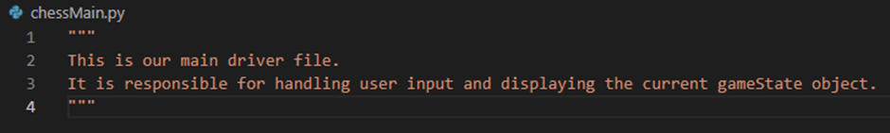
* chessEngine.py: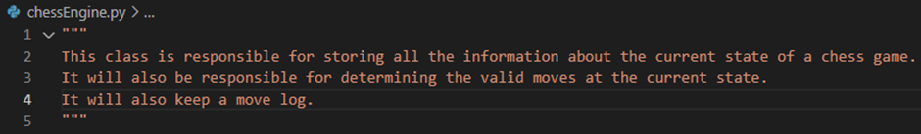

(The bits inside the triple speech marks are called multi-line comments. These are notes written by developers on projects. In this case, they give me a quick summary of what each file does. Another way of writing comments in Python is by using a hashtag.)

Next, we’re going to go inside of our chessEngine.py file and create our gameState class that we designed but only up to the move log for now:

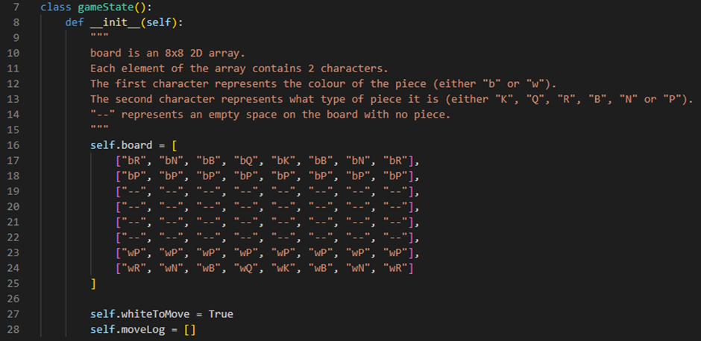

Line 7 defines a class in our chessEngine.py file called gameState. Line 8 defines our constructor procedure for this class. Inside our constructor procedure, from lines 16-25, we have defined our board attribute. This attribute is an 8 by 8 2D array used to represent our chessboard in terms of strings inside this 2D array. Each element of board contains strings of 2 characters. The first character will be used to represent the colour of the piece (either “b” for black or “w” for white). The second character will be used to represent what type of piece it is (either “K” for king, “Q” for queen, “R” for rook, “B” for bishop, “N” for knight or “P” for pawn). If the element inside the array is “--” then that means it is an empty space on the board with no piece. Line 27 defines our whiteToMove attribute which is a boolean flag variable that will be used to tell us what colour’s turn it is to move. It will always start off as being set to True because in chess white always has the first move. Line 28 defines our moveLog attribute which is an array that will hold any moves that have been played in the order that they have been played. This will be used when we start to make moves and undo moves.

We will write the rest of the constructor procedure later. For now, this is enough for us to get started on drawing the squares of the chessboard to the screen and drawing our pieces on the screen.

To do this, we are going to go into our chessMain.py file and write the following code:

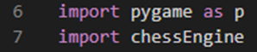

Line 6 imports the PyGame Python library into our file. This will be the library that we use to display our current gameState object as 2D graphics on the screen based on the designs we made earlier. Line 7 imports our chessEngine.py file into our file. This will allow us to make a reference to the gameState class in the form of an object inside of our chessMain.py file.

Next, we need to initialise some important variables:

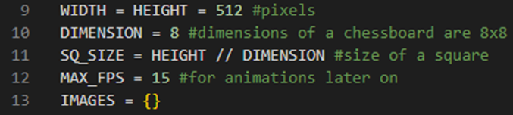

Line 9 defines the WIDTH and HEIGHT of our screen. They are going to be set to the same number of pixels in order to form a square shaped screen. In this case, 512 pixels. 512 is a nice number because it is evenly divisible by 8 which are the dimensions of a chessboard (8 by 8). Line 10 defines the DIMENSION of our chessboard as 8. Line 11 defines the SQ_SIZE which represents the size of a square in pixels on our screen. This is calculated by the equation: HEIGHT // DIMENSION which will always return the whole number of a division (rather than a remainder or a decimal number). Calculating the SQ_SIZE this way is useful because it allows us to be able to change WIDTH and HEIGHT to a different number of pixels and have SQ_SIZE change proportionally and accordingly. Line 12 defines the MAX_FPS of our PyGame window. We have it set to 15 FPS but we will not be using this variable until we add animations later on (an addition recommended by one of my stakeholders). Line 13 defines an empty dictionary and stores it in a variable called IMAGES. This dictionary is what we will use to store the image links we want to use for our chess pieces. We are going to be using a dictionary because this allows us to establish a key:value pair relationship between the name of our piece and its corresponding image link.

Next, we are going to create a new folder in our project’s directory. We are going to call this folder pieces and it will store all of the images that we are going to use for our pieces:

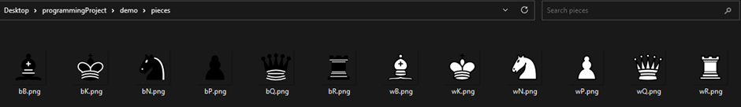

As you can see, the images are named using the same naming convention we used for our pieces in the board attribute of our gameState class in our chessEngine.py file. I found these images online and made sure they had a transparent background.

Next, we are going to define a procedure called loadImages. This procedure will use a for loop to go through every image in the pieces folder and load them into the empty global dictionary variable, IMAGES, we initialised earlier and scale them to our defined SQ_SIZE. This is a very resource heavy task and should only be called once in the main, otherwise it may cause a massive drop in performance.

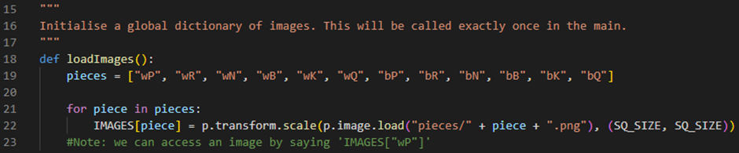

Line 18 defines our procedure and calls it loadImages. It takes no parameters. Line 19 defines an array called pieces that holds all of our different names for all of our different types of pieces using the same naming convention from earlier. These all correlate to the names of our images in the pieces folder we just created. Line 21 defines a for loop that goes through every piece in our pieces array. Line 22 takes an element from our pieces array and turns it into a key for the global IMAGES dictionary. This key’s value is then assigned to be its corresponding loaded image from the pieces folder that has been scaled to a square with (width, height) dimensions of (SQ_SIZE, SQ_SIZE) which we have defined earlier. The for loop will then repeat this process for every piece in pieces until all of our images have been loaded into our IMAGES dictionary and scaled appropriately.

Next, we are going to define our main procedure. This procedure will be used to handle all of our user input and update the graphics of our chessboard.

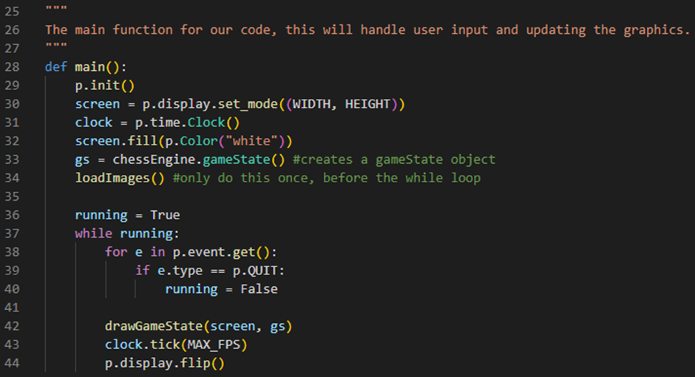

Line 28 defines our procedure and calls it main. It takes no parameters. Line 29 initialises the PyGame library’s modules so that they are ready to use. Line 30 initialises our screen variable which holds information about the GUI window screen that the chessboard will soon display on. For example, it is currently holding information about the WIDTH and HEIGHT we want our GUI window screen to be. Line 31 initialises our clock variable which stores an object that will track the framerate of the chess engine. Line 32 fills the background colour of our screen all white. Line 33 initialises our gs variable which stores our gameState object which we created the class for earlier in our chessEngine.py file. Line 34 runs the loadImages procedure we just defined. Line 36 initialises our running flag variable. This variable is important as it will control when our while loop is running. It must initially be set to True so that our while loop runs. Line 37 defines our while loop. Line 38 defines our event handler for loop. It will loop through any event, e, that it catches in p.event.get() for every iteration of our while loop. Line 39 checks if the event type of e is a p.QUIT event (for example, when you click on the x in the corner of the screen to close an application). If it is, then running will be set to False, causing the while loop to stop running and the application will close. Line 42 runs a yet to be defined procedure called drawGameState which takes two parameters, the screen variable and gs variable. Line 43 sets the framerate of our application to our MAX_FPS variable, which in this case is 15 FPS, using the tick method of our clock variable. Line 44 is a method which refreshes the GUI window screen and updates it.

The following section of code is used to run the main procedure when the program is run:

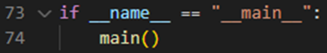

Next, we are going to define our drawGameState procedure. This will be the procedure that is responsible for displaying all the graphics within a current game state.

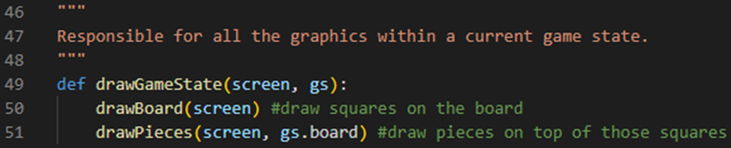

Line 49 defines our procedure and calls it drawGameState. It takes two parameters, the screen variable which holds the PyGame GUI window screen and the gs variable which holds the gameState object. Line 50 calls another yet to be defined procedure called drawBoard (which takes the screen variable as a parameter) and this procedure will draw the squares on the board. Line 51 calls another yet to be defined procedure called drawPieces (which takes the screen variable and the board attribute of the gameState object as parameters) and this procedure will draw the pieces on top of their respective squares on the board.

Next, we are going to define our drawBoard procedure. This will be the procedure that will draw the squares of our chessboard onto the GUI window screen.

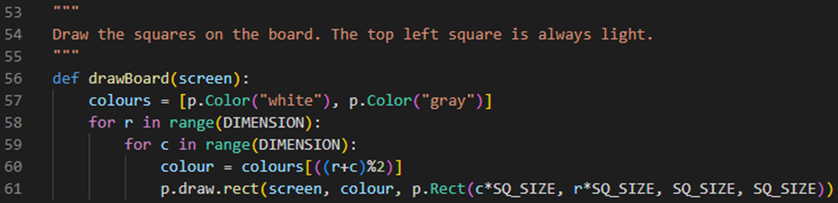

Line 56 defines our procedure and calls it drawBoard. It takes one parameter, the screen variable which holds the GUI window screen. Line 57 initialises an array called colours which holds the two colours, “white” (0) and “gray” (1). This is going to be the colour scheme of our chessboard. Line 58 defines a for loop which goes through every row, r, of our chessboard. Line 59 then defines a nested for loop which goes through every column, c, of our chessboard. Line 60 returns a colour for the square we are currently drawing to the screen. It does this by using the equation ((r+c)%2) to find the corresponding index of our colours array. Line 61 draws our square to the screen using the p.draw.rect method. This method will draw a rectangle to a screen given the screen to draw it to, its colour and the rectangle object itself. p.Rect creates this rectangle object given its x-position (c*SQ_SIZE), y-position (r*SQ_SIZE), width (SQ_SIZE) and height (SQ_SIZE).

By commenting the undefined drawPieces procedure in the drawGameState procedure out, we can then run our program to produce the following output to our screen:

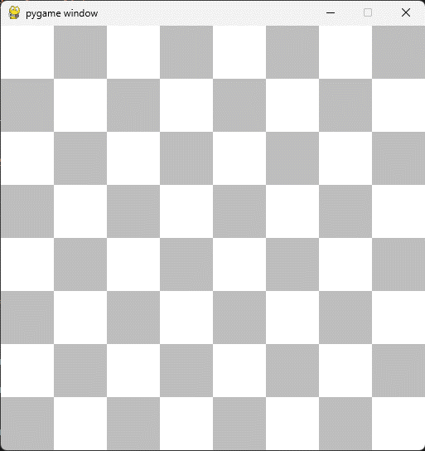

So far, everything is working as we expect it to!

Next, we can uncomment the undefined drawPieces procedure in the drawGameState procedure and define it. This will be the procedure that draws the pieces onto their respective squares on our chessboard using the current gameState.board attribute.

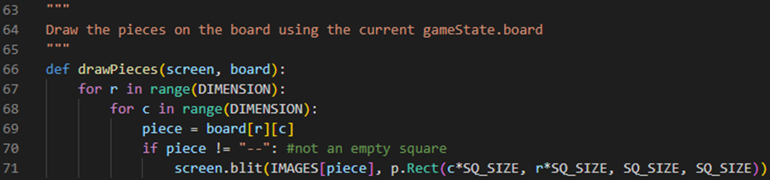

Line 66 defines our procedure and calls it drawPieces. It takes two parameters, the screen variable which holds the GUI window screen and the board variable which holds the current gameState.board 2D array attribute. Line 67 defines a for loop which goes through every row, r, of our chessboard. Line 68 then defines a nested for loop which goes through every column, c, of our chessboard. Line 69 returns the corresponding element on that row and column that we are evaluating from the board variable. This element is then stored in a variable called piece. Line 70 checks that if the piece is not an empty square (because we don’t want to draw anything for empty squares) then we go onto line 71 which draws the corresponding image from our global IMAGES dictionary from earlier onto the screen (using the piece variable as our key). We do this by calling the blit method of our screen variable which places an image onto the screen given the loaded image and a rectangle object to place it on. p.Rect creates this rectangle object given its x-position (c*SQ_SIZE), y-position (r*SQ_SIZE), width (SQ_SIZE) and height (SQ_SIZE).

We can now run the program and produce the following output to our screen:

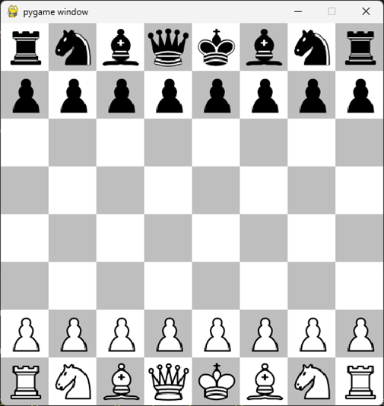

So far, everything is working as we expect it to!

Moving the Pieces

In this section, we are going to be focusing on moving the pieces on the board. In order to do this, we are going to be using some event-driven programming. Event-driven programming is a programming paradigm in which the flow of the program is determined by events such as user inputs. This is exactly what we are going to be using it for. The goal is that the program should listen for the user to left click on a piece and then the user should be able to select a piece they want to move then click on a square to move it to that square.

First, we’re going to go inside of our chessEngine.py file and create a new class called Move. This will be the class which stores all the information about a move on our chessboard that a user might want to play.

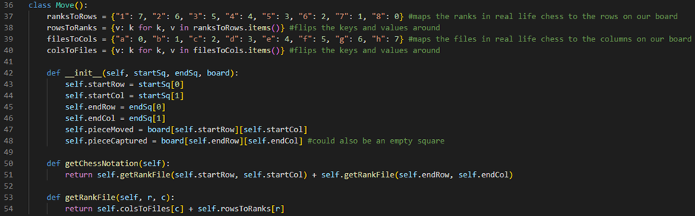

Line 36 defines our class and calls it Move. Line 37 defines a variable called ranksToRows which stores a dictionary. This dictionary is used to map the ranks of a real life chessboard to the rows on our 2D array board attribute. Line 38 defines a variable called rowsToRanks which stores a dictionary. This dictionary serves the same purpose as the one on line 37 but vice versa. The shorthand for loop inside of the dictionary simply flips the keys and values around.

Line 39 defines a variable called filesToCols which stores a dictionary. This dictionary is used to map the files of a real life chessboard to the columns on our 2D array board attribute. Line 40 defines a variable called colsToFiles which stores a dictionary. This dictionary serves the same purpose as the one on line 39 but vice versa. The shorthand for loop inside of the dictionary simply flips the keys and values around. These four dictionaries are going to be used to write out a very simple chess notation for our moves to the console log whenever a move has been made. The chess notation will take the file and rank that our piece starts on and then it will concatenate next to it the file and rank that we have ended on and then output this 4-character string. This will hopefully make testing and debugging (if need be) easier in the future. Line 42 defines our constructor procedure for this class. To create a Move object you will require 3 parameters: the startSq which takes a (row, col) tuple which will be the first of our player’s clicks, the endSq which takes a (row, col) tuple which will be the second of our player’s clicks and, lastly, our current 2D array board attribute. Inside our constructor procedure, line 43 defines our startRow by taking the first element of the startSq tuple. Line 44 defines our startCol by taking the second element of the startSq tuple. Line 45 defines our endRow by taking the first element of our endSq tuple. Line 46 defines our endCol by taking the second element of our endSq tuple. Line 47 defines our pieceMoved by returning the element stored at the startRow and startCol positions on our 2D array board attribute. Line 48 defines our pieceCaptured by returning the element stored at the endRow and endCol positions on our 2D array board attribute. The value stored here could also be an empty square, not necessarily a piece. Line 50 defines a getChessNotation method for our Move class. It takes no parameters. Line 51 returns the output of calling a yet to be defined method called getRankFile which will convert a given row and column into their rank and file counterparts. Here, we use this method to obtain the rank and file of our startRow and startCol and concatenate this value to the rank and file of our endRow and endCol. We then return this string value. Line 53 defines this getRankFile method. It takes two parameters: a row, r, and a column, c. Line 54 returns the corresponding file to our given column, c, by using it as a key for our colsToFiles dictionary. We then return the corresponding rank to our given row, r, by using it as a key for our rowsToRanks dictionary. We then concatenate these two characters together and return this value.

Next, we are going to inside of our gameState class and define a new method called makeMove. This method will be called when we want to make a move on our chessboard.

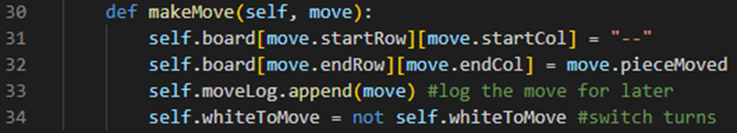

Line 30 defines a new method of our gameState class called makeMove. It takes one parameter: the Move object of the move we want to make on our chessboard. Line 31 takes the element stored on the startRow and startCol of our move on our 2D array board attribute and sets it to be an empty square. Line 32 takes the element stored on the endRow and endCol of our move on our 2D array board attribute and sets it to be our pieceMoved of our move. Line 33 appends our move to our moveLog (this is so that we can undo moves later). Line 34 reverses whiteToMove thereby switching the player’s turn.

Next, we are going to go inside of our chessMain.py file and update our main procedure.

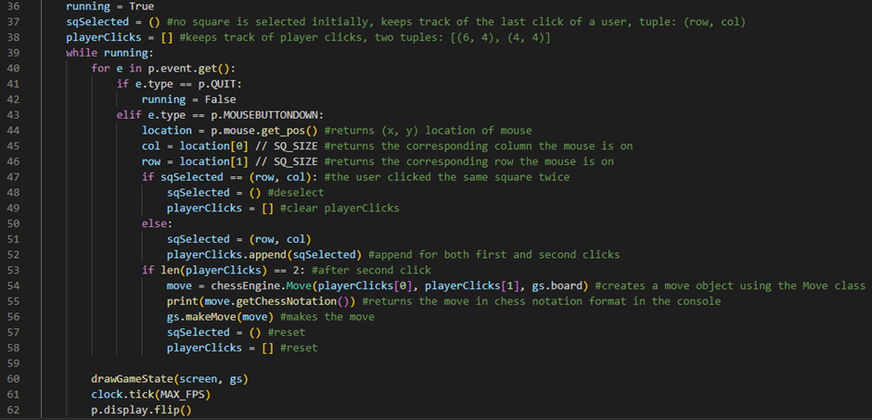

Line 37 defines our sqSelected variable which initially stores an empty tuple. This variable will be used to keep track of the last square a player has clicked on. Line 38 defines our playerClicks variable which initially stores an empty array. This variable will be used to keep track of our player’s clicks. Lines 43-58, define our event handler code for when our program hears a left button mouse click. Line 43 checks if our event, e, has an event type of MOUSEBUTTONDOWN (left button mouse click). If it does, then line 44 will return the (x, y) location of where the player’s mouse was on the screen when they clicked and store it in a variable called location. Line 45 returns the first value (x-value) of location and divides this by SQ_SIZE to get the corresponding column the player has clicked on and stores it in a variable called col. Line 46 returns the second value (y-value) of location and divides this by SQ_SIZE to get the corresponding row the player has clicked on and stores it in a variable called row. Line 47 checks if sqSelected is equal to our (row, col). If it is then it means that our user has clicked on the same square twice. If they have then line 48 sets our sqSelected variable back to an empty tuple, deselecting the square and line 49 sets our playerClicks variable back to an empty array, clearing our playerClicks. If the user has not clicked on the same square twice, then line 51 will set our sqSelected to our (row, col) tuple and line 52 will append this sqSelected to our playerClicks array. Line 53 then checks if our playerClicks array has 2 elements in it. If it does, then our player has made two valid clicks. Line 54 will then create a Move object giving the first element of playerClicks, the second element of playerClicks and the current game state’s 2D array board attribute as arguments. We then store this Move object in a variable called move. Line 55 prints this move’s chess notation by calling the getChessNotation method we defined earlier and printing the value returned by it to the console log. Line 56 then makes this move on the chessboard by calling the game state’s makeMove method and giving the move we just created as an argument. Line 57 then sets our sqSelected variable back to an empty tuple and line 58 sets our playerClicks back to an empty array.

We can now run the program and test to see if we can move our pieces on the chessboard:

Valid move:



Console:

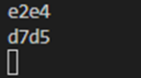

Here, our code works perfectly as expected! We can now click on a piece to move it to a different square on our chessboard and our chess notation is printed out in our console log.

Invalid move:



Here we can see that because we haven’t validated any of our moves yet, we can move a piece anywhere we want on the board and the same player can also move twice in a row.

Bug:



Here the bug is that we can pick an empty square and move it on top of a piece.

Both of these issues are going to be solved once we validate our moves later on.

Undo Moves and Starting on Move Validation

In this section, we are going to implement the ability to undo moves on our chessboard. This is going to make debugging a lot easier for me when we start fully implementing our move validation because I am going to be able to go back and see what went wrong. We are then also going to start implementing our move validation code.

So, first, let’s go into our chessEngine.py file and inside of our gameState class we are going to create a new method called undoMove. This method will undo the last move recorded in the current gameState’s moveLog array.

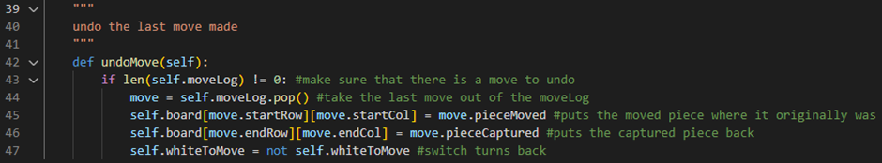

Line 42 defines a new method of our gameState class called undoMove. It takes no parameters. Line 43 checks if the current gameState’s moveLog array is not empty. If it is empty, then we have no move to undo so we want to skip the rest of the code. Line 44 defines our move that we want to undo and stores it in a variable called move. It does this by using the pop method to take the last move out of the moveLog array. Line 45 puts the moved piece back to where it originally was by placing it on the board at the startRow and startCol of the move variable. Line 46 puts the captured piece back to where it originally was by placing it on the board at the endRow and endCol of the move variable. Line 47 then switches the turns back by reversing the whiteToMove boolean variable.

Next, we are going to go into our chessMain.py file and update our main procedure so that the event handler for loop listens for when a user presses the z key on their keyboard. When they press the z key, we then want to undo the last move that was played.

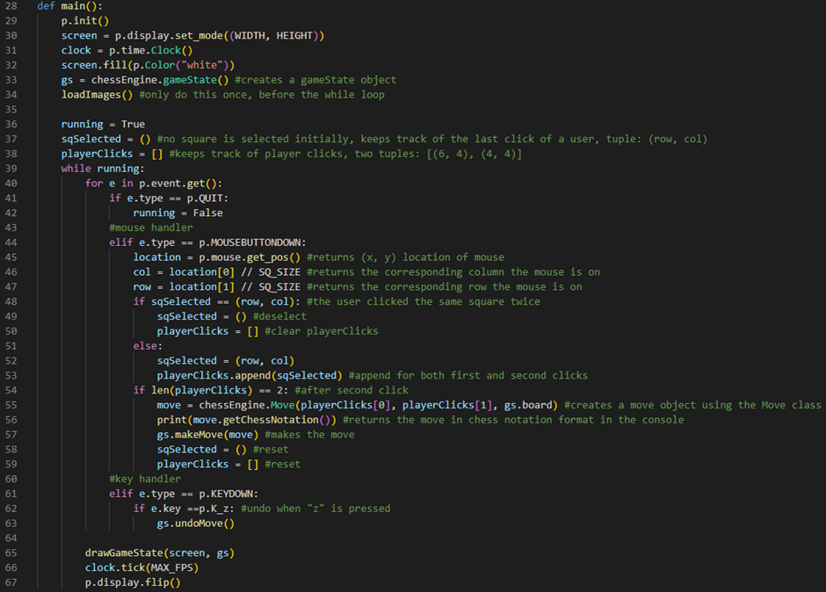

Line 61 checks if the event type of our event e is a keyboard button press down. If it is, then line 62 checks if the keyboard button that was pressed was a z key. If it was, then the current gameState’s undoMove method will be called (line 63).

We can now run the program and test to see if we can undo moves on our chessboard:



Here, our code works perfectly as expected! We can now undo the last move from our move log by pressing z on our keyboard.

Next, we’re going to work on validating our user’s moves. The way this is going to work is, we’re going to create two more methods inside of our gameState class inside of the chessEngine.py file. These methods are going to be called “getAllPossibleMoves” and “getValidMoves”. getAllPossibleMoves is going to return all the possible moves a user can make on that turn. getValidMoves is going to return only the valid moves a user can make on that turn. We are going to determine whether or not a move is valid by considering checks. To explain this better, take the following situation in a real game of chess for example:

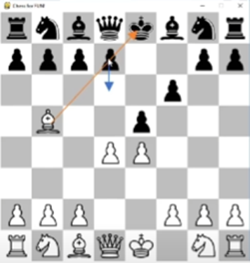

It is black’s turn. Technically, it is a legal move for black to move their pawn down from d7 to d6 like illustrated in the image. However, this would leave the black king open to a check from the bishop on b5. Therefore, in a real game of chess this move is invalid and should not be allowed to be played. Our chess engine will need to be able to recognise situations like these and prevent invalid moves like these from being able to be played.

In order to accomplish this, getValidMoves will work like this:

1. It is going to call the getAllPossibleMoves method.
2. For each possible move, it is then going to check to see if it is a valid move by doing the following:
3. It is going to return a list of only valid moves.

Firstly, we’re going to code an abstracted version of our getValidMoves method in our gameState class inside of our chessEngine.py file:

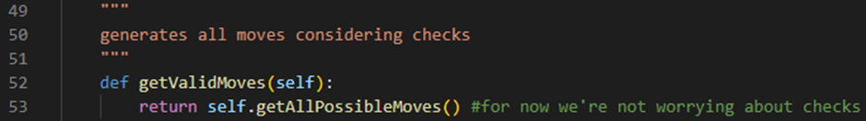

Line 52 defines a new method and calls it getValidMoves. It takes no parameters. Line 53 calls getAllPossibleMoves and returns the list of moves we get from calling this method.

Next, we are going to define three different methods in our gameState class inside of our chessEngine.py file. These are going to be a getAllPossibleMoves method, a getPawnMoves method and a getRookMoves method:

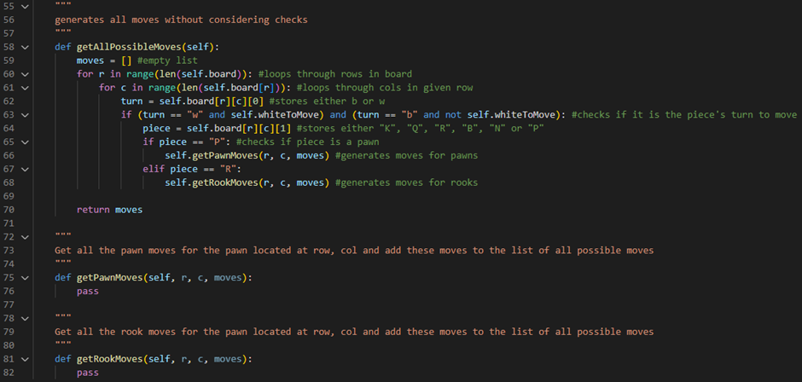

Line 58 defines a method called getAllPossibleMoves. It takes no parameters. Line 59 creates an empty array and stores it in a variable called moves. Line 60 uses a for loop to iterate through the rows, r, of our board 2D array attribute. Line 61 uses a for loop to iterate through columns, c, of our rows in our board 2D array attribute. Line 62 defines a variable called turn which stores the first character of the square we are looking at on the board by evaluating the first character stored at the row (r) and column (c) positions of our board 2D array attribute. This variable will always store either a “w” (for white’s turn) or a “b” (for black’s turn). Line 63 checks if it is the piece’s turn to move by checking if the turn variable stores “w” and if whiteToMove is True and if the turn variable stores “b” and if whiteToMove is False. Line 64 defines a variable called piece which stores the second character of the square we are looking at on the board by evaluating the second character stored at the row (r) and column (c) positions of our board 2D array attribute. This variable will always store either a “K” (for king), a “Q” (for queen), a “R” (for rook), a “B” (for bishop), a “N” (for knight) or a “P” (for pawn). Line 65 checks if our piece variable stores “P”. If it does, then the piece we are looking at is a pawn so we want to generate and append to our moves array all the possible pawn moves for this particular pawn. We do this by calling the yet to be defined getPawnMoves method of our gameState class (line 66). Line 67 checks if our piece variable stores “R”. If it does, then the piece we are looking at is a rook so we want to generate and append to our moves array all the possible rook moves for this particular rook. We do this by calling the yet to be defined getRookMoves method of our gameState class (line 68). Next we would do this for all the pieces, however, I want to only set up our pawns and rooks for now for the sake of testing what we have so far. Line 70 returns our moves array which will, in the end, store all possible moves available on our chessboard. Line 75 defines the getPawnMoves method of our gameState class. It will take three parameters: the row, r, and column, c, of the pawn we are generating the moves for and our current moves array. Line 76 currently just has the command pass which tells our program to do nothing. This is just here temporarily for the sake of testing what we already have. Line 81 defines the getRookMoves method of our gameState class. It will take three parameters: the row, r, and column, c, of the rook we are generating the moves for and our current moves array. Line 82 currently just has the command pass which tells our program to do nothing. This is just here temporarily for the sake of testing what we already have.

Next, we need to go inside of our chessMain.py file and update our main procedure:

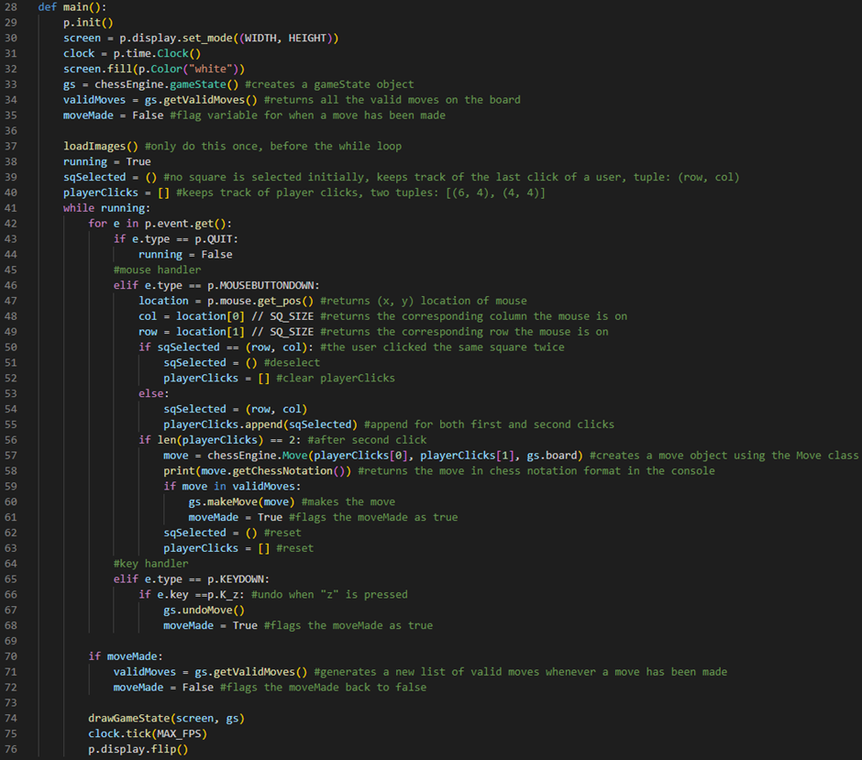

Line 34 defines a new variable called validMoves. This variable will store all the valid moves available on the board by calling our gameState’s getValidMoves method. Line 35 defines a new flag variable called moveMade. This flag variable will return True when a move has been made during a given iteration of the while loop. It will initially be set to False. Line 59 checks if the move we created using our playerClicks is within our list of validMoves. If it is, then we make that move by calling our gameState’s makeMove method and giving the move as a parameter (line 60). We then also set our moveMade flag variable to True (line 61). Line 68 also sets our moveMade flag variable to True if a player has undone a move. This is because we want to generate a new list of validMoves if they have undone a move. Line 70 checks if our moveMade flag variable is currently storing True. If it is, then a new list of valid moves will be generated by calling our gameState’s getValidMoves method and storing it in our validMoves variable (line 71) and then we set our moveMade flag variable back to False (line 72).

Lastly, before we can run our program and test what we have done so far, we need to go back into our chessEngine.py file and we are going to need to update our Move class. More specifically, we are going to need to override Python’s equal method on our Move class. This is because Python checks if an object is the same, not by checking if all its attributes and methods are the same, but by actually checking if it is really the same object or not in memory. We need to check if a move is equal to another move and if it is then, we need to make it. The best way to do that is by creating a moveID for all unique combinations of moves on the board.

The way I have chosen to go about doing this is by updating our Move class constructor and adding a moveID variable:

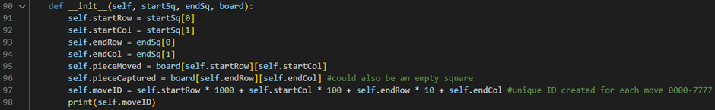

Line 97 defines our moveID variable which stores a unique combination for every move possible on the board by creating a 4-digit code. The first digit represents the startRow, the second digit represents the startCol, the third digit represents the endRow and the last digit represents the endCol. Line 98 prints this variable out to the console whenever a Move object is constructed.

Next, we need to override the original Python equals method of our Move class, so that we can check if a Move object is equal to another Move object:

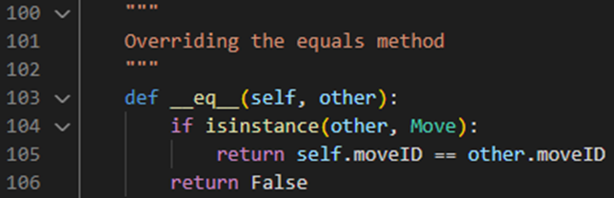

Line 103 defines our original Python equals method of our Move class which has the name “__eq__”. It takes one parameter: the other object you’re comparing it to. Line 104 checks if the instance type of the other object is a Move instance. If it is, then the method will return True if our Move object’s moveID and the other Move object’s moveID are equal. If the moveIDs are not equal then the method will return False (line 105). Line 106 will return False if the instance type of the other object is not a Move instance.

Finally, all we need to do is construct a Move object and manually put it inside of our moves array inside of our getAllPossibleMoves method:



Line 59 should now make it so that we can only move our pawn on row 6, column 4 to row 4, column 4.

We can now run the program and test to see if our code is going to work once we implement move generation for all our pieces:



As you can see, that is the only move the engine is allowing me to play because it is apparently the only valid move on the board. We have now set the foundations for what we need to validate all of our user’s moves.

Generating all possible pawn moves

In this section, we are going to be focusing on generating all possible pawn moves on the board.

Firstly, we need to get rid of the Move object we hardcoded into our moves list inside of our getAllPossibleMoves method:

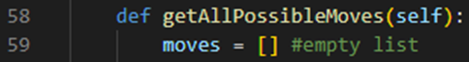

All pieces in chess work in a very unique way. Each piece’s behaviour will need to be programmed inside of their own method. For now, we are just going to be focusing on pawns. On the first turn moving a pawn, they can choose to either go one square down or two squares down. After the first move, they are only allowed to go one square down each turn. Additionally, a pawn can only capture another piece diagonally. With these sets of rules in mind we need to code the behaviour of our pawn pieces.

First, let’s work on moving our pawn pieces two squares down on the first turn and one square down for the rest of their turns:

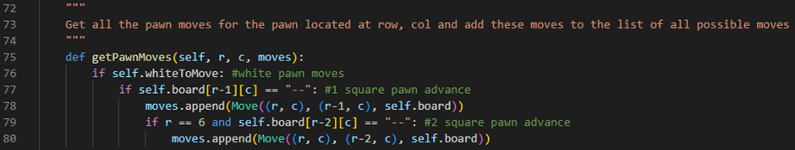

Line 75 defines the getPawnMoves method of our gameState class. It takes three parameters: the row, r, and column, c, of the pawn we are generating the moves for and our current moves array. Line 76 checks if the whiteToMove flag variable is set to True. If it is, then line 77 will check if the space in front of the white pawn on the board is an empty space. It does this by evaluating the position [r-1, c] on the 2D array board attribute and checking if the element stored at this position is a “--” string. If it is, then line 78 will append this one square pawn advance move to our moves array by calling the append method of our moves array and creating a Move object (with a startSq of (r, c), an endSq of (r-1, c) and a board of our current board attribute) to give as an argument. Line 79 will then check if r stores a value of 6 and if the space 2 squares in front of the white pawn on the board is an empty space. It does this by evaluating the position [r-2, c] on the 2D array board attribute and checking if the element stored at this position is a “--” string. If it is, then line 80 will append this two square pawn advance move to our moves array by calling the append method of our moves array and creating a Move object (with a startSq of (r, c), an endSq of (r-2, c), and a board of our current board attribute) to give as an argument.

We can now run the program and test to see if our getPawnMoves method is working so far:



It is not working!

Now, we need to debug and figure out what went wrong. When you encounter bugs in programming it is a good idea to print out all of your key variables in order to track what your program is actually doing. The variable that we are interested in is the moves array that we are trying to append to and we are looking to see why our moves are not being appended to it.

So, we’re going to go inside of our getAllPossibleMoves method:

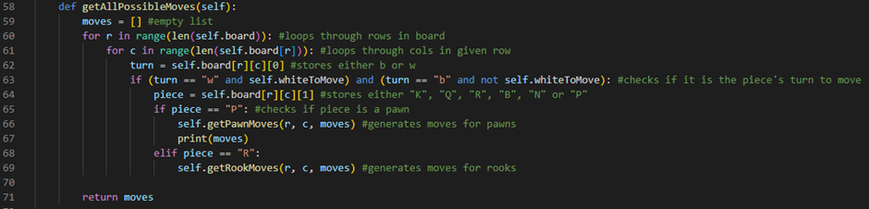

On line 67, we have added a print statement that will print out our moves array after our getPawnMoves method has been run.

When we run our program and try to move a pawn, we get nothing in our console except for our moveID and our chess notation:



This tells us that the if statement on line 65, which checks if the piece variable is storing the string “P”, is not being run. This means that our chess engine is not getting the pawn moves and something has gone awry around there.

So, we’re going to go inside of our getAllPossibleMoves method:

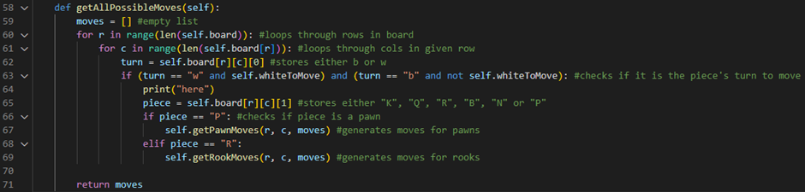

On line 64, we have added a print statement that will print our moves array after the if statement on line 63, which checks if it is the piece’s turn to move, has run.

When we run our program and try to move a pawn, we again get nothing in our console except for our moveID and our chess notation:



This tells us that the if statement on line 63 is also not being run.

Here, I can now actually spot my bug. On line 63, the middle and needs to be changed to an or otherwise that if statement will never be run:

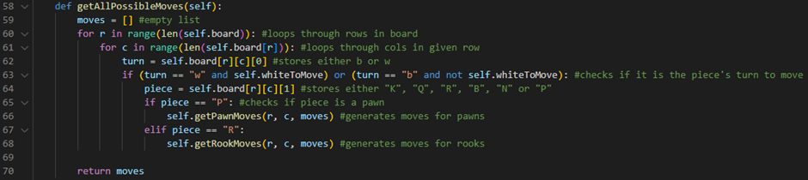

Now that we have found our bug and fixed it, let’s try and run our program again in order to test to see if our getPawnMoves method is working so far:



Now, it works perfectly as we expect it to! We are allowed to make our pawn move and all our possible moves are outputted to the console as they are constructed:

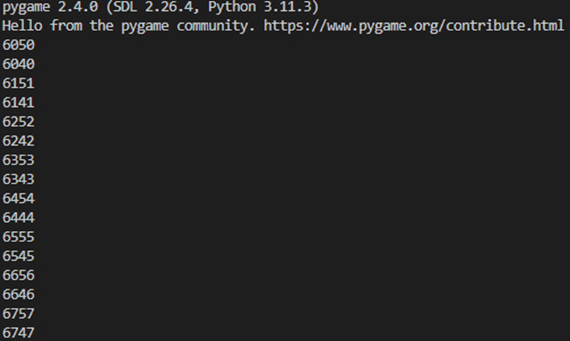

Since we know that our Move class is working now, we can actually get rid of our moveID print statement inside of our Move class:

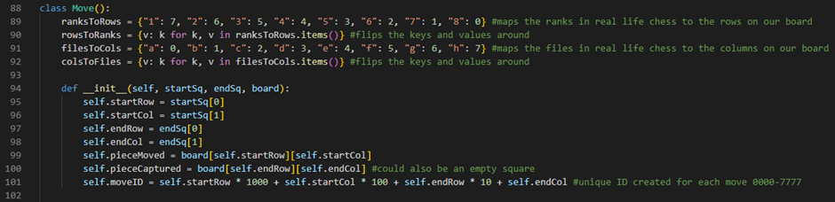

The print statement on line 102 is now gone.

Next, we are going to be programming the white pawn’s captures behaviours inside of the getPawnMoves method of our gameState class (lines 81-86):

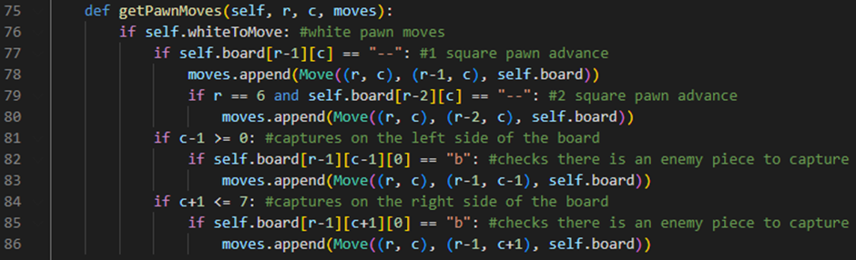

Line 81 checks if c-1 is greater than or equal to 0 because if it is less than zero then we would be evaluating a square that is on the other side of the board. Line 82 checks if there is an enemy piece to capture diagonally on the left hand side of the board. It does this by checking if the first character of the element stored on the board position (r-1, c-1) has a value of the character “b”. If it does, then line 83 will append this pawn capture move to our moves array by calling the append method of our moves array and creating a Move object (with a startSq of (r, c), an endSq of (r-1, c-1), and a board of our current board attribute) to give as an argument. Line 84 checks if c+1 is less than or equal to 7 because if it is greater than 7 then we would be evaluating a square that does not exist on the board. Line 85 checks if there is an enemy piece to capture diagonally on the right hand side of the board. It does this by checking if the first character of the element stored on the board position (r-1, c+1) has a value of the character “b”. If it does, then line 86 will append this pawn capture move to our moves array by calling the append method of our moves array and creating a Move object (with a startSq of (r, c), an endSq of (r-1, c+1), and a board of our current board attribute) to give as an argument.

To test if the pawn captures are working, we are going to add a black pawn in front of our white pawns by hardcoding it into our board attribute inside of our gameState class:

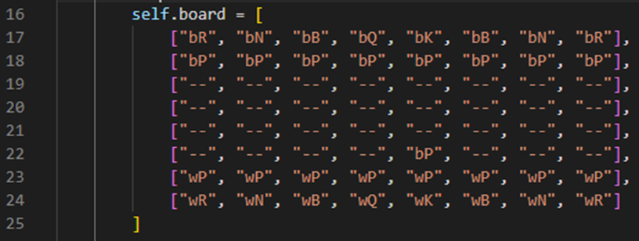

We can now run the program and test to see if we can capture this black pawn:



So far, it’s working perfectly as we expect it to!

Next, there’s actually a more efficient way of calling our move methods inside of our getAllPossibleMoves method. Rather than having a clunky, long series of if statements for each piece type, although it may work, it would be more efficient to map the piece types to their respective functions inside of a dictionary and call them that way instead. This dictionary will be stored in an attribute called moveFunctions inside of our gameState class:

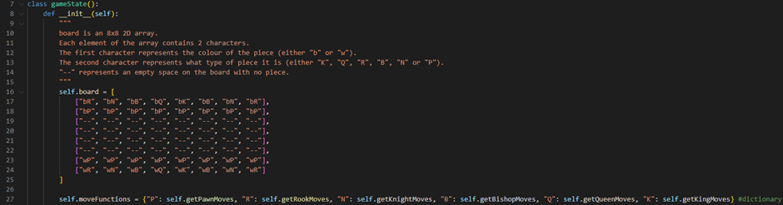

As you can see, we got rid of the black pawn that was in front of our white pawns. Additionally, we have added the moveFunctions dictionary on line 27. This dictionary stores our piece type strings (e.g., “P” for pawn, “R” for rook, “N” for knight, etc.) as keys for their respective move methods which are stored as values.

Doing this means that we are also going to need to create the rest of our abstracted move methods like so:

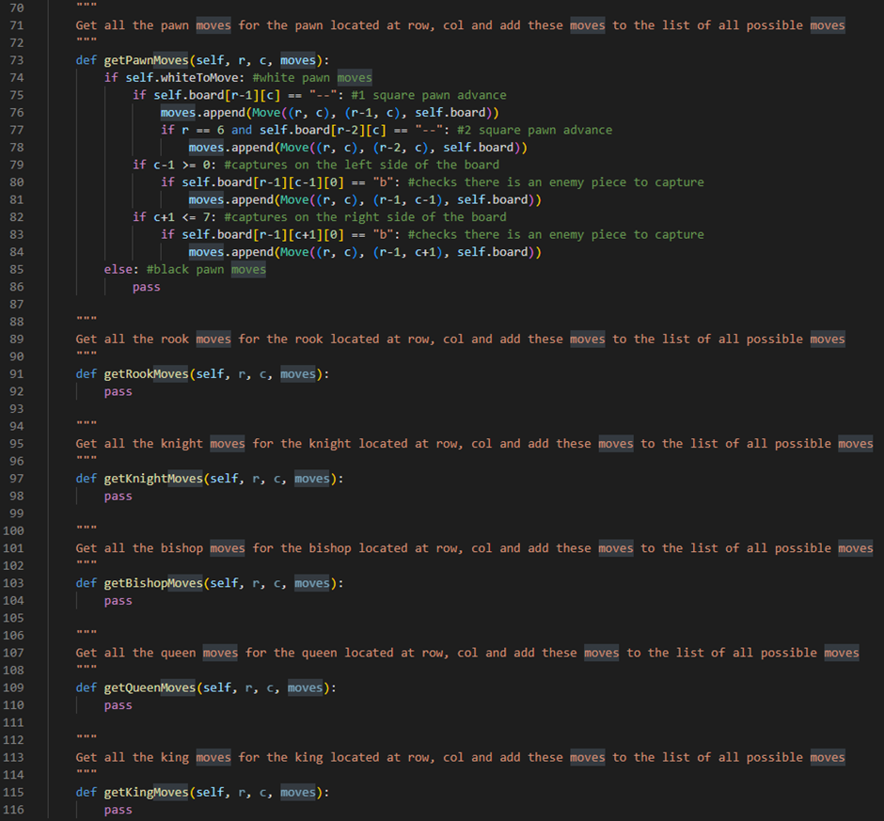

Line 97 defines the getKnightMoves method of our gameState class. It will take three parameters: the row, r, and column, c, of the knight we are generating the moves for and our current moves array. Line 98 currently just has the command pass which tells our program to do nothing. Line 103 defines the getBishopMoves method of our gameState class. It will take three parameters: the row, r, and column, c, of the bishop we are generating the moves for and our current moves array. Line 104 currently just has the command pass which tells our program to do nothing. Line 109 defines the getQueenMoves method of our gameState class. It will take three parameters: the row, r, and column, c, of the queen we are generating the moves for and our current moves array. Line 110 currently just has the command pass which tells our program to do nothing. Line 115 defines the getKingMoves method of our gameState class. It will take three parameters: the row, r, and the column, c, of the king we are generating the moves for and our current moves array. Line 116 currently just has the command pass which tells our program to do nothing.

Now, we can go into our getAllPossibleMoves method:

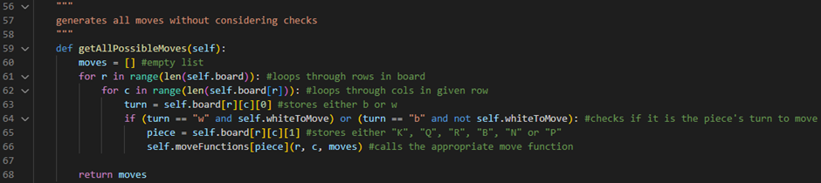

Now, we can replace what would have been a really long if statement with just one line of code: line 66. This line calls the respective move method of the piece we are currently generating the moves for by returning its respective move method from the moveFunctions dictionary and using the piece variable as a key. This move method is then called given the r variable, the c variable and the current moves array as arguments.

Next, our chess engine recognises that it is now black’s turn to move a piece but we haven’t programmed black’s pawn moves yet. Let’s do that now inside of our getPawnMoves method:

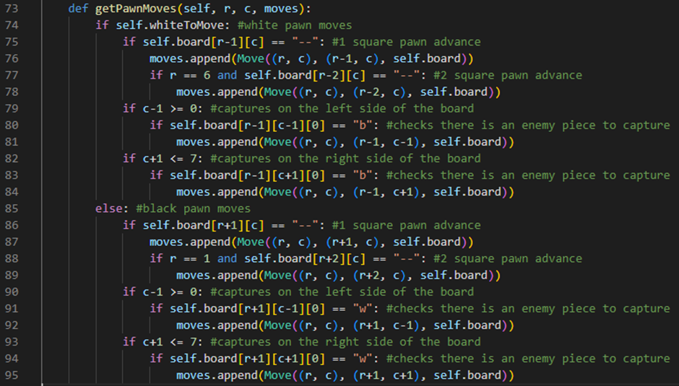

Line 85 is an else statement which will run when the whiteToMove flag variable is set to False. If it is, then line 86 will check if the space in front of the black pawn on the board is an empty space. It does this by evaluating the position [r+1, c] on the 2D array board attribute and checking if the element stored at this position is a “--” string. If it is, then line 87 will append this one square pawn advance move to our moves array by calling the append method of our moves array and creating a Move object (with a startSq of (r, c), and endSq of (r+1, c) and a board of our current board attribute) to give as an argument. Line 88 will then check if r stores a value of 1 and if the space 2 squares in front of the black pawn on the board is an empty space. It does this by evaluating the position [r+2, c] on the 2D array board attribute and checking if the element stored at this position is a “--” string. If it is, then line 89 will append append this two square pawn advance move to our moves array by calling the append method of our moves array and creating a Move object (with a startSq of (r, c), an endSq of (r+2, c), and a board of our current board attribute) to give as an argument. Line 90 checks if c-1 is greater than or equal to 0 because if it is less than zero then we would be evaluating a square that is on the other side of the board. Line 91 checks if there is an enemy piece to capture diagonally on the left hand side of the board. It does this by checking if the first character of the element stored on the board position (r+1, c-1) has a value of the character “w”. If it does, then line 92 will append this pawn capture move to our moves array by calling the append method of our moves array and creating a Move object (with a startSq of (r, c), an endSq of (r+1, c-1), and a board of our current board attribute) to give as an argument. Line 93 checks if c+1 is less than or equal to 7 because if it is greater than 7 then we would be evaluating a square that does not exist on the board. Line 94 checks if there is an enemy piece to capture diagonally on the right hand side of the board. It does this by checking if the first character of the element stored on the board position (r+1, c+1) has a value of the character “w”. If it does, then line 95 will append this pawn capture move to our moves array by calling the append method of our moves array and creating a Move object (with a startSq of (r, c), an endSq of (r+1, c+1), and a board of our current board attribute) to give as an argument.

We can now run the program and test to see if our black pawns can move:



So far, it’s working as we expect it to! The turns are being switched and all our pawns move perfectly.

Pawn moves test table:

|  |  |  |
| --- | --- | --- |
| Test Data | Expected Outcome | Actual Outcome |
| First click on the board (Main Procedure) | When the user clicks on a pawn on the board, the pawn is selected. | As expected. |
| Second click on the board (Main Procedure) | When the user clicks on a square on the board that is for a pawn move, the move is made on the board. | As expected. |

Generating the rest of the moves

In this section, we are going to focus on generating the rest of the possible moves on the board.

Firstly, we are going to program the behaviour of our rooks. Rooks in chess can move anywhere straight down or up the board and across the board as long as there is not a piece in the way. With these rules in mind, let’s code our getRookMoves method:

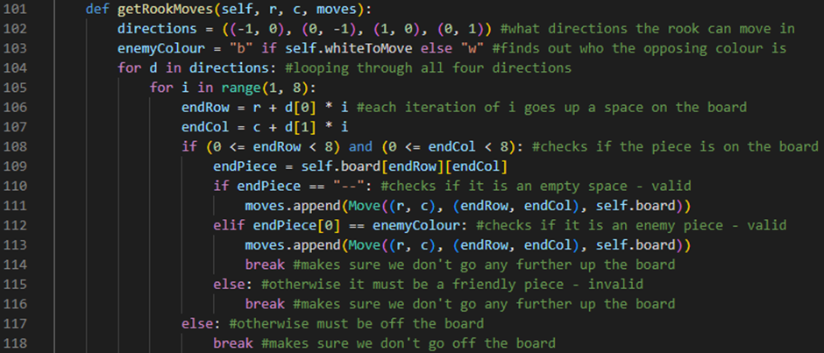

Line 101 defines our getRookMoves method. It will take three parameters: the row, r, and column, c, of the rook we are generating the moves for and our current moves array. Line 102 defines a 2D tuple which is stored in a variable called directions. Each tuple inside of this 2D tuple holds (x, y) coordinate increments for the directions a rook can travel in on the board. For example, (-1, 0) is down the x-axis of the board, (0, -1) is down the y-axis of the board, (1, 0) is up the x-axis of the board and (0, 1) is up the y-axis of the board. Line 103 finds out what the opposing colour is on this turn and stores this in a variable called enemyColour. It does this by using a shorthand if statement which returns “b” if the whiteToMove flag variable is set to True or returns “w” if the whiteToMove flag variable is set to False. Line 104 defines a for loop which will loop through all four tuples inside of our directions 2D tuple variable. Line 105 defines an embedded for loop which will run 8 times (once for each square on the board in a given direction). Line 106 defines a variable called endRow which stores the row we are going to move the rook to on a given move. It does this by taking the start row of the move, r, and adding to it the first element inside of our direction tuple, d, multiplied by our for loop counter variable, i.

Line 107 defines a variable called endCol which stores the column we are going to move the rook to on a given move. It does this by taking the start column of the move, c, and adding to it the second element of our direction tuple, d, multiplied by our for loop counter variable, i. Line 108 checks if the square we are looking at is actually on the board. It does this by evaluating if endRow is greater than or equal to 0 and if endRow is less than 8 and if endCol is greater than or equal to 0 and if endCol is less than 8. Line 109 defines a variable called endPiece which returns the square we are looking at on the board by returning the element stored on our 2D array board attribute at the (endRow, endCol) position. Line 110 checks if the square we are looking at is empty by checking if endPiece stores a value of the “--” string. If it does, then line 111 will append this rook move to our moves array by calling the append method of our moves array and creating a Move object (with a startSq of (r, c), and endSq of (endRow, endCol) and a board of our current board attribute) to give as an argument. Line 112 checks if the square we are looking at is an enemy piece by checking if the first element of endPiece stores the same value as our enemyColour variable. If it does, then line 113 will append this rook capture move to our moves array by calling the append method of our moves array and creating a Move object (with a startSq of (r, c), and endSq of (endRow, endCol) and a board of our current board attribute) to give as an argument. Line 114 then runs a break command which will make sure the rook can not go any further up the board by breaking us out of the loop. Line 115 is an else statement which will run if the square we are looking at is an allied piece. Line 116 then also runs a break command which will make sure the rook can not go any further up the board by breaking us out of the loop. Line 117 is an else statement which will run if the square we are looking at is off the board. Line 118 then runs a break command which will make sure the rook does not go off the board by breaking us out of the loop.

We can now run the program and test to see if our rooks can move:



So far, it’s working as we expect it to! Our rooks can move anywhere straight up, down and across the board (as long as there is not a piece in the way) and capture other enemy pieces.

Rook moves test table:

|  |  |  |
| --- | --- | --- |
| Test Data | Expected Outcome | Actual Outcome |
| First click on the board (Main Procedure) | When the user clicks on a rook on the board, the rook is selected. | As expected. |
| Second click on the board (Main Procedure) | When the user clicks on a square on the board that is for a rook move, the move is made on the board. | As expected. |

Next, we are going to program the behaviour of our knights. Knights in chess can only move in an L shape and can jump over other pieces on the board. With these rules in mind, let’s code our getKnightMoves method:

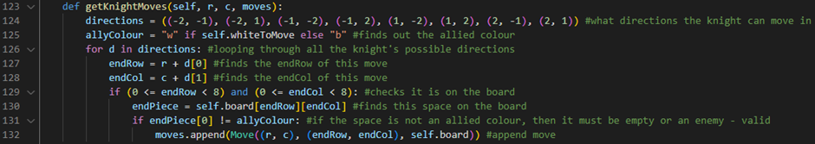

Line 123 defines our getKnightMoves method. It will take three parameters: the row, r, and column, c, of the knight we are generating the moves for and our current moves array. Line 124 defines a 2D tuple which is stored in a variable called directions. Each tuple inside of this 2D tuple holds (x, y) coordinate increments for the directions a knight can travel in on the board. For example, (-2, -1) is down 2 squares on the x-axis and down 1 square on the y-axis, (-2, 1) is down 2 squares on the x-axis and up 1 square on the y-axis, (-1, -2) is down 1 square on the x-axis and down 2 squares on the y-axis, (-1, 2) is down 1 square on the x-axis and up 2 squares on the y-axis, (1, -2) is up 1 square on the x-axis and down 2 squares on the y-axis, (1, 2) is up 1 square on the x-axis and up 2 squares on the y-axis, (2, -1) is up 2 squares on the x-axis and down 1 square on the y-axis and (2, 1) is up 2 squares on the x-axis and up 1 square on the y-axis. Line 125 finds out what the allied colour is on this turn and stores this in a variable called allyColour. It does this by using a shorthand if statement which returns “w” if the whiteToMove flag variable is set to True or returns “b” if the whiteToMove flag variable is set to False. Line 126 defines a for loop which will loop through all eight tuples inside of our directions 2D tuple variable. Line 127 defines a variable called endRow which stores the row we are going to move the knight to on a given move. It does this by taking the start row of the move, r, and adding to it the first element inside of our direction tuple, d. Line 128 defines a variable called endCol which stores the column we are going to move the knight to on a given move. It does this by taking the end column of the move, c, and adding to it the second element inside of our direction tuple, d. Line 129 checks if the square we are looking at is actually on the board. It does this by evaluating if endRow is greater than or equal to 0 and if endRow is less than 8 and if endCol is greater than or equal to 0 and if endCol is less than 8. Line 130 defines a variable called endPiece which returns the square we are looking at on the board by returning the element stored on our 2D array board attribute at the (endRow, endCol) position. Line 131 checks if the square we are looking at is not an allied piece by checking if the first element of endPiece does not store the same value as our allyColour variable. If it is not an allied piece, then it must be an empty square or an enemy piece. If this is the case, then line 132 will append this knight move to our moves array by calling the append method of our moves array and creating a Move object (with a startSq of (r, c), and endSq of (endRow, endCol) and a board of our current board attribute) to give as an argument.

We can now run the program and test to see if our knights can move:



So far, it’s working as we expect it to! Our knights can move in an L shape, jump over other pieces on the board and capture enemy pieces.

Knight moves test table:

|  |  |  |
| --- | --- | --- |
| Test Data | Expected Outcome | Actual Outcome |
| First click on the board (Main Procedure) | When the user clicks on a knight on the board, the knight is selected. | As expected. |
| Second click on the board (Main Procedure) | When the user clicks on a square on the board that is for a knight move, the move is made on the board. | As expected. |

Next, we are going to program the behaviour of our bishops. Bishops in chess can move anywhere diagonally up and down the board as long as there is not a piece in the way. With these rules in mind, let’s code our getBishopMoves method:

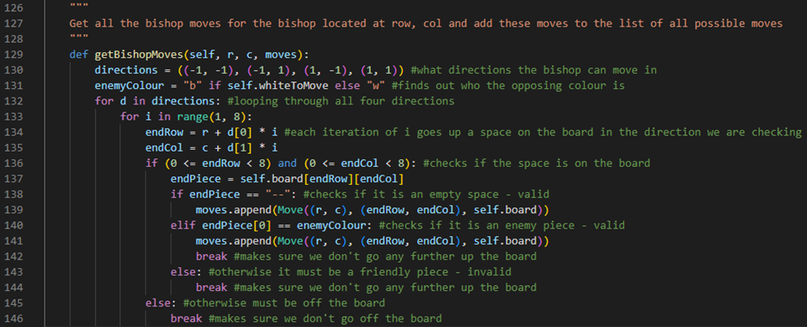

Line 129 defines our getBishopMoves method. It will take three parameters: the row, r, and column, c, of the bishop we are generating the moves for and our current moves array. Line 130 defines a 2D tuple which is stored in a variable called directions. Each tuple inside of this 2D tuple holds (x, y) coordinate increments for the directions a bishop can travel in on the board. For example, (-1, -1) is down 1 square on the x-axis and down 1 square on the y-axis, (-1, 1) is down 1 square on the x-axis and up 1 square on the y-axis, (1, -1) is up 1 square on the x-axis and down 1 square on the y-axis and (1, 1) is up 1 square on the x-axis and up 1 square on the y-axis. Line 131 finds out what the opposing colour is on this turn and stores this in a variable called enemyColour. It does this by using a shorthand if statement which returns “b” if the whiteToMove flag variable is set to True or returns “w” if the whiteToMove flag variable is set to False. Line 132 defines a for loop which will loop through all four tuples inside of our directions 2D tuple variable. Line 133 defines an embedded for loop which will run 8 times (once for each square on the board in a given direction). Line 134 defines a variable called endRow which stores the row we are going to move the bishop to on a given move. It does this by taking the start row of the move, r, and adding to it the first element inside of our direction tuple, d, multiplied by our for loop counter variable, i. Line 135 defines a variable called endCol which stores the column we are going to move the bishop to on a given move. It does this by taking the start column of the move, c, and adding to it the second element inside of our direction tuple, d, multiplied by our for loop counter variable, i. Line 136 checks if the square we are looking at is actually on the board. It does this by evaluating if endRow is greater than or equal to 0 and if endRow is less than 8 and if endCol is greater than or equal to 0 and if endCol is less than 8. Line 137 defines a variable called endPiece which returns the square we are looking at on the board by returning the element stored on our 2D array board attribute at the (endRow, endCol) position. Line 138 checks if the square we are looking at is empty by checking if endPiece stores a value of the “--” string. If it does, then line 139 will append this bishop move to our moves array by calling the append method of our moves array and creating a Move object (with a startSq of (r, c), and endSq of (endRow, endCol) and a board of our current board attribute) to give as an argument. Line 140 checks if the square we are looking at is an enemy piece by checking if the first element of endPiece stores the same value as our enemyColour variable. If it does, then line 141 will append this bishop capture move to our moves array by calling the append method of our moves array and creating a Move object (with a startSq of (r, c), and endSq of (endRow, endCol) and a board of our current board attribute) to give as an argument. Line 142 then runs a break command which will make sure the bishop can not go any further up the board by breaking us out of the loop. Line 143 is an else statement which will run if the square we are looking at is an allied piece. Line 144 then also runs a break command which will make sure the bishop can not go any further up the board by breaking us out of the loop. Line 145 is an else statement which will run if the square we are looking at is off the board. Line 146 then runs a break command which will make sure the bishop does not go off the board by breaking us out of the loop.

We can now run the program and test to see if our bishops can move:



So far, it’s working as we expect it to! Our bishops can move anywhere diagonally up and down the board (as long as there is not a piece in the way) and capture other enemy pieces.

Bishop moves test table:

|  |  |  |
| --- | --- | --- |
| Test Data | Expected Outcome | Actual Outcome |
| First click on the board (Main Procedure) | When the user clicks on a bishop on the board, the bishop is selected. | As expected. |
| Second click on the board (Main Procedure) | When the user clicks on a square on the board that is for a bishop move, the move is made on the board. | As expected. |

Next, we are going to program the behaviour of our queens. Queens in chess can move anywhere diagonally up and down and straight up, down and across the board as long as there is not a piece in the way. In other words, they move the same way a rook moves and a bishop moves combined. With these rules in mind, let’s code our getQueenMoves method:

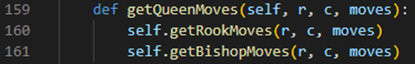

Line 159 defines our getQueenMoves method. It will take three parameters: the row, r, and column, c, of the queen we are generating the moves for and our current moves array. Line 160 calls our getRookMoves method given the row, r, and column, c, of the queen we are generating the moves for and our current moves array as arguments. Line 161 calls our getBishopMoves method given the row, r, and column, c, of the queen we are generating the moves for and our current moves array as arguments.

We can now run the program and test to see if our queens can move:



So far, it’s working as we expect it to! Our queens can move anywhere diagonally up and down and straight up, down and across the board (as long as there is not a piece in the way) and capture other enemy pieces.

Queen moves test table:

|  |  |  |
| --- | --- | --- |
| Test Data | Expected Outcome | Actual Outcome |
| First click on the board (Main Procedure) | When the user clicks on a queen on the board, the queen is selected. | As expected. |
| Second click on the board (Main Procedure) | When the user clicks on a square on the board that is for a queen move, the move is made on the board. | As expected. |

Finally, we are going to program the behaviour of our kings. Kings in chess can move one space in any direction around them. With these rules in mind, let’s code our getKingMoves method:

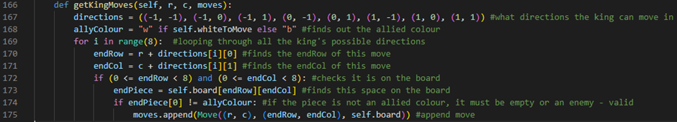

Line 166 defines our getKingMoves method. It will take three parameters: the row, r, and the column, c, of the king we are generating the moves for and our current moves array. Line 167 defines a 2D tuple which is stored in a variable called directions. Each tuple inside of this 2D tuple holds (x, y) coordinate increments for the directions a king can travel in on the board. For example, (-1, -1) is down 1 square on the x-axis and down 1 square on the y-axis, (-1, 0) is down 1 square on the x-axis, (-1, 1) is down 1 square on the x-axis and up 1 square on the y-axis, (0, -1) is down 1 square on the y-axis, (0, 1) is up 1 square on the y-axis, (1, -1) is up 1 square on the x-axis and down 1 square on the y-axis, (1, 0) is up 1 square on the x-axis and (1, 1) is up 1 square on the x-axis and up 1 square on the y-axis. Line 168 finds out what the allied colour is on this turn and stores this in a variable called allyColour. It does this by using a shorthand if statement which returns “w” if the whiteToMove flag variable is set to True or returns “b” if the whiteToMove flag variable is set to False. Line 169 defines a for loop which will run eight times (once for each direction a king can move in). Line 170 defines a variable called endRow which stores the row we are going to move the king to on a given move. It does this by taking the start row of the move, r, and adding to it the first element of the ith direction tuple, directions[i]. Line 171 defines a variable called endCol which stores the column we are going to move the king to on a given move. It does this by taking the start column of the move, c, and adding it to the second element of the ith direction tuple, directions[i]. Line 172 checks if the square we are looking at is actually on the board. It does this by evaluating if endRow is greater than or equal to 0 and if endRow is less than 8 and if endCol is greater than or equal to 0 and if endCol is less than 8. Line 173 defines a variable called endPiece which returns the square we are looking at on the board by returning the element stored on our 2D array board attribute at the (endRow, endCol) position. Line 174 checks if the square we are looking at is not an allied piece by checking if the first element of endPiece does not store the same value as our allyColour variable. If it is not an allied piece, then it must be an empty square or an enemy piece. If this is the case, line 175 will append this king move to our moves array by calling the append method of our moves array and creating a Move object (with a startSq of (r, c), and endSq of (endRow, endCol) and a board of our current board attribute) to give as an argument.

We can now run the program and test to see if our kings can move:



So far, it’s working as we expect it to! Our kings can move one space in any direction around them (as long as there isn’t an allied piece in the way). However, technically, in chess the king isn’t really allowed to move like this because if he gets too close to the opposing king he’d actually be in check but we haven’t programmed that yet.

King moves test table:

|  |  |  |
| --- | --- | --- |
| Test Data | Expected Outcome | Actual Outcome |
| First click on the board (Main Procedure) | When the user clicks on a king on the board, the king is selected. | As expected. |
| Second click on the board (Main Procedure) | When the user clicks on a square on the board that is for a king move, the move is made on the board. | As expected. |

Before the end here, I actually noticed a quick quality of life update we can make for our chess engine that I forgot to make when we made our main procedure originally. When we click on a piece on our board, we have to deselect that piece before we can click on another piece we want to move. Otherwise, the engine thinks we are trying to move the piece we first clicked on to the square where the piece we actually want to move is. Luckily, there’s a quick fix for this:

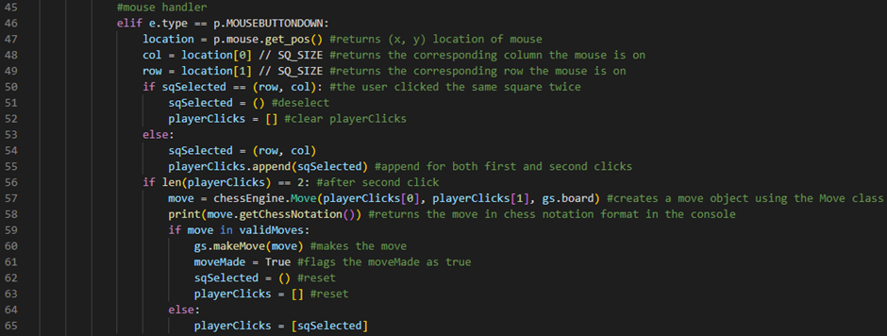

All we have to do is go into our chessMain.py file inside our main procedure and inside our mouse handler section of our code, we indent lines 62 and 63 so that they are inside our if statement. This now makes it so that our sqSelected tuple and playerClicks array are reset whenever a valid move is made. We then add an else statement on line 64 which will run if a move a player tried to make is not valid. If this is the case, line 65 will set the playerClicks array to an array with the new sqSelected tuple that the player just selected inside of it.

We can now run the program and test to see if our clicks are now working as expected:



So far, it’s working as we expect it to! We can now click on a piece to select it and then directly click on a different piece to select it and move it.

Check, checkmate and stalemate

Naïve algorithm

In chess, the game can end by either a stalemate or a checkmate. Now that all our pieces can move the way they are meant to on the board, we now need to program the checking, checkmating and stalemating functionality of our chess engine.

To be able to see if our king is in check or not we need to keep track of the kings’ locations. To do this, we’re going to need to go into our gameState class inside our constructor procedure:

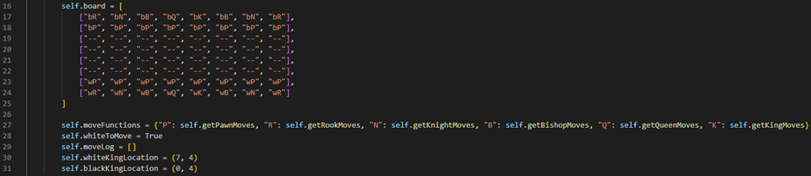

Line 30 defines a variable called whiteKingLocation which stores a tuple. This tuple stores the (row, column) coordinates of the white king piece on the board. Initially, this tuple will store (7, 4) as these are the starting coordinates of the white king piece. Line 31 defines a variable called blackKingLocation which stores a tuple. This tuple stores the (row, column) coordinates of the black king piece on the board. Initially, this tuple will store (0, 4) as these are the starting coordinates of the black king piece.

Next, we’re going to go into our makeMove method and update it so that we keep track of our kings’ locations whenever a move has been made:

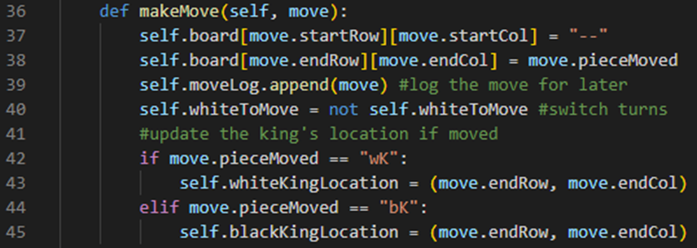

Line 42 is an if statement which will check if the piece we moved was a white king piece. It does this by evaluating if the move’s pieceMoved attribute has a value of the “wK” string. If it does, line 43 will update our white king’s location by setting the whiteKingLocation tuple to a tuple that stores our move’s endRow and endCol attributes. Line 44 is an if statement which will check if the piece we moved was a black king piece. It does this by evaluating if the move’s pieceMoved attribute has a value of the “bK” string. If it does, line 45 will update our black king’s location by setting the blackKingLocation tuple to a tuple that stores our move’s endRow and endCol attributes.

Next, we’re going to go into our undoMove method and update it so that we can keep track of our kings’ locations whenever a move has been undone:

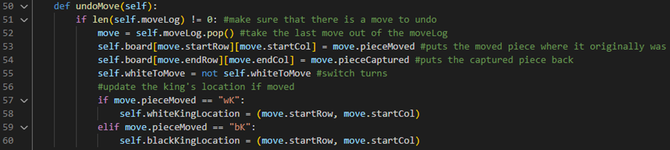

Line 57 is an if statement which will check if the piece of the move we undid was a white king piece. It does this by evaluating if the move’s pieceMoved attribute has a value of the “wK” string. If it does, line 58 will update our white king’s location by setting the whiteKingLocation tuple to a tuple that stores our move’s startRow and startCol attributes. Line 59 is an if statement which will check if the piece of the move we undid was a black king piece. It does this by evaluating if the move’s pieceMoved attribute has a value of the “bK” string. If it does, line 60 will update our black king’s location by setting the blackKingLocation tuple to a tuple that stores our move’s startRow and startCol attributes.

Now that we have our kings’ locations trackers set up, we are ready to move onto the logic behind generating valid moves.

This process will take 5 steps:

1. Generate all possible moves
2. For each move, make the move
3. Generate all of the opponent’s moves
4. For each of your opponent’s moves, check if your king is being attacked
5. If your king is not being attacked, it is a valid move

So, let’s go into our gameState class and create three new methods that will help us accomplish these steps:

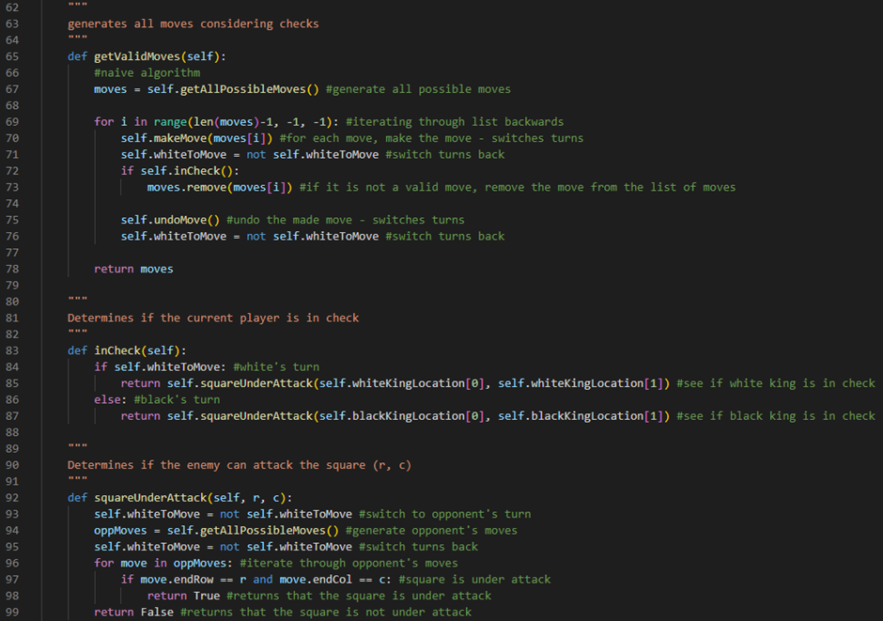

Line 65 defines our getValidMoves method. It will take no parameters. Line 67 runs our getAllPossibleMoves method and stores the product of running this method in a variable called moves. Line 69 starts a for loop which will loop through the moves array backwards. We will be looping through this array backwards because we will be removing elements from this array. When you remove elements from an array, the rest of the elements’ index values change and if you are looping through an array from start to finish you could potentially get an “array out of bound” error. Looping through the array backwards means that this error will never occur. Line 70 makes a move from our moves array. This will switch turns. Line 71 switches the player’s turn back by reversing the whiteToMove flag variable. Line 72 evaluates the product of running our inCheck method which will return either True if our king piece is in check or False if it is not. If our king piece is in check, then our move is not valid and line 73 removes it from our moves array by running the remove method of our moves array and passing moves[i] as an argument. Line 75 runs our undoMove method to undo the move we just made. This will switch turns. Line 76 switches the player’s turn back by reversing the whiteToMove flag variable. Line 78 then returns our final moves array with all of our valid moves in it.

Line 83 defines our inCheck method. It will take no parameters. Line 84 checks if the whiteToMove flag variable is set to True. If it is, then Line 85 will return the product of running our squareUnderAttack method given the first element of our whiteKingLocation tuple and the second element of our whiteKingLocation tuple as arguments. Line 86 is an else statement which will run if the whiteToMove flag variable is set to False. If it is, then line 87 will return the product of running our squareUnderAttack method given the first element of our blackKingLocation tuple and the second element of our blackKingLocation tuple as arguments.

Line 92 defines our squareUnderAttack method. It will take two parameters: r, the row of the square we are checking and c, the column of the square we are checking. Line 93 switches to the opponent’s turn by reversing the whiteToMove flag variable. Line 94 runs our getAllPossibleMoves method and stores the product of running this method in a variable called oppMoves. Line 95 switches the turns back by reversing the whiteToMove flag variable. Line 96 defines a for loop which will iterate through all through every move in oppMoves. Line 97 will then check if a square is under attack by evaluating if our move’s endRow attribute has the same value as our r variable and if our move’s endCol attribute has the same value as our c variable. If the square is under attack, then line 98 will return True. If no squares are under attack, then line 99 will return False.

We can now run the program and test to see if our checks work:



So far, it’s working as we expect it to! I am unable to move my pawn in front because it would leave my king in check.

Next, we need to program the end of a chess game - a checkmate or a stalemate.

To do this, we’re going to first add two more variables into our gameState class constructor:



Line 32 defines a flag variable called checkMate. This will initially be set to False. It will be set to True if our chess engine finds a checkmate. Line 33 defines a flag variable called staleMate. This will initially be set to False. It will be set to True if our chess engine finds a stalemate.

Next, we are going to go back into our getValidMoves method:

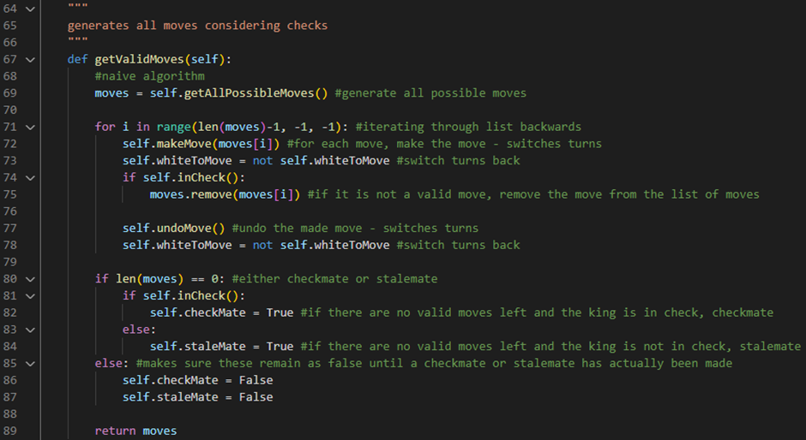

Line 80 determines if a checkmate or a stalemate has occurred by checking if our moves array is empty. If it is, then line 81 evaluates the product of running our inCheck method. If it returns True, then line 82 will set the checkMate flag variable to True. If it returns False, then line 84 will set the staleMate flag variable to True. If our moves array is not empty, then line 86 will make sure the checkMate flag variable remains as False by setting it to False and line 87 will make sure the staleMate flag variable remains as False by setting it to False.

We could test if our checkmate or stalemate code is working by printing these variables out, however, I am confident that this logic is correct for now and I will test these later on once we add some endgame text. Instead, I would like to actually make a change from my original design for our move validation algorithm.

Valid moves test table:

|  |  |  |
| --- | --- | --- |
| Test Data | Expected Outcome | Actual Outcome |
| First click on the board (Main Procedure) | When the user clicks on a piece on the board, the piece is selected. | As expected. |
| Second click on the board (Main Procedure) | When the user clicks on a square on the board that is for a valid move, the move is made on the board. | As expected. |

Advanced algorithm

The algorithm for our move validation that I used in our design for our chess engine and the one I have just implemented is one I like to call the naïve algorithm. I call it this because it inefficiently finds if our king is in check by going through and generating all of our moves and then all of our opponent’s moves and seeing if in any of the opponent’s moves the king is under attack. If it is, then it is not a valid move. This is a very inefficient and lazy way of solving this problem. However, there is a more efficient and complex way of doing it.

This more efficient and complex algorithm is one that I like to call the advanced algorithm. The main difference between the naïve algorithm and the advanced algorithm is that the advanced algorithm not only looks if a piece is going to be in check but it also looks for something in chess called pins. A pin in chess is a tactic in which a defending piece cannot move out of an attacking piece’s line of attack without exposing a more valuable defending piece. In our algorithm, we are going to be looking for pins against our king. It is also going to be looking for another thing in chess called a double check. This is when two pieces are checking the king, meaning that the only way the king can get out of the check is by moving.

So, let’s begin by going into our gameState class constructor and adding three new attributes:

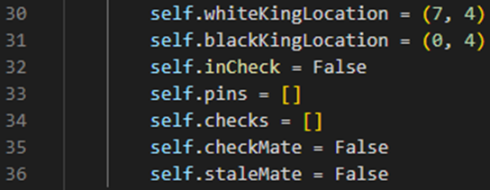

Line 32 defines a flag variable called inCheck. This will initially be set to False. It will be set to True if our chess engine finds a check on our king. Line 33 defines a variable called pins which is initially set to an empty array. This array will store any pins from other pieces that we find on our king. Line 34 defines a variable called checks which is initially set to an empty array. This array will store any checks from other pieces that we find on our king.

Next, we will write a new method for our gameState class called checkForPinsAndChecks:

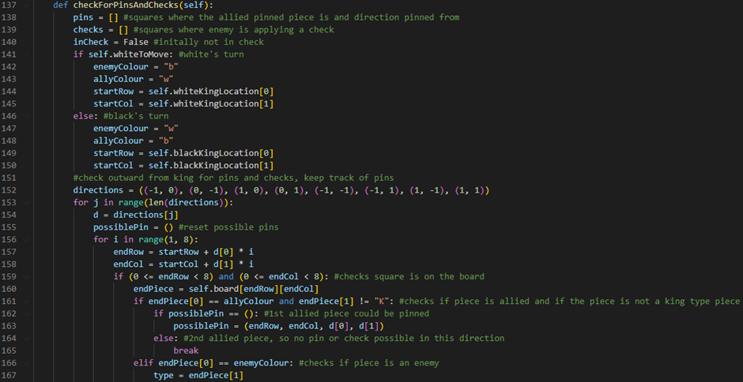

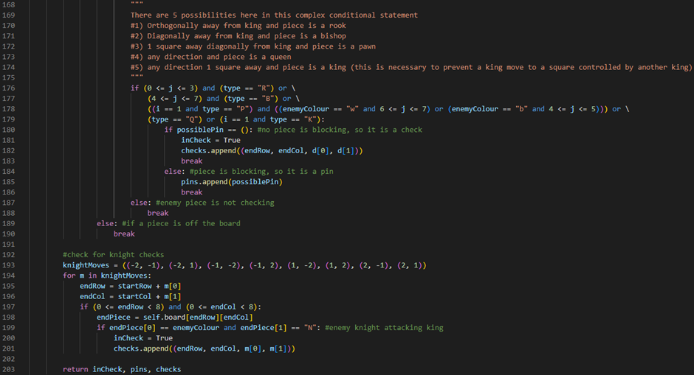

Line 137 defines our checkForPinsAndChecks method. It will take no parameters. Line 138 defines a variable called pins which initially stores an empty array. It will be used to store squares where allied pinned pieces are and the direction they are pinned from. Line 139 defines a variable called checks which initially stores an empty array. It will be used to store squares where enemy pieces are applying a check to the king and the direction they are checking from. Line 140 defines a flag variable called inCheck which will initially be set to False. It will be set to True if we find that the king is in check by an enemy piece. Line 141 checks if it is white’s turn to move by evaluating if the whiteToMove flag variable is set to True. If it is, then line 142 will define a variable called enemyColour and set it to “b”, line 143 will define a variable called allyColour and set it to “w”, line 144 will define a variable called startRow and set it to the first element of our whiteKingLocation tuple and line 145 will define a variable called startCol and set it to the second element of our whiteKingLocation tuple. Line 146 is an else statement which will run if the whiteToMove flag variable is set to False. If this is the case, then line 147 will define a variable called enemyColour and set it to “w”, line 148 will define a variable called allyColour and set it to “b”, line 149 will define a variable called startRow and set it to the first element of our blackKingLocation tuple and line 150 will define a variable called startCol and set it to the second element of our blackKingLocation tuple. Line 152 defines a 2D tuple called directions. Every tuple inside this 2D tuple represents a direction around the king piece. For example, (-1, 0) is down the x-axis of the board, (0, -1) is down the y-axis of the board, (1, 0) is up the x-axis of the board, (0, 1) is up the y-axis of the board, (-1, -1) is down 1 square on the x-axis and down 1 square on the y-axis, (-1, 1) is down 1 square on the x-axis and up 1 square on the y-axis, (1, -1) is up 1 square on the x-axis and down 1 square on the y-axis and (1, 1) is up 1 square on the x-axis and up 1 square on the y-axis. Line 153 defines a for loop which will iterate through our directions 2D tuple. Line 154 defines a variable called d which stores the current direction tuple from our directions 2D tuple that we are evaluating. Line 155 defines a variable called possiblePin which is set to an empty tuple. Line 156 defines a for loop which will iterate through 8 times (once for each square possible on the board in a given direction). Line 157 defines a variable called endRow which stores the row our allied pinned piece or enemy checking piece is on. It does this by taking our startRow variable and adding to it the first element of our current direction tuple, d, multiplied by our for loop counter variable, i. Line 158 defines a variable called endCol which stores the column our allied pinned piece or enemy checking piece is on. It does this by taking our startCol variable and adding to it the second element of our current direction tuple, d, multiplied by our for loop counter variable, i. Line 159 checks if the square we are looking at is actually on the board. It does this by evaluating if endRow is greater than or equal to 0 and if endRow is less than 8 and if endCol is greater than or equal to 0 and if endCol is less than 8. Line 160 defines a variable called endPiece which returns the square we are looking at on the board by returning the element stored on our 2D array board attribute at the (endRow, endCol) position. Line 161 checks if the piece we are looking at is allied and if the piece is not a king type piece by checking if the first character of our endPiece variable has the same value as our allyColour variable and the second character of our endPiece variable does not have a value of the “K” character. Line 162 checks if our possiblePin tuple is still an empty tuple. If it is, then line 163 will set our possiblePin tuple to a tuple that stores our endRow variable, our endCol variable, first element of our direction tuple d and second element of our direction tuple d. Line 164 is an else statement which will run if our possiblePin tuple is not empty. If this is the case, line 165 will run a break command which will break us out of our for loop because there are no pins or checks possible in this direction. Line 166 checks if the first character of our endPiece variable has the same value as our enemyColour variable. If this is the case, line 167 will define a variable called type which will store the second character of our endPiece variable. Lines 176-179 is an if statement which checks a complex conditional statement. This complex conditional statement checks for 5 possibilities:

1. The piece we are looking at is orthogonally away from the king and the piece is a rook
2. The piece we are looking at is diagonally away from the king and the piece is a bishop
3. The piece we are looking at is one square away diagonally from the king and the piece is a pawn
4. The piece we are looking at is in the direction of the king from any direction and the piece is a queen
5. The piece we are looking at is one square away from the king and the piece is a king.

These 5 possibilities are checked by checking if our j counter variable is between 0 and 3 and if our type variable stores a value of the character “R” (line 176), or if our j counter variable is between 4 and 7 and if our type variable stores a value of the character “B” (line 177), or if our i counter variable stores a value of the integer 1 and if our type variable stores a value of the character “P” and our enemyColour variable stores a value of the character “w” and our j counter variable is between 6 and 7 or our enemyColour variable stores a value of the character “b” and our j counter variable is between 4 and 5 (line 178), or if our type variable stores a value of the character “Q” or if our i counter variable stores a value of the integer 1 and if our type variable stores a value of the character “K” (line 179). If this complex conditional statement returns True, then line 180 will check if our possiblePin tuple is still an empty tuple. If it is, then line 181 will set our inCheck flag variable to True. Line 182 will then append a tuple storing our endRow variable, our endCol variable, first element of our direction tuple, d, and second element of our direction tuple, d, to our checks array. Line 183 will then run a break command which will break us out of our for loop. Line 184 is an else statement which will run if our possiblePin tuple is not empty. If this is the case, line 185 will append our possiblePin tuple to our pins array. Line 186 will then run a break command which will break us out of our for loop. Line 187 is an else statement which will run if the complex conditional statement returns False. If this is the case, then line 188 will run a break command which will break us out of our for loop. Line 189 is an else statement which will run if the square we are looking at does not exist on the board. If this is the case, line 190 will run a break command which will break us out of our for loop. Line 193 defines a 2D tuple called knightMoves. Every tuple inside this 2D tuple represents a knight piece’s possible move. For example, (-2, -1) is down 2 squares on the x-axis and down 1 square on the y-axis, (-2, 1) is down 2 squares on the x-axis and up 1 square on the y-axis, (-1, -2) is down 1 square on the x-axis and down 2 squares on the y-axis, (-1, 2) is down 1 square on the x-axis and up 2 squares on the y-axis, (1, -2) is up 1 square on the x-axis and down 2 squares on the y-axis, (1, 2) is up 1 square on the x-axis and up 2 squares on the y-axis, (2, -1) is up 2 squares on the x-axis and down 1 square on the y-axis and (2, 1) is up 2 squares on the x-axis and up 1 square on the y-axis. Line 194 defines a for loop which will iterate through every move, m, in our knightMoves 2D tuple. Line 195 defines a variable called endRow which will store the row of our checking knight piece. It does this by taking our startRow variable and adding to it the first element of our m tuple. Line 196 defines a variable called endCol which will store the column of our checking knight piece. It does this by taking our startCol variable and adding to it the second element of our m tuple. Line 197 checks if the square we are looking at is actually on the board. It does this by evaluating if endRow is greater than or equal to 0 and if endRow is less than 8 and if endCol is greater than or equal to 0 and if endCol is less than 8. Line 198 defines a variable called endPiece which returns the square we are looking at on the board by returning the element stored on our 2D array board attribute at the (endRow, endCol) position. Line 199 checks if an enemy knight is attacking the king piece by checking if the first character of our endPiece variable has the same value as our enemyColour variable and if the second character of our endPiece variable has a value of the character “N”. If this is the case, then line 200 will set our inCheck flag variable to True and line 201 will append a tuple storing our endRow variable, our endCol variable, first element of our move tuple, m, and second element of our move tuple, m, to our checks array. Line 203 will then return our inCheck flag variable, our pins array and our checks array.

Next, we are going to go into our getValidMoves method and comment out our naive algorithm from before:

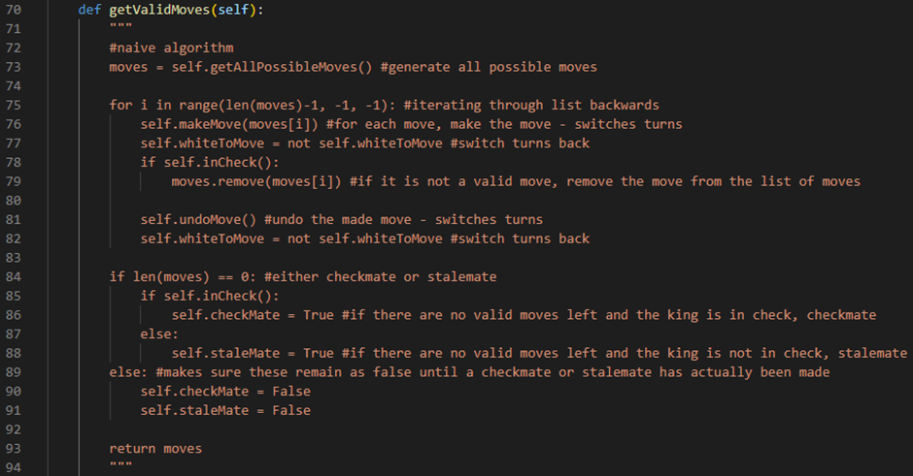

Next, we are going to write our advanced algorithm version of our getValidMoves method:

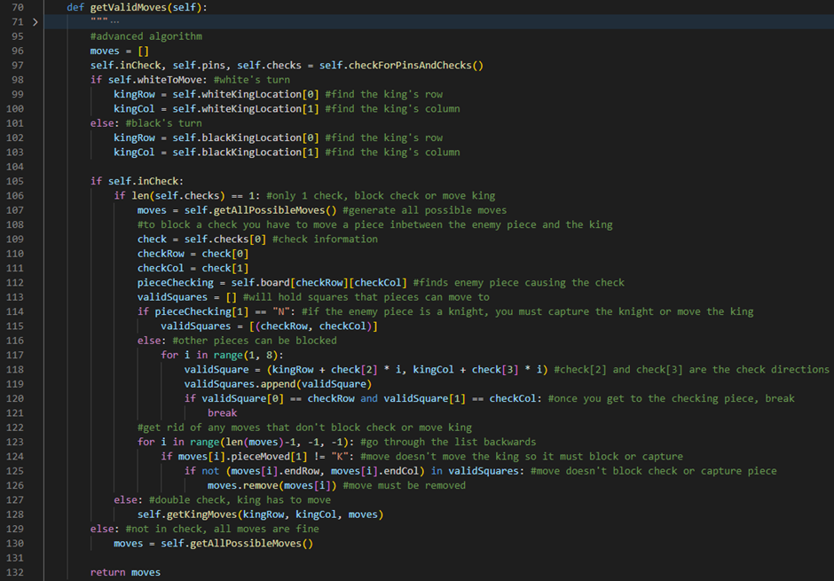

Line 70 defines our getValidMoves method. It will take no parameters. Line 96 defines a variable called moves which will initially store an empty array. Line 97 updates our gameState object’s inCheck flag variable, pins array and checks array by storing the product of running our checkForPinsAndChecks method. Line 98 checks if it is white’s turn to move by evaluating if the whiteToMove flag variable is set to True. If it is, then line 99 will define a variable called kingRow which will store the first element of our gameState object’s whiteKingLocation tuple and line 100 will define a variable called kingCol which will store the second element of our gameState object’s whiteKingLocation tuple. Line 101 is an else statement which will run if the whiteToMove flag variable is set to False. If it is, then line 102 will define a variable called kingRow which will store the first element of our gameState object’s blackKingLocation tuple and line 103 will define a variable called kingCol which will store the second element of our gameState object’s blackKingLocation tuple. Line 105 checks if our gameState object’s inCheck variable is set to True. If it is, then line 106 will check if our gameState object’s checks array has only 1 element inside it. If it does, then line 107 will store the product of running our getAllPossibleMoves method inside our moves variable. Line 109 defines a variable called check which will store our check data by storing the first element of our checks array. Line 110 will then define a variable called checkRow which will store the row of our checking enemy piece by storing the first element of our check variable. Line 111 will then define a variable called checkCol which will store the column of our checking enemy piece by storing the second element of our check variable. Line 112 defines a variable called pieceChecking which stores the enemy piece that is causing the check by returning the element stored on our gameState object’s 2D array board attribute at the (checkRow, checkCol) position. Line 113 defines a variable called validSquares which initially stores an empty array. This array will later hold squares that pieces can move to. Line 114 checks if the enemy piece is a knight by evaluating if the second character of our pieceChecking variable has a value of the character “N”. If this is the case, then you must capture the knight or move the king so line 115 will set our validSquares variable to an array that stores a tuple which stores our checkRow variable and our checkCol variable. Line 116 is an else statement which will run if the enemy piece is not a knight. If this is the case, line 117 will define a for loop that runs 7 times (once for each square from the king, except for the king’s square). Line 118 will then define a variable called validSquare which will store a tuple. This tuple will store our kingRow variable plus the third element of our check variable multiplied by our counter variable, i, and our kingCol variable plus the fourth element of our check variable multiplied by our counter variable, i. Line 119 will then add our validSquare variable to our validSquares array by using the validSquares array’s append method and giving our validSquare variable as an argument. Line 120 checks if we have gotten up to our checking piece by evaluating if the first element of our validSquare tuple has the same value as our checkRow variable and if the second element of our validSquare tuple has the same value as our checkCol variable. If this is the case, then line 121 will run a break command which will break us out of our for loop. Line 123 defines a for loop which will loop through the moves array backwards. We will be looping through this array backwards because we will be removing elements from this array. When you remove elements from an array, the rest of the elements’ index values change and if you are looping through an array from start to finish you could potentially get an “array out of bound” error. Looping through the array backwards means that this error will never occur. Line 124 checks if the current move we are looking at has a pieceMoved attribute that is not equal to the character “K”. If this is the case, then the move does not move the king so it must block the check or capture the checking enemy piece. Line 125 checks if the current move we are looking at has an end square that is not in our validSquares array. It does this by taking our current move’s endRow attribute and endCol attribute in a tuple and evaluating if this does not match any of the tuples inside of our validSquares array. If this is the case, then the move does not block the check or capture the checking enemy piece so line 126 will remove this move from our moves array by running the remove method of our moves array and passing moves[i] as an argument. Line 127 is an else statement which will run if our checks array has more than one element inside of it. If this is the case, then a double check has occurred which means the king must move to get out of it. Line 128 will run our getKingMoves method given the kingRow variable, kingCol variable and moves array as arguments. Line 129 is an else statement which will run if our gameState object’s inCheck flag variable is set to False. If this is the case, then our king is not in check and all our moves are fine. Line 130 will set our moves variable to the product of running our getAllPossibleMoves method. Line 132 will then return our final moves array.

Now, so far, our algorithm is successfully looking for checks but doesn’t do anything about pinned pieces. To do something about our pinned pieces, we are going to need to modify all of our move functions for each piece.

Firstly, let’s update our getPawnMoves method:

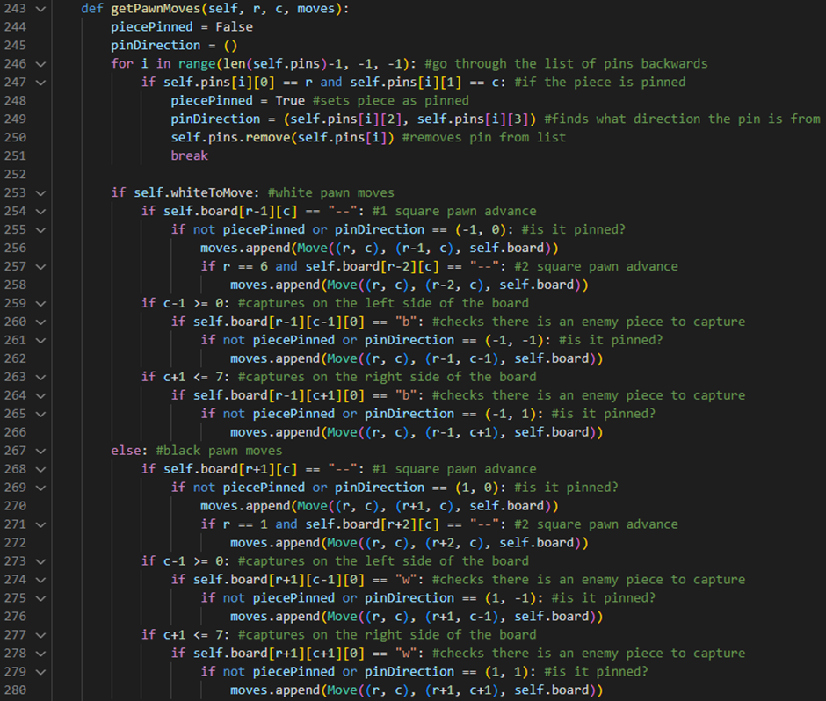

Line 244 defines a flag variable called piecePinned. It will initially be set to False. It will return True if the pawn we are generating the moves for is pinned. Line 245 defines an empty tuple called pinDirection. This tuple will store the directions of our pin. Line 246 defines a for loop which will loop through the pins array backwards. We will be looping through this array backwards because we will be removing elements from this array. When you remove elements from an array, the rest of the elements’ index values change and if you are looping through an array from start to finish you could potentially get an “array out of bound” error. Looping through the array backwards means that this error will never occur. Line 247 checks if the pawn is pinned by evaluating if the pin we are looking at has a first element that has the same value as our r variable and if its second element has the same value as our c variable. If this is the case, then line 248 will set the piecePinned flag variable to True. Line 249 will set our pinDirection tuple to a tuple containing the third element and fourth element of the pin we are looking at. Line 250 will remove the pin we are looking at from our array of pins by running the remove method of our pins array and passing pins[i] as an argument. Line 251 will then run a break command which will break us out of our for loop. Line 255 checks if our pawn is not being pinned by checking if piecePinned is set to False or if pinDirection has a value of the tuple (-1, 0). If this is the case, then our pawn can make the following move. Line 261 checks if our pawn is not being pinned by checking if piecePinned is set to False or if pinDirection has a value of the tuple (-1, -1). If this is the case, then our pawn can make the following move. Line 265 checks if our pawn is not being pinned by checking if piecePinned is set to False or if pinDirection has a value of the tuple (-1, 1). If this is the case, then our pawn can make the following move. Line 269 checks if our pawn is not being pinned by checking if piecePinned is set to False or if pinDirection has a value of the tuple (1, 0). If this is the case, then our pawn can make the following move. Line 275 checks if our pawn is not being pinned by checking if piecePinned is set to False or if pinDirection has a value of the tuple (1, -1). If this is the case, then our pawn can make the following move. Line 279 checks if our pawn is not being pinned by checking if piecePinned is set to False or if pinDirection has a value of the tuple (1, 1). If this is the case, then our pawn can make the following move.

Secondly, let’s update our getRookMoves method:

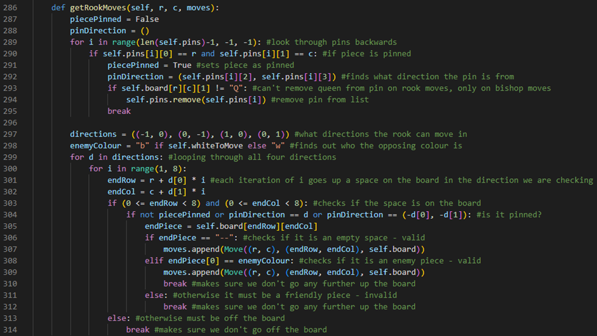

Line 287 defines a flag variable called piecePinned. It will initially be set to False. It will return True if the rook we are generating the moves for is pinned. Line 288 defines an empty tuple called pinDirection. This tuple will store the directions of our pin. Line 289 defines a for loop which will loop through the pins array backwards. We will be looping through this array backwards because we will be removing elements from this array. When you remove elements from an array, the rest of the elements’ index values change and if you are looping through an array from start to finish you could potentially get an “array out of bound” error. Looping through the array backwards means that this error will never occur. Line 290 checks if the rook is pinned by evaluating if the pin we are looking at has a first element that has the same value as our r variable and if its second element has the same value as our c variable. If this is the case, then line 291 will set the piecePinned flag variable to True. Line 292 will set our pinDirection tuple to a tuple containing the third element and fourth element of the pin we are looking at. Line 293 checks if the piece we are generating the moves for is not a queen by evaluating if the second character of the element stored on our 2D board array attribute at the position (r, c) does not have a value of the character “Q”. This is because we do not want to remove queens from pins on rook moves, only on bishop moves. If this is the case, then line 294 will remove the pin we are looking at from our array of pins by running the remove method of our pins array and passing pins[i] as an argument. Line 295 will then run a break command which will break us out of our for loop. Line 304 checks if our rook is not being pinned by checking if piecePinned is set to False or if pinDirection has the same value as our d variable or if our pinDirection stores a tuple containing the reverse of the first element of our d variable and the reverse of the second element of our d variable. If this is the case, then our rook can make the following move.

Thirdly, let’s update our getKnightMoves method:

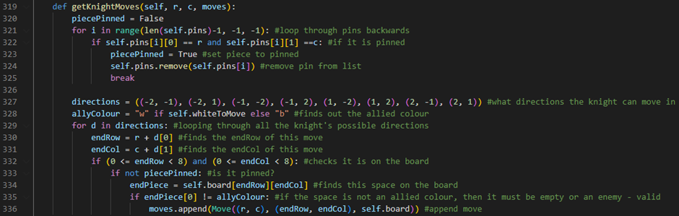

Line 320 defines a flag variable called piecePinned. It will initially be set to False. It will return True if the knight we are generating the moves for is pinned. Line 321 defines a for loop which will loop through the pins array backwards. We will be looping through this array backwards because we will be removing elements from this array. When you remove elements from an array, the rest of the elements’ index values change and if you are looping through an array from start to finish you could potentially get an “array out of bound” error. Looping through the array backwards means that this error will never occur. Line 322 checks if the knight is pinned by evaluating if the pin we are looking at has a first element that has the same value as our r variable and if its second element has the same value as our c variable. If this is the case, then line 323 will set the piecePinned flag variable to True. Line 324 will remove the pin we are looking at from our array of pins by running the remove method of our pins array and passing pins[i] as an argument. Line 325 will then run a break command which will break us out of our for loop. Line 333 checks if our knight is not being pinned by checking if piecePinned is set to False. If this is the case, then our knight can make the following move.

Fourthly, let’s update our getBishopMoves method:

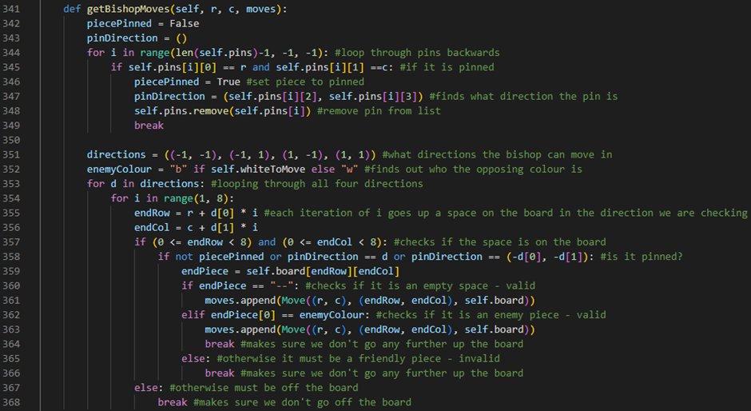

Line 342 defines a flag variable called piecePinned. It will initially be set to False. It will return True if the bishop we are generating the moves for is pinned. Line 343 defines an empty tuple called pinDirection. This tuple will store the directions of our pin. Line 344 defines a for loop which will loop through the pins array backwards. We will be looping through this array backwards because we will be removing elements from this array. When you remove elements from an array, the rest of the elements’ index values change and if you are looping through an array from start to finish you could potentially get an “array out of bound” error. Looping through the array backwards means that this error will never occur. Line 345 checks if the bishop is pinned by evaluating if the pin we are looking at has a first element that has the same value as our r variable and if its second element has the same value as our c variable. If this is the case, then line 346 will set the piecePinned flag variable to True. Line 347 will set our pinDirection tuple to a tuple containing the third element and fourth element of the pin we are looking at. Line 348 will remove the pin we are looking at from our array of pins by running the remove method of our pins array and passing pins[i] as an argument. Line 349 will then run a break command which will break us out of our for loop. Line 358 checks if our bishop is not being pinned by checking if piecePinned is set to False or if pinDirection has the same value as our d variable or if our pinDirection stores a tuple containing the reverse of the first element of our d variable and the reverse of the second element of our d variable. If this is the case, then our bishop can make the following move.

Lastly, let’s update our getKingMoves method:

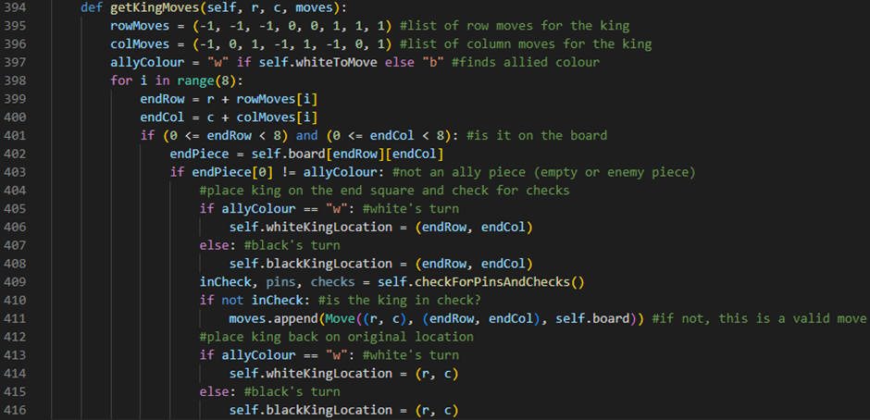

Line 394 defines our getKingMoves method. It will take three parameters: the row, r, and the column, c, of the king we are generating the moves for and our current moves array. Line 395 defines a variable called rowMoves which stores a tuple. Each element inside this tuple represents a row direction that our king piece could move towards. Line 396 defines a variable called colMoves which stores a tuple. Each element inside this tuple represents a column direction that our king piece could move towards. Line 397 defines a variable called allyColour which returns “w” if the whiteToMove flag variable is set to True or returns “b” if the whiteToMove flag variable is set to False. Line 398 defines a for loop which will run eight times (once for each square around the king). Line 399 defines a variable called endRow which stores the row we are going to move the king to on a given move. It does this by taking the start row of the move, r, and adding to it the ith element of our rowMoves tuple. Line 400 defines a variable called endCol which stores the column we are going to move the king to on a given move. It does this by taking the start column of the move, c, and adding to it the ith element of our colMoves tuple. Line 401 checks if the square we are looking at is actually on the board. It does this by evaluating if endRow is greater than or equal to 0 and if endRow is less than 8 and if endCol is greater than or equal to 0 and if endCol is less than 8. Line 402 defines a variable called endPiece which returns the square we are looking at on the board by returning the element stored on our 2D array board attribute at the (endRow, endCol) position. Line 403 checks if the square we are looking at is not an ally piece by evaluating if the first character of our endPiece variable does not have the same value as our allyColour variable. If this is the case, then the endPiece must be an empty square or an enemy piece. Line 405 will then check if it is white’s turn to move by checking if our allyColour variable stores a value of the character “w”. If it does then line 406 will set our whiteKingLocation to a tuple containing our endRow and endCol variables. Line 407 is an else statement which will run if it is black’s turn to move. Line 408 will set our blackKingLocation to a tuple containing our endRow and endCol variables. Line 409 will define an inCheck variable, pins variable and checks variable by storing the product of running our checkForPinsAndChecks method. Line 410 will check if the king is not in check by evaluating if the inCheck variable is set to False. If this is the case, then line 411 will append this king move to our moves array by calling the append method of our moves array and creating a Move object (with a startSq of (r, c), and endSq of (endRow, endCol) and a board of our current board attribute) to give as an argument. Line 413 will then check if it is white’s turn to move by checking if our allyColour variable stores a value of the character “w”. If it does then line 414 will set our whiteKingLocation to a tuple containing our r and c variables. Line 415 is an else statement which will run if it is black’s turn to move. Line 416 will set our blackKingLocation to a tuple containing our r and c variables.

You may have noticed that we haven’t checked to see if the queen is being pinned. This is because the queen’s moves are obtained by calling the getBishopMoves method and the getRookMoves method. Since these functions already get rid of any pins on them, we don’t have to modify the getQueenMoves method at all.

We can now run the program and test to see if our advanced algorithm works:



So far, it’s working as we expect it to! Our king is in checkmate and cannot move.

Next, we’re just going to add some checkmate or stalemate logic for our advanced algorithm into our getValidMoves method:

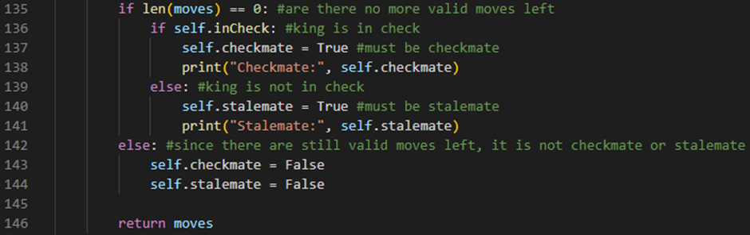

Line 135 checks if our moves array has no elements inside of it. If this is the case, then line 136 will check if our gameState object’s inCheck attribute is set to True. If it is, then line 137 will set our gameState object’s checkmate attribute to True. Line 138 will then print to the console “Checkmate:” followed by our gameState object’s checkmate attribute. Line 139 is an else statement which will run if our gameState object’s inCheck attribute is set to False. If it is, then line 140 will set our gameState object’s stalemate attribute to True. Line 141 will then print to the console “Stalemate:” followed by our gameState object’s stalemate attribute. Line 142 is an else statement which will run if our moves array has elements inside of it. If this is the case, then line 143 will set our gameState object’s checkmate attribute to False and line 144 will set our gameState object’s stalemate attribute to False.

We can now run the program and test to see if our checkmate or stalemate logic works:



Console:

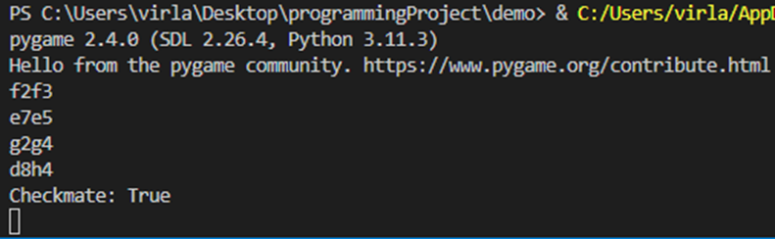

So far, it’s working as we expect it to! Our king has been checkmated and our chess engine has also calculated this.

## Second Prototype

During the development of this prototype, my goal is to work on additional features of our chessMain.py and chessEngine.py files that were not originally included in our design for the chess engine application. These features are mostly additions that have been recommended by my stakeholders and it will include things such as special moves, move animation, move highlighting, a reset board functionality and some endgame text.

Pawn promotion and en passant

Next, my stakeholder has actually asked me to implement special moves in our chess engine in order for it to replicate a real life game of chess and its rules. These special moves are pawn promotion, en passant and castling. For now, we are going to be focusing on pawn promotion and en passant because these two moves revolve around how our pawns behave.

A pawn promotion is a move that happens whenever a pawn reaches the end of the chessboard. The pawn that has reached the end of the chessboard can then choose to promote to any other piece except for a king. En passant is a more rare chess move that describes the capture by a pawn of an enemy on the same rank and an adjacent file that has just made an initial two-square advance. The capturing pawn moves to the square that the enemy pawn passed over, as if the enemy pawn had advanced only one square.

The way we are going to implement pawn promotion moves and en passant moves is by using flag variables which will be set to True whenever a pawn promotion move or an en passant move has been made. However, for this to work, we need to open our chessMain.py file and go into our main procedure and update our mouse handler code:

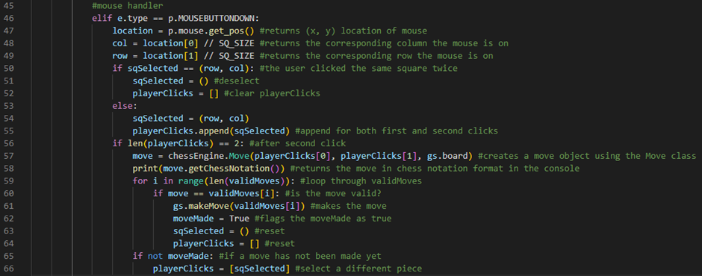

Line 59 defines a for loop which will iterate through our validMoves array. Line 60 checks if our move variable is the same as the current element we are iterating through from our validMoves array. If it is then line 61 will make the move from our validMoves array. The difference between this code and our previous code is that in this code we are making the move generated by our chess engine rather than the move generated by our user’s clicks. Line 65 checks if our moveMade flag variable is set to False. If it is then line 66 will set our playerClicks array to an array containing our sqSelected tuple. This code does the same thing as it did before where it lets us directly click on a different piece to select it rather than having to deselect our current piece and then select a different one.

Next, we’re going to start working on our pawn promotion moves. The way this is going to work is, we’re going to have a flag variable that is going to be set to True whenever a pawn reaches the back rank. So, whenever a white pawn reaches row 0 or whenever a black pawn reaches row 7, it can be promoted to a different piece except for a king. The information required for this to work is going to be stored in our Move objects.

So, we’re going to go into our Move class constructor procedure and update it:

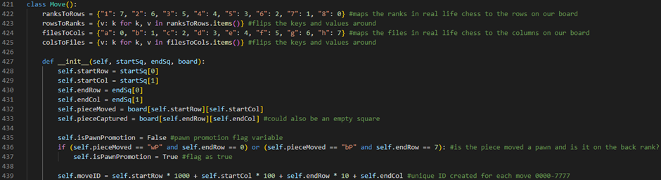

Line 435 defines an attribute called isPawnPromotion. This attribute is a flag variable that will initially be set to False. It will be set to True whenever the player has made a pawn promotion move. Line 436 checks if a move is a pawn promotion move by checking if the pieceMoved attribute has a value of the string “wP” and the endRow attribute has a value of the integer 0 or if the pieceMoved attribute has a value of the string “bP” and the endRow attribute has a value of the integer 7. If this is the case then line 437 will set our isPawnPromotion flag variable attribute to True.

Next, we need to go into our makeMove method and update it:

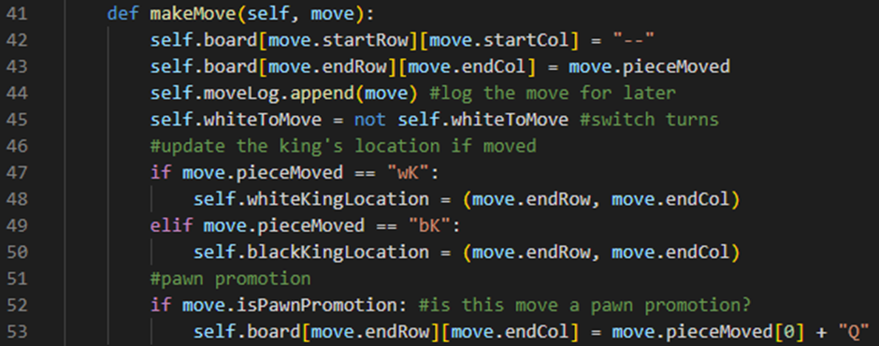

Line 52 checks if our move’s isPawnPromotion flag variable attribute is set to True. If it is, then line 53 will turn our pawn into a queen by accessing the element stored in our gameState object’s 2D array board attribute at our move’s endRow attribute and endCol attribute position and setting this element to the first character of our move’s pieceMoved attribute plus the character “Q”.

We can now run the program and test to see if our pawn promotion logic works:



So far, it’s working as we expect it to! When our pawns reach their respective back ranks they turn into queen type pieces.

However, in a real game of chess you can actually choose what piece you want to promote into. To add this functionality we are going to go back into our makeMove method and update our pawn promotion section of code:

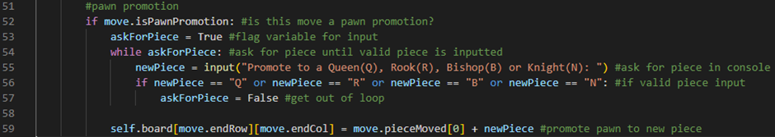

Line 52 checks if our move’s isPawnPromotion flag variable attribute is set to True. If it is, then line 53 will define a flag variable called askForPiece. It will initially be set to True. It will be set to False when our player has inputted a valid piece that they want to promote to. Line 54 defines a while loop which will run while our askForPiece flag variable is set to True. Whilst this is the case, line 55 will define a variable called newPiece which will output the string: “Promote to a Queen(Q), Rook(R), Bishop(B) or Knight(N): ” and store the user’s input. Line 56 will then check if our newPiece variable stores a value of the character “Q”, “R”, “B” or “N”. If this is the case, then line 57 will set our askForPiece flag variable to False and break us out of the while loop. The user will be asked to input a piece type until they have inputted a valid one. Once they have, line 59 will turn our pawn into the piece type they want to promote to by accessing the element stored in our gameState object’s 2D array board attribute at our move’s endRow attribute and endCol attribute position and setting this element to the first character of our move’s pieceMoved attribute plus our newPiece variable.

We can now run the program and test to see if our new pawn promotion logic works:



Console:

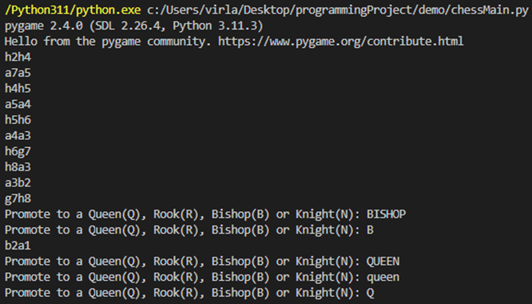

So far, it’s working as we expect it to! When our pawns reach their respective back ranks they turn into whatever type of piece we want to promote it to.

However, this solution, although it works, is still not ideal because our user has to tab out and type what piece they would like to promote to the console.

Next, we can work on our en passant moves.

To do this, firstly, we are going to need to go into our gameState class constructor procedure and update it:

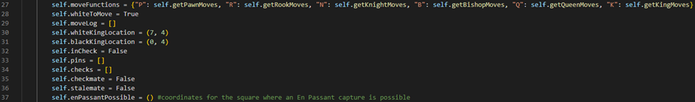

Line 37 defines an attribute called enPassantPossible which stores an empty tuple. This will later on store (row, col) coordinates for the square where an en passant capture is possible.

Next, we’re going to go into our Move class constructor procedure and update it:

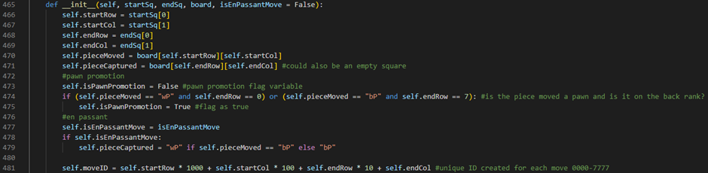

On line 465 we have added an optional parameter called isEnPassantMove and we have set the default value of this optional parameter to the boolean value of False. Line 477 defines an attribute called isEnPassantMove. This attribute is a flag variable that will be set to the value of our optional parameter isEnPassantMove. Line 478 checks if our isEnPassantMove attribute is set to True. If it is, then line 479 sets our pieceCaptured attribute to the string “wP” if our pieceMoved attribute is set to the string “bP” otherwise our pieceCaptured attribute will be set to the string “bP”. This tells our chess engine what piece was captured when the en passant move was made.

An en passant move is always a capture move. Knowing this, let’s go into our getPawnMoves method and update our capture piece code accordingly:

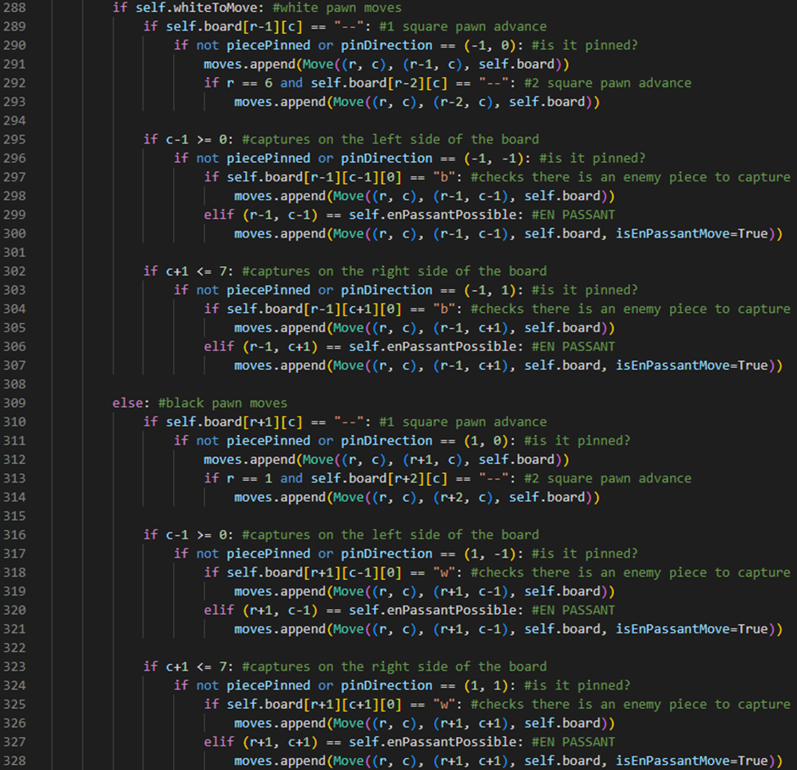

Line 299 is an if statement which checks if a tuple containing r-1 and c-1 (our end row and end column on this move) is the same as our gameState object’s enPassantPossible attribute. If this is the case, then line 300 will append this en passant capture move to our moves array by calling the append method of our moves array and creating a Move object (with a startSq of (r, c), an endSq of (r-1, c-1), a board of our current board attribute and an isEnPassantMove flag variable set to True) to give as an argument. Line 306 is an if statement which checks if a tuple containing r-1 and c+1 (our end row and end column on this move) is the same as our gameState object’s enPassantPossible attribute. If this is the case, then line 307 will append this en passant capture move to our moves array by calling the append method of our moves array and creating a Move object (with a startSq of (r, c), an endSq of (r-1, c+1), a board of our current board attribute and an isEnPassantMove flag variable set to True) to give as an argument. Line 320 is an if statement which checks if a tuple containing r+1 and c-1 (our end row and end column on this move) is the same as our gameState object’s enPassantPossible attribute. If this is the case, then line 321 will append this en passant capture move to our moves array by calling the append method of our moves array and creating a Move object (with a startSq of (r, c), an endSq of (r+1, c-1), a board of our current board attribute and an isEnPassantMove flag variable set to True) to give as an argument. Line 327 is an if statement which checks if a tuple containing r+1 and c+1 (our end row and end column on this move) is the same as our gameState object’s enPassantPossible attribute. If this is the case, then line 328 will append this en passant capture move to our moves array by calling the append method of our moves array and creating a Move object (with a startSq of (r, c), an endSq of (r+1, c+1), a board of our current board attribute and an isEnPassantMove flag variable set to True) to give as an argument.

Next, we’re going to go into our makeMove method and update it:

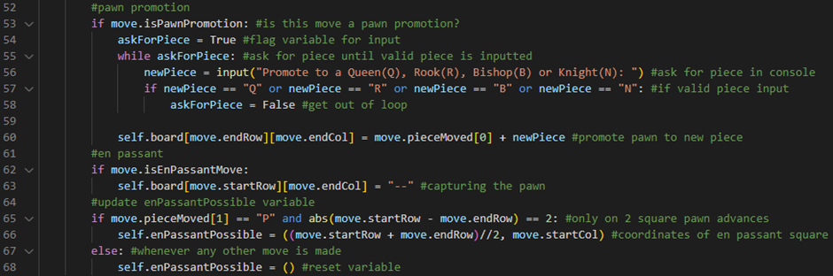

Line 62 checks if our move’s isEnPassantMove flag variable is set to True. If it is, then line 63 will set the element stored on our 2D array board attribute at our move’s startRow attribute and endCol attribute position to the string “--”. This line of code makes the en passant capture. Line 65 checks if the move we made was a 2 square pawn advance by evaluating if the second character of our move’s pieceMoved attribute has a value of the character “P” and the absolute difference of our move’s startRow attribute and endRow attribute is equal to 2. If this is the case, then line 66 will set our gameState object’s enPassantPossible attribute to a tuple containing our move’s startRow attribute plus our move’s endRow attribute divided by 2 and our move’s startCol attribute. In other words, this tuple will contain the coordinates of our en passant square. Line 67 is an else statement which will run if the move we made was not a 2 square pawn advance. If this is the case, then line 68 will set our gameState object’s enPassantPossible attribute to an empty tuple. This is because whenever any other move has been made, we want to reset our enPassantPossible attribute.

Finally, we’re going to go into our undoMove method and update it:

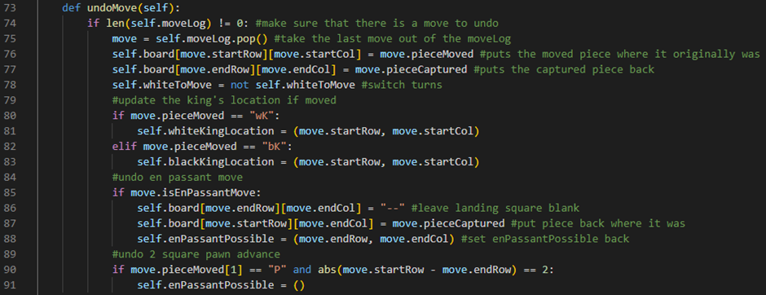

Line 85 checks if our move’s isEnPassantMove flag variable is set to True. If it is, then line 86 will leave our landing square empty by setting the element stored on our 2D array board attribute at our move’s endRow attribute and endCol attribute position to the string “--”. Line 87 will then put our captured piece back where it was by setting the element stored on our 2D array board attribute at our move’s startRow attribute and endCol attribute position to our move’s pieceCaptured attribute. Line 88 will then set our enPassantPossible tuple back by setting it to a tuple containing our move’s endRow attribute and endCol attribute. Line 90 checks if the move we made was a 2 square pawn advance by evaluating if the second character of our move’s pieceMoved attribute has a value of the character “P” and the absolute difference of our move’s startRow attribute and endRow attribute is equal to 2. If this is the case, then line 91 will set our gameState object’s enPassantPossible attribute to an empty tuple.

We can now run the program and test to see if our enPassant moves work:



So far, it’s working as we expect it to! This concludes our work on our pawns’ behaviour. They can now capture en passant and be promoted.

Castling

Castling is a move in chess which consists of moving the king two squares towards a rook on the same rank and then moving the rook to the square that the king passed over. Castling is permitted only if neither the king nor the rook has previously moved; the squares between the king and the rook are vacant; and the king does not leave, cross over, or finish on a square attacked by an enemy piece. Castling is the only move in chess in which two pieces are moved at once.

The way we’re going to implement this is by, firstly, creating a new class in our chessEngine.py file called CastleRights, like so:

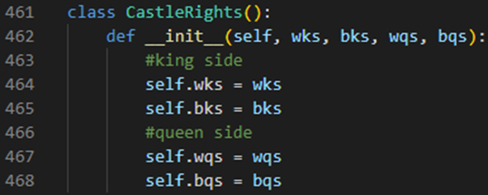

Line 461 defines a class called CastleRights. Line 462 defines our CastleRights constructor procedure. It will take 4 parameters: a wks (white king side) boolean, a bks (black king side) boolean, a wqs (white queen side) boolean and a bqs (black queen side) boolean. Line 464 defines an attribute of our CastleRights class called wks. This attribute will hold our wks boolean parameter. Line 465 defines an attribute of our CastleRights class called bks. This attribute will hold our bks boolean parameter. Line 467 defines an attribute of our CastleRights class called wqs. This attribute will hold our wqs boolean parameter. Line 468 defines an attribute of our CastleRights class called bqs. This attribute will hold our bqs boolean parameter. All these attributes represent sides where our kings can castle.

Next, we’re going to go into our gameState class constructor procedure and update it:



Line 38 defines an attribute called currentCastlingRights which stores a CastleRights object with a wks value of True, a bks value of True, a wqs value of True and a bqs value of True. Line 39 defines an attribute called castleRightsLog which stores an array holding a CastleRights object with a wks value of our currentCastlingRights’s wks value, a bks value of our currentCastlingRights’s bks value, a wqs value of our currentCastlingRights’s wqs value and a bqs value of our currentCastlingRights’s bqs value. The currentCastlingRights attribute will tell our chess engine which sides our kings can still castle on. The castleRightsLog attribute will keep track of our currentCastlingRights as the game progresses so that we can correctly undo castling moves.

Next, we’re going to create a new method inside of our gameState class called updateCastleRights:

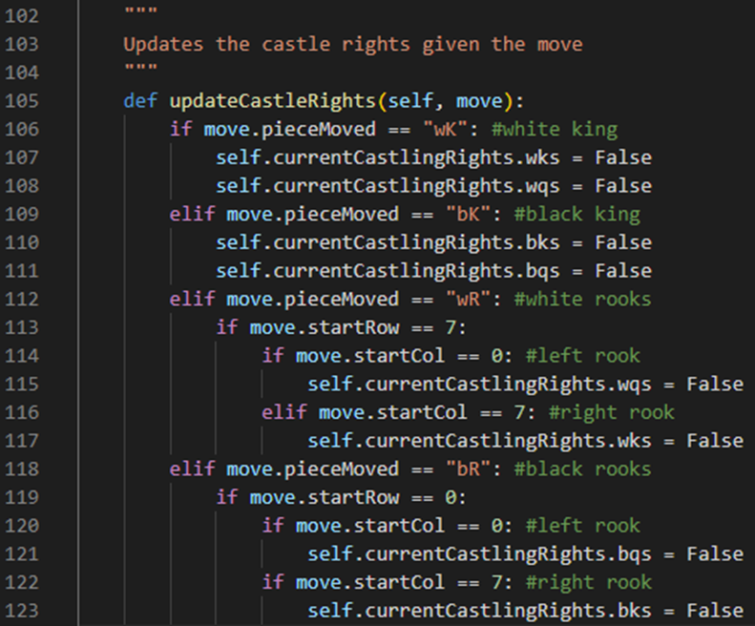

Line 105 defines our updateCastleRights method. It will take one parameter: the move we are updating the castle rights for. Line 106 checks if the piece we moved was a white king by evaluating if our move’s pieceMoved attribute stores a value of the “wK” string. If this is the case, then line 107 will set our gameState object’s currentCastlingRight’s wks attribute to False and line 108 will set our gameState object’s currentCastlingRight’s wqs attribute to False. This is because, in chess, if the white king is moved then it loses both of its rights to castle. Line 109 checks if the piece we moved was a black king by evaluating if our move’s pieceMoved attribute stores a value of the “bK” string. Line 110 will set our gameState object’s currentCastlingRight’s bks attribute to False and line 111 will set our gameState object’s currentCastlingRight’s bqs attribute to False. This is because, in chess, if the black king is moved then it loses both of its rights to castle. Line 112 checks if the piece we moved was a white rook by evaluating if our move’s pieceMoved attribute stores a value of the “wR” string. If this is the case, then line 113 will check if our move’s startRow attribute stores a value of the integer 7. If this is the case, then line 114 will check if our move’s startCol attribute stores a value of the integer 0. If this is the case, then line 115 will set our gameState object’s currentCastlingRight’s wqs attribute to False. This is because, in chess, if the left white rook is moved then the white king loses its queenside castle rights. Line 116 checks if our move’s startCol attribute stores a value of the integer 7. If this is the case, then line 117 will set our gameState object’s currentCastlingRight’s wks attribute to False. This is because, in chess, if the right white rook is moved then the white king loses its kingside castle rights. Line 118 checks if the piece we moved was a black rook by evaluating if our move’s pieceMoved attribute stores a value of the “bR” string. If this is the case, then line 119 will check if our move’s startRow attribute stores a value of the integer 0. If this is the case, then line 120 will check if our move’s startCol attribute stores a value of the integer 0. If this is the case, then line 121 will set our gameState object’s currentCastlingRight’s bqs attribute to False. This is because, in chess, if the left black rook is moved then the black king loses its queenside castle rights. Line 122 checks if our move’s startCol attribute stores a value of the integer 7. If this is the case, then line 123 will set our gameState object’s currentCastlingRight’s bks attribute to False. This is because, in chess, if the right black rook is moved then the black king loses its kingside castle rights.

Next, we’re going to go into our makeMove method and update it:



Line 77 runs our updateCastleRights method, passing the move we’re making as an argument. Line 78 appends our updated currentCastlingRights to our castleRightsLog by running the castleRightsLog’s append method and passing a CastleRights object with a wks value of our currentCastlingRights’s wks value, a bks value of our currentCastlingRights’s bks value, a wqs value of our currentCastlingRights’s wqs value and a bqs value of our currentCastlingRights’s bqs value as an argument.

Next, we’re going to go into our undoMove method and update it:



Line 106 gets rid of our last castling rights from our castleRightsLog by running its pop method. Line 107 then grabs the last element of our castleRightsLog and stores this in a variable called newRights by accessing the element stored in our castleRightsLog at the index value of -1. Line 108 then sets our gameState object’s currentCastlingRights attribute to a CastleRights object with a wks value of our newRight’s wks value, a bks value of our newRight’s bks value, a wqs value of our newRight’s wqs value and a bqs value of our newRight’s bqs value.

Now that we have set up our castle rights, we are ready to implement our actual castling moves. To do this, we’re going to use our squareUnderAttack method which we originally used for our naïve algorithm.

First, we’re going to go into our Move class constructor procedure and update it:

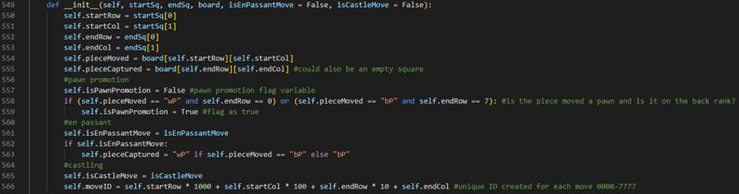

On line 549 we have added an optional parameter called isCastleMove. The default value for this optional parameter is False. It will be set to True whenever a castle type move has been made. Line 565 defines an attribute called isCastleMove which will be set to the value of our optional parameter isCastleMove.

Next, we’re going to create three more methods inside of our gameState class which will help us generate our castle moves. These methods are called getCastleMoves, getKingsideCastleMoves and getQueensideCastleMoves:

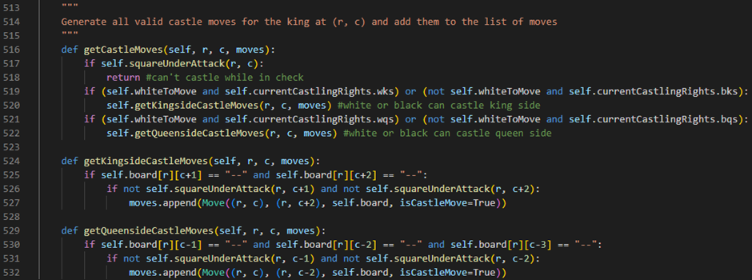

Line 516 defines our getCastleMoves method. It will take three parameters: our king’s start row, r, our king’s start column, c, and our current moves array. Line 517 checks if our king’s square is under attack. If this is the case, then line 518 will return nothing because, in chess, we cannot castle whilst our king is in check. Line 519 checks if our white king or black king can castle kingside by evaluating if our gameState object’s whiteToMove attribute is set to True and our gameState object’s currentCastlingRights’s wks attribute is set to True or if our gameState object’s whiteToMove attribute is set to False and our gameState object’s currentCastlingRights’s bks attribute is set to True. If this is the case, then line 520 will generate our king’s kingside castle moves by running our getKingsideCastleMoves method and passing our king’s start row, r, our king’s start column, c, and our current moves array as arguments. Line 521 checks if our white king or black king can castle queenside by evaluating if our gameState object’s whiteToMove attribute is set to True and our gameState object’s currentCastlingRights’s wqs attribute is set to True or if our gameState object’s whiteToMove attribute is set to False and our gameState object’s currentCastlingRights’s bqs attribute is set to True. If this is the case, then line 522 will generate our king’s queenside castle moves by running our getQueensideCastleMoves method and passing our king’s start row, r, our king’s start column, c, and our current moves array as arguments.

Line 524 defines our getKingsideCastleMoves method. It will take three parameters: our king’s start row, r, our king’s start column, c, and our current moves array. Line 525 checks if there are two empty squares in between our king and our kingside rook by evaluating if the element stored on our 2D board array attribute at the r and c+1 position stores a “--” string and if the element stored on our 2D board array attribute at the r and c+2 position stores a “--” string. If this is the case, then line 526 will check if these two empty squares are not under attack by evaluating if our squareUnderAttack method, passing r and c+1 as arguments, returns False and if our squareUnderAttack method, passing r and c+2 as arguments, returns False. If this is the case, then line 527 will append this kingside castle move to our moves array by calling the append method of our moves array and creating a Move object (with a startSq of (r, c), an endSq of (r, c+2), a board of our current board attribute and an isCastleMove value of True) to give as an argument.

Line 529 defines our getQueensideCastleMoves method. It will take three parameters: our king’s start row, r, our king’s start column, c, and our current moves array. Line 530 checks if there are three empty squares in between our king and our queenside rook by evaluating if the element stored on our 2D board array attribute at the r and c-1 position stores a “--” string and if the element stored on our 2D board array attribute at the r and c-2 position stores a “--” string and if the element stored on our 2D board array attribute at the r and c-3 position stores a “--” string. If this is the case, then line 531 will check if the first two empty squares are not under attack by evaluating if our squareUnderAttack method, passing r and c-1 as arguments, returns False and if our squareUnderAttack method, passing r and c-2 as arguments, returns False. If this is the case, then line 532 will append this queenside castle move to our moves array by calling the append method of our moves array and creating a Move object (with a startSq of (r, c), an endSq of (r, c-2), a board of our current board attribute and an isCastleMove value of True) to give as an argument.

Next, we need to go into our getValidMoves method and update it:

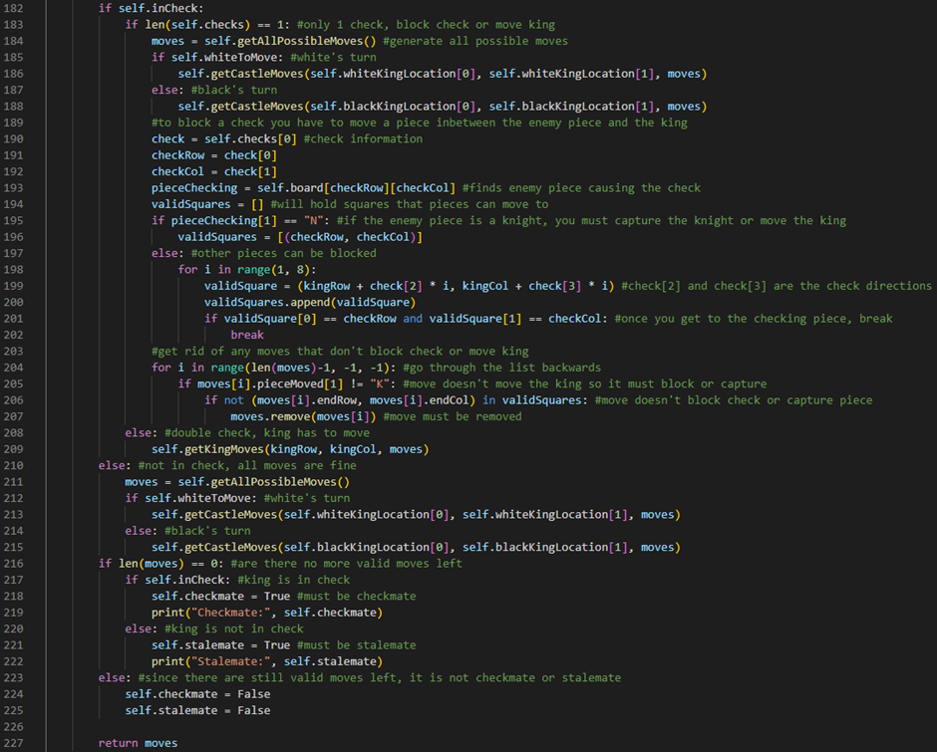

Line 185 checks if it is white’s turn to move by checking if our gameState object’s whiteToMove attribute is set to True. If it is then line 186 will get our white king’s castle moves (if applicable) by running our getCastleMoves method, passing the first element of our gameState object’s whiteKingLocation tuple, the second element of our gameState object’s whiteKingLocation tuple and our current moves array as arguments. Line 187 is an else statement which will run if it is black’s turn to move. If this is the case, then line 188 will get our black king’s castle moves (if applicable) by running our getCastleMoves method, passing the first element of our gameState object’s blackKingLocation tuple, the second element of our gameState object’s blackKingLocation tuple and our current moves array as arguments. Line 212 checks if it is white’s turn to move by checking if our gameState object’s whiteToMove attribute is set to True. If it is then line 213 will get our white king’s castle moves (if applicable) by running our getCastleMoves method, passing the first element of our gameState object’s whiteKingLocation tuple, the second element of our gameState object’s whiteKingLocation tuple and our current moves array as arguments. Line 214 is an else statement which will run if it is black’s turn to move. If this is the case, then line 215 will get our black king’s castle moves (if applicable) by running our getCastleMoves method, passing the first element of our gameState object’s blackKingLocation tuple, the second element of our gameState object’s blackKingLocation tuple and our current moves array as arguments.

Next, we’re going to go into our makeMove method and update it:

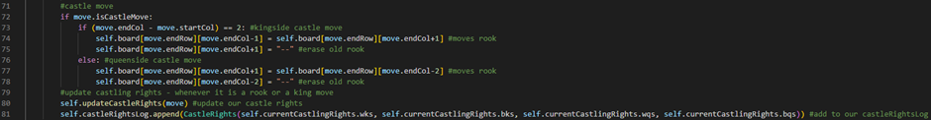

Line 72 checks if our move’s isCastleMove attribute is set to True. If it is, then line 73 will check if it was a kingside castle move by evaluating if our move’s endCol attribute minus our move’s startCol attribute is equal to the integer value of 2. If this is the case, then line 74 will move our rook by setting the element stored on our 2D board array attribute at our move’s endRow and endCol-1 position to the element stored on our 2D board array attribute at our move’s endRow and endCol+1 position. Line 75 will then replace our old rook with an empty square by setting the element stored on our 2D board array attribute at our move’s endRow and endCol+1 position to the string “--”. Line 76 is an else statement which will run if our castle move was a queenside castle move. If this is the case, then line 77 will move our rook by setting the element stored on our 2D board array attribute at our move’s endRow and endCol+1 position to the element stored on our 2D board array attribute at our move’s endRow and endCol-2 position. Line 78 will then replace our old rook with an empty square by setting the element stored on our 2D board array attribute at our move’s endRow and endCol-2 position to the string “--”.

Next, we’re going to go into our undoMove method and update it:

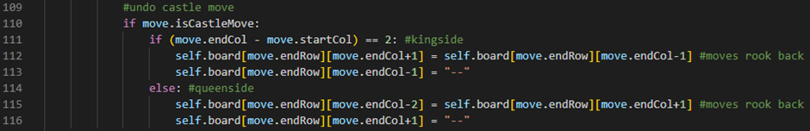

Line 110 checks if our move’s isCastleMove attribute is set to True. If it is, then line 111 will check if it was a kingside castle move by evaluating if our move’s endCol attribute minus our move’s startCol attribute is equal to the integer value of 2. If this is the case, then line 112 will move our rook back by setting the element stored on our 2D board array attribute at our move’s endRow and endCol+1 position to the element stored on our 2D board array attribute at our move’s endRow and endCol-1 position. Line 113 will then replace our old rook with an empty square by setting the element stored on our 2D board array attribute at our move’s endRow and endCol-1 position to the string “--”. Line 114 is an else statement which will run if our castle move was a queenside castle move. If this is the case, then line 115 will move our rook back by setting the element stored on our 2D board array attribute at our move’s endRow and endCol-2 position to the element stored on our 2D board array attribute at our move’s endRow and endCol+1 position. Line 116 will then replace our old rook with an empty square by setting the element stored on our 2D board array attribute at our move’s endRow and endCol+1 position to the string “--”.

We can now run the program and test to see if our castling moves work:

Kingside test:



Queenside test:



So far, it’s working as we expect it to! This concludes our work on our chess engine for now.

Move highlighting, move animation, reset board functionality and endgame text

Now that our chess engine is fully implemented and working, I would like to make some quality of life updates to our chess engine application. For example, I want to add a move highlighting feature as well as some move animation. I also want to add a reset board functionality as well as some endgame text to our chess engine application.

To do this, we’re going to go open our chessMain.py file and define a new procedure called highlightSquares:

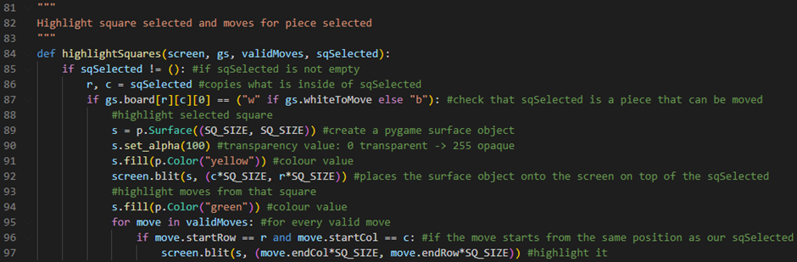

Line 84 defines our highlightSquares procedure. It will take 4 parameters: the screen we’re going to be highlighting the squares on, our current gameState object, our current validMoves array and our current sqSelected tuple. Line 85 checks if our sqSelected tuple is not an empty tuple. If it isn’t, then line 86 will define two variables called r (which will store the first element of our sqSelected tuple) and c (which will store the second element of our sqSelected tuple). Line 87 will then check if our sqSelected tuple stores the coordinates of a piece that can be moved on this turn by evaluating if the first character of the element stored on our gameState object’s 2D board array attribute at the r and c position has the same value as a shorthand if statement which returns “w” if our gameState object’s whiteToMove attribute is set to True or otherwise returns “b”. Line 89 creates a PyGame surface object with a (width, height) tuple of (SQ_SIZE, SQ_SIZE) and stores it in a variable called s. Line 90 makes our surface object more transparent by running its set_alpha method and passing 100 as an argument. Line 91 colours our surface object yellow by running its fill method and passing a PyGame Colour object (with a colour of “yellow”) as an argument. Line 92 places our surface object onto the screen on top of our sqSelected coordinates by running the screen’s blit method and passing our surface object, s, and a tuple containing (x, y) coordinates of (c multiplied by SQ_SIZE, r multiplied by SQ_SIZE) as arguments. Line 94 colours our surface object green by running its fill method and passing a PyGame Colour object (with a colour of “green”) as an argument. Line 95 defines a for loop which will iterate through every move in our validMoves array. Line 96 checks if the move we are currently looking at starts from the same position as our user’s selected piece by evaluating if our move's startRow stores the same value as our r variable and if our move’s startCol stores the same value as our c variable. If this is the case, then line 97 will highlight this move by running the screen’s blit method and passing our surface object, s, and a tuple containing (x, y) coordinates of (our move’s endCol attribute multiplied by SQ_SIZE, our move’s endRow attribute multiplied by SQ_SIZE) as arguments.

Next, we need to call this procedure inside of our drawGameState procedure:

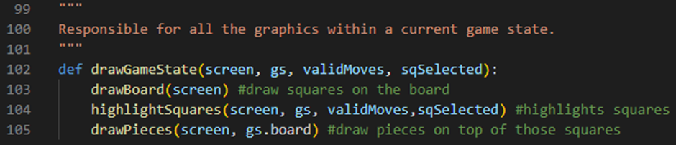

On line 102 we have added two more parameters to our drawGameState procedure: our validMoves array and our sqSelected tuple. Line 104 then calls our highlightSquares procedure passing our screen variable, gs variable, validMoves variable and sqSelected variable as arguments. The order of our procedure calls matters here because if we call our highlightSquares procedure after our drawPieces procedure then our highlighting is going to go over our pieces and it will look weird. If we call it before our drawBoard procedure then our highlighting is not even going to show because our board will be drawn on top of it. We put the highlightSquares procedure with our drawBoard procedure in front of it and our drawPieces procedure behind it so that the highlighting is drawn on top of our board and then the pieces are drawn on top of our highlighting which (in my opinion at least) looks very nice.

Finally, since we changed our parameters around, we need to go into our main procedure and update it accordingly:

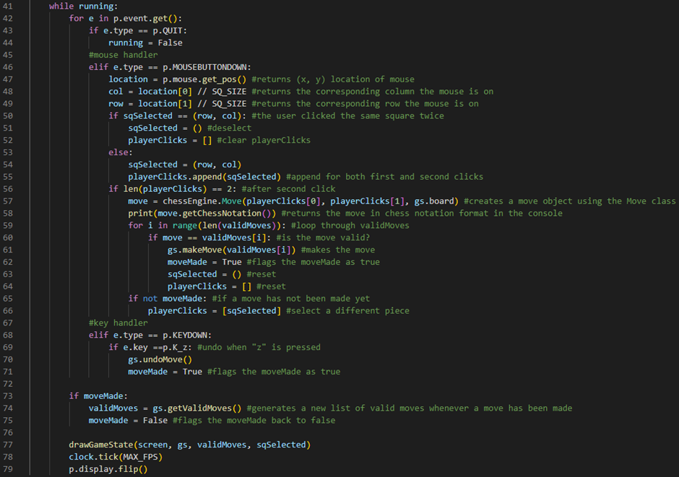

Line 77 runs our drawGameState procedure, passing our screen variable, gs variable, validMoves variable and sqSelected variable as arguments.

We can now run the program and test to see if our move highlighting works:



So far, it’s working as we expect it to! Our selected piece and its possible moves are now being highlighted.

Next, we’re going to work on animating our moves.

To do this, firstly, we’re going to go into our drawBoard procedure:

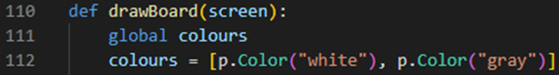

On line 111 we have set the scope of our colours variable to a global scope. This means that we can now access it from outside of our drawBoard procedure.

Next, we’re going to define a new procedure called animateMove:

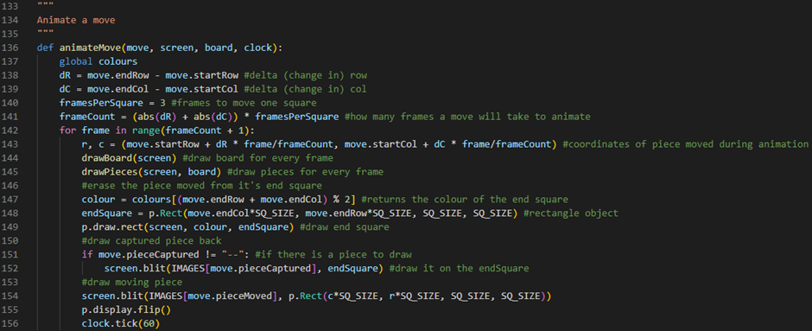

Line 136 defines our animateMove procedure. It takes 4 parameters: the move we want to animate, the screen we are going to be animating it on, our current 2D array board attribute and our PyGame clock object. Line 137 sets the scope of our colours variable to a global scope. This means that we can now access it from outside of our animateMove procedure. Line 138 defines a variable called dR which will store our change in rows. It will calculate this by finding the difference between our move’s endRow attribute and our move’s startRow attribute. Line 139 defines a variable called dC which will store our change in columns. It will calculate this by finding the difference between our move’s endCol attribute and our move’s startCol attribute. Line 140 defines a variable called framesPerSquare and sets it to the integer 3. This variable will tell our procedure how many frames it should take for a piece to move one square. Line 141 defines a variable called frameCount which stores how many frames a move will take to animate. It will calculate this by adding the absolute values of our dR and dC variables and multiplying this number by our framesPerSquare variable. Line 142 defines a for loop which will go through every frame of our move’s animation. Line 143 defines two variables called r (which is calculated by taking our move’s startRow attribute and adding to it our dR variable multiplied by our frame counter variable divided by our frameCount variable) and c (which is calculated by taking our move’s startCol attribute and adding to it our dC variable multiplied by our frame counter variable divided by our frameCount variable). These two variables represent the row and column of the piece being moved during our animation. Line 144 runs our drawBoard procedure, passing our screen variable as an argument. Line 145 runs our drawPieces procedure, passing our screen variable and our current 2D array board attribute. Line 147 defines a variable called colour which returns the colour of our endSquare. It does this by returning a colour from our colours array at the index position calculated by adding our move’s endRow attribute and endCol attribute together then using the modulo operator on this by 2. Line 148 defines a variable called endSquare which stores a PyGame Rect object with an x-position of (our move’s endCol attribute multiplied by SQ_SIZE), y-position of (our move’s endRow attribute multiplied by SQ_SIZE), width of (SQ_SIZE) and height of (SQ_SIZE). Line 149 draws our endSquare variable on the screen by running the p.draw.rect method and passing our screen variable, our colour variable and our endSquare variable as arguments. Line 151 will then check if there is a captured piece to draw by evaluating if our move’s pieceCaptured attribute does not store a value of the string “--”. If this is the case, then line 152 will draw our captured piece on the endSquare by running the screen’s blit method and passing our loaded image of the captured piece (from our IMAGES dictionary and using our move’s pieceCaptured attribute as a key) and our endSquare variable as arguments. Line 154 will then draw our moving piece to the screen by running the screen’s blit method and passing our loaded image of the captured piece (from our IMAGES dictionary and using our move’s pieceMoved attribute as a key) and a PyGame Rect object with an x-position of (our c variable multiplied by SQ_SIZE), y-position of (our r variable multiplied by SQ_SIZE), width of (SQ_SIZE) and height of (SQ_SIZE) as arguments. Line 155 runs the p.display.flip method which refreshes the GUI window screen and updates it. Line 156 sets the framerate of our application to 60 FPS by using the tick method of our clock variable and passing the integer 60 as an argument.

Finally we can go into our main procedure and update it accordingly:

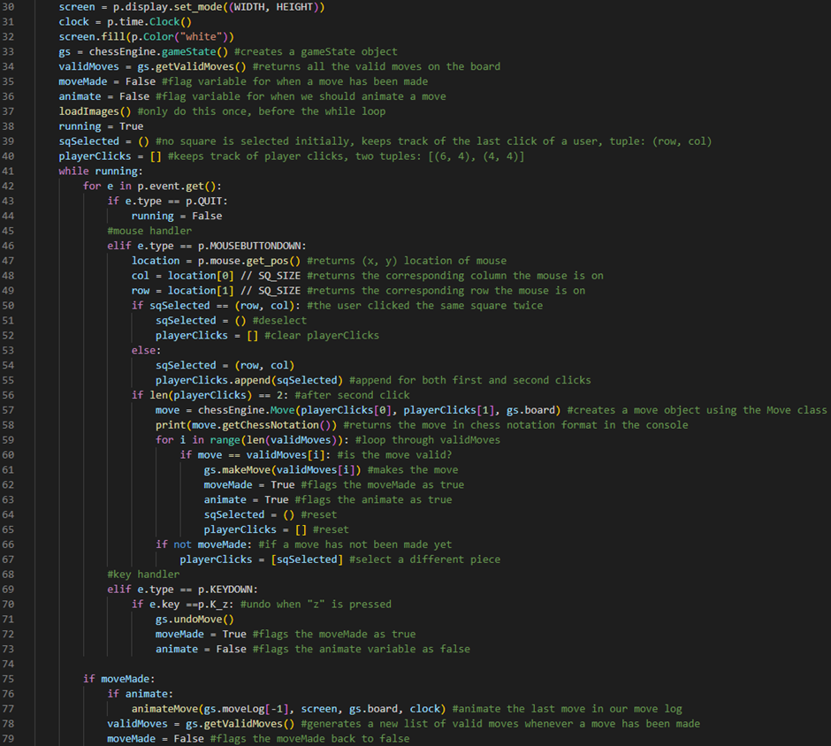

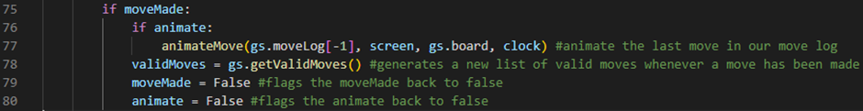

Line 36 defines a new flag variable called animate. It will initially be set to False. It will be set to True when we need to animate a move. This variable is necessary because we do not want to animate a move if we are undoing a move. On line 63, we set the animate flag variable to True because we have made a move and we are not undoing a move. On line 73, we set the animate variable to False because we are undoing a move and we do not want to animate this. Line 76 checks if our animate flag variable is set to True. If it is, then line 77 will run our animateMove procedure given the last element in our current gameState object’s moveLog array, our screen variable, our current gameState object’s 2D array board attribute and our clock variable. Line 80 will then set our animate flag variable back to False so that it is ready for the next iteration of our while loop.

We can now run the program and test to see if our move animations works:



So far, it’s working as we expect it to! Our moves are now animated.

One side note here: we could set our frameCount variable inside of our animateMove procedure to a constant, that way all our moves take the same amount of frames to finish animating. However, I personally prefer the way we have done it here instead.

Next, we’re going to add a reset board functionality to our chess engine.

To do this, we’re going to go into our main procedure and update our key handler section of code:

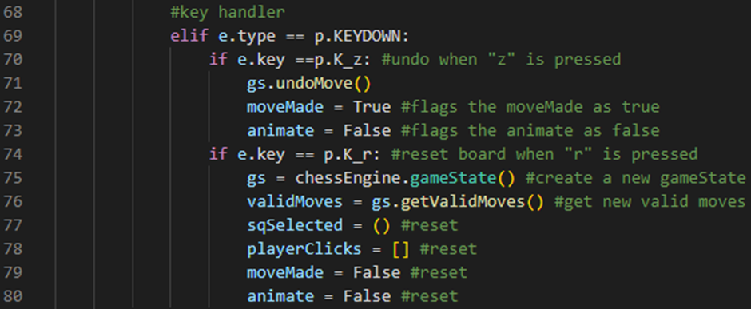

Line 74 checks if the keyboard button that was pressed was an r key. If it was, then line 75 sets our gs variable to a new gameState object. Line 76 sets our validMoves variable to a new validMoves array by calling our new gameState object’s getValidMoves method. Line 77 sets our sqSelected tuple back to an empty tuple. Line 78 sets our playerClicks array back to an empty array. Line 79 sets our moveMade flag variable back to False. Line 80 sets our animate flag variable back to False.

We can now run the program and test to see if our reset board functionality is working:



So far, it’s working as we expect it to! We can now reset our board when we press r on our keyboard.

Finally, we’re going to add some endgame text to our chess engine for when a checkmate or a stalemate has been found.

Firstly, we’re going to define a new procedure called drawText:

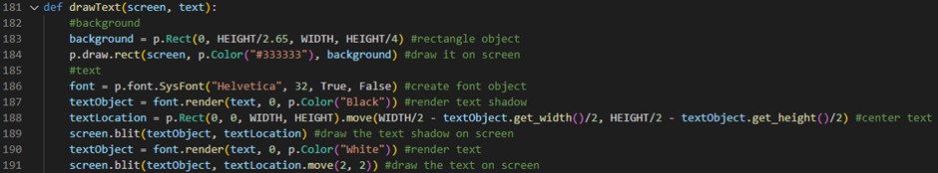

Line 181 defines our drawText procedure. It will take 2 parameters: our screen variable and the text we want to draw to the screen. Line 183 defines a variable called background which will be set to a PyGame Rect object with an x-position of (0), y-position of (our HEIGHT variable divided by 2.65), width of (our WIDTH variable) and height of (our HEIGHT variable divided by 4). Line 184 then draws our background rectangle object on the screen by running the p.draw.rect method and passing our screen variable, a PyGame Colour object with a colour of the hex value “#333333” and our background variable as arguments. Line 186 defines a variable called font which stores a PyGame font object. This font object is going to be a Helvetica font with a font size of 32, a bold value of True and an italic value of False. Line 187 defines a variable called textObject which is set to our rendered text shadow by using the render method of our font variable and passing our text variable, an antialias value of 0 and a colour object of the colour Black as arguments. Line 188 defines a variable called textLocation which stores a PyGame Rect object with an x-position of (0), y-position of (0), width of (our WIDTH variable) and height of (our HEIGHT variable). On the same line, our textLocation variable is placed in the centre of our screen by running the Rect object’s move method and passing an x-position value of (our WIDTH variable divided by 2 minus our textObject variable’s width divided by 2) and a y-position value of (our HEIGHT variable divided by 2 minus our textObject variable’s height divided by 2). Line 189 then draws our text shadow to the screen by running our screen variable’s blit method and passing our textObject variable and our textLocation variable as arguments. Line 190 then renders our actual text by using the render method of our font variable and passing our text variable, an antialias value of 0 and a colour object of the colour White as arguments. Line 191 then draws our text to the screen by running our screen variable’s blit method and passing our textObject variable and our textLocation variable (which has been offset using its move method and passing an x-position value of 2 and a y-position value of 2 as arguments) as arguments.

Next, we’re going to go into our main procedure and update it accordingly:

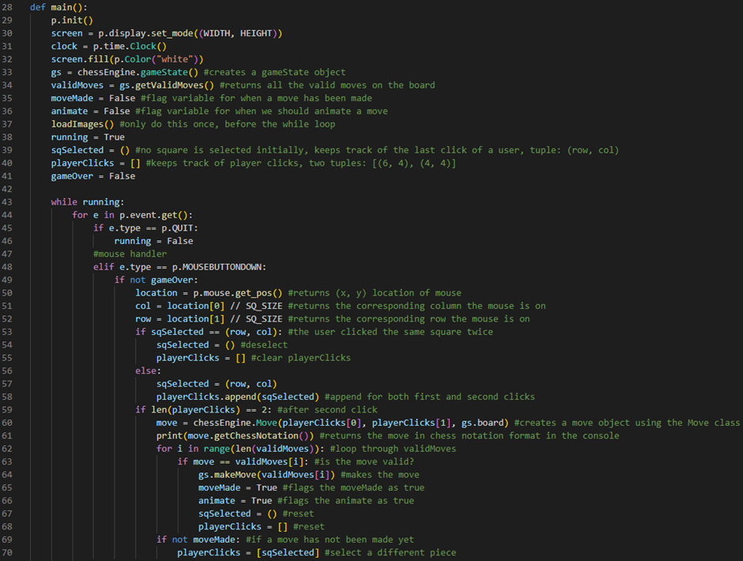

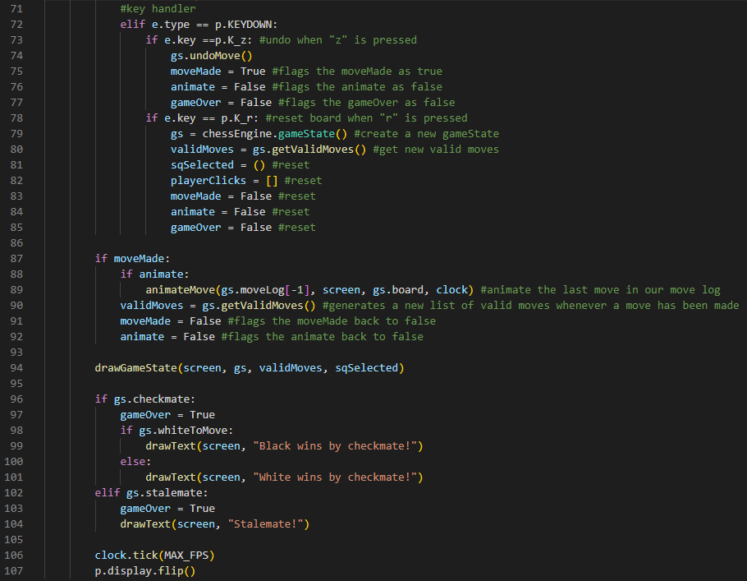

Line 41 defines a new flag variable called gameOver. It will initially be set to False. It will be set to True if our chess engine calculates a checkmate or a stalemate. Line 49 checks if our gameOver flag variable is set to False. If it is, then our player should be allowed to click on the board. Line 77 sets our gameOver flag variable to False if our player has undone a move. This will allow them to be able to click on the board again. Line 85 sets our gameOver flag variable back to False when the player has reset the board. Line 96 checks if our current gameState object’s checkmate attribute is set to True. If it is, then line 97 will set our gameOver flag variable to True. Line 98 will then check if our current gameState object’s whiteToMove attribute is set to True. If it is, then line 99 will run our drawText procedure, passing our screen variable and “Black wins by checkmate!” text as arguments. Line 100 is an else statement which will run if our current gameState object’s whiteToMove attribute is set to False. If it is, then line 101 will run our drawText procedure, passing our screen variable and “White wins by checkmate!” text as arguments. Line 102 will check if our current gameState object’s stalemate attribute is set to True. If it is, then line 103 will set our gameOver flag variable to True. Line 104 will run our drawText procedure, passing our screen variable and “Stalemate!” text as arguments.

We can now run the program and test to see if our endgame text is working:

White checkmate:



Black checkmate:



Stalemate:



So far, it’s working as we expect it to! We have now added endgame text to our chess engine whenever a checkmate or a stalemate has been found.

## Third Prototype

During the development of this prototype, my goal is to work on the artificial intelligence features of our chess engine application. These features will include: a random move AI algorithm, a greedy move AI algorithm, a MinMax AI algorithm and a NegaMax AI algorithm. All of these algorithms will be found on a separate python file of my project called chessAI.py.

Random move AI algorithm

Our chess engine is now ready for the first of our AI algorithms to be implemented. This is going to be the simplest and the easiest AI algorithm that we implement into our chess engine.

So, let’s begin by creating a new python file in our project directory called “chessAI.py”:

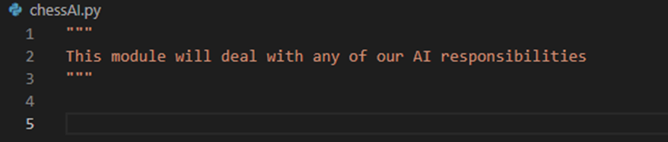

Next, we’re going to write a new function called findRandomMove:

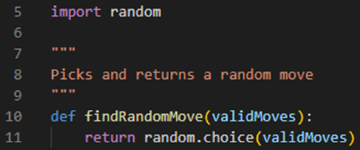

Line 5 imports Python’s random module. This module is going to be what we use to select a random move for our AI to play. Line 10 defines our findRandomMove function. It will take one parameter: our current validMoves array. Line 11 will return a random move from our validMoves array by using the random module’s choice method and passing our validMoves array as an argument.

Next, we’re going to go open our chessMain.py file:

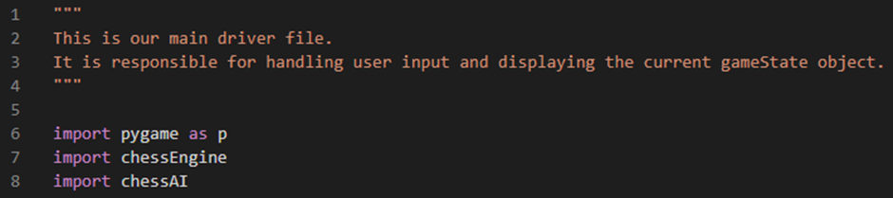

Line 8 imports our chessAI.py file inside of our chessMain.py file. This will let us access all of the AI algorithms that we define inside of our chessAI.py file.

Next, we’re going to go into our main procedure:

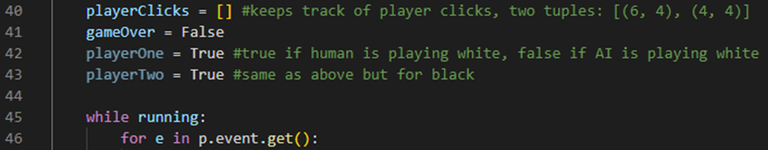

Line 42 defines a variable called playerOne. This variable will return True if a human is playing white or it will return False if an AI is playing white. Line 43 defines a variable called playerTwo. This variable will return True if a human is playing black or it will return False if an AI is playing black.

Next, we’re going to go into our while running loop:

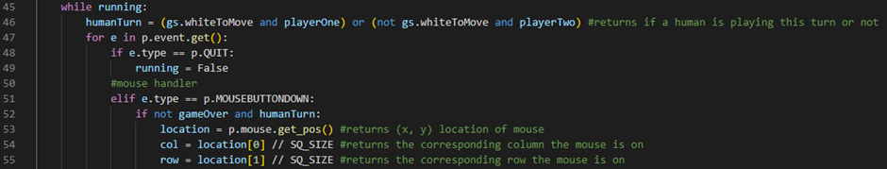

Line 46 defines a flag variable called humanTurn. It will return True if our current gameState object’s whiteToMove attribute is set to True and our playerOne variable is set to True or if our current gameState object’s whiteToMove attribute is set to False and our playerTwo variable is set to True. In other words, it will return True if a human is playing this turn or it will return False if an AI is playing this turn. Line 52 checks if our gameOver flag variable is set to False and if our humanTurn flag variable is set to True. If this is the case, then our player should be allowed to click on the board.

Finally, we can add this AI move finder logic under our event handlers:

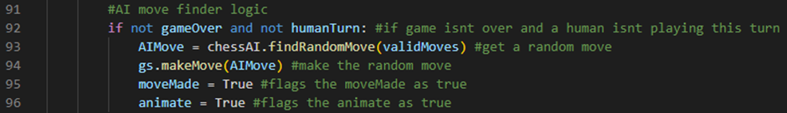

Line 92 checks if our gameOver flag variable is set to False and if our humanTurn flag variable is set to False. If this is the case, then line 93 will define a variable called AIMove which will be set to our chessAI.py file’s findRandomMove function call, passing our current validMoves array as an argument. Line 94 will then make our AI’s random move by calling our gameState object’s makeMove method and passing our AIMove variable as an argument. Line 95 will then set our moveMade flag variable to True. Line 96 will then set our animate flag variable to True.

We can now set our playerTwo variable to False and run the program to test to see if our chessEngine will now play against us using random moves:



So far, it’s working as we expect it to! We have implemented our random move AI algorithm into our chess engine.

findRandomMove function test table:

|  |  |  |
| --- | --- | --- |
| Test Data | Expected Outcome | Actual Outcome |
| Enemy Move | A random move is played by our chess engine. | As expected. |

Greedy move AI algorithm and MinMax AI algorithm (without recursion)

Now, we’re going to be looking at a slightly smarter AI algorithm called the greedy move AI algorithm. This algorithm will play the best move possible on the board on a given turn, by scoring the pieces on the board based only on their material value (instead of their positional value, for example).

To implement this, firstly, we are going to go into our chessAI.py file:



Line 7 defines a variable called pieceScores which stores a dictionary of all of our pieces and their respective material values. For example, our king piece “K” has a material value of 0 (because you cannot capture the king in chess), our queen piece “Q” has a material value of 9, our rook piece “R” has a material value of 5, our bishop piece “B” has a material value of 3, our knight piece “N” has a material value of 3 and our pawn piece “P” has a material value of 1. Line 8 defines a variable called CHECKMATE which stores an integer value of 1000. This will be the score awarded to a checkmate move by our AI algorithms. It is the highest score possible because we want our AI algorithms to always play a checkmate move if it is the best move available. Line 9 defines a variable called STALEMATE which stores an integer value of 0. This will be the score awarded to a stalemate move by our AI algorithms. It is a score that is neither good nor bad because we want our AI algorithms to go for a stalemate move but only if it is not at all possible for them to go for a checkmate move and win.

Next, we’re going to create a new function called scoreMaterial:

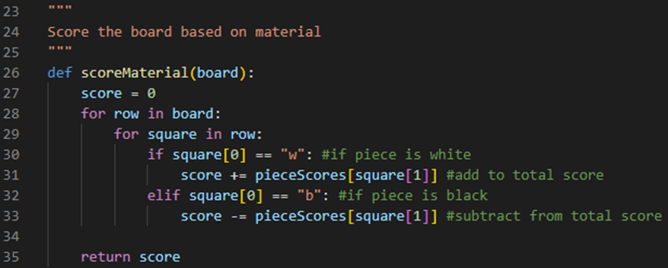

Line 26 defines our scoreMaterial function. It will take one parameter: our current 2D array board. Line 27 defines a variable called score which initially stores an integer value of 0. Line 28 defines a for loop which will iterate through every row in our 2D array board. Line 29 defines an embedded for loop which will iterate through every square in these rows. Line 30 checks if the piece we are looking at is white by evaluating if the first character of our square variable has a value of the character “w”. If this is the case, then line 31 will add to our score variable our piece’s respective material value by accessing our piece’s respective material value from our pieceScores dictionary, using the second character of our square variable as a key, and adding this value to our score variable. Line 32 will check if the piece we are looking at is black by evaluating if the first character of our square variable has a value of the character “b”. If this is the case, then line 33 will subtract from our score variable our piece’s respective material value by accessing our piece’s respective material value from our pieceScores dictionary, using the second character of our square variable as a key, and subtracting this value from our score variable. Line 35 will then return our final score variable.

Next, we’re going to create a new function called findBestMove:

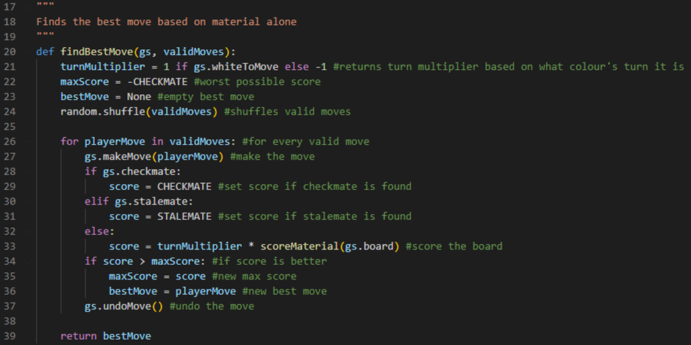

Line 20 defines our findBestMove function. It will take two parameters: our current gameState object and our current validMoves array. Line 21 defines a variable called turnMultiplier which will store the integer value 1 if our current gameState object’s whiteToMove attribute is set to True otherwise it will store the integer value -1. Line 22 defines a variable called maxScore. It will initially store a value of our CHECKMATE variable multiplied by -1 because we want to start with the worst possible score. Line 23 defines a variable called bestMove which initially stores a None object. Line 24 shuffles our validMoves array by calling the random module’s shuffle method and passing our validMoves array as an argument. This line is necessary because without it our algorithm will pick the same first move every time. Line 26 defines a for loop which will iterate through every playerMove in our validMoves array. Line 27 will make our current playerMove on the board by running our gameState object’s makeMove method and passing our current playerMove variable as an argument. Line 28 checks if the move we made was a checkmate move by evaluating if our gameState object’s checkmate attribute is set to True. If it was, then line 29 will define a variable called score which will be set to our CHECKMATE variable. Line 30 checks if the move we made was a stalemate move by evaluating if our gameState object’s stalemate attribute is set to True. If it was, then line 31 will define a variable called score which will be set to our STALEMATE variable. Line 32 is an else statement which will run if the move we made was neither a checkmate move nor a stalemate move. If this is the case, then line 33 will define a variable called score which will be set to our turnMultiplier variable multiplied by the product of running our scoreMaterial function and passing our gameState object’s board attribute as an argument. This line of code is what scores the board by our pieces’ respective material values. Line 34 then checks if our score variable is greater than our maxScore variable. If it is, then line 35 sets our maxScore variable to our score variable and line 36 sets our bestMove variable to our current playerMove variable. Line 37 will then undo the move we made by running our gameState object’s undoMove method. Line 39 returns our final bestMove variable.

Finally, we need to open our chessMain.py file and update our AI move finder logic:

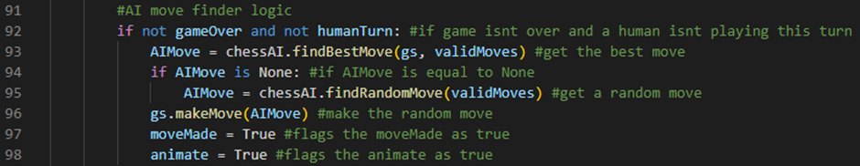

Line 93 defines a variable called AIMove which will store the product of running our chessAI.py file’s findBestMove function, passing our current gameState object and our current validMoves array as arguments. Line 94 checks if our AIMove is a None object. If this is the case, then line 95 will set our AIMove variable to the product of running our chessAI.py file’s findRandomMove function, passing our current validMoves array as an argument. This is necessary because if we let our AIMove variable be set to a None object then this could cause our program to crash when we make our AIMove on line 96.

We can now run the program and test to see if our greedy move AI algorithm works:



So far, it’s working as we expect it to! We have implemented our greedy move AI algorithm into our chess engine.

Greedy move test table:

|  |  |  |
| --- | --- | --- |
| Test Data | Expected Outcome | Actual Outcome |
| Enemy Move | The greediest move possible on the board is played by our chess engine. | As expected. |

Next, before we start working on our MinMax AI algorithm (without recursion), we’re going to duplicate our findBestMove function and then we’re going to rename one of them to findGreedyMove and change all instances of our bestMove variable to greedyMove:

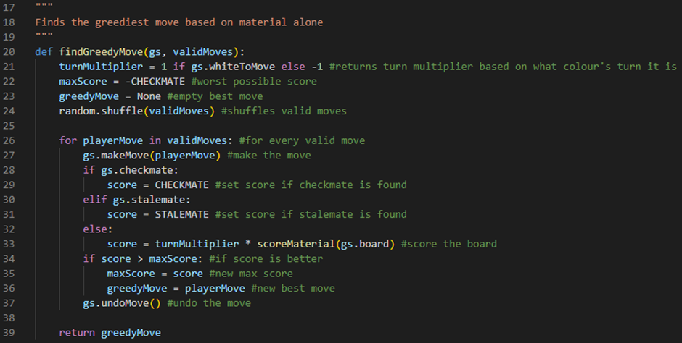

Now, we are ready to work on our MinMax AI algorithm (without recursion).

One of the main differences between our MinMax AI algorithm and our greedy move AI algorithm is that our MinMax AI algorithm will also take our opponent’s moves into consideration. This makes our MinMax AI algorithm a lot smarter.

With this in mind, let’s implement this algorithm in our duplicated findBestMove function:

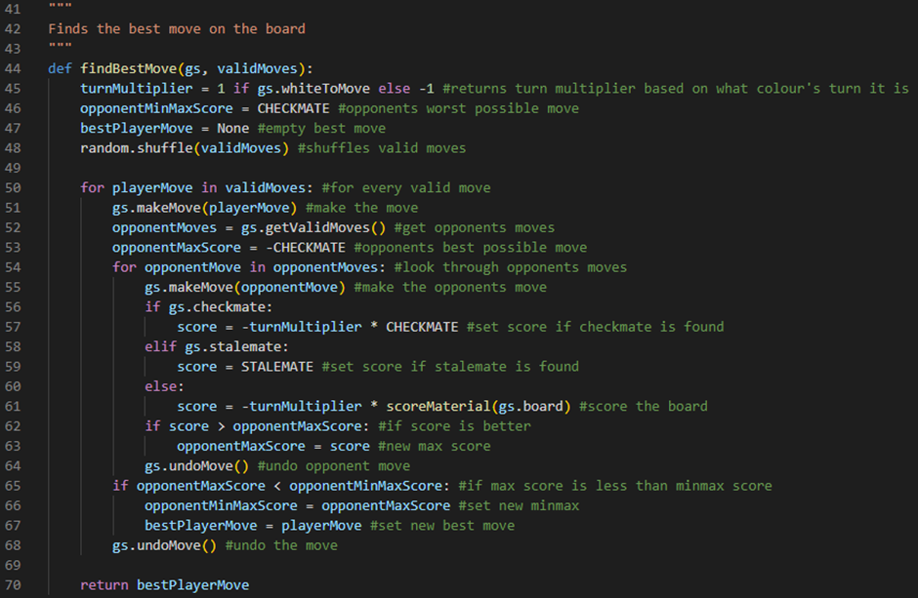

Line 44 defines our findBestMove function. It will take two parameters: our current gameState object and our current validMoves array. Line 45 defines a variable called turnMultiplier which will store the integer value 1 if our current gameState object’s whiteToMove attribute is set to True otherwise it will store the integer value -1. Line 46 defines a variable called opponentMinMaxScore. It will initially store our CHECKMATE variable because we want it to start as our opponent’s worst possible score. Line 47 defines a variable called bestPlayerMove which will initially be set to a None object. Line 48 shuffles our validMoves array by calling the random module’s shuffle method and passing our validMoves array as an argument. This line is necessary because without it our algorithm will pick the same first move every time. Line 50 defines a for loop which will iterate through every playerMove in our validMoves array. Line 51 will make our current playerMove on the board by running our gameState object’s makeMove method and passing our current playerMove variable as an argument. Line 52 defines a variable called opponentMoves which will set to our new array of valid moves by storing the product of calling our gameState object’s getValidMoves method. Line 53 defines a variable called opponentMaxScore which stores our CHECKMATE variable multiplied by -1 because we want it to start with our opponent’s best possible score. Line 54 defines a for loop which will iterate through every opponentMove in our opponentMoves array. Line 55 will make our current opponentMove on the board by running our gameState object’s makeMove method and passing our current opponentMove variable as an argument. Line 56 checks if our opponent’s move was a checkmate move by evaluating if our gameState object’s checkmate attribute is set to True. If it was, then line 57 will define a variable called score which will be set to our turnMultiplier variable multiplied by -1 multiplied by our CHECKMATE variable. Line 58 checks if our opponent’s move was a stalemate move by evaluating if our gameState object’s stalemate attribute is set to True. If it was, then line 59 will define a variable called score which will be set to our STALEMATE variable. Line 60 is an else statement which will run if our opponent’s move was neither a checkmate move nor a stalemate move. If this is the case, then line 61 will define a variable called score which will be set to our turnMultiplier variable multiplied by -1 multiplied by the product of running our scoreMaterial function and passing our gameState object’s board attribute as an argument. Line 62 checks if our score variable is greater than our opponentMaxScore variable. If it is, then line 63 will set our opponentMaxScore variable to our score variable. Line 64 will then undo our opponent’s move that we made by running our gameState object’s undoMove method. Line 65 will then check if our opponentMaxScore variable is less than our opponentMinMaxScore variable. If it is, then line 66 will set our opponentMinMaxScore variable to our opponentMaxScore variable and line 67 will set our bestPlayerMove variable to our current playerMove variable. Line 68 will then undo our move that we made by running our gameState object’s undoMove method. Line 70 returns our final bestPlayerMove variable.

We can now go into our chessMain.py file and set our playerOne and our playerTwo variables to False and run the program to test to see if our MinMax AI algorithm works:



So far, it’s working as we expect it to! We have implemented our MinMax AI algorithm into our chess engine.

MinMax AI algorithm (with recursion)

Before we start implementing our MinMax AI algorithm recursively, there actually a few bugs with our MinMax AI algorithm without recursion that I would like to fix first:

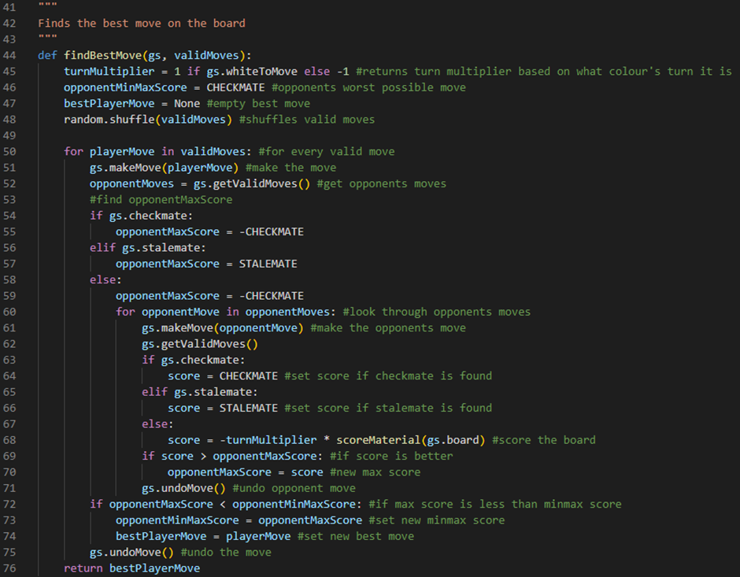

The first change we made is that we cannot just set our opponentMaxScore variable to our CHECKMATE variable multiplied by -1. This is because our opponentMaxScore variable will change depending on the outcome of our current playerMove being made. Line 54 checks if our current playerMove has resulted in a checkmate by evaluating if our gameState object’s checkmate attribute is set to True. If it is then line 55 will set our opponentMaxScore variable to our CHECKMATE variable multiplied by -1. Line 56 checks if our current playerMove has resulted in a stalemate by evaluating if our gameState object’s stalemate attribute is set to True. If it is then line 57 will set our opponentMaxScore variable to our STALEMATE variable. Line 58 is an else statement which will run if our current playerMove has not resulted in a checkmate nor a stalemate. If this is the case, then line 59 will set our opponentMaxScore variable to our CHECKMATE variable multiplied by -1. Our second change that we made is that line 62 will now generate our gameState object’s next set of valid moves by running our gameState object’s getValidMoves method. We do not need to store this set of valid moves because we will not be iterating through them, however, we still need to generate them because the situation on the board has changed. Our third and final change that we made is that line 64 now sets our score variable to our CHECKMATE variable (not multiplied by our turnMultiplier variable multiplied by -1). Previously, this line of code was simply wrong. It has now been corrected.

Next, we need to fix a bug to do with undoing our moves. This means that we need to open our chessEngine.py file and go update our undoMove method:

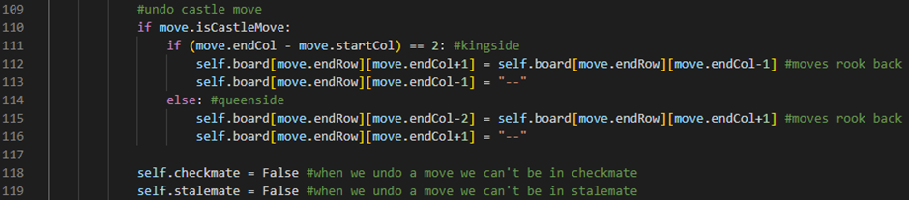

Line 118 sets our gameState object’s checkmate attribute to False whenever a move has been undone. This is because if a move has been undone then we cannot be in checkmate. Line 119 sets our gameState object’s stalemate attribute to False whenever a move has been undone. This is because if a move has been undone then we cannot be in stalemate.

We can now go into our chessMain.py file and set our playerOne and our playerTwo variables to False and run the program to test to see if our MinMax AI algorithm works:



So far, it’s working as we expect it to! We have now fully implemented our MinMax AI algorithm into our chess engine.

Our current MinMax AI algorithm is already playing a lot smarter, however, it is only looking 2 moves ahead so far because that is all that we have programmed it to do. We can make our MinMax AI algorithm look more moves ahead by implementing this algorithm recursively.

So, let’s do that.

Firstly, we’re going to go into our chessAI.py file and add a new variable at the top of our file:

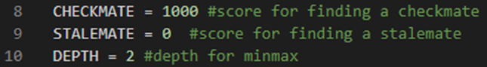

Line 10 defines a variable called DEPTH. This variable will store the depth of our recursive function (in other words, how many moves into the future we want to evaluate). It will currently store an integer value of 2 (in other words, for now, our recursive function will only look 2 moves into the future). One side note here is that increasing this variable will make our recursive function run exponentially slower every time we add one to it.

Next, we’re going to define a new function called findBestMoveMinMax:

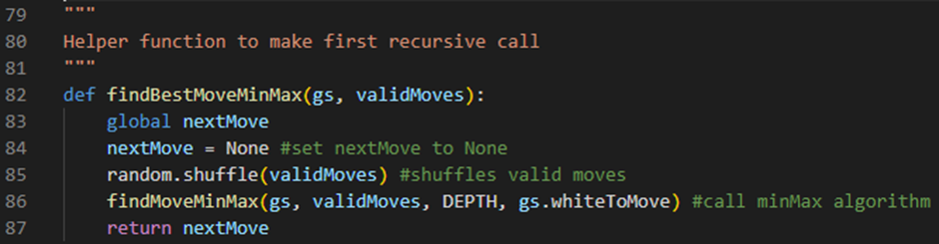

Line 82 defines a function called findBestMoveMinMax. It will take two parameters: our current gameState object and our current validMoves array. Line 83 sets the scope of a variable called nextMove to global, allowing it to be accessed from outside of our function. Line 84 defines a variable called nextMove and sets it to a None object. Line 85 shuffles our validMoves array by calling the random module’s shuffle method and passing our validMoves array as an argument. Line 86 calls our recursive function called findMoveMinMax, passing our current gameState object, our current validMoves array, our DEPTH variable and our current gameState object’s whiteToMove attribute as arguments. Line 87 returns our final nextMove variable.

Next, we’re going to define another new function called scoreBoard:

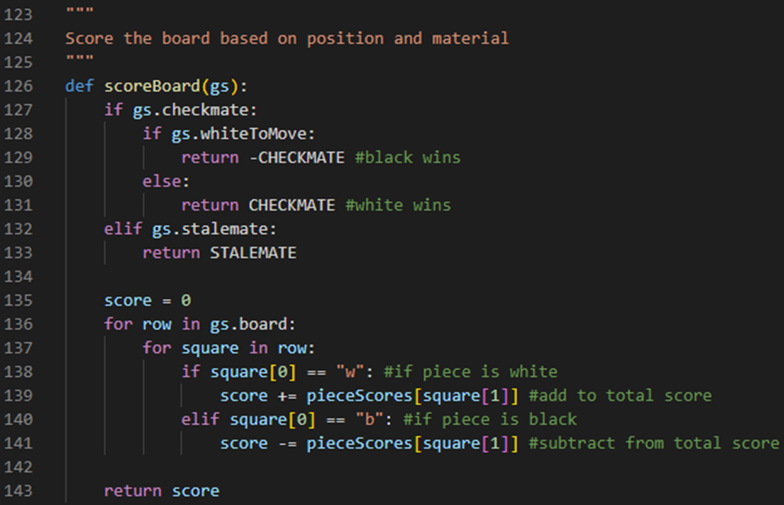

Line 126 defines a function called scoreBoard. It will take one parameter: our current gameState object. Line 127 checks if our gameState object’s checkmate attribute is set to True. If it is, then line 128 will check if our gameState object’s whiteToMove attribute is set to True. If it is, then line 129 will return our CHECKMATE variable multiplied by -1. Line 130 is an else statement which will run if our gameState object’s whiteToMove attribute is set to False. If this is the case, then line 131 will return our CHECKMATE variable. Line 132 checks if our gameState object’s stalemate attribute is set to True. If it is, then line 133 will return our STALEMATE variable. Line 135 defines a variable called score which is initially set to the integer 0. Line 136 defines a for loop which will iterate through every row in our current gameState object’s 2D array board. Line 137 defines an embedded for loop which will iterate through every square in these rows. Line 138 checks if the piece we are looking at is white by evaluating if the first character of our square variable has a value of the character “w”. If this is the case, then line 139 will add to our score variable our piece’s respective material value by accessing our piece’s respective material value from our pieceScores dictionary, using the second character of our square variable as a key, and adding this value to our score variable. Line 140 will check if the piece we are looking at is black by evaluating if the first character of our square variable has a value of the character “b”. If this is the case, then line 141 will subtract from our score variable our piece’s respective material value by accessing our piece’s respective material value from our pieceScores dictionary, using the second character of our square variable as a key, and subtracting this value from our score variable. Line 143 will then return our final score variable. You’ll notice that this function currently doesn’t do anything too different from our scoreMaterial function, however, later on we will update this function so that it also accounts for our pieces’ respective positional values instead of just our pieces’ respective material values.

Next, we’re going to define our recursive function called findMoveMinMax:

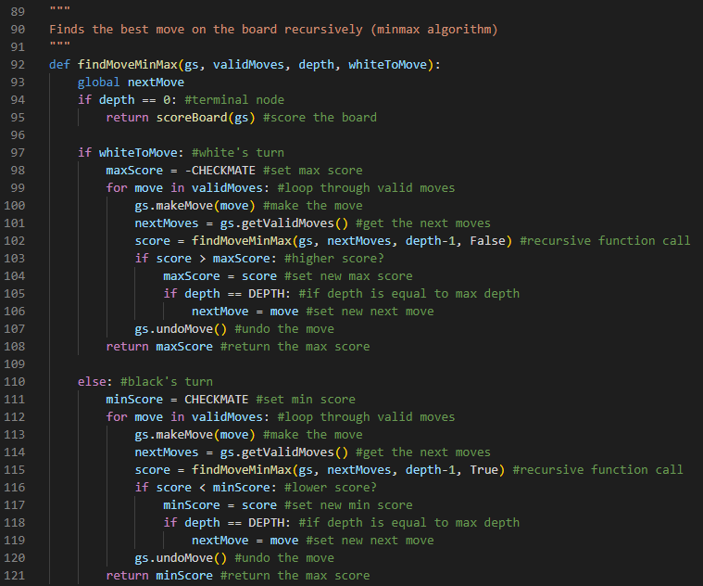

Line 92 defines a function called findMoveMinMax. This function will take 4 parameters: our current gameState object, our current validMoves array, our current depth variable and our current whiteToMove variable. Line 93 sets the scope of a variable called nextMove to global, allowing it to be accessed from outside of our function. Line 94 checks if our current depth variable is equal to the integer 0. If it is, then we have reached our recursive function’s terminal node and line 95 will return the product of running our scoreBoard function, given our current gameState object as an argument. Line 97 will check if it is white’s turn to move by evaluating if our whiteToMove variable is set to True. If it is, then line 98 will define a variable called maxScore which will be set to our CHECKMATE variable multiplied by -1. Line 99 defines a for loop which will iterate through every move in our current validMoves array. Line 100 will then make our current move by running our gameState object’s makeMove method and passing our move variable as an argument. Line 101 will define a variable called nextMoves which will store our new set of validMoves by storing the product of running our gameState object’s getValidMoves method. Line 102 will define a variable called score which will be set to the product of running our findMoveMinMax function and passing our current gameState object, our nextMoves variable, our current depth variable minus 1 and a boolean value of False as arguments. This line of code is one of our recursive function calls. Line 103 will then check if our score variable is greater than our maxScore variable. If it is, then line 104 will set our maxScore variable to our score variable. Line 105 will check if our depth variable is equal to our DEPTH variable. If it is, then line 106 will set our nextMove variable to our current move variable. Line 107 will undo the move we made by running our gameState object’s undoMove method. Line 108 will then return our maxScore variable. Line 110 is an else statement which will run if our whiteToMove variable is set to False. If this is the case, then line 111 will define a variable called minScore which will be set to our CHECKMATE variable. Line 112 defines a for loop which will iterate through every move in our current validMoves array. Line 113 will then make our current move by running our gameState object’s makeMove method and passing our move variable as an argument. Line 114 will define a variable called nextMoves which will store our new set of validMoves by storing the product of running our gameState object’s getValidMoves method. Line 115 will define a variable called score which will be set to the product of running our findMoveMinMax function and passing our current gameState object, our nextMoves variable, our current depth variable minus 1 and a boolean value of True as arguments. This line of code is one of our recursive function calls. Line 116 will then check if our score variable is less than our minScore variable. If it is, then line 117 will set our minScore variable to our score variable. Line 118 will check if our depth variable is equal to our DEPTH variable. If it is, then line 119 will set our nextMove variable to our current move variable. Line 120 will undo the move we made by running our gameState object’s undoMove method. Line 121 will then return our minScore variable.

Finally, we need to go into our chessMain.py file and update our AI move finder logic:

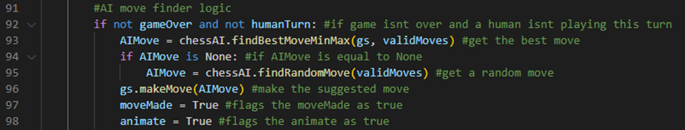

Line 93 now defines a variable called AIMove which will be set to the product of running our chessAI.py file’s findBestMoveMinMax function, passing our current gameState object and our current validMoves array as arguments.

We can now set our playerOne and our playerTwo variables to False and run the program to test to see if our recursive MinMax AI algorithm works:



So far, it’s working as we expect it to! We have now implemented our recursive MinMax AI algorithm into our chess engine.

MinMaxAI test table:

|  |  |  |
| --- | --- | --- |
| Test Data | Expected Outcome | Actual Outcome |
| Enemy Move | The best move possible on the board is played by our chess engine. | As expected. |

NegaMax AI algorithm (with recursion) and alpha-beta pruning

Now, we’re going to be implementing our final AI algorithm called the NegaMax algorithm. This AI algorithm is essentially the same as our MinMax algorithm except it is a lot more efficient. This is because it focuses solely on maximising the score for the current player whose turn it is.

First, we need to define a new function called findBestMoveNegaMax:

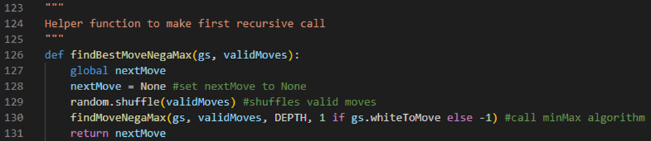

Line 126 defines a function called findBestMoveNegaMax. It will take two parameters: our current gameState object and our current validMoves array. Line 127 sets the scope of a variable called nextMove to global, allowing it to be accessed from outside of our function. Line 128 defines a variable called nextMove and sets it to a None object. Line 129 shuffles our validMoves array by calling the random module’s shuffle method and passing our validMoves array as an argument. Line 130 calls our recursive function called findMoveNegaMax, passing our current gameState object, our current validMoves array, our DEPTH variable and an integer value of 1 if our current gameState object’s whiteToMove attribute is set to True otherwise an integer value of -1 as arguments. Line 131 returns our final nextMove variable.

Next, we need to define our recursive function called findMoveNegaMax:

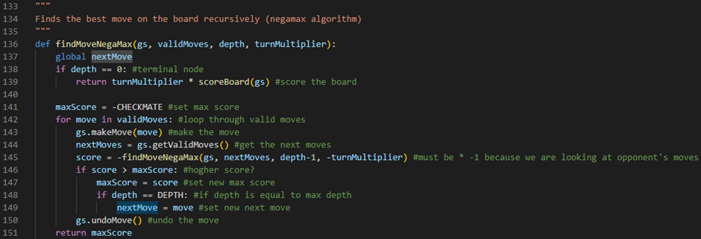

Line 136 defines a function called findMoveNegaMax. This function will take 4 parameters: our current gameState object, our current validMoves array, our current depth variable and our current turnMultiplier variable. Line 137 sets the scope of a variable called nextMove to global, allowing it to be accessed from outside of our function. Line 138 checks if our current depth variable is equal to the integer 0. If it is, then we have reached our recursive function’s terminal node and line 139 will return our turnMultiplier variable multiplied by the product of running our scoreBoard function, given our current gameState object as an argument. Line 141 will define a variable called maxScore which will be set to our CHECKMATE variable multiplied by -1. Line 142 defines a for loop which will iterate through every move in our current validMoves array. Line 143 will then make our current move by running our gameState object’s makeMove method and passing our move variable as an argument. Line 144 will define a variable called nextMoves which will store our new set of validMoves by storing the product of running our gameState object’s getValidMoves method. Line 145 will define a variable called score which will be set to the product of running our findMoveNegaMax function, passing our current gameState object, our nextMoves variable, our current depth variable minus 1 and our turnMultiplier multiplied by -1 as arguments, multiplied by -1. This line of code is our recursive function call. Line 146 will then check if our score variable is greater than our maxScore variable. If it is, then line 147 will set our maxScore variable to our score variable. Line 148 will check if our depth variable is equal to our DEPTH variable. If it is, then line 149 will set our nextMove variable to our current move variable. Line 150 will undo the move we made by running our gameState object’s undoMove method. Line 151 will then return our maxScore variable.

Finally, we need to go into our chessMain.py file and update our AI move finder logic:

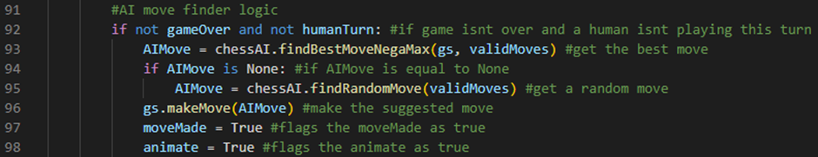

Line 93 now defines a variable called AIMove which will be set to the product of running our chessAI.py file’s findBestMoveNegaMax function, passing our current gameState object and our current validMoves array as arguments.

We can now set our playerOne and our playerTwo variables to False and run the program to test to see if our recursive NegaMax AI algorithm works:



So far, it’s working as we expect it to! We have now implemented our recursive NegaMax AI algorithm into our chess engine.

NegaMaxAI test table:

|  |  |  |
| --- | --- | --- |
| Test Data | Expected Outcome | Actual Outcome |
| Enemy Move | The best move possible on the board is played by our chess engine. | As expected. |

Next, we’re going to implement alpha-beta pruning into our chess engine. Alpha-beta pruning reduces the time complexity of our AI algorithms by efficiently pruning branches that are guaranteed not to influence the final decision. This is going to boost the efficiency of our AI algorithms, however, we won’t really be able to spot the difference until we score our board by our pieces’ respective material and positional values.

We’re going to do this inside of entirely new functions.

First, we’re going to define a new function called findBestMoveNegaMaxAlphaBeta:

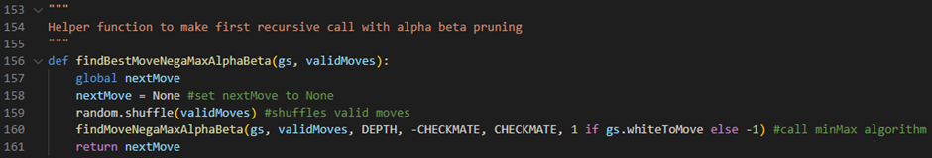

Line 156 defines a function called findBestMoveNegaMaxAlphaBeta. It will take 2 parameters: our current gameState object and our current validMoves array. A majority of the code here is copy and pasted from our findBestMoveNegaMax function so I will only be explaining parts of the code which are newly added. Line 160 calls our recursive function called findMoveNegaMaxAlphaBeta, passing our current gameState object, our current validMoves array, our DEPTH variable, our CHECKMATE variable multiplied by -1, our CHECKMATE variable and an integer value of 1 if our current gameState object’s whiteToMove attribute is set to True otherwise an integer value of -1 as arguments.

Next, we’re going to define a new function called findMoveNegaMaxAlphaBeta:

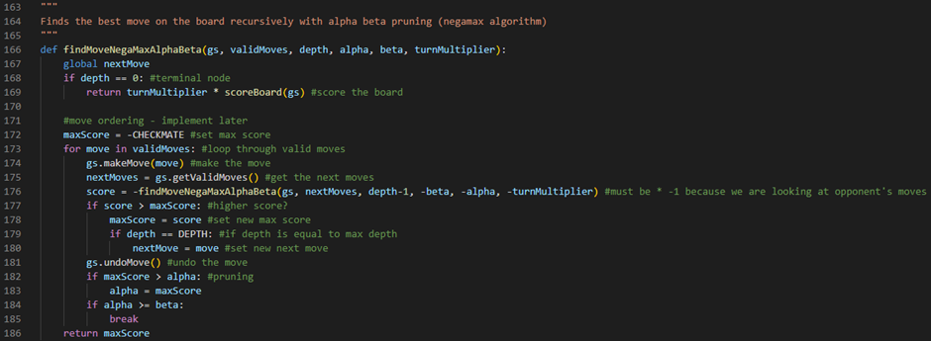

Line 166 defines a function called findMoveNegaMaxAlphaBeta. It will take 6 parameters: our current gameState object, our current validMoves array, our current depth variable, our current alpha variable, our current beta variable and our current turnMultiplier variable. A majority of the code here is copy and pasted from our findMoveNegaMax function so I will only be explaining parts of the code which are newly added. Line 176 will define a variable called score which will be set to the product of running our findMoveNegaMaxAlphaBeta function, passing our current gameState object, our nextMoves variable, our current depth variable minus 1, our beta variable multiplied by -1, our alpha variable multiplied by -1 and our turnMultiplier multiplied by -1 as arguments, multiplied by -1. This line of code is our recursive function call. Line 182 checks if our maxScore variable is greater than our alpha variable. If it is, then line 183 will set our alpha variable to our maxScore variable. Line 184 checks if our alpha variable is greater than or equal to our beta variable. If it is, then line 185 will run a break command which will break us out of our for loop. This line of code is what prunes branches that are guaranteed not to influence the final decision.

Finally, we need to go into our chessMain.py file and update our AI move finder logic:

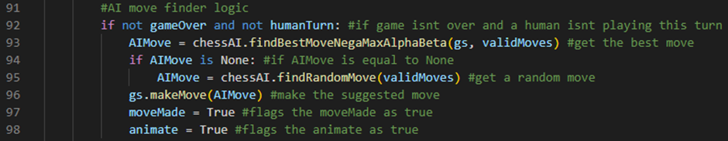

Line 93 now defines a variable called AIMove which will be set to the product of running our chessAI.py file’s findBestMoveNegaMaxAlphaBeta function, passing our current gameState object and our current validMoves array as arguments.

We can now set our DEPTH variable to an integer value of 3 and our playerOne and our playerTwo variables to False and run the program to test to see if our recursive NegaMax AI algorithm with alpha-beta pruning works:



So far, it’s working as we expect it to! We have now implemented our recursive NegaMax AI algorithm with alpha-beta pruning into our chess engine.

You might notice that our run-time is a tiny bit slower than before. This is because we increased our DEPTH variable from an integer value of 2 to an integer value of 3. This also means that our algorithm is now looking 3 moves ahead and playing smarter moves.

Next, we’re going to implement alpha-beta pruning into our MinMax AI algorithm. We’re going to do this inside of entirely new functions.

First, we’re going to define a new function called findBestMoveMinMaxAlphaBeta

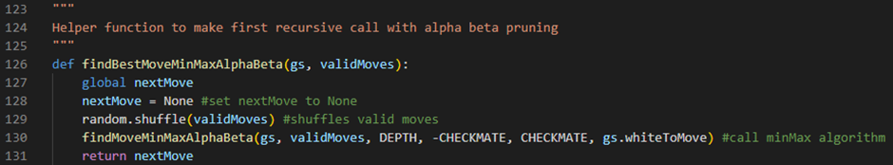

Line 126 defines a function called findBestMoveMinMaxAlphaBeta. It will take 2 parameters: our current gameState object and our current validMoves array. A majority of the code here is copy and pasted from our findBestMoveMinMax function so I will only be explaining parts of the code which are newly added. Line 130 calls our recursive function called findMoveMinMaxAlphaBeta, passing our current gameState object, our current validMoves array, our DEPTH variable, our CHECKMATE variable multiplied by -1, our CHECKMATE variable and our current gameState object’s whiteToMove attribute.

Next, we’re going to define a new function called findMoveMinMaxAlphaBeta:

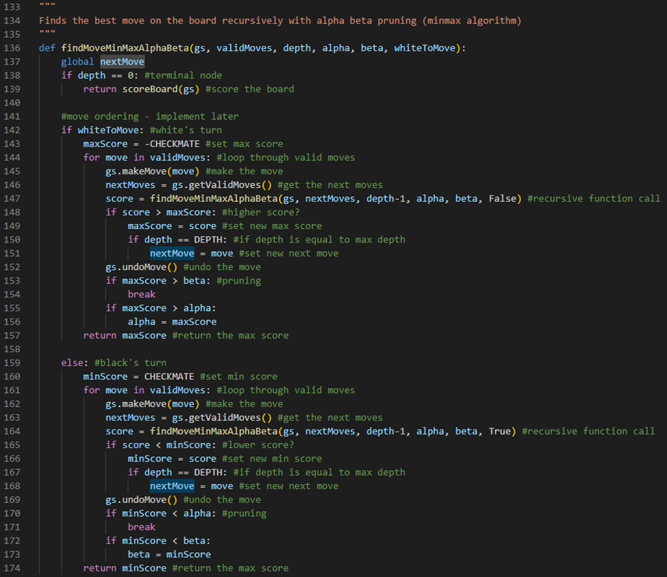

Line 136 defines a function called findMoveMinMaxAlphaBeta. It will take 6 parameters: our current gameState object, our current validMoves array, our current depth variable, our current alpha variable, our current beta variable and our current whiteToMove variable. A majority of the code here is copy and pasted from our findMoveMinMax function so I will only be explaining parts of the code which are newly added. Line 147 will define a variable called score which will be set to the product of running our findMoveMinMaxAlphaBeta function, passing our current gameState object, our nextMoves variable, our current depth variable minus 1, our alpha variable, our beta variable and a boolean value of False as arguments. This line of code is one of our recursive function calls. Line 153 checks if our maxScore variable is greater than our beta variable. If it is, then line 154 will run a break command which will break us out of our for loop. This line of code is what prunes branches that are guaranteed not to influence the final decision. Line 155 checks if our maxScore variable is greater than our alpha variable. If it is, then line 156 will set our alpha variable to our maxScore variable. Line 164 will define a variable called score which will be set to the product of running our findMoveMinMaxAlphaBeta function, passing our current gameState object, our nextMoves variable, our current depth variable minus 1, our alpha variable, our beta variable and a boolean value of True as arguments. This line of code is one of our recursive function calls. Line 170 checks if our minScore variable is less than our alpha variable. If it is, then line 171 will run a break command which will break us out of our for loop. This line of code is what prunes branches that are guaranteed not to influence the final decision. Line 172 checks if our minScore variable is less than our beta variable. If it is, then line 173 will set our beta variable to our minScore variable.

Finally, we need to go into our chessMain.py file and update our AI move finder logic:

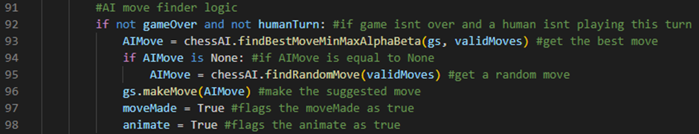

Line 93 now defines a variable called AIMove which will be set to the product of running our chessAI.py file’s findBestMoveMinMaxAlphaBeta function, passing our current gameState object and our current validMoves array as arguments.

We can now set our DEPTH variable to an integer value of 3 and our playerOne and our playerTwo variables to False and run the program to test to see if our recursive MinMax AI algorithm with alpha-beta pruning works:



So far, it’s working as we expect it to! We have now implemented our recursive MinMax AI algorithm with alpha-beta pruning into our chess engine.

However, you might notice that our run-time is extremely slow. This is because we are using a MinMax AI algorithm instead of our NegaMax AI algorithm. Our AI algorithms would also be playing better moves if we scored our board by our pieces’ material and positional values.

Move Log Display

Here, we’re going to work on implementing a move log display for our chess engine. However, before that, through testing I have found a couple of bugs with our chess engine that I would quickly like to fix now.

Firstly, I forgot to add the logic which tells the chess engine not to let us castle if our rook gets captured. This led to the following bug occurring:



Luckily, this is easy to fix. All we need to do is open our chessEngine.py file and update our updateCastleRights method:

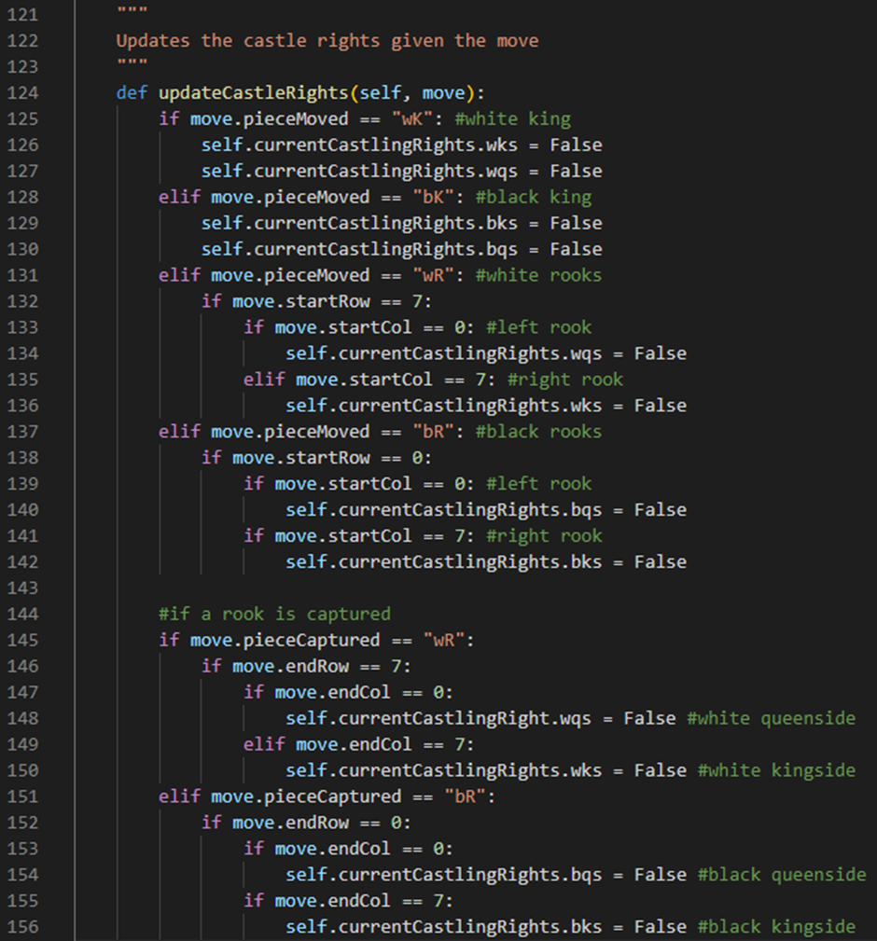

Line 145 checks if a white rook has been captured by evaluating if our move’s pieceCaptured attribute is set to a value of the string “wR”. If it is, then line 146 will check if our move’s endRow attribute is set to a value of the integer 7. If it is, then line 147 will check if our move’s endCol attribute is set to a value of the integer 0. If it is, then line 148 will set our gameState object’s currentCastlingRight’s wqs attribute to False. This is because, in chess, if the left white rook is captured then the white king loses its queenside castle rights. Line 149 checks if our move’s endCol attribute is set to a value of the integer 7. If it is, then line 150 will set our gameState object’s currentCastlingRight’s wks attribute to False. This is because, in chess, if the right white rook is captured then the white king loses its kingside castle rights. Line 151 checks if a black rook has been captured by evaluating if our move’s pieceCaptured attribute is set to a value of the string “bR”. If it is, then line 152 will check if our move’s endRow attribute is set to a value of the integer 0. If it is, then line 153 will check if our move’s endCol attribute is set to a value of the integer 0. If it is, then line 154 will set our gameState object’s currentCastlingRight’s bqs attribute to False. This is because, in chess, if the left black rook is captured then the black king loses its queenside castle rights. Line 155 checks if our move’s endCol attribute is set to a value of the integer 7. If it is, then line 156 will set our gameState object’s currentCastlingRight’s bks attribute to False. This is because, in chess, if the right black rook is captured then the black king loses its kingside castle rights.

We can now run the program and test to see if we can still castle after our rook gets captured:



So far, it’s working as we expect it to! We have now fixed our castling moves.

Next, I found a bug to do with our en passant moves:



This bug is occurring because, at the moment in our code, the only time we give back our en passant rights is when the move we just undid is an en passant move. This is a problem because when we make more moves past that, our en passant rights are not correctly updated when we undo those moves.

To fix this, we’re going to go into our gameState class constructor and update it:



Line 38 defines an attribute called enPassantPossibleLog which stores an array containing our enPassantPossible attribute. This array will be appended to as our chess game goes on.

Next, we’re going to go into our makeMove method and update it:

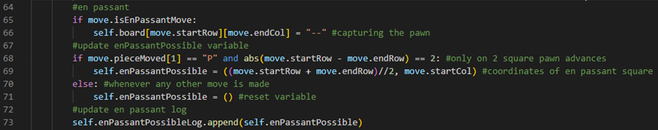

Line 73 appends our enPassantPossible attribute to our enPassantPossibleLog array attribute by calling the append method of our enPassantPossibleLog array attribute and passing our enPassantPossible attribute as an argument.

Next, we’re going to go into our undoMove method and update it:

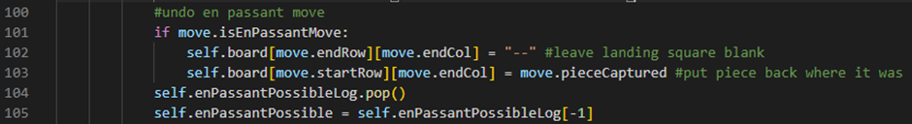

Line 104 takes the last element out of our enPassantPossibleLog array attribute by calling the pop method of our enPassantPossibleLog array attribute. Line 105 then sets our enPassantPossible attribute to the last element in our current enPassantPossibleLog array attribute by accessing the element stored in our current enPassantPossibleLog array attribute at the index value of -1.

We can now run the program and test to see if we can en passant after making multiple moves and then undoing them:



So far, it’s working as we expect it to! We have now fixed our en passant moves.

Next, you might notice that our en passant animation looks a bit weird.

We’re going to fix this by opening up our chessMain.py file and updating our animateMove procedure:

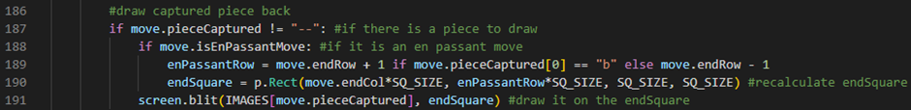

Line 188 will check if the move we are animating is an en passant move by evaluating if our move’s isEnPassantMove attribute is set to true. If it is, then line 189 will define a variable called enPassantRow which will be set to our move’s endRow attribute + 1 if the first element of our move’s pieceCaptured attribute stores a value of the character “b”, otherwise it will be set to our move’s endRow attribute - 1. Line 190 will then define a variable called endSquare which stores a PyGame Rect object with an x-position of (our move’s endCol attribute multiplied by SQ_SIZE), y-position of (our enPassantRow variable multiplied by SQ_SIZE), width of (SQ_SIZE) and height of (SQ_SIZE).

We can now run the program and test to see if our en passant animation looks better:



So far, it’s working as we expect it to! Our animation from before is fixed and the pawn no longer looks like it gets randomly taken to the square it is being captured from.

This is it for all the bugs I have found so far.

Next, we’re going to rename our drawText procedure to drawEndGameText:

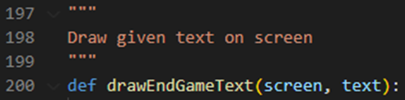

Line 200 now defines a procedure called drawEndGameText which takes two parameters: our screen variable which we are going to draw on and our text variable which we are going to draw.

Next, we’re going to go into our main procedure and update it:



Line 109 checks if our chess engine has calculated either a checkmate or a stalemate by evaluating if our current gameState object’s checkmate attribute is set to True or if our current gameState object’s stalemate attribute is set to True. If this is the case, then line 110 will set our gameOver variable to True. Line 111 will then run our drawEndGameText procedure, passing our screen variable and the string value “Stalemate” if our current gameState object’s stalemate attribute is set to True otherwise, it will pass the string value “Black wins by checkmate” if our current gameState object’s checkmate attribute is set to True otherwise, it will pass the string value “White wins by checkmate”. This code does the same thing as before except now it is all on one line which makes our code much neater and more streamlined.

We can now run the program and test to see if our little update works:

White checkmate:



Black checkmate:



Stalemate:



So far, it’s working as we expect it to! As you can see, the code still works in the exact same way, the only difference is that it is a bit more concise in the way that it is written.

Now, we can start on implementing a move log display for our chess engine.

First, we’re going to create a new procedure called drawMoveLog:

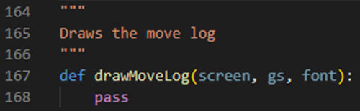

Line 167 defines a procedure called drawMoveLog. It will take 3 parameters: our screen variable, our current gameState object and our font variable. Line 168 currently just runs a pass statement which tells our program to not do anything.

Next, we’re going to go inside our main procedure and update it:

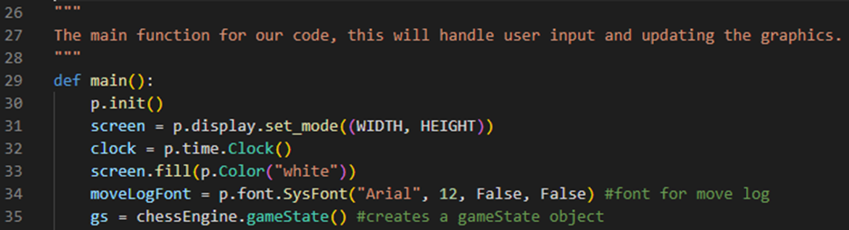

Line 34 defines a variable called moveLog font which stores a PyGame font object. This font object is going to be an Arial font with a font size of 12, a bold value of False and an italic value of False.

Next, we’re going to update our drawGameState procedure:

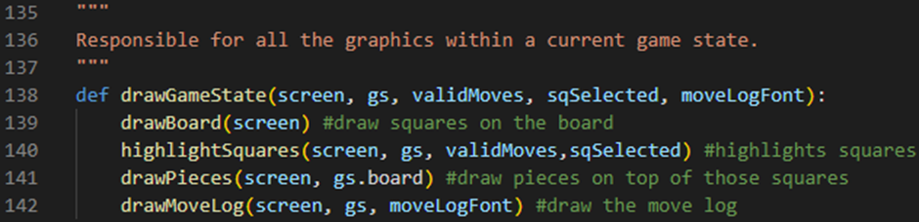

Line 138 now defines a procedure called drawGameState which takes 5 parameters: our screen variable, our current gameState object, our current validMoves array, our current sqSelected tuple and our moveLogFont variable. Line 142 calls our drawMoveLog procedure, passing our screen variable, our current gameState object and our moveLogFont variable as arguments.

Next, we’re going to update our main procedure again:



Line 108 now calls our drawGameState procedure, passing our screen variable, our current gameState object, our current validMoves array, our current sqSelected tuple and our moveLogFont variable as arguments.

Next, we’re going to add two more variables to the top of our chessMain.py file:

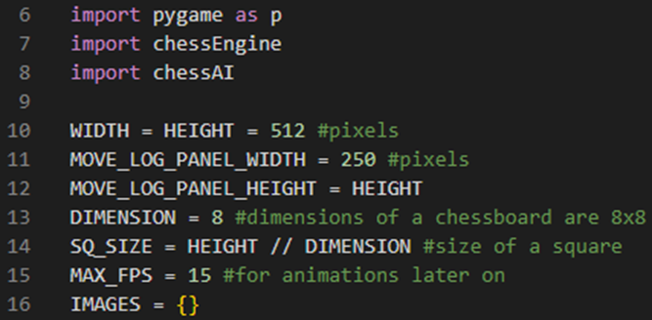

Line 11 defines a variable called MOVE_LOG_PANEL_WIDTH which is set to an integer value of 250. This value represents 250 pixels on our screen. Line 12 defines a variable called MOVE_LOG_PANEL_HEIGHT which is set to our HEIGHT variable. This is because we want our move log display to be the same height as the rest of our application.

Next, we’re going to update our main procedure again:

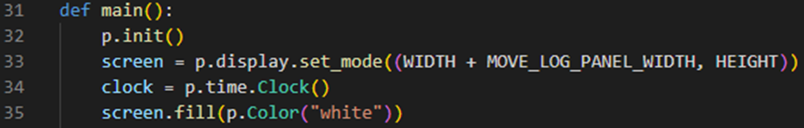

Line 33 now defines a variable called screen which holds information about the GUI window screen that the chessboard will soon display on. For example, our screen’s width is set to our WIDTH variable plus our MOVE_LOG_PANEL_WIDTH variable and our screen’s height is set to our HEIGHT variable.

We can now run the program and test to see if our space on the screen for our move log is being displayed:

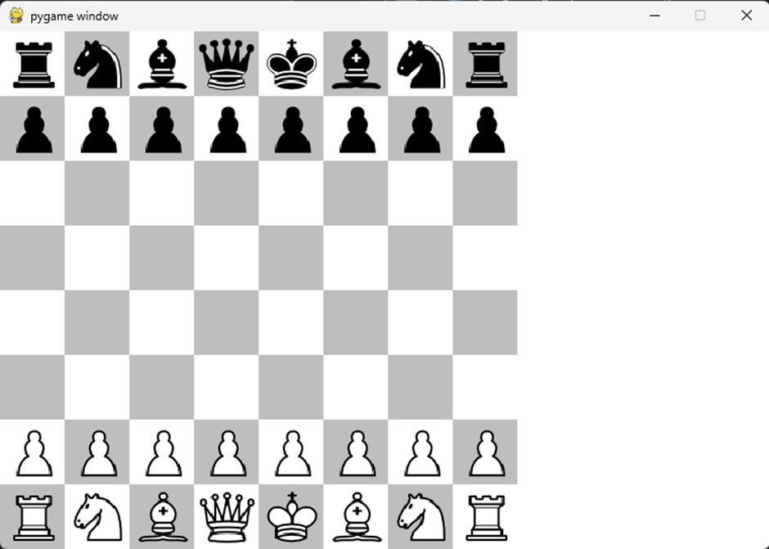

So far, it’s working as we expect it to!

However, when we click on the move log, we get an error message:

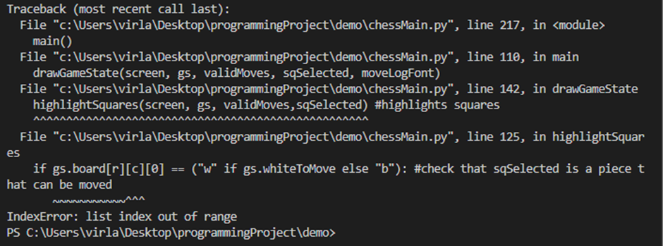

This is because when we click on the move log, it is trying to select an index in our board array which is out of range.

To fix this, we’re going to go into our main procedure and update our mouse handler:

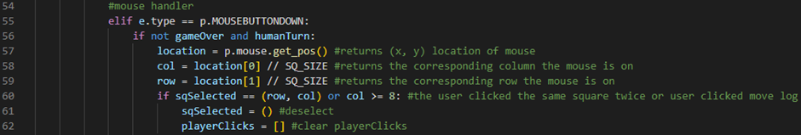

Line 60 now checks if our sqSelected variable stores a tuple containing our row variable and our col variable or if our col variable is greater than or equal to 8. If this is the case, then our current square will be deselected.

We can now run the program and test to see if we still get that error:



So far, it’s working as we expect it to! Now, when we click on the move log we no longer get an error message. It will instead deselect any piece we have selected.

Next, we can write our drawMoveLog procedure:

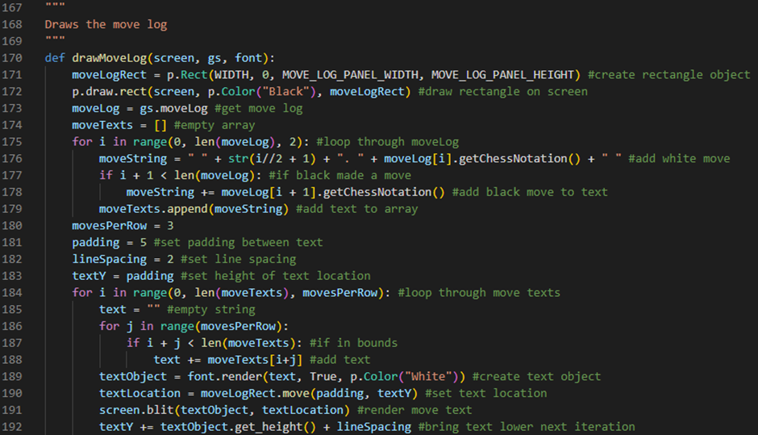

Line 170 defines a procedure called drawMoveLog. It will take 3 parameters: our screen variable, our current gameState object and our font variable. Line 171 defines a variable called moveLogRect which stores a PyGame Rect object with an x-position of (our WIDTH variable), y-position of (0), width of (our MOVE_LOG_PANEL_WIDTH variable) and height of (our MOVE_LOG_PANEL_HEIGHT variable). Line 172 then draws our moveLogRect rectangle object on the screen by running the p.draw.rect method and passing our screen variable, a PyGame Colour object with a colour of “Black” and our moveLogRect variable as arguments. Line 173 defines a variable called moveLog which is set to our current gameState object’s moveLog attribute. Line 174 defines a variable called moveTexts which is set to an empty array. Line 175 defines a for loop which will iterate through every two moves in our move log. Line 176 defines a variable called moveString which is set to a whitespace character, “ “, plus the number of our move as a string, (calculated by i // 2 + 1), plus a period and a whitespace character, “. “, plus our current move’s chess notation, moveLog[i].getChessNotation(), plus a whitespace character, “ “. This line of code is what generates the text for our white move. Line 177 checks if black has made a move yet by checking if i + 1 is less than the amount of elements inside our moveLog variable. If this is the case, then line 178 will add to our moveString variable our black move’s chess notation, moveLog[i+1].getChessNotation(). Line 179 will append our moveString variable to our moveTexts array by running our moveTexts array’s append method and passing our moveString variable as an argument. Line 180 will define a variable called movesPerRow which will store an integer value of 3. This number represents how many moves we want per row on our move log display. Line 181 will define a variable called padding which will store an integer value of 5. This number represents how much padding we want around our text. Line 182 will define a variable called lineSpacing which will store an integer value of 2. This number represents how much line spacing we want around our text. Line 183 will define a variable called textY which will be set to our padding variable. This variable will dictate the height of our text location. Line 184 defines a for loop which will iterate through our moveTexts array every 3 moves (or however many moves we set per row). Line 185 will define a variable called text which will store an empty string. Line 186 defines an embedded for loop which will loop through 3 times (or however many moves we set per row). Line 187 checks if the text we are going to try to draw is in bounds by evaluating if i + j is less than the amount of elements in our moveTexts array. If this is the case, then line 188 will add to our text variable the element stored in our moveTexts array at the index of i + j. Line 189 defines a variable called textObject which is set to our rendered text by using the render method of our font variable and passing our text variable, an antialias value of True and a colour object of the colour White as arguments.Line 190 defines a variable called textLocation which stores the product of running our moveLogRect variable’s move method and passing our padding variable and our textY variable as arguments. Line 191 then draws our text to the screen by running our screen variable’s blit method and passing our textObject variable and our textLocation variable as arguments. Line 192 increments our textY variable by our textObject’s height (obtained by running its get_height method) plus our lineSpacing variable.

We can now run the program and test to see if our move log display is working:



So far, it’s working as we expect it to! We have now implemented a move log display into our chess engine.

However, we can still improve this a bit by making our text a bit more like actual chess notation.

To do this, we’re going to open our chessEngine.py file and update our Move class constructor:



Line 585 defines an attribute called isCaptureMove which will be set to True if our pieceCaptured attribute is not set to the string “--”. Otherwise, it will be set to False.

Next, we’re going to override our Move class’s str() method:

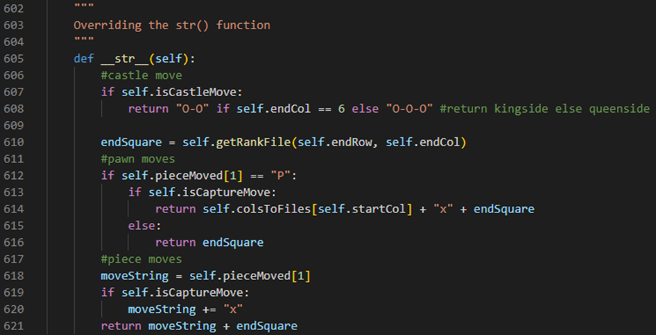

Line 605 defines our Move class’s str() method. It will take no parameters. Line 607 checks if our move is a castle move by evaluating if our move’s isCastleMove attribute is set to True. If it is, then line 608 will return the string “O-O” if our move’s endCol attribute is set to the integer 6 (this represents our kingside castle move) otherwise it will return the string “O-O-O” (this represents our queenside castle move). Line 610 defines a variable called endSquare which is set to the product of running our getRankFile method and passing our endRow attribute and our endCol attribute as arguments. Line 612 checks if the piece we moved was a pawn by checking if the second character of our move’s pieceMoved attribute is set to the string “P”. If it is, then line 613 will check if our move was a capture move by checking if our move’s isCaptureMove attribute is set to True. If it is, then line 614 will return the value stored in our colsToFiles dictionary when accessed by our move’s startCol as a key plus the character “x” plus our endSquare variable. Line 615 is an else statement which will run if our move is not a capture move. If this is the case, then line 616 will return our endSquare variable. Line 618 will define a variable called moveString which will store the second element of our move’s pieceMoved attribute. Line 619 will check if our move was a capture move by checking if our move’s isCaptureMove attribute is set to True. If it is, then line 620 will add the character “x” to our moveString variable. Line 621 will then return our moveString variable plus our endSquare variable.

Finally, we’re going to update our drawMoveLog procedure:

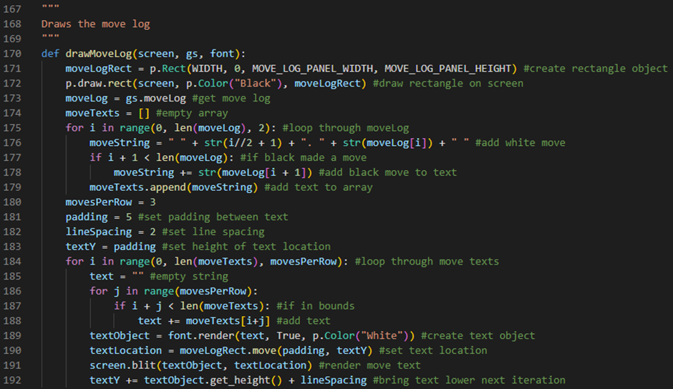

Line 176 now defines a variable called moveString which is set to a whitespace character, “ “, plus the number of our move as a string, (calculated by i // 2 + 1), plus a period and a whitespace character, “. “, plus our current move’s chess notation using our Move class’s overridden string method, str(moveLog[i]), plus a whitespace character, “ “. Line 178 will now add to our moveString variable our black move’s chess notation using our Move class’s overridden string method, str(moveLog[i+1]).

We can now run the program and test to see if our new chess notation is working:





So far, it’s working as we expect it to! We have now implemented a move log display with accurate chess notation.

AI improvement and threading

Before we get started on improving our AI algorithms by adding positional scoring to our scoreBoard function and implementing threading into our chess engine, I would like to first fix another bug that I found with our en passant functionality.

This bug is actually game breaking as it allows our king to be captured by an enemy piece which should never be allowed to happen in a chess game. A king can never be captured in chess, only checkmated. This is the bug:



Luckily, the fix for this is easy enough.

To do this, we are going to need to open our chessEngine.py file and update our getPawnMoves method:

White pawn left side en passant capture:

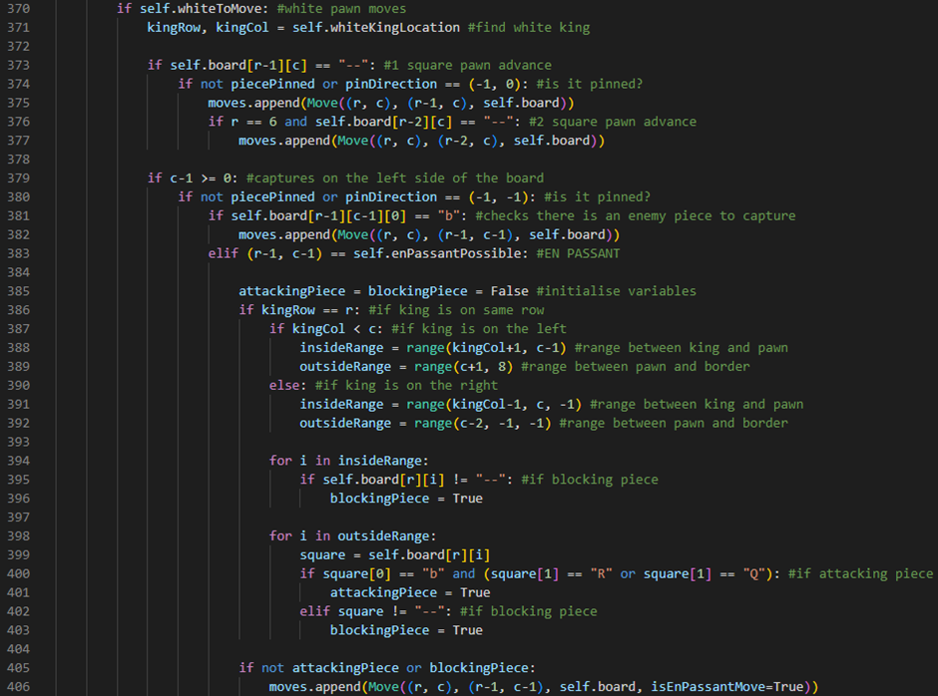

Line 371 defines two variables called kingRow and kingCol. Our kingRow variable stores the first element of our gameState object’s whiteKingLocation tuple (which returns the row our white king is on) and our kingCol variable stores the second element of our gameState object’s whiteKingLocation tuple (which returns the column our white king is on). Line 385 defines two variables called attackingPiece and blockingPiece. These two variables are going to be initialised to False. Line 386 checks if the king is on the same row as our pawn by evaluating if our kingRow variable stores the same value as our r variable. If this is the case, then line 387 will check if our king is on the left of our pawn by evaluating if our kingCol variable is less than our c variable. If this is the case, then line 388 will define a variable called insideRange which will be set to the range between our king and our pawn. This range is returned by running our range built-in function and passing a start of our kingCol variable plus one and a stop of our c variable minus one. Line 389 will define a variable called outsideRange which will be set to the range between our pawn and the border of our board. This range is returned by running our range built-in function and passing a start of our c variable plus one and a stop of the integer 8. Line 390 is an else statement which will run if our king is on the right of our pawn. If this is the case, then line 391 will define a variable called insideRange which will be set to the range between our king and our pawn. This range is returned by running our range built-in function and passing a start of our kingCol variable minus one, a stop of our c variable and a step of the integer -1. Line 392 will define a variable called outsideRange which will be set to the range between our pawn and the border of our board. This range is returned by running our range built-in function and passing a start of our c variable minus two, a stop of the integer -1 and a step of the integer -1. Line 394 defines a for loop which will iterate through our insideRange variable. Line 395 will check if there is a blocking piece in this range by evaluating if the element stored on our board 2D array at the (our r variable, our i counter variable) position does not have a value of the string “--”. If this is the case, then line 396 will set our blockingPiece variable to True. Line 398 defines a for loop which will iterate through our outsideRange variable. Line 399 defines a variable called square which stores the element stored on our board 2D array at the (our r variable, our i counter variable) position. Line 400 checks if there is an attacking piece in this range by evaluating if the first character of our square variable is the character “b” and if the second character of our square variable is the character “R” or “Q”. If this is the case, then line 401 will set our attackingPiece variable to True. Line 402 will check if there is a blocking piece in this range by evaluating if our square variable does not have a value of the string “--”. If this is the case, then line 403 will set our blockingPiece variable to True. Line 405 will check if our attackingPiece variable is set to False or if our blockingPiece variable is set to True. If this is the case, then line 406 will append this en passant capture move to our moves array by calling the append method of our moves array and creating a Move object (with a startSq of (r, c), an endSq of (r-1, c-1), a board of our current board attribute and an isEnPassantMove flag variable set to True) to give as an argument.

White pawn right side en passant capture:

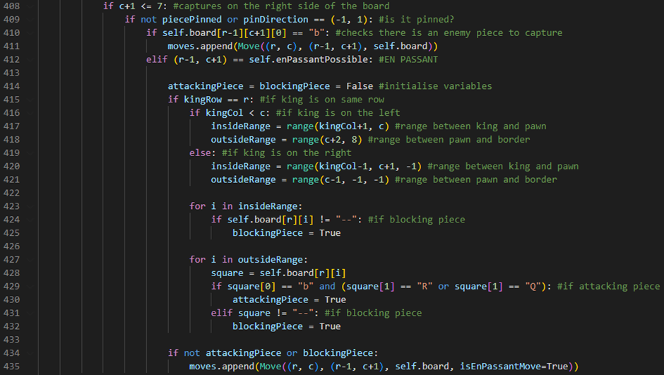

Line 414 defines two variables called attackingPiece and blockingPiece. These two variables are going to be initialised to False. Line 415 checks if the king is on the same row as our pawn by evaluating if our kingRow variable stores the same value as our r variable. If this is the case, then line 416 will check if our king is on the left of our pawn by evaluating if our kingCol variable is less than our c variable. If this is the case, then line 417 will define a variable called insideRange which will be set to the range between our king and our pawn. This range is returned by running our range built-in function and passing a start of our kingCol variable plus one and a stop of our c variable. Line 418 will define a variable called outsideRange which will be set to the range between our pawn and the border of our board. This range is returned by running our range built-in function and passing a start of our c variable plus two and a stop of the integer 8. Line 419 is an else statement which will run if our king is on the right of our pawn. If this is the case, then line 420 will define a variable called insideRange which will be set to the range between our king and our pawn. This range is returned by running our range built-in function and passing a start of our kingCol variable minus one, a stop of our c variable plus one and a step of the integer -1. Line 421 will define a variable called outsideRange which will be set to the range between our pawn and the border of our board. This range is returned by running our range built-in function and passing a start of our c variable minus one, a stop of the integer -1 and a step of the integer -1. Line 423 defines a for loop which will iterate through our insideRange variable. Line 424 will check if there is a blocking piece in this range by evaluating if the element stored on our board 2D array at the (our r variable, our i counter variable) position does not have a value of the string “--”. If this is the case, then line 425 will set our blockingPiece variable to True. Line 427 defines a for loop which will iterate through our outsideRange variable. Line 428 defines a variable called square which stores the element stored on our board 2D array at the (our r variable, our i counter variable) position. Line 429 checks if there is an attacking piece in this range by evaluating if the first character of our square variable is the character “b” and if the second character of our square variable is the character “R” or “Q”. If this is the case, then line 430 will set our attackingPiece variable to True. Line 431 will check if there is a blocking piece in this range by evaluating if our square variable does not have a value of the string “--”. If this is the case, then line 432 will set our blockingPiece variable to True. Line 434 will check if our attackingPiece variable is set to False or if our blockingPiece variable is set to True. If this is the case, then line 435 will append this en passant capture move to our moves array by calling the append method of our moves array and creating a Move object (with a startSq of (r, c), an endSq of (r-1, c+1), a board of our current board attribute and an isEnPassantMove flag variable set to True) to give as an argument.

Black pawn left side en passant capture:

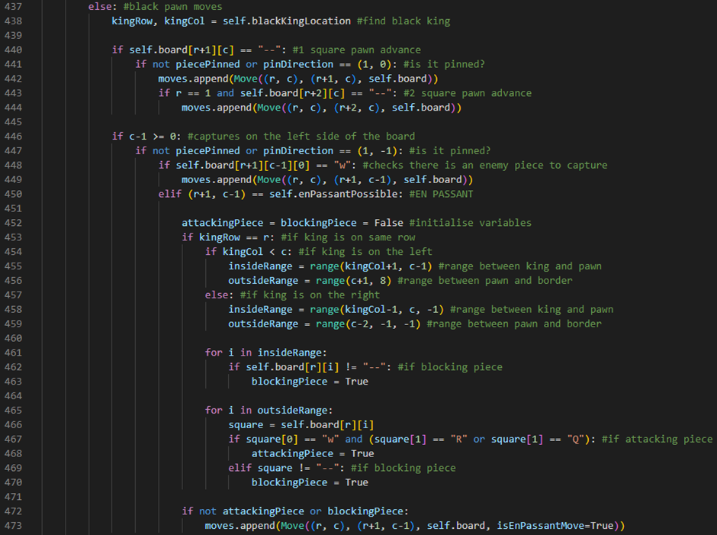

Line 438 defines two variables called kingRow and kingCol. Our kingRow variable stores the first element of our gameState object’s blackKingLocation tuple (which returns the row our black king is on) and our kingCol variable stores the second element of our gameState object’s blackKingLocation tuple (which returns the column our black king is on). Line 452 defines two variables called attackingPiece and blockingPiece. These two variables are going to be initialised to False. Line 453 checks if the king is on the same row as our pawn by evaluating if our kingRow variable stores the same value as our r variable. If this is the case, then line 454 will check if our king is on the left of our pawn by evaluating if our kingCol variable is less than our c variable. If this is the case, then line 455 will define a variable called insideRange which will be set to the range between our king and our pawn. This range is returned by running our range built-in function and passing a start of our kingCol variable plus one and a stop of our c variable minus one. Line 456 will define a variable called outsideRange which will be set to the range between our pawn and the border of our board. This range is returned by running our range built-in function and passing a start of our c variable plus one and a stop of the integer 8. Line 457 is an else statement which will run if our king is on the right of our pawn. If this is the case, then line 458 will define a variable called insideRange which will be set to the range between our king and our pawn. This range is returned by running our range built-in function and passing a start of our kingCol variable minus one, a stop of our c variable and a step of the integer -1. Line 459 will define a variable called outsideRange which will be set to the range between our pawn and the border of our board. This range is returned by running our range built-in function and passing a start of our c variable minus two, a stop of the integer -1 and a step of the integer -1. Line 461 defines a for loop which will iterate through our insideRange variable. Line 462 will check if there is a blocking piece in this range by evaluating if the element stored on our board 2D array at the (our r variable, our i counter variable) position does not have a value of the string “--”. If this is the case, then line 463 will set our blockingPiece variable to True. Line 465 defines a for loop which will iterate through our outsideRange variable. Line 466 defines a variable called square which stores the element stored on our board 2D array at the (our r variable, our i counter variable) position. Line 467 checks if there is an attacking piece in this range by evaluating if the first character of our square variable is the character “w” and if the second character of our square variable is the character “R” or “Q”. If this is the case, then line 468 will set our attackingPiece variable to True. Line 469 will check if there is a blocking piece in this range by evaluating if our square variable does not have a value of the string “--”. If this is the case, then line 470 will set our blockingPiece variable to True. Line 472 will check if our attackingPiece variable is set to False or if our blockingPiece variable is set to True. If this is the case, then line 473 will append this en passant capture move to our moves array by calling the append method of our moves array and creating a Move object (with a startSq of (r, c), an endSq of (r+1, c-1), a board of our current board attribute and an isEnPassantMove flag variable set to True) to give as an argument.

Black pawn right side en passant capture:

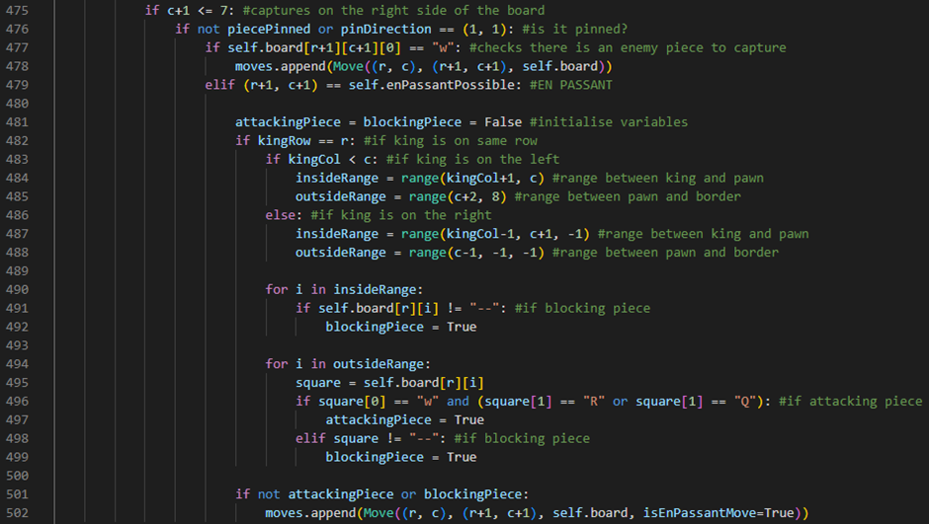

Line 481 defines two variables called attackingPiece and blockingPiece. These two variables are going to be initialised to False. Line 482 checks if the king is on the same row as our pawn by evaluating if our kingRow variable stores the same value as our r variable. If this is the case, then line 483 will check if our king is on the left of our pawn by evaluating if our kingCol variable is less than our c variable. If this is the case, then line 484 will define a variable called insideRange which will be set to the range between our king and our pawn. This range is returned by running our range built-in function and passing a start of our kingCol variable plus one and a stop of our c variable. Line 485 will define a variable called outsideRange which will be set to the range between our pawn and the border of our board. This range is returned by running our range built-in function and passing a start of our c variable plus two and a stop of the integer 8. Line 486 is an else statement which will run if our king is on the right of our pawn. If this is the case, then line 487 will define a variable called insideRange which will be set to the range between our king and our pawn. This range is returned by running our range built-in function and passing a start of our kingCol variable minus one, a stop of our c variable plus one and a step of the integer -1. Line 488 will define a variable called outsideRange which will be set to the range between our pawn and the border of our board. This range is returned by running our range built-in function and passing a start of our c variable minus one, a stop of the integer -1 and a step of the integer -1. Line 490 defines a for loop which will iterate through our insideRange variable. Line 491 will check if there is a blocking piece in this range by evaluating if the element stored on our board 2D array at the (our r variable, our i counter variable) position does not have a value of the string “--”. If this is the case, then line 492 will set our blockingPiece variable to True. Line 494 defines a for loop which will iterate through our outsideRange variable. Line 495 defines a variable called square which stores the element stored on our board 2D array at the (our r variable, our i counter variable) position. Line 496 checks if there is an attacking piece in this range by evaluating if the first character of our square variable is the character “w” and if the second character of our square variable is the character “R” or “Q”. If this is the case, then line 497 will set our attackingPiece variable to True. Line 498 will check if there is a blocking piece in this range by evaluating if our square variable does not have a value of the string “--”. If this is the case, then line 499 will set our blockingPiece variable to True. Line 501 will check if our attackingPiece variable is set to False or if our blockingPiece variable is set to True. If this is the case, then line 502 will append this en passant capture move to our moves array by calling the append method of our moves array and creating a Move object (with a startSq of (r, c), an endSq of (r+1, c+1), a board of our current board attribute and an isEnPassantMove flag variable set to True) to give as an argument.

We can now run the program and test to see if our bug has been fixed.



So far, it’s working as we expect it to! The previous illegal move for white is now no longer playable and our en passant should now be fully functioning.

Next, we’re going to improve our AI algorithms by adding positional scoring to our scoreBoard function. To do this, we’re first going to open our chessAI.py file:

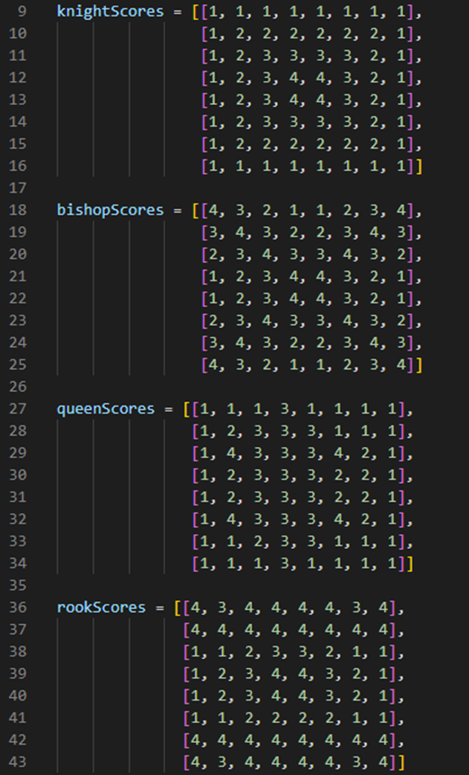

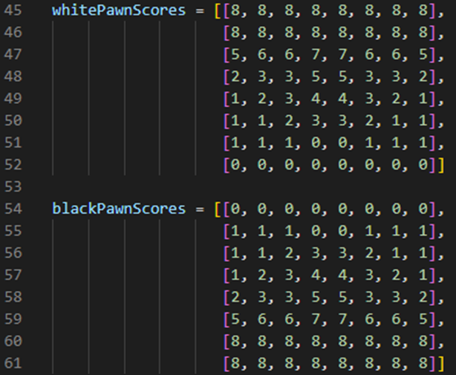

Lines 9-16 define a variable called knightScores. This variable stores a 2D array. Each element inside the 2D array corresponds to a score for a position on our gameState object’s board attribute for a knight piece. The larger the number, the better the position is for the piece. Lines 18-25 define a variable called bishopScores. This variable stores a 2D array. Each element inside the 2D array corresponds to a score for a position on our gameState object’s board attribute for a bishop piece. The larger the number, the better the position is for the piece. Lines 27-34 define a variable called queenScores. This variable stores a 2D array. Each element inside the 2D array corresponds to a score for a position on our gameState object’s board attribute for a queen piece. The larger the number, the better the position is for the piece. Lines 36-43 define a variable called rookScores. This variable stores a 2D array. Each element inside the 2D array corresponds to a score for a position on our gameState object’s board attribute for a rook piece. The larger the number, the better the position is for the piece. Lines 45-52 define a variable called whitePawnScores. This variable stores a 2D array. Each element inside the 2D array corresponds to a score for a position on our gameState object’s board attribute for a white pawn piece. The larger the number, the better the position is for the piece. Lines 54-61 define a variable called blackPawnScores. This variable stores a 2D array. Each element inside the 2D array corresponds to a score for a position on our gameState object’s board attribute for a black pawn piece. The larger the number, the better the position is for the piece.

Next, we’re going to create a dictionary that maps our pieces to their positional scores:



Line 63 defines a dictionary called piecePositionScores. This dictionary maps our pieces to their respective positional scores by using our naming convention for our pieces as keys and pairing their values as their respective 2D array. For example, piecePositionScores[“N”] would return our knightScores 2D array.

Finally, we’re going to update our scoreBoard function:

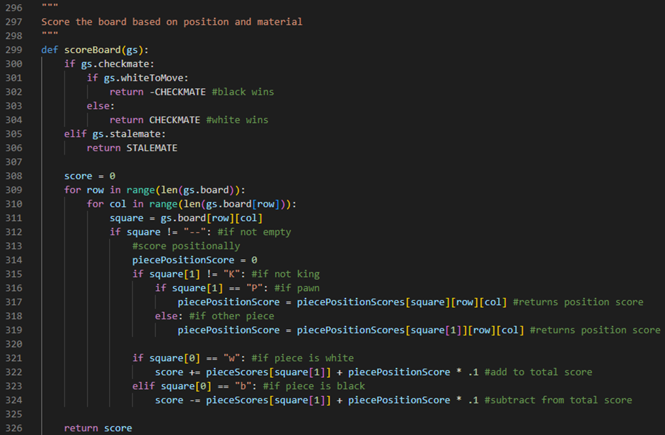

Line 308 defines a variable called score which is initialised to the integer value of 0. Line 309 defines a for loop which iterates through the rows of our gameState object’s board attribute. Line 310 defines an embedded for loop which iterates through the columns of our current row in our gameState object’s board attribute. Line 311 defines a variable called square which stores the element stored on our gameState object’s board attribute at the (row, col) position. Line 312 checks if the square we are looking at is not empty by evaluating if our square variable does not store a value of the string “--”. Line 314 defines a variable called piecePositionScore which is initialised to the integer value of 0. Line 315 checks if the square we are looking at is not a king piece by evaluating if the second character of our square variable does not store a value of the character “K”. If this is the case, then line 316 checks if the square we are looking at is a pawn piece by evaluating if the second character of our square variable stores a value of the character “P”. If this is the case, then line 317 will set our piecePositionScore variable to our pawn piece’s position score by using our square variable as a key for our piecePositionScores dictionary and storing the element stored at the (row, col) position of the resulting 2D array. Line 318 is an else statement which will run if the square we are looking at is not a pawn piece. If this is the case, then line 319 will set our piecePositionScore variable to our piece’s position score by using the second character of our square variable as a key for our piecePositionScores dictionary and storing the element stored at the (row, col) position of the resulting 2D array. Line 321 checks if the piece we are looking at is white by evaluating if the first character of our square variable has a value of the character “w”. If this is the case, then line 322 will add to our score variable our piece’s respective material and positional value by accessing our piece’s respective material value from our pieceScores dictionary, using the second character of our square variable as a key, plus our piecePositionScore variable multiplied by 0.1, and adding this value to our score variable. Line 323 will check if the piece we are looking at is black by evaluating if the first character of our square variable has a value of the character “b”. If this is the case, then line 324 will subtract from our score variable our piece’s respective material and positional value by accessing our piece’s respective material value from our pieceScores dictionary, using the second character of our square variable as a key, plus our piecePositionScore variable multiplied by 0.1, and subtracting this value from our score variable. Line 326 will then return our final score variable.

We can now set our DEPTH variable to an integer value of 3 and our playerOne variable to True and our playerTwo variable to False and run the program to test to see if our AI algorithm’s moves have improved:



So far, it’s working as we expect it to! The AI is now trying to control the centre of the board more and is playing much smarter.

Next, we’re going to add threading to our chess engine application. This is also known as asynchronous functions. This will allow us to interact with our chess engine application even whilst our AI is thinking of the next move to play.

To do this, we’re first going to open our chessMain.py file and import two packages:



Line 9 imports the Process and Queue packages from our multiprocessing library. These are the packages we are going to use in order to implement threading into our chess engine application.

Next, we’re going to go inside our main procedure and create three new variables:

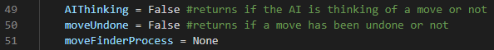

Line 49 defines a flag variable called AIThinking which will be initialised to False. It will be set to True if our AI is currently thinking of a move to play. Line 50 defines a flag variable called moveUndone which will be initialised to False. It will be set to True if a move has been undone or our board has been reset. Line 51 defines a variable called moveFinderProcess which will be initialised to a None object. This variable will hold our Process object for our AI move finder logic.

Next, we’re going to open our chessMain.py file and update our mouse handler:

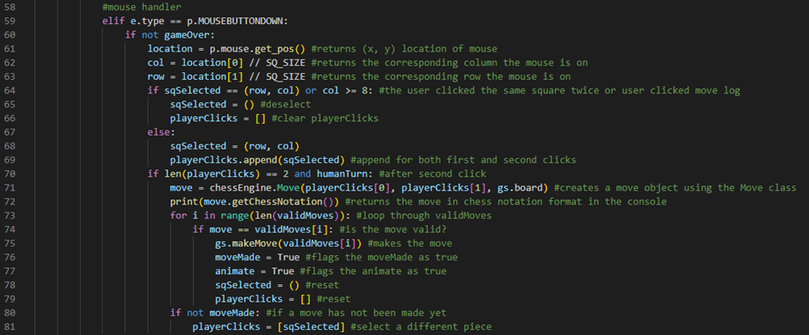

Line 60 checks if the game is not over by evaluating if our gameOver flag variable is set to False. If this is the case, then our player should be allowed to click on the board. Line 70 now checks if our playerClicks array has two elements in it and if our humanTurn variable is set to True. If this is the case, then our player should be allowed to make a move on the board.

Next, we’re going to update our key handler:

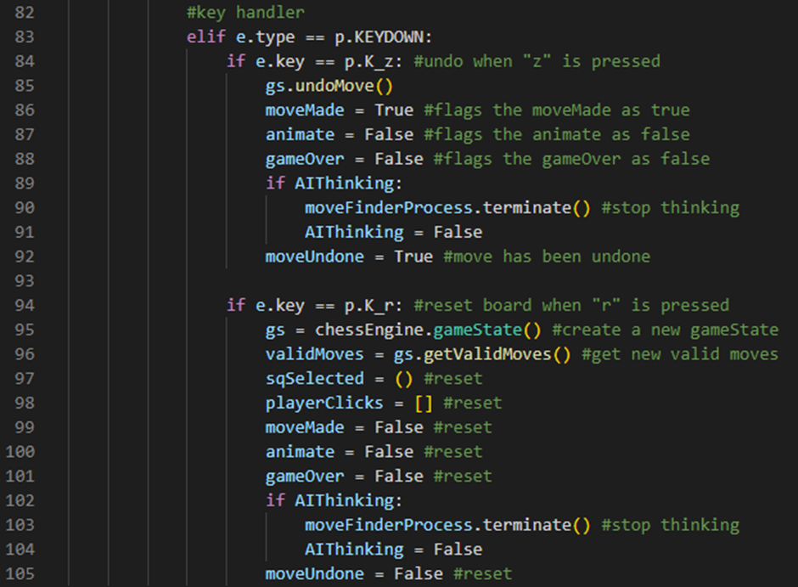

Line 89 checks if our AIThinking flag variable is set to True. If this is the case, then line 90 will tell our AI to stop thinking by running our moveFinderProcess’s terminate method and line 91 will set our AIThinking flag variable to False. Line 92 will then set our moveUndone flag variable to True. Line 102 checks if our AIThinking flag variable is set to True. If this is the case, then line 103 will tell our AI to stop thinking by running our moveFinderProcess’s terminate method and line 104 will set our AIThinking flag variable to False. Line 105 will then set our moveUndone flag variable to False.

Next, we’re going to update our AI move finder logic:

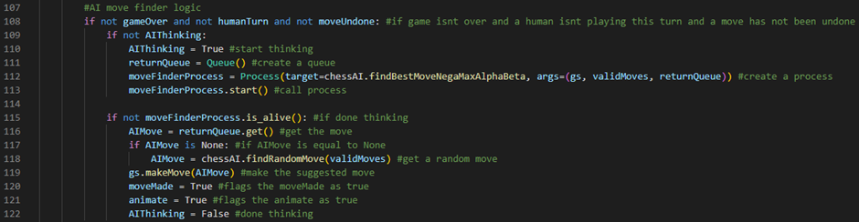

Line 108 checks if the game is not over and a human is not playing this turn and a move has not been undone by evaluating if our gameOver flag variable is set to False and our humanTurn flag variable is set to False and our moveUndone flag variable is set to False. If this is the case, then line 109 will check if our AI is not thinking by checking if our AIThinking flag variable is set to False. If this is the case, then line 110 will set our AIThinking flag variable to True. Line 111 will define a variable called returnQueue which will store an empty Queue object. Line 112 will set our moveFinderProcess variable to a Process object with a target of our chessAI.py file’s findBestMoveNegaMaxAlphaBeta function and args of our current gameState object, our current validMoves array and our returnQueue variable. Line 113 calls our process by running our moveFinderProcess variable’s start method. Line 115 checks if our AI is done thinking of a move by checking if our moveFinderProcess variable’s is_alive method returns False. If this is the case, then line 116 will define a variable called AIMove which will be initialised to the result of running our returnQueue variable’s get method. Line 117 checks if our AIMove is a None object. If this is the case, then line 118 will set our AIMove variable to the product of running our chessAI.py file’s findRandomMove function, passing our current validMoves array as an argument. Line 119 will then make our AI algorithm’s move by calling our gameState object’s makeMove method and passing our AIMove variable as an argument. Line 120 will then set our moveMade flag variable to True. Line 121 will then set our animate flag variable to True. Line 122 will then set our AIThinking flag variable to False.

Next, we’re going to update our moveMade logic:

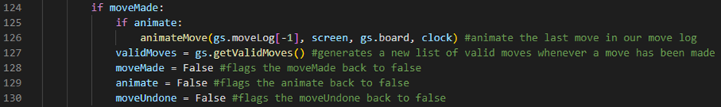

Line 130 resets our moveUndone flag variable by setting it back to False.

Finally, we’re going to open our chessAI.py file and update our AI algorithm’s helper function:

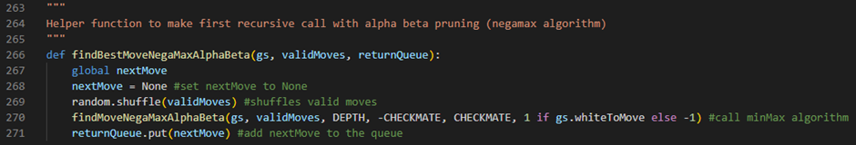

Line 266 now defines a procedure called findBestMoveNegaMaxAlphaBeta which takes 3 parameters: our current gameState object, our current validMoves array and our returnQueue variable. Line 271 now adds our nextMove variable to our returnQueue variable by running our returnQueue variable’s put method and passing our nextMove variable as an argument.

We can also do the exact same thing for the rest of our recursive AI algorithms’ helper functions. However, I will only be using this recursive AI algorithm for our final version of our chess engine application because it is the most optimised and efficient one.

We can now set our DEPTH variable to an integer value of 4 and our playerOne variable to True and our playerTwo variable to False and run the program to test to see if our threading logic works:



So far, it’s working as we expect it to! We have now implemented threading into our chess engine application, allowing our player to be able to interact with our chess engine application even whilst our AI is thinking of the next move to play.

## Fourth prototype

During the development of this prototype, my goal is to work on the menus and login system features of my chess engine application. Our user will be able to interact with a series of menus that will allow them to sign up to our database and log in to their account. Once they have logged in, they will be able to see their statistics (how many wins, draws and losses they have) and be able to choose a difficulty to play chess in. After a game has been played, their statistics will be updated accordingly and the user will be sent back to the main menu screen.

Menus and Login System

The first thing we’re going to do is open our chessMain.py file and import four more packages that we are going to be using to implement our menus and login system into our chess engine application:

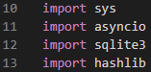

Line 10 imports the sys module. The sys module in Python will provide us with functions and variables that can be used to manipulate different parts of the Python runtime environment. Line 11 imports the asyncio module. The asyncio module can be used to write concurrent code with async and await syntax. Line 12 imports the sqlite3 module. The sqlite3 module allows us to execute SQL commands. Line 13 imports the hashlib module. The hashlib module in Python will allow us to generate secure hash values for data using hashing algorithms.

Next, we’re going to add a title to our PyGame GUI window and define some new variables:

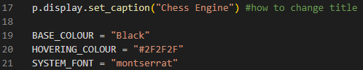

Line 17 sets our PyGame GUI window’s caption to “Chess Engine”. Line 19 defines a variable called BASE_COLOUR which is set to the string value “Black”. This variable will define the colour of our menu’s text. Line 20 defines a variable called HOVERING_COLOUR which is set to the string value “#2F2F2F”. This variable will define the colour of our menu’s buttons when our user is hovering their mouse over them. Line 21 defines a variable called SYSTEM_FONT which is set to the string value “montserrat”. This variable will define the font of our menu’s text.

Next, we’re going to define a button class for our menu screens:

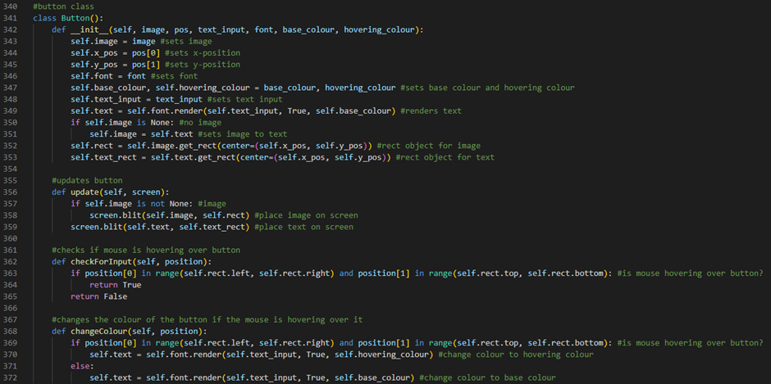

Line 341 defines a class called Button. Line 342 defines our Button class’s constructor procedure. It will take 6 parameters: an image (if applicable), position coordinates, text, font, base colour and hovering colour. Line 343 defines an attribute called image which is set to our image parameter. Line 344 defines an attribute called x_pos which is set to the first element of our pos parameter. Line 345 defines an attribute called y_pos which is set to the second element of our pos parameter. Line 346 defines an attribute called font which is set to our font parameter. Line 347 defines 2 attributes called base_colour, which is set to our base_colour parameter, and hovering_colour which is set to our hovering_colour parameter. Line 348 defines an attribute called text_input which is set to our text_input parameter. Line 349 defines an attribute called text which is set to our rendered text by running our font attribute’s render method and passing a text value of our text_input attribute, an antialias value of True and a colour value of our base_colour attribute as arguments. Line 350 checks if there is no image in our image attribute by checking if our image attribute is a None object. If this is the case, then line 351 will set our image attribute to our text attribute. Line 352 defines an attribute called rect which stores our rect object for our image attribute by calling our image attribute’s get_rect method and passing a centre of (our x_pos attribute, our y_pos attribute) as an argument. Line 353 defines an attribute called text_rect which stores our rect object for our text attribute by calling our text attribute’s get_rect method and passing a centre of (our x_pos attribute, our y_pos attribute) as an argument. Line 356 defines a method called update which takes 1 parameter: our screen variable. Line 357 checks if our image attribute is storing an image by checking if our image attribute is not a None object. If this is the case, then line 358 will draw our image on the screen by running our screen variable’s blit method and passing our image attribute and our rect attribute as arguments. Line 359 will then draw our text on the screen by running our screen variable’s blit method and passing our text attribute and our text_rect attribute as arguments. Line 362 defines a method called checkForInput which takes 1 parameter: a position. Line 363 checks if our user’s mouse is hovering over our button by evaluating if the first element of our position variable is in the range of our rect attribute’s left attribute and our rect attribute’s right attribute and the second element of our position variable is in the range of our rect attribute’s top attribute and our rect attribute’s bottom attribute. If this is the case, then line 364 will return True. Otherwise, line 365 will return False. Line 368 defines a method called changeColour which takes 1 parameter: a position. Line 369 checks if our user’s mouse is hovering over our button by evaluating if the first element of our position variable is in the range of our rect attribute’s left attribute and our rect attribute’s right attribute and the second element of our position variable is in the range of our rect attribute’s top attribute and our rect attribute’s bottom attribute. If this is the case, then line 370 will change our text’s colour to our hovering colour by running our font attribute’s render method and passing a text value of our text_input attribute, an antialias value of True and a colour value of our hovering_colour attribute as arguments. Line 371 is an else statement which will run if our user’s mouse is not hovering over our button. If this is the case, then line 372 will change our text’s colour to our base colour by running our font attribute’s render method and passing a text value of our text_input attribute, an antialias value of True and a colour value of our base_colour attribute as arguments.

Next, we’re going to define our start menu procedure:

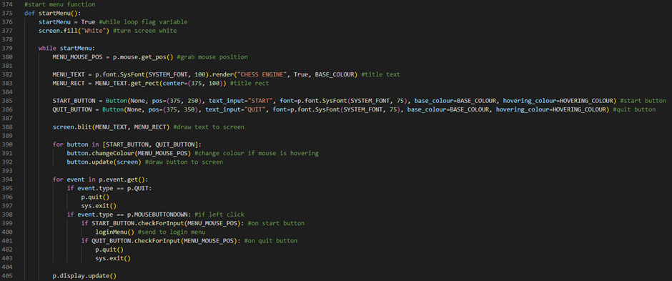

Line 375 defines our startMenu procedure. It will take no parameters. Line 376 defines a flag variable called startMenu which will control our while loop. It will be initialised to True. Line 377 will turn our screen white by running our screen variable’s fill method and passing an argument of the string value “White”. Line 379 defines a while loop which will run while our startMenu flag variable is set to True. Line 380 defines a variable called MENU_MOUSE_POS which stores our user’s mouse position by running PyGame’s Mouse attribute’s get_pos method. Line 382 defines a variable called MENU_TEXT which stores our title text by running PyGame’s font attribute’s SysFont method and passing a font of our SYSTEM_FONT variable and a text size of 100 as arguments then running this object’s render method and passing a text value of the string “CHESS ENGINE”, an antialias value of True and a colour value of our BASE_COLOUR variable as arguments. Line 383 defines a variable called MENU_RECT which stores our title rect by running our MENU_TEXT’s get_rect method and passing a centre of (375, 100) as an argument. Line 385 defines a variable called START_BUTTON which stores our start button by creating a Button with an image attribute of None, a pos attribute of (375, 250), a text_input attribute of the string “START”, a font attribute of PyGame’s font attribute’s SysFont method (passing a font of our SYSTEM_FONT variable and a text size of 75 as arguments), a base_colour attribute of BASE_COLOUR and a hovering_colour attribute of HOVERING_COLOUR. Line 386 defines a variable called QUIT_BUTTON which stores our quit button by creating a Button with an image attribute of None, a pos attribute of (375, 350), a text_input attribute of the string “QUIT”, a font attribute of PyGame’s font attribute’s SysFont method (passing a font of our SYSTEM_FONT variable and a text size of 75 as arguments), a base_colour attribute of BASE_COLOUR and a hovering_colour attribute of HOVERING_COLOUR. Line 388 draws our title text to the screen by running our screen variable’s blit method and passing our MENU_TEXT variable and our MENU_RECT variable as arguments. Line 390 defines a for loop which will iterate through an array that stores our START_BUTTON variable and our QUIT_BUTTON variable. Line 391 changes our current button’s colour if our user’s mouse is hovering over it by running our current button’s changeColour method and passing our MENU_MOUSE_POS variable as an argument. Line 392 draws our current button to the screen by running our current button’s update method and passing our screen variable as an argument. Line 394 defines the start of our event handler for loop. Line 395 checks if our user has closed the application by evaluating if our current event’s type is a PyGame QUIT event. If this is the case, then line 396 will run PyGame’s quit method and line 397 will run our system’s exit method. Line 398 checks if our user has left clicked with their mouse by evaluating if our current event’s type is a PyGame MOUSEBUTTONDOWN event. If this is the case, then line 399 will check if our user has left clicked on our start button by running our START_BUTTON variable’s checkForInput method, passing our MENU_MOUSE_POS variable as an argument, and evaluating if it returns True. If this is the case, then line 400 will send our user to our login menu by running our loginMenu procedure. Line 401 will check if our user has left clicked on our quit button by running our QUIT_BUTTON variable’s checkForInput method, passing our MENU_MOUSE_POS variable as an argument, and evaluating if it returns True. If this is the case, then line 402 will run PyGame’s quit method and line 403 will run our system’s exit method. Line 405 will then update our PyGame GUI window by running PyGame’s display attribute’s update method.

Next, we’re going to call our start menu procedure:



Line 855 defines a statement which will only execute when our program is directly run. Line 856 defines a variable called screen which holds information about the GUI window screen that our menus will display on. For example, our screen’s width is set to our WIDTH variable plus our MOVE_LOG_PANEL_WIDTH variable and our screen’s height is set to our HEIGHT variable. Line 857 will then run our startMenu procedure.

We can now run the program and test to see if our start menu is working:



So far, it’s working as we expect it to!

startMenu procedure test table:

|  |  |  |
| --- | --- | --- |
| Test Data | Expected Outcome | Actual Outcome |
| Start Button | When the user clicks the start button, they are sent to the login menu screen. | As expected. |
| Quit Button | When the user clicks the quit button, the software is closed. | As expected. |

Next, we’re going to define our login menu procedure:

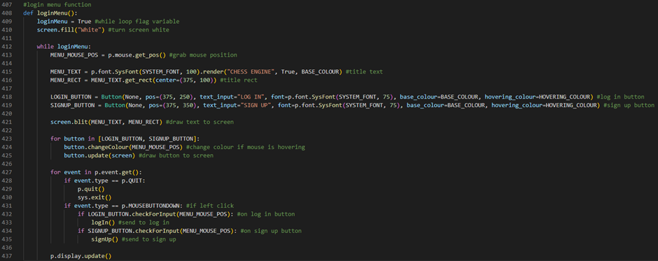

Line 408 defines our loginMenu procedure. It will take no parameters. Line 409 defines a flag variable called loginMenu which will control our while loop. It will be initialised to True. Line 410 will turn our screen white by running our screen variable’s fill method and passing an argument of the string value “White”. Line 412 defines a while loop which will run while our loginMenu flag variable is set to True. Line 413 defines a variable called MENU_MOUSE_POS which stores our user’s mouse position by running PyGame’s Mouse attribute’s get_pos method. Line 415 defines a variable called MENU_TEXT which stores our title text by running PyGame’s font attribute’s SysFont method and passing a font of our SYSTEM_FONT variable and a text size of 100 as arguments then running this object’s render method and passing a text value of the string “CHESS ENGINE”, an antialias value of True and a colour value of our BASE_COLOUR variable as arguments. Line 416 defines a variable called MENU_RECT which stores our title rect by running our MENU_TEXT’s get_rect method and passing a centre of (375, 100) as an argument. Line 418 defines a variable called LOGIN_BUTTON which stores our login button by creating a Button with an image attribute of None, a pos attribute of (375, 250), a text_input attribute of the string “LOG IN”, a font attribute of PyGame’s font attribute’s SysFont method (passing a font of our SYSTEM_FONT variable and a text size of 75 as arguments), a base_colour attribute of BASE_COLOUR and a hovering_colour attribute of HOVERING_COLOUR. Line 419 defines a variable called SIGNUP_BUTTON which stores our signup button by creating a Button with an image attribute of None, a pos attribute of (375, 350), a text_input attribute of the string “SIGN UP”, a font attribute of PyGame’s font attribute’s SysFont method (passing a font of our SYSTEM_FONT variable and a text size of 75 as arguments), a base_colour attribute of BASE_COLOUR and a hovering_colour attribute of HOVERING_COLOUR. Line 421 draws our title text to the screen by running our screen variable’s blit method and passing our MENU_TEXT variable and our MENU_RECT variable as arguments. Line 423 defines a for loop which will iterate through an array that stores our LOGIN_BUTTON variable and our SIGNUP_BUTTON variable. Line 424 changes our current button’s colour if our user’s mouse is hovering over it by running our current button’s changeColour method and passing our MENU_MOUSE_POS variable as an argument. Line 425 draws our current button to the screen by running our current button’s update method and passing our screen variable as an argument. Line 427 defines the start of our event handler for loop. Line 428 checks if our user has closed the application by evaluating if our current event’s type is a PyGame QUIT event. If this is the case, then line 429 will run PyGame’s quit method and line 430 will run our system’s exit method. Line 431 checks if our user has left clicked with their mouse by evaluating if our current event’s type is a PyGame MOUSEBUTTONDOWN event. If this is the case, then line 432 will check if our user has left clicked on our login button by running our LOGIN_BUTTON variable’s checkForInput method, passing our MENU_MOUSE_POS variable as an argument, and evaluating if it returns True. If this is the case, then line 433 will send our user to log in by running our logIn procedure. Line 434 will check if our user has left clicked on our signup button by running our SIGNUP_BUTTON variable’s checkForInput method, passing our MENU_MOUSE_POS variable as an argument, and evaluating if it returns True. If this is the case, then line 435 will send our user to sign up by running our signUp procedure. Line 437 will then update our PyGame GUI window by running PyGame’s display attribute’s update method.

We can now run the program and test to see if our login menu is working:



So far, it’s working as we expect it to!

loginMenu procedure test table:

|  |  |  |
| --- | --- | --- |
| Test Data | Expected Outcome | Actual Outcome |
| Log In Button | When the user clicks the log in button, they are sent to the log in screen. | As expected. |
| Sign Up Button | When the user clicks the sign up button, they are sent to the sign up screen. | As expected. |

Next, we’re going to work on our login system.

To do this, we’re going to have to create a database which will store our user’s usernames, passwords, wins, draws and losses. Our login system will work using a type of client-server system where the client is our chessMain.py file and our server will be another Python file. The client will send data to the server through a stream socket and the server will process it, hopefully, allowing the user to be able to sign up and log in successfully.

First, let’s create our database by creating a new Python file called database.py:

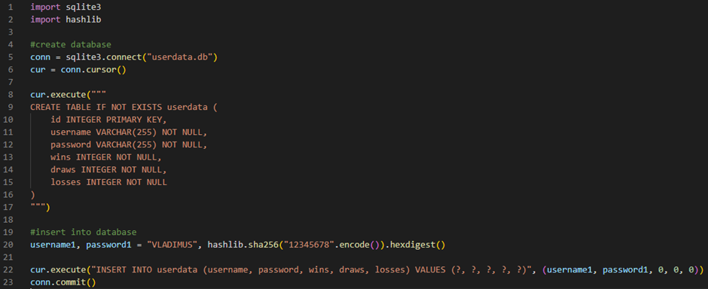

Line 1 imports the sqlite3 module. The sqlite3 module allows us to execute SQL commands. Line 2 imports the hashlib module. The hashlib module in Python will allow us to generate secure hash values for data using hashing algorithms. Line 5 defines a variable called conn which stores a connection to a database file called userdata by running sqlite3’s connect method and passing the string value “userdata.db” as an argument. Line 6 defines a variable called cur which stores our connection’s cursor by running our conn variable’s cursor method. Line 8 creates our database if it is not already existing by running our cur variable’s execute method and passing the string “CREATE TABLE IF NOT EXISTS userdata (id INTEGER PRIMARY KEY, username VARCHAR(255) NOT NULL, password VARCHAR(255) NOT NULL, wins INTEGER NOT NULL, draws INTEGER NOT NULL, losses INTEGER NOT NULL)” as an argument. Line 20 defines 2 variables: username1 which stores the string value “VLADIMUS” and password1 which stores the hexdigest of the encoded value of the string value “12345678” by running hashlib’s sha256 method and passing the product of running the string value “12345678”’s encode method as an argument then running the hexdigest method of this. Line 22 inserts a user with the username VLADIMUS, the password 12345678, 0 wins, 0 draws and 0 losses into our userdata database by running our cur variable’s execute method and passing the string “INSERT INTO userdata (username, password, wins, draws, losses) VALUES (?, ?, ?, ?, ?)” and a tuple containing our username1 variable, our password1 variable and three of the integers 0 as arguments. Line 23 then saves these changes to our database by running our conn variable’s commit method.

Next, let’s create another new Python file called server.py which will act as our server:

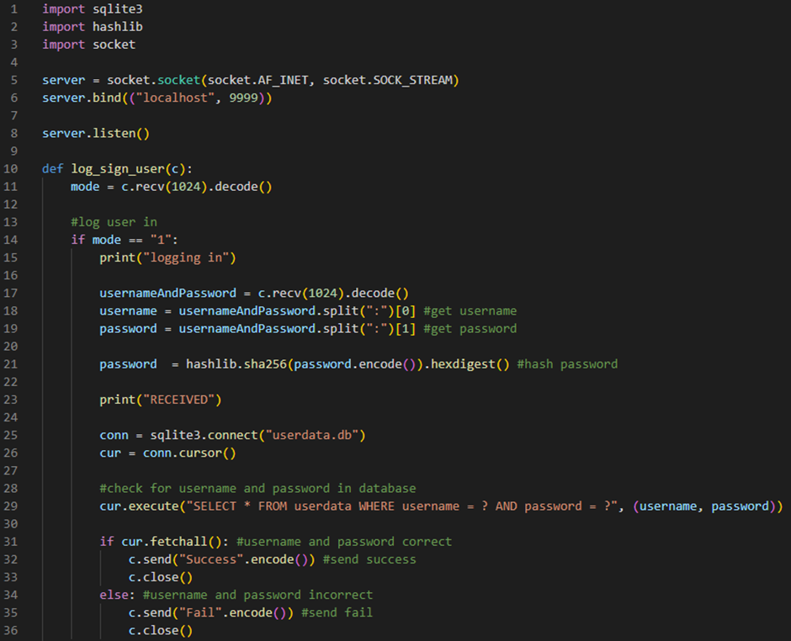

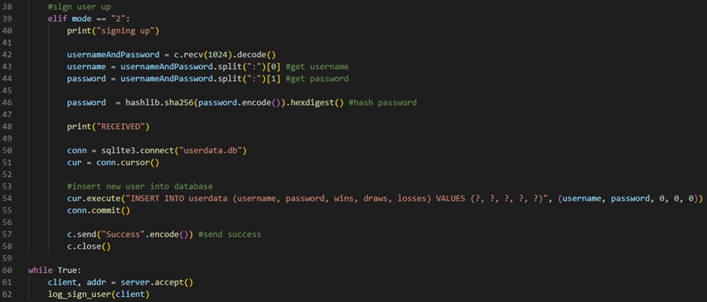

Line 1 imports the sqlite3 module. The sqlite3 module allows us to execute SQL commands. Line 2 imports the hashlib module. The hashlib module in Python will allow us to generate secure hash values for data using hashing algorithms. Line 3 imports the socket module. The socket module in Python provides a way to work with sockets which allow us to establish network connections over various network protocols such as TCP to send and receive data. Line 5 defines a variable called server which stores our socket object by running the socket module’s socket constructor procedure and passing an address family of AF_INET and a socket type of SOCK_STREAM. Line 6 binds our server socket to our local host IP address on the 9999 port by running our server variable’s bind method and passing a tuple containing the string value “localhost” and the integer value 9999. Line 8 enables our server to accept connections by running our server variable’s listen method. Line 10 defines a procedure called log_sign_user which takes one parameter: our client, c. Line 11 defines a variable called mode which stores the first 1024 bytes of data received from our client as a string value by running our c variable’s recv method and passing the integer value 1024 as an argument then running the decode method of this. This variable will tell us if our client is trying to log a user in or sign a user up. Line 14 checks if our mode variable stores a character value of “1”. If this is the case, then line 15 prints “logging in” to the console by running the print function and passing a string value of “logging in” as an argument. Line 17 defines a variable called usernameAndPassword which stores the second 1024 bytes of data received from our client as a string value by running our c variable’s recv method and passing the integer value 1024 as an argument then running the decode method of this. Line 18 defines a variable called username which stores the first element of our usernameAndPassword variable when we use its split method and pass a character of the value “:” as an argument. Line 19 defines a variable called password which stores the second element of our usernameAndPassword variable when we use its split method and pass a character of the value “:” as an argument. Line 21 sets our password variable to our hashed password by running the hashlib module’s sha256 method and passing the product of running our password variable’s encode method as an argument then running the hexdigest method of this. Line 23 prints “RECEIVED” to the console by running the print function and passing a string value of “RECEIVED” as an argument. Line 25 defines a variable called conn which stores a connection to a database file called userdata by running sqlite3’s connect method and passing the string value “userdata.db” as an argument. Line 26 defines a variable called cur which stores our connection’s cursor by running our conn variable’s cursor method. Line 29 will check if this username and password pair exists in our database by by running our cur variable’s execute method and passing the string value “SELECT * FROM userdata WHERE username = ? AND password = ?” and a tuple containing our username variable and our password variable as arguments. Line 31 checks if our SQL command was able to fetch any matching records from the database by evaluating if our cur variable’s fetchall method returns True. If it does, then line 32 will let our client know that the login was successful by running our c variable’s send method and passing the product of running the string value “Success”’s encode method as an argument. Line 33 will then close our connection with our client by running our c variable’s close method. Line 34 is an else statement which will run if the username or password was incorrect. If this is the case, then line 35 will let our client know that the login was not successful by running our c variable’s send method and passing the product of running the string value “Fail”’s encode method as an argument. Line 36 will then close our connection with our client by running our c variable’s close method. Line 39 checks if our mode variable stores a character value of “2”. If this is the case, then line 40 prints “signing up” to the console by running the print function and passing a string value of “signing up” as an argument. Line 42 defines a variable called usernameAndPassword which stores the second 1024 bytes of data received from our client as a string value by running our c variable’s recv method and passing the integer value 1024 as an argument then running the decode method of this. Line 43 defines a variable called username which stores the first element of our usernameAndPassword variable when we use its split method and pass a character of the value “:” as an argument. Line 44 defines a variable called password which stores the second element of our usernameAndPassword variable when we use its split method and pass a character of the value “:” as an argument. Line 46 sets our password variable to our hashed password by running the hashlib module’s sha256 method and passing the product of running our password variable’s encode method as an argument then running the hexdigest method of this. Line 48 prints “RECEIVED” to the console by running the print function and passing a string value of “RECEIVED” as an argument. Line 50 defines a variable called conn which stores a connection to a database file called userdata by running sqlite3’s connect method and passing the string value “userdata.db” as an argument. Line 51 defines a variable called cur which stores our connection’s cursor by running our conn variable’s cursor method. Line 54 inserts our new user into our userdata database by running our cur variable’s execute method and passing the string “INSERT INTO userdata (username, password, wins, draws, losses) VALUES (?, ?, ?, ?, ?)” and a tuple containing our username variable, our password variable and three of the integers 0 as arguments. Line 55 then saves this change to our database by running our conn variable’s commit method. Line 57 will then let our client know that the sign up was successful by running our c variable’s send method and passing the product of running the string value “Success”’s encode method as an argument. Line 58 will then close our connection with our client by running our c variable’s close method. Line 60 defines a while loop which will always run as long as our server.py file is running. Line 61 defines two variables called client, which stores our client’s connection, and addr, which stores our client’s IP address, by running our server variable’s accept method. Line 62 then calls our log_sign_user procedure, passing our client variable as an argument.

Next, we’re going to open our chessMain.py file and define a function which will log the user in:

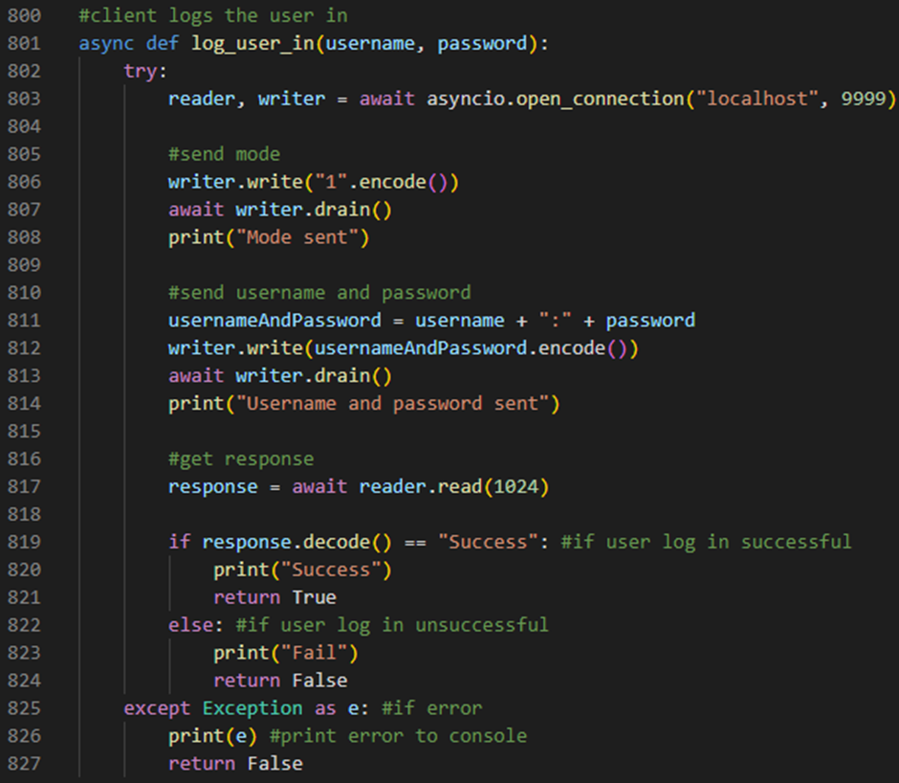

Line 801 defines an asynchronous function called log_user_in. It will take 2 parameters: a username and a password. Line 802 defines a try statement. Line 803 defines 2 variables: reader, which stores our server’s reader, and writer, which stores our server’s writer, by running the asyncio module’s open_connection method and passing a string value of “localhost” and an integer value of 9999 as arguments. Line 806 sends our mode to our server by running our writer variable’s write method and passing the product of running the character value “1”’s encode method as an argument. Line 807 waits until it is appropriate to resume writing to the stream by running our writer variable’s drain method. Line 808 prints “Mode sent” to the console by running the print function and passing a string value of “Mode sent” as an argument. Line 811 defines a variable called usernameAndPassword which stores our username variable plus a “:” character plus our password variable. Line 812 sends our usernameAndPassword variable to our server by running our writer variable’s write method and passing the product of running our usernameAndPassword variable’s encode method as an argument. Line 813 waits until it is appropriate to resume writing to the stream by running our writer variable’s drain method. Line 814 prints “Username and password sent” to the console by running the print function and passing a string value of “Username and password sent” as an argument. Line 817 defines a variable called response which stores our server’s response by running our reader variable’s read method and passing the integer 1024 as an argument. Line 819 checks if our user’s login was successful by evaluating if the product of running our response variable’s decode method returns a string value of “Success”. If it does, then line 820 will print “Success” to the console by running the print function and passing a string value of “Success” as an argument. Line 821 will then return True. Line 822 is an else statement which will run if our user’s login was unsuccessful. If this is the case, then line 823 will print “Fail” to the console by running the print function and passing a string value of “Fail” as an argument. Line 824 will then return False. Line 825 is an except statement which will run if an error occurs. If this is the case, then line 826 will print our error message to the console and line 827 will return False.

Next, we’re going to define our log in procedure:

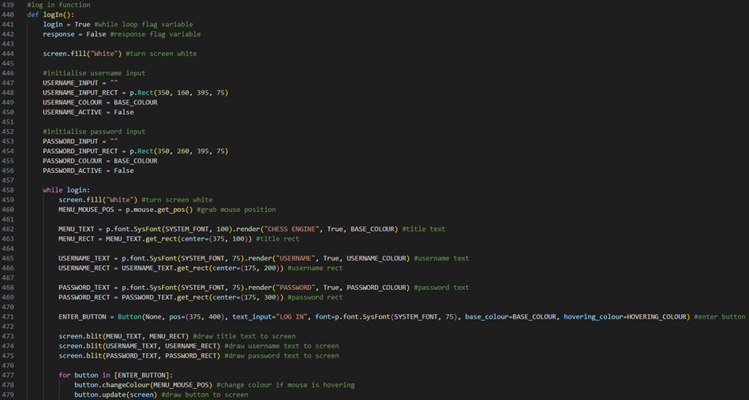

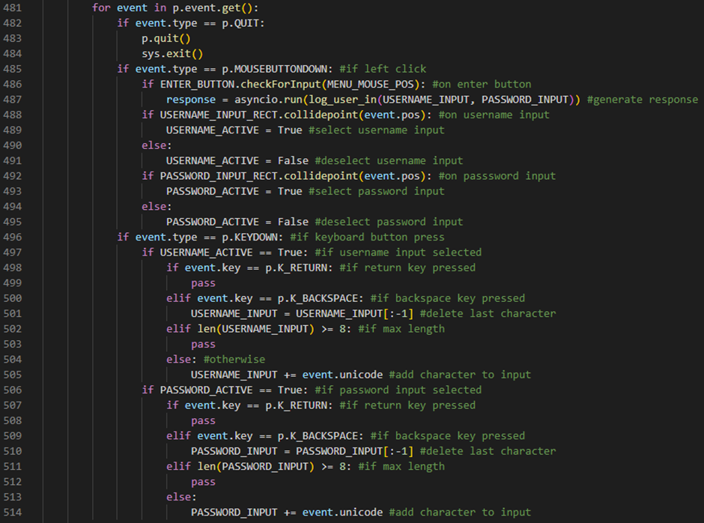

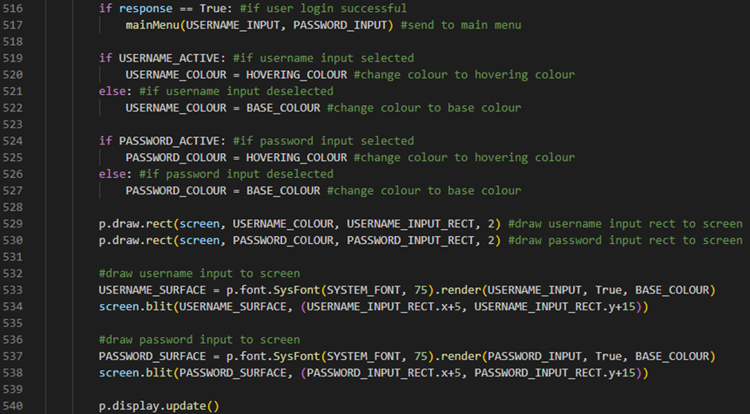

Line 440 defines our logIn procedure. It will take no parameters. Line 441 defines a flag variable called login which will control our while loop. It will be initialised to True. Line 442 defines a flag variable called response which will tell us if a login attempt has been successful or not by returning either True or False. It will be initialised to False. Line 444 will turn our screen white by running our screen variable’s fill method and passing an argument of the string value “White”. Line 447 defines a variable called USERNAME_INPUT which stores a blank string. This variable will later store our user’s username input. Line 448 defines a variable called USERNAME_INPUT_RECT which stores a PyGame Rect object with an x-position value of 350, a y-position value of 160, a width of 395 and a height of 75. Line 449 defines a variable called USERNAME_COLOUR which will store our BASE_COLOUR variable. Line 450 defines a variable called USERNAME_ACTIVE which stores False. This variable will return True if our username input is currently selected by our user. Line 453 defines a variable called PASSWORD_INPUT which stores a blank string. This variable will later store our user’s password input. Line 454 defines a variable called PASSWORD_INPUT_RECT which stores a PyGame Rect object with an x-position value of 350, a y-position value of 260, a width of 395 and a height of 75. Line 455 defines a variable called PASSWORD_COLOUR which will store our BASE_COLOUR variable. Line 456 defines a variable called PASSWORD_ACTIVE which stores False. This variable will return True if our password input is currently selected by our user. Line 458 defines a while loop which will run while our login flag variable is set to True. Line 459 will turn our screen white by running our screen variable’s fill method and passing an argument of the string value “White”. Line 460 defines a variable called MENU_MOUSE_POS which stores our user’s mouse position by running PyGame’s Mouse attribute’s get_pos method. Line 462 defines a variable called MENU_TEXT which stores our title text by running PyGame’s font attribute’s SysFont method and passing a font of our SYSTEM_FONT variable and a text size of 100 as arguments then running this object’s render method and passing a text value of the string “CHESS ENGINE”, an antialias of True and a colour value of our BASE_COLOUR variable as arguments. Line 463 defines a variable called MENU_RECT which stores our title rect by running our MENU_TEXT’s get_rect method and passing a centre of (375, 100) as an argument. Line 465 defines a variable called USERNAME_TEXT which stores our username text by running PyGame’s font attribute’s SysFont method and passing a font of our SYSTEM_FONT variable and a text size of 75 as arguments then running this object’s render method and passing a text value of the string “USERNAME”, an antialias of True and a colour value of our USERNAME_COLOUR variable as arguments. Line 466 defines a variable called USERNAME_RECT which stores our username rect by running our USERNAME_TEXT’s get_rect method and passing a centre of (175, 200) as an argument. Line 468 defines a variable called PASSWORD_TEXT which stores our password text by running PyGame’s font attribute’s SysFont method and passing a font of our SYSTEM_FONT variable and a text size of 75 as arguments then running this object’s render method and passing a text value of the string “PASSWORD”, an antialias of True and a colour value of our PASSWORD_COLOUR variable as arguments. Line 469 defines a variable called PASSWORD_RECT which stores our password rect by running our PASSWORD_TEXT’s get_rect method and passing a centre of (175, 300) as an argument. Line 471 defines a variable called ENTER_BUTTON which stores our enter button by creating a Button with an image attribute of None, a pos attribute of (375, 400), a text_input attribute of the string “LOG IN”, a font attribute of PyGame’s font attribute’s SysFont method (passing a font of our SYSTEM_FONT variable and a text size of 75 as arguments), a base_colour attribute of BASE_COLOUR and a hovering_colour attribute of HOVERING_COLOUR. Line 473 draws our title text to the screen by running our screen variable’s blit method and passing our MENU_TEXT variable and our MENU_RECT variable as arguments. Line 474 draws our username text to the screen by running our screen variable’s blit method and passing our USERNAME_TEXT variable and our USERNAME_RECT variable as arguments. Line 475 draws our password text to the screen by running our screen variable’s blit method and passing our PASSWORD_TEXT variable and our PASSWORD_RECT variable as arguments. Line 477 defines a for loop which will iterate through an array that stores our ENTER_BUTTON variable. Line 478 changes our current button’s colour if our user’s mouse is hovering over it by running our current button’s changeColour method and passing our MENU_MOUSE_POS variable as an argument. Line 479 draws our current button to the screen by running our current button’s update method and passing our screen variable as an argument. Line 481 defines the start of our event handler for loop. Line 482 checks if our user has closed the application by evaluating if our current event’s type is a PyGame QUIT event. If this is the case, line 483 will run PyGame’s quit method and line 484 will run our system’s exit method. Line 485 checks if our user has left clicked with their mouse by evaluating if our current event’s type is a PyGame MOUSEBUTTONDOWN event. If this is the case, then line 486 will check if our user has left clicked on our enter button by running our ENTER_BUTTON variable’s checkForInput method, passing our MENU_MOUSE_POS variable as an argument, and evaluating if it returns True. If this is the case, then line 487 will set our response flag variable to the product of running our asyncio module’s run method and passing our log_user_in function call, passing our USERNAME_INPUT variable and our PASSWORD_INPUT variable as arguments, as an argument. Line 488 checks if our user has left clicked on our username input by running our USERNAME_INPUT_RECT’s collidepoint method, passing our current event’s pos attribute as an argument, and evaluating if this returns True. If it does, then line 489 will select our username input by setting our USERNAME_ACTIVE variable to True. Line 490 is an else statement which will run if our user has not left clicked on our username input. If this is the case, then line 491 will deselect our username input by setting our USERNAME_ACTIVE variable to False. Line 492 checks if our user has left clicked on our password input by running our PASSWORD_INPUT_RECT’s collidepoint method, passing our current event’s pos attribute as an argument, and evaluating if this returns True. If it does, then line 493 will select our password input by setting our PASSWORD_ACTIVE variable to True. Line 494 is an else statement which will run if our user has not left clicked on our password input. If this is the case, then line 495 will deselect our password input by setting our PASSWORD_ACTIVE variable to False. Line 496 checks if our user has pressed a button on their keyboard by evaluating if our current event’s type is a PyGame KEYDOWN event. Line 497 will check if our username input is selected by evaluating if our USERNAME_ACTIVE variable is set to True. If this is the case, then line 498 will check if our user has pressed the return key by evaluating if our event’s key is a PyGame K_RETURN key. If this is the case, then line 499 will run a pass command which tells our program to do nothing. Line 500 will check if our user has pressed the backspace key by evaluating if our event’s key is a PyGame K_BACKSPACE key. If this is the case, then line 501 will delete the last character in our USERNAME_INPUT variable by setting our USERNAME_INPUT variable to our USERNAME_INPUT variable with the last character sliced off. Line 502 will check if our USERNAME_INPUT variable is at its max length (8 or more characters). If this is the case, then line 503 will run a pass command which tells our program to do nothing. Line 504 is an else statement which will run if none of the other if statements were met. If this is the case, then line 505 will add the character our user typed to our USERNAME_INPUT variable by adding to our USERNAME_INPUT variable our event’s unicode attribute. Line 506 will check if our password input is selected by evaluating if our PASSWORD_ACTIVE variable is set to True. If this is the case, then line 507 will check if our user has pressed the return key by evaluating if our event’s key is a PyGame K_RETURN key. If this is the case, then line 508 will run a pass command which tells our program to do nothing. Line 509 will check if our user has pressed the backspace key by evaluating if our event’s key is a PyGame K_BACKSPACE key. If this is the case, then line 510 will delete the last character in our PASSWORD_INPUT variable by setting our PASSWORD_INPUT variable to our PASSWORD_INPUT variable with the last character sliced off. Line 511 will check if our PASSWORD_INPUT variable is at its max length (8 or more characters). If this is the case, then line 512 will run a pass command which tells our program to do nothing. Line 513 is an else statement which will run if none of the other if statements were met. If this is the case, then line 514 will add the character our user typed to our PASSWORD_INPUT variable by adding to our PASSWORD_INPUT variable our event’s unicode attribute. Line 516 will check if our user login was successful by evaluating if our response variable is set to True. If it is, then line 517 will send our user to the main menu screen by running our mainMenu procedure and passing our USERNAME_INPUT variable and our PASSWORD_INPUT variable as arguments. Line 519 will check if our username input has been selected by evaluating if our USERNAME_ACTIVE variable is set to True. If this is the case, then line 520 will change our username input’s colour to our hovering colour by setting our USERNAME_COLOUR variable to our HOVERING_COLOUR variable. Line 521 is an else statement which will run if our username input has been deselected. If this is the case, then line 522 will change our username input’s colour to our base colour by setting our USERNAME_COLOUR variable to our BASE_COLOUR variable. Line 524 will check if our password input has been selected by evaluating if our PASSWORD_ACTIVE variable is set to True. If this is the case, then line 525 will change our password input’s colour to our hovering colour by setting our PASSWORD_COLOUR variable to our HOVERING_COLOUR variable. Line 526 is an else statement which will run if our password input has been deselected. If this is the case, then line 527 will change our password input’s colour to our base colour by setting our PASSWORD_COLOUR variable to our BASE_COLOUR variable. Line 529 will draw our username input rect to the screen by running PyGame’s draw attribute’s rect method and passing our screen variable, our USERNAME_COLOUR variable, our USERNAME_INPUT_RECT variable and a width of 2 as arguments. Line 530 will draw our password input rect to the screen by running PyGame’s draw attribute’s rect method and passing our screen variable, our PASSWORD_COLOUR variable, our PASSWORD_INPUT_RECT variable and a width of 2 as arguments. Line 533 defines a variable called USERNAME_SURFACE which will store the surface our username input text is going to be drawn on by running PyGame’s font attribute’s SysFont method and passing a font of our SYSTEM_FONT variable and a text size of 75 as arguments then running this object’s render method and passing a text value of our USERNAME_INPUT variable, an antialias value of True and a colour value of our BASE_COLOUR variable as arguments. Line 534 will then draw our username input to the screen by running our screen variable’s blit method and passing our USERNAME_SURFACE variable and a tuple containing our USERNAME_INPUT_RECT variable’s x attribute plus 5 and our USERNAME_INPUT_RECT variable’s y attribute plus 15 as arguments. Line 537 defines a variable called PASSWORD_SURFACE which will store the surface our password input text is going to be drawn on by running PyGame’s font attribute’s SysFont method and passing a font of our SYSTEM_FONT variable and a text size of 75 as arguments then running this object’s render method and passing a text value of our PASSWORD_INPUT variable, an antialias value of True and a colour value of our BASE_COLOUR variable as arguments. Line 538 will then draw our password input to the screen by running our screen variable’s blit method and passing our PASSWORD_SURFACE variable and a tuple containing our PASSWORD_INPUT_RECT variable’s x attribute plus 5 and our PASSWORD_INPUT_RECT variable’s y attribute plus 15 as arguments. Line 540 will then update our PyGame GUI window by running PyGame’s display attribute’s update method.

We can now run our server.py file and our chessMain.py file to test to see if our user login functionality is working:



Console:

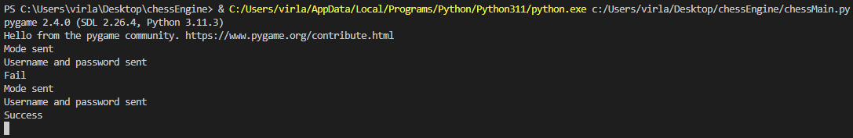

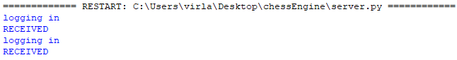

So far, it’s working as we expect it to!

logIn procedure test table:

|  |  |  |
| --- | --- | --- |
| Test Data | Expected Outcome | Actual Outcome |
| Username Input | **Invalid:** When the user has entered an invalid username and tries to log in, the process is unsuccessful.  **Valid:** When the user has entered a valid username and tries to log in, the process is successful. | As expected. |
| Password Input | **Invalid:** When the user has entered an invalid password and tries to log in, the process is unsuccessful.  **Valid:** When the user has entered a valid password and tries to log in, the process is successful. | As expected. |

Next, we’re going to define a function which will sign the user up:

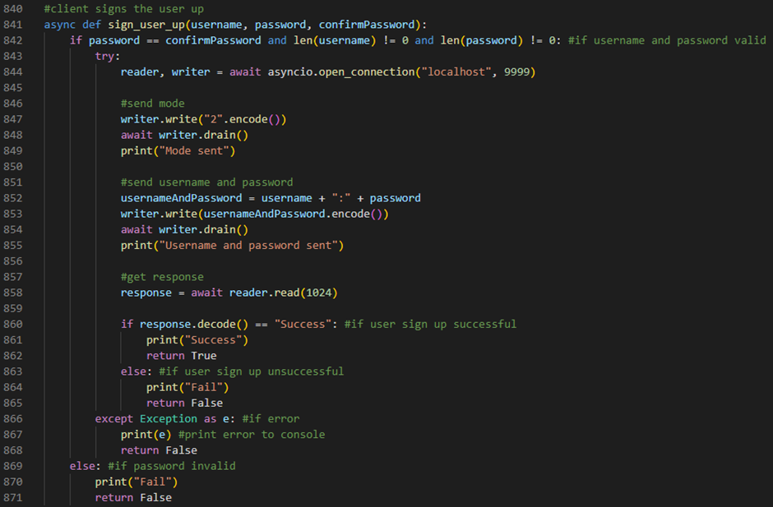

Lines 841 defines an asynchronous function called sign_user_up. It will take 3 parameters: a username, a password and a password confirmation. Line 842 checks if our username variable and our password variable are valid by evaluating if our password variable stores the same value as our confirmPassword variable and the length of our username variable is not 0 characters and the length of our password variable is not 0 characters. If this is the case, then line 843 will define a try statement. Line 844 will define 2 variables: reader, which stores our server’s reader, and writer, which stores our server’s writer, by running the asyncio module’s open_connection method and passing a string value of “localhost” and an integer value of 9999 as arguments. Line 847 sends our mode to our server by running our writer variable’s write method and passing the product of running the character value “2”’s encode method as an argument. Line 848 waits until it is appropriate to resume writing to the stream by running our writer variable’s drain method. Line 849 prints “Mode sent” to the console by running the print function and passing a string value of “Mode sent” as an argument. Line 852 defines a variable called usernameAndPassword which stores our username variable plus a “:” character plus our password variable. Line 853 sends our usernameAndPassword variable to our server by running our writer variable’s write method and passing the product of running our usernameAndPassword variable’s encode method as an argument. Line 854 waits until it is appropriate to resume writing to the stream by running our writer variable’s drain method. Line 855 prints “Username and password sent” to the console by running the print function and passing a string value of “Username and password sent” as an argument. Line 858 defines a variable called response which stores our server’s response by running our reader variable’s read method and passing the integer 1024 as an argument. Line 860 checks if our user’s sign up was successful by evaluating if the product of running our response variable’s decode method returns a string value of “Success”. If it does, then line 861 will print “Success” to the console by running the print function and passing a string value of “Success” as an argument. Line 862 will then return True. Line 863 is an else statement which will run if our user’s sign up was unsuccessful. If this is the case, then line 864 will print “Fail” to the console by running the print function and passing a string value of “Fail” as an argument. Line 865 will then return False. Line 866 is an except statement which will run if an error occurs. If this is the case, then line 867 will print our error message to the console and line 868 will return False. Line 869 is an else statement which will run if our username variable and our password variable is not valid. If this is the case, then line 870 will print “Fail” to the console by running the print function and passing a string value of “Fail” as an argument. Line 871 will then return False.

Next, we’re going to define our sign up procedure:

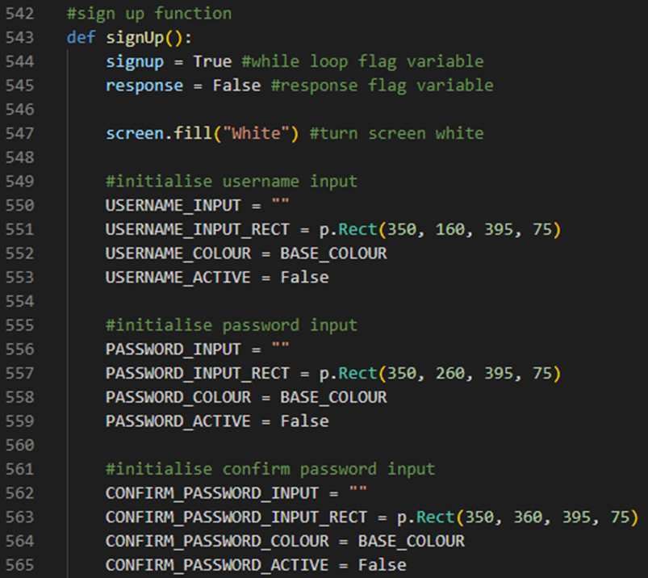

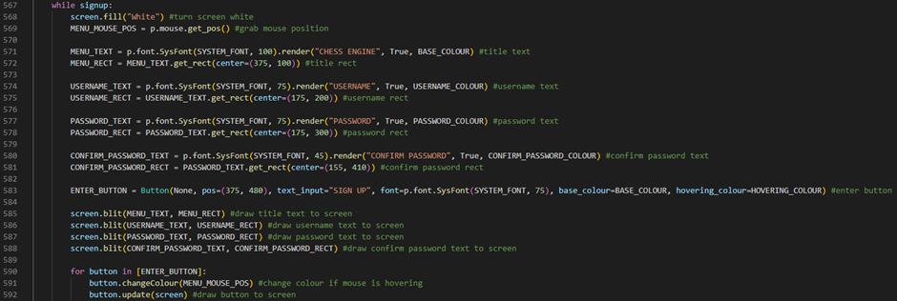

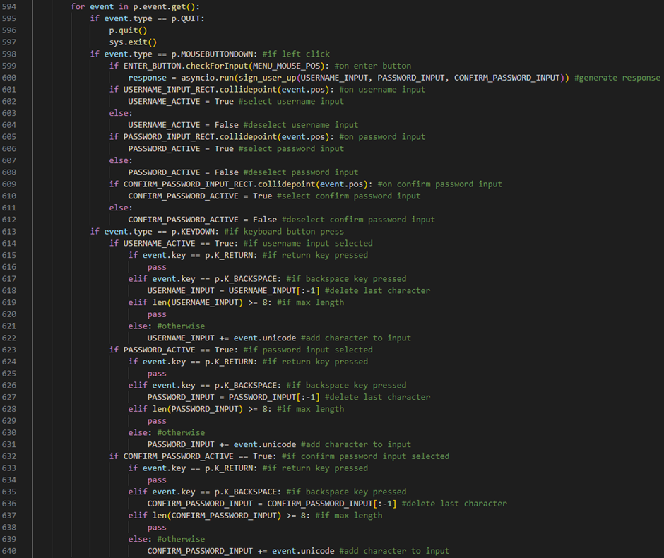

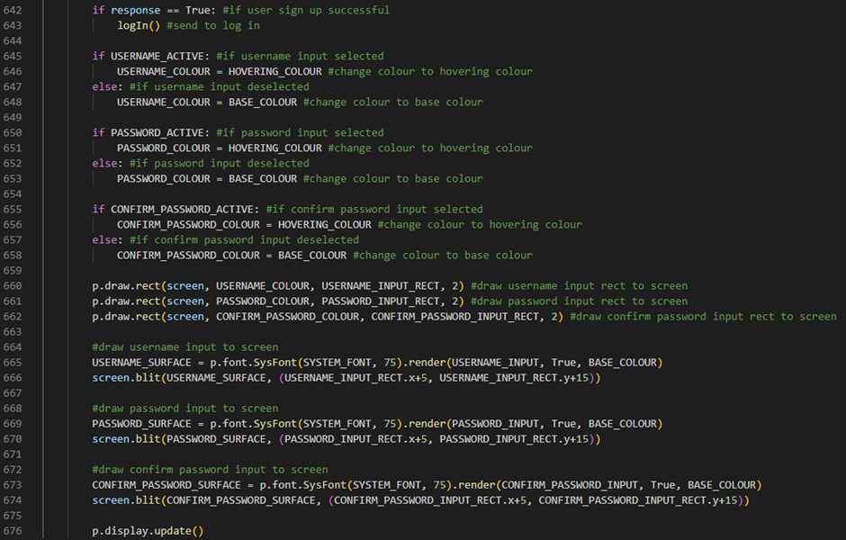

Line 543 defines our signup procedure. It will take no parameters. Line 544 defines a flag variable called signup which will control our while loop. It will be initialised to True. Line 545 defines a flag variable called response which will tell us if a sign up attempt has been successful or not by returning either True or False. It will be initialised to False. Line 547 will turn our screen white by running our screen variable’s fill method and passing an argument of the string value “White”. Line 550 defines a variable called USERNAME_INPUT which stores a blank string. This variable will later store our user’s username input. Line 551 defines a variable called USERNAME_INPUT_RECT which stores a PyGame Rect object with an x-position value of 350, a y-position value of 160, a width of 395 and a height of 75. Line 552 defines a variable called USERNAME_COLOUR which will store our BASE_COLOUR variable. Line 553 defines a variable called USERNAME_ACTIVE which stores False. This variable will return True if our username input is currently selected by our user. Line 556 defines a variable called PASSWORD_INPUT which stores a blank string. This variable will later store our user’s password input. Line 557 defines a variable called PASSWORD_INPUT_RECT which stores a PyGame Rect object with an x-position value of 350, a y-position value of 260, a width of 395 and a height of 75. Line 558 defines a variable called PASSWORD_COLOUR which will store our BASE_COLOUR variable. Line 559 defines a variable called PASSWORD_ACTIVE which stores False. This variable will return True if our password input is currently selected by our user. Line 562 defines a variable called CONFIRM_PASSWORD_INPUT which stores a blank string. This variable will later store our user’s password confirmation input. Line 563 defines a variable called CONFIRM_PASSWORD_INPUT_RECT which stores a PyGame Rect object with an x-position value of 350, a y-position value of 360, a width of 395 and a height of 75. Line 564 defines a variable called CONFIRM_PASSWORD_COLOUR which will store our BASE_COLOUR variable. Line 565 defines a variable called CONFIRM_PASSWORD_ACTIVE which stores False. This variable will return True if our password confirmation input is currently selected by our user. Line 567 defines a while loop which will run while our signup flag variable is set to True. Line 568 will turn our screen white by running our screen variable’s fill method and passing an argument of the string value “White”. Line 569 defines a variable called MENU_MOUSE_POS which stores our user’s mouse position by running PyGame’s Mouse attribute’s get_pos method. Line 571 defines a variable called MENU_TEXT which stores our title text by running PyGame’s font attribute’s SysFont method and passing a font of our SYSTEM_FONT variable and a text size of 100 as arguments then running this object’s render method and passing a text value of the string “CHESS ENGINE”, an antialias of True and a colour value of our BASE_COLOUR variable as arguments. Line 572 defines a variable called MENU_RECT which stores our title rect by running our MENU_TEXT’s get_rect method and passing a centre of (375, 100) as an argument. Line 574 defines a variable called USERNAME_TEXT which stores our username text by running PyGame’s font attribute’s SysFont method and passing a font of our SYSTEM_FONT variable and a text size of 75 as arguments then running this object’s render method and passing a text value of the string “USERNAME”, an antialias of True and a colour value of our USERNAME_COLOUR variable as arguments. Line 575 defines a variable called USERNAME_RECT which stores our username rect by running our USERNAME_TEXT’s get_rect method and passing a centre of (175, 200) as an argument. Line 577 defines a variable called PASSWORD_TEXT which stores our password text by running PyGame’s font attribute’s SysFont method and passing a font of our SYSTEM_FONT variable and a text size of 75 as arguments then running this object’s render method and passing a text value of the string “PASSWORD”, an antialias of True and a colour value of our PASSWORD_COLOUR variable as arguments. Line 578 defines a variable called PASSWORD_RECT which stores our password rect by running our PASSWORD_TEXT’s get_rect method and passing a centre of (175, 300) as an argument. Line 580 defines a variable called CONFIRM_PASSWORD_TEXT which stores our password confirmation text by running PyGame’s font attribute’s SysFont method and passing a font of our SYSTEM_FONT variable and a text size of 45 as arguments then running this object’s render method and passing a text value of the string “CONFIRM PASSWORD”, an antialias of True and a colour value of our CONFIRM_PASSWORD_COLOUR variable as arguments. Line 581 defines a variable called CONFIRM_PASSWORD_RECT which stores our password confirmation rect by running our CONFIRM_PASSWORD_TEXT’s get_rect method and passing a centre of (155, 410) as an argument. Line 583 defines a variable called ENTER_BUTTON which stores our enter button by creating a Button with an image attribute of None, a pos attribute of (375, 480), a text_input attribute of the string “SIGN UP”, a font attribute of PyGame’s font attribute’s SysFont method (passing a font of our SYSTEM_FONT variable and a text size of 75 as arguments), a base_colour attribute of BASE_COLOUR and a hovering_colour attribute of HOVERING_COLOUR. Line 585 draws our title text to the screen by running our screen variable’s blit method and passing our MENU_TEXT variable and our MENU_RECT variable as arguments. Line 586 draws our username text to the screen by running our screen variable’s blit method and passing our USERNAME_TEXT variable and our USERNAME_RECT variable as arguments. Line 587 draws our password text to the screen by running our screen variable’s blit method and passing our PASSWORD_TEXT variable and our PASSWORD_RECT variable as arguments. Line 588 draws our password confirmation text to the screen by running our screen variable’s blit method and passing our CONFIRM_PASSWORD_TEXT variable and our CONFIRM_PASSWORD_RECT variable as arguments. Line 590 defines a for loop which will iterate through an array that stores our ENTER_BUTTON variable. Line 591 changes our current button’s colour if our user’s mouse is hovering over it by running our current button’s changeColour method and passing our MENU_MOUSE_POS variable as an argument. Line 592 draws our current button to the screen by running our current button’s update method and passing our screen variable as an argument. Line 594 defines the start of our event handler for loop. Line 595 checks if our user has closed the application by evaluating if our current event’s type is a PyGame QUIT event. If this is the case, line 596 will run PyGame’s quit method and line 597 will run our system’s exit method. Line 598 checks if our user has left clicked with their mouse by evaluating if our current event’s type is a PyGame MOUSEBUTTONDOWN event. If this is the case, then line 599 will check if our user has left clicked on our enter button by running our ENTER_BUTTON variable’s checkForInput method, passing our MENU_MOUSE_POS variable as an argument, and evaluating if it returns True. If this is the case, then line 600 will set our response flag variable to the product of running our asyncio module’s run method and passing our sign_user_up function call, passing our USERNAME_INPUT variable, our PASSWORD_INPUT variable and our CONFIRM_PASSWORD_INPUT variable as arguments, as an argument. Line 601 checks if our user has left clicked on our username input by running our USERNAME_INPUT_RECT’s collidepoint method, passing our current event’s pos attribute as an argument, and evaluating if this returns True. If it does, then line 602 will select our username input by setting our USERNAME_ACTIVE variable to True. Line 603 is an else statement which will run if our user has not left clicked on our username input. If this is the case, then line 604 will deselect our username input by setting our USERNAME_ACTIVE variable to False. Line 605 checks if our user has left clicked on our password input by running our PASSWORD_INPUT_RECT’s collidepoint method, passing our current event’s pos attribute as an argument, and evaluating if this returns True. If it does, then line 606 will select our password input by setting our PASSWORD_ACTIVE variable to True. Line 607 is an else statement which will run if our user has not left clicked on our password input. If this is the case, then line 608 will deselect our password input by setting our PASSWORD_ACTIVE variable to False. Line 609 checks if our user has left clicked on our password confirmation input by running our CONFIRM_PASSWORD_INPUT_RECT’s collidepoint method, passing our current event’s pos attribute as an argument, and evaluating if this returns True. If it does, then line 610 will select our password confirmation input by setting our CONFIRM_PASSWORD_ACTIVE variable to True. Line 611 is an else statement which will run if our user has not left clicked on our password confirmation input. If this is the case, then line 612 will deselect our password confirmation input by setting our CONFIRM_PASSWORD_ACTIVE variable to False. Line 613 checks if our user has pressed a button on their keyboard by evaluating if our current event’s type is a PyGame KEYDOWN event. Line 614 will check if our username input is selected by evaluating if our USERNAME_ACTIVE variable is set to True. If this is the case, then line 615 will check if our user has pressed the return key by evaluating if our event’s key is a PyGame K_RETURN key. If this is the case, then line 616 will run a pass command which tells our program to do nothing. Line 617 will check if our user has pressed the backspace key by evaluating if our event’s key is a PyGame K_BACKSPACE key. If this is the case, then line 618 will delete the last character in our USERNAME_INPUT variable by setting our USERNAME_INPUT variable to our USERNAME_INPUT variable with the last character sliced off. Line 619 will check if our USERNAME_INPUT variable is at its max length (8 or more characters). If this is the case, then line 620 will run a pass command which tells our program to do nothing. Line 621 is an else statement which will run if none of the other if statements were met. If this is the case, then line 622 will add the character our user typed to our USERNAME_INPUT variable by adding to our USERNAME_INPUT variable our event’s unicode attribute. Line 623 will check if our password input is selected by evaluating if our PASSWORD_ACTIVE variable is set to True. If this is the case, then line 624 will check if our user has pressed the return key by evaluating if our event’s key is a PyGame K_RETURN key. If this is the case, then line 625 will run a pass command which tells our program to do nothing. Line 626 will check if our user has pressed the backspace key by evaluating if our event’s key is a PyGame K_BACKSPACE key. If this is the case, then line 627 will delete the last character in our PASSWORD_INPUT variable by setting our PASSWORD_INPUT variable to our PASSWORD_INPUT variable with the last character sliced off. Line 628 will check if our PASSWORD_INPUT variable is at its max length (8 or more characters). If this is the case, then line 629 will run a pass command which tells our program to do nothing. Line 630 is an else statement which will run if none of the other if statements were met. If this is the case, then line 631 will add the character our user typed to our PASSWORD_INPUT variable by adding to our PASSWORD_INPUT variable our event’s unicode attribute. Line 632 will check if our password confirmation input is selected by evaluating if our CONFIRM_PASSWORD_ACTIVE variable is set to True. If this is the case, then line 633 will check if our user has pressed the return key by evaluating if our event’s key is a PyGame K_RETURN key. If this is the case, then line 634 will run a pass command which tells our program to do nothing. Line 635 will check if our user has pressed the backspace key by evaluating if our event’s key is a PyGame K_BACKSPACE key. If this is the case, then line 636 will delete the last character in our CONFIRM_PASSWORD_INPUT variable by setting our CONFIRM_PASSWORD_INPUT variable to our CONFIRM_PASSWORD_INPUT variable with the last character sliced off. Line 637 will check if our CONFIRM_PASSWORD_INPUT variable is at its max length (8 or more characters). If this is the case, then line 638 will run a pass command which tells our program to do nothing. Line 639 is an else statement which will run if none of the other if statements were met. If this is the case, then line 640 will add the character our user typed to our CONFIRM_PASSWORD_INPUT variable by adding to our CONFIRM_PASSWORD_INPUT variable our event’s unicode attribute. Line 642 will check if our user sign up was successful by evaluating if our response variable is set to True. If it is, then line 643 will send our user to log in by running our logIn procedure. Line 645 will check if our username input has been selected by evaluating if our USERNAME_ACTIVE variable is set to True. If this is the case, then line 646 will change our username input’s colour to our hovering colour by setting our USERNAME_COLOUR variable to our HOVERING_COLOUR variable. Line 647 is an else statement which will run if our username input has been deselected. If this is the case, then line 648 will change our username input’s colour to our base colour by setting our USERNAME_COLOUR variable to our BASE_COLOUR variable. Line 650 will check if our password input has been selected by evaluating if our PASSWORD_ACTIVE variable is set to True. If this is the case, then line 651 will change our password input’s colour to our hovering colour by setting our PASSWORD_COLOUR variable to our HOVERING_COLOUR variable. Line 652 is an else statement which will run if our password input has been deselected. If this is the case, then line 653 will change our password input’s colour to our base colour by setting our PASSWORD_COLOUR variable to our BASE_COLOUR variable. Line 655 will check if our password confirmation input has been selected by evaluating if our CONFIRM_PASSWORD_ACTIVE variable is set to True. If this is the case, then line 656 will change our password confirmation input’s colour to our hovering colour by setting our CONFIRM_PASSWORD_COLOUR variable to our HOVERING_COLOUR variable. Line 657 is an else statement which will run if our password confirmation input has been deselected. If this is the case, then line 658 will change our password confirmation input’s colour to our base colour by setting our CONFIRM_PASSWORD_COLOUR variable to our BASE_COLOUR variable. Line 660 will draw our username input rect to the screen by running PyGame’s draw attribute’s rect method and passing our screen variable, our USERNAME_COLOUR variable, our USERNAME_INPUT_RECT variable and a width of 2 as arguments. Line 661 will draw our password input rect to the screen by running PyGame’s draw attribute’s rect method and passing our screen variable, our PASSWORD_COLOUR variable, our PASSWORD_INPUT_RECT variable and a width of 2 as arguments. Line 662 will draw our password confirmation input rect to the screen by running PyGame’s draw attribute’s rect method and passing our screen variable, our CONFIRM_PASSWORD_COLOUR variable, our CONFIRM_PASSWORD_INPUT_RECT variable and a width of 2 as arguments. Line 665 defines a variable called USERNAME_SURFACE which will store the surface our username input text is going to be drawn on by running PyGame’s font attribute’s SysFont method and passing a font of our SYSTEM_FONT variable and a text size of 75 as arguments then running this object’s render method and passing a text value of our USERNAME_INPUT variable, an antialias value of True and a colour value of our BASE_COLOUR variable as arguments. Line 666 will then draw our username input to the screen by running our screen variable’s blit method and passing our USERNAME_SURFACE variable and a tuple containing our USERNAME_INPUT_RECT variable’s x attribute plus 5 and our USERNAME_INPUT_RECT variable’s y attribute plus 15 as arguments. Line 669 defines a variable called PASSWORD_SURFACE which will store the surface our password input text is going to be drawn on by running PyGame’s font attribute’s SysFont method and passing a font of our SYSTEM_FONT variable and a text size of 75 as arguments then running this object’s render method and passing a text value of our PASSWORD_INPUT variable, an antialias value of True and a colour value of our BASE_COLOUR variable as arguments. Line 670 will then draw our password input to the screen by running our screen variable’s blit method and passing our PASSWORD_SURFACE variable and a tuple containing our PASSWORD_INPUT_RECT variable’s x attribute plus 5 and our PASSWORD_INPUT_RECT variable’s y attribute plus 15 as arguments. Line 673 defines a variable called CONFIRM_PASSWORD_SURFACE which will store the surface our password confirmation input text is going to be drawn on by running PyGame’s font attribute’s SysFont method and passing a font of our SYSTEM_FONT variable and a text size of 75 as arguments then running this object’s render method and passing a text value of our CONFIRM_PASSWORD_INPUT variable, an antialias value of True and a colour value of our BASE_COLOUR variable as arguments. Line 674 will then draw our password confirmation input to the screen by running our screen variable’s blit method and passing our CONFIRM_PASSWORD_SURFACE variable and a tuple containing our CONFIRM_PASSWORD_INPUT_RECT variable’s x attribute plus 5 and our CONFIRM_PASSWORD_INPUT_RECT variable’s y attribute plus 15 as arguments. Line 676 will then update our PyGame GUI window by running PyGame’s display attribute’s update method.

We can now run our server.py file and our chessMain.py file to test to see if our user sign up functionality is working:



Console:

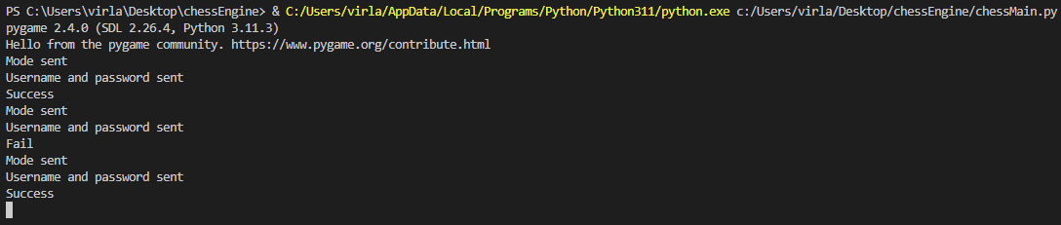

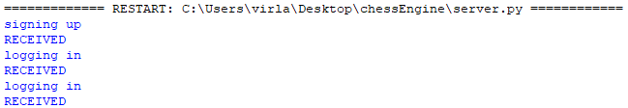

So far, it’s working as we expect it to!

signUp procedure test table:

|  |  |  |
| --- | --- | --- |
| Test Data | Expected Outcome | Actual Outcome |
| Username Input | **Invalid:** When the user has not entered a username and tries to sign up, the process is unsuccessful.  **Valid:** When the user has entered a username and tries to sign up, the process is successful. | As expected. |
| Password Input | **Invalid:** When the user has not entered a password and tries to sign up, the process is unsuccessful.  **Valid:** When the user has entered a password and tries to sign up, the process is successful. | As expected. |
| Password Confirmation Input | **Invalid:** When the user has entered a password confirmation that does not match the password and tries to sign up, the process is unsuccessful.  **Valid:** When the user has entered a password confirmation that does match the password and tries to sign up, the process is successful. | As expected. |

Next, we’re going to define our main menu procedure:

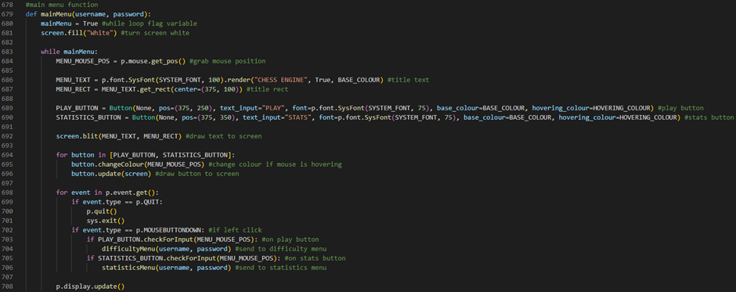

Line 679 defines our mainMenu procedure. It will take 2 parameters: our user’s username and our user’s password. Line 680 defines a flag variable called mainMenu which will control our while loop. It will be initialised to True. Line 681 will turn our screen white by running our screen variable’s fill method and passing an argument of the string value “White”. Line 683 defines a while loop which will run while our mainMenu flag variable is set to True. Line 684 defines a variable called MENU_MOUSE_POS which stores our user’s mouse position by running PyGame’s Mouse attribute’s get_pos method. Line 686 defines a variable called MENU_TEXT which stores our title text by running PyGame’s font attribute’s SysFont method and passing a font of our SYSTEM_FONT variable and a text size of 100 as arguments then running this object’s render method and passing a text value of the string “CHESS ENGINE”, an antialias value of True and a colour value of our BASE_COLOUR variable as arguments. Line 687 defines a variable called MENU_RECT which stores our title rect by running our MENU_TEXT’s get_rect method and passing a centre of (375, 100) as an argument. Line 689 defines a variable called PLAY_BUTTON which stores our play button by creating a Button with an image attribute of None, a pos attribute of (375, 250), a text_input attribute of the string “PLAY”, a font attribute of PyGame’s font attribute’s SysFont method (passing a font of our SYSTEM_FONT variable and a text size of 75 as arguments), a base_colour attribute of BASE_COLOUR and a hovering_colour attribute of HOVERING_COLOUR. Line 690 defines a variable called STATISTICS_BUTTON which stores our statistics button by creating a Button with an image attribute of None, a pos attribute of (375, 350), a text_input attribute of the string “STATS”, a font attribute of PyGame’s font attribute’s SysFont method (passing a font of our SYSTEM_FONT variable and a text size of 75 as arguments), a base_colour attribute of BASE_COLOUR and a hovering_colour attribute of HOVERING_COLOUR. Line 692 draws our title text to the screen by running our screen variable’s blit method and passing our MENU_TEXT variable and our MENU_RECT variable as arguments. Line 694 defines a for loop which will iterate through an array that stores our PLAY_BUTTON variable and our STATISTICS_BUTTON variable. Line 695 changes our current button’s colour if our user’s mouse is hovering over it by running our current button’s changeColour method and passing our MENU_MOUSE_POS variable as an argument. Line 696 draws our current button to the screen by running our current button’s update method and passing our screen variable as an argument. Line 698 defines the start of our event handler for loop. Line 699 checks if our user has closed the application by evaluating if our current event’s type is a PyGame QUIT event. If this is the case, then line 700 will run PyGame’s quit method and line 701 will run our system’s exit method. Line 702 checks if our user has left clicked with their mouse by evaluating if our current event’s type is a PyGame MOUSEBUTTONDOWN event. If this is the case, then line 703 will check if our user has left clicked on our play button by running our PLAY_BUTTON variable’s checkForInput method, passing our MENU_MOUSE_POS variable as an argument, and evaluating if it returns True. If this is the case, then line 704 will send our user to our difficulty menu by running our difficultyMenu procedure and passing our username variable and our password variable as arguments. Line 705 will check if our user has left clicked on our statistics button by running our STATISTICS_BUTTON variable’s checkForInput method, passing our MENU_MOUSE_POS variable as an argument, and evaluating if it returns True. If this is the case, then line 706 will send our user to our statistics menu by running our statisticsMenu procedure and passing our username variable and our password variable as arguments. Line 708 will then update our PyGame GUI window by running PyGame’s display attribute’s update method.

We can now run our server.py file and our chessMain.py file to test to see if our main menu is working:



Console:

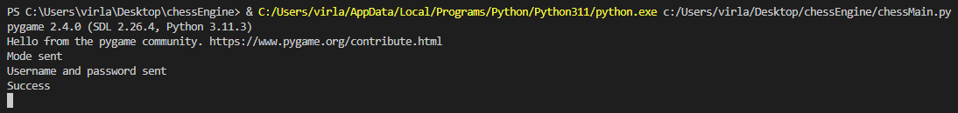



So far, it’s working as we expect it to!

mainMenu procedure test table:

|  |  |  |
| --- | --- | --- |
| Test Data | Expected Outcome | Actual Outcome |
| Play Button | When the user clicks the play button, they are sent to the difficulty menu screen. | As expected. |
| Statistics Button | When the user clicks the statistics button, they are sent to the statistics menu screen. | As expected. |

Next, we’re going to define a function which will set our game’s settings:

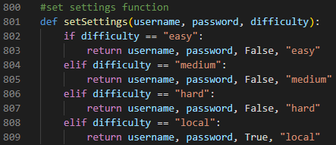

Line 801 defines a function called setSettings which takes 3 parameters: a username, a password and a difficulty setting. Line 802 checks if our difficulty variable is set to the string value “easy”. If this is the case, then line 803 will return a tuple containing our username variable, our password variable, a boolean value of False and a string value of “easy”. Line 804 checks if our difficulty variable is set to the string value “medium”. If this is the case, then line 805 will return a tuple containing our username variable, our password variable, a boolean value of False and a string value of “medium”. Line 806 checks if our difficulty variable is set to the string value “hard”. If this is the case, then line 807 will return a tuple containing our username variable, our password variable, a boolean value of False and a string value of “hard”. Line 808 checks if our difficulty variable is set to the string value “local”. If this is the case, then line 809 will return a tuple containing our username variable, our password variable, a boolean value of False and a string value of “local”.

Next, we’re going to define our difficulty menu procedure:

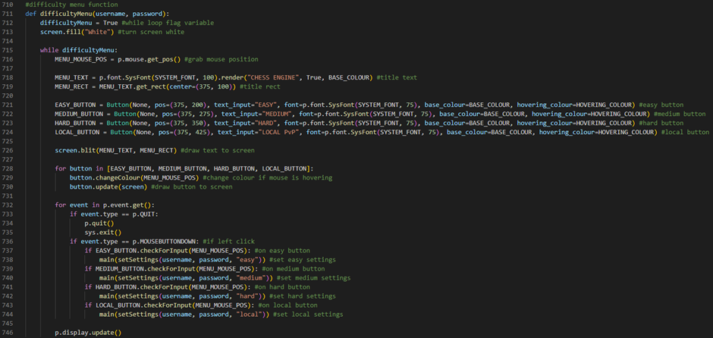

Line 711 defines our difficultyMenu procedure. It will take 2 parameters: our user’s username and our user’s password. Line 712 defines a flag variable called difficultyMenu which will control our while loop. It will be initialised to True. Line 713 will turn our screen white by running our screen variable’s fill method and passing an argument of the string value “White”. Line 715 defines a while loop which will run while our difficultyMenu flag variable is set to True. Line 716 defines a variable called MENU_MOUSE_POS which stores our user’s mouse position by running PyGame’s Mouse attribute’s get_pos method. Line 718 defines a variable called MENU_TEXT which stores our title text by running PyGame’s font attribute’s SysFont method and passing a font of our SYSTEM_FONT variable and a text size of 100 as arguments then running this object’s render method and passing a text value of the string “CHESS ENGINE”, an antialias value of True and a colour value of our BASE_COLOUR variable as arguments. Line 719 defines a variable called MENU_RECT which stores our title rect by running our MENU_TEXT’s get_rect method and passing a centre of (375, 100) as an argument. Line 721 defines a variable called EASY_BUTTON which stores our easy button by creating a Button with an image attribute of None, a pos attribute of (375, 200), a text_input attribute of the string “EASY”, a font attribute of PyGame’s font attribute’s SysFont method (passing a font of our SYSTEM_FONT variable and a text size of 75 as arguments), a base_colour attribute of BASE_COLOUR and a hovering_colour attribute of HOVERING_COLOUR. Line 722 defines a variable called MEDIUM_BUTTON which stores our medium button by creating a Button with an image attribute of None, a pos attribute of (375, 275), a text_input attribute of the string “MEDIUM”, a font attribute of PyGame’s font attribute’s SysFont method (passing a font of our SYSTEM_FONT variable and a text size of 75 as arguments), a base_colour attribute of BASE_COLOUR and a hovering_colour attribute of HOVERING_COLOUR. Line 723 defines a variable called HARD_BUTTON which stores our hard button by creating a Button with an image attribute of None, a pos attribute of (375, 350), a text_input attribute of the string “HARD”, a font attribute of PyGame’s font attribute’s SysFont method (passing a font of our SYSTEM_FONT variable and a text size of 75 as arguments), a base_colour attribute of BASE_COLOUR and a hovering_colour attribute of HOVERING_COLOUR. Line 724 defines a variable called LOCAL_BUTTON which stores our local button by creating a Button with an image attribute of None, a pos attribute of (375, 425), a text_input attribute of the string “LOCAL PvP”, a font attribute of PyGame’s font attribute’s SysFont method (passing a font of our SYSTEM_FONT variable and a text size of 75 as arguments), a base_colour attribute of BASE_COLOUR and a hovering_colour attribute of HOVERING_COLOUR. Line 726 draws our title text to the screen by running our screen variable’s blit method and passing our MENU_TEXT variable and our MENU_RECT variable as arguments. Line 728 defines a for loop which will iterate through an array that stores our EASY_BUTTON variable, our MEDIUM_BUTTON variable, our HARD_BUTTON variable and our LOCAL_BUTTON variable. Line 729 changes our current button’s colour if our user’s mouse is hovering over it by running our current button’s changeColour method and passing our MENU_MOUSE_POS variable as an argument. Line 730 draws our current button to the screen by running our current button’s update method and passing our screen variable as an argument. Line 732 defines the start of our event handler for loop. Line 733 checks if our user has closed the application by evaluating if our current event’s type is a PyGame QUIT event. If this is the case, then line 734 will run PyGame’s quit method and line 735 will run our system’s exit method. Line 736 checks if our user has left clicked with their mouse by evaluating if our current event’s type is a PyGame MOUSEBUTTONDOWN event. If this is the case, then line 737 will check if our user has left clicked on our easy button by running our EASY_BUTTON variable’s checkForInput method, passing our MENU_MOUSE_POS variable as an argument, and evaluating if it returns True. If this is the case, then line 738 will send our user to our main procedure on easy settings by running our main procedure and passing the product of running our setSettings function, passing our username variable, our password variable and the string value “easy” as arguments, as an argument. Line 739 will check if our user has left clicked on our medium button by running our MEDIUM_BUTTON variable’s checkForInput method, passing our MENU_MOUSE_POS variable as an argument, and evaluating if it returns True. If this is the case, then line 740 will send our user to our main procedure on medium settings by running our main procedure and passing the product of running our setSettings function, passing our username variable, our password variable and the string value “medium” as arguments, as an argument. Line 741 will check if our user has left clicked on our hard button by running our HARD_BUTTON variable’s checkForInput method, passing our MENU_MOUSE_POS variable as an argument, and evaluating if it returns True. If this is the case, then line 742 will send our user to our main procedure on hard settings by running our main procedure and passing the product of running our setSettings function, passing our username variable, our password variable and the string value “hard” as arguments, as an argument. Line 743 will check if our user has left clicked on our local button by running our LOCAL_BUTTON variable’s checkForInput method, passing our MENU_MOUSE_POS variable as an argument, and evaluating if it returns True. If this is the case, then line 744 will send our user to our main procedure on local settings by running our main procedure and passing the product of running our setSettings function, passing our username variable, our password variable and the string value “local” as arguments, as an argument. Line 746 will then update our PyGame GUI window by running PyGame’s display attribute’s update method.

We can now run our server.py file and our chessMain.py file to test to see if our difficulty menu is working:



Console:

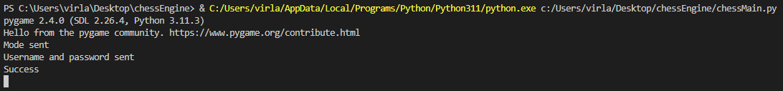



So far, it’s working as we expect it to!

difficultyMenu procedure test table:

|  |  |  |
| --- | --- | --- |
| Test Data | Expected Outcome | Actual Outcome |
| Easy Button | When the user clicks the easy button, they are sent to the main procedure on easy difficulty settings. | As expected. |
| Medium Button | When the user clicks the medium button, they are sent to the main procedure on medium difficulty settings. | As expected. |
| Hard Button | When the user clicks the hard button, they are sent to the main procedure on hard difficulty settings. | As expected. |
| Local Button | When the user clicks the local button, they are sent to the main procedure on local multiplayer settings. | As expected. |

Next, we’re going to define our statistics menu procedure:

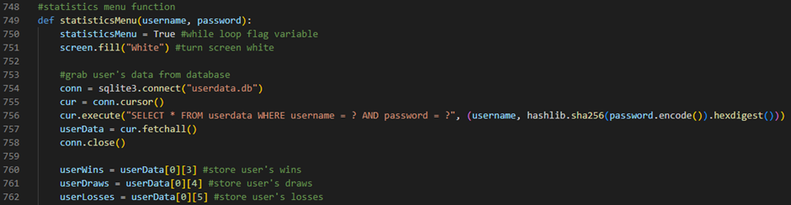

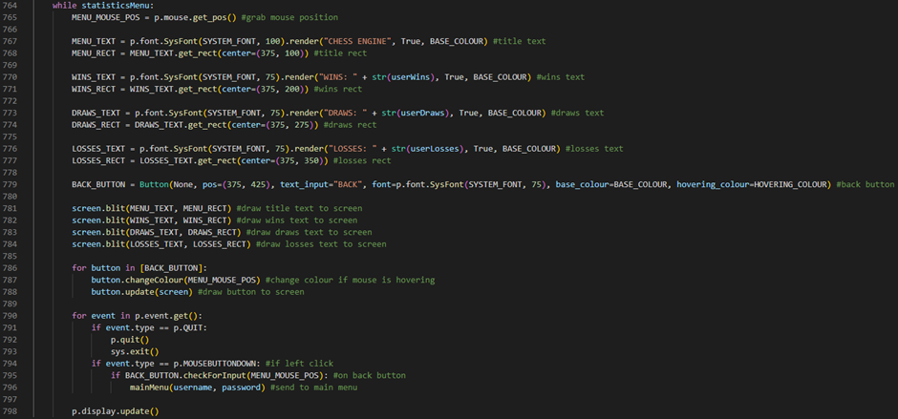

Line 749 defines our statisticsMenu procedure. It will take 2 parameters: our user’s username and our user’s password. Line 750 defines a flag variable called statisticsMenu which will control our while loop. It will be initialised to True. Line 751 will turn our screen white by running our screen variable’s fill method and passing an argument of the string value “White”. Line 754 defines a variable called conn which stores a connection to a database file called userdata by running sqlite3’s connect method and passing the string value “userdata.db” as an argument. Line 755 defines a variable called cur which stores our connection’s cursor by running our conn variable’s cursor method. Line 756 grabs our user’s data from our database by running our cur variable’s execute method and passing the string “SELECT * FROM userdata WHERE username = ? AND password = ?” and a tuple containing our username variable and the product of running our hashlib module’s sha256 method and passing the product of running our password variable’s encode method as an argument then running the hexdigest method of this as arguments. Line 757 defines a variable called userData which will store our user’s data by storing the product of running our cur variable’s fetchall method. Line 758 will then close our connection to our database by running our conn variable’s close method. Line 760 defines a variable called userWins which will store our user’s wins by storing the fourth element on the first row of our userData variable. Line 761 defines a variable called userDraws which will store our user’s draws by storing the fifth element on the first row of our userData variable. Line 762 defines a variable called userLosses which will store our user’s losses by storing the sixth element on the first row of our userData variable. Line 764 defines a while loop which will run while our statisticsMenu flag variable is set to True. Line 765 defines a variable called MENU_MOUSE_POS which stores our user’s mouse position by running PyGame’s Mouse attribute’s get_pos method. Line 767 defines a variable called MENU_TEXT which stores our title text by running PyGame’s font attribute’s SysFont method and passing a font of our SYSTEM_FONT variable and a text size of 100 as arguments then running this object’s render method and passing a text value of the string “CHESS ENGINE”, an antialias value of True and a colour value of our BASE_COLOUR variable as arguments. Line 768 defines a variable called MENU_RECT which stores our title rect by running our MENU_TEXT’s get_rect method and passing a centre of (375, 100) as an argument. Line 770 defines a variable called WINS_TEXT which stores our wins text by running PyGame’s font attribute’s SysFont method and passing a font of our SYSTEM_FONT variable and a text size of 75 as arguments then running this object’s render method and passing a text value of the string “WINS:” plus our userWins variable as a string, an antialias value of True and a colour value of our BASE_COLOUR variable as arguments. Line 771 defines a variable called WINS_RECT which stores our wins rect by running our WINS_TEXT’s get_rect method and passing a centre of (375, 200) as an argument. Line 773 defines a variable called DRAWS_TEXT which stores our draws text by running PyGame’s font attribute’s SysFont method and passing a font of our SYSTEM_FONT variable and a text size of 75 as arguments then running this object’s render method and passing a text value of the string “DRAWS:” plus our userDraws variable as a string, an antialias value of True and a colour value of our BASE_COLOUR variable as arguments. Line 774 defines a variable called DRAWS_RECT which stores our draws rect by running our DRAWS_TEXT’s get_rect method and passing a centre of (375, 275) as an argument. Line 776 defines a variable called LOSSES_TEXT which stores our losses text by running PyGame’s font attribute’s SysFont method and passing a font of our SYSTEM_FONT variable and a text size of 75 as arguments then running this object’s render method and passing a text value of the string “LOSSES:” plus our userLosses variable as a string, an antialias value of True and a colour value of our BASE_COLOUR variable as arguments. Line 777 defines a variable called LOSSES_RECT which stores our losses rect by running our LOSSES_TEXT’s get_rect method and passing a centre of (375, 350) as an argument. Line 779 defines a variable called BACK_BUTTON which stores our back button by creating a Button with an image attribute of None, a pos attribute of (375, 425), a text_input attribute of the string “BACK”, a font attribute of PyGame’s font attribute’s SysFont method (passing a font of our SYSTEM_FONT variable and a text size of 75 as arguments), a base_colour attribute of BASE_COLOUR and a hovering_colour attribute of HOVERING_COLOUR. Line 781 draws our title text to the screen by running our screen variable’s blit method and passing our MENU_TEXT variable and our MENU_RECT variable as arguments. Line 782 draws our wins text to the screen by running our screen variable’s blit method and passing our WINS_TEXT variable and our WINS_RECT variable as arguments. Line 783 draws our draws text to the screen by running our screen variable’s blit method and passing our DRAWS_TEXT variable and our DRAWS_RECT variable as arguments. Line 784 draws our losses text to the screen by running our screen variable’s blit method and passing our LOSSES_TEXT variable and our LOSSES_RECT variable as arguments. Line 786 defines a for loop which will iterate through an array that stores our BACK_BUTTON variable. Line 787 changes our current button’s colour if our user’s mouse is hovering over it by running our current button’s changeColour method and passing our MENU_MOUSE_POS variable as an argument. Line 788 draws our current button to the screen by running our current button’s update method and passing our screen variable as an argument. Line 790 defines the start of our event handler for loop. Line 791 checks if our user has closed the application by evaluating if our current event’s type is a PyGame QUIT event. If this is the case, then line 792 will run PyGame’s quit method and line 793 will run our system’s exit method. Line 794 checks if our user has left clicked with their mouse by evaluating if our current event’s type is a PyGame MOUSEBUTTONDOWN event. If this is the case, then line 795 will check if our user has left clicked on our back button by running our BACK_BUTTON variable’s checkForInput method, passing our MENU_MOUSE_POS variable as an argument, and evaluating if it returns True. If this is the case, then line 796 will send our user to our main menu by running our mainMenu procedure and passing our username variable and our password variable as arguments. Line 798 will then update our PyGame GUI window by running PyGame’s display attribute’s update method.

We can now run our server.py file and our chessMain.py file to test to see if our statistics menu is working:



Console:





So far, it’s working as we expect it to!

statisticsMenu procedure test table:

|  |  |  |
| --- | --- | --- |
| Test Data | Expected Outcome | Actual Outcome |
| Wins Text | This text object displays the user’s current number of wins to the screen. | As expected. |
| Draws Text | This text object displays the user’s current number of draws to the screen. | As expected. |
| Losses Text | This text object displays the user’s current number of losses to the screen. | As expected. |
| Back Button | When the user clicks the back button, they are sent to the main menu screen. | As expected. |

Next, we’re going to define a procedure which will update our user’s statistics after a game has ended and send them back to the main menu:

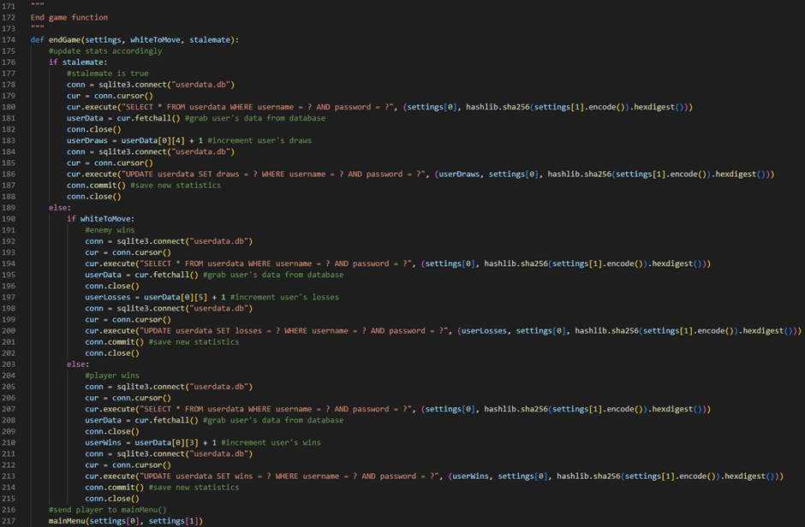

Line 174 defines a procedure called endGame which takes 3 parameters: our settings tuple, our whiteToMove flag variable and our stalemate flag variable. Line 176 checks if our stalemate flag variable is set to True. If it is, then line 178 defines a variable called conn which stores a connection to a database file called userdata by running sqlite3’s connect method and passing the string value “userdata.db” as an argument. Line 179 defines a variable called cur which stores our connection’s cursor by running our conn variable’s cursor method. Line 180 grabs our user’s data from our database by running our cur variable’s execute method and passing the string “SELECT * FROM userdata WHERE username = ? AND password = ?” and a tuple containing the first element of our settings tuple and the product of running our hashlib module’s sha256 method and passing the product of running the second element of our settings tuple’s encode method as an argument then running the hexdigest method of this as arguments. Line 181 defines a variable called userData which will store our user’s data by storing the product of running our cur variable’s fetchall method. Line 182 will then close our connection to our database by running our conn variable’s close method. Line 183 defines a variable called userDraws which will store our incremented user’s draws by storing the fifth element on the first row of our userData variable plus 1. Line 184 defines a variable called conn which stores a connection to a database file called userdata by running sqlite3’s connect method and passing the string value “userdata.db” as an argument. Line 185 defines a variable called cur which stores our connection’s cursor by running our conn variable’s cursor method. Line 186 updates our user’s draws by running our cur variable’s execute method and passing the string “UPDATE userdata SET draws = ? WHERE username = ? AND password = ?” and a tuple containing our userDraws variable, the first element of our settings tuple and the product of running our hashlib module’s sha256 method and passing the product of running the second element of our settings tuple’s encode method as an argument then running the hexdigest method of this as arguments. Line 187 will save our user’s new statistics to the database by running our conn variable’s commit method. Line 188 will then close our connection to our database by running our conn variable’s close method. Line 189 is an else statement which will run if our stalemate flag variable is set to False. If this is the case, then line 190 will check if our whiteToMove flag variable is set to True. If it is, then line 192 defines a variable called conn which stores a connection to a database file called userdata by running sqlite3’s connect method and passing the string value “userdata.db” as an argument. Line 193 defines a variable called cur which stores our connection’s cursor by running our conn variable’s cursor method. Line 194 grabs our user’s data from our database by running our cur variable’s execute method and passing the string “SELECT * FROM userdata WHERE username = ? AND password = ?” and a tuple containing the first element of our settings tuple and the product of running our hashlib module’s sha256 method and passing the product of running the second element of our settings tuple’s encode method as an argument then running the hexdigest method of this as arguments. Line 195 defines a variable called userData which will store our user’s data by storing the product of running our cur variable’s fetchall method. Line 196 will then close our connection to our database by running our conn variable’s close method. Line 197 defines a variable called userLosses which will store our incremented user’s losses by storing the sixth element on the first row of our userData variable plus 1. Line 198 defines a variable called conn which stores a connection to a database file called userdata by running sqlite3’s connect method and passing the string value “userdata.db” as an argument. Line 199 defines a variable called cur which stores our connection’s cursor by running our conn variable’s cursor method. Line 200 updates our user’s losses by running our cur variable’s execute method and passing the string “UPDATE userdata SET losses = ? WHERE username = ? AND password = ?” and a tuple containing our userLosses variable, the first element of our settings tuple and the product of running our hashlib module’s sha256 method and passing the product of running the second element of our settings tuple’s encode method as an argument then running the hexdigest method of this as arguments. Line 201 will save our user’s new statistics to the database by running our conn variable’s commit method. Line 202 will then close our connection to our database by running our conn variable’s close method. Line 203 is an else statement which will run if our whiteToMove flag variable is set to False. If this is the case, then line 205 defines a variable called conn which stores a connection to a database file called userdata by running sqlite3’s connect method and passing the string value “userdata.db” as an argument. Line 206 defines a variable called cur which stores our connection’s cursor by running our conn variable’s cursor method. Line 207 grabs our user’s data from our database by running our cur variable’s execute method and passing the string “SELECT * FROM userdata WHERE username = ? AND password = ?” and a tuple containing the first element of our settings tuple and the product of running our hashlib module’s sha256 method and passing the product of running the second element of our settings tuple’s encode method as an argument then running the hexdigest method of this as arguments. Line 208 defines a variable called userData which will store our user’s data by storing the product of running our cur variable’s fetchall method. Line 209 will then close our connection to our database by running our conn variable’s close method. Line 210 defines a variable called userWins which will store our incremented user’s wins by storing the fourth element on the first row of our userData variable plus 1. Line 211 defines a variable called conn which stores a connection to a database file called userdata by running sqlite3’s connect method and passing the string value “userdata.db” as an argument. Line 212 defines a variable called cur which stores our connection’s cursor by running our conn variable’s cursor method. Line 213 updates our user’s wins by running our cur variable’s execute method and passing the string “UPDATE userdata SET wins = ? WHERE username = ? AND password = ?” and a tuple containing our userWins variable, the first element of our settings tuple and the product of running our hashlib module’s sha256 method and passing the product of running the second element of our settings tuple’s encode method as an argument then running the hexdigest method of this as arguments. Line 214 will save our user’s new statistics to the database by running our conn variable’s commit method. Line 215 will then close our connection to our database by running our conn variable’s close method. Line 217 will send our user to our main menu by running our mainMenu procedure and passing the first element of our settings tuple and the second element of our settings tuple as arguments.

Finally, we’re going to update our main procedure:

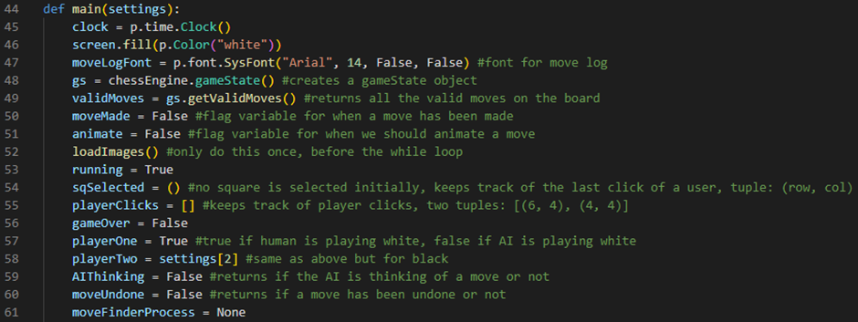

Line 44 now defines a procedure called main which takes one parameter: our settings tuple. Line 58 now sets our playerTwo flag variable to the third element of our settings tuple.

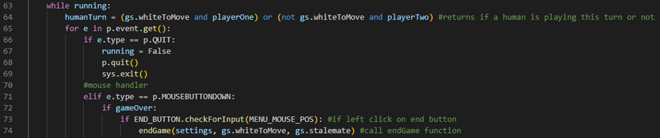

Line 72 checks if our gameOver flag variable is set to True when our player clicks on the screen. If this is the case, then line 73 will check if our user has left clicked on our end button by running our END_BUTTON variable’s checkForInput method, passing our MENU_MOUSE_POS variable as an argument, and evaluating if it returns True. If this is the case, then line 74 will run our endGame procedure, passing our settings tuple, our current gamestate’s whiteToMove flag variable and our current gamestate’s stalemate flag variable as arguments.

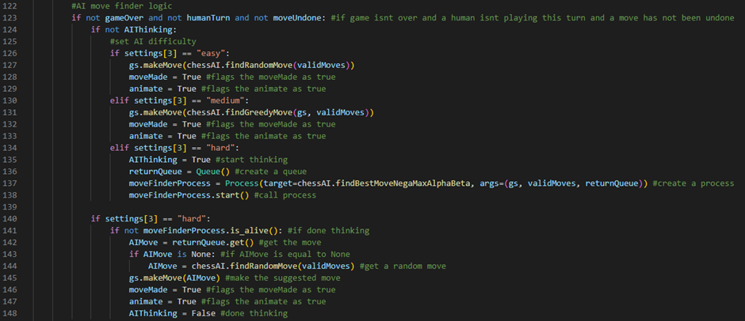

Line 123 checks if the game is not over and if a human is not playing this turn and a move has not been undone by evaluating if our gameOver flag variable is set to False and our humanTurn flag variable is set to False and our moveUndone flag variable is set to False. If this is the case, then line 124 will check if our AIThinking flag variable is set to False. If it is, then line 126 will check if the fourth element in our settings tuple stores a value of the string “easy”. If it does, then line 127 will make a random move by running our current gamestate’s makeMove method and passing the product of running our chessAI.py file’s findRandomMove function call, passing our current validMoves array as an argument, as an argument. Line 128 will then set our moveMade flag variable to True. Line 129 will then set our animate flag variable to True. Line 130 will check if the fourth element in our settings tuple stores a value of the string “medium”. If it does, then line 131 will make a greedy move by running our current gamestate’s makeMove method and passing the product of running our chessAI.py file’s findGreedyMove function call, passing our current gamestate and our current validMoves array as arguments, as an argument. Line 132 will then set our moveMade flag variable to True. Line 133 will then set our animate flag variable to True. Line 134 will check if the fourth element in our settings tuple stores a value of the string “hard”. If it does, then line 135 will set our AIThinking flag variable to True. Line 136 will define a variable called returnQueue which will store an empty Queue object. Line 137 will set our moveFinderProcess variable to a Process object with a target of our chessAI.py file’s findBestMoveNegaMaxAlphaBeta function and args of our current gameState object, our current validMoves array and our returnQueue variable. Line 138 calls our process by running our moveFinderProcess variable’s start method. Line 140 will check if the fourth element in our settings tuple stores a value of the string “hard”. If it does, then line 141 will check if our AI is done thinking of a move by checking if our moveFinderProcess variable’s is_alive method returns False. If this is the case, then line 142 will define a variable called AIMove which will be initialised to the result of running our returnQueue variable’s get method. Line 143 checks if our AIMove is a None object. If this is the case, then line 144 will set our AIMove variable to the product of running our chessAI.py file’s findRandomMove function, passing our current validMoves array as an argument. Line 145 will then make our AI algorithm’s move by calling our gameState object’s makeMove method and passing our AIMove variable as an argument. Line 146 will then set our moveMade flag variable to True. Line 147 will then set our animate flag variable to True. Line 148 will then set our AIThinking flag variable to False.



Line 160 checks if a checkmate or a stalemate has been calculated by our chess engine by evaluating if our current gamestate’s checkmate flag variable is set to True or our current gamestate’s stalemate flag variable is set to True. If this is the case, then line 161 will set our gameOver flag variable to True and line 162 will run our drawEndGameText procedure, passing our screen variable and the string value “Stalemate” if our current gameState object’s stalemate attribute is set to True otherwise, it will pass the string value “Black wins by checkmate” if our current gameState object’s checkmate attribute is set to True otherwise, it will pass the string value “White wins by checkmate”. Line 163 defines a variable called MENU_MOUSE_POS which stores our user’s mouse position by running PyGame’s Mouse attribute’s get_pos method. Line 164 defines a variable called END_BUTTON which stores our end button by creating a Button with an image attribute of None, a pos attribute of (260, 300), a text_input attribute of the string “END GAME”, a font attribute of PyGame’s font attribute’s SysFont method (passing a font of our SYSTEM_FONT variable and a text size of 45 as arguments), a base_colour attribute of the string “white” and a hovering_colour attribute of the string “red”. Line 165 changes our end button’s colour if the user’s mouse is hovering over it by running our END_BUTTON variable’s changeColour method and passing our MENU_MOUSE_POS variable as an argument. Line 166 draws our end button to the screen by running our END_BUTTON’s update method and passing our screen variable as an argument.

We can now run our server.py file and our chessMain.py file to test to see if our end game functionality is working:

Win test:



Console:

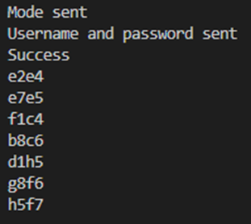

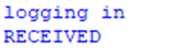

Loss test:



Console:

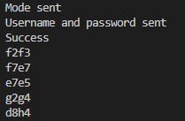



Draw test:



Console:

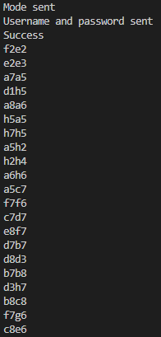



So far, it’s working as we expect it to!

main procedure test table:

|  |  |  |
| --- | --- | --- |
| Test Data | Expected Outcome | Actual Outcome |
| First click on the board | When the user clicks on a square on the board, the square is selected. | As expected. |
| Second click on the board | When the user clicks on a square on the board that is for a valid move, the move is made on the board.  When the user clicks on a square on the board that is for an invalid move, the square they clicked on is selected instead.  When the user clicks on the same square on the board, the square is deselected. | As expected. |
| Win Text | This text object displays that white has won by checkmate when the chess engine calculates that our user has won by checkmate. | As expected. |
| Draw Text | This text object displays stalemate when the chess engine calculates that our user has drawn by stalemate. | As expected. |
| Loss Text | This text object displays that black has won by checkmate when the chess engine calculates that our user has lost by checkmate. | As expected. |
| End Button | When the user clicks the end button, their statistics are updated according to the outcome of the chess game and they are sent to the main menu screen. | As expected. |

# Evaluation

## Testing for the evaluation

Now we can test our chess engine software using our post development test data.

First, we’re going to run our server.py file and chessMain.py file to test our sign up feature:



Console:

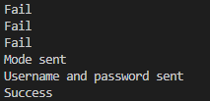

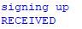

Sign up feature test table:

|  |  |  |
| --- | --- | --- |
| Test Data | Expected Outcome | Actual Outcome |
| Start Button (Start Menu Screen) | When the user clicks the start button, they are sent to the login menu screen. | As expected. |
| Quit Button (Start Menu Screen) | When the user clicks the quit button, the software is closed. | As expected. |
| Sign Up Button (Login Menu Screen) | When the user clicks the sign up button, they are sent to the sign up screen. | As expected. |
| Username Input (Sign Up Screen) | **Invalid:** When the user has not entered a username and tries to sign up, the process is unsuccessful.  **Valid:** When the user has entered a username and tries to sign up, the process is successful. | As expected. |
| Password Input (Sign Up Screen) | **Invalid:** When the user has not entered a password and tries to sign up, the process is unsuccessful.  **Valid:** When the user has entered a password and tries to sign up, the process is successful. | As expected. |
| Password Confirmation Input (Sign Up Screen) | **Invalid:** When the user has entered a password confirmation that does not match the password and tries to sign up, the process is unsuccessful.  **Valid:** When the user has entered a password confirmation that does match the password and tries to sign up, the process is successful. | As expected. |

Next, we’re going to run our server.py file and chessMain.py file to test our login feature:



Console:

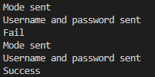

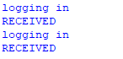

Login feature test table:

|  |  |  |
| --- | --- | --- |
| Test Data | Expected Outcome | Actual Outcome |
| Start Button (Start Menu Screen) | When the user clicks the start button, they are sent to the login menu screen. | As expected. |
| Quit Button (Start Menu Screen) | When the user clicks the quit button, the software is closed. | As expected. |
| Log In Button (Login Menu Screen) | When the user clicks the log in button, they are sent to the log in screen. | As expected. |
| Username Input (Log In Screen) | **Invalid:** When the user has entered an invalid username and tries to log in, the process is unsuccessful.  **Valid:** When the user has entered a valid username and tries to log in, the process is successful. | As expected. |
| Password Input (Log In Screen) | **Invalid:** When the user has entered an invalid password and tries to log in, the process is unsuccessful.  **Valid:** When the user has entered a valid password and tries to log in, the process is successful. | As expected. |

Next, we’re going to run our server.py file and chessMain.py file to test our main menu screen:



Console:

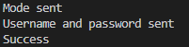

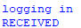

Main menu screen test table:

|  |  |  |
| --- | --- | --- |
| Test Data | Expected Outcome | Actual Outcome |
| Start Button (Start Menu Screen) | When the user clicks the start button, they are sent to the login menu screen. | As expected. |
| Quit Button (Start Menu Screen) | When the user clicks the quit button, the software is closed. | As expected. |
| Log In Button (Login Menu Screen) | When the user clicks the log in button, they are sent to the log in screen. | As expected. |
| Username Input (Log In Screen) | **Invalid:** When the user has entered an invalid username and tries to log in, the process is unsuccessful.  **Valid:** When the user has entered a valid username and tries to log in, the process is successful. | As expected. |
| Password Input (Log In Screen) | **Invalid:** When the user has entered an invalid password and tries to log in, the process is unsuccessful.  **Valid:** When the user has entered a valid password and tries to log in, the process is successful. | As expected. |
| Play Button (Main Menu Screen) | When the user clicks the play button, they are sent to the difficulty menu screen. | As expected. |
| Statistics Button (Main Menu Screen) | When the user clicks the statistics button, they are sent to the statistics menu screen. | As expected. |

Next, we’re going to run our server.py file and chessMain.py file to test our statistics menu screen:



Console:

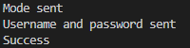

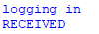

Statistics menu screen test table:

|  |  |  |
| --- | --- | --- |
| Test Data | Expected Outcome | Actual Outcome |
| Start Button (Start Menu Screen) | When the user clicks the start button, they are sent to the login menu screen. | As expected. |
| Quit Button (Start Menu Screen) | When the user clicks the quit button, the software is closed. | As expected. |
| Log In Button (Login Menu Screen) | When the user clicks the log in button, they are sent to the log in screen. | As expected. |
| Username Input (Log In Screen) | **Invalid:** When the user has entered an invalid username and tries to log in, the process is unsuccessful.  **Valid:** When the user has entered a valid username and tries to log in, the process is successful. | As expected. |
| Password Input (Log In Screen) | **Invalid:** When the user has entered an invalid password and tries to log in, the process is unsuccessful.  **Valid:** When the user has entered a valid password and tries to log in, the process is successful. | As expected. |
| Statistics Button (Main Menu Screen) | When the user clicks the statistics button, they are sent to the statistics menu screen. | As expected. |
| Wins Text (Statistics Menu Screen) | This text object displays the user’s current number of wins to the screen. | As expected. |
| Draws Text (Statistics Menu Screen) | This text object displays the user’s current number of draws to the screen. | As expected. |
| Losses Text (Statistics Menu Screen) | This text object displays the user’s current number of losses to the screen. | As expected. |
| Back Button (Statistics Menu Screen) | When the user clicks the back button, they are sent to the main menu screen. | As expected. |

Next, we’re going to run our server.py file and chessMain.py file to test our difficulty menu screen:



Console:

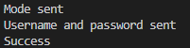

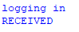

Difficulty menu screen test table:

|  |  |  |
| --- | --- | --- |
| Test Data | Expected Outcome | Actual Outcome |
| Start Button (Start Menu Screen) | When the user clicks the start button, they are sent to the login menu screen. | As expected. |
| Quit Button (Start Menu Screen) | When the user clicks the quit button, the software is closed. | As expected. |
| Log In Button (Login Menu Screen) | When the user clicks the log in button, they are sent to the log in screen. | As expected. |
| Username Input (Log In Screen) | **Invalid:** When the user has entered an invalid username and tries to log in, the process is unsuccessful.  **Valid:** When the user has entered a valid username and tries to log in, the process is successful. | As expected. |
| Password Input (Log In Screen) | **Invalid:** When the user has entered an invalid password and tries to log in, the process is unsuccessful.  **Valid:** When the user has entered a valid password and tries to log in, the process is successful. | As expected. |
| Play Button (Main Menu Screen) | When the user clicks the play button, they are sent to the difficulty menu screen. | As expected. |
| Easy Button (Difficulty Menu Screen) | When the user clicks the easy button, they are sent to the main procedure on easy difficulty settings. | As expected. |
| Medium Button (Difficulty Menu Screen) | When the user clicks the medium button, they are sent to the main procedure on medium difficulty settings. | As expected. |
| Hard Button (Difficulty Menu Screen) | When the user clicks the hard button, they are sent to the main procedure on hard difficulty settings. | As expected. |
| Local Button (Difficulty Menu Screen) | When the user clicks the local button, they are sent to the main procedure on local multiplayer settings. | As expected. |

Next, we’re going to run our server.py file and chessMain.py file to test our local multiplayer mode:



Console:

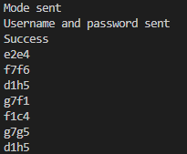

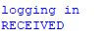

Local multiplayer mode test table:

|  |  |  |
| --- | --- | --- |
| Test Data | Expected Outcome | Actual Outcome |
| Start Button (Start Menu Screen) | When the user clicks the start button, they are sent to the login menu screen. | As expected. |
| Quit Button (Start Menu Screen) | When the user clicks the quit button, the software is closed. | As expected. |
| Log In Button (Login Menu Screen) | When the user clicks the log in button, they are sent to the log in screen. | As expected. |
| Username Input (Log In Screen) | **Invalid:** When the user has entered an invalid username and tries to log in, the process is unsuccessful.  **Valid:** When the user has entered a valid username and tries to log in, the process is successful. | As expected. |
| Password Input (Log In Screen) | **Invalid:** When the user has entered an invalid password and tries to log in, the process is unsuccessful.  **Valid:** When the user has entered a valid password and tries to log in, the process is successful. | As expected. |
| Play Button (Main Menu Screen) | When the user clicks the play button, they are sent to the difficulty menu screen. | As expected. |
| Local Button (Difficulty Menu Screen) | When the user clicks the local button, they are sent to the main procedure on local multiplayer settings. | As expected. |
| First click on the board (Main Procedure) | When the user clicks on a square on the board, the square is selected. | As expected. |
| Second click on the board (Main Procedure) | When the user clicks on a square on the board that is for a valid move, the move is made on the board.  When the user clicks on a square on the board that is for an invalid move, the square they clicked on is selected instead.  When the user clicks on the same square on the board, the square is deselected. | As expected. |

Next, we’re going to run our server.py file and chessMain.py file to test our single-player mode’s easy difficulty setting:



Console:

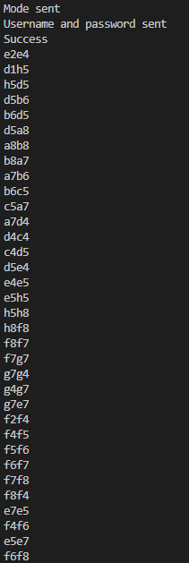

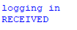

Easy difficulty test table:

|  |  |  |
| --- | --- | --- |
| Test Data | Expected Outcome | Actual Outcome |
| Start Button (Start Menu Screen) | When the user clicks the start button, they are sent to the login menu screen. | As expected. |
| Quit Button (Start Menu Screen) | When the user clicks the quit button, the software is closed. | As expected. |
| Log In Button (Login Menu Screen) | When the user clicks the log in button, they are sent to the log in screen. | As expected. |
| Username Input (Log In Screen) | **Invalid:** When the user has entered an invalid username and tries to log in, the process is unsuccessful.  **Valid:** When the user has entered a valid username and tries to log in, the process is successful. | As expected. |
| Password Input (Log In Screen) | **Invalid:** When the user has entered an invalid password and tries to log in, the process is unsuccessful.  **Valid:** When the user has entered a valid password and tries to log in, the process is successful. | As expected. |
| Play Button (Main Menu Screen) | When the user clicks the play button, they are sent to the difficulty menu screen. | As expected. |
| Easy Button (Difficulty Menu Screen) | When the user clicks the easy button, they are sent to the main procedure on easy difficulty settings. | As expected. |
| First click on the board (Main Procedure) | When the user clicks on a square on the board, the square is selected. | As expected. |
| Second click on the board (Main Procedure) | When the user clicks on a square on the board that is for a valid move, the move is made on the board.  When the user clicks on a square on the board that is for an invalid move, the square they clicked on is selected instead.  When the user clicks on the same square on the board, the square is deselected. | As expected. |

Next, we’re going to run our server.py file and chessMain.py file to test our single-player mode’s medium difficulty setting:



Console:

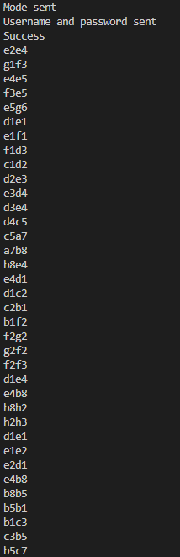

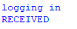

Medium difficulty test table:

|  |  |  |
| --- | --- | --- |
| Test Data | Expected Outcome | Actual Outcome |
| Start Button (Start Menu Screen) | When the user clicks the start button, they are sent to the login menu screen. | As expected. |
| Quit Button (Start Menu Screen) | When the user clicks the quit button, the software is closed. | As expected. |
| Log In Button (Login Menu Screen) | When the user clicks the log in button, they are sent to the log in screen. | As expected. |
| Username Input (Log In Screen) | **Invalid:** When the user has entered an invalid username and tries to log in, the process is unsuccessful.  **Valid:** When the user has entered a valid username and tries to log in, the process is successful. | As expected. |
| Password Input (Log In Screen) | **Invalid:** When the user has entered an invalid password and tries to log in, the process is unsuccessful.  **Valid:** When the user has entered a valid password and tries to log in, the process is successful. | As expected. |
| Play Button (Main Menu Screen) | When the user clicks the play button, they are sent to the difficulty menu screen. | As expected. |
| Medium Button (Difficulty Menu Screen) | When the user clicks the medium button, they are sent to the main procedure on medium difficulty settings. | As expected. |
| First click on the board (Main Procedure) | When the user clicks on a square on the board, the square is selected. | As expected. |
| Second click on the board (Main Procedure) | When the user clicks on a square on the board that is for a valid move, the move is made on the board.  When the user clicks on a square on the board that is for an invalid move, the square they clicked on is selected instead.  When the user clicks on the same square on the board, the square is deselected. | As expected. |

Next, we’re going to run our server.py file and chessMain.py file to test our single-player mode’s hard difficulty setting:



Console:

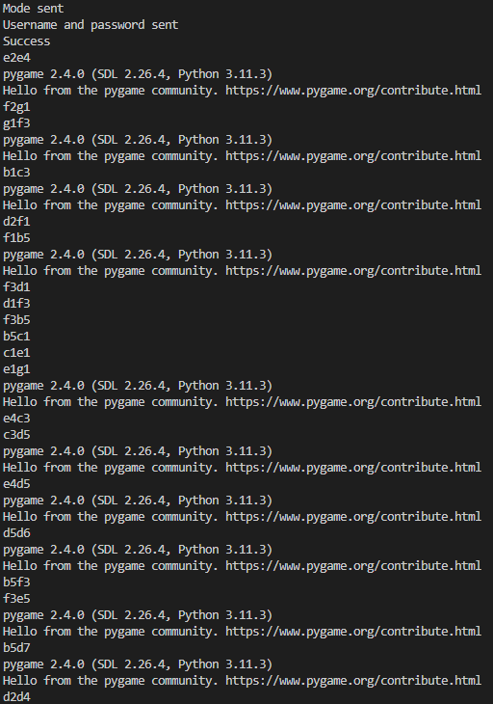

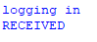

Hard difficulty test table:

|  |  |  |
| --- | --- | --- |
| Test Data | Expected Outcome | Actual Outcome |
| Start Button (Start Menu Screen) | When the user clicks the start button, they are sent to the login menu screen. | As expected. |
| Quit Button (Start Menu Screen) | When the user clicks the quit button, the software is closed. | As expected. |
| Log In Button (Login Menu Screen) | When the user clicks the log in button, they are sent to the log in screen. | As expected. |
| Username Input (Log In Screen) | **Invalid:** When the user has entered an invalid username and tries to log in, the process is unsuccessful.  **Valid:** When the user has entered a valid username and tries to log in, the process is successful. | As expected. |
| Password Input (Log In Screen) | **Invalid:** When the user has entered an invalid password and tries to log in, the process is unsuccessful.  **Valid:** When the user has entered a valid password and tries to log in, the process is successful. | As expected. |
| Play Button (Main Menu Screen) | When the user clicks the play button, they are sent to the difficulty menu screen. | As expected. |
| Hard Button (Difficulty Menu Screen) | When the user clicks the hard button, they are sent to the main procedure on hard difficulty settings. | As expected. |
| First click on the board (Main Procedure) | When the user clicks on a square on the board, the square is selected. | As expected. |
| Second click on the board (Main Procedure) | When the user clicks on a square on the board that is for a valid move, the move is made on the board.  When the user clicks on a square on the board that is for an invalid move, the square they clicked on is selected instead.  When the user clicks on the same square on the board, the square is deselected. | As expected. |

Next, we’re going to run our server.py file and chessMain.py file to test our game screen:



Console:

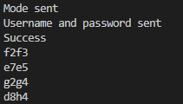

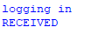

Game screen test table:

|  |  |  |
| --- | --- | --- |
| Test Data | Expected Outcome | Actual Outcome |
| Start Button (Start Menu Screen) | When the user clicks the start button, they are sent to the login menu screen. | As expected. |
| Quit Button (Start Menu Screen) | When the user clicks the quit button, the software is closed. | As expected. |
| Log In Button (Login Menu Screen) | When the user clicks the log in button, they are sent to the log in screen. | As expected. |
| Username Input (Log In Screen) | **Invalid:** When the user has entered an invalid username and tries to log in, the process is unsuccessful.  **Valid:** When the user has entered a valid username and tries to log in, the process is successful. | As expected. |
| Password Input (Log In Screen) | **Invalid:** When the user has entered an invalid password and tries to log in, the process is unsuccessful.  **Valid:** When the user has entered a valid password and tries to log in, the process is successful. | As expected. |
| Play Button (Main Menu Screen) | When the user clicks the play button, they are sent to the difficulty menu screen. | As expected. |
| Local Button (Difficulty Menu Screen) | When the user clicks the local button, they are sent to the main procedure on local multiplayer settings. | As expected. |
| First click on the board (Main Procedure) | When the user clicks on a square on the board, the square is selected. | As expected. |
| Second click on the board (Main Procedure) | When the user clicks on a square on the board that is for a valid move, the move is made on the board.  When the user clicks on a square on the board that is for an invalid move, the square they clicked on is selected instead.  When the user clicks on the same square on the board, the square is deselected. | As expected. |

Next, we’re going to run our server.py file and chessMain.py file to test our user statistics feature:

Win test:



Console:





Loss test:



Console:





Draw test:



Console:





User statistics feature test table:

|  |  |  |
| --- | --- | --- |
| Test Data | Expected Outcome | Actual Outcome |
| Start Button (Start Menu Screen) | When the user clicks the start button, they are sent to the login menu screen. | As expected. |
| Quit Button (Start Menu Screen) | When the user clicks the quit button, the software is closed. | As expected. |
| Log In Button (Login Menu Screen) | When the user clicks the log in button, they are sent to the log in screen. | As expected. |
| Username Input (Log In Screen) | **Invalid:** When the user has entered an invalid username and tries to log in, the process is unsuccessful.  **Valid:** When the user has entered a valid username and tries to log in, the process is successful. | As expected. |
| Password Input (Log In Screen) | **Invalid:** When the user has entered an invalid password and tries to log in, the process is unsuccessful.  **Valid:** When the user has entered a valid password and tries to log in, the process is successful. | As expected. |
| Play Button (Main Menu Screen) | When the user clicks the play button, they are sent to the difficulty menu screen. | As expected. |
| Local Button (Difficulty Menu Screen) | When the user clicks the local button, they are sent to the main procedure on local multiplayer settings. | As expected. |
| First click on the board (Main Procedure) | When the user clicks on a square on the board, the square is selected. | As expected. |
| Second click on the board (Main Procedure) | When the user clicks on a square on the board that is for a valid move, the move is made on the board.  When the user clicks on a square on the board that is for an invalid move, the square they clicked on is selected instead.  When the user clicks on the same square on the board, the square is deselected. | As expected. |
| Win Text (Main Procedure) | This text object displays that white has won by checkmate when the chess engine calculates that our user has won by checkmate. | As expected. |
| Draw Text (Main Procedure) | This text object displays stalemate when the chess engine calculates that our user has drawn by stalemate. | As expected. |
| Loss Text (Main Procedure) | This text object displays that black has won by checkmate when the chess engine calculates that our user has lost by checkmate. | As expected. |
| End Button (Main Procedure) | When the user clicks the end button, their statistics are updated according to the outcome of the chess game and they are sent to the main menu screen. | As expected. |
| Statistics Button (Main Menu Screen) | When the user clicks the statistics button, they are sent to the statistics menu screen. | As expected. |
| Wins Text (Statistics Menu Screen) | This text object displays the user’s updated number of wins to the screen. | As expected. |
| Draws Text (Statistics Menu Screen) | This text object displays the user’s updated number of draws to the screen. | As expected. |
| Losses Text (Statistics Menu Screen) | This text object displays the user’s updated number of losses to the screen. | As expected. |
| Back Button (Statistics Menu Screen) | When the user clicks the back button, they are sent to the main menu screen. | As expected. |

## Evaluation of success criteria

In the following section, I am going to be evaluating the success criteria that I set for this project in the analysis stage. I will use test evidence from the previous section to evaluate the solution and explain how it shows that the criteria has been fully, partially or not met in each case.

Success criteria:

* Sign Up Feature:
  + Testing evidence: Page 416.
  + I was able to fully implement this feature into our chess engine software.
  + The test evidence shows that when the program is run, the user is presented with a start menu. From here, the user can choose to click on the start button which will take them to the login menu. From here, the user can choose to click on the sign up button which will take them to the sign up screen. From here, the user can input their username, password and password confirmation into their respective input boxes. They do this by clicking on the appropriate input box and then typing on their keyboard. To try and sign up a new account with their inputted details, the user then clicks on the sign up button at the bottom of the screen.
  + Four attempts to sign up a new account are carried out in the test evidence:
    - *First attempt:* The first attempt was a presence check. When no username and no password has been entered, our program returns that our sign up attempt has been unsuccessful to the console.
    - *Second attempt:* The second attempt was a presence check. When a username has been entered but no password has been entered, our program returns that our sign up attempt has been unsuccessful to the console.
    - *Third attempt:* The third attempt was a format check. When a password and a password confirmation do not match, our program returns that our sign up attempt has been unsuccessful to the console.
    - *Fourth attempt:* The fourth attempt was a valid test. When a username and a password has been entered and the password and the password confirmation match, our program returns that our sign up attempt has been successful to the console. The user’s new account has been successfully added to the database.
  + As shown in the test evidence, after a user has managed to successfully create a new account they are taken to the log in screen.
  + Therefore, this shows that our users are able to sign up for a new account with our chess engine software and our success criteria has been fully met.
* Login Feature:
  + Testing evidence: Page 418.
  + I was able to fully implement this feature into our chess engine software.
  + The test evidence shows that when the program is run, the user is presented with a start menu. From here, the user can choose to click on the start button which will take them to the login menu. From here, the user can choose to click on the log in button which will take them to the log in screen. From here, the user can input their username and password into their respective input boxes. They do this by clicking on the appropriate input box and then typing on their keyboard. To try and log into an already existing account with their inputted details, the user then clicks on the log in button at the bottom of the screen.
  + Two attempts to log into an already existing account are carried out in the test evidence:
    - *First attempt:* The first attempt was an invalid test. When the wrong password for the account has been entered, our program returns that our login attempt has been unsuccessful to the console.
    - *Second attempt:* The second attempt was a valid test. When the correct password for the account has been entered, our program returns that our login attempt has been successful to the console.
  + As shown in the test evidence, after a user has managed to successfully log into an already existing account they are taken to the main menu screen.
  + Therefore, this shows that our users are able to log into an already existing account with our chess engine software and our success criteria has been fully met.
* Main Menu Screen:
  + Testing evidence: Page 420.
  + I was able to fully implement this feature into our chess engine software.
  + The test evidence shows that when the program is run, the user is presented with a start menu. From here, the user can choose to click on the start button which will take them to the login menu. From here, the user can choose to click on the log in button which will take them to the log in screen. From here, the user can input their username and password into their respective input boxes. They do this by clicking on the appropriate input box and then typing on their keyboard. To try and log into an already existing account with their inputted details, the user then clicks on the log in button at the bottom of the screen. Once the user has managed to successfully log into an already existing account, they are taken to the main menu. From here, the user can click on the stats button to see their statistics or click on the play button to play a new chess game.
  + Therefore, this shows that our users are able to access a main menu screen where they can select to see their statistics or play a new chess game and our success criteria has been fully met.
* Statistics Menu Screen:
  + Testing evidence: Page 422.
  + I was able to fully implement this feature into our chess engine software.
  + The test evidence shows that when the program is run, the user is presented with a start menu. From here, the user can choose to click on the start button which will take them to the login menu. From here, the user can choose to click on the log in button which will take them to the log in screen. From here, the user can input their username and password into their respective input boxes. They do this by clicking on the appropriate input box and then typing on their keyboard. To try and log into an already existing account with their inputted details, the user then clicks on the log in button at the bottom of the screen. Once the user has managed to successfully log into an already existing account, they are taken to the main menu. From here, the user can click on the stats button which will take them to the statistics menu. From here, the user can see their current number of wins, draws and losses. They can also choose to click on the back button at the bottom of the screen which will take them back to the main menu.
  + Therefore, this shows that our users are able to access a statistics menu screen where they are able to view their current number of wins, draws and losses and our success criteria has been fully met.
* Difficulty Menu Screen:
  + Testing evidence: Page 424.
  + I was able to fully implement this feature into our chess engine software.
  + The test evidence shows that when the program is run, the user is presented with a start menu. From here, the user can choose to click on the start button which will take them to the login menu. From here, the user can choose to click on the log in button which will take them to the log in screen. From here, the user can input their username and password into their respective input boxes. They do this by clicking on the appropriate input box and then typing on their keyboard. To try and log into an already existing account with their inputted details, the user then clicks on the log in button at the bottom of the screen. Once the user has managed to successfully log into an already existing account, they are taken to the main menu. From here, the user can click on the play button which will take them to the difficulty menu. From here, they are able to click on the easy button if they want to play in single-player mode against an easy difficulty computer opponent, click on the medium button if they want to play in single-player mode against a medium difficulty computer opponent, click on the hard button if they want to play in single-player mode against a hard difficulty computer opponent or click on the local button if they want to play in local multiplayer mode against friends and family locally.
  + Therefore, this shows that our users are able to access a difficulty menu screen where they are able to select to play against a computer opponent (single-player mode) or against friends and family locally (local multiplayer mode) and our success criteria has been fully met.
* Local Multiplayer Mode:
  + Testing evidence: Page 426.
  + I was able to fully implement this feature into our chess engine software.
  + The test evidence shows that when the program is run, the user is presented with a start menu. From here, the user can choose to click on the start button which will take them to the login menu. From here, the user can choose to click on the log in button which will take them to the log in screen. From here, the user can input their username and password into their respective input boxes. They do this by clicking on the appropriate input box and then typing on their keyboard. To try and log into an already existing account with their inputted details, the user then clicks on the log in button at the bottom of the screen. Once the user has managed to successfully log into an already existing account, they are taken to the main menu. From here, the user can click on the play button which will take them to the difficulty menu. From here, they are able to click on the local button which will take the user to the game screen on local multiplayer mode settings. From here, our user is able to play a full game of chess against friends and family locally on the same device.
  + Therefore, this shows that our users are able to play a full game of chess against friends and family locally on the same device and our success criteria has been fully met.
* Single-Player Mode:
  + Testing evidence: Page 429, Page 433, Page 437.
  + I was able to fully implement this feature into our chess engine software.
  + The test evidence shows that when the program is run, the user is presented with a start menu. From here, the user can choose to click on the start button which will take them to the login menu. From here, the user can choose to click on the log in button which will take them to the log in screen. From here, the user can input their username and password into their respective input boxes. They do this by clicking on the appropriate input box and then typing on their keyboard. To try and log into an already existing account with their inputted details, the user then clicks on the log in button at the bottom of the screen. Once the user has managed to successfully log into an already existing account, they are taken to the main menu. From here, the user can click on the play button which will take them to the difficulty menu. From here, they are able to click on the easy button if they want to play in single-player mode against an easy difficulty computer opponent, click on the medium button if they want to play in single-player mode against a medium difficulty computer opponent or click on the hard button if they want to play in single-player mode against a hard difficulty computer opponent. After clicking on the easy button, medium button or hard button, our user is taken to the game screen on their chosen settings. From here, our user is able to play a full game of chess against a computer opponent on their preferred difficulty setting (easy difficulty, medium difficulty or hard difficulty).
  + Therefore, this shows that our users are able to play a full game of chess against a computer opponent on their preferred difficulty setting (easy difficulty, medium difficulty or hard difficulty) and our success criteria has been fully met.
* Difficulty Settings:
  + Easy Difficulty:
    - Testing evidence: Page 429.
    - I was able to fully implement this feature into our chess engine software.
    - The test evidence shows that when the program is run, the user is presented with a start menu. From here, the user can choose to click on the start button which will take them to the login menu. From here, the user can choose to click on the log in button which will take them to the log in screen. From here, the user can input their username and password into their respective input boxes. They do this by clicking on the appropriate input box and then typing on their keyboard. To try and log into an already existing account with their inputted details, the user then clicks on the log in button at the bottom of the screen. Once the user has managed to successfully log into an already existing account, they are taken to the main menu. From here, the user can click on the play button which will take them to the difficulty menu. From here, they are able to click on the easy button which will take the user to the game screen on easy difficulty settings. From here, our user is able to play a full game of chess against a computer opponent which uses a random move algorithm to generate its moves.
    - Therefore, this shows that our users are able to play a full game of chess against a computer opponent which uses a random move algorithm to generate its moves and our success criteria has been fully met.
  + Medium Difficulty:
    - Testing evidence: Page 433.
    - I was able to fully implement this feature into our chess engine software.
    - The test evidence shows that when the program is run, the user is presented with a start menu. From here, the user can choose to click on the start button which will take them to the login menu. From here, the user can choose to click on the log in button which will take them to the log in screen. From here, the user can input their username and password into their respective input boxes. They do this by clicking on the appropriate input box and then typing on their keyboard. To try and log into an already existing account with their inputted details, the user then clicks on the log in button at the bottom of the screen. Once the user has managed to successfully log into an already existing account, they are taken to the main menu. From here, the user can click on the play button which will take them to the difficulty menu. From here, they are able to click on the medium button which will take the user to the game screen on medium difficulty settings. From here, our user is able to play a full game of chess against a computer opponent which uses a greedy move algorithm to generate its moves.
    - Therefore, this shows that our users are able to play a full game of chess against a computer opponent which uses a greedy move algorithm to generate its moves and our success criteria has been fully met.
  + Hard Difficulty:
    - Testing evidence: Page 437.
    - I was able to fully implement this feature into our chess engine software.
    - The test evidence shows that when the program is run, the user is presented with a start menu. From here, the user can choose to click on the start button which will take them to the login menu. From here, the user can choose to click on the log in button which will take them to the log in screen. From here, the user can input their username and password into their respective input boxes. They do this by clicking on the appropriate input box and then typing on their keyboard. To try and log into an already existing account with their inputted details, the user then clicks on the log in button at the bottom of the screen. Once the user has managed to successfully log into an already existing account, they are taken to the main menu. From here, the user can click on the play button which will take them to the difficulty menu. From here, they are able to click on the hard button which will take the user to the game screen on hard difficulty settings. From here, our user is able to play a full game of chess against a computer opponent which uses a NegaMax AI algorithm to generate its moves.
    - Therefore, this shows that our users are able to play a full game of chess against a computer opponent which uses a NegaMax AI algorithm to generate its moves and our success criteria has been fully met.
* Game Screen:
  + Testing evidence: Page 441.
  + I was able to fully implement this feature into our chess engine software.
  + The test evidence shows that when the program is run, the user is presented with a start menu. From here, the user can choose to click on the start button which will take them to the login menu. From here, the user can choose to click on the log in button which will take them to the log in screen. From here, the user can input their username and password into their respective input boxes. They do this by clicking on the appropriate input box and then typing on their keyboard. To try and log into an already existing account with their inputted details, the user then clicks on the log in button at the bottom of the screen. Once the user has managed to successfully log into an already existing account, they are taken to the main menu. From here, the user can click on the play button which will take them to the difficulty menu. From here, they are able to click on the easy button if they want to play in single-player mode against an easy difficulty computer opponent, click on the medium button if they want to play in single-player mode against a medium difficulty computer opponent, click on the hard button if they want to play in single-player mode against a hard difficulty computer opponent or click on the local button if they want to play in local multiplayer mode against friends and family locally. In the test evidence, the user chooses to click on the local button and they are sent to the game screen on local multiplayer mode settings. From here, the user is able to play a full game of chess that adheres to official chess rules.
  + Therefore, this shows that our users are able to access a game screen where they are able to play a full game of chess that adheres to official chess rules and our success criteria has been fully met.
  + Additionally, pages 426, 429, 433 and 437 can be used as testing evidence for this too.
* User Statistics:
  + Testing evidence: Page 443.
  + I was able to fully implement this feature into our chess engine software.
  + The test evidence shows that when the program is run, the user is presented with a start menu. From here, the user can choose to click on the start button which will take them to the login menu. From here, the user can choose to click on the log in button which will take them to the log in screen. From here, the user can input their username and password into their respective input boxes. They do this by clicking on the appropriate input box and then typing on their keyboard. To try and log into an already existing account with their inputted details, the user then clicks on the log in button at the bottom of the screen. Once the user has managed to successfully log into an already existing account, they are taken to the main menu. From here, the user can click on the play button which will take them to the difficulty menu. From here, they are able to click on the easy button if they want to play in single-player mode against an easy difficulty computer opponent, click on the medium button if they want to play in single-player mode against a medium difficulty computer opponent, click on the hard button if they want to play in single-player mode against a hard difficulty computer opponent or click on the local button if they want to play in local multiplayer mode against friends and family locally. In the test evidence, the user chooses to click on the local button and they are sent to the game screen on local multiplayer mode settings. From here, the user is able to play a full game of chess that adheres to official chess rules. When a game is over, there can only be 3 possible outcomes: the user has either won, lost or drawn the game.
  + Win test:
    - The test evidence shows that when the user has won the game, their number of wins on their account is incremented and their new statistics are updated to the database. These updated statistics can be seen in the statistics menu screen after the game has ended.
  + Loss test:
    - The test evidence shows that when the user has lost the game, their number of losses on their account is incremented and their new statistics are updated to the database. These updated statistics can be seen in the statistics menu screen after the game has ended.
  + Draw test:
    - The test evidence shows that when the user has drawn the game, their number of draws on their account is incremented and their new statistics are updated to the database. These updated statistics can be seen in the statistics menu screen after the game has ended.
  + Therefore, this shows that our users are able to track their progress by the chess engine software’s capability to update and save their user statistics such as their number of wins, draws and losses and our success criteria has been fully met.

## Evaluation of usability features

In the following section, I am going to be evaluating the usability features that I set for this project in the design stage. I will provide evidence of the usability features and justify how successful they are as effective usability features.

Our chess engine application has adopted a sleek and minimalistic black and white colour scheme, reminiscent of a traditional real life chessboard’s colour scheme. This is an effective usability feature because this makes our chess engine more intuitive and enjoyable for our users to interact with.

Firstly, we’ll go through our start menu screen:

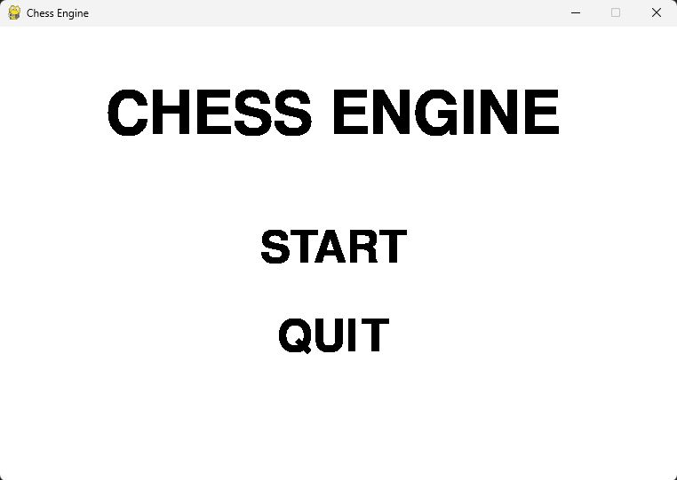

Here, our screen displays our start menu screen’s title text at the top of the screen. This title text displays the words “CHESS ENGINE” which is the name of our chess engine application. This is an effective usability feature because this eye-catching text makes it very clear what the purpose of our application is to the user from the start. Below our title text, our start menu screen’s start button is displayed. This button displays the word “START”. This is an effective usability feature because it makes it very clear that the purpose of this button is to start our chess engine application and send our user to the next screen, the login menu screen, when it is left clicked on by our user. Below our start button, our start menu screen’s quit button is displayed. This button displays the word “QUIT”. This is an effective usability feature because it makes it very clear that the purpose of this button is to close our chess engine application when it is left clicked on by our user. If the user clicks on anything that is not a button, nothing happens. If the user hovers over a button, the button changes colour to grey to show that it is being hovered over. This is an effective usability feature because it makes the start menu screen more intuitive and enjoyable for our users to interact with. The start menu screen displays until either button is left clicked on.

Stakeholder review:

“For the start menu screen, I found that it was very basic and simple. The buttons are clearly displayed on the start menu with clear, bold text which allow them to be easily seen. Whilst there isn't much graphical design, the simplicity allows people who may not understand English well to still be able to play. There could be more work done on the UI, maybe add in images and pictures of chess pieces to make it more unique.” - Dinuk M.

Next, we’ll go through our login menu screen:

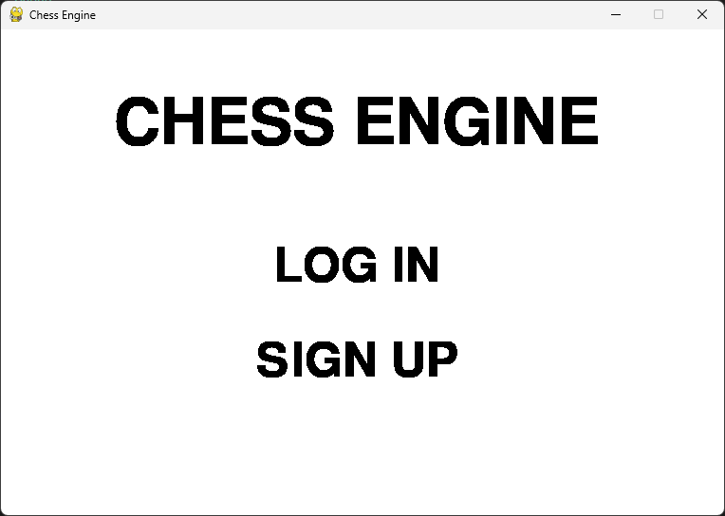

Here, our screen displays our login menu screen’s title text at the top of the screen. This title text displays the words “CHESS ENGINE” which is the name of our chess engine application. This is an effective usability feature because this eye-catching text makes it very clear what the purpose of our application is to the user from the start. Below our title text, our login menu screen’s log in button is displayed. This button displays the words “LOG IN”. This is an effective usability feature because it makes it very clear that the purpose of this button is to send our user to the log in screen when it is left clicked on by our user. Below our log in button, our login menu screen’s sign up button is displayed. This button displays the words “SIGN UP”. This is an effective usability feature because it makes it very clear that the purpose of this button is to send our user to the sign up screen when it is left clicked on by our user. If the user clicks on anything that is not a button, nothing happens. If the user hovers over a button, the button changes colour to grey to show that it is being hovered over. This is an effective usability feature because it makes the login menu screen more intuitive and enjoyable for our users to interact with. The login menu screen displays until either button is left clicked on.

Stakeholder review:

“For the login menu screen, I found that it was very basic and simple. The buttons are clearly displayed on the login menu with clear, bold text which allow them to be easily seen. Whilst there isn't much graphical design, the simplicity allows people who may not understand English well to still be able to create a new account or log in. There could be more work done on the UI to make it look more unique.” - Dinuk M.

Next, we’ll go through our sign up screen:

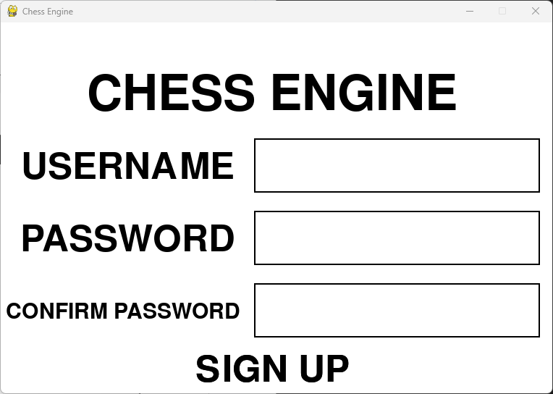

Here, our screen displays our sign up screen’s title text at the top of the screen. This title text displays the words “CHESS ENGINE” which is the name of our chess engine application. This is an effective usability feature because this eye-catching text makes it very clear what the purpose of our application is to the user from the start. Below our title text, our sign up screen’s username input is displayed. This input displays the word “USERNAME” with an input field next to it. This is an effective usability feature because it makes it very clear that the purpose of this input is to receive our user’s username that they want to use to sign up to our chess engine application. If the user clicks on the input field it will select it and allow them to be able to enter their username. Below our username input, our sign up screen’s password input is displayed. This input displays the word “PASSWORD” with an input field next to it. This is an effective usability feature because it makes it very clear that the purpose of this input is to receive our user’s password that they want to use to sign up to our chess engine application. If the user clicks on the input field it will select it and allow them to be able to enter their password. Below our password input, our sign up screen’s password confirmation input is displayed. This input displays the words “CONFIRM PASSWORD” with an input field next to it. This is an effective usability feature because it makes it very clear that the purpose of this input is to receive our user’s password confirmation that they want to use to sign up to our chess engine application. If the user clicks on the input field it will select it and allow them to be able to enter their password confirmation. Below our password confirmation input, our sign up screen’s sign up button is displayed. This button displays the words “SIGN UP”. This is an effective usability feature because it makes it very clear that the purpose of this button is to try to sign our user up to our chess engine application when it is left clicked on by our user. If this process is successful, then our user is sent to our log in screen. If the user clicks off an input field, it is deselected. If the user has selected an input field, the text next to it changes colour to grey to show that it has been selected. This is an effective usability feature because it makes the sign up screen more intuitive and enjoyable for our users to interact with. If the user hovers over a button, the button changes colour to grey to show that it is being hovered over. This is an effective usability feature because it makes the sign up screen more intuitive and enjoyable for our users to interact with. The sign up screen displays until our user has been successfully signed up.

Stakeholder review:

“On the sign up screen, the same simplistic style is used just like in the start menu, which makes navigation easier for the user. A reconfirmation of the passwords is useful to prevent accidental typos made in the password, preventing users from accidentally getting locked out of their accounts because they misspelt their passwords. However, the password is not censored when it is typed which could lead to account security issues.” - Dinuk M.

Next, we’ll go through our log in screen:

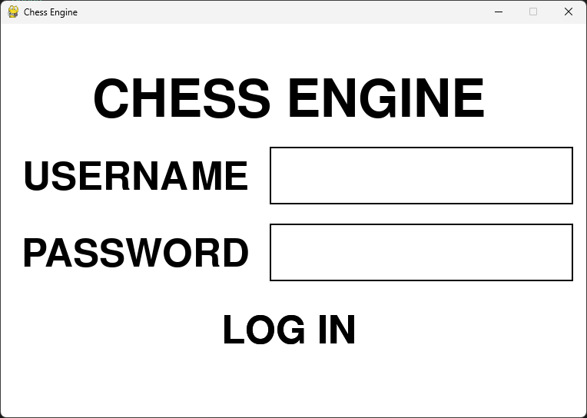

Here, our screen displays our log in screen’s title text at the top of the screen. This title text displays the words “CHESS ENGINE” which is the name of our chess engine application. This is an effective usability feature because this eye-catching text makes it very clear what the purpose of our application is to the user from the start. Below our title text, our log in screen’s username input is displayed. This input displays the word “USERNAME” with an input field next to it. This is an effective usability feature because it makes it very clear that the purpose of this input is to receive our user’s username that they want to use to log in to our chess engine application. If the user clicks on the input field it will select it and allow them to be able to enter their username. Below our username input, our log in screen’s password input is displayed. This input displays the word “PASSWORD” with an input field next to it. This is an effective usability feature because it makes it very clear that the purpose of this input is to receive our user’s password that they want to use to log in to our chess engine application. If the user clicks on the input field it will select it and allow them to be able to enter their password. Below our password input, our log in screen’s log in button is displayed. This button displays the words “LOG IN”. This is an effective usability feature because it makes it very clear that the purpose of this button is to try to log our user in to our chess engine application when it is left clicked on by our user. If this process is successful, then our user is sent to our main menu screen. If the user clicks off an input field, it is deselected. If the user has selected an input field, the text next to it changes colour to grey to show that it has been selected. This is an effective usability feature because it makes the log in screen more intuitive and enjoyable for our users to interact with. If the user hovers over a button, the button changes colour to grey to show that it is being hovered over. This is an effective usability feature because it makes the log in screen more intuitive and enjoyable for our users to interact with. The log in screen displays until our user has been successfully logged in.

Stakeholder review:

“On the log in screen, the same simplistic style is used just like in the start menu, which makes navigation easier for the user. However, just as before, the password is not censored when it is typed which could lead to account security issues.” - Dinuk M.

Next, we’ll go through our main menu screen:

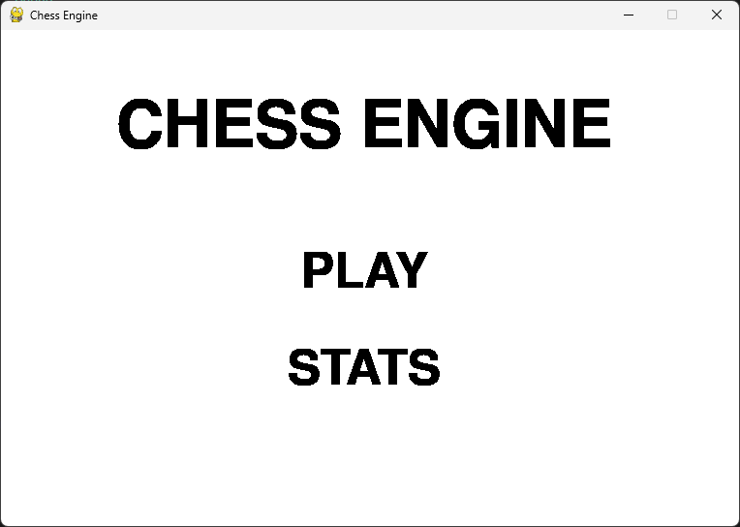

Here, our screen displays our main menu screen’s title text at the top of the screen. This title text displays the words “CHESS ENGINE” which is the name of our chess engine application. This is an effective usability feature because this eye-catching text makes it very clear what the purpose of our application is to the user from the start. Below our title text, our main menu screen’s play button is displayed. This button displays the word “PLAY”. This is an effective usability feature because it makes it very clear that the purpose of this button is to send our user to the difficulty menu screen to choose a difficulty to play a chess game when it is left clicked on by our user. Below our play button, our main menu screen’s stats button is displayed. This button displays the word “STATS”. This is an effective usability feature because it makes it very clear that the purpose of this button is to send our user to the statistics menu screen to look at their saved wins, draws and losses when it is left clicked on by our user. If the user clicks on anything that is not a button, nothing happens. If the user hovers over a button, the button changes colour to grey to show that it is being hovered over. This is an effective usability feature because it makes the main menu screen more intuitive and enjoyable for our users to interact with. The main menu screen displays until either button is left clicked on.

Stakeholder review:

“For the main menu screen, I found that it was very basic and simple. The buttons are clearly displayed on the main menu with clear, bold text which allow them to be easily seen. Whilst there isn't much graphical design, the simplicity allows people who may not understand English well to still be able to play and access their user statistics. There could be more work done on the UI to make it look more unique.” - Dinuk M.

Next, we’ll go through our statistics menu screen:

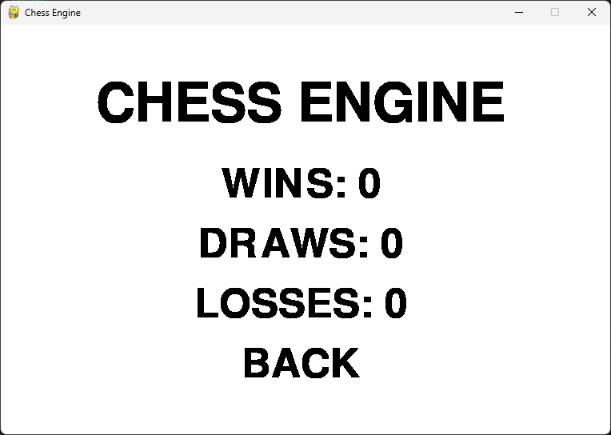

Here, our screen displays our statistics menu screen’s title text at the top of the screen. This title text displays the words “CHESS ENGINE” which is the name of our chess engine application. This is an effective usability feature because this eye-catching text makes it very clear what the purpose of our application is to the user from the start. Below our title text, our statistics menu screen’s wins text is displayed. This text displays the word “WINS” followed by our user’s number of wins. This is an effective usability feature because this text makes it very clear how many wins our user has. Below our wins text, our statistics menu screen’s draws text is displayed. This text displays the word “DRAWS” followed by our user’s number of draws. This is an effective usability feature because this text makes it very clear how many draws our user has. Below our draws text, our statistics menu screen’s losses text is displayed. This text displays the word “LOSSES” followed by our user’s number of losses. This is an effective usability feature because this text makes it very clear how many losses our user has. Below our losses text, our statistics menu screen’s back button is displayed. This button displays the word “BACK”. This is an effective usability feature because it makes it very clear that the purpose of this button is to send our user back to the main menu screen when it is left clicked on by our user. If the user clicks on anything that is not a button, nothing happens. If the user hovers over a button, the button changes colour to grey to show that it is being hovered over. This is an effective usability feature because it makes the statistics menu screen more intuitive and enjoyable for our users to interact with. The statistics menu screen displays until the back button is left clicked on.

Stakeholder review:

“For the statistics menu screen, the player is given necessary statistics about how well they've played. Additionally, it follows the application’s trademark simplistic design which makes navigation more intuitive for the user. However, it'd be nice if it displayed win rate for different difficulties and an elo ranking would also be interesting.” - Dinuk M.

Next, we’ll go through our difficulty menu screen:

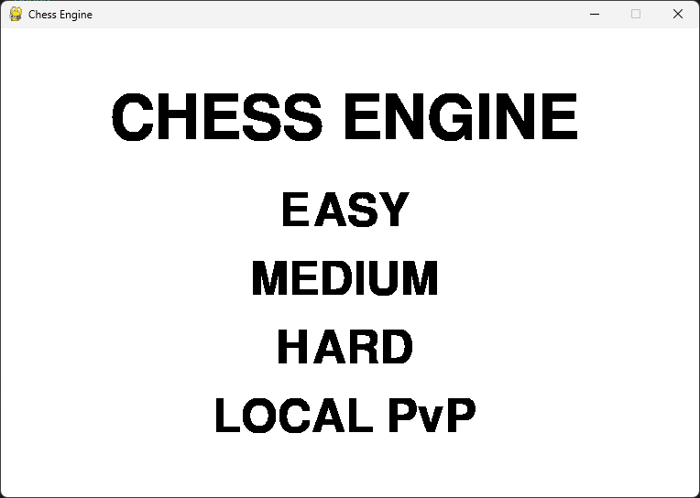

Here, our screen displays our difficulty menu screen’s title text at the top of the screen. This title text displays the words “CHESS ENGINE” which is the name of our chess engine application. This is an effective usability feature because this eye-catching text makes it very clear what the purpose of our application is to the user from the start. Below our title text, our difficulty menu’s easy button is displayed. This button displays the word “EASY”. This is an effective usability feature because it makes it very clear that the purpose of this button is to send our user to the game screen on easy settings when it is left clicked on by our user. Below our easy button, our difficulty menu’s medium button is displayed. This button displays the word “MEDIUM”. This is an effective usability feature because it makes it very clear that the purpose of this button is to send our user to the game screen on medium settings when it is left clicked on by our user. Below our medium button, our difficulty menu’s hard button is displayed. This button displays the word “HARD”. This is an effective usability feature because it makes it very clear that the purpose of this button is to send our user to the game screen on hard settings when it is left clicked on by our user. Below our hard button, our difficulty menu’s local button is displayed. This button displays the words “LOCAL PvP”. This is an effective usability feature because it makes it very clear that the purpose of this button is to send our user to the game screen on local PvP settings when it is left clicked on by our user. If the user clicks on anything that is not a button, nothing happens. If the user hovers over a button, the button changes colour to grey to show that it is being hovered over. This is an effective usability feature because it makes the difficulty menu screen more intuitive and enjoyable for our users to interact with. The difficulty menu screen displays until any of the buttons have been left clicked on.

Stakeholder review:

“For the difficulty menu screen, the player is presented with all the relevant buttons that correspond with the game difficulty and also includes a local multiplayer mode. However, a greater emphasis on differentiation between single-player modes and local multiplayer modes would be appreciated.” - Dinuk M.

Next, we’ll go through our game screen:

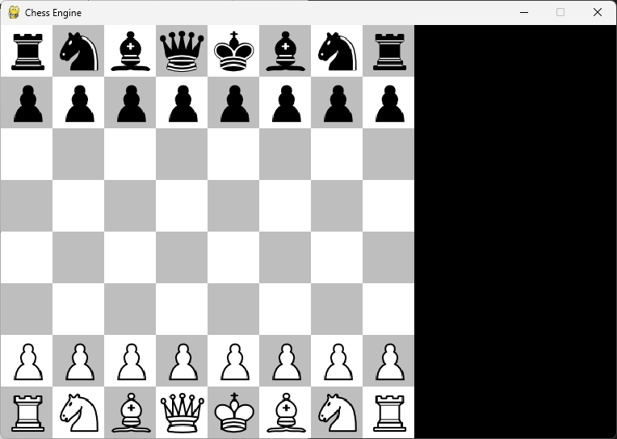

Here, our screen displays our chessboard on the screen. It displays as a chequered pattern of black and white squares with our chess pieces on top of them. This is an effective usability feature because a black and white colour scheme is reminiscent of a traditional chessboard’s colour scheme, allowing our chess engine application to be more intuitive and enjoyable for our user to interact with. At the start of the game, the chessboard is set up with our white pieces at the bottom of the screen and our black pieces at the top of the screen. This is an effective usability feature because this makes it very clear to the user that they are playing white and are meant to make the first move. The pieces are set up just as the pieces on a traditional chessboard would be with rook pieces on either end of the board, after that our knight pieces on either end, after that our bishop pieces on either end, after that our queen piece on the left hand side, after that our king piece on the right hand side and, finally, after that a row of pawns in front. This is an effective usability feature because it allows our chess engine application to be able to mimic real life games of chess in order to make it as intuitive and enjoyable to use as possible for our user. On the right hand side of our screen, our move log is displayed. This shows all the moves that have been made on the chessboard in chess notation format. This is an effective usability feature because it makes our chess engine application more intuitive and enjoyable for our users to interact with.

A pawn piece is able to move forward one square but is able to optionally move two squares forward on its first move. It is also only able to capture pieces diagonally. A rook piece is able to move horizontally or vertically any number of squares. A knight piece is able to move in an L shape, two squares in one direction followed by one square perpendicular to that direction. It is also able to jump over other pieces. A bishop piece is able to move diagonally any number of squares. A queen piece is able to move horizontally, vertically or diagonally any number of squares. A king piece is able to move one square in any direction as long as it will not move into check (a check is when the king is under immediate threat of capture by an opponent’s piece). This is an effective usability feature because this is just as a traditional game of chess is played, allowing our chess engine application to be as intuitive and easy to use as possible for our user.

To make the first move, our user is able to left click on one of their white pieces to select them. They are then allowed to make a second click which will either make the move if it is a valid move or it will deselect the piece if it is not a valid move. If our user wants to select a different piece to move, they can click on the new piece that they want to move. This is an effective usability feature because this system of handling how our moves are made by our user is the most intuitive and easy to use approach for our user. After white has played the first move, black is allowed to make a move. If the user has chosen to play on easy settings in the difficulty menu screen then a random move will be made by our chess engine. If the user has chosen to play on medium settings in the difficulty menu screen then the greediest move possible will be made by our chess engine. If the user has chosen to play on hard settings in the difficulty menu screen then the best move possible will be made by our chess engine. If the user has chosen to play on local PvP settings in the difficulty menu screen then black will be able to make clicks on the screen, in the same way white was able to, in order to make a move. This is an effective usability feature because this system of handling how our moves are made by our user’s opponent is the most intuitive and easy to use approach for our user. Our chess engine application has also implemented threading which allows our user to be able to interact with our chess engine application even whilst our AI algorithm is thinking of the next move to play. This is an effective usability feature because it makes our chess engine application more intuitive and enjoyable for our user to interact with.

Additionally, either player is able to press the z key on their keyboard to undo the last move that was made on the chessboard. This is an effective usability feature because this makes our chess engine application as intuitive and easy to use as possible for our user. Furthermore, either player is able to press the r key on their keyboard to reset the chessboard back to the beginning of the game. This is an effective usability feature because this makes our chess engine application as intuitive and easy to use as possible for our user.

This process of turn taking continues until our chess engine has calculated that either a checkmate or a stalemate has occurred. If a stalemate has occurred, then our user has drawn the game and our draw text will appear on the screen as well as our end game button:

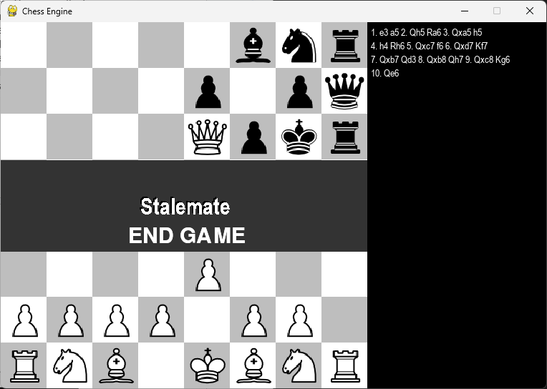

Here, our screen displays our draw text displays the word “Stalemate”. This is an effective usability feature because this text makes it very clear that our user has drawn the game. Below our draw text, our screen displays our end game button. This button displays the words “END GAME”. This is an effective usability feature because it makes it very clear that the purpose of this button is to update our user’s statistics according to the outcome of the chess game and send our user to the main menu screen when it is left clicked on by our user. If the user clicks on anything that is not a button, nothing happens. If the user hovers over the end game button, the button changes colour to red to show that it is being hovered over. This is an effective usability feature because it makes our chess engine application more intuitive and enjoyable for our users to interact with. The screen displays until the end game button is left clicked on, our user undoes the last move that was made on the chessboard by pressing the z key on their keyboard or our user resets the chessboard back to the beginning of the game by pressing the r key on their keyboard.

If a checkmate has occurred and it is currently white’s turn to move, then our user has lost the game and our loss text will appear on the screen as well as our end game button:

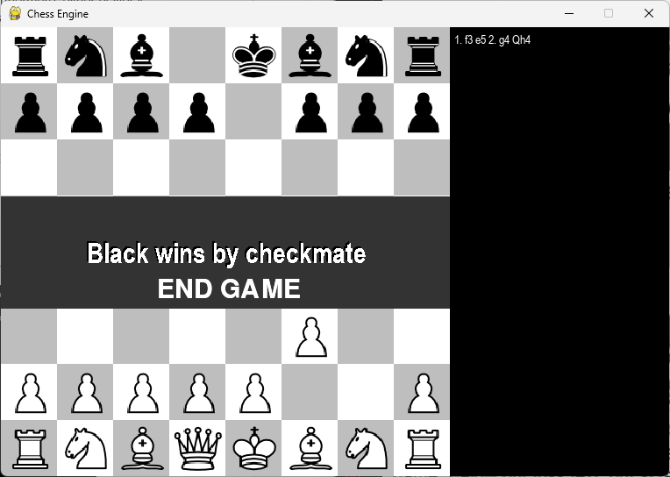

Here, our screen displays our loss text which displays the words “Black wins by checkmate”. This is an effective usability feature because this text makes it very clear that our user has lost the game. Below our loss text, our screen displays our end game button. This button displays the words “END GAME”. This is an effective usability feature because it makes it very clear that the purpose of this button is to update our user’s statistics according to the outcome of the chess game and send our user to the main menu screen when it is left clicked on by our user. If the user clicks on anything that is not a button, nothing happens. If the user hovers over the end game button, the button changes colour to red to show that it is being hovered over. This is an effective usability feature because it makes our chess engine application more intuitive and enjoyable for our users to interact with. The screen displays until the end game button is left clicked on, our user undoes the last move that was made on the chessboard by pressing the z key on their keyboard or our user resets the chessboard back to the beginning of the game by pressing the r key on their keyboard.

If a checkmate has occurred and it is currently black’s turn to move, then our user has won the game and our win text will appear on the screen as well as our end game button:

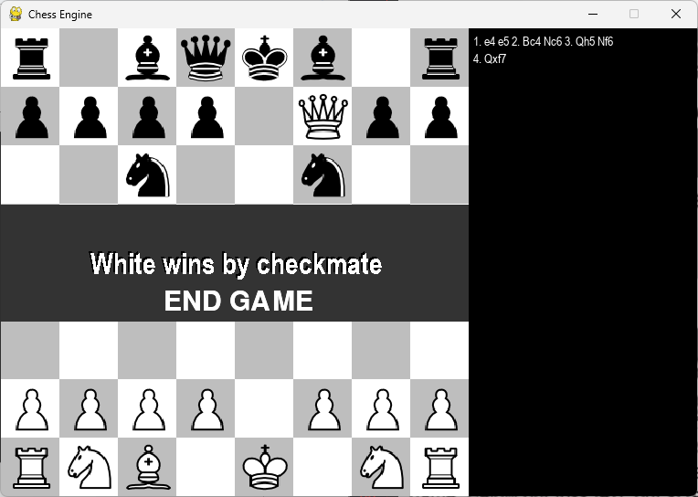

Here, our screen displays our win text which displays the words “White wins by checkmate”. This is an effective usability feature because this text makes it very clear that our user has won the game. Below our win text, our screen displays our end game button. This button displays the words “END GAME”. This is an effective usability feature because it makes it very clear that the purpose of this button is to update our user’s statistics according to the outcome of the chess game and send our user to the main menu screen when it is left clicked on by our user. If the user clicks on anything that is not a button, nothing happens. If the user hovers over the end game button, the button changes colour to red to show that it is being hovered over. This is an effective usability feature because it makes our chess engine application more intuitive and enjoyable for our users to interact with. The screen displays until the end game button is left clicked on, our user undoes the last move that was made on the chessboard by pressing the z key on their keyboard or our user resets the chessboard back to the beginning of the game by pressing the r key on their keyboard.

When a user left clicks on a piece, the piece they have left clicked on is highlighted in yellow and any valid moves that piece can make are highlighted in green:

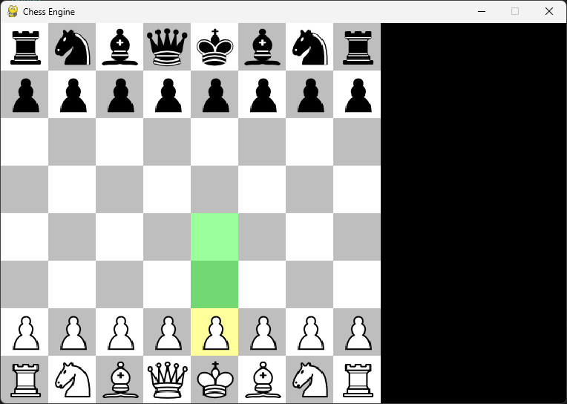

This is an effective usability feature because it makes our chess engine application more intuitive and enjoyable for our users to interact with. Additionally, when a player has made a move, their move is animated on the board. This is an effective usability feature because it makes our chess engine application more exciting and engaging for our users to interact with.

Stakeholder review:

“For the game screen, the most useful tool in the game is the move highlighting, where all legal moves are highlighted to show the player where they can move. The key shortcuts are also very useful for quickly restarting the game or reverting a move. However, these key shortcuts aren't explained before within the game, so a tutorial or a helpful tooltip may be needed for players to understand how to use them.” - Dinuk M.

## Limitations and maintenance

In the following section, I am going to be talking about the limitations and the maintenance issues of my chess engine software. Additionally, I will describe how the program could be further developed to deal with limitations of potential improvements.

Limitations:

* Online Functionality:
  + Online functionality would provide our user with the ability to engage in online multiplayer matches with anyone, anywhere, at any time using our chess engine application.
  + To implement online functionality, I would implement networking communication protocols, server infrastructure for matchmaking and game hosting as well as anti-cheating measures. The user would be able to queue for an online match by navigating to the difficulty menu screen and left clicking on a button that displays the words “Online PvP”. After this, a matchmaking process would occur involving our server infrastructure. Once a match has been found, our user would be taken to the game screen where they would be able to play an online chess game with a human opponent. Once the game has reached a conclusion, user statistics would be updated accordingly and users will be taken back to the main menu.
* Computer Analysis:
  + Computer analysis would provide our user with valuable insight and feedback on their gameplay. This would allow users to delve deeper into the strategic nuances of their moves or understand where they went wrong in their games.
  + To implement computer analysis, I would implement algorithms for post-game analysis and visualisation tools for displaying analysis results. The user would be able to access their post-game analysis results by left clicking on a button that displays the words “Post-Game Analysis” on the game screen after a game has ended. After this, they would be taken to a new screen where they can see every move that was played in this game and an in-depth analysis of how good the moves were and any possible alternative move that could have been played. Additionally, statistics such as overall move accuracy for each player could also be displayed here. The user would then be able to click on a back button to go back to the game screen when they are done looking at their post-game analysis.
* Chess Puzzles:
  + Chess puzzles would provide our user with the ability to engage in focused and interactive learning experiences using our chess engine application.
  + To implement chess puzzles, I would generate a diverse set of puzzle positions and implement a solution verification system. The user would be able to use this feature by navigating to the difficulty menu screen and left clicking on a button that displays the word “Puzzle”. After this, the user would be taken to the game screen with the puzzle loaded up. The user would then be able to attempt to solve the puzzle with their solution being checked by our solution verification system. If the user gets it right then the screen would display a message that says “Correct Solution”. If the user gets it wrong then the screen would display a message that says “Wrong Solution”. In either case, the user would then be able to press the end game button to go back to the main menu screen.
* Daily Challenges:
  + Daily challenges would provide our user with the ability to engage with fresh and varied puzzle scenarios on a regular basis which encourage consistent practice and skill development.
  + To implement daily challenges, I would design a system for generating unique daily puzzles or scenarios and implement a scheduling mechanism to deliver new challenges to users each day. The user would be able to use this feature by navigating to the difficulty menu screen and left clicking on a button that displays the words “Daily Challenge”. After this, the user would be taken to the game screen with the daily puzzle loaded up. The user would then be able to attempt to solve the daily puzzle with their solution being checked by a solution verification system. If the user gets it right then the screen would display a message that says “Correct Solution”. If the user gets it wrong then the screen would display a message that says “Wrong Solution”. In either case, the user would then be able to press the end game button to go back to the main menu screen. Each day our scheduling mechanism would deliver a new challenge for our users to solve.
* Chess Learning:
  + Chess learning would provide our user with opportunities for structured skill improvement and strategic understanding of the game. This allows them to receive tailored guidance on their strengths and weaknesses and access instructional content to deepen their understanding of chess strategies.
  + To implement chess learning, I would implement a sophisticated algorithm for analysing user games and providing personalised feedback, integrate a user-friendly interface for presenting learning materials such as tutorials and annotated games and incorporate machine learning techniques for adaptive learning. The user would be able to use this feature by navigating to the main menu screen and left clicking on a button that displays the word “Learn”. This would take them to a screen where they can choose a tutorial to watch and follow by clicking on it. The tutorials would have a title and be organised by beginner, intermediate and advanced categories. The user would then be able to click on a back button to go back to the main menu screen when they are done with their tutorial. Additionally, at the end of every game that has been played, our user would have access to a post-game analysis of the game as described in the computer analysis limitation.
* Customisation:
  + Customisation would provide our user with the ability to personalise their gaming experience to suit their preferences instead of being limited to a standard interface and aesthetic.
  + To implement customisation, I would implement features such as customisable piece sets, board themes and user preferences, as well as develop a flexible user interface for configuring these options. The user would be able to access this interface from the main menu screen by left clicking on a button that displays the word “Settings”. This would take them to a screen where they can see all the possible piece sets, board themes and other user preferences that they have access to and be able to select their preferences. The user would then be able to click on a back button to save these settings and go back to the main menu screen when they are done selecting their preferences.
* Self-Learning AI:
  + Self-learning AI would provide our software with the ability to adapt and improve over time based on gameplay experiences. This means that the software would no longer struggle to keep pace with evolving gameplay trends and user strategies, leading to more challenging and interesting gameplay experiences.
  + To implement self-learning AI, I would implement advanced machine learning algorithms such as reinforcement learning or deep learning and use an extensive training data collection to train and fine-tune the model. Additionally, it would involve developing mechanisms for the AI to learn from its own gameplay experiences and improve its decision making over time. This AI would be used as our AI for generating the moves for our user’s computer opponent in the hard difficulty setting. The NegaMax AI algorithm would then be used for generating the moves for our user’s computer opponent in the medium difficulty setting. The greedy move algorithm would then be used for generating the moves for our user’s computer opponent in the easy difficulty setting. The random move algorithm would no longer be used for generating moves.
* Mobile Application:
  + A mobile application would provide our user with accessibility and convenience for those who prefer to play chess on mobile devices.
  + To develop a mobile application, I would have to update our chess engine software’s event handlers to listen for touchscreen events on the screen. I would then have to test this by using a mobile device emulator to run our software.

Maintenance issues:

I have currently found no ongoing issues or bugs with my chess engine software.

However, my solution is probably not perfect and requires regular testing and debugging procedures in order to identify and address any issues or bugs in the codebase promptly. Additionally, constant efforts should be made to optimise the performance of the chess engine, such as implementing move ordering, transposition tables and more efficient data structures to store our chessboard.

Furthermore, in order to address the stakeholder feedback I received from the evaluation of the usability features, I would like to update the menu screens so that they are more engaging for the user to interact with by incorporating a more colourful colour scheme as well as adding images of chess pieces in the background. I would also like to update the sign up screen and log in screen so that any passwords are censored by asterisks when typed into their respective inputs on the screen in order to prevent any potential account security issues. Additionally, I would like to integrate more user statistics for our chess engine to keep track of such as a win rate statistic (total number of wins divided by total number of chess matches played) and an elo ranking statistic in order to give the user a better sense of progression and achievement. Moreover, I would like to update the game screen to provide helpful tooltips for the user that explain any important shortcuts such as pressing “z” on the keyboard to undo a move and pressing “r” on the keyboard to restart the game.

Community feedback from users of my chess engine software regarding suggestions and bugs from other developers or chess enthusiasts can lead to huge improvements of the software. If I had more time, I would have liked to create a discord server, twitter page or professional email for the software to allow users to contact me regarding these matters.

# Code Listings

chessMain.py file:

|  |
| --- |
| """  This is our main driver file.  It is responsible for handling user input and displaying the current gameState object.  """  import pygame as p  import chessEngine  import chessAI  from multiprocessing import Process, Queue  import sys  import asyncio  import sqlite3  import hashlib  p.init()  p.display.set_caption("Chess Engine") #how to change title  BASE_COLOUR = "Black"  HOVERING_COLOUR = "#2F2F2F"  SYSTEM_FONT = "montserrat"  WIDTH = HEIGHT = 512 #pixels  MOVE_LOG_PANEL_WIDTH = 250 #pixels  MOVE_LOG_PANEL_HEIGHT = HEIGHT  DIMENSION = 8 #dimensions of a chessboard are 8x8  SQ_SIZE = HEIGHT // DIMENSION #size of a square  MAX_FPS = 15 #for animations later on  IMAGES = {}  """  Initialise a global dictionary of images. This will be called exactly once in the main.  """  def loadImages():  pieces = ["wP", "wR", "wN", "wB", "wK", "wQ", "bP", "bR", "bN", "bB", "bK", "bQ"]  for piece in pieces:  IMAGES[piece] = p.transform.scale(p.image.load("pieces/" + piece + ".png"), (SQ_SIZE, SQ_SIZE))  #Note: we can access an image by saying 'IMAGES["wP"]'  """  The main function for our code, this will handle user input and updating the graphics.  """  def main(settings):  clock = p.time.Clock()  screen.fill(p.Color("white"))  moveLogFont = p.font.SysFont("Arial", 14, False, False) #font for move log  gs = chessEngine.gameState() #creates a gameState object  validMoves = gs.getValidMoves() #returns all the valid moves on the board  moveMade = False #flag variable for when a move has been made  animate = False #flag variable for when we should animate a move  loadImages() #only do this once, before the while loop  running = True  sqSelected = () #no square is selected initially, keeps track of the last click of a user, tuple: (row, col)  playerClicks = [] #keeps track of player clicks, two tuples: [(6, 4), (4, 4)]  gameOver = False  playerOne = True #true if human is playing white, false if AI is playing white  playerTwo = settings[2] #same as above but for black  AIThinking = False #returns if the AI is thinking of a move or not  moveUndone = False #returns if a move has been undone or not  moveFinderProcess = None  while running:  humanTurn = (gs.whiteToMove and playerOne) or (not gs.whiteToMove and playerTwo) #returns if a human is playing this turn or not  for e in p.event.get():  if e.type == p.QUIT:  running = False  p.quit()  sys.exit()  #mouse handler  elif e.type == p.MOUSEBUTTONDOWN:  if gameOver:  if END_BUTTON.checkForInput(MENU_MOUSE_POS): #if left click on end button  endGame(settings, gs.whiteToMove, gs.stalemate) #call endGame function  if not gameOver:  location = p.mouse.get_pos() #returns (x, y) location of mouse  col = location[0] // SQ_SIZE #returns the corresponding column the mouse is on  row = location[1] // SQ_SIZE #returns the corresponding row the mouse is on  if sqSelected == (row, col) or col >= 8: #the user clicked the same square twice or user clicked move log  sqSelected = () #deselect  playerClicks = [] #clear playerClicks  else:  sqSelected = (row, col)  playerClicks.append(sqSelected) #append for both first and second clicks  if len(playerClicks) == 2 and humanTurn: #after second click  move = chessEngine.Move(playerClicks[0], playerClicks[1], gs.board) #creates a move object using the Move class  print(move.getChessNotation()) #returns the move in chess notation format in the console  for i in range(len(validMoves)): #loop through validMoves  if move == validMoves[i]: #is the move valid?  gs.makeMove(validMoves[i]) #makes the move  moveMade = True #flags the moveMade as true  animate = True #flags the animate as true  sqSelected = () #reset  playerClicks = [] #reset  if not moveMade: #if a move has not been made yet  playerClicks = [sqSelected] #select a different piece  #key handler  elif e.type == p.KEYDOWN:  if e.key == p.K_z: #undo when "z" is pressed  gs.undoMove()  moveMade = True #flags the moveMade as true  animate = False #flags the animate as false  gameOver = False #flags the gameOver as false  if AIThinking:  moveFinderProcess.terminate() #stop thinking  AIThinking = False  moveUndone = True #move has been undone  if e.key == p.K_r: #reset board when "r" is pressed  gs = chessEngine.gameState() #create a new gameState  validMoves = gs.getValidMoves() #get new valid moves  sqSelected = () #reset  playerClicks = [] #reset  moveMade = False #reset  animate = False #reset  gameOver = False #reset  if AIThinking:  moveFinderProcess.terminate() #stop thinking  AIThinking = False  moveUndone = False #reset  #AI move finder logic  if not gameOver and not humanTurn and not moveUndone: #if game isnt over and a human isnt playing this turn and a move has not been undone  if not AIThinking:  #set AI difficulty  if settings[3] == "easy":  gs.makeMove(chessAI.findRandomMove(validMoves))  moveMade = True #flags the moveMade as true  animate = True #flags the animate as true  elif settings[3] == "medium":  gs.makeMove(chessAI.findGreedyMove(gs, validMoves))  moveMade = True #flags the moveMade as true  animate = True #flags the animate as true  elif settings[3] == "hard":  AIThinking = True #start thinking  returnQueue = Queue() #create a queue  moveFinderProcess = Process(target=chessAI.findBestMoveNegaMaxAlphaBeta, args=(gs, validMoves, returnQueue)) #create a process  moveFinderProcess.start() #call process    if settings[3] == "hard":  if not moveFinderProcess.is_alive(): #if done thinking  AIMove = returnQueue.get() #get the move  if AIMove is None: #if AIMove is equal to None  AIMove = chessAI.findRandomMove(validMoves) #get a random move  gs.makeMove(AIMove) #make the suggested move  moveMade = True #flags the moveMade as true  animate = True #flags the animate as true  AIThinking = False #done thinking  if moveMade:  if animate:  animateMove(gs.moveLog[-1], screen, gs.board, clock) #animate the last move in our move log  validMoves = gs.getValidMoves() #generates a new list of valid moves whenever a move has been made  moveMade = False #flags the moveMade back to false  animate = False #flags the animate back to false  moveUndone = False #flags the moveUndone back to false  drawGameState(screen, gs, validMoves, sqSelected, moveLogFont)  if gs.checkmate or gs.stalemate:  gameOver = True #flags the gameOver as true  drawEndGameText(screen, "Stalemate" if gs.stalemate else "Black wins by checkmate" if gs.whiteToMove else "White wins by checkmate") #draw end game text  MENU_MOUSE_POS = p.mouse.get_pos() #grab mouse position  END_BUTTON = Button(None, pos=(260, 300), text_input="END GAME", font=p.font.SysFont(SYSTEM_FONT, 45), base_colour="white", hovering_colour="red") #end button  END_BUTTON.changeColour(MENU_MOUSE_POS) #change colour if mouse is hovering  END_BUTTON.update(screen) #draw button to screen  clock.tick(MAX_FPS)  p.display.flip()  """  End game function  """  def endGame(settings, whiteToMove, stalemate):  #update stats accordingly  if stalemate:  #stalemate is true  conn = sqlite3.connect("userdata.db")  cur = conn.cursor()  cur.execute("SELECT * FROM userdata WHERE username = ? AND password = ?", (settings[0], hashlib.sha256(settings[1].encode()).hexdigest()))  userData = cur.fetchall() #grab user's data from database  conn.close()  userDraws = userData[0][4] + 1 #increment user's draws  conn = sqlite3.connect("userdata.db")  cur = conn.cursor()  cur.execute("UPDATE userdata SET draws = ? WHERE username = ? AND password = ?", (userDraws, settings[0], hashlib.sha256(settings[1].encode()).hexdigest()))  conn.commit() #save new statistics  conn.close()  else:  if whiteToMove:  #enemy wins  conn = sqlite3.connect("userdata.db")  cur = conn.cursor()  cur.execute("SELECT * FROM userdata WHERE username = ? AND password = ?", (settings[0], hashlib.sha256(settings[1].encode()).hexdigest()))  userData = cur.fetchall() #grab user's data from database  conn.close()  userLosses = userData[0][5] + 1 #increment user's losses  conn = sqlite3.connect("userdata.db")  cur = conn.cursor()  cur.execute("UPDATE userdata SET losses = ? WHERE username = ? AND password = ?", (userLosses, settings[0], hashlib.sha256(settings[1].encode()).hexdigest()))  conn.commit() #save new statistics  conn.close()  else:  #player wins  conn = sqlite3.connect("userdata.db")  cur = conn.cursor()  cur.execute("SELECT * FROM userdata WHERE username = ? AND password = ?", (settings[0], hashlib.sha256(settings[1].encode()).hexdigest()))  userData = cur.fetchall() #grab user's data from database  conn.close()  userWins = userData[0][3] + 1 #increment user's wins  conn = sqlite3.connect("userdata.db")  cur = conn.cursor()  cur.execute("UPDATE userdata SET wins = ? WHERE username = ? AND password = ?", (userWins, settings[0], hashlib.sha256(settings[1].encode()).hexdigest()))  conn.commit() #save new statistics  conn.close()  #send player to mainMenu()  mainMenu(settings[0], settings[1])  """  Highlight square selected and moves for piece selected  """  def highlightSquares(screen, gs, validMoves, sqSelected):  if sqSelected != (): #if sqSelected is not empty  r, c = sqSelected #copies what is inside of sqSelected  if gs.board[r][c][0] == ("w" if gs.whiteToMove else "b"): #check that sqSelected is a piece that can be moved  #highlight selected square  s = p.Surface((SQ_SIZE, SQ_SIZE)) #create a pygame surface object  s.set_alpha(100) #transparency value: 0 transparent -> 255 opaque  s.fill(p.Color("yellow")) #colour value  screen.blit(s, (c*SQ_SIZE, r*SQ_SIZE)) #places the surface object onto the screen on top of the sqSelected  #highlight moves from that square  s.fill(p.Color("green")) #colour value  for move in validMoves: #for every valid move  if move.startRow == r and move.startCol == c: #if the move starts from the same position as our sqSelected  screen.blit(s, (move.endCol*SQ_SIZE, move.endRow*SQ_SIZE)) #highlight it  """  Responsible for all the graphics within a current game state.  """  def drawGameState(screen, gs, validMoves, sqSelected, moveLogFont):  drawBoard(screen) #draw squares on the board  highlightSquares(screen, gs, validMoves,sqSelected) #highlights squares  drawPieces(screen, gs.board) #draw pieces on top of those squares  drawMoveLog(screen, gs, moveLogFont) #draw the move log  """  Draw the squares on the board. The top left square is always light.  """  def drawBoard(screen):  global colours  colours = [p.Color("white"), p.Color("gray")]  for r in range(DIMENSION):  for c in range(DIMENSION):  colour = colours[((r+c)%2)]  p.draw.rect(screen, colour, p.Rect(c*SQ_SIZE, r*SQ_SIZE, SQ_SIZE, SQ_SIZE))  """  Draw the pieces on the board using the current gameState.board  """  def drawPieces(screen, board):  for r in range(DIMENSION):  for c in range(DIMENSION):  piece = board[r][c]  if piece != "--": #not an empty square  screen.blit(IMAGES[piece], p.Rect(c*SQ_SIZE, r*SQ_SIZE, SQ_SIZE, SQ_SIZE))  """  Draws the move log  """  def drawMoveLog(screen, gs, font):  moveLogRect = p.Rect(WIDTH, 0, MOVE_LOG_PANEL_WIDTH, MOVE_LOG_PANEL_HEIGHT) #create rectangle object  p.draw.rect(screen, p.Color("Black"), moveLogRect) #draw rectangle on screen  moveLog = gs.moveLog #get move log  moveTexts = [] #empty array  for i in range(0, len(moveLog), 2): #loop through moveLog  moveString = str(i//2 + 1) + ". " + str(moveLog[i]) + " " #add white move  if i + 1 < len(moveLog): #if black made a move  moveString += str(moveLog[i + 1]) + " " #add black move to text  moveTexts.append(moveString) #add text to array  movesPerRow = 3  padding = 5 #set padding between text  lineSpacing = 2 #set line spacing  textY = padding #set height of text location  for i in range(0, len(moveTexts), movesPerRow): #loop through move texts  text = "" #empty string  for j in range(movesPerRow):  if i + j < len(moveTexts): #if in bounds  text += moveTexts[i+j] #add text  textObject = font.render(text, True, p.Color("White")) #create text object  textLocation = moveLogRect.move(padding, textY) #set text location  screen.blit(textObject, textLocation) #render move text  textY += textObject.get_height() + lineSpacing #bring text lower next iteration  """  Animate a move  """  def animateMove(move, screen, board, clock):  global colours  dR = move.endRow - move.startRow #delta (change in) row  dC = move.endCol - move.startCol #delta (change in) col  framesPerSquare = 3 #frames to move one square  frameCount = (abs(dR) + abs(dC)) * framesPerSquare #how many frames a move will take to animate  for frame in range(frameCount + 1):  r, c = (move.startRow + dR * frame/frameCount, move.startCol + dC * frame/frameCount) #coordinates of piece moved during animation  drawBoard(screen) #draw board for every frame  drawPieces(screen, board) #draw pieces for every frame  #erase the piece moved from it's end square  colour = colours[(move.endRow + move.endCol) % 2] #returns the colour of the end square  endSquare = p.Rect(move.endCol*SQ_SIZE, move.endRow*SQ_SIZE, SQ_SIZE, SQ_SIZE) #rectangle object  p.draw.rect(screen, colour, endSquare) #draw end square  #draw captured piece back  if move.pieceCaptured != "--": #if there is a piece to draw  if move.isEnPassantMove: #if it is an en passant move  enPassantRow = move.endRow + 1 if move.pieceCaptured[0] == "b" else move.endRow - 1  endSquare = p.Rect(move.endCol*SQ_SIZE, enPassantRow*SQ_SIZE, SQ_SIZE, SQ_SIZE) #recalculate endSquare  screen.blit(IMAGES[move.pieceCaptured], endSquare) #draw it on the endSquare  #draw moving piece  screen.blit(IMAGES[move.pieceMoved], p.Rect(c*SQ_SIZE, r*SQ_SIZE, SQ_SIZE, SQ_SIZE))  p.display.flip()  clock.tick(60)  """  Draw given text on screen  """  def drawEndGameText(screen, text):  #background  background = p.Rect(0, HEIGHT/2.65, WIDTH, HEIGHT/4) #rectangle object  p.draw.rect(screen, p.Color("#333333"), background) #draw it on screen  #text  font = p.font.SysFont("Helvetica", 32, True, False) #create font object  textObject = font.render(text, 0, p.Color("Black")) #render text shadow  textLocation = p.Rect(0, 0, WIDTH, HEIGHT).move(WIDTH/2 - textObject.get_width()/2, HEIGHT/2 - textObject.get_height()/2) #center text  screen.blit(textObject, textLocation) #draw the text shadow on screen  textObject = font.render(text, 0, p.Color("White")) #render text  screen.blit(textObject, textLocation.move(2, 2)) #draw the text on screen  """  MENU FUNCTIONS  """  #button class  class Button():  def __init__(self, image, pos, text_input, font, base_colour, hovering_colour):  self.image = image #sets image  self.x_pos = pos[0] #sets x-position  self.y_pos = pos[1] #sets y-position  self.font = font #sets font  self.base_colour, self.hovering_colour = base_colour, hovering_colour #sets base colour and hovering colour  self.text_input = text_input #sets text input  self.text = self.font.render(self.text_input, True, self.base_colour) #renders text  if self.image is None: #no image  self.image = self.text #sets image to text  self.rect = self.image.get_rect(center=(self.x_pos, self.y_pos)) #rect object for image  self.text_rect = self.text.get_rect(center=(self.x_pos, self.y_pos)) #rect object for text  #updates button  def update(self, screen):  if self.image is not None: #image  screen.blit(self.image, self.rect) #place image on screen  screen.blit(self.text, self.text_rect) #place text on screen    #checks if mouse is hovering over button  def checkForInput(self, position):  if position[0] in range(self.rect.left, self.rect.right) and position[1] in range(self.rect.top, self.rect.bottom): #is mouse hovering over button?  return True  return False    #changes the colour of the button if the mouse is hovering over it  def changeColour(self, position):  if position[0] in range(self.rect.left, self.rect.right) and position[1] in range(self.rect.top, self.rect.bottom): #is mouse hovering over button?  self.text = self.font.render(self.text_input, True, self.hovering_colour) #change colour to hovering colour  else:  self.text = self.font.render(self.text_input, True, self.base_colour) #change colour to base colour  #start menu function  def startMenu():  startMenu = True #while loop flag variable  screen.fill("White") #turn screen white  while startMenu:  MENU_MOUSE_POS = p.mouse.get_pos() #grab mouse position  MENU_TEXT = p.font.SysFont(SYSTEM_FONT, 100).render("CHESS ENGINE", True, BASE_COLOUR) #title text  MENU_RECT = MENU_TEXT.get_rect(center=(375, 100)) #title rect  START_BUTTON = Button(None, pos=(375, 250), text_input="START", font=p.font.SysFont(SYSTEM_FONT, 75), base_colour=BASE_COLOUR, hovering_colour=HOVERING_COLOUR) #start button  QUIT_BUTTON = Button(None, pos=(375, 350), text_input="QUIT", font=p.font.SysFont(SYSTEM_FONT, 75), base_colour=BASE_COLOUR, hovering_colour=HOVERING_COLOUR) #quit button  screen.blit(MENU_TEXT, MENU_RECT) #draw text to screen  for button in [START_BUTTON, QUIT_BUTTON]:  button.changeColour(MENU_MOUSE_POS) #change colour if mouse is hovering  button.update(screen) #draw button to screen    for event in p.event.get():  if event.type == p.QUIT:  p.quit()  sys.exit()  if event.type == p.MOUSEBUTTONDOWN: #if left click  if START_BUTTON.checkForInput(MENU_MOUSE_POS): #on start button  loginMenu() #send to login menu  if QUIT_BUTTON.checkForInput(MENU_MOUSE_POS): #on quit button  p.quit()  sys.exit()    p.display.update()  #login menu function  def loginMenu():  loginMenu = True #while loop flag variable  screen.fill("White") #turn screen white  while loginMenu:  MENU_MOUSE_POS = p.mouse.get_pos() #grab mouse position  MENU_TEXT = p.font.SysFont(SYSTEM_FONT, 100).render("CHESS ENGINE", True, BASE_COLOUR) #title text  MENU_RECT = MENU_TEXT.get_rect(center=(375, 100)) #title rect  LOGIN_BUTTON = Button(None, pos=(375, 250), text_input="LOG IN", font=p.font.SysFont(SYSTEM_FONT, 75), base_colour=BASE_COLOUR, hovering_colour=HOVERING_COLOUR) #log in button  SIGNUP_BUTTON = Button(None, pos=(375, 350), text_input="SIGN UP", font=p.font.SysFont(SYSTEM_FONT, 75), base_colour=BASE_COLOUR, hovering_colour=HOVERING_COLOUR) #sign up button    screen.blit(MENU_TEXT, MENU_RECT) #draw text to screen  for button in [LOGIN_BUTTON, SIGNUP_BUTTON]:  button.changeColour(MENU_MOUSE_POS) #change colour if mouse is hovering  button.update(screen) #draw button to screen    for event in p.event.get():  if event.type == p.QUIT:  p.quit()  sys.exit()  if event.type == p.MOUSEBUTTONDOWN: #if left click  if LOGIN_BUTTON.checkForInput(MENU_MOUSE_POS): #on log in button  logIn() #send to log in  if SIGNUP_BUTTON.checkForInput(MENU_MOUSE_POS): #on sign up button  signUp() #send to sign up    p.display.update()  #log in function  def logIn():  login = True #while loop flag variable  response = False #response flag variable  screen.fill("White") #turn screen white  #initialise username input  USERNAME_INPUT = ""  USERNAME_INPUT_RECT = p.Rect(350, 160, 395, 75)  USERNAME_COLOUR = BASE_COLOUR  USERNAME_ACTIVE = False  #initialise password input  PASSWORD_INPUT = ""  PASSWORD_INPUT_RECT = p.Rect(350, 260, 395, 75)  PASSWORD_COLOUR = BASE_COLOUR  PASSWORD_ACTIVE = False  while login:  screen.fill("White") #turn screen white  MENU_MOUSE_POS = p.mouse.get_pos() #grab mouse position  MENU_TEXT = p.font.SysFont(SYSTEM_FONT, 100).render("CHESS ENGINE", True, BASE_COLOUR) #title text  MENU_RECT = MENU_TEXT.get_rect(center=(375, 100)) #title rect    USERNAME_TEXT = p.font.SysFont(SYSTEM_FONT, 75).render("USERNAME", True, USERNAME_COLOUR) #username text  USERNAME_RECT = USERNAME_TEXT.get_rect(center=(175, 200)) #username rect    PASSWORD_TEXT = p.font.SysFont(SYSTEM_FONT, 75).render("PASSWORD", True, PASSWORD_COLOUR) #password text  PASSWORD_RECT = PASSWORD_TEXT.get_rect(center=(175, 300)) #password rect  ENTER_BUTTON = Button(None, pos=(375, 400), text_input="LOG IN", font=p.font.SysFont(SYSTEM_FONT, 75), base_colour=BASE_COLOUR, hovering_colour=HOVERING_COLOUR) #enter button  screen.blit(MENU_TEXT, MENU_RECT) #draw title text to screen  screen.blit(USERNAME_TEXT, USERNAME_RECT) #draw username text to screen  screen.blit(PASSWORD_TEXT, PASSWORD_RECT) #draw password text to screen    for button in [ENTER_BUTTON]:  button.changeColour(MENU_MOUSE_POS) #change colour if mouse is hovering  button.update(screen) #draw button to screen  for event in p.event.get():  if event.type == p.QUIT:  p.quit()  sys.exit()  if event.type == p.MOUSEBUTTONDOWN: #if left click  if ENTER_BUTTON.checkForInput(MENU_MOUSE_POS): #on enter button  response = asyncio.run(log_user_in(USERNAME_INPUT, PASSWORD_INPUT)) #generate response  if USERNAME_INPUT_RECT.collidepoint(event.pos): #on username input  USERNAME_ACTIVE = True #select username input  else:  USERNAME_ACTIVE = False #deselect username input  if PASSWORD_INPUT_RECT.collidepoint(event.pos): #on passsword input  PASSWORD_ACTIVE = True #select password input  else:  PASSWORD_ACTIVE = False #deselect password input  if event.type == p.KEYDOWN: #if keyboard button press  if USERNAME_ACTIVE == True: #if username input selected  if event.key == p.K_RETURN: #if return key pressed  pass  elif event.key == p.K_BACKSPACE: #if backspace key pressed  USERNAME_INPUT = USERNAME_INPUT[:-1] #delete last character  elif len(USERNAME_INPUT) >= 8: #if max length  pass  else: #otherwise  USERNAME_INPUT += event.unicode #add character to input  if PASSWORD_ACTIVE == True: #if password input selected  if event.key == p.K_RETURN: #if return key pressed  pass  elif event.key == p.K_BACKSPACE: #if backspace key pressed  PASSWORD_INPUT = PASSWORD_INPUT[:-1] #delete last character  elif len(PASSWORD_INPUT) >= 8: #if max length  pass  else:  PASSWORD_INPUT += event.unicode #add character to input    if response == True: #if user login successful  mainMenu(USERNAME_INPUT, PASSWORD_INPUT) #send to main menu  if USERNAME_ACTIVE: #if username input selected  USERNAME_COLOUR = HOVERING_COLOUR #change colour to hovering colour  else: #if username input deselected  USERNAME_COLOUR = BASE_COLOUR #change colour to base colour    if PASSWORD_ACTIVE: #if password input selected  PASSWORD_COLOUR = HOVERING_COLOUR #change colour to hovering colour  else: #if password input deselected  PASSWORD_COLOUR = BASE_COLOUR #change colour to base colour  p.draw.rect(screen, USERNAME_COLOUR, USERNAME_INPUT_RECT, 2) #draw username input rect to screen  p.draw.rect(screen, PASSWORD_COLOUR, PASSWORD_INPUT_RECT, 2) #draw password input rect to screen  #draw username input to screen  USERNAME_SURFACE = p.font.SysFont(SYSTEM_FONT, 75).render(USERNAME_INPUT, True, BASE_COLOUR)  screen.blit(USERNAME_SURFACE, (USERNAME_INPUT_RECT.x+5, USERNAME_INPUT_RECT.y+15))  #draw password input to screen  PASSWORD_SURFACE = p.font.SysFont(SYSTEM_FONT, 75).render(PASSWORD_INPUT, True, BASE_COLOUR)  screen.blit(PASSWORD_SURFACE, (PASSWORD_INPUT_RECT.x+5, PASSWORD_INPUT_RECT.y+15))  p.display.update()  #sign up function  def signUp():  signup = True #while loop flag variable  response = False #response flag variable  screen.fill("White") #turn screen white  #initialise username input  USERNAME_INPUT = ""  USERNAME_INPUT_RECT = p.Rect(350, 160, 395, 75)  USERNAME_COLOUR = BASE_COLOUR  USERNAME_ACTIVE = False  #initialise password input  PASSWORD_INPUT = ""  PASSWORD_INPUT_RECT = p.Rect(350, 260, 395, 75)  PASSWORD_COLOUR = BASE_COLOUR  PASSWORD_ACTIVE = False  #initialise confirm password input  CONFIRM_PASSWORD_INPUT = ""  CONFIRM_PASSWORD_INPUT_RECT = p.Rect(350, 360, 395, 75)  CONFIRM_PASSWORD_COLOUR = BASE_COLOUR  CONFIRM_PASSWORD_ACTIVE = False  while signup:  screen.fill("White") #turn screen white  MENU_MOUSE_POS = p.mouse.get_pos() #grab mouse position  MENU_TEXT = p.font.SysFont(SYSTEM_FONT, 100).render("CHESS ENGINE", True, BASE_COLOUR) #title text  MENU_RECT = MENU_TEXT.get_rect(center=(375, 100)) #title rect    USERNAME_TEXT = p.font.SysFont(SYSTEM_FONT, 75).render("USERNAME", True, USERNAME_COLOUR) #username text  USERNAME_RECT = USERNAME_TEXT.get_rect(center=(175, 200)) #username rect    PASSWORD_TEXT = p.font.SysFont(SYSTEM_FONT, 75).render("PASSWORD", True, PASSWORD_COLOUR) #password text  PASSWORD_RECT = PASSWORD_TEXT.get_rect(center=(175, 300)) #password rect  CONFIRM_PASSWORD_TEXT = p.font.SysFont(SYSTEM_FONT, 45).render("CONFIRM PASSWORD", True, CONFIRM_PASSWORD_COLOUR) #confirm password text  CONFIRM_PASSWORD_RECT = PASSWORD_TEXT.get_rect(center=(155, 410)) #confirm password rect  ENTER_BUTTON = Button(None, pos=(375, 480), text_input="SIGN UP", font=p.font.SysFont(SYSTEM_FONT, 75), base_colour=BASE_COLOUR, hovering_colour=HOVERING_COLOUR) #enter button  screen.blit(MENU_TEXT, MENU_RECT) #draw title text to screen  screen.blit(USERNAME_TEXT, USERNAME_RECT) #draw username text to screen  screen.blit(PASSWORD_TEXT, PASSWORD_RECT) #draw password text to screen  screen.blit(CONFIRM_PASSWORD_TEXT, CONFIRM_PASSWORD_RECT) #draw confirm password text to screen  for button in [ENTER_BUTTON]:  button.changeColour(MENU_MOUSE_POS) #change colour if mouse is hovering  button.update(screen) #draw button to screen  for event in p.event.get():  if event.type == p.QUIT:  p.quit()  sys.exit()  if event.type == p.MOUSEBUTTONDOWN: #if left click  if ENTER_BUTTON.checkForInput(MENU_MOUSE_POS): #on enter button  response = asyncio.run(sign_user_up(USERNAME_INPUT, PASSWORD_INPUT, CONFIRM_PASSWORD_INPUT)) #generate response  if USERNAME_INPUT_RECT.collidepoint(event.pos): #on username input  USERNAME_ACTIVE = True #select username input  else:  USERNAME_ACTIVE = False #deselect username input  if PASSWORD_INPUT_RECT.collidepoint(event.pos): #on password input  PASSWORD_ACTIVE = True #select password input  else:  PASSWORD_ACTIVE = False #deselect password input  if CONFIRM_PASSWORD_INPUT_RECT.collidepoint(event.pos): #on confirm password input  CONFIRM_PASSWORD_ACTIVE = True #select confirm password input  else:  CONFIRM_PASSWORD_ACTIVE = False #deselect confirm password input  if event.type == p.KEYDOWN: #if keyboard button press  if USERNAME_ACTIVE == True: #if username input selected  if event.key == p.K_RETURN: #if return key pressed  pass  elif event.key == p.K_BACKSPACE: #if backspace key pressed  USERNAME_INPUT = USERNAME_INPUT[:-1] #delete last character  elif len(USERNAME_INPUT) >= 8: #if max length  pass  else: #otherwise  USERNAME_INPUT += event.unicode #add character to input  if PASSWORD_ACTIVE == True: #if password input selected  if event.key == p.K_RETURN: #if return key pressed  pass  elif event.key == p.K_BACKSPACE: #if backspace key pressed  PASSWORD_INPUT = PASSWORD_INPUT[:-1] #delete last character  elif len(PASSWORD_INPUT) >= 8: #if max length  pass  else: #otherwise  PASSWORD_INPUT += event.unicode #add character to input  if CONFIRM_PASSWORD_ACTIVE == True: #if confirm password input selected  if event.key == p.K_RETURN: #if return key pressed  pass  elif event.key == p.K_BACKSPACE: #if backspace key pressed  CONFIRM_PASSWORD_INPUT = CONFIRM_PASSWORD_INPUT[:-1] #delete last character  elif len(CONFIRM_PASSWORD_INPUT) >= 8: #if max length  pass  else: #otherwise  CONFIRM_PASSWORD_INPUT += event.unicode #add character to input    if response == True: #if user sign up successful  logIn() #send to log in  if USERNAME_ACTIVE: #if username input selected  USERNAME_COLOUR = HOVERING_COLOUR #change colour to hovering colour  else: #if username input deselected  USERNAME_COLOUR = BASE_COLOUR #change colour to base colour    if PASSWORD_ACTIVE: #if password input selected  PASSWORD_COLOUR = HOVERING_COLOUR #change colour to hovering colour  else: #if password input deselected  PASSWORD_COLOUR = BASE_COLOUR #change colour to base colour  if CONFIRM_PASSWORD_ACTIVE: #if confirm password input selected  CONFIRM_PASSWORD_COLOUR = HOVERING_COLOUR #change colour to hovering colour  else: #if confirm password input deselected  CONFIRM_PASSWORD_COLOUR = BASE_COLOUR #change colour to base colour  p.draw.rect(screen, USERNAME_COLOUR, USERNAME_INPUT_RECT, 2) #draw username input rect to screen  p.draw.rect(screen, PASSWORD_COLOUR, PASSWORD_INPUT_RECT, 2) #draw password input rect to screen  p.draw.rect(screen, CONFIRM_PASSWORD_COLOUR, CONFIRM_PASSWORD_INPUT_RECT, 2) #draw confirm password input rect to screen  #draw username input to screen  USERNAME_SURFACE = p.font.SysFont(SYSTEM_FONT, 75).render(USERNAME_INPUT, True, BASE_COLOUR)  screen.blit(USERNAME_SURFACE, (USERNAME_INPUT_RECT.x+5, USERNAME_INPUT_RECT.y+15))    #draw password input to screen  PASSWORD_SURFACE = p.font.SysFont(SYSTEM_FONT, 75).render(PASSWORD_INPUT, True, BASE_COLOUR)  screen.blit(PASSWORD_SURFACE, (PASSWORD_INPUT_RECT.x+5, PASSWORD_INPUT_RECT.y+15))  #draw confirm password input to screen  CONFIRM_PASSWORD_SURFACE = p.font.SysFont(SYSTEM_FONT, 75).render(CONFIRM_PASSWORD_INPUT, True, BASE_COLOUR)  screen.blit(CONFIRM_PASSWORD_SURFACE, (CONFIRM_PASSWORD_INPUT_RECT.x+5, CONFIRM_PASSWORD_INPUT_RECT.y+15))  p.display.update()  #main menu function  def mainMenu(username, password):  mainMenu = True #while loop flag variable  screen.fill("White") #turn screen white    while mainMenu:  MENU_MOUSE_POS = p.mouse.get_pos() #grab mouse position  MENU_TEXT = p.font.SysFont(SYSTEM_FONT, 100).render("CHESS ENGINE", True, BASE_COLOUR) #title text  MENU_RECT = MENU_TEXT.get_rect(center=(375, 100)) #title rect  PLAY_BUTTON = Button(None, pos=(375, 250), text_input="PLAY", font=p.font.SysFont(SYSTEM_FONT, 75), base_colour=BASE_COLOUR, hovering_colour=HOVERING_COLOUR) #play button  STATISTICS_BUTTON = Button(None, pos=(375, 350), text_input="STATS", font=p.font.SysFont(SYSTEM_FONT, 75), base_colour=BASE_COLOUR, hovering_colour=HOVERING_COLOUR) #stats button  screen.blit(MENU_TEXT, MENU_RECT) #draw text to screen  for button in [PLAY_BUTTON, STATISTICS_BUTTON]:  button.changeColour(MENU_MOUSE_POS) #change colour if mouse is hovering  button.update(screen) #draw button to screen    for event in p.event.get():  if event.type == p.QUIT:  p.quit()  sys.exit()  if event.type == p.MOUSEBUTTONDOWN: #if left click  if PLAY_BUTTON.checkForInput(MENU_MOUSE_POS): #on play button  difficultyMenu(username, password) #send to difficulty menu  if STATISTICS_BUTTON.checkForInput(MENU_MOUSE_POS): #on stats button  statisticsMenu(username, password) #send to statistics menu    p.display.update()  #difficulty menu function  def difficultyMenu(username, password):  difficultyMenu = True #while loop flag variable  screen.fill("White") #turn screen white  while difficultyMenu:  MENU_MOUSE_POS = p.mouse.get_pos() #grab mouse position  MENU_TEXT = p.font.SysFont(SYSTEM_FONT, 100).render("CHESS ENGINE", True, BASE_COLOUR) #title text  MENU_RECT = MENU_TEXT.get_rect(center=(375, 100)) #title rect  EASY_BUTTON = Button(None, pos=(375, 200), text_input="EASY", font=p.font.SysFont(SYSTEM_FONT, 75), base_colour=BASE_COLOUR, hovering_colour=HOVERING_COLOUR) #easy button  MEDIUM_BUTTON = Button(None, pos=(375, 275), text_input="MEDIUM", font=p.font.SysFont(SYSTEM_FONT, 75), base_colour=BASE_COLOUR, hovering_colour=HOVERING_COLOUR) #medium button  HARD_BUTTON = Button(None, pos=(375, 350), text_input="HARD", font=p.font.SysFont(SYSTEM_FONT, 75), base_colour=BASE_COLOUR, hovering_colour=HOVERING_COLOUR) #hard button  LOCAL_BUTTON = Button(None, pos=(375, 425), text_input="LOCAL PvP", font=p.font.SysFont(SYSTEM_FONT, 75), base_colour=BASE_COLOUR, hovering_colour=HOVERING_COLOUR) #local button  screen.blit(MENU_TEXT, MENU_RECT) #draw text to screen  for button in [EASY_BUTTON, MEDIUM_BUTTON, HARD_BUTTON, LOCAL_BUTTON]:  button.changeColour(MENU_MOUSE_POS) #change colour if mouse is hovering  button.update(screen) #draw button to screen    for event in p.event.get():  if event.type == p.QUIT:  p.quit()  sys.exit()  if event.type == p.MOUSEBUTTONDOWN: #if left click  if EASY_BUTTON.checkForInput(MENU_MOUSE_POS): #on easy button  main(setSettings(username, password, "easy")) #set easy settings  if MEDIUM_BUTTON.checkForInput(MENU_MOUSE_POS): #on medium button  main(setSettings(username, password, "medium")) #set medium settings  if HARD_BUTTON.checkForInput(MENU_MOUSE_POS): #on hard button  main(setSettings(username, password, "hard")) #set hard settings  if LOCAL_BUTTON.checkForInput(MENU_MOUSE_POS): #on local button  main(setSettings(username, password, "local")) #set local settings    p.display.update()  #statistics menu function  def statisticsMenu(username, password):  statisticsMenu = True #while loop flag variable  screen.fill("White") #turn screen white    #grab user's data from database  conn = sqlite3.connect("userdata.db")  cur = conn.cursor()  cur.execute("SELECT * FROM userdata WHERE username = ? AND password = ?", (username, hashlib.sha256(password.encode()).hexdigest()))  userData = cur.fetchall()  conn.close()  userWins = userData[0][3] #store user's wins  userDraws = userData[0][4] #store user's draws  userLosses = userData[0][5] #store user's losses  while statisticsMenu:  MENU_MOUSE_POS = p.mouse.get_pos() #grab mouse position  MENU_TEXT = p.font.SysFont(SYSTEM_FONT, 100).render("CHESS ENGINE", True, BASE_COLOUR) #title text  MENU_RECT = MENU_TEXT.get_rect(center=(375, 100)) #title rect  WINS_TEXT = p.font.SysFont(SYSTEM_FONT, 75).render("WINS: " + str(userWins), True, BASE_COLOUR) #wins text  WINS_RECT = WINS_TEXT.get_rect(center=(375, 200)) #wins rect  DRAWS_TEXT = p.font.SysFont(SYSTEM_FONT, 75).render("DRAWS: " + str(userDraws), True, BASE_COLOUR) #draws text  DRAWS_RECT = DRAWS_TEXT.get_rect(center=(375, 275)) #draws rect  LOSSES_TEXT = p.font.SysFont(SYSTEM_FONT, 75).render("LOSSES: " + str(userLosses), True, BASE_COLOUR) #losses text  LOSSES_RECT = LOSSES_TEXT.get_rect(center=(375, 350)) #losses rect  BACK_BUTTON = Button(None, pos=(375, 425), text_input="BACK", font=p.font.SysFont(SYSTEM_FONT, 75), base_colour=BASE_COLOUR, hovering_colour=HOVERING_COLOUR) #back button  screen.blit(MENU_TEXT, MENU_RECT) #draw title text to screen  screen.blit(WINS_TEXT, WINS_RECT) #draw wins text to screen  screen.blit(DRAWS_TEXT, DRAWS_RECT) #draw draws text to screen  screen.blit(LOSSES_TEXT, LOSSES_RECT) #draw losses text to screen  for button in [BACK_BUTTON]:  button.changeColour(MENU_MOUSE_POS) #change colour if mouse is hovering  button.update(screen) #draw button to screen    for event in p.event.get():  if event.type == p.QUIT:  p.quit()  sys.exit()  if event.type == p.MOUSEBUTTONDOWN: #if left click  if BACK_BUTTON.checkForInput(MENU_MOUSE_POS): #on back button  mainMenu(username, password) #send to main menu    p.display.update()  #set settings function  def setSettings(username, password, difficulty):  if difficulty == "easy":  return username, password, False, "easy"  elif difficulty == "medium":  return username, password, False, "medium"  elif difficulty == "hard":  return username, password, False, "hard"  elif difficulty == "local":  return username, password, True, "local"  #client logs the user in  async def log_user_in(username, password):  try:  reader, writer = await asyncio.open_connection("localhost", 9999)  #send mode  writer.write("1".encode())  await writer.drain()  print("Mode sent")  #send username and password  usernameAndPassword = username + ":" + password  writer.write(usernameAndPassword.encode())  await writer.drain()  print("Username and password sent")  #get response  response = await reader.read(1024)  if response.decode() == "Success": #if user log in successful  print("Success")  return True  else: #if user log in unsuccessful  print("Fail")  return False  except Exception as e: #if error  print(e) #print error to console  return False  #client signs the user up  async def sign_user_up(username, password, confirmPassword):  if password == confirmPassword and len(username) != 0 and len(password) != 0: #if username and password valid  try:  reader, writer = await asyncio.open_connection("localhost", 9999)  #send mode  writer.write("2".encode())  await writer.drain()  print("Mode sent")  #send username and password  usernameAndPassword = username + ":" + password  writer.write(usernameAndPassword.encode())  await writer.drain()  print("Username and password sent")  #get response  response = await reader.read(1024)  if response.decode() == "Success": #if user sign up successful  print("Success")  return True  else: #if user sign up unsuccessful  print("Fail")  return False  except Exception as e: #if error  print(e) #print error to console  return False  else: #if password invalid  print("Fail")  return False  if __name__ == "__main__":  screen = p.display.set_mode((WIDTH + MOVE_LOG_PANEL_WIDTH, HEIGHT))  startMenu() |

chessEngine.py file:

|  |
| --- |
| """  This class is responsible for storing all the information about the current state of a chess game.  It will also be responsible for determining the valid moves at the current state.  It will also keep a move log.  """  class gameState():  def __init__(self):  """  board is an 8x8 2D array.  Each element of the array contains 2 characters.  The first character represents the colour of the piece (either "b" or "w").  The second character represents what type of piece it is (either "K", "Q", "R", "B", "N" or "P").  "--" represents an empty space on the board with no piece.  """  self.board = [  ["bR", "bN", "bB", "bQ", "bK", "bB", "bN", "bR"],  ["bP", "bP", "bP", "bP", "bP", "bP", "bP", "bP"],  ["--", "--", "--", "--", "--", "--", "--", "--"],  ["--", "--", "--", "--", "--", "--", "--", "--"],  ["--", "--", "--", "--", "--", "--", "--", "--"],  ["--", "--", "--", "--", "--", "--", "--", "--"],  ["wP", "wP", "wP", "wP", "wP", "wP", "wP", "wP"],  ["wR", "wN", "wB", "wQ", "wK", "wB", "wN", "wR"]  ]  self.moveFunctions = {"P": self.getPawnMoves, "R": self.getRookMoves, "N": self.getKnightMoves, "B": self.getBishopMoves, "Q": self.getQueenMoves, "K": self.getKingMoves} #dictionary of all our move functions  self.whiteToMove = True  self.moveLog = []  self.whiteKingLocation = (7, 4)  self.blackKingLocation = (0, 4)  self.inCheck = False  self.pins = []  self.checks = []  self.checkmate = False  self.stalemate = False  self.enPassantPossible = () #coordinates for the square where an En Passant capture is possible  self.enPassantPossibleLog = [self.enPassantPossible]  self.currentCastlingRights = CastleRights(True, True, True, True)  self.castleRightsLog = [CastleRights(self.currentCastlingRights.wks, self.currentCastlingRights.bks, self.currentCastlingRights.wqs, self.currentCastlingRights.bqs)]  """  takes a move object as a parameter and executes it (will not work for castling, pawn promotion or en-passant)  """  def makeMove(self, move):  self.board[move.startRow][move.startCol] = "--"  self.board[move.endRow][move.endCol] = move.pieceMoved  self.moveLog.append(move) #log the move for later  self.whiteToMove = not self.whiteToMove #switch turns  #update the king's location if moved  if move.pieceMoved == "wK":  self.whiteKingLocation = (move.endRow, move.endCol)  elif move.pieceMoved == "bK":  self.blackKingLocation = (move.endRow, move.endCol)  #pawn promotion  if move.isPawnPromotion: #is this move a pawn promotion?  """  askForPiece = True #flag variable for input  while askForPiece: #ask for piece until valid piece is inputted  newPiece = input("Promote to a Queen(Q), Rook(R), Bishop(B) or Knight(N): ") #ask for piece in console  if newPiece == "Q" or newPiece == "R" or newPiece == "B" or newPiece == "N": #if valid piece input  askForPiece = False #get out of loop  """  newPiece = "Q"  self.board[move.endRow][move.endCol] = move.pieceMoved[0] + newPiece #promote pawn to new piece  #en passant  if move.isEnPassantMove:  self.board[move.startRow][move.endCol] = "--" #capturing the pawn  #update enPassantPossible variable  if move.pieceMoved[1] == "P" and abs(move.startRow - move.endRow) == 2: #only on 2 square pawn advances  self.enPassantPossible = ((move.startRow + move.endRow)//2, move.startCol) #coordinates of en passant square  else: #whenever any other move is made  self.enPassantPossible = () #reset variable  #update en passant log  self.enPassantPossibleLog.append(self.enPassantPossible)  #castle move  if move.isCastleMove:  if (move.endCol - move.startCol) == 2: #kingside castle move  self.board[move.endRow][move.endCol-1] = self.board[move.endRow][move.endCol+1] #moves rook  self.board[move.endRow][move.endCol+1] = "--" #erase old rook  else: #queenside castle move  self.board[move.endRow][move.endCol+1] = self.board[move.endRow][move.endCol-2] #moves rook  self.board[move.endRow][move.endCol-2] = "--" #erase old rook  #update castling rights - whenever it is a rook or a king move  self.updateCastleRights(move) #update our castle rights  self.castleRightsLog.append(CastleRights(self.currentCastlingRights.wks, self.currentCastlingRights.bks, self.currentCastlingRights.wqs, self.currentCastlingRights.bqs)) #add to our castleRightsLog  """  undo the last move made  """  def undoMove(self):  if len(self.moveLog) != 0: #make sure that there is a move to undo  move = self.moveLog.pop() #take the last move out of the moveLog  self.board[move.startRow][move.startCol] = move.pieceMoved #puts the moved piece where it originally was  self.board[move.endRow][move.endCol] = move.pieceCaptured #puts the captured piece back  self.whiteToMove = not self.whiteToMove #switch turns  #update the king's location if moved  if move.pieceMoved == "wK":  self.whiteKingLocation = (move.startRow, move.startCol)  elif move.pieceMoved == "bK":  self.blackKingLocation = (move.startRow, move.startCol)  #undo en passant move  if move.isEnPassantMove:  self.board[move.endRow][move.endCol] = "--" #leave landing square blank  self.board[move.startRow][move.endCol] = move.pieceCaptured #put piece back where it was  self.enPassantPossibleLog.pop()  self.enPassantPossible = self.enPassantPossibleLog[-1]  #undo castling rights  self.castleRightsLog.pop() #get rid of the last castling rights  newRights = self.castleRightsLog[-1]  self.currentCastlingRights = CastleRights(newRights.wks, newRights.bks, newRights.wqs, newRights.bqs) #set the current castling rights to the now last one  #undo castle move  if move.isCastleMove:  if (move.endCol - move.startCol) == 2: #kingside  self.board[move.endRow][move.endCol+1] = self.board[move.endRow][move.endCol-1] #moves rook back  self.board[move.endRow][move.endCol-1] = "--"  else: #queenside  self.board[move.endRow][move.endCol-2] = self.board[move.endRow][move.endCol+1] #moves rook back  self.board[move.endRow][move.endCol+1] = "--"    self.checkmate = False #when we undo a move we can't be in checkmate  self.stalemate = False #when we undo a move we can't be in stalemate  """  Updates the castle rights given the move  """  def updateCastleRights(self, move):  if move.pieceMoved == "wK": #white king  self.currentCastlingRights.wks = False  self.currentCastlingRights.wqs = False  elif move.pieceMoved == "bK": #black king  self.currentCastlingRights.bks = False  self.currentCastlingRights.bqs = False  elif move.pieceMoved == "wR": #white rooks  if move.startRow == 7:  if move.startCol == 0: #left rook  self.currentCastlingRights.wqs = False  elif move.startCol == 7: #right rook  self.currentCastlingRights.wks = False  elif move.pieceMoved == "bR": #black rooks  if move.startRow == 0:  if move.startCol == 0: #left rook  self.currentCastlingRights.bqs = False  if move.startCol == 7: #right rook  self.currentCastlingRights.bks = False  #if a rook is captured  if move.pieceCaptured == "wR":  if move.endRow == 7:  if move.endCol == 0:  self.currentCastlingRights.wqs = False #white queenside  elif move.endCol == 7:  self.currentCastlingRights.wks = False #white kingside  elif move.pieceCaptured == "bR":  if move.endRow == 0:  if move.endCol == 0:  self.currentCastlingRights.bqs = False #black queenside  if move.endCol == 7:  self.currentCastlingRights.bks = False #black kingside  """  generates all moves considering checks  """  def getValidMoves(self):  """  #naive algorithm  moves = self.getAllPossibleMoves() #generate all possible moves    for i in range(len(moves)-1, -1, -1): #iterating through list backwards  self.makeMove(moves[i]) #for each move, make the move - switches turns  self.whiteToMove = not self.whiteToMove #switch turns back  if self.inCheck():  moves.remove(moves[i]) #if it is not a valid move, remove the move from the list of moves    self.undoMove() #undo the made move - switches turns  self.whiteToMove = not self.whiteToMove #switch turns back  if len(moves) == 0: #either checkmate or stalemate  if self.inCheck():  self.checkmate = True #if there are no valid moves left and the king is in check, checkmate  print("Checkmate!")  else:  self.stalemate = True #if there are no valid moves left and the king is not in check, stalemate  print("Stalemate!")  else: #makes sure these remain as false until a checkmate or stalemate has actually been made  self.checkmate = False  self.stalemate = False  return moves  """  #advanced algorithm  moves = []  self.inCheck, self.pins, self.checks = self.checkForPinsAndChecks()  if self.whiteToMove: #white's turn  kingRow = self.whiteKingLocation[0] #find the king's row  kingCol = self.whiteKingLocation[1] #find the king's column  else: #black's turn  kingRow = self.blackKingLocation[0] #find the king's row  kingCol = self.blackKingLocation[1] #find the king's column    if self.inCheck:  if len(self.checks) == 1: #only 1 check, block check or move king  moves = self.getAllPossibleMoves() #generate all possible moves  if self.whiteToMove: #white's turn  self.getCastleMoves(self.whiteKingLocation[0], self.whiteKingLocation[1], moves)  else: #black's turn  self.getCastleMoves(self.blackKingLocation[0], self.blackKingLocation[1], moves)  #to block a check you have to move a piece inbetween the enemy piece and the king  check = self.checks[0] #check information  checkRow = check[0]  checkCol = check[1]  pieceChecking = self.board[checkRow][checkCol] #finds enemy piece causing the check  validSquares = [] #will hold squares that pieces can move to  if pieceChecking[1] == "N": #if the enemy piece is a knight, you must capture the knight or move the king  validSquares = [(checkRow, checkCol)]  else: #other pieces can be blocked  for i in range(1, 8):  validSquare = (kingRow + check[2] * i, kingCol + check[3] * i) #check[2] and check[3] are the check directions  validSquares.append(validSquare)  if validSquare[0] == checkRow and validSquare[1] == checkCol: #once you get to the checking piece, break  break  #get rid of any moves that don't block check or move king  for i in range(len(moves)-1, -1, -1): #go through the list backwards  if moves[i].pieceMoved[1] != "K": #move doesn't move the king so it must block or capture  if not (moves[i].endRow, moves[i].endCol) in validSquares: #move doesn't block check or capture piece  moves.remove(moves[i]) #move must be removed  else: #double check, king has to move  self.getKingMoves(kingRow, kingCol, moves)  else: #not in check, all moves are fine  moves = self.getAllPossibleMoves()  if self.whiteToMove: #white's turn  self.getCastleMoves(self.whiteKingLocation[0], self.whiteKingLocation[1], moves)  else: #black's turn  self.getCastleMoves(self.blackKingLocation[0], self.blackKingLocation[1], moves)  if len(moves) == 0: #are there no more valid moves left  if self.inCheck: #king is in check  self.checkmate = True #must be checkmate  #print("Checkmate:", self.checkmate)  else: #king is not in check  self.stalemate = True #must be stalemate  #print("Stalemate:", self.stalemate)  else: #since there are still valid moves left, it is not checkmate or stalemate  self.checkmate = False  self.stalemate = False  return moves    """  Returns if the player is in check, a list of pins and a list of checks  """  def checkForPinsAndChecks(self):  pins = [] #squares where the allied pinned piece is and direction pinned from  checks = [] #squares where enemy is applying a check  inCheck = False #initally not in check  if self.whiteToMove: #white's turn  enemyColour = "b"  allyColour = "w"  startRow = self.whiteKingLocation[0]  startCol = self.whiteKingLocation[1]  else: #black's turn  enemyColour = "w"  allyColour = "b"  startRow = self.blackKingLocation[0]  startCol = self.blackKingLocation[1]  #check outward from king for pins and checks, keep track of pins  directions = ((-1, 0), (0, -1), (1, 0), (0, 1), (-1, -1), (-1, 1), (1, -1), (1, 1))  for j in range(len(directions)):  d = directions[j]  possiblePin = () #reset possible pins  for i in range(1, 8):  endRow = startRow + d[0] * i  endCol = startCol + d[1] * i  if (0 <= endRow < 8) and (0 <= endCol < 8): #checks square is on the board  endPiece = self.board[endRow][endCol]  if endPiece[0] == allyColour and endPiece[1] != "K": #checks if piece is allied and if the piece is not a king type piece  if possiblePin == (): #1st allied piece could be pinned  possiblePin = (endRow, endCol, d[0], d[1])  else: #2nd allied piece, so no pin or check possible in this direction  break  elif endPiece[0] == enemyColour: #checks if piece is an enemy  type = endPiece[1]  """  There are 5 possibilities here in this complex conditional statement  #1) Orthogonally away from king and piece is a rook  #2) Diagonally away from king and piece is a bishop  #3) 1 square away diagonally from king and piece is a pawn  #4) any direction and piece is a queen  #5) any direction 1 square away and piece is a king (this is necessary to prevent a king move to a square controlled by another king)  """  if (0 <= j <= 3) and (type == "R") or \  (4 <= j <= 7) and (type == "B") or \  ((i == 1 and type == "P") and ((enemyColour == "w" and 6 <= j <= 7) or (enemyColour == "b" and 4 <= j <= 5))) or \  (type == "Q") or (i == 1 and type == "K"):  if possiblePin == (): #no piece is blocking, so it is a check  inCheck = True  checks.append((endRow, endCol, d[0], d[1]))  break  else: #piece is blocking, so it is a pin  pins.append(possiblePin)  break  else: #enemy piece is not checking  break  else: #if a piece is off the board  break  #check for knight checks  knightMoves = ((-2, -1), (-2, 1), (-1, -2), (-1, 2), (1, -2), (1, 2), (2, -1), (2, 1))  for m in knightMoves:  endRow = startRow + m[0]  endCol = startCol + m[1]  if (0 <= endRow < 8) and (0 <= endCol < 8):  endPiece = self.board[endRow][endCol]  if endPiece[0] == enemyColour and endPiece[1] == "N": #enemy knight attacking king  inCheck = True  checks.append((endRow, endCol, m[0], m[1]))    return inCheck, pins, checks    """  Determines if the current player is in check  """  """  def inCheck(self):  if self.whiteToMove: #white's turn  return self.squareUnderAttack(self.whiteKingLocation[0], self.whiteKingLocation[1]) #see if white king is in check  else: #black's turn  return self.squareUnderAttack(self.blackKingLocation[0], self.blackKingLocation[1]) #see if black king is in check  """    """  Determines if the enemy can attack the square (r, c)  """  def squareUnderAttack(self, r, c):  self.whiteToMove = not self.whiteToMove #switch to opponent's turn  oppMoves = self.getAllPossibleMoves() #generate opponent's moves  self.whiteToMove = not self.whiteToMove #switch turns back  for move in oppMoves: #iterate through opponent's moves  if move.endRow == r and move.endCol == c: #square is under attack  return True #returns that the square is under attack  return False #returns that the square is not under attack  """  generates all moves without considering checks  """  def getAllPossibleMoves(self):  moves = [] #empty list  for r in range(len(self.board)): #loops through rows in board  for c in range(len(self.board[r])): #loops through cols in given row  turn = self.board[r][c][0] #stores either b or w  if (turn == "w" and self.whiteToMove) or (turn == "b" and not self.whiteToMove): #checks if it is the piece's turn to move  piece = self.board[r][c][1] #stores either "K", "Q", "R", "B", "N" or "P"  self.moveFunctions[piece](r, c, moves) #calls the appropriate move function    return moves  """  Get all the pawn moves for the pawn located at row, col and add these moves to the list of all possible moves  """  def getPawnMoves(self, r, c, moves):  piecePinned = False  pinDirection = ()  for i in range(len(self.pins)-1, -1, -1): #go through the list of pins backwards  if self.pins[i][0] == r and self.pins[i][1] == c: #if the piece is pinned  piecePinned = True #sets piece as pinned  pinDirection = (self.pins[i][2], self.pins[i][3]) #finds what direction the pin is from  self.pins.remove(self.pins[i]) #removes pin from list  break  if self.whiteToMove: #white pawn moves  kingRow, kingCol = self.whiteKingLocation #find white king  if self.board[r-1][c] == "--": #1 square pawn advance  if not piecePinned or pinDirection == (-1, 0): #is it pinned?  moves.append(Move((r, c), (r-1, c), self.board))  if r == 6 and self.board[r-2][c] == "--": #2 square pawn advance  moves.append(Move((r, c), (r-2, c), self.board))  if c-1 >= 0: #captures on the left side of the board  if not piecePinned or pinDirection == (-1, -1): #is it pinned?  if self.board[r-1][c-1][0] == "b": #checks there is an enemy piece to capture  moves.append(Move((r, c), (r-1, c-1), self.board))  elif (r-1, c-1) == self.enPassantPossible: #EN PASSANT    attackingPiece = blockingPiece = False #initialise variables  if kingRow == r: #if king is on same row  if kingCol < c: #if king is on the left  insideRange = range(kingCol+1, c-1) #range between king and pawn  outsideRange = range(c+1, 8) #range between pawn and border  else: #if king is on the right  insideRange = range(kingCol-1, c, -1) #range between king and pawn  outsideRange = range(c-2, -1, -1) #range between pawn and border    for i in insideRange:  if self.board[r][i] != "--": #if blocking piece  blockingPiece = True    for i in outsideRange:  square = self.board[r][i]  if square[0] == "b" and (square[1] == "R" or square[1] == "Q"): #if attacking piece  attackingPiece = True  elif square != "--": #if blocking piece  blockingPiece = True    if not attackingPiece or blockingPiece:  moves.append(Move((r, c), (r-1, c-1), self.board, isEnPassantMove=True))  if c+1 <= 7: #captures on the right side of the board  if not piecePinned or pinDirection == (-1, 1): #is it pinned?  if self.board[r-1][c+1][0] == "b": #checks there is an enemy piece to capture  moves.append(Move((r, c), (r-1, c+1), self.board))  elif (r-1, c+1) == self.enPassantPossible: #EN PASSANT  attackingPiece = blockingPiece = False #initialise variables  if kingRow == r: #if king is on same row  if kingCol < c: #if king is on the left  insideRange = range(kingCol+1, c) #range between king and pawn  outsideRange = range(c+2, 8) #range between pawn and border  else: #if king is on the right  insideRange = range(kingCol-1, c+1, -1) #range between king and pawn  outsideRange = range(c-1, -1, -1) #range between pawn and border    for i in insideRange:  if self.board[r][i] != "--": #if blocking piece  blockingPiece = True    for i in outsideRange:  square = self.board[r][i]  if square[0] == "b" and (square[1] == "R" or square[1] == "Q"): #if attacking piece  attackingPiece = True  elif square != "--": #if blocking piece  blockingPiece = True    if not attackingPiece or blockingPiece:  moves.append(Move((r, c), (r-1, c+1), self.board, isEnPassantMove=True))  else: #black pawn moves  kingRow, kingCol = self.blackKingLocation #find black king    if self.board[r+1][c] == "--": #1 square pawn advance  if not piecePinned or pinDirection == (1, 0): #is it pinned?  moves.append(Move((r, c), (r+1, c), self.board))  if r == 1 and self.board[r+2][c] == "--": #2 square pawn advance  moves.append(Move((r, c), (r+2, c), self.board))  if c-1 >= 0: #captures on the left side of the board  if not piecePinned or pinDirection == (1, -1): #is it pinned?  if self.board[r+1][c-1][0] == "w": #checks there is an enemy piece to capture  moves.append(Move((r, c), (r+1, c-1), self.board))  elif (r+1, c-1) == self.enPassantPossible: #EN PASSANT  attackingPiece = blockingPiece = False #initialise variables  if kingRow == r: #if king is on same row  if kingCol < c: #if king is on the left  insideRange = range(kingCol+1, c-1) #range between king and pawn  outsideRange = range(c+1, 8) #range between pawn and border  else: #if king is on the right  insideRange = range(kingCol-1, c, -1) #range between king and pawn  outsideRange = range(c-2, -1, -1) #range between pawn and border    for i in insideRange:  if self.board[r][i] != "--": #if blocking piece  blockingPiece = True    for i in outsideRange:  square = self.board[r][i]  if square[0] == "w" and (square[1] == "R" or square[1] == "Q"): #if attacking piece  attackingPiece = True  elif square != "--": #if blocking piece  blockingPiece = True    if not attackingPiece or blockingPiece:  moves.append(Move((r, c), (r+1, c-1), self.board, isEnPassantMove=True))  if c+1 <= 7: #captures on the right side of the board  if not piecePinned or pinDirection == (1, 1): #is it pinned?  if self.board[r+1][c+1][0] == "w": #checks there is an enemy piece to capture  moves.append(Move((r, c), (r+1, c+1), self.board))  elif (r+1, c+1) == self.enPassantPossible: #EN PASSANT  attackingPiece = blockingPiece = False #initialise variables  if kingRow == r: #if king is on same row  if kingCol < c: #if king is on the left  insideRange = range(kingCol+1, c) #range between king and pawn  outsideRange = range(c+2, 8) #range between pawn and border  else: #if king is on the right  insideRange = range(kingCol-1, c+1, -1) #range between king and pawn  outsideRange = range(c-1, -1, -1) #range between pawn and border    for i in insideRange:  if self.board[r][i] != "--": #if blocking piece  blockingPiece = True    for i in outsideRange:  square = self.board[r][i]  if square[0] == "w" and (square[1] == "R" or square[1] == "Q"): #if attacking piece  attackingPiece = True  elif square != "--": #if blocking piece  blockingPiece = True    if not attackingPiece or blockingPiece:  moves.append(Move((r, c), (r+1, c+1), self.board, isEnPassantMove=True))  """  Get all the rook moves for the rook located at row, col and add these moves to the list of all possible moves  """  def getRookMoves(self, r, c, moves):  piecePinned = False  pinDirection = ()  for i in range(len(self.pins)-1, -1, -1): #look through pins backwards  if self.pins[i][0] == r and self.pins[i][1] == c: #if piece is pinned  piecePinned = True #sets piece as pinned  pinDirection = (self.pins[i][2], self.pins[i][3]) #finds what direction the pin is from  if self.board[r][c][1] != "Q": #can't remove queen from pin on rook moves, only on bishop moves  self.pins.remove(self.pins[i]) #remove pin from list  break  directions = ((-1, 0), (0, -1), (1, 0), (0, 1)) #what directions the rook can move in  enemyColour = "b" if self.whiteToMove else "w" #finds out who the opposing colour is  for d in directions: #looping through all four directions  for i in range(1, 8):  endRow = r + d[0] * i #each iteration of i goes up a space on the board in the direction we are checking  endCol = c + d[1] * i  if (0 <= endRow < 8) and (0 <= endCol < 8): #checks if the space is on the board  if not piecePinned or pinDirection == d or pinDirection == (-d[0], -d[1]): #is it pinned?  endPiece = self.board[endRow][endCol]  if endPiece == "--": #checks if it is an empty space - valid  moves.append(Move((r, c), (endRow, endCol), self.board))  elif endPiece[0] == enemyColour: #checks if it is an enemy piece - valid  moves.append(Move((r, c), (endRow, endCol), self.board))  break #makes sure we don't go any further up the board  else: #otherwise it must be a friendly piece - invalid  break #makes sure we don't go any further up the board  else: #otherwise must be off the board  break #makes sure we don't go off the board  """  Get all the knight moves for the knight located at row, col and add these moves to the list of all possible moves  """  def getKnightMoves(self, r, c, moves):  piecePinned = False  for i in range(len(self.pins)-1, -1, -1): #loop through pins backwards  if self.pins[i][0] == r and self.pins[i][1] == c: #if it is pinned  piecePinned = True #set piece to pinned  self.pins.remove(self.pins[i]) #remove pin from list  break  directions = ((-2, -1), (-2, 1), (-1, -2), (-1, 2), (1, -2), (1, 2), (2, -1), (2, 1)) #what directions the knight can move in  allyColour = "w" if self.whiteToMove else "b" #finds out the allied colour  for d in directions: #looping through all the knight's possible directions  endRow = r + d[0] #finds the endRow of this move  endCol = c + d[1] #finds the endCol of this move  if (0 <= endRow < 8) and (0 <= endCol < 8): #checks it is on the board  if not piecePinned: #is it pinned?  endPiece = self.board[endRow][endCol] #finds this space on the board  if endPiece[0] != allyColour: #if the space is not an allied colour, then it must be empty or an enemy - valid  moves.append(Move((r, c), (endRow, endCol), self.board)) #append move  """  Get all the bishop moves for the bishop located at row, col and add these moves to the list of all possible moves  """  def getBishopMoves(self, r, c, moves):  piecePinned = False  pinDirection = ()  for i in range(len(self.pins)-1, -1, -1): #loop through pins backwards  if self.pins[i][0] == r and self.pins[i][1] == c: #if it is pinned  piecePinned = True #set piece to pinned  pinDirection = (self.pins[i][2], self.pins[i][3]) #finds what direction the pin is  self.pins.remove(self.pins[i]) #remove pin from list  break  directions = ((-1, -1), (-1, 1), (1, -1), (1, 1)) #what directions the bishop can move in  enemyColour = "b" if self.whiteToMove else "w" #finds out who the opposing colour is  for d in directions: #looping through all four directions  for i in range(1, 8):  endRow = r + d[0] * i #each iteration of i goes up a space on the board in the direction we are checking  endCol = c + d[1] * i  if (0 <= endRow < 8) and (0 <= endCol < 8): #checks if the space is on the board  if not piecePinned or pinDirection == d or pinDirection == (-d[0], -d[1]): #is it pinned?  endPiece = self.board[endRow][endCol]  if endPiece == "--": #checks if it is an empty space - valid  moves.append(Move((r, c), (endRow, endCol), self.board))  elif endPiece[0] == enemyColour: #checks if it is an enemy piece - valid  moves.append(Move((r, c), (endRow, endCol), self.board))  break #makes sure we don't go any further up the board  else: #otherwise it must be a friendly piece - invalid  break #makes sure we don't go any further up the board  else: #otherwise must be off the board  break #makes sure we don't go off the board    """  Get all the queen moves for the queen located at row, col and add these moves to the list of all possible moves  """  def getQueenMoves(self, r, c, moves):  self.getRookMoves(r, c, moves)  self.getBishopMoves(r, c, moves)    """  Get all the king moves for the king located at row, col and add these moves to the list of all possible moves  """  def getKingMoves(self, r, c, moves):  rowMoves = (-1, -1, -1, 0, 0, 1, 1, 1) #list of row moves for the king  colMoves = (-1, 0, 1, -1, 1, -1, 0, 1) #list of column moves for the king  allyColour = "w" if self.whiteToMove else "b" #finds allied colour  for i in range(8):  endRow = r + rowMoves[i]  endCol = c + colMoves[i]  if (0 <= endRow < 8) and (0 <= endCol < 8): #is it on the board  endPiece = self.board[endRow][endCol]  if endPiece[0] != allyColour: #not an ally piece (empty or enemy piece)  #place king on the end square and check for checks  if allyColour == "w": #white's turn  self.whiteKingLocation = (endRow, endCol)  else: #black's turn  self.blackKingLocation = (endRow, endCol)  inCheck, pins, checks = self.checkForPinsAndChecks()  if not inCheck: #is the king in check?  moves.append(Move((r, c), (endRow, endCol), self.board)) #if not, this is a valid move  #place king back on original location  if allyColour == "w": #white's turn  self.whiteKingLocation = (r, c)  else: #black's turn  self.blackKingLocation = (r, c)  """  Generate all valid castle moves for the king at (r, c) and add them to the list of moves  """  def getCastleMoves(self, r, c, moves):  if self.squareUnderAttack(r, c):  return #can't castle while in check  if (self.whiteToMove and self.currentCastlingRights.wks) or (not self.whiteToMove and self.currentCastlingRights.bks):  self.getKingsideCastleMoves(r, c, moves) #white or black can castle king side  if (self.whiteToMove and self.currentCastlingRights.wqs) or (not self.whiteToMove and self.currentCastlingRights.bqs):  self.getQueensideCastleMoves(r, c, moves) #white or black can castle queen side  def getKingsideCastleMoves(self, r, c, moves):  if self.board[r][c+1] == "--" and self.board[r][c+2] == "--":  if not self.squareUnderAttack(r, c+1) and not self.squareUnderAttack(r, c+2):  moves.append(Move((r, c), (r, c+2), self.board, isCastleMove=True))  def getQueensideCastleMoves(self, r, c, moves):  if self.board[r][c-1] == "--" and self.board[r][c-2] == "--" and self.board[r][c-3] == "--":  if not self.squareUnderAttack(r, c-1) and not self.squareUnderAttack(r, c-2):  moves.append(Move((r, c), (r, c-2), self.board, isCastleMove=True))    class CastleRights():  def __init__(self, wks, bks, wqs, bqs):  #king side  self.wks = wks  self.bks = bks  #queen side  self.wqs = wqs  self.bqs = bqs  class Move():  ranksToRows = {"1": 7, "2": 6, "3": 5, "4": 4, "5": 3, "6": 2, "7": 1, "8": 0} #maps the ranks in real life chess to the rows on our board  rowsToRanks = {v: k for k, v in ranksToRows.items()} #flips the keys and values around  filesToCols = {"a": 0, "b": 1, "c": 2, "d": 3, "e": 4, "f": 5, "g": 6, "h": 7} #maps the files in real life chess to the columns on our board  colsToFiles = {v: k for k, v in filesToCols.items()} #flips the keys and values around  def __init__(self, startSq, endSq, board, isEnPassantMove = False, isCastleMove = False):  self.startRow = startSq[0]  self.startCol = startSq[1]  self.endRow = endSq[0]  self.endCol = endSq[1]  self.pieceMoved = board[self.startRow][self.startCol]  self.pieceCaptured = board[self.endRow][self.endCol] #could also be an empty square  #pawn promotion  self.isPawnPromotion = False #pawn promotion flag variable  if (self.pieceMoved == "wP" and self.endRow == 0) or (self.pieceMoved == "bP" and self.endRow == 7): #is the piece moved a pawn and is it on the back rank?  self.isPawnPromotion = True #flag as true  #en passant  self.isEnPassantMove = isEnPassantMove  if self.isEnPassantMove:  self.pieceCaptured = "wP" if self.pieceMoved == "bP" else "bP"  #castling  self.isCastleMove = isCastleMove  #capture move  self.isCaptureMove = self.pieceCaptured != "--"  self.moveID = self.startRow * 1000 + self.startCol * 100 + self.endRow * 10 + self.endCol #unique ID created for each move 0000-7777  """  Overriding the equals method  """  def __eq__(self, other):  if isinstance(other, Move):  return self.moveID == other.moveID  return False  def getChessNotation(self):  return self.getRankFile(self.startRow, self.startCol) + self.getRankFile(self.endRow, self.endCol)  def getRankFile(self, r, c):  return self.colsToFiles[c] + self.rowsToRanks[r]    """  Overriding the str() function  """  def __str__(self):  #castle move  if self.isCastleMove:  return "O-O" if self.endCol == 6 else "O-O-O" #return kingside else queenside    endSquare = self.getRankFile(self.endRow, self.endCol)  #pawn moves  if self.pieceMoved[1] == "P":  if self.isCaptureMove:  return self.colsToFiles[self.startCol] + "x" + endSquare  else:  return endSquare  #piece moves  moveString = self.pieceMoved[1]  if self.isCaptureMove:  moveString += "x"  return moveString + endSquare |

chessAI.py file:

|  |
| --- |
| """  This module will deal with any of our AI responsibilities  """  import random  pieceScores = {"K": 0, "Q": 9, "R": 5, "B": 3, "N": 3, "P": 1} #dictionary of our pieces and their respective material values  #positional scores  knightScores = [[1, 1, 1, 1, 1, 1, 1, 1],  [1, 2, 2, 2, 2, 2, 2, 1],  [1, 2, 3, 3, 3, 3, 2, 1],  [1, 2, 3, 4, 4, 3, 2, 1],  [1, 2, 3, 4, 4, 3, 2, 1],  [1, 2, 3, 3, 3, 3, 2, 1],  [1, 2, 2, 2, 2, 2, 2, 1],  [1, 1, 1, 1, 1, 1, 1, 1]]  bishopScores = [[4, 3, 2, 1, 1, 2, 3, 4],  [3, 4, 3, 2, 2, 3, 4, 3],  [2, 3, 4, 3, 3, 4, 3, 2],  [1, 2, 3, 4, 4, 3, 2, 1],  [1, 2, 3, 4, 4, 3, 2, 1],  [2, 3, 4, 3, 3, 4, 3, 2],  [3, 4, 3, 2, 2, 3, 4, 3],  [4, 3, 2, 1, 1, 2, 3, 4]]  queenScores = [[1, 1, 1, 3, 1, 1, 1, 1],  [1, 2, 3, 3, 3, 1, 1, 1],  [1, 4, 3, 3, 3, 4, 2, 1],  [1, 2, 3, 3, 3, 2, 2, 1],  [1, 2, 3, 3, 3, 2, 2, 1],  [1, 4, 3, 3, 3, 4, 2, 1],  [1, 1, 2, 3, 3, 1, 1, 1],  [1, 1, 1, 3, 1, 1, 1, 1]]  rookScores = [[4, 3, 4, 4, 4, 4, 3, 4],  [4, 4, 4, 4, 4, 4, 4, 4],  [1, 1, 2, 3, 3, 2, 1, 1],  [1, 2, 3, 4, 4, 3, 2, 1],  [1, 2, 3, 4, 4, 3, 2, 1],  [1, 1, 2, 2, 2, 2, 1, 1],  [4, 4, 4, 4, 4, 4, 4, 4],  [4, 3, 4, 4, 4, 4, 3, 4]]  whitePawnScores = [[8, 8, 8, 8, 8, 8, 8, 8],  [8, 8, 8, 8, 8, 8, 8, 8],  [5, 6, 6, 7, 7, 6, 6, 5],  [2, 3, 3, 5, 5, 3, 3, 2],  [1, 2, 3, 4, 4, 3, 2, 1],  [1, 1, 2, 3, 3, 2, 1, 1],  [1, 1, 1, 0, 0, 1, 1, 1],  [0, 0, 0, 0, 0, 0, 0, 0]]  blackPawnScores = [[0, 0, 0, 0, 0, 0, 0, 0],  [1, 1, 1, 0, 0, 1, 1, 1],  [1, 1, 2, 3, 3, 2, 1, 1],  [1, 2, 3, 4, 4, 3, 2, 1],  [2, 3, 3, 5, 5, 3, 3, 2],  [5, 6, 6, 7, 7, 6, 6, 5],  [8, 8, 8, 8, 8, 8, 8, 8],  [8, 8, 8, 8, 8, 8, 8, 8]]  piecePositionScores = {"N": knightScores, "Q": queenScores, "B": bishopScores, "R": rookScores, "bP": blackPawnScores, "wP": whitePawnScores}  CHECKMATE = 1000 #score for finding a checkmate  STALEMATE = 0 #score for finding a stalemate  DEPTH = 3 #depth for recursive functions  """  Picks and returns a random move  """  def findRandomMove(validMoves):  return random.choice(validMoves)  """  Finds the greediest move based on material alone  """  def findGreedyMove(gs, validMoves):  turnMultiplier = 1 if gs.whiteToMove else -1 #returns turn multiplier based on what colour's turn it is  maxScore = -CHECKMATE #worst possible score  greedyMove = None #empty best move  random.shuffle(validMoves) #shuffles valid moves    for playerMove in validMoves: #for every valid move  gs.makeMove(playerMove) #make the move  if gs.checkmate:  score = CHECKMATE #set score if checkmate is found  elif gs.stalemate:  score = STALEMATE #set score if stalemate is found  else:  score = turnMultiplier * scoreMaterial(gs.board) #score the board  if score > maxScore: #if score is better  maxScore = score #new max score  greedyMove = playerMove #new best move  gs.undoMove() #undo the move    return greedyMove  """  Finds the best move on the board - minmax no recursion  """  def findBestMove(gs, validMoves):  turnMultiplier = 1 if gs.whiteToMove else -1 #returns turn multiplier based on what colour's turn it is  opponentMinMaxScore = CHECKMATE #opponents worst possible move  bestPlayerMove = None #empty best move  random.shuffle(validMoves) #shuffles valid moves    for playerMove in validMoves: #for every valid move  gs.makeMove(playerMove) #make the move  opponentMoves = gs.getValidMoves() #get opponents moves  #find opponentMaxScore  if gs.stalemate:  opponentMaxScore = STALEMATE  elif gs.checkmate:  opponentMaxScore = -CHECKMATE  else:  opponentMaxScore = -CHECKMATE  for opponentMove in opponentMoves: #look through opponents moves  gs.makeMove(opponentMove) #make the opponents move  gs.getValidMoves()  if gs.checkmate:  score = CHECKMATE #set score if checkmate is found  elif gs.stalemate:  score = STALEMATE #set score if stalemate is found  else:  score = -turnMultiplier * scoreBoard(gs) #score the board  if score > opponentMaxScore: #if score is better  opponentMaxScore = score #new max score  gs.undoMove() #undo opponent move  if opponentMaxScore < opponentMinMaxScore: #if max score is less than minmax score  opponentMinMaxScore = opponentMaxScore #set new minmax score  bestPlayerMove = playerMove #set new best move  gs.undoMove() #undo the move  return bestPlayerMove  """  Helper function to make first recursive call  """  def findBestMoveMinMax(gs, validMoves, returnQueue):  global nextMove  nextMove = None #set nextMove to None  random.shuffle(validMoves) #shuffles valid moves  findMoveMinMax(gs, validMoves, DEPTH, gs.whiteToMove) #call minMax algorithm  returnQueue.put(nextMove) #add nextMove to the queue  """  Finds the best move on the board recursively (minmax algorithm)  """  def findMoveMinMax(gs, validMoves, depth, whiteToMove):  global nextMove  if depth == 0: #terminal node  return scoreBoard(gs) #score the board    if whiteToMove: #white's turn  maxScore = -CHECKMATE #set max score  for move in validMoves: #loop through valid moves  gs.makeMove(move) #make the move  nextMoves = gs.getValidMoves() #get the next moves  score = findMoveMinMax(gs, nextMoves, depth-1, False) #recursive function call  if score > maxScore: #higher score?  maxScore = score #set new max score  if depth == DEPTH: #if depth is equal to max depth  nextMove = move #set new next move  gs.undoMove() #undo the move  return maxScore #return the max score  else: #black's turn  minScore = CHECKMATE #set min score  for move in validMoves: #loop through valid moves  gs.makeMove(move) #make the move  nextMoves = gs.getValidMoves() #get the next moves  score = findMoveMinMax(gs, nextMoves, depth-1, True) #recursive function call  if score < minScore: #lower score?  minScore = score #set new min score  if depth == DEPTH: #if depth is equal to max depth  nextMove = move #set new next move  gs.undoMove() #undo the move  return minScore #return the max score  """  Helper function to make first recursive call with alpha beta pruning  """  def findBestMoveMinMaxAlphaBeta(gs, validMoves, returnQueue):  global nextMove  nextMove = None #set nextMove to None  random.shuffle(validMoves) #shuffles valid moves  findMoveMinMaxAlphaBeta(gs, validMoves, DEPTH, -CHECKMATE, CHECKMATE, gs.whiteToMove) #call minMax algorithm  returnQueue.put(nextMove) #add nextMove to the queue  """  Finds the best move on the board recursively with alpha beta pruning (minmax algorithm)  """  def findMoveMinMaxAlphaBeta(gs, validMoves, depth, alpha, beta, whiteToMove):  global nextMove  if depth == 0: #terminal node  return scoreBoard(gs) #score the board  if whiteToMove: #white's turn  maxScore = -CHECKMATE #set max score  for move in validMoves: #loop through valid moves  gs.makeMove(move) #make the move  nextMoves = gs.getValidMoves() #get the next moves  score = findMoveMinMaxAlphaBeta(gs, nextMoves, depth-1, alpha, beta, False) #recursive function call  if score > maxScore: #higher score?  maxScore = score #set new max score  if depth == DEPTH: #if depth is equal to max depth  nextMove = move #set new next move  gs.undoMove() #undo the move  if maxScore > beta: #pruning  break  if maxScore > alpha:  alpha = maxScore  return maxScore #return the max score  else: #black's turn  minScore = CHECKMATE #set min score  for move in validMoves: #loop through valid moves  gs.makeMove(move) #make the move  nextMoves = gs.getValidMoves() #get the next moves  score = findMoveMinMaxAlphaBeta(gs, nextMoves, depth-1, alpha, beta, True) #recursive function call  if score < minScore: #lower score?  minScore = score #set new min score  if depth == DEPTH: #if depth is equal to max depth  nextMove = move #set new next move  gs.undoMove() #undo the move  if minScore < alpha: #pruning  break  if minScore < beta:  beta = minScore  return minScore #return the max score  """  Helper function to make first recursive call  """  def findBestMoveNegaMax(gs, validMoves, returnQueue):  global nextMove  nextMove = None #set nextMove to None  random.shuffle(validMoves) #shuffles valid moves  findMoveNegaMax(gs, validMoves, DEPTH, 1 if gs.whiteToMove else -1) #call negaMax algorithm  returnQueue.put(nextMove) #add nextMove to the queue  """  Finds the best move on the board recursively (negamax algorithm)  """  def findMoveNegaMax(gs, validMoves, depth, turnMultiplier):  global nextMove  if depth == 0: #terminal node  return turnMultiplier * scoreBoard(gs) #score the board    maxScore = -CHECKMATE #set max score  for move in validMoves: #loop through valid moves  gs.makeMove(move) #make the move  nextMoves = gs.getValidMoves() #get the next moves  score = -findMoveNegaMax(gs, nextMoves, depth-1, -turnMultiplier) #must be * -1 because we are looking at opponent's moves  if score > maxScore: #higher score?  maxScore = score #set new max score  if depth == DEPTH: #if depth is equal to max depth  nextMove = move #set new next move  gs.undoMove() #undo the move  return maxScore  """  Helper function to make first recursive call with alpha beta pruning (negamax algorithm)  """  def findBestMoveNegaMaxAlphaBeta(gs, validMoves, returnQueue):  global nextMove  nextMove = None #set nextMove to None  random.shuffle(validMoves) #shuffles valid moves  findMoveNegaMaxAlphaBeta(gs, validMoves, DEPTH, -CHECKMATE, CHECKMATE, 1 if gs.whiteToMove else -1) #call minMax algorithm  returnQueue.put(nextMove) #add nextMove to the queue  """  Finds the best move on the board recursively with alpha beta pruning (negamax algorithm)  """  def findMoveNegaMaxAlphaBeta(gs, validMoves, depth, alpha, beta, turnMultiplier):  global nextMove  if depth == 0: #terminal node  return turnMultiplier * scoreBoard(gs) #score the board  maxScore = -CHECKMATE #set max score  for move in validMoves: #loop through valid moves  gs.makeMove(move) #make the move  nextMoves = gs.getValidMoves() #get the next moves  score = -findMoveNegaMaxAlphaBeta(gs, nextMoves, depth-1, -beta, -alpha, -turnMultiplier) #must be * -1 because we are looking at opponent's moves  if score > maxScore: #higher score?  maxScore = score #set new max score  if depth == DEPTH: #if depth is equal to max depth  nextMove = move #set new next move  gs.undoMove() #undo the move  if maxScore > alpha: #pruning  alpha = maxScore  if alpha >= beta:  break  return maxScore  """  Score the board based on position and material  """  def scoreBoard(gs):  if gs.checkmate:  if gs.whiteToMove:  return -CHECKMATE #black wins  else:  return CHECKMATE #white wins  elif gs.stalemate:  return STALEMATE  score = 0  for row in range(len(gs.board)):  for col in range(len(gs.board[row])):  square = gs.board[row][col]  if square != "--": #if not empty  #score positionally  piecePositionScore = 0  if square[1] != "K": #if not king  if square[1] == "P": #if pawn  piecePositionScore = piecePositionScores[square][row][col] #returns position score  else: #if other piece  piecePositionScore = piecePositionScores[square[1]][row][col] #returns position score  if square[0] == "w": #if piece is white  score += pieceScores[square[1]] + piecePositionScore * .1 #add to total score  elif square[0] == "b": #if piece is black  score -= pieceScores[square[1]] + piecePositionScore * .1 #subtract from total score    return score  """  Score the board based on material  """  def scoreMaterial(board):  score = 0  for row in board:  for square in row:  if square[0] == "w": #if piece is white  score += pieceScores[square[1]] #add to total score  elif square[0] == "b": #if piece is black  score -= pieceScores[square[1]] #subtract from total score    return score |

database.py file:

|  |
| --- |
| import sqlite3  import hashlib  #create database  conn = sqlite3.connect("userdata.db")  cur = conn.cursor()  cur.execute("""  CREATE TABLE IF NOT EXISTS userdata (  id INTEGER PRIMARY KEY,  username VARCHAR(255) NOT NULL,  password VARCHAR(255) NOT NULL,  wins INTEGER NOT NULL,  draws INTEGER NOT NULL,  losses INTEGER NOT NULL  )  """)  #insert into database  username1, password1 = "VLADIMUS", hashlib.sha256("12345678".encode()).hexdigest()  cur.execute("INSERT INTO userdata (username, password, wins, draws, losses) VALUES (?, ?, ?, ?, ?)", (username1, password1, 0, 0, 0))  conn.commit() |

server.py file:

|  |
| --- |
| import sqlite3  import hashlib  import socket  server = socket.socket(socket.AF_INET, socket.SOCK_STREAM)  server.bind(("localhost", 9999))  server.listen()  def log_sign_user(c):  mode = c.recv(1024).decode()  #log user in  if mode == "1":  print("logging in")    usernameAndPassword = c.recv(1024).decode()  username = usernameAndPassword.split(":")[0] #get username  password = usernameAndPassword.split(":")[1] #get password    password = hashlib.sha256(password.encode()).hexdigest() #hash password  print("RECEIVED")  conn = sqlite3.connect("userdata.db")  cur = conn.cursor()  #check for username and password in database  cur.execute("SELECT * FROM userdata WHERE username = ? AND password = ?", (username, password))    if cur.fetchall(): #username and password correct  c.send("Success".encode()) #send success  c.close()  else: #username and password incorrect  c.send("Fail".encode()) #send fail  c.close()  #sign user up  elif mode == "2":  print("signing up")  usernameAndPassword = c.recv(1024).decode()  username = usernameAndPassword.split(":")[0] #get username  password = usernameAndPassword.split(":")[1] #get password    password = hashlib.sha256(password.encode()).hexdigest() #hash password  print("RECEIVED")  conn = sqlite3.connect("userdata.db")  cur = conn.cursor()  #insert new user into database  cur.execute("INSERT INTO userdata (username, password, wins, draws, losses) VALUES (?, ?, ?, ?, ?)", (username, password, 0, 0, 0))  conn.commit()  c.send("Success".encode()) #send success  c.close()  while True:  client, addr = server.accept()  log_sign_user(client) |

# Bibliography

* Chess Engine Tutorial in Python YouTube Playlist:
  + [Chess Engine in Python - Part 1 - Drawing the board](https://www.youtube.com/watch?v=EnYui0e73Rs&list=PLBwF487qi8MGU81nDGaeNE1EnNEPYWKY_)